Supplementary figures:
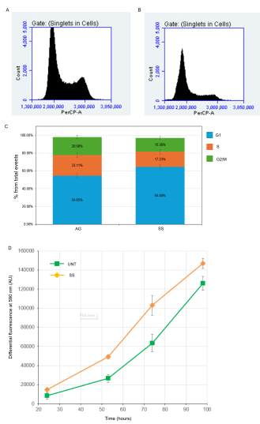
Figure S1. Starvation induces G1 accumulation without compromising cell viability or proliferative recovery in U2OS cells.
(A, B) Representative flow cytometry histograms of propidium iodide (PI)-stained U2OS cells gated on singlets. The x-axis shows PI fluorescence intensity (PerCP-A channel) and the y-axis shows cell count. (A) Actively growing (AG) cells display a characteristic asynchronous cell cycle profile with distinct G1 and G2/M peaks. (B) Starved (SS) cells show a shift in cell cycle distribution with an increased proportion of cells in G1 phase relative to AG controls, consistent with starvation-induced G1 accumulation.
(C) Quantification of cell cycle phase distribution from PI-FACS analysis. Stacked bar chart shows the percentage of total events in G1 (blue), S (orange), and G2/M (green) phases for AG and SS conditions. AG cells exhibit 54.65% G1, 23.11% S, and 20.08% G2/M. Starved cells show an increased G1 fraction (64.40%) with concomitant reductions in S phase (17.23%) and G2/M (15.36%), indicating partial G1 arrest upon nutrient deprivation. Error bars represent standard deviation (n=3).
(D) Proliferative recovery assessed by PrestoBlue metabolic activity assay. Equal numbers of untreated (UNT; green squares) and previously starved (SS; orange diamonds) cells were replated in complete medium, and metabolic activity was measured by differential fluorescence at 590 nm (arbitrary units, AU) over a time course from 24 to 96 hours. Both conditions show progressive increases in fluorescence signal, indicating active cell proliferation following replating. Starved cells display comparable or slightly higher metabolic activity relative to untreated controls across all time points, demonstrating that proliferative capacity is fully retained following 18 h of starvation. Error bars represent standard deviation from biological replicates (n=3).

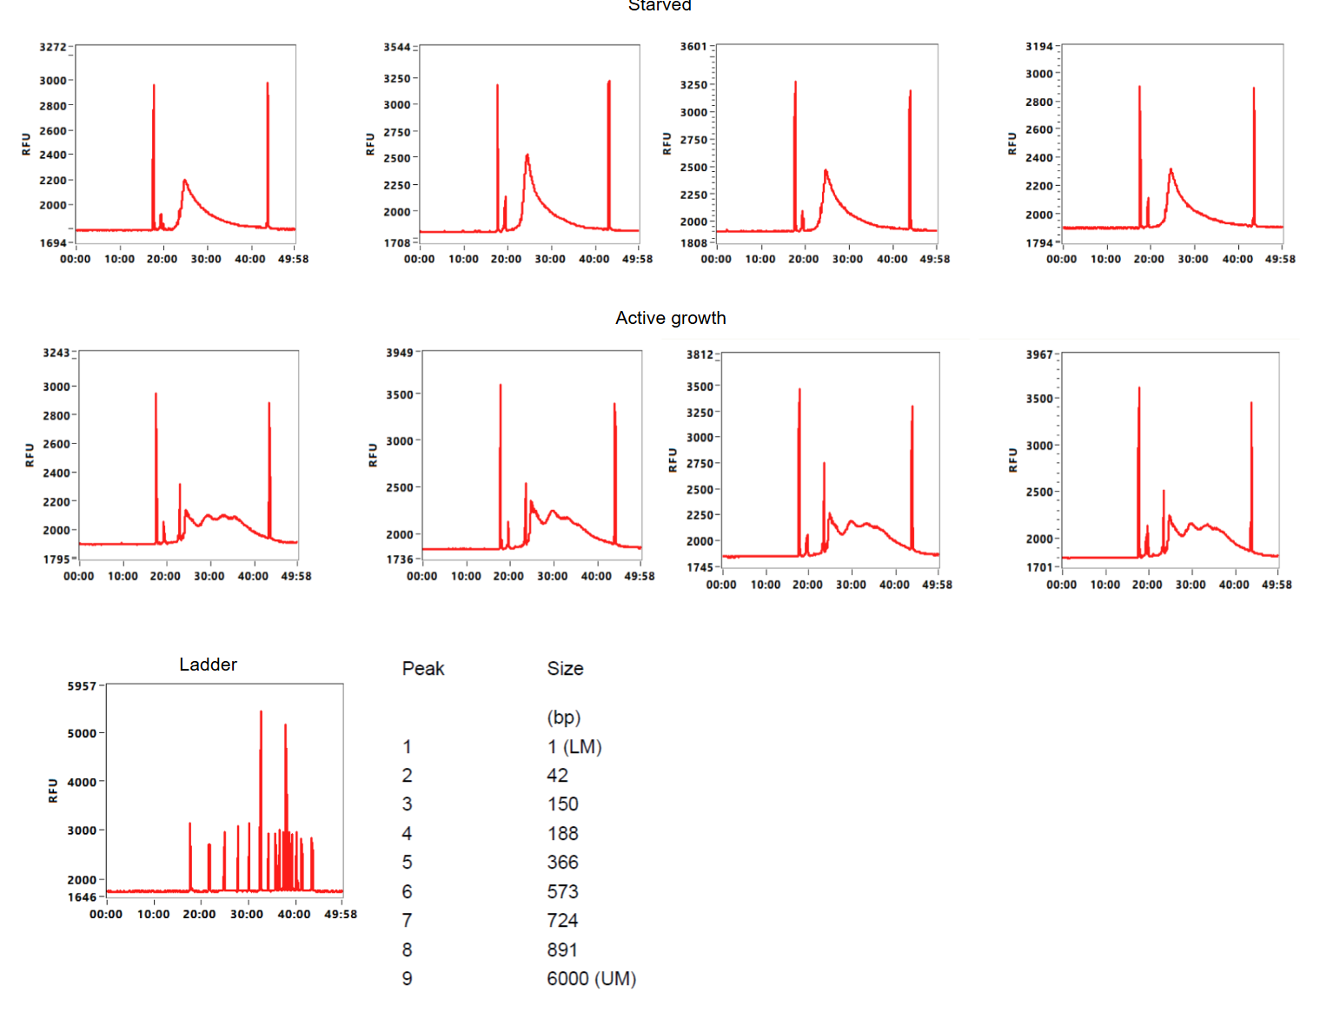

Figure S2. ATAC-seq library fragment size distribution profiles assessed by capillary electrophoresis.
Representative electropherograms of ATAC-seq libraries from starved (SS, top row; n = 4 biological replicates) and actively growing (AG, bottom row; n = 4 biological replicates) U2OS cells, analysed using the Agilent 5200 Fragment Analyzer. The x-axis represents migration time (minutes:seconds), and the y-axis indicates relative fluorescence units (RFU), proportional to fragment concentration. The DNA size ladder (bottom left panel) with corresponding peak assignments (bottom right table) shows size markers ranging from the lower marker (LM; 1 bp) to the upper marker (UM; 6000 bp), with intermediate peaks at 42, 150, 188, 366, 573, 724, and 891 bp.
Both SS and AG libraries exhibit the characteristic nucleosomal periodicity pattern expected for successful ATAC-seq experiments, with a prominent peak in the nucleosome-free region (NFR; ~50 bp), followed by mono-nucleosomal (~200 bp), di-nucleosomal (~400 bp), and higher-order nucleosomal fragments. Notably, AG samples display more sharply defined and discrete nucleosomal peaks with clear separation between mono-, di-, and tri-nucleosomal fragments, whereas SS samples show a comparatively broader and less structured distribution pattern, particularly in the higher molecular weight regions. This difference in peak resolution is consistent with the global chromatin compaction observed in starved cells, where reduced chromatin accessibility may alter the efficiency of Tn5 transposase insertion and the resulting fragment size distribution. Despite these differences, both conditions retain the characteristic NFR peak at approximately 50 bp (mode: 49–50 bp) and preserve overall nucleosomal periodicity, confirming successful Tn5 transposition and adequate library quality across all samples. As reported in Figure 1E, the NFR fraction was slightly lower in SS samples (40.4%) compared to AG samples (46.9%, p = 0.012), consistent with partial chromatin compaction, while the preserved nucleosomal periodicity confirms that the reduced quality metrics (FRiP and TSS enrichment scores) observed in SS samples reflect genuine biological chromatin closure rather than technical library preparation failure.

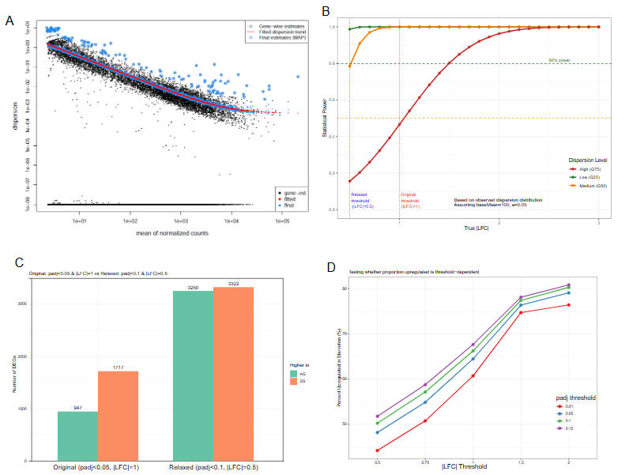
Figure S3. Statistical characterization of RNA-seq differential expression analysis with n=2 replicates. (A) Dispersion estimates from DESeq2 showing gene-wise (black points), fitted trend (red line), and maximum a posteriori (MAP) estimates (blue points). With n=2 replicates, DESeq2 relies on empirical Bayes shrinkage toward the fitted trend to stabilize variance estimates. Median dispersion = 0.023. (B) Statistical power analysis based on observed dispersion distribution. Power curves shown for genes with low (25th percentile), medium (50th percentile), and high (75th percentile) dispersion at baseMean=100. At median dispersion, power exceeds 99% for |LFC| ≥ 1 (original threshold, red dashed line) and 78% for |LFC| ≥ 0.5 (relaxed threshold, blue dashed line). (C) Sensitivity analysis comparing original thresholds (padj<0.05, |LFC|≥1) to relaxed thresholds (padj<0.1, |LFC|≥0.5). Number of DEGs increased from 2,664 to 6,572, while proportion upregulated decreased from 64.5% to 50.5%, arguing against detection bias. Green bars – actively growing (AG), orange bars – starved samples. (D) Proportion stability analysis across varying threshold combinations. Percentage of upregulated genes increases with stricter |LFC| thresholds across all padj cutoffs, indicating that starvation-upregulated genes exhibit larger magnitude changes than downregulated genes. This directional asymmetry is maintained despite global chromatin compaction (95% of ATAC peaks decreased).

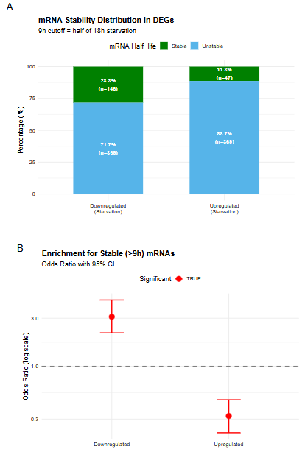
Figure S4. mRNA half-life enrichment analysis distinguishes transcriptional activation from mRNA stabilization.
(A) Stacked bar chart showing mRNA stability distribution in differentially expressed genes. Upregulated genes (n=416) and downregulated genes (n=515) are stratified by mRNA half-life using a 9-hour threshold (half the 18-hour starvation duration). Green bars represent stable mRNAs (half-life >9h); blue bars represent unstable mRNAs (half-life ≤9h). Percentages and gene counts are displayed within each segment. Upregulated genes show strong enrichment for unstable mRNAs (88.7%, n=369), whereas downregulated genes are enriched for stable mRNAs (28.3%, n=146). Under first-order decay kinetics, mRNAs with half-lives ≤9h would be reduced to ≤25% of initial abundance after 18 hours without new synthesis, indicating that their elevated levels require ongoing transcription rather than selective stabilization.
(B) Odds ratio plot with 95% confidence intervals for enrichment of stable (>9h) mRNAs. Each point represents the odds ratio for a differential expression category, with error bars indicating 95% confidence intervals. The horizontal dashed line at OR=1 indicates no enrichment. Upregulated genes show significant depletion of stable mRNAs (OR=0.322, 95% CI [0.225–0.461], p=8.5×10⁻¹¹), corresponding to a 3.1-fold enrichment for unstable mRNAs. Downregulated genes show the reciprocal pattern with significant enrichment for stable mRNAs (OR=3.10, 95% CI [2.17–4.45], p<10⁻¹⁰). Red points indicate statistically significant enrichment (p<0.05); grey points indicate non-significant results. Half-life data from {Tani, 2012 #5542}. Statistical analysis by Fisher's exact test.

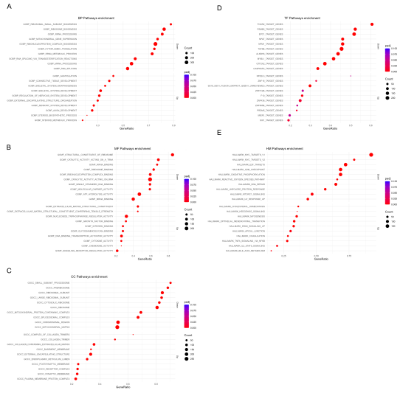
Figure S5. Individual pathway enrichment results. (A) Dot plot of significantly enriched GO:BP pathways. (B) Dot plot of significantly enriched GO:MF pathways. (C) Dot plot of significantly enriched GO:CC pathways. (D) Dot plot of significantly enriched TF targets. (E) Dot plot of significantly enriched Hallmark pathways. Dot size represents leading-edge gene count; colour indicates padj value.

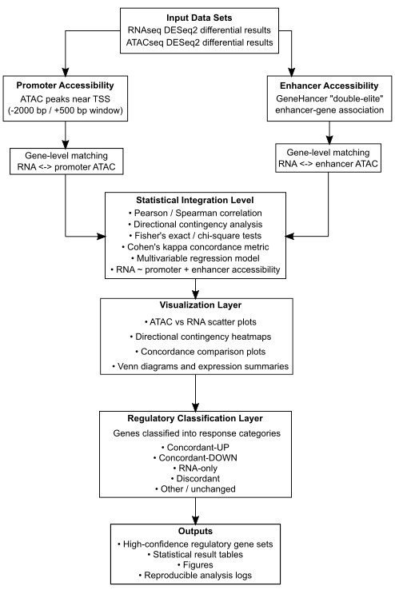
Figure S6. Architecture of the ATAC–RNA integration pipeline. Differential expression results from RNA-seq and differential chromatin accessibility results from ATAC-seq were integrated using a modular R-based workflow. ATAC peaks were first annotated to genes using promoter proximity or high-confidence enhancer–gene associations from the GeneHancer database. RNA and ATAC features were matched at the gene level separately for promoter and enhancer regulatory layers. Statistical integration analyses quantified chromatin–transcription relationships using correlation analysis, contingency testing, concordance metrics, and multivariable regression models. Visualization modules generated exploratory and publication-quality plots summarizing regulatory patterns. Genes were subsequently classified into regulatory response categories including concordant regulation, ATAC-only, RNA-only, and discordant responses, and high-confidence regulatory events were identified for downstream analysis.

