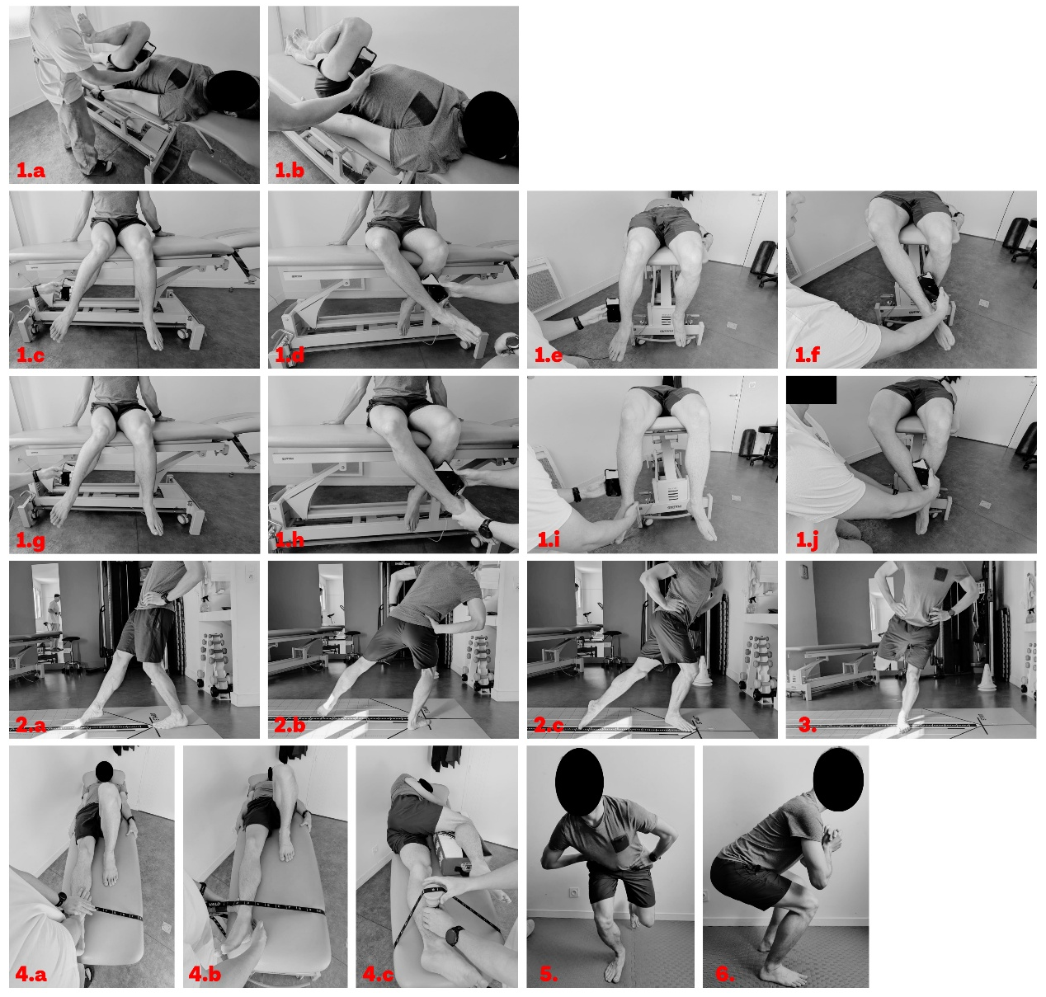
Appendix A. Standardized test positions included in the hip assessment battery.
Panels 1a and 1b illustrate passive and active hip flexion, respectively, measured using an inclinometer aligned with the longitudinal axis of the femur. Passive internal and external hip rotation are presented in a seated position at 90° of hip flexion (1c–1d) and in a neutral position (0° flexion) (1i–1j), while active internal and external rotation in neutral position are shown in 1e–1f. Additional passive rotational assessments at 90° of hip flexion are depicted in 1g–1h. Panels 2a–2c correspond to the modified Star Excursion Balance Test performed in the anterior, posterolateral, and posteromedial directions. Panel 3 illustrates the medial hop test. Maximal isometric strength assessments are shown in panels 4a–4c for the hip flexors (with hip and knee at 0°), abductors, and adductors, respectively. Dynamic performance is assessed using a single-leg squat (panel 5), while muscular endurance is evaluated with a squat held at approximately 100° of knee flexion (panel 6).

