Supplementary Material
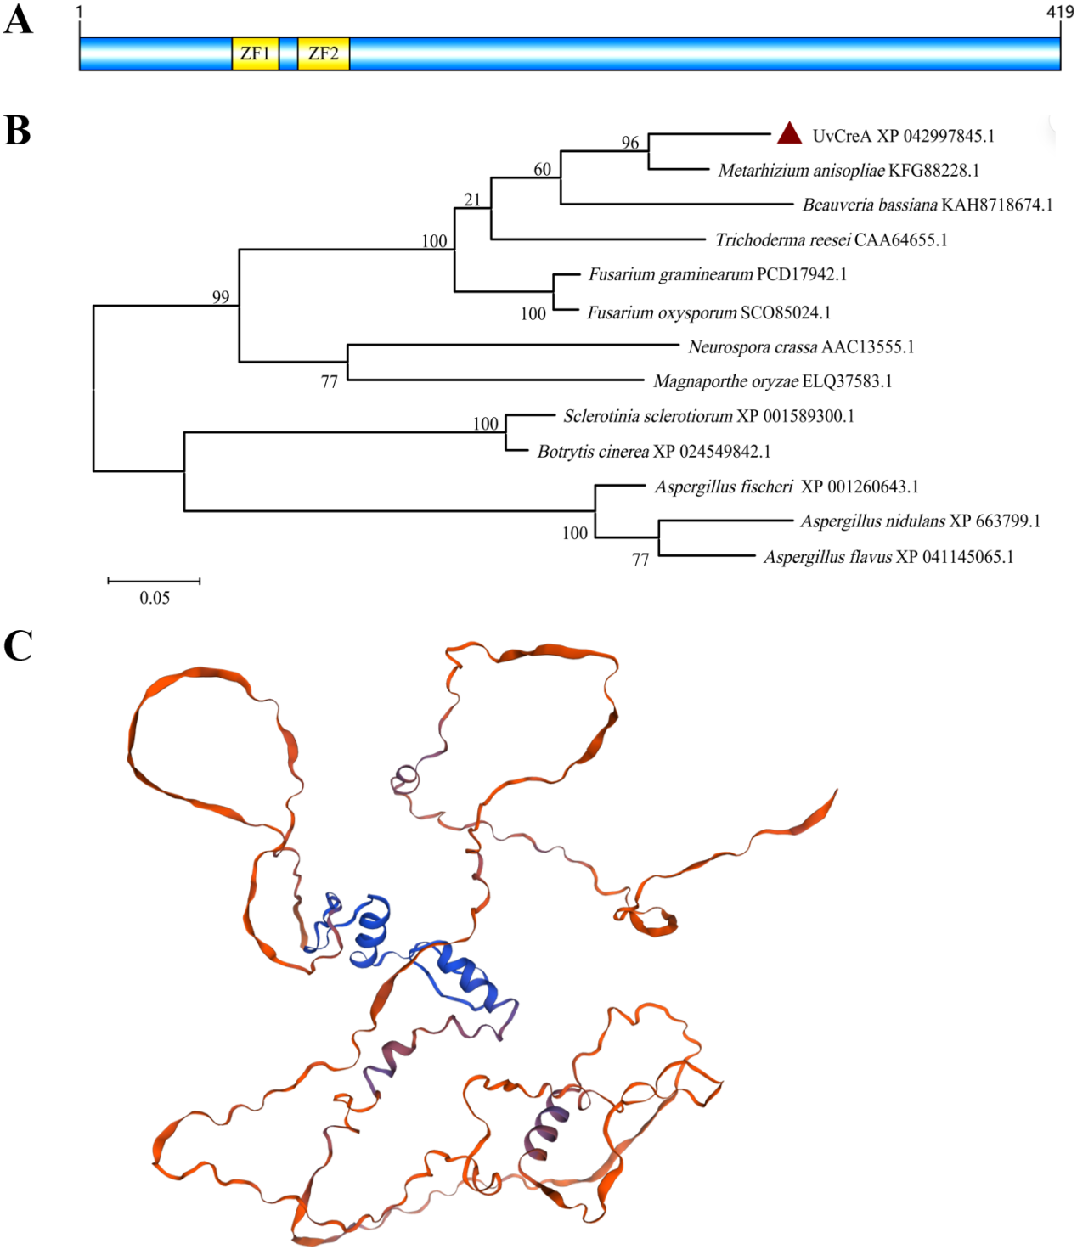

Fig. S1 Structural and phylogenetic analyses of UvCreA and its homologs.
(A) The conserved domains in UvCreA. ZF, zinc finger domains. (B) The phylogenetic tree constructed for UvCreA and its homologs from related fungal species. (C) The three-dimensional structure of UvCreA predicted through AlphaFold2. The zinc finger domains are highlighted in blue.

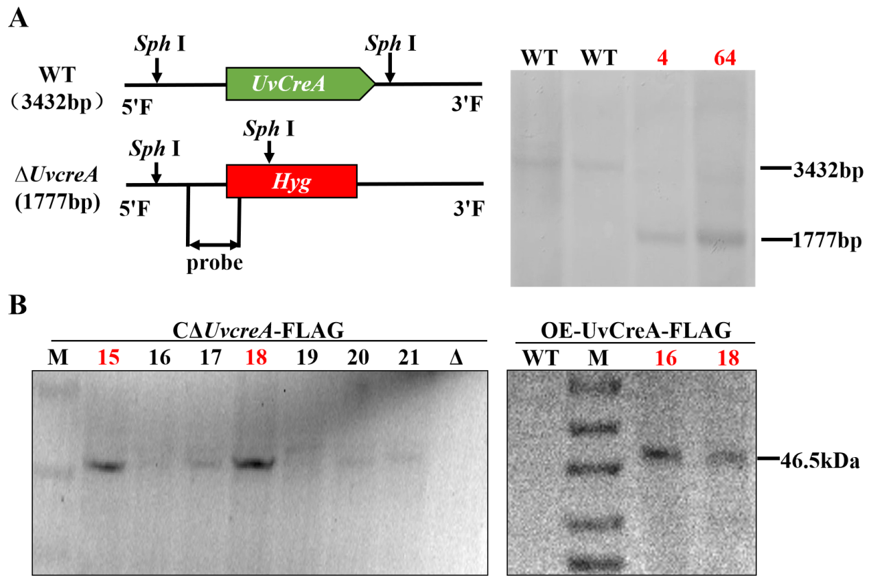
Fig. S2 Construction of UvCreA-knockout, complementation, and overexpression strains in U. virens.
- Southern blot analysis to verify the knockout strains. (B) Immunoblot analysis to verify the UvCreA complemented and overexpression strains. The blots were probed with anti-FLAG antibody.
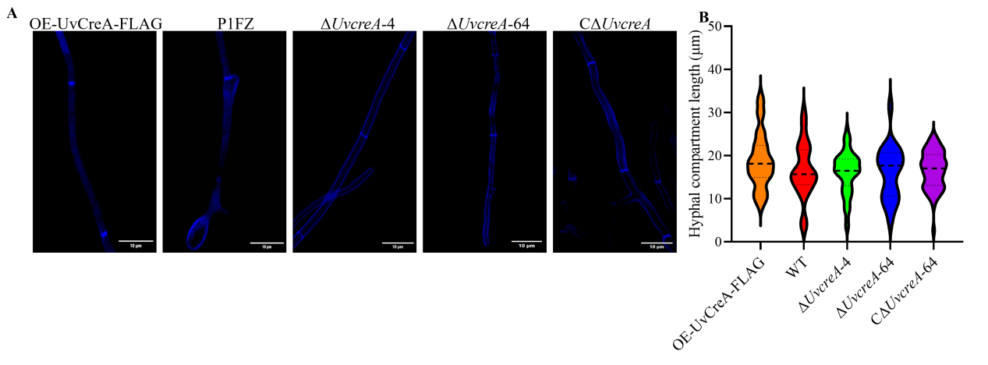
Fig. S3 UvCreA is not required for hyphal length in U. virens.
(A) Hyphal morphology observed after CFW staining of wild-type, ΔUvcreA-4/64, CΔUvcreA-64, and OE-UvCreA-FLAG strains. (B) Statistics of hyphal length based on CFW staining in the indicated strains.
Table S1 Primers used in this study
Primer name | Primer sequence （5'-3'）
CRISPR-UvCreA-F | ACCTCCGCATATGCTCCACGAGGG
CRISPR-UvCreA-R | AAACCCCTCGTGGAGCATATGCGG
Fusion-UvCreA-1F | AATCATCGTCTCACTGCTTGCGG
Fusion-UvCreA-2R | GCCGACCGGGAACCAGTTATCGTGATGCGAGACTGGCCCA
Fusion-UvCreA-3F | TGGGCCAGTCTCGCATCACGATAACTGGTTCCCGGTCGGC
Fusion-UvCreA-4R | AGCGTCTCACGGGGCCATCTTTGGTTTAGTCGTCAGGCGGT
Fusion-UvCreA-5F | ACCGCCTGACGACTAAACCAAAGATGGCCCCGTGAGACGCT
Fusion-UvCreA-6R | GAAGCGACTGCCTTGCTGCT
Hyg-F | CTCGCTCCAGTCAATGACCG
Hyg-R | GGGCGAAGAATCTCGTGCTTT
Gene-UvCreA-F | ATGCAACCATCACTGCCAGCC
Gene-UvCreA-R | CTAGACGCGATCCATGAGATC
Up-UvCreA-F | AATCATCGTCTCACTGCTTGCGG
Up-UvCreA-R | TGGGCCAGTCTCGCATCACGATAACTGGTTCCCGGTCGGC
Down-UvCreA-F | ACCGCCTGACGACTAAACCAAAGATGGCCCCGTGAGACGCT
Down-UvCreA-R | GAAGCGACTGCCTTGCTGCT
probe-UvCreA-F | GAGGACATGGAGGTACGTTGACC
probe-UvCreA-R | CGCCTGGGCCAGTCTCGCATCAC
C-UvCreA-EcoR V- FLAG-F | ACGCCAACAAGCTTGATATCATGCAACCATCACTGCCAGCC
C-UvCreA-Pst Ⅰ-FLAG-R | AGATTCTCCCCGGGCTGCAGCTAGACGCGATCCATGAGATC
α-tubulin-F | GGCGTTTACAATGGCACTTC
α-tubulin-R | CGGAACAGTTGACCAAAAGG
qRT-UgsR1-F | GCATGATACGGCACAGCAAG
qRT-UgsR1-R | CAGTTTTTGCCGGTTCTGGG
qRT-UgsR2-F | GCGCAGTACCCGTATCCTTT
qRT-UgsR2-R | AACGAGGGTGTGGTTGAGAC
qRT-UgsO-F | ATTGGAGACAGCGTCAAGCA
qRT-UgsO-R | CAGCGGCGGATTTGTATGTG
qRT-UvPKS1-F | GCTCACTGTCCTACACCACC
qRT-UvPKS1-R | ATCTCATCAACCGACGAGCC
qRT-UgsZ-F | TCGGCCCGGATCATGAAAAG
qRT-UgsZ-R | CCCGTTAATCAAGAGAGGCGA
qRT-UgsT-F | CCCACCGCCATTTCTCTCAT
qRT-UgsT-R | CGGTTCTCAACACGAGGTCA
qRT-UgsH-F | TTCGACACGCTCAACAACCT
qRT-UgsH-R | ATCTCGCAAACACACTCCGT
qRT-UgsJ-R | GGCCTGTACTCTCCATCAGC
qRT-UgsJ-F | GGCGTCTCGACCCTATCAAG
GST-UvCreA-F | ATCTGGTTCCGCGTGGATCCATGCAACCATCACTGCCAGCC
GST-UvCreA-R | TCGAGTCGACCCGGGAATTCCTAGACGCGATCCATGAGATC
pB42AD-UvCreA-F | TGCCTCTCCCGAATTCATGCAACCATCACTGCCAGCC
pB42AD-UvCreA-R | CGAGTCGGCCGAATTCCTAGACGCGATCCATGAGATC
pLacZi-UgsJ-F | ATCTGTCGACCTCGAGAGTTGACCGAGACATGCAGC
pLacZi-UgsJ-R | GAGCACATGCCTCGAGAACTGGGACCGGCATCAAAC
pLacZi-UvPKS1-F | ATCTGTCGACCTCGAGACCACATTCATGCACGCCT
pLacZi-UvPKS1-R | GAGCACATGCCTCGAGATTACACCAAGTCAGAGC
probe-UvPKS1-F-bio | CCTCCCTCTCCCCCACCGTCGGGAAG
probe -UvPKS1-F | CCTCCCTCTCCCCCACCGTCGGGAAG
probe -UvPKS1-R | CTTCCCGACGGTGGGGGAGAGGGAGG
mutant-UvPKS1-probe-bio-F | CCTCCCTCTCAAAAGACGTCGGGAAG
mutant-UvPKS1-probe-R | CTTCCCGACGTCTTTTGAGAGGGAGG
probe-UgsJ-F-bio | ATCGCCAATCGTGGGGGTGTTGGACG
probe-UgsJ-F | ATCGCCAATCGTGGGGGTGTTGGACG
probe-UgsJ-R | CGTCCAACACCCCCACGATTGGCGAT
mutant-UgsJ-probe-bio-F | ATCGCCAATCAGAAAAGTGTTGGACG
mutant-UgsJ-probe-R | CGTCCAACACTTTTCTGATTGGCGAT
ChIP-UvPKS1_{Pro}-1-F | AGCAAACAAGAGAGCCAGCC
ChIP-UvPKS1_{Pro}-1-R | TCGGTCGTTCGTCCCTGCG
ChIP-UvPKS1_{Pro}-2-F | AATGTGAAACACGAGGCCT
ChIP-UvPKS1_{Pro}-2-R | TGAGGCCAAAAAGCTCAGT
ChIP-UgsJ_{Pro}-1-F | TTACGTCAAGGATACCTGAC
ChIP-UgsJ_{Pro}-1-R | ATCATGTGGGCTTTTTACC
ChIP-UgsJ_{Pro}-2-F | AAAACACCGTTTGTGAAGAT
ChIP-UgsJ_{Pro}-2-R | TGCCTCAAGATGACTTCTT

Table S2 The number of putative UvCreA-binding cis-elements in the promoter regions of the genes involved in ustilaginoidin biosynthesis.
Ugs genes | Number of cis-elements
UgsR1 | 16
UgsO | 12
UvPKS1 | 7
UgsZ | 12
UgsT | 4
UgsH | 4
UgsJ | 12
UgsL | 12

