Data Screening Code Book CWTT
University of Johannesburg *
Prof Arnesh*

Prior to exploratory factor analysis, the data were screened in a structured sequence to ensure that the item responses were suitable for multivariate analysis. First, accuracy was evaluated by checking that all variables were correctly imported, labelled, and coded, and that response categories matched the original survey format. This step is essential because factor analysis depends on the quality of the observed item matrix; any coding errors, inconsistent scales, or misplaced missing-value codes can distort the correlation structure. Second, missing data were examined at both the item and case level to determine the extent and pattern of nonresponse.
High rates of missingness can reduce statistical power, bias estimates, and destabilize the inter-item correlation matrix, so the amount and distribution of missing data must be understood before proceeding. Third, outliers were assessed to identify unusual response patterns that might exert disproportionate influence on correlations and extraction results. In the context of questionnaire data, outliers may reflect data entry error, inattentive responding, or genuinely extreme scores, and each possibility must be considered before deciding whether exclusion is justified. After these initial checks, the assumptions relevant to the planned analyses were considered. These included additivity, normality, linearity, and homogeneity. Additivity refers to the expectation that relationships among variables combine in a consistent way, such that the total association can be represented as the sum of component effects without major distortion from complex interactions. Normality was reviewed to determine whether item distributions or summed indicators were excessively skewed or kurtotic, since severe departures from normality can affect correlations and subsequent estimation. Linearity was examined because factor analysis is based on the covariance or correlation among variables, and these associations are most appropriately represented when the relationships between items are approximately linear. Homogeneity was also considered, meaning that the items entered into a given analysis should reflect a reasonably coherent domain rather than a mixture of unrelated constructs. Together, these screening steps help ensure that the dataset is accurate, interpretable, and appropriate for exploratory factor analysis.

Accuracy
# =========================================================
# EFA DATA SCREENING: STEP 1 = ACCURACY
# Creates CWTT_items_accuracy_clean for later chunks
# Adds compact sjPlot tables to minimize long console output
# =========================================================
library(readr)
library(dplyr)
library(stringr)
library(ggplot2)
library(tidyr)
library(sjPlot)
library(wesanderson)
library(scales)
# ---------------------------------------------------------
# 1. Import raw data and retain questionnaire items
# ---------------------------------------------------------
CWTT_raw <- read_csv("CWTT_raw_data.csv")
CWTT_items <- CWTT_raw %>%
select(matches("^Question_"))
# ---------------------------------------------------------
# 2. Initial class check before cleaning
# ---------------------------------------------------------
item_classes_before <- sapply(CWTT_items, class)
class_summary_before <- data.frame(
class = as.character(item_classes_before),
stringsAsFactors = FALSE
) %>%
count(class, name = "n_items") %>%
arrange(desc(n_items))
# ---------------------------------------------------------
# 3. Convert blank strings to NA and convert numeric-looking text
# ---------------------------------------------------------
CWTT_items <- CWTT_items %>%
mutate(across(everything(), ~ if (is.character(.x)) na_if(.x, "") else .x)) %>%
mutate(across(everything(), ~ suppressWarnings(type.convert(.x, as.is = TRUE))))
# ---------------------------------------------------------
# 4. Recheck class after cleaning
# ---------------------------------------------------------
item_classes_after <- sapply(CWTT_items, class)
class_summary_after <- data.frame(
class = as.character(item_classes_after),
stringsAsFactors = FALSE
) %>%
count(class, name = "n_items") %>%
arrange(desc(n_items))
non_numeric_items_after <- names(CWTT_items)[!sapply(CWTT_items, is.numeric)]
# ---------------------------------------------------------
# 5. Compute accuracy diagnostics
# ---------------------------------------------------------
n_unique <- sapply(CWTT_items, function(x) length(unique(x[!is.na(x)])))
item_sd <- sapply(CWTT_items, function(x) suppressWarnings(sd(x, na.rm = TRUE)))
invalid_values <- lapply(CWTT_items, function(x) {
vals <- unique(x[!is.na(x)])
vals[!vals %in% 1:7]
})
invalid_items <- names(invalid_values)[sapply(invalid_values, length) > 0]
invalid_counts <- sapply(invalid_values, length)
constant_items <- names(n_unique[n_unique <= 1])
zero_variance_items <- names(item_sd[is.na(item_sd) | item_sd == 0])
accuracy_summary <- data.frame(
variable = names(CWTT_items),
class = sapply(CWTT_items, function(x) paste(class(x), collapse = ", ")),
n_missing = sapply(CWTT_items, function(x) sum(is.na(x))),
n_unique = n_unique,
min_value = sapply(CWTT_items, function(x) suppressWarnings(if (all(is.na(x))) NA else min(x, na.rm = TRUE))),
max_value = sapply(CWTT_items, function(x) suppressWarnings(if (all(is.na(x))) NA else max(x, na.rm = TRUE))),
sd = item_sd,
has_invalid_values = names(CWTT_items) %in% invalid_items,
invalid_value_count = ifelse(
names(CWTT_items) %in% names(invalid_counts),
as.numeric(invalid_counts[names(CWTT_items)]),
0
),
is_constant = names(CWTT_items) %in% constant_items,
is_zero_variance = names(CWTT_items) %in% zero_variance_items,
stringsAsFactors = FALSE
)
# ---------------------------------------------------------
# 6. Create cleaned dataset for downstream steps
# ---------------------------------------------------------
CWTT_items_accuracy_clean <- CWTT_items %>%
select(where(is.numeric)) %>%
select(where(~ sd(.x, na.rm = TRUE) > 0))
# ---------------------------------------------------------
# 7. Compact summary for manuscript text
# ---------------------------------------------------------
accuracy_report <- data.frame(
Metric = c(
"Total cases",
"Total questionnaire items",
"Non-numeric items after cleaning",
"Items with invalid values",
"Constant items",
"Zero-variance items",
"Retained items after accuracy screening"
),
Value = c(
nrow(CWTT_items),
ncol(CWTT_items),
length(non_numeric_items_after),
length(invalid_items),
length(constant_items),
length(zero_variance_items),
ncol(CWTT_items_accuracy_clean)
),
stringsAsFactors = FALSE
)
# ---------------------------------------------------------
# 8. Nature-style theme and palette
# ---------------------------------------------------------
wes_main <- wes_palette("GrandBudapest1", 5, type = "continuous")
wes_alt <- wes_palette("Moonrise2", 4, type = "continuous")
theme_nature_wes <- function() {
theme_classic(base_size = 11) +
theme(
plot.title = element_text(face = "bold", size = 12),
plot.subtitle = element_text(size = 9, color = "grey30"),
axis.title = element_text(face = "bold"),
legend.position = "right"
)
}
# ---------------------------------------------------------
# 9. Compact sjPlot table: overall accuracy summary
# ---------------------------------------------------------
sjPlot::tab_df(
accuracy_report,
title = "Table 1. Accuracy screening summary",
show.rownames = FALSE,
show.col.type = FALSE,
alternate.rows = TRUE,
digits = 2,
CSS = list(
css.table = "width:70%; margin-left:auto; margin-right:auto; border-collapse:collapse;",
css.tdata = "padding:6px 10px;",
css.colnames = "font-weight:bold; border-bottom:1px solid #333;",
css.summary = "font-weight:bold;"
)
)

The accuracy screening indicated that the raw questionnaire export required substantial preprocessing before it was suitable for exploratory factor analysis. The dataset contained 162 cases and 190 questionnaire variables, but not all of these variables were immediately appropriate for psychometric analysis. After initial cleaning, 14 items remained non-numeric, indicating that some variables were either open-text responses, improperly imported, or otherwise not stored in a format compatible with factor analysis. In addition, 24 items contained values outside the expected response range, suggesting the presence of inconsistent coding, special response codes, or data-entry anomalies that required review. These findings show that the raw file included a mixture of analytically relevant Likert-type items and variables that were not directly suitable for inclusion in the EFA item matrix. Further screening identified 12 constant items and 14 zero-variance items. Such variables do not contribute meaningful covariance information and can distort or destabilize the correlation matrix used in factor extraction. Their presence suggests that some questions were either unanswered across all cases, coded uniformly, or functioned in a way that produced no observable variation in this sample. As a result, these items were excluded from the analysis set. Following the removal of non-numeric and zero-variance variables, 176 items were retained after accuracy screening. This indicates that although the majority of the questionnaire variables could be preserved, the original export required careful data-quality review to distinguish usable psychometric indicators from structurally unsuitable variables. Overall, the screening results support the need for systematic preprocessing prior to factor analysis and justify the exclusion of items that were miscoded, invariant, or otherwise incompatible with the assumptions of multivariate analysis.
Table 1. Accuracy screening summary
Metric | Value
Total cases | 162
Total questionnaire items | 190
Non-numeric items after cleaning | 14
Items with invalid values | 24
Constant items | 12
Zero-variance items | 14
Retained items after accuracy screening | 176

Table 2. Variable classes before and after cleaning
class | before_cleaning | after_cleaning
numeric | 176 | 0
logical | 12 | 12
character | 2 | 2
integer | 0 | 176

Table 3. Most problematic items identified during accuracy screening
variable |  | class |  | n_missing |  | n_unique |  | min_value |  | max_value |  | sd |  | issue
Question_1A |  | logical |  | 162 |  | 0 |  | NA |  | NA |  | NA |  | non-numeric; constant; zero variance
Question_2A |  | logical |  | 162 |  | 0 |  | NA |  | NA |  | NA |  | non-numeric; constant; zero variance
Question_37A |  | logical |  | 162 |  | 0 |  | NA |  | NA |  | NA |  | non-numeric; constant; zero variance
Question_49A |  | logical |  | 162 |  | 0 |  | NA |  | NA |  | NA |  | non-numeric; constant; zero variance
Question_50 |  | logical |  | 162 |  | 0 |  | NA |  | NA |  | NA |  | non-numeric; constant; zero variance
Question_50A |  | logical |  | 162 |  | 0 |  | NA |  | NA |  | NA |  | non-numeric; constant; zero variance
Question_55 |  | logical |  | 162 |  | 0 |  | NA |  | NA |  | NA |  | non-numeric; constant; zero variance
Question_57 |  | logical |  | 162 |  | 0 |  | NA |  | NA |  | NA |  | non-numeric; constant; zero variance
Question_65A |  | logical |  | 162 |  | 0 |  | NA |  | NA |  | NA |  | non-numeric; constant; zero variance
Question_69A |  | logical |  | 162 |  | 0 |  | NA |  | NA |  | NA |  | non-numeric; constant; zero variance
Question_70 |  | logical |  | 162 |  | 0 |  | NA |  | NA |  | NA |  | non-numeric; constant; zero variance
Question_70A |  | logical |  | 162 |  | 0 |  | NA |  | NA |  | NA |  | non-numeric; constant; zero variance
Question_68 |  | character |  | 8 |  | 70 |  | . |  | We were |  | 0.00 |  | non-numeric; invalid range; zero variance
Question_13A |  | integer |  | 7 |  | 3 |  | 0 |  | 2 |  | 0.20 |  | invalid range
Question_18A | integer |  | 7 |  | 5 |  | 0 |  | 7 |  | 1.58 |  | invalid range
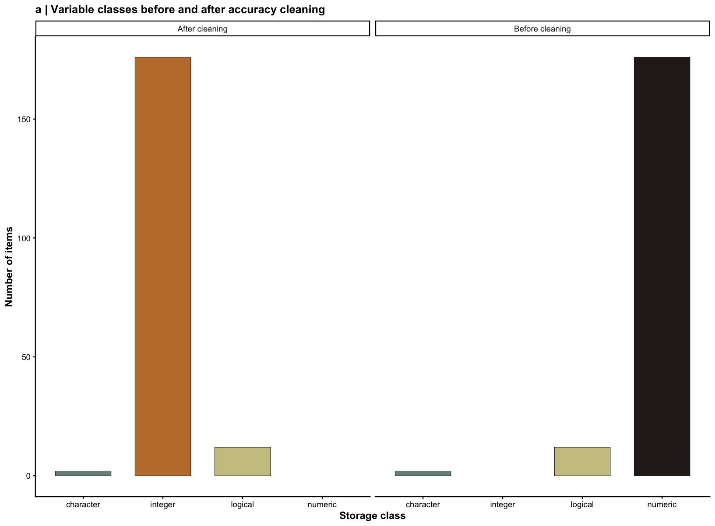
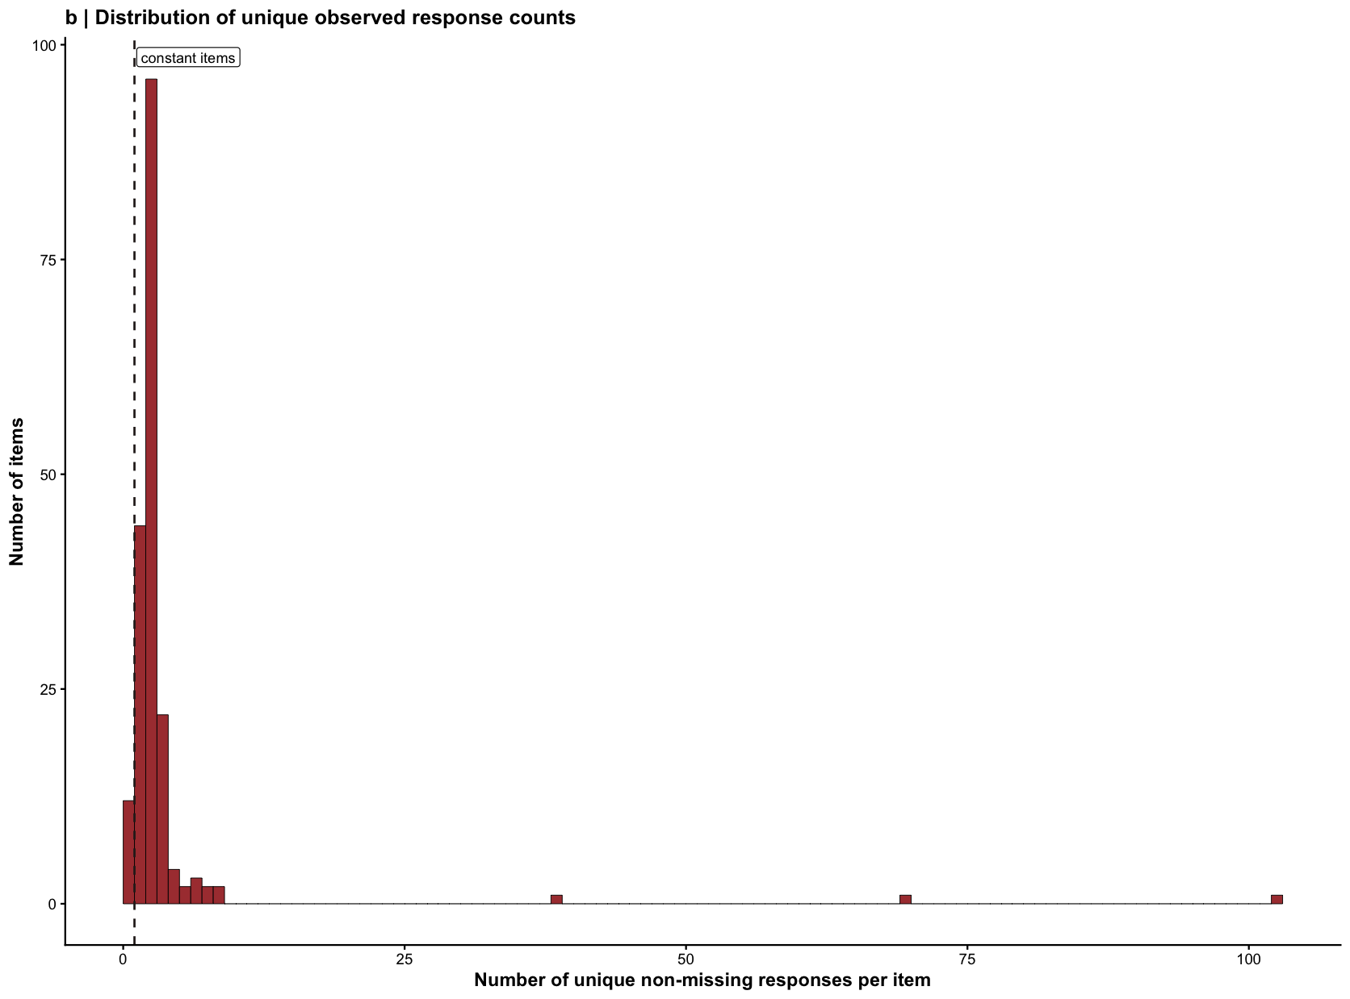
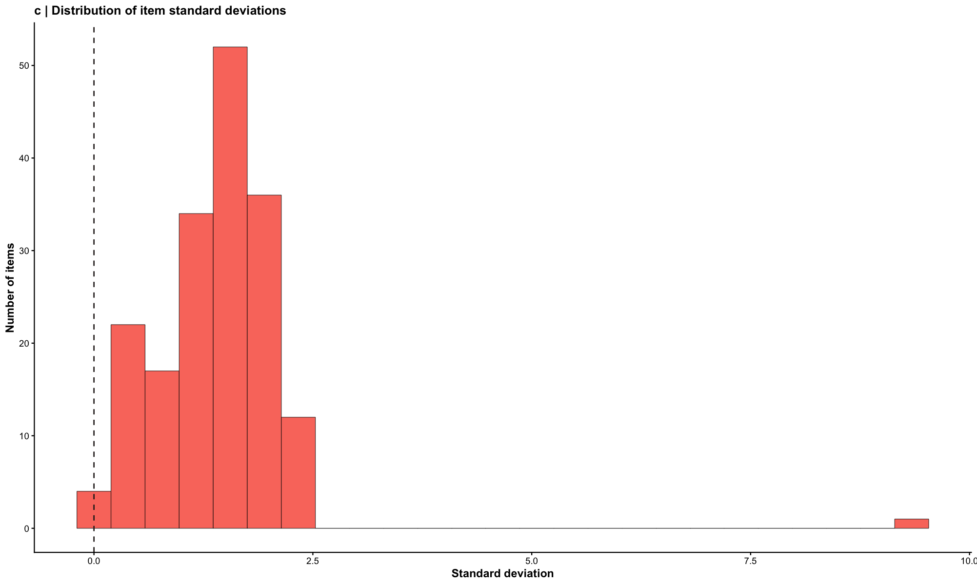
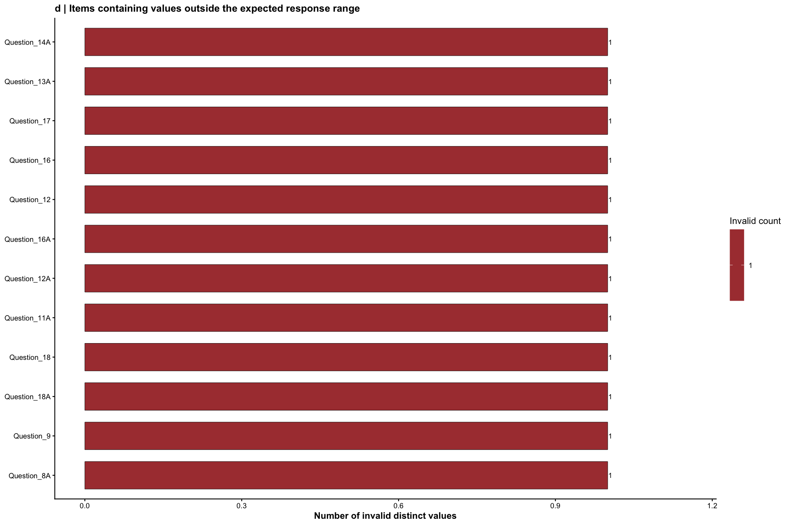

Missing Values
# =========================================================
# EFA DATA SCREENING: STEP 2 = MISSING DATA
# Nature-style, plot-forward version
# Creates CWTT_items_missing_clean for later chunks
# =========================================================
library(dplyr)
library(ggplot2)
library(wesanderson)
library(scales)
# ---------------------------------------------------------
# 1. Start from the accuracy-screened item dataset
# This object must be created in Step 1
# ---------------------------------------------------------
X <- CWTT_items_accuracy_clean
# ---------------------------------------------------------
# 2. Compute missingness summaries
# ---------------------------------------------------------
item_missing_n <- sapply(X, function(x) sum(is.na(x)))
item_missing_pct <- sapply(X, function(x) mean(is.na(x)) * 100)
item_missing_summary <- data.frame(
variable = names(X),
n_missing = item_missing_n,
pct_missing = round(item_missing_pct, 2),
stringsAsFactors = FALSE
) %>%
arrange(desc(pct_missing))
case_missing_n <- apply(X, 1, function(x) sum(is.na(x)))
case_missing_pct <- apply(X, 1, function(x) mean(is.na(x)) * 100)
case_missing_summary <- data.frame(
case_id = 1:nrow(X),
n_missing = case_missing_n,
pct_missing = round(case_missing_pct, 2),
stringsAsFactors = FALSE
)
# ---------------------------------------------------------
# 3. Flag items and cases with notable missingness
# ---------------------------------------------------------
items_over_5pct <- item_missing_summary %>% filter(pct_missing > 5)
items_over_10pct <- item_missing_summary %>% filter(pct_missing > 10)
cases_over_5pct <- case_missing_summary %>% filter(pct_missing > 5)
cases_over_10pct <- case_missing_summary %>% filter(pct_missing > 10)
# ---------------------------------------------------------
# 4. Overall missingness summary
# ---------------------------------------------------------
overall_missing_pct <- mean(is.na(X)) * 100
n_complete_cases <- sum(complete.cases(X))
n_incomplete_cases <- nrow(X) - n_complete_cases
missing_report <- data.frame(
total_cases = nrow(X),
total_items = ncol(X),
overall_missing_pct = round(overall_missing_pct, 2),
complete_cases = n_complete_cases,
incomplete_cases = n_incomplete_cases,
items_above_5pct_missing = nrow(items_over_5pct),
items_above_10pct_missing = nrow(items_over_10pct),
cases_above_5pct_missing = nrow(cases_over_5pct),
cases_above_10pct_missing = nrow(cases_over_10pct),
stringsAsFactors = FALSE
)
missing_report
total_cases total_items overall_missing_pct complete_cases incomplete_cases
1 162 176 4.17 80 82
items_above_5pct_missing items_above_10pct_missing cases_above_5pct_missing
1 34 2 19
cases_above_10pct_missing
1 17
# ---------------------------------------------------------
# 5. Nature-style theme and palette
# ---------------------------------------------------------
wes_main <- wes_palette("GrandBudapest1", 5, type = "continuous")
wes_alt <- wes_palette("Moonrise2", 4, type = "continuous")
theme_nature_wes <- function() {
theme_classic(base_size = 11) +
theme(
plot.title = element_text(face = "bold", size = 12),
plot.subtitle = element_text(size = 9, color = "grey30"),
axis.title = element_text(face = "bold"),
legend.position = "right"
)
}
# ---------------------------------------------------------
# 6. Figure A: distribution of item-level missingness
# ---------------------------------------------------------
ggplot(item_missing_summary, aes(x = pct_missing)) +
geom_histogram(
bins = 20,
fill = wes_main[3],
color = "black",
linewidth = 0.2
) +
geom_vline(xintercept = 5, color = wes_alt[4], linetype = "dashed", linewidth = 0.6) +
geom_vline(xintercept = 10, color = wes_alt[2], linetype = "dotted", linewidth = 0.8) +
annotate("label",
x = 5, y = Inf, label = "5% reference",
vjust = 1.5, hjust = -0.05, size = 3,
fill = alpha("white", 0.8), label.size = 0.15) +
annotate("label",
x = 10, y = Inf, label = "10% reference",
vjust = 3.0, hjust = -0.05, size = 3,
fill = alpha("white", 0.8), label.size = 0.15) +
labs(
title = "a | Distribution of item-level missingness",
subtitle = "Vertical demarcations indicate common screening reference thresholds",
x = "Missing responses per item (%)",
y = "Number of items"
) +
theme_nature_wes()

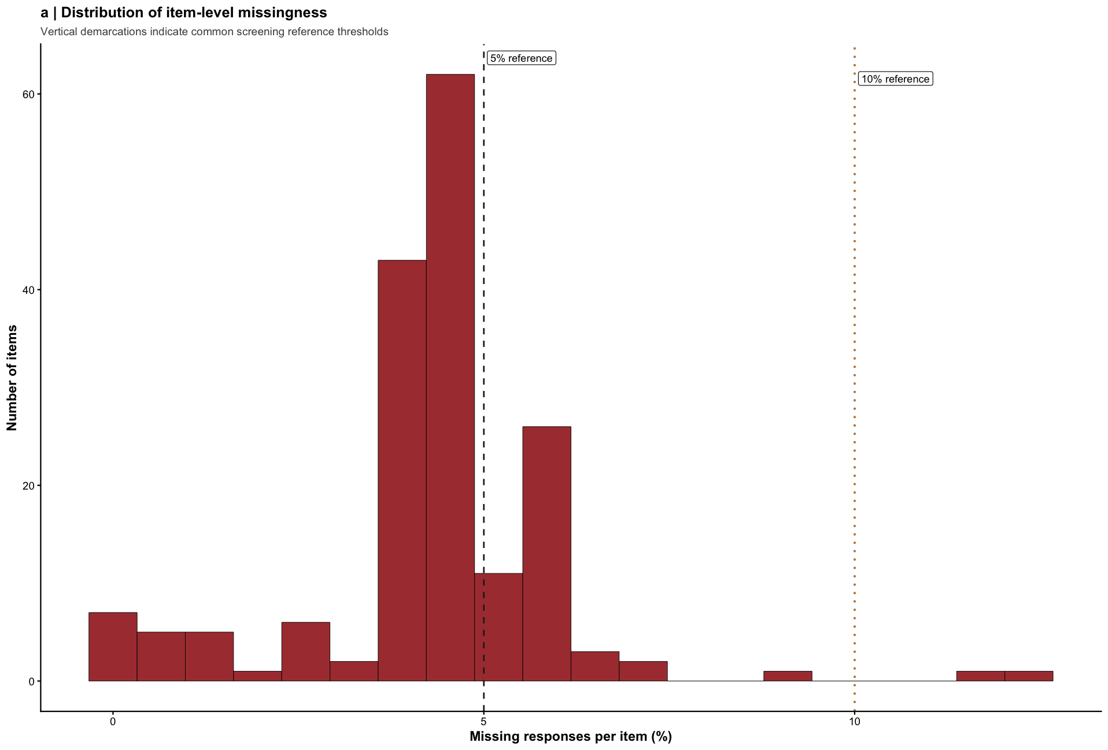
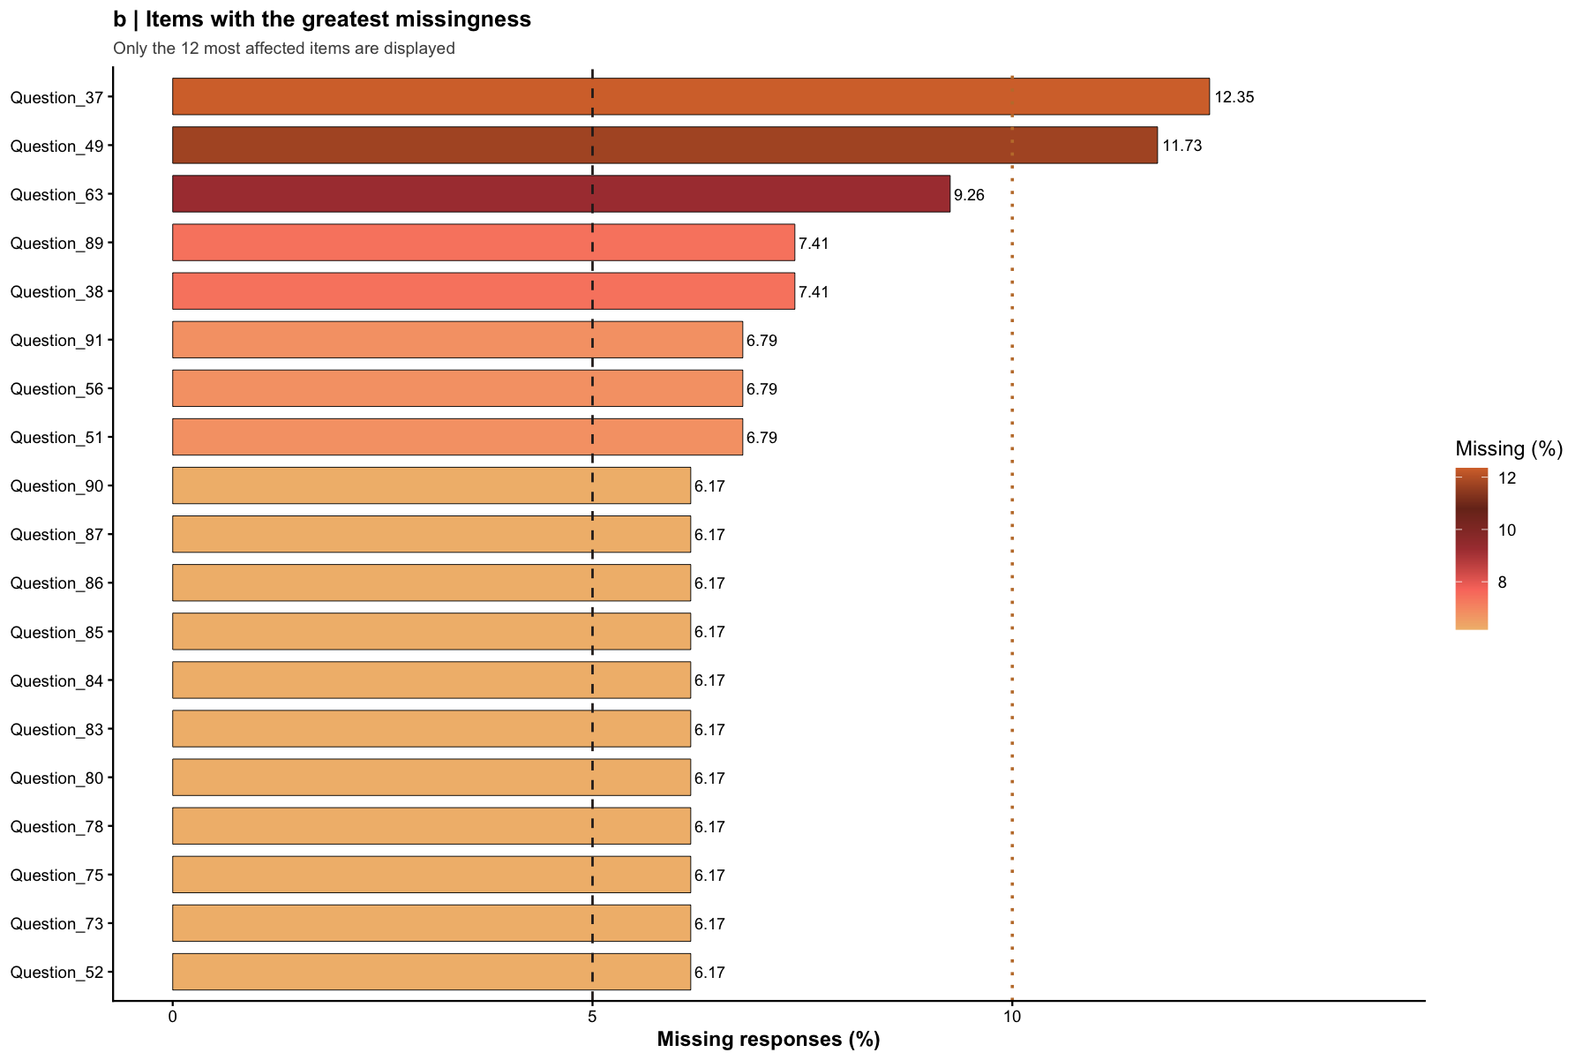
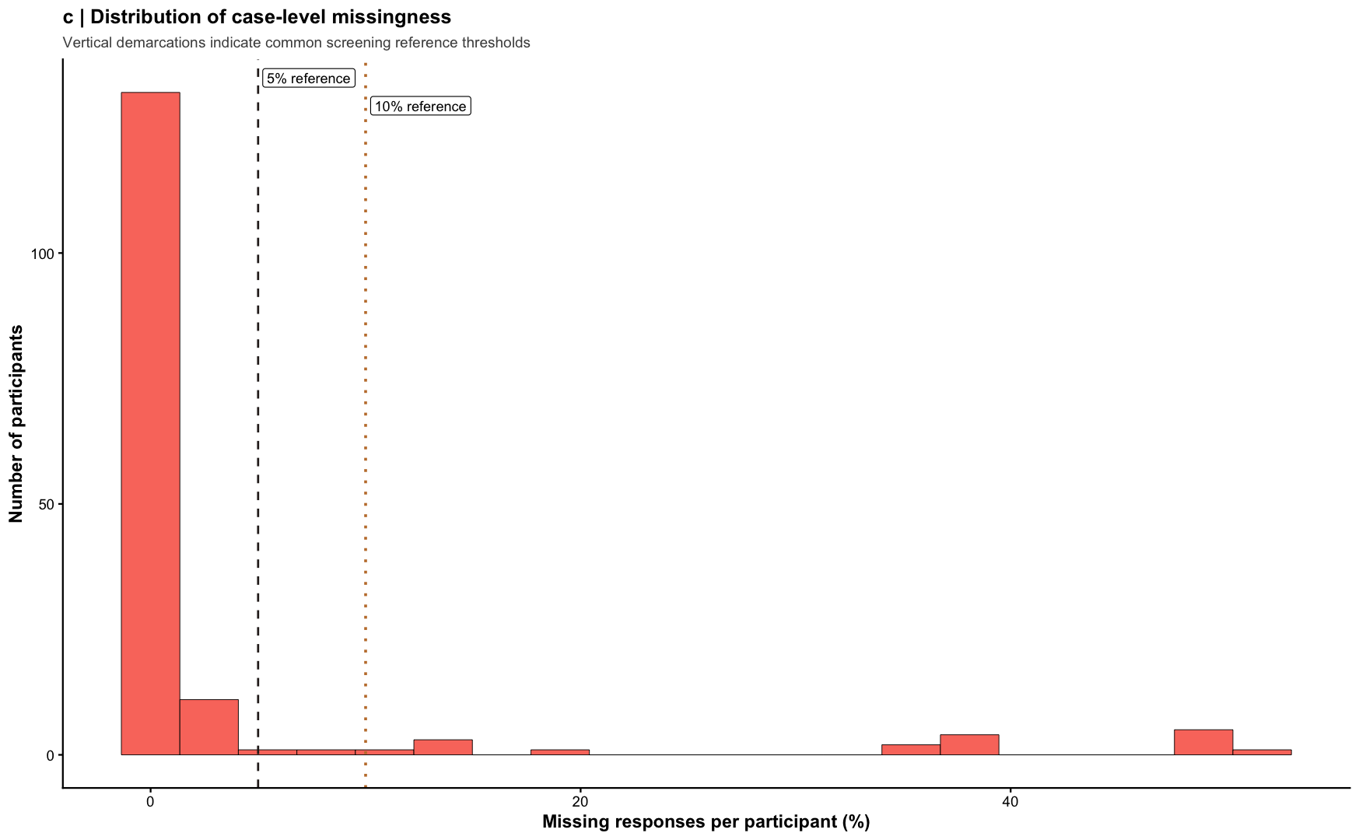
retained_cases retained_items
1 145 176

Outliers
Multivariate outliers were considered using Mahalanobis distance; however, the full questionnaire item set produced a singular covariance matrix, indicating that the number of variables was too large relative to the number of complete cases and/or that some items were linearly dependent. Because Mahalanobis distance requires an invertible covariance matrix, multivariate outlier detection was not performed on the full item matrix. Instead, outlier assessment focused on univariate standardized scores and, where appropriate, would be applied to reduced item subsets rather than the entire questionnaire simultaneously.
# =========================================================
# EFA DATA SCREENING: STEP 3 = OUTLIERS
# Revised multivariate outlier workflow for high-dimensional item data
# This handles singular covariance problems explicitly
# =========================================================
library(dplyr)
# ---------------------------------------------------------
# 1. Start from the missing-data-screened item dataset
# ---------------------------------------------------------
X <- CWTT_items_missing_clean
# Keep complete cases for multivariate outlier analysis
X_complete <- X %>%
filter(complete.cases(.))
# Basic dimensions
n_cases <- nrow(X_complete)
n_vars <- ncol(X_complete)
n_cases
[1] 80
n_vars
[1] 176
# ---------------------------------------------------------
# 2. Check for zero-variance items
# Zero-variance variables make covariance singular
# ---------------------------------------------------------
item_sd <- sapply(X_complete, sd, na.rm = TRUE)
zero_var_items <- names(item_sd[item_sd == 0 | is.na(item_sd)])
zero_var_items
[1] "Question_17A" "Question_5" "Question_46"
length(zero_var_items)
[1] 3
# Remove zero-variance items
X_complete_nzv <- X_complete %>%
select(where(~ sd(.x, na.rm = TRUE) > 0))
# ---------------------------------------------------------
# 3. Check for duplicate columns
# Exact duplicates also create singularity
# ---------------------------------------------------------
duplicate_cols <- duplicated(as.list(X_complete_nzv))
names(X_complete_nzv)[duplicate_cols]
character(0)
# Remove exact duplicate columns
X_complete_nzv <- X_complete_nzv[, !duplicate_cols, drop = FALSE]
# ---------------------------------------------------------
# 4. Check for perfect correlations
# Perfect or near-perfect correlations can also break inversion
# ---------------------------------------------------------
cor_mat <- cor(X_complete_nzv, use = "complete.obs")
# Find perfectly correlated pairs excluding the diagonal
perfect_pairs <- which(abs(cor_mat) == 1 & row(cor_mat) != col(cor_mat), arr.ind = TRUE)
perfect_pairs
row col
if (nrow(perfect_pairs) > 0) {
perfect_corr_table <- unique(data.frame(
var1 = rownames(cor_mat)[perfect_pairs[, 1]],
var2 = colnames(cor_mat)[perfect_pairs[, 2]]
))
perfect_corr_table
}
# ---------------------------------------------------------
# 5. Recheck dimensions after cleanup
# Mahalanobis generally requires more cases than variables
# ---------------------------------------------------------
n_cases_clean <- nrow(X_complete_nzv)
n_vars_clean <- ncol(X_complete_nzv)
n_cases_clean
[1] 80
n_vars_clean
[1] 173
# ---------------------------------------------------------
# 6. Decide whether full Mahalanobis is appropriate
# If p >= n, do NOT run Mahalanobis on the full item set
# ---------------------------------------------------------
if (n_vars_clean >= n_cases_clean) {
message("Mahalanobis distance is not appropriate on the full item set because p >= n.")
message("Use a reduced variable set, a subscale block, or factor scores instead.")
}
# ---------------------------------------------------------
# 7. Optional: reduce the item set before Mahalanobis
# Example strategy: keep only the first 20 items temporarily
# Replace this with a theory-based block or subscale
# ---------------------------------------------------------
X_reduced <- X_complete_nzv %>%
select(1:min(20, ncol(.)))
dim(X_reduced)
[1] 80 20
# ---------------------------------------------------------
# 8. Run Mahalanobis only if cases exceed variables
# ---------------------------------------------------------
if (nrow(X_reduced) > ncol(X_reduced)) {
md <- mahalanobis(
x = X_reduced,
center = colMeans(X_reduced, na.rm = TRUE),
cov = cov(X_reduced, use = "complete.obs")
)
df_md <- ncol(X_reduced)
md_cutoff <- qchisq(.001, df = df_md, lower.tail = FALSE)
multivariate_outliers <- data.frame(
case_id_complete = 1:nrow(X_reduced),
mahalanobis_distance = md,
cutoff_p001 = md_cutoff,
is_multivariate_outlier = md > md_cutoff
) %>%
arrange(desc(mahalanobis_distance))
multivariate_outliers
} else {
message("Even the reduced set still has too many variables for the number of complete cases.")
}
case_id_complete mahalanobis_distance cutoff_p001 is_multivariate_outlier
1 4 78.012500 45.31475 TRUE
2 50 78.012500 45.31475 TRUE
3 72 78.012500 45.31475 TRUE
4 79 78.012500 45.31475 TRUE
5 20 78.012500 45.31475 TRUE
6 55 45.904645 45.31475 TRUE
7 12 39.196915 45.31475 FALSE
8 49 39.020041 45.31475 FALSE
9 29 33.707335 45.31475 FALSE
10 61 33.485858 45.31475 FALSE
11 15 32.899326 45.31475 FALSE
12 70 28.271047 45.31475 FALSE
13 34 27.604118 45.31475 FALSE
14 38 27.278063 45.31475 FALSE
15 39 25.930479 45.31475 FALSE
16 22 24.156036 45.31475 FALSE
17 10 23.862047 45.31475 FALSE
18 35 22.570862 45.31475 FALSE
19 1 22.540650 45.31475 FALSE
20 18 20.609676 45.31475 FALSE
21 31 20.299882 45.31475 FALSE
22 48 20.133518 45.31475 FALSE
23 16 20.081897 45.31475 FALSE
24 14 19.729015 45.31475 FALSE
25 9 19.576180 45.31475 FALSE
26 42 18.540749 45.31475 FALSE
27 6 18.514797 45.31475 FALSE
28 62 17.859749 45.31475 FALSE
29 78 17.207369 45.31475 FALSE
30 41 16.766269 45.31475 FALSE
31 75 16.420266 45.31475 FALSE
32 30 16.182824 45.31475 FALSE
33 54 16.109157 45.31475 FALSE
34 17 15.512468 45.31475 FALSE
35 51 15.099595 45.31475 FALSE
36 23 15.017202 45.31475 FALSE
37 13 14.999681 45.31475 FALSE
38 32 14.932271 45.31475 FALSE
39 2 14.829333 45.31475 FALSE
40 73 14.738540 45.31475 FALSE
41 80 14.580628 45.31475 FALSE
42 67 14.054234 45.31475 FALSE
43 25 13.796367 45.31475 FALSE
44 77 13.470447 45.31475 FALSE
45 68 13.337110 45.31475 FALSE
46 5 12.735800 45.31475 FALSE
47 11 12.601170 45.31475 FALSE
48 47 12.388570 45.31475 FALSE
49 69 12.242433 45.31475 FALSE
50 24 12.196672 45.31475 FALSE
51 76 11.948883 45.31475 FALSE
52 37 11.843265 45.31475 FALSE
53 53 11.630093 45.31475 FALSE
54 43 11.559838 45.31475 FALSE
55 59 11.397757 45.31475 FALSE
56 45 10.601131 45.31475 FALSE
57 3 10.476752 45.31475 FALSE
58 52 10.340853 45.31475 FALSE
59 36 9.862873 45.31475 FALSE
60 28 9.841916 45.31475 FALSE
61 56 9.804051 45.31475 FALSE
62 66 9.782375 45.31475 FALSE
63 71 9.620529 45.31475 FALSE
64 46 9.554695 45.31475 FALSE
65 44 9.253223 45.31475 FALSE
66 58 8.496770 45.31475 FALSE
67 21 8.398240 45.31475 FALSE
68 74 8.176067 45.31475 FALSE
69 65 8.172603 45.31475 FALSE
70 7 8.157233 45.31475 FALSE
71 8 8.113177 45.31475 FALSE
72 19 8.006493 45.31475 FALSE
73 64 7.963857 45.31475 FALSE
74 27 7.746632 45.31475 FALSE
75 26 7.283881 45.31475 FALSE
76 33 6.986341 45.31475 FALSE
77 57 6.318375 45.31475 FALSE
78 63 6.147596 45.31475 FALSE
79 40 5.858834 45.31475 FALSE
80 60 5.601878 45.31475 FALSE
# ---------------------------------------------------------
# 9. Univariate outliers can still be assessed separately
# These do not require matrix inversion
# ---------------------------------------------------------
X_z <- as.data.frame(scale(X))
univariate_outlier_counts <- sapply(X_z, function(x) sum(abs(x) > 3.29, na.rm = TRUE))
univariate_outlier_summary <- data.frame(
variable = names(X_z),
n_extreme_z = univariate_outlier_counts
) %>%
arrange(desc(n_extreme_z))
head(univariate_outlier_summary)
variable n_extreme_z
Question_54 Question_54 11
Question_64A Question_64A 9
Question_71 Question_71 9
Question_23A Question_23A 8
Question_31A Question_31A 8
Question_87 Question_87 8

Assumptions : additivity, normality, linearity, and homogeneity
Homogeneity was evaluated after screening for accuracy, missing data, and outliers. An initial attempt to estimate Cronbach’s alpha for the full item set was not possible because pairwise handling of missing data still yielded NA values in the inter-item correlation matrix, indicating that some variables had insufficient usable overlap with the remainder of the dataset. These items were identified through inspection of item-level missingness, response variability, and the pairwise correlation matrix, and structurally unusable items were removed before any reliability estimation was attempted. Because coefficient alpha is a measure of internal consistency reliability rather than a direct test of unidimensionality, it was interpreted cautiously and considered appropriate only for reduced, conceptually coherent item sets rather than the entire heterogeneous item pool
input_cases input_items items_implicated_in_na_cor items_flagged
1 145 176 10 10
retained_items remaining_na_correlations
1 166 0
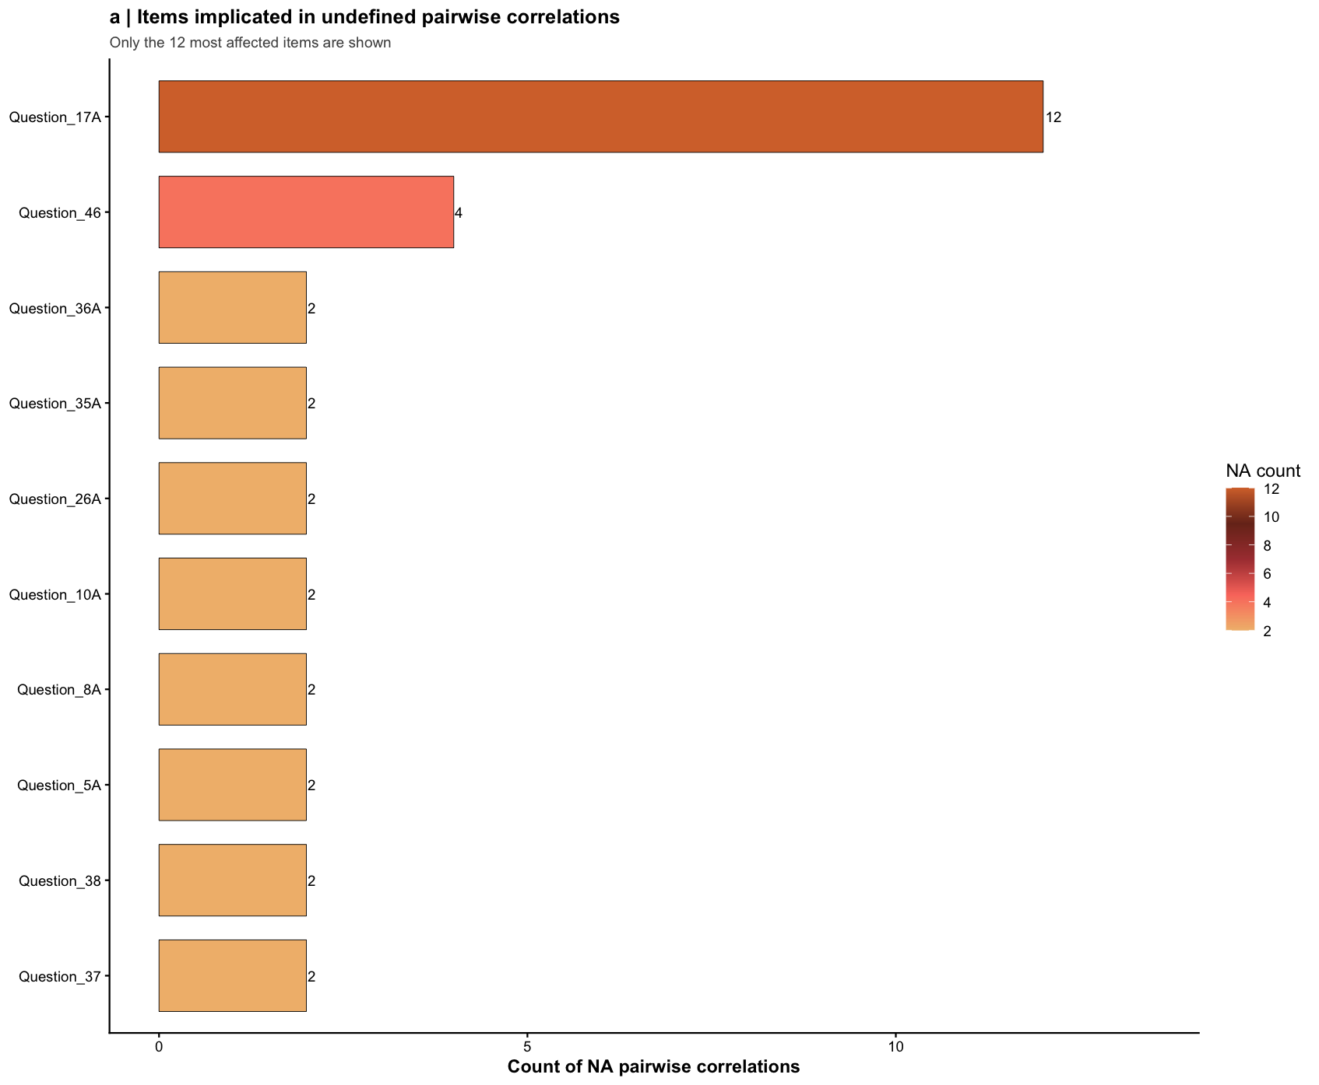
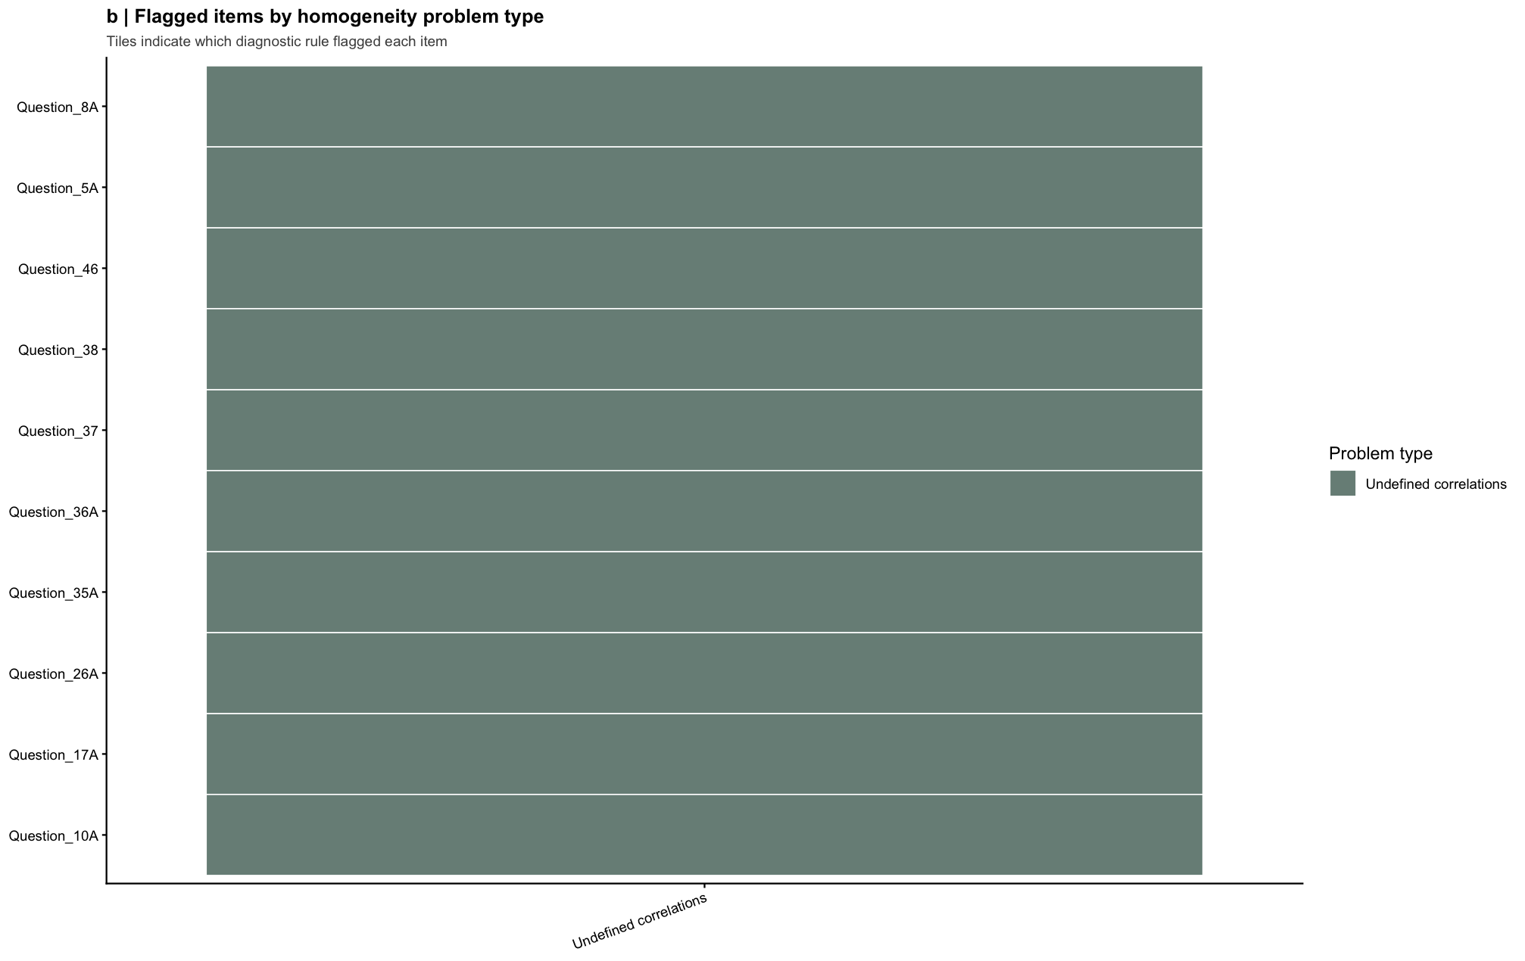
Some items ( Question_9A Question_11A Question_12A Question_13A Question_14A Question_15A Question_16A Question_20A Question_25A Question_34A Question_39A Question_40A Question_41A Question_44A Question_45A Question_47A Question_48A Question_52A Question_53A Question_56A Question_60A Question_63A Question_66A Question_68A Question_93A Question_3 Question_4 Question_5 Question_7 Question_8 Question_9 Question_11 Question_14 Question_15 Question_18 Question_20 Question_26 Question_27 Question_28 Question_33 Question_34 Question_35 Question_40 Question_42 Question_44 Question_45 Question_49 Question_52 Question_54 Question_58 Question_63 Question_66 Question_67 Question_71 Question_72 Question_73 Question_74 Question_75 Question_78 Question_79 Question_80 Question_83 Question_85 Question_88 Question_89 Question_90 Question_92 Question_93 Question_94 ) were negatively correlated with the first principal component and
probably should be reversed.
To do this, run the function again with the 'check.keys=TRUE' option
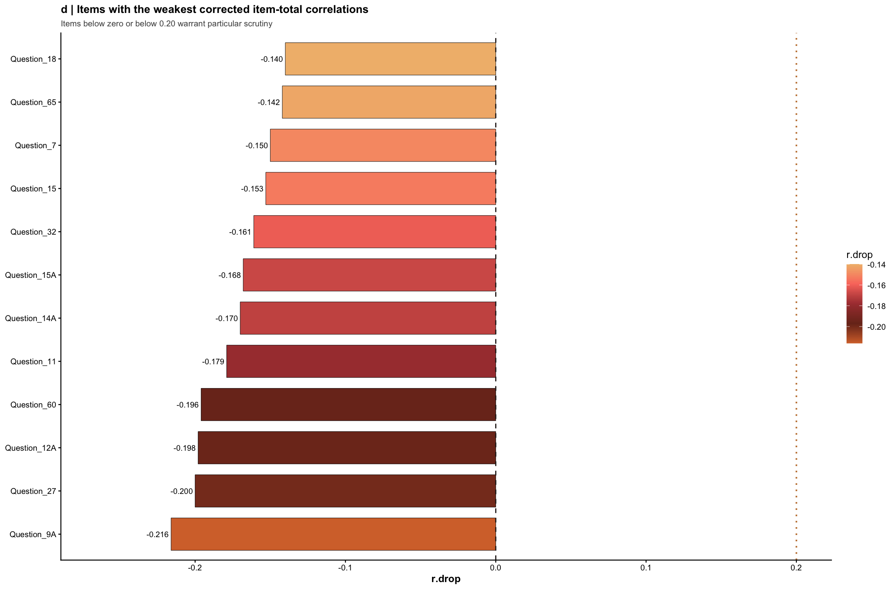
strict_alpha_possible strict_alpha_items
1 FALSE 176

Citations
# Cite all packages currently attached
pkgs <- .packages()
lapply(pkgs, citation)
[[1]]
To cite package 'psych' in publications use:
William Revelle (2026). _psych: Procedures for Psychological,
Psychometric, and Personality Research_. Northwestern University,
Evanston, Illinois. R package version 2.6.3,
<https://CRAN.R-project.org/package=psych>.
A BibTeX entry for LaTeX users is
@Manual{,
title = {psych: Procedures for Psychological, Psychometric, and Personality Research},
author = {{William Revelle}},
organization = {Northwestern University},
address = {Evanston, Illinois},
year = {2026},
note = {R package version 2.6.3},
url = {https://CRAN.R-project.org/package=psych},
}
[[2]]
To cite package 'scales' in publications use:
Wickham H, Pedersen T, Seidel D (2025). _scales: Scale Functions for
Visualization_. doi:10.32614/CRAN.package.scales
<https://doi.org/10.32614/CRAN.package.scales>, R package version
1.4.0, <https://CRAN.R-project.org/package=scales>.
A BibTeX entry for LaTeX users is
@Manual{,
title = {scales: Scale Functions for Visualization},
author = {Hadley Wickham and Thomas Lin Pedersen and Dana Seidel},
year = {2025},
note = {R package version 1.4.0},
url = {https://CRAN.R-project.org/package=scales},
doi = {10.32614/CRAN.package.scales},
}
[[3]]
To cite package 'wesanderson' in publications use:
Ram K, Wickham H (2023). _wesanderson: A Wes Anderson Palette
Generator_. doi:10.32614/CRAN.package.wesanderson
<https://doi.org/10.32614/CRAN.package.wesanderson>, R package
version 0.3.7, <https://CRAN.R-project.org/package=wesanderson>.
A BibTeX entry for LaTeX users is
@Manual{,
title = {wesanderson: A Wes Anderson Palette Generator},
author = {Karthik Ram and Hadley Wickham},
year = {2023},
note = {R package version 0.3.7},
url = {https://CRAN.R-project.org/package=wesanderson},
doi = {10.32614/CRAN.package.wesanderson},
}
[[4]]
To cite package 'sjPlot' in publications use:
Lüdecke D (2025). _sjPlot: Data Visualization for Statistics in
Social Science_. R package version 2.9.0,
<https://CRAN.R-project.org/package=sjPlot>.
A BibTeX entry for LaTeX users is
@Manual{,
title = {sjPlot: Data Visualization for Statistics in Social Science},
author = {Daniel Lüdecke},
year = {2025},
note = {R package version 2.9.0},
url = {https://CRAN.R-project.org/package=sjPlot},
}
[[5]]
To cite package 'tidyr' in publications use:
Wickham H, Vaughan D, Girlich M (2025). _tidyr: Tidy Messy Data_.
doi:10.32614/CRAN.package.tidyr
<https://doi.org/10.32614/CRAN.package.tidyr>, R package version
1.3.2, <https://CRAN.R-project.org/package=tidyr>.
A BibTeX entry for LaTeX users is
@Manual{,
title = {tidyr: Tidy Messy Data},
author = {Hadley Wickham and Davis Vaughan and Maximilian Girlich},
year = {2025},
note = {R package version 1.3.2},
url = {https://CRAN.R-project.org/package=tidyr},
doi = {10.32614/CRAN.package.tidyr},
}
[[6]]
To cite ggplot2 in publications, please use
H. Wickham. ggplot2: Elegant Graphics for Data Analysis.
Springer-Verlag New York, 2016.
A BibTeX entry for LaTeX users is
@Book{,
author = {Hadley Wickham},
title = {ggplot2: Elegant Graphics for Data Analysis},
publisher = {Springer-Verlag New York},
year = {2016},
isbn = {978-3-319-24277-4},
url = {https://ggplot2.tidyverse.org},
}
[[7]]
To cite package 'stringr' in publications use:
Wickham H (2025). _stringr: Simple, Consistent Wrappers for Common
String Operations_. doi:10.32614/CRAN.package.stringr
<https://doi.org/10.32614/CRAN.package.stringr>, R package version
1.6.0, <https://CRAN.R-project.org/package=stringr>.
A BibTeX entry for LaTeX users is
@Manual{,
title = {stringr: Simple, Consistent Wrappers for Common String Operations},
author = {Hadley Wickham},
year = {2025},
note = {R package version 1.6.0},
url = {https://CRAN.R-project.org/package=stringr},
doi = {10.32614/CRAN.package.stringr},
}
[[8]]
To cite package 'dplyr' in publications use:
Wickham H, François R, Henry L, Müller K, Vaughan D (2026). _dplyr: A
Grammar of Data Manipulation_. doi:10.32614/CRAN.package.dplyr
<https://doi.org/10.32614/CRAN.package.dplyr>, R package version
1.2.0, <https://CRAN.R-project.org/package=dplyr>.
A BibTeX entry for LaTeX users is
@Manual{,
title = {dplyr: A Grammar of Data Manipulation},
author = {Hadley Wickham and Romain François and Lionel Henry and Kirill Müller and Davis Vaughan},
year = {2026},
note = {R package version 1.2.0},
url = {https://CRAN.R-project.org/package=dplyr},
doi = {10.32614/CRAN.package.dplyr},
}
[[9]]
To cite package 'readr' in publications use:
Wickham H, Hester J, Bryan J (2025). _readr: Read Rectangular Text
Data_. doi:10.32614/CRAN.package.readr
<https://doi.org/10.32614/CRAN.package.readr>, R package version
2.1.6, <https://CRAN.R-project.org/package=readr>.
A BibTeX entry for LaTeX users is
@Manual{,
title = {readr: Read Rectangular Text Data},
author = {Hadley Wickham and Jim Hester and Jennifer Bryan},
year = {2025},
note = {R package version 2.1.6},
url = {https://CRAN.R-project.org/package=readr},
doi = {10.32614/CRAN.package.readr},
}
[[10]]
The 'stats' package is part of R. To cite R in publications use:
R Core Team (2025). _R: A Language and Environment for Statistical
Computing_. R Foundation for Statistical Computing, Vienna, Austria.
<https://www.R-project.org/>.
A BibTeX entry for LaTeX users is
@Manual{,
title = {R: A Language and Environment for Statistical Computing},
author = {{R Core Team}},
organization = {R Foundation for Statistical Computing},
address = {Vienna, Austria},
year = {2025},
url = {https://www.R-project.org/},
}
We have invested a lot of time and effort in creating R, please cite it
when using it for data analysis. See also 'citation("pkgname")' for
citing R packages.
[[11]]
The 'graphics' package is part of R. To cite R in publications use:
R Core Team (2025). _R: A Language and Environment for Statistical
Computing_. R Foundation for Statistical Computing, Vienna, Austria.
<https://www.R-project.org/>.
A BibTeX entry for LaTeX users is
@Manual{,
title = {R: A Language and Environment for Statistical Computing},
author = {{R Core Team}},
organization = {R Foundation for Statistical Computing},
address = {Vienna, Austria},
year = {2025},
url = {https://www.R-project.org/},
}
We have invested a lot of time and effort in creating R, please cite it
when using it for data analysis. See also 'citation("pkgname")' for
citing R packages.
[[12]]
The 'grDevices' package is part of R. To cite R in publications use:
R Core Team (2025). _R: A Language and Environment for Statistical
Computing_. R Foundation for Statistical Computing, Vienna, Austria.
<https://www.R-project.org/>.
A BibTeX entry for LaTeX users is
@Manual{,
title = {R: A Language and Environment for Statistical Computing},
author = {{R Core Team}},
organization = {R Foundation for Statistical Computing},
address = {Vienna, Austria},
year = {2025},
url = {https://www.R-project.org/},
}
We have invested a lot of time and effort in creating R, please cite it
when using it for data analysis. See also 'citation("pkgname")' for
citing R packages.
[[13]]
The 'utils' package is part of R. To cite R in publications use:
R Core Team (2025). _R: A Language and Environment for Statistical
Computing_. R Foundation for Statistical Computing, Vienna, Austria.
<https://www.R-project.org/>.
A BibTeX entry for LaTeX users is
@Manual{,
title = {R: A Language and Environment for Statistical Computing},
author = {{R Core Team}},
organization = {R Foundation for Statistical Computing},
address = {Vienna, Austria},
year = {2025},
url = {https://www.R-project.org/},
}
We have invested a lot of time and effort in creating R, please cite it
when using it for data analysis. See also 'citation("pkgname")' for
citing R packages.
[[14]]
The 'datasets' package is part of R. To cite R in publications use:
R Core Team (2025). _R: A Language and Environment for Statistical
Computing_. R Foundation for Statistical Computing, Vienna, Austria.
<https://www.R-project.org/>.
A BibTeX entry for LaTeX users is
@Manual{,
title = {R: A Language and Environment for Statistical Computing},
author = {{R Core Team}},
organization = {R Foundation for Statistical Computing},
address = {Vienna, Austria},
year = {2025},
url = {https://www.R-project.org/},
}
We have invested a lot of time and effort in creating R, please cite it
when using it for data analysis. See also 'citation("pkgname")' for
citing R packages.
[[15]]
The 'methods' package is part of R. To cite R in publications use:
R Core Team (2025). _R: A Language and Environment for Statistical
Computing_. R Foundation for Statistical Computing, Vienna, Austria.
<https://www.R-project.org/>.
A BibTeX entry for LaTeX users is
@Manual{,
title = {R: A Language and Environment for Statistical Computing},
author = {{R Core Team}},
organization = {R Foundation for Statistical Computing},
address = {Vienna, Austria},
year = {2025},
url = {https://www.R-project.org/},
}
We have invested a lot of time and effort in creating R, please cite it
when using it for data analysis. See also 'citation("pkgname")' for
citing R packages.
[[16]]
To cite R in publications use:
R Core Team (2025). _R: A Language and Environment for Statistical
Computing_. R Foundation for Statistical Computing, Vienna, Austria.
<https://www.R-project.org/>.
A BibTeX entry for LaTeX users is
@Manual{,
title = {R: A Language and Environment for Statistical Computing},
author = {{R Core Team}},
organization = {R Foundation for Statistical Computing},
address = {Vienna, Austria},
year = {2025},
url = {https://www.R-project.org/},
}
We have invested a lot of time and effort in creating R, please cite it
when using it for data analysis. See also 'citation("pkgname")' for
citing R packages.
# If you want cleaner printed output
for (p in .packages()) {
cat("\n==============================\n")
cat("Package:", p, "\n")
print(citation(p))
}
==============================
Package: psych
To cite package 'psych' in publications use:
William Revelle (2026). _psych: Procedures for Psychological,
Psychometric, and Personality Research_. Northwestern University,
Evanston, Illinois. R package version 2.6.3,
<https://CRAN.R-project.org/package=psych>.
A BibTeX entry for LaTeX users is
@Manual{,
title = {psych: Procedures for Psychological, Psychometric, and Personality Research},
author = {{William Revelle}},
organization = {Northwestern University},
address = {Evanston, Illinois},
year = {2026},
note = {R package version 2.6.3},
url = {https://CRAN.R-project.org/package=psych},
}
==============================
Package: scales
To cite package 'scales' in publications use:
Wickham H, Pedersen T, Seidel D (2025). _scales: Scale Functions for
Visualization_. doi:10.32614/CRAN.package.scales
<https://doi.org/10.32614/CRAN.package.scales>, R package version
1.4.0, <https://CRAN.R-project.org/package=scales>.
A BibTeX entry for LaTeX users is
@Manual{,
title = {scales: Scale Functions for Visualization},
author = {Hadley Wickham and Thomas Lin Pedersen and Dana Seidel},
year = {2025},
note = {R package version 1.4.0},
url = {https://CRAN.R-project.org/package=scales},
doi = {10.32614/CRAN.package.scales},
}
==============================
Package: wesanderson
To cite package 'wesanderson' in publications use:
Ram K, Wickham H (2023). _wesanderson: A Wes Anderson Palette
Generator_. doi:10.32614/CRAN.package.wesanderson
<https://doi.org/10.32614/CRAN.package.wesanderson>, R package
version 0.3.7, <https://CRAN.R-project.org/package=wesanderson>.
A BibTeX entry for LaTeX users is
@Manual{,
title = {wesanderson: A Wes Anderson Palette Generator},
author = {Karthik Ram and Hadley Wickham},
year = {2023},
note = {R package version 0.3.7},
url = {https://CRAN.R-project.org/package=wesanderson},
doi = {10.32614/CRAN.package.wesanderson},
}
==============================
Package: sjPlot
To cite package 'sjPlot' in publications use:
Lüdecke D (2025). _sjPlot: Data Visualization for Statistics in
Social Science_. R package version 2.9.0,
<https://CRAN.R-project.org/package=sjPlot>.
A BibTeX entry for LaTeX users is
@Manual{,
title = {sjPlot: Data Visualization for Statistics in Social Science},
author = {Daniel Lüdecke},
year = {2025},
note = {R package version 2.9.0},
url = {https://CRAN.R-project.org/package=sjPlot},
}
==============================
Package: tidyr
To cite package 'tidyr' in publications use:
Wickham H, Vaughan D, Girlich M (2025). _tidyr: Tidy Messy Data_.
doi:10.32614/CRAN.package.tidyr
<https://doi.org/10.32614/CRAN.package.tidyr>, R package version
1.3.2, <https://CRAN.R-project.org/package=tidyr>.
A BibTeX entry for LaTeX users is
@Manual{,
title = {tidyr: Tidy Messy Data},
author = {Hadley Wickham and Davis Vaughan and Maximilian Girlich},
year = {2025},
note = {R package version 1.3.2},
url = {https://CRAN.R-project.org/package=tidyr},
doi = {10.32614/CRAN.package.tidyr},
}
==============================
Package: ggplot2
To cite ggplot2 in publications, please use
H. Wickham. ggplot2: Elegant Graphics for Data Analysis.
Springer-Verlag New York, 2016.
A BibTeX entry for LaTeX users is
@Book{,
author = {Hadley Wickham},
title = {ggplot2: Elegant Graphics for Data Analysis},
publisher = {Springer-Verlag New York},
year = {2016},
isbn = {978-3-319-24277-4},
url = {https://ggplot2.tidyverse.org},
}
==============================
Package: stringr
To cite package 'stringr' in publications use:
Wickham H (2025). _stringr: Simple, Consistent Wrappers for Common
String Operations_. doi:10.32614/CRAN.package.stringr
<https://doi.org/10.32614/CRAN.package.stringr>, R package version
1.6.0, <https://CRAN.R-project.org/package=stringr>.
A BibTeX entry for LaTeX users is
@Manual{,
title = {stringr: Simple, Consistent Wrappers for Common String Operations},
author = {Hadley Wickham},
year = {2025},
note = {R package version 1.6.0},
url = {https://CRAN.R-project.org/package=stringr},
doi = {10.32614/CRAN.package.stringr},
}
==============================
Package: dplyr
To cite package 'dplyr' in publications use:
Wickham H, François R, Henry L, Müller K, Vaughan D (2026). _dplyr: A
Grammar of Data Manipulation_. doi:10.32614/CRAN.package.dplyr
<https://doi.org/10.32614/CRAN.package.dplyr>, R package version
1.2.0, <https://CRAN.R-project.org/package=dplyr>.
A BibTeX entry for LaTeX users is
@Manual{,
title = {dplyr: A Grammar of Data Manipulation},
author = {Hadley Wickham and Romain François and Lionel Henry and Kirill Müller and Davis Vaughan},
year = {2026},
note = {R package version 1.2.0},
url = {https://CRAN.R-project.org/package=dplyr},
doi = {10.32614/CRAN.package.dplyr},
}
==============================
Package: readr
To cite package 'readr' in publications use:
Wickham H, Hester J, Bryan J (2025). _readr: Read Rectangular Text
Data_. doi:10.32614/CRAN.package.readr
<https://doi.org/10.32614/CRAN.package.readr>, R package version
2.1.6, <https://CRAN.R-project.org/package=readr>.
A BibTeX entry for LaTeX users is
@Manual{,
title = {readr: Read Rectangular Text Data},
author = {Hadley Wickham and Jim Hester and Jennifer Bryan},
year = {2025},
note = {R package version 2.1.6},
url = {https://CRAN.R-project.org/package=readr},
doi = {10.32614/CRAN.package.readr},
}
==============================
Package: stats
The 'stats' package is part of R. To cite R in publications use:
R Core Team (2025). _R: A Language and Environment for Statistical
Computing_. R Foundation for Statistical Computing, Vienna, Austria.
<https://www.R-project.org/>.
A BibTeX entry for LaTeX users is
@Manual{,
title = {R: A Language and Environment for Statistical Computing},
author = {{R Core Team}},
organization = {R Foundation for Statistical Computing},
address = {Vienna, Austria},
year = {2025},
url = {https://www.R-project.org/},
}
We have invested a lot of time and effort in creating R, please cite it
when using it for data analysis. See also 'citation("pkgname")' for
citing R packages.
==============================
Package: graphics
The 'graphics' package is part of R. To cite R in publications use:
R Core Team (2025). _R: A Language and Environment for Statistical
Computing_. R Foundation for Statistical Computing, Vienna, Austria.
<https://www.R-project.org/>.
A BibTeX entry for LaTeX users is
@Manual{,
title = {R: A Language and Environment for Statistical Computing},
author = {{R Core Team}},
organization = {R Foundation for Statistical Computing},
address = {Vienna, Austria},
year = {2025},
url = {https://www.R-project.org/},
}
We have invested a lot of time and effort in creating R, please cite it
when using it for data analysis. See also 'citation("pkgname")' for
citing R packages.
==============================
Package: grDevices
The 'grDevices' package is part of R. To cite R in publications use:
R Core Team (2025). _R: A Language and Environment for Statistical
Computing_. R Foundation for Statistical Computing, Vienna, Austria.
<https://www.R-project.org/>.
A BibTeX entry for LaTeX users is
@Manual{,
title = {R: A Language and Environment for Statistical Computing},
author = {{R Core Team}},
organization = {R Foundation for Statistical Computing},
address = {Vienna, Austria},
year = {2025},
url = {https://www.R-project.org/},
}
We have invested a lot of time and effort in creating R, please cite it
when using it for data analysis. See also 'citation("pkgname")' for
citing R packages.
==============================
Package: utils
The 'utils' package is part of R. To cite R in publications use:
R Core Team (2025). _R: A Language and Environment for Statistical
Computing_. R Foundation for Statistical Computing, Vienna, Austria.
<https://www.R-project.org/>.
A BibTeX entry for LaTeX users is
@Manual{,
title = {R: A Language and Environment for Statistical Computing},
author = {{R Core Team}},
organization = {R Foundation for Statistical Computing},
address = {Vienna, Austria},
year = {2025},
url = {https://www.R-project.org/},
}
We have invested a lot of time and effort in creating R, please cite it
when using it for data analysis. See also 'citation("pkgname")' for
citing R packages.
==============================
Package: datasets
The 'datasets' package is part of R. To cite R in publications use:
R Core Team (2025). _R: A Language and Environment for Statistical
Computing_. R Foundation for Statistical Computing, Vienna, Austria.
<https://www.R-project.org/>.
A BibTeX entry for LaTeX users is
@Manual{,
title = {R: A Language and Environment for Statistical Computing},
author = {{R Core Team}},
organization = {R Foundation for Statistical Computing},
address = {Vienna, Austria},
year = {2025},
url = {https://www.R-project.org/},
}
We have invested a lot of time and effort in creating R, please cite it
when using it for data analysis. See also 'citation("pkgname")' for
citing R packages.
==============================
Package: methods
The 'methods' package is part of R. To cite R in publications use:
R Core Team (2025). _R: A Language and Environment for Statistical
Computing_. R Foundation for Statistical Computing, Vienna, Austria.
<https://www.R-project.org/>.
A BibTeX entry for LaTeX users is
@Manual{,
title = {R: A Language and Environment for Statistical Computing},
author = {{R Core Team}},
organization = {R Foundation for Statistical Computing},
address = {Vienna, Austria},
year = {2025},
url = {https://www.R-project.org/},
}
We have invested a lot of time and effort in creating R, please cite it
when using it for data analysis. See also 'citation("pkgname")' for
citing R packages.
==============================
Package: base
To cite R in publications use:
R Core Team (2025). _R: A Language and Environment for Statistical
Computing_. R Foundation for Statistical Computing, Vienna, Austria.
<https://www.R-project.org/>.
A BibTeX entry for LaTeX users is
@Manual{,
title = {R: A Language and Environment for Statistical Computing},
author = {{R Core Team}},
organization = {R Foundation for Statistical Computing},
address = {Vienna, Austria},
year = {2025},
url = {https://www.R-project.org/},
}
We have invested a lot of time and effort in creating R, please cite it
when using it for data analysis. See also 'citation("pkgname")' for
citing R packages.

