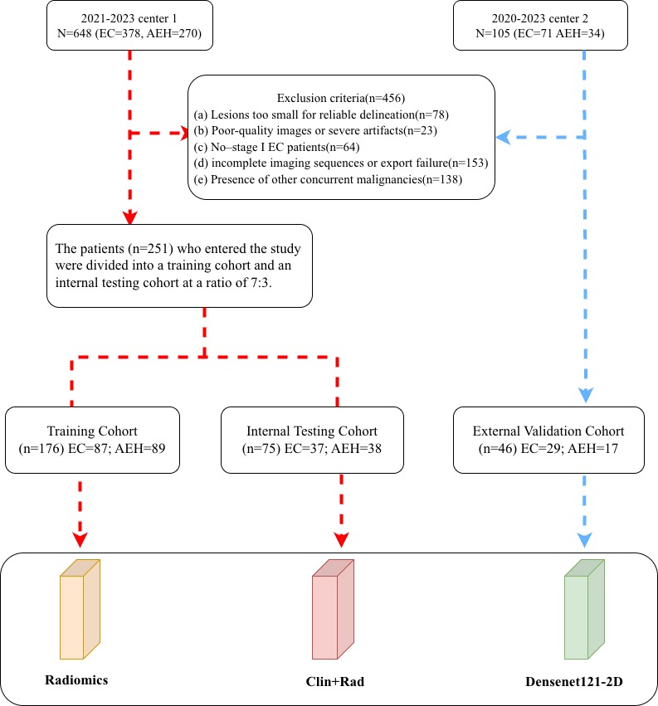
Supplementary Figure S1: Flow chart of patient inclusion and exclusion criteria, and cohort assignment.

