“Phytoconstituent Effect on Morphology of ZnO nanostructure: Synthesis, characterisation and photocatalytic degradation of Methylene blue, Malachite green, Brilliant cresyl blue, Rb171, Eosin yellow and Congo red dye”
Suneel ^{a*},Haroon ^{b}, Mohd. Shabeer^{c}, Zainab Feroz^{d}, Nafees Ahmadª, Qazi Inamur Rahman ª*
Supplementary File
Table. S1 Structural parameter of syntheised ZnO NSª
ZnO Ns  Sample | 2θ (°) | hkl | FWHM  (°) | Crystalline size  calculated by  D=kλ/βCosθ  (nm) | (101/002)  Intensity ratio | Inter  Planar  spacing  (A°) | Lattice constant (A°)) |  |  | Unit cell volume  (A°)³ | Dislocation density (x10⁻³ nm⁻²) | Strain  ε  (x10⁻³)
 |  |  |  |  |  |  | a | c | c/a | Unit cell volume  (A°)³ | Dislocation density (x10⁻³ nm⁻²) | Strain  ε  (x10⁻³)
S | 31.979 | 100 | 1.122 | 7.245 | 2.397 | 2.796 | 3.23  ±0.01 | 5.16  ±0.02 | 1.597 | 46.06  ±0.33 | 19.70 | 17.1
S | 34.795 | 002 | 1.099 | 7.446 | 2.397 | 2.579 |  |  |  |  | 18.0 | 14.3
S | 36.448 | 102 | 1.304 | 6.321 | 2.397 | 2.463 |  |  |  |  | 25.0 | 16.0
S | 47.762 | 110 | 1.334 | 6.397 | 2.397 | 1.904 |  |  |  |  | 24.4 | 12.7
S | 56.825 | 103 | 1.501 | 5.934 | 2.397 | 1.620 |  |  |  |  | 28.4 | 12.4
P | 31.92 | 100 | 0.462 | 16.394 | 2.24 | 2.81 | 3.23  ±0.006 | 5.18±0.012 | 1.069 | 47.09  ±0.22 | 3.72 | 7.04
P | 34.567 | 002 | 0.368 | 19.856 | 2.24 | 2.60 |  |  |  |  | 2.54 | 4.79
P | 36.399 | 101 | 0.443 | 16.894 | 2.24 | 2.47 |  |  |  |  | 3.50 | 5.43
P | 47.687 | 102 | 0.475 | 16.174 | 2.24 | 1.91 |  |  |  |  | 3.82 | 4.41
P | 56.727 | 110 | 0.532 | 15.353 | 2.24 | 1.62 |  |  |  |  | 4.24 | 4.38
M | 31.745 | 100 | 0.660 | 11.969 | 1.584 | 2.816 | 3.250  ± 0.004 | 5.19±0.012 | 1.064 | 47.52  ± 0.16 | 6.98 | 8.86
M | 34.515 | 002 | 0.627 | 12.638 | 1.584 | 2.597 |  |  |  |  | 6.26 | 8.31
M | 36.216 | 101 | 0.620 | 12.702 | 1.584 | 2.478 |  |  |  |  | 6.20 | 7.63
M | 47.47 | 102 | 0.573 | 13.863 | 1.584 | 1.914 |  |  |  |  | 5.20 | 5.43
M | 56.57 | 110 | 0.696 | 12.191 | 1.584 | 1.626 |  |  |  |  | 6.73 | 5.83
A | 31.698 | 100 | 0.583 | 13.384 | 1.899 | 2.820 | 3.256 ± 0.0028 | 5.22±0.013 | 1.603 | 47.99  ±0.08 | 5.58 | 8.73
A | 34.3 | 002 | 0.545 | 14.309 | 1.899 | 2.612 |  |  |  |  | 4.88 | 7.08
A | 36.16 | 101 | 0.560 | 13.881 | 1.899 | 2.482 |  |  |  |  | 5.18 | 6.91
A | 47.41 | 102 | 0.584 | 13.642 | 1.899 | 1.916 |  |  |  |  | 5.37 | 5.46
A | 56.48 | 110 | 0.605 | 13.767 | 1.899 | 1.627 |  |  |  |  | 5.27 | 5.13

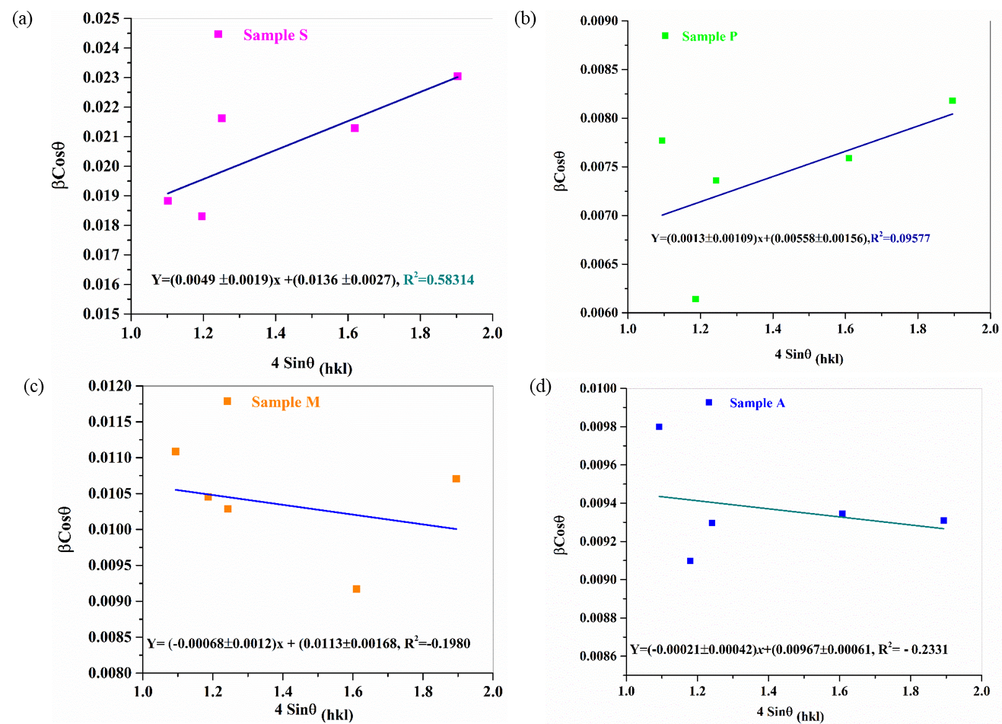

Fig.S1 W-H plot of linear fitting of(a) S (b) P (c) M and (d) A for the estimation of Size and lattice strain (microstrain)

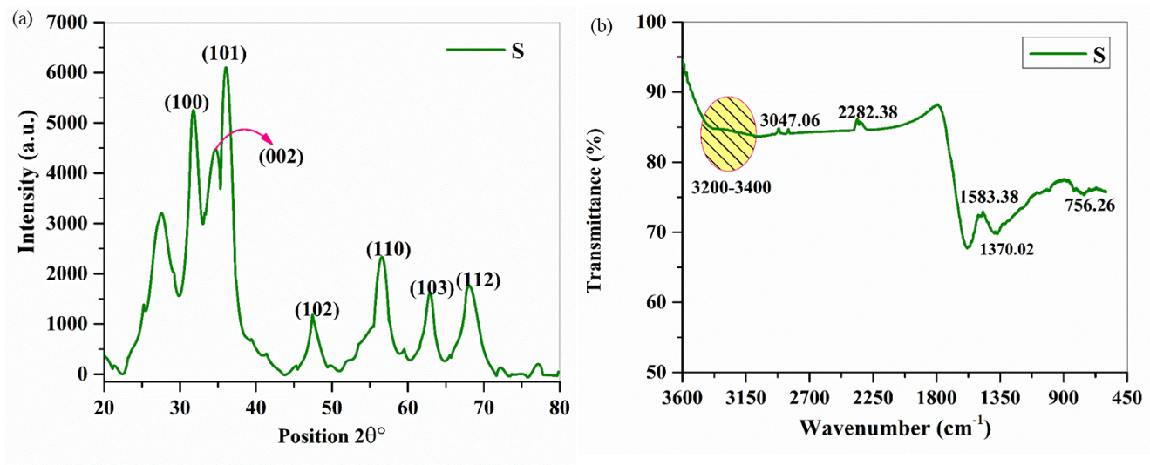
Fig.S2 Illustration of (a) XRD and (b) FTIR spectra of ZnO NS, sample S after reusability test

Table xxx Photodegradation performance of ZnO nanostructure derived from S, P, M and A, exposure to 120 min of open sunlight
Catalytic and |  |  |  | Kinetics Parameter
Model  Pollutants  (dye) | Nanomaterial (sample) | Conc of dyes and its Volume | Degradation efficiency (%) | K_{app} (min⁻¹) | Half-life (t_{1/2})  min | Regression coefficient (R²⁾
MB | S | 10 ppm,  100mL | 93.6 | 0.0252 | 30.08 | 0.98942
MB | P | 10 ppm,  100mL | 92.80 | 0.0204 | 33.96 | 0.96166
MB | M | 10 ppm,  100mL | 93.28 | 0.0024 | 30.86 | 0.99062
MB | A | 10 ppm,  100mL | 93.71 | 0.0231 | 29.98 | 0.98853
MG | S | 10 ppm,  100mL | 66.83 | 0.0088 | 78.59 | 0.99745
MG | P | 10 ppm,  100mL | 68.26 | 0.0090 | 76.76 | 0.99692
MG | M | 10 ppm,  100mL | 44.57, | 0.0047 | 145.3 | 0.99776
MG | A | 10 ppm,  100mL | 60.72 | 0.0074 | 92.92 | 0.97471
BCB | S | 10 ppm,  100mL | 57.27 | 0.00651 | 106.48 | 0.99072
BCB | P | 10 ppm,  100mL | 47.16 | 0.00508 | 136.45 | 0.9883
BCB | M | 10 ppm,  100mL | 41.98 | 0.00446 | 155.42 | 0.98367
BCB | A | 10 ppm,  100mL | 58.28 | 0.00708 | 97.90 | 0.9831
Rb171 | S | 10 ppm,  100mL | 46.74 | 0.00474 | 146.24 | 0.92729
Rb171 | P | 10 ppm,  100mL | 41.38 | 0.00428 | 161.96 | 0.99695
Rb171 | M | 10 ppm,  100mL | 70.37 | 0.00807 | 85.89 | 0.96279
Rb171 | A | 10 ppm,  100mL | 54.16 | 0.00567 | 122.31 | 0.9466
EY | S | 10 ppm,  100mL | 43.72 | 0.00472 | 146.8 | 0.99673
EY | P | 10 ppm,  100mL | 38.52 | 0.00382 | 181.5 | 0.98503
EY | M | 10 ppm,  100mL | 52.19 | 0.00551 | 125.8 | 0.99823
EY | A | 10 ppm,  100mL | 66.47 | 0.00506 | 136.9 | 0.96907
CR | S | 10 ppm,  100mL | 50.52 | 0.0056 | 138.8 | 0.98555
CR | P | 10 ppm,  100mL | 42.58 | 0.0046 | 150.3 | 0.98211
CR | M | 10 ppm,  100mL | 37.33 | 0.0039 | 174.2 | 0.9369
CR | A | 10 ppm,  100mL | 56.07 | 0.0071 | 97.6 | 0.9397

Table 5. Comparative catalytic performance of plant fabricated ZnO nanostructure with reported research
Photocatalyst  size (nm) and shape | Source of Reducing / stabilizing, capping agent | Band gap  (eV) | Pollutants & degradation (%) | Conc. of Pollutant /Volume of solution (mL) | Time  (min) | Source of  illumination | Kapp (min⁻¹) | Half-life (t_{1/2})  min | Reference
Cu₂S, 17.77 nm  Hexagonal | Chemical | 3.13 | RhB,53 | 5 ppm,50 mL | 180 | 70W mercury lamp | 0.0062 | 111.8 | 16
FeO-MNPs  16.5, spherical | A. indica  (leaf extract) | 3.27 | RY176  95.18 | 30 ppm/L  pH=4 | 250 | 500 W Xenon lamp | 0.0212 | 3.26 | 17
α-Fe₂O_{3,}32.50 nm  spherical  ZnO,37.50  triangular  S  P  M  A | Livistona chinensis  S. cumuni  P. guajava  M. oleifera  A. indica | 2.25  2.98  2.90  2.66  2.74  2.92 | MG, 68  MG, 79  MG,66.83  68.26  44.57,  60.72 | 10ppm,  100 mL  10ppm,  100mL | 90  120 | Visible light  Open  sunlight | 0.0109  0.0136  0.0088  0.0090  0.0047  0.0074 | 63.59  50.97  78.59  76.76  145.3  92.92 | 18  PW
CeO₂ NPs  S  P  M  A | Aegle marmelos  S. cumuni  P. guajava  M. oleifera  S. cumuni | 2.90  2.66  2.74  2.92 | MB,98  MB ,93.6  92.80  93.28  93.71 | 10 ppm,50mL  10 ppm,  100mL | 180  120 | 500‐W lamp  Open  sunlight  (OSL) | 0.2038  0.0252  0.0204  0.0024  0.0231 | 3.40  30.08  33.96  30.86  29.98 | 19  PW
ZnO_{W},23.6 nm  Hexagonal | Water |  | CR ,70.04 | 50 ppm, 100mL | 60 | Solar light | 0.0132 | 52.51 | 22
ZnO-SG, 50 nm  HxR  ZnO-PP,100nm HxW | chemical | 3.26  3.28 | Phenol,85  100 | 50 ppm | 120 | Solar Light photo radiometer (PMA2200 at 90 W/m² ) | 0.0155  0.0312 | 44.72  22.21 | 23
PVA/ZnO, ~70 | PVA | 3.09 | CV, 48 | 1mg/100mL | 90 | sunlight | 0.00694 | 100.4 | 24
S  P  M  A | S. cumuni  P. guajava  M. oleifera  S. cumuni | 2.90  2.66  2.74  2.92 | CR ,50.52  42.58  37.33  56.07 | 10 ppm,  100mL | 120 | OSL | 0.0056  0.0046  0.0039  0.0071 | 138.8  150.3  174.2  97.6 | PW
ZnO,250-500 nm  Nest like | NH₄OH  Hydrothermal | - | MB, 95.34 | 100ppm,  100 mL | 150 | UV-light. | 0.064 | 10.83 | 26
Zn/Ag (1%) | chitosan | 3.22 | MB, 79.1 | 6.4 ppm, 100mL | 240 | Hg, lamp | 0.0067 | 103.5 | 29
ZnO, spherical | egg white | 3.28 | MB, 100 | 10ppm, 50mL | 55 | 8 W, UV lamps | 0.158 | 0.158 | 30
ZnO ,56 ,Hx W | Hylocereus polyrhizus | 3.36 | MB, 95 | 20ppm, 50mL | 120 | Sunlight | 0.0145 | 47.80 | 31
ZnO, 40-60 nm  spherical | Clerodendrum phlomidis | 3.1 | MB, 86 | 6.39 ppm, 20 | 60 | 500 W Xe lamp | ND | - | 33
ZnO-J1, 20-40 | Hibiscus sabdariffa | 2.96 | MB, 97 | 15 ppm, | 150 | 500 W,UV lamp | 0.0182 | 38.08 | 34
ZnO,32.8 nm  HxW | Garcinia Cambogia | 3.24 | CV, 76  PR, 83 | 15ppm,30 mL | 90  120 | 25W, UV lamp | 0.011  0.0067 | 63.01  103.4 | 35
ZnO, 42.23, Hx | Myristica fragrans | 3.29 | MB, 88 | 20 ppm, 45 | 140 | UV light | ND |  | 36
ZnO,21, spherical; | Garcinia mangostana | 3.32 | MG, 99 | 10ppm ,50 mL | 180 | Solar light | 0.0245 | 28.29 | 38
ZnO,19, spherical | Zizyphus jujuba | 3.36 | ECBT, 86 | 100ppm,15mL | 300 | Sunlight | 0.0067 | 103.4 | 39
Al-ZnO, 50 nm  tetrameric | Amomum longiligulare | ND | MG, 38.1 | 50μM, | 60 | UV light (CL-1000) | 0.008 | 86.65 | 40
Al-ZnO, 50 nm  tetrameric | Amomum longiligulare | ND | MB, 66 | 50μM, | 60 | UV light (CL-1000) | 0.014 | 49.51 | 40
ZnO, nano Flower | C.haematocephala | ND | MB, 88, | 20ppm,100mL | 270 | Solar light | 0.01 | 69.32 | 43
ZnO,14 nm  spherical | Brassica oleracea L | 4.09 | PR, 71  MB, 74 | 5x10⁻² M  25 mL | 180 | 250 W He  (Helium) lamp | 0.0066  0.0073 | 105.0  94.95 | 45
ZnO,15.6  spherical | Phoenix roebelenii | 3.24 | MB,98 | 10 ppm | 105 | 250W ,UV lamp | 0.037 | 18.8 | 47
ZnO, 10-20 nm  spherical | Morinda umbellata | 2.75 | MG, 98.9  CR,92.8 | 20,10ppm,0.1L, at pH 10&6 | 90 | UV light | 0.0204  0.0123 | 33.98  56.35 | 48
ZnO,20.17nm  Flower like  S  P  M  A | H. hamnoides  S. cumuni  P. guajava  M. oleifera  S. cumuni | ND  2.90  2.66  2.74  2.92 | MG,89  EY,95  EY, 43.72  38.52  52.19  66.47 | 10 ppm  10 ppm  100 mL | 180  120 | UV  OSL | ND  0.00472  0.00382  0.00551  0.00506 | -  146.8  181.5  125.8  136.9 | 50  PW
ZnO,20 nm  cauliflower | Alchemilla vulgaris | 3.27 | RhB,75 | 10 ppm,80 mL | 120 | 500 W Xe lamp SHBC XSS-5XD | ND | - | 51
ZnO pure  ZnO-Cu(3%) | Synadium grantii | 3.10  3.20 | IC,26.5  IC,78.2 | 10 ppm,  100 mL | 80 | 30 W  UV (254nm) | 0.0192  0.0301 | 36.10  23.02 | 52
ZnO,19.31 | Epipremnum aureum | 3.73 | CR,56.6 | 10 ppm | 100 | UV | 0.014 | 49.51 | 53
ZnO ,26.14 | Salvia officinalis | 2.96 | MO, 92.47 | 5 ppm,100mL | 120 | 500W Hg lamp | 0.02134 | 32.48 | 54
ZnO ,11.35 nm | S. Cumini | 3.32 | MB,91.4 | 40ppm,50 mL | 180 | UV–vis | 0.004 | 173.3 | 55
ZnF-CA-LP | P. guajava | - | MB, 96 | 5 ppm,50mL | 120 | UV lamp | 0.0165 | 42.01 | 57
ZnO ,40.05 nm | M. oleifera | 3.02 | MB,80 | 3.2ppm,50 mL | 60 | 300 W, Halogen | 0.013 | 53.32 | 60
gCN/ZnO (50%)  M  A | ZAD and Urea  M. oleifera  S. cumuni | 2.03  2.74  2.92 | Rb171,89.2  Rb171,70.4  54.16 | 10ppm,100mL | 140  120 | Sunlight  OSL | 0.0150  0.00807  0.00567 | 46.21  85.89  122.3 | 71  PW
ZnO,9-18 | corriandrum sativum | ND | C₁₄H₁₀, 96 | 0.1ppm | 240 | 2 UV lamps,20W | 0.009 | 77.02 | 72
Ag/ZnO sf | Hydrothermal | 3.09 | MO,99.7  RhB,99.3 | 10ppm,80mL at 8.8 and 8.7 pH | 35 | UV, Xenon  lamp | 0.1104  0.0542 | 6.27  12.78 | 73
ZnO (C_{3%}),47 nm | Laser method | 3.30 | RhB, ≈13.8 | 9.58ppm, | 20 | Hg UV | 0.0074 | 93.5 | 74
ZnO, 20-25 nm  HxW | Chemical | ND | MO,99.7  CR,97.5  DB38,89.5 | 30ppm  50 mL | 30 | 1000-W  UV lamp | 0.1578  0.1119  0.0803 | 4.39  6.19  8.63 | 75
ZnO (disklike) | Sol gel, NH₄OH |  | RhB,85.14 | ~4.8 ppm,20mL | 80 | 360 W, UV | 0.0431 | 16.08 | 76

ª CR F₃BS= coraleneredF3BS, RY =Reactive yellow, Hxw= Hexagonal wurtzite, AR27= Acid red 27, DB38=Direct blue, CV= crystal violet, Acid Blue 92, AB92, TY= Titan Yellow, AMP= acetaminophen, SDZ =sulfadiazine
OSL= open sunlight, RBB= Remazol Brilliant Blue, MOR=Mordenite

