Figure S1:Temporal trends in the number of randomized controlled trials (2004–2024)

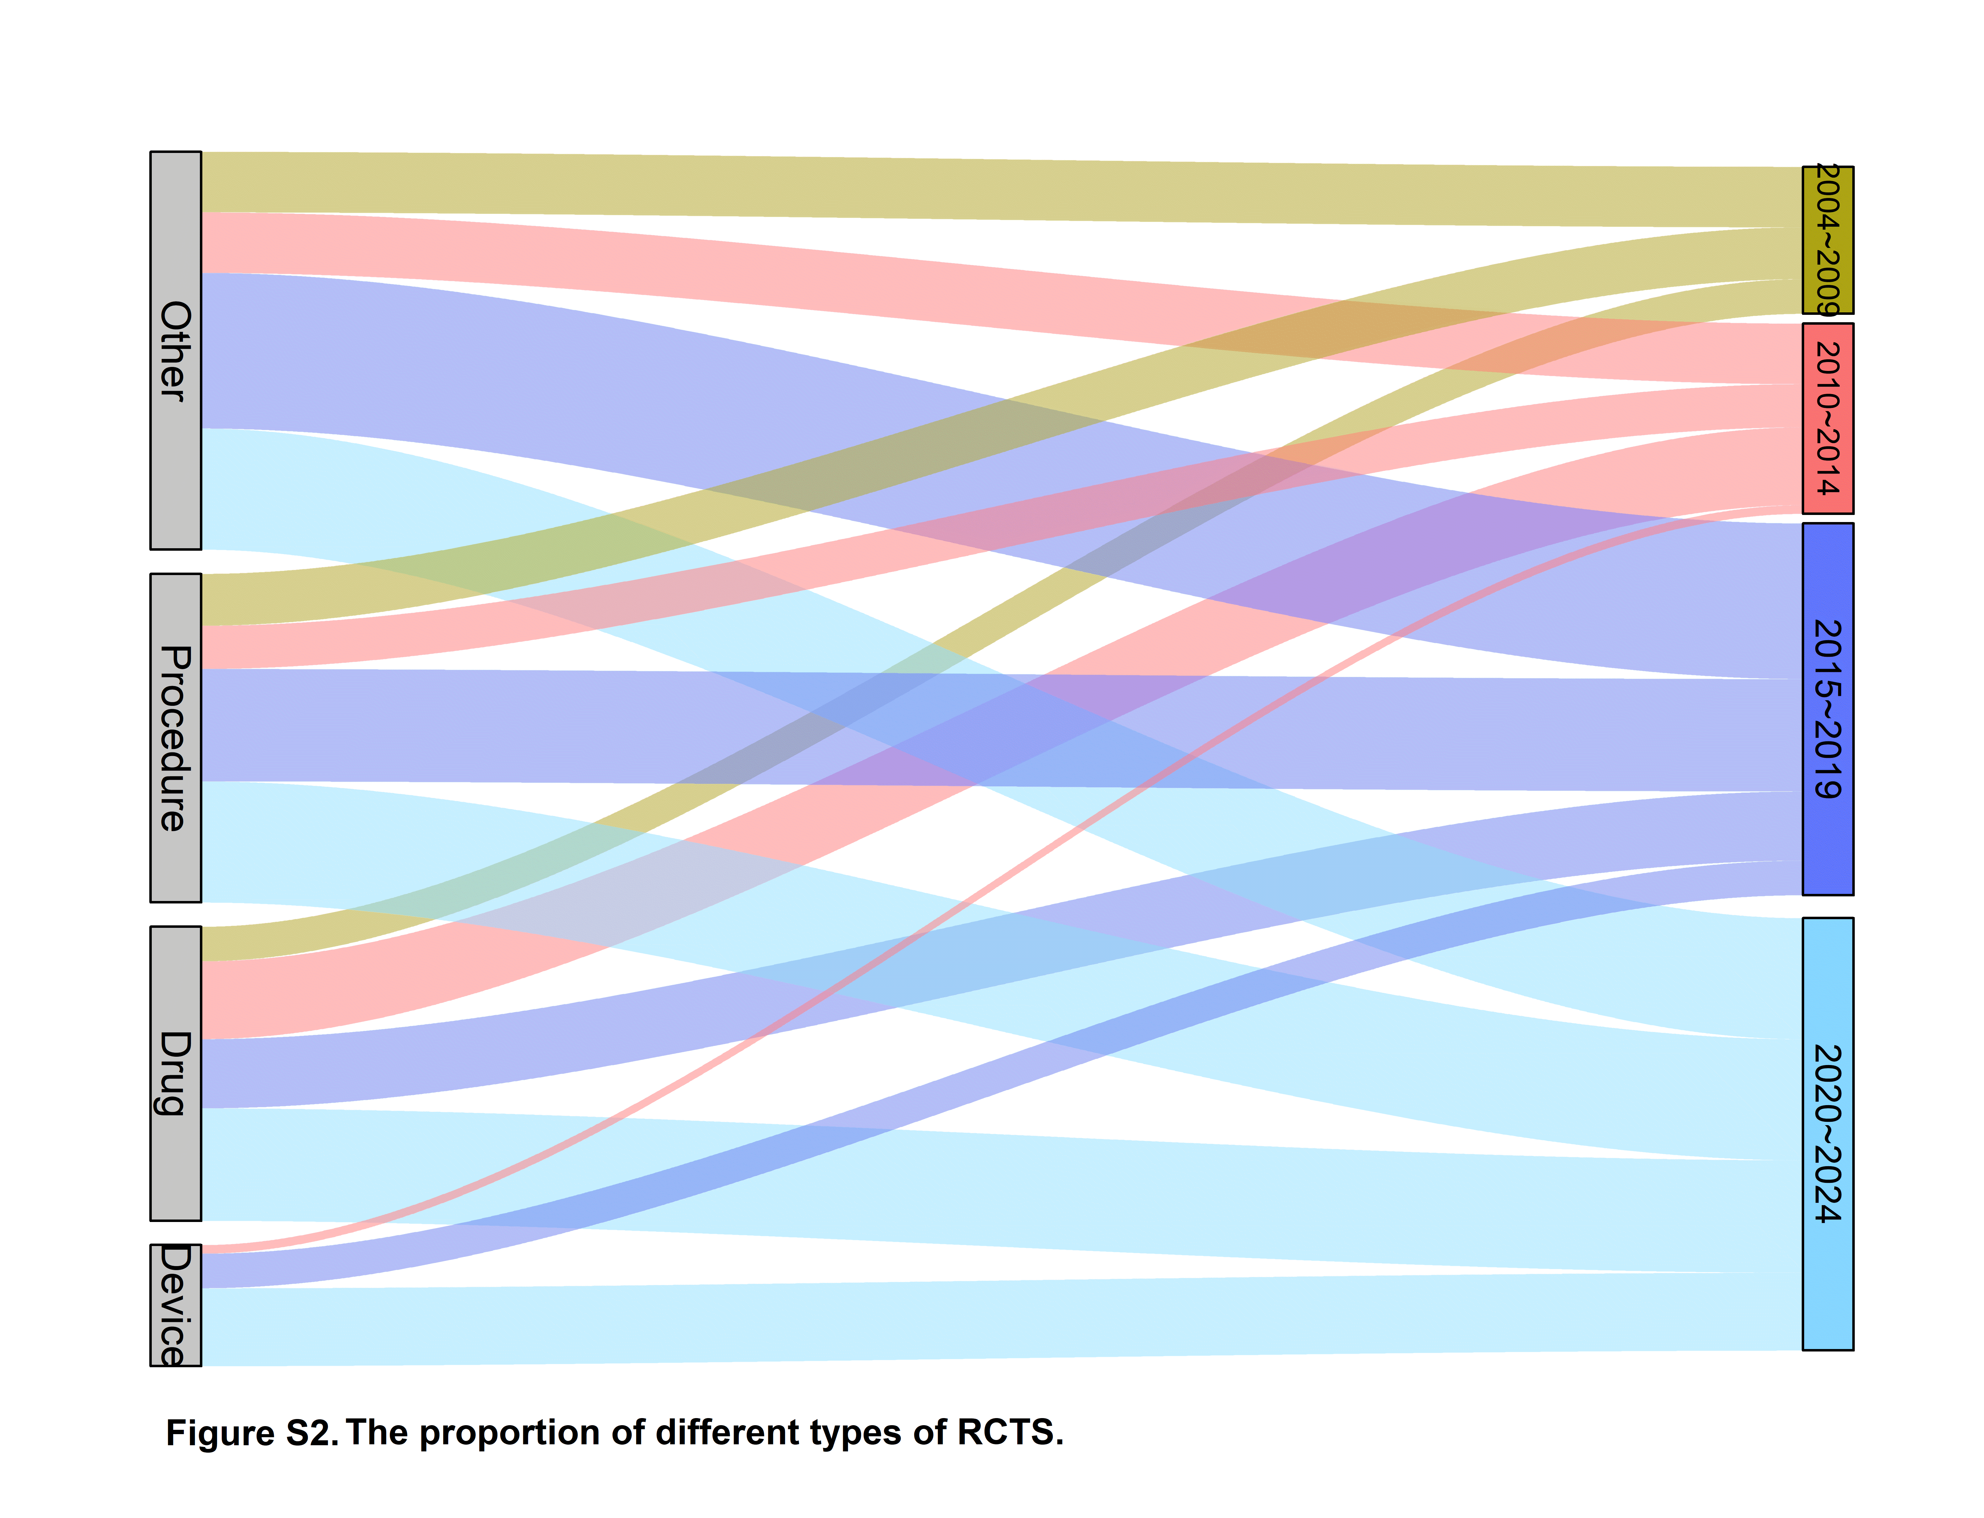

Table S1.Comparison of trial characteristics according to publication status
Characteristic | Not published, No. (%) | Published, No. (%) | Total, No. (%) | P
Funder Type
None or departmental | 52(96.30) | 71(97.26) | 123(96.85) | 0.570
Industry or other external | 2(3.70) | 2(2.74) | 4(3.15)
Intervention
Procedure | 21(38.89) | 16(21.92) | 37(29.13) | 0.017*
Drug | 7(12.96) | 23(31.5) | 30(23.62)
Device | 6(11.11) | 3(4.11) | 9(7.09)
Other | 20(37.04) | 31(42.47) | 51(40.16)
Recruitment
Single centre | 31(57.41) | 39(53.42) | 70(55.12) | 0.034*
Multicentre | 19(35.19) | 34(46.58) | 53(41.73)
Missing | 4（7.41) | 0(0.00) | 4(3.15）
Arm
2 | 47(87.0) | 66(90.41) | 113(89.0) | 0.297
≥3 | 5(9.3) | 7(9.6) | 12(9.4)
Missing | 2（3.7） | 0(0.00) | 2（1.6）
Intervention modle
Crossover | 4(7.41) | 5(6.85) | 9(7.09) | 0.710
Parallel | 49(90.74) | 68(93.15) | 117(92.13)
Sequential | 1(1.85) | 0(0) | 1(0.79)
Blinding
None or open label | 35(64.81) | 41(56.16) | 76(59.84) | 0.616
Single | 9(16.66) | 16(21.92) | 25(19.69)
Double or more | 10(18.52) | 16(21.92) | 26(20.47)
Primary purpose
Prevent | 6(11.11) | 7(9.59) | 13(10.24) | 0.758
Other | 10(18.52) | 9(12.33) | 19(14.96)
Supportive | 13(24.07) | 21(28.77) | 34(26.77)
Treatment | 25(46.30) | 36(49.32) | 61(48.03)
No. of participants
<350 | 58(90.63) | 53(72.60) | 101(79.53) | 0.009*
≥350 | 6(9.38) | 20(27.40) | 26(20.47)
PI region
<90 | 47(87.04) | 70(95.89) | 117(92.13) | 0.177
≥90 | 2(3.70) | 1(1.33) | 3(2.36)
miss | 5(9.26) | 2(2.74) | 7(5.51)
PI region
North America | 20(37.04) | 37(50.68) | 57(44.88) | 0.166
Europe | 18(33.33) | 24(32.88) | 42(33.07)
Other | 16(29.63) | 12(16.44) | 28(22.05)
PI region
Non-high SDI | 4(7.41) | 7(9.59) | 11(8.66) | 0.031*
High SDI | 45(83.33) | 66(90.41) | 111(87.40)
MISS | 5(9.26) | 0（0.00） | 5(3.94)
PI region
High income | 45(83.33) | 66(90.41) | 111(87.40) | 0.031*
Non-high income | 4(7.41) | 7(9.59) | 11(8.66)
Miss | 5(9.26) | 0（0.00） | 5(3.94)
Time of registration
2004~2013.06 | 12(22.22) | 19(26.03) | 31(24.41) | 0.680
2013.06~2023 | 42(77.78) | 54(73.97) | 96(75.59)
* p<0.05 ** p<0.01

Table S2.Multivariable logistic regression analysis of factors associated with publication
 | Univariate analysis |  | Multivariate analysis
 | OR(95%CI) | P value | OR(95%CI) | P value
Time of registration
2003~2013.06 | 1
2013.06~2023 | 0.812(0.355~1.858) | 0.622
Intervention
Non-pharmacological-related | 1
Pharmacological-related | 3.089(1.212~7.868) | 0.018* | 0.330(0.136~0.801) | 0.014*
Arm
2 | 1
≥3 | 0.997(0.298~3.334) | 0.996
Blinding
None or open label | 1
Single | 1.518(0.597~3.858) | 0.381
Double or more | 1.366(0.550~3.392) | 0.502
Funder Type
None or departmental | 1
Industry or other external | 0.732(0.100~5.370) | 0.759
Recruitment
Single centre | 1
Multicenter | 1.422(0.683~2.961) | 0.346
No. of participants
<350 | 1
≥350 | 3.648(1.362~9.772) | 0.010* | 0.825(0.328~2.076) | 0.684
PI region
Non-high SDI | 1
High SDI | 0.838(0.232~3.031) | 0.788
PI region
<90 | 1
≥90 | 0.336(0.030~3.809) | 0.378
PI region
High income | 1
Non-high income | 1.193(0.330~4.315) | 0.788
PI region
North America | 1
Europe | 0.721(0.318~1.633) | 0.433
Other | 0.405(0.161~1.023) | 0.056
* p<0.05 ** p<0.01

Table S3.Characteristics of randomized controlled trials according to reporting adequacy
Characteristic | Adequate reporting, No. (%) | Inadequate reporting, No. (%) | Total,No. (%) | P
Time of registration
2004~2013.06 | 5(16.7) | 7(25.9) | 12(21.1) | 0.392
2013.06~2023 | 25(83.3) | 20(74.1) | 45(78.9)
Primary purpose
Treatment | 17(56.7) | 15(55.6) | 32(56.1) | 0.933
Other | 13(43.3) | 12(44.4) | 25(43.9)
Intervention modle
Crossover | 3(10.0) | 2(7.4) | 5(8.8) | 1.000
Parallel | 27(90.0) | 25(92.6) | 52(91.2)
Arm
2 | 26(86.7) | 26(96.3) | 52(91.2) | 0.415
3 | 4(13.3) | 1(3.7) | 5(8.8)
Blinding
None or open label | 14(46.7) | 18(66.7) | 32(56.1) | 0.025*
Single | 5(16.7) | 7(25.9) | 12(21.1)
Double or more | 11(36.7) | 2(7.4) | 13(22.8)
Funder Type
None or departmental | 30(100.00) | 26 (96.3) | 56(98.2) | 0.288
Industry or other external | 0(0.00) | 1(3.7) | 1(1.8)
Recruitment
Single centre | 17(56.7) | 14(51.9) | 31(54.4) | 0.716
Multicentre | 13(43.3) | 13(48.1) | 26(45.6)
No. of participants
<350 | 23(76.7) | 20(74.1) | 43(75.4) | 0.820
≥350 | 7(23.3) | 7(25.9) | 14(24.6)
PI region
Non-high SDI | 4(13.3) | 3(11.1) | 7(12.3) | 1.000
High SDI | 26(86.7) | 24(88.9) | 50(87.7)
PI region
<90 | 25(83.3) | 24(88.9) | 49(86.0) | 0.825
≥90 | 5(16.7) | 3(11.1) | 8(14.0)
PI region
High income | 26(86.7) | 24(88.9) | 50(87.7) | 1.000
Non-high income | 4(13.3) | 3(11.1) | 7(12.3)
PI region
North America | 16(53.3) | 15(55.6) | 31(54.5) | 0.827
Europe | 9(30.0) | 9(33.3) | 18(31.6)
Other | 5(16.7) | 3(11.1) | 8(14.0)
* p<0.05 ** p<0.01

Table S4.Compliance with CONSORT 2010 checklist items

CONSORT Item |  | Pharmacological n=20 | NPI n=37
1a | Identification as a randomised trial in the title | 16(80.0%) | 28(75.6%)
1b | Structured summary of trial design, methods, results, and conclusions | 20(100.0%) | 36(97.2%)
2a | Scientific background and explanation of rationale | 20(100.0%) | 37(100.0%)
2b | Specific objectives or hypotheses | 20(100.0%) | 37(100.0%)
3a | Description of trial design (such as parallel, factorial) including allocation ratio | 19(95.0%) | 37(100.0%)
3b* | Important changes to methods after trial commencement (such as eligibility criteria), with reasons | - | -
4a | Eligibility criteria for participants | 20(100.0%) | 37(100.0%)
4b | Settings and locations where the data were collected | 20(100..0%) | 36(97.2%)
5 | The interventions for each group with sufficient details to allow replication | 20(100.0%) | 36(97.2%)
5A** | Description of the components of the interventions and, if applicable, the procedure for individualizing treatment | N/A | 29(78.3%)
5B** | Details of how the interventions were standardized | N/A | 28(75.6%)
5C** | Details of how the adherence of care provers with the protocol was assessed or enhanced | N/A | 19(51.3%)
6a | Completely defined pre-specified primary and secondary outcome measures | 20(100.0%) | 36(97.2%)
6b* | Any changes to trial outcomes after the trial commenced, with reasons | - | -
7a | How sample size was determined | 15(75.0%) | 30(80.1%)
7b* | When applicable, explanation of any interim analyses and stopping guidelines | - | -
8a | Method used to generate the random allocation sequence | 11(55.0%) | 33(89.1%)
8b | Type of randomisation; details of any restriction (such as blocking and block size) | 7(35.0%) | 22(59.4%)
9 | Mechanism used to implement the random allocation sequence | 11(55.0%) | 25(67.5%)
10 | Who generated the random allocation sequence, enrolled participants, and assigned participants to interventions | 10(52.6%) | 25(67.5%)
11a | If done, who was blinded after assignment to interventions and how | 14(70.0%) | 12(32.4%)
11b* | If relevant, description of the similarity of interventions | - | -
12a | Statistical methods used to compare groups for primary and secondary outcomes | 20(100.0%) | 37(100.0%)
12b* | Methods for additional analyses, such as subgroup analyses and adjusted analyses | - | -
13a | The numbers of participants who were randomised, received treatment, and analysed for the primary outcome | 19(95.0%) | 36(97.2%)
13b | For each group, losses and exclusions after randomisation, together with reasons | 20(100.0%) | 32(86.4%)
14a | Dates defining the periods of recruitment and follow-up | 17(85.0%) | 36(97.2%)
14b* | Why the trial ended or was stopped | - | -
15 | A table showing baseline demographic and clinical characteristics for each group | 20(100.0%) | 35(94.5%)
16 | For each group, number of participants analysed and whether the analysis was by original assigned groups | 20(100.0%) | 37(100.0%)
17a | For each primary and secondary outcome, results for each group, and the estimated effect size and its precision | 20(100.0%) | 34(91.8%)
17b | For binary outcomes, presentation of both absolute and relative effect sizes is recommended | 18(90.0%) | 25(67.5%)

18* | Results of any other analyses performed, including subgroup analyses and adjusted analyses | - | -
19 | All important harms or unintended effects in each group | 19(95.0%) | 26(70.2%)
20 | Trial limitations, addressing sources of potential bias, imprecision, and, if relevant, multiplicity of analyses | 20(100.0%) | 37(100.0%)
21 | Generalisability (external validity, applicability) of the trial findings | 20(100.0%) | 33(89.1%)
22 | Interpretation consistent with results, balancing benefits and harms, and considering other relevant evidence | 20(100.0%) | 36(97.2%)
23 | Registration number and name of trial registry | 18(90.0%) | 35(94.5%)
24 | Where the full trial protocol can be accessed, if available | 2(10.0%) | 13(35.1%)
25 | Sources of funding and other support (such as supply of drugs), role offunders | 20(100.0%) | 33(89.1%)
* indicates a conditional item for which not all manuscripts were scored; ** items relate to non-pharmacological (NPI) RCTs only
Table S5.Characteristics of randomized controlled trials according to the presence of avoidable design flaws
Characteristic | Absence of design flaw, No. (%) | Presence of design flaw, No. (%) | Total, No. (%) | P
Time of registration
2004~2013.06 | 5(15.6) | 7(28.0) | 12(21.1) | 0.257
2013.06~2023 | 27(84.4) | 18(72.0) | 45(78.9)
Primary purpose
Treatment | 17(53.1) | 15(60.0) | 32(56.1) | 0.603
Other | 15(46.9) | 10(40.0) | 25(43.9)
Intervention
Pharmacological | 14(43.8) | 6(24.0) | 20(35.1) | 0.117
Nonpharmacological | 18(56.3) | 19(76.0) | 37(64.9)
Intervention modle
Crossover | 1(3.1) | 4(16.0) | 5(8.8) | 0.217
Parallel | 31(96.9) | 21(84.0) | 52(91.2)
Arm
2 | 29(90.6) | 23(92.0) | 52(91.2) | 1.000
3 | 3(9.4) | 2(8.0) | 5(8.8)
Blinding
None or open label | 15(46.9) | 17(68.0) | 32(56.1) | 0.032*
Single | 6(18.8) | 6(24.0) | 12(21.1)
Double or more | 11(34.4) | 2(8.0) | 13(22.8)
Funder Type
None or departmental | 31(96.9) | 25(100.00) | 56(98.2) | 0.373
Industry or other external | 1(3.1) | 0(0.00) | 1(1.8)
Recruitment
Single centre | 17(53.1) | 14(56.0) | 31(54.4) | 0.829
Multicentre | 15(46.9) | 11(44.0) | 26(45.6)
No. of participants
<350 | 24(75.0) | 19(76.0) | 43(75.4) | 0.931
≥350 | 8(25.0) | 6(24.0) | 14(24.6)
PI region
Non-high SDI | 5(15.6) | 2(8.0) | 7(12.3) | 0.643
High SDI | 27(84.4) | 23(92.0) | 50(87.7)
PI region
<90 | 30(93.8) | 19(76.0) | 49(86.0) | 0.126
≥90 | 2(6.2) | 6(24.0) | 8(14.0)
PI region
High income | 27(84.4) | 23(92.0) | 50(87.7) | 0.643
Non-high income | 5(15.6) | 2(8.0) | 7(12.3)
PI region
North America | 18(56.3) | 13(52.0) | 31(54.4) | 0.398
Europe | 7(21.9) | 9(36.0) | 16(28.1)
Other | 7(21.9) | 3(12.0) | 10(17.5)
* p<0.05 ** p<0.01

Table S6.Characteristics of randomized controlled trials according to citation in clinical guidelines
Characteristic | Absence of citing by guidelines, No. (%) | Presence of citing by guidelines, No. (%) | Total, No. (%) | P
Time of registration
2003~2013.06 | 7(16.7) | 5(33.3) | 12(21.1) | 0.322
2013.06~2023 | 35(83.8) | 10(66.7) | 45(78.9)
Primary purpose
Treatment | 20(47.6) | 12(80.0) | 32(56.1) | 0.025*
Other | 22(52.4) | 3(20.0) | 25(43.9)
Intervention
Pharmacological | 14(33.3) | 6(40.0) | 20(35.1) | 0.644
Non pharmacological | 28(66.6) | 9(60.0) | 37(64.9)
Intervention modle
Crossover | 4(9.5) | 1(6.7) | 5(8.8) | 1.000
Parallel | 38(90.5) | 14(93.3) | 52(91.2)
Arm
2 | 37(88.1) | 15(100.0) | 52(91.2) | 0.386
3 | 5(11.9) | 0(0.00) | 5(8.8)
Blinding
None or open label | 21(50.9) | 11(73.3) | 32(56.1) | 0.280
Single | 10(23.8) | 2(13.3) | 12(21.1)
Double or more | 11(26.2) | 2(13.3) | 13(22.8)
Funder Type
None or departmental | 42(100.0) | 14(93.3) | 56(98.2) | 0.091
Industry or other external | 0(0.0) | 1(6.7) | 1(1.8)
Recruitment
Single centre | 28(66.7) | 3(20.0) | 31(54.4) | 0.01**
Multicentre | 14(33.3) | 12(80.0) | 26(45.6)
No. of participants
<350 | 34(81.0) | 9(60.0) | 43(75.4) | 0.204
≥350 | 8(19.0) | 6(40.0) | 14(24.6)
PI region
Non-high SDI | 7(16.7) | 0(0.00) | 7(12.3) | 0.219
High SDI | 35(83.3) | 15(100.0) | 50(87.7) | 0.219
PI region
<90 | 35(83.3) | 14(93.3) | 49(86.0) | 0.600
≥90 | 7(16.7) | 1(6.7) | 8(14.0)
PI region
High income | 35(83.3) | 15(100.0) | 50(87.7) | 0.219
Non-high income | 7(16.7) | 0(0.0) | 7(12.3)
PI region
North America | 20(47.6) | 11(73.3) | 31(54.4) | 0.025*
Europe | 12(28.6) | 4(26.7) | 16(28.1)
Other | 10(23.8) | 0(0.0) | 10(17.5)
* p<0.05 ** p<0.01

Table S7.Multivariable logistic regression analysis of factors associated with citation in clinical guidelines
 | Univariate analysis |  | Multivariate analysis
 | OR(95%CI) | P value | OR(95%CI) | P value
Time of registration
2003~2013.06 | 1
2013.06~2023 | 2.500(0.651~9.602) | 0.182
Primary purpose
Treatment | 1
Other | 0.227（0.056~0.924） | 0.038* | 2.886(0.643~12.955) | 0.166
Intervention
Non-pharmacological-related | 1
Pharmacological-related | 0.750(0.222~2.530) | 0.643
Intervention modle
Crossover | 1
Parallel | 1.474（0.151~14.341） | 0.738
Blinding
None or open label | 1
Single | 0.382（0.071~2.058） | 0.263
Double or more | 0.347（0.065~1.851） | 0.215
Recruitment
Single centre | 1
Multicenter | 8.000(1.937~33.048) | 0.004** | 0.158(0.037~0.679) | 0.013**
No. of participants
<350 | 1
≥350 | 2.833(0.781~10.277) | 0.113
PI region
<90 | 1
≥90 | 0.357(0.040~3.175) | 0.356
PI region
North America | 1
Other | 0.331(0.091~1.207) | 0.094
* p<0.05 ** p<0.01

Table S8.Characteristics of randomized controlled trials according to reuse of prospective data
Characteristic | Absence of reuse of prospective data, No. (%) | Presence of reuse of prospective data, No. (%) |  | Total, No. (%) | P
Time of registration
2004~2013.06 | 11(19.6) |  | 1(100.0) | 12(21.1) | 0.051
2013.06~2023 | 45(80.4) |  | 0(0.0) | 45(78.9)
Primary purpose
Treatment | 31(55.4) |  | 1(100.0) | 32(56.1) | 0.373
Other | 25(44.6) |  | 0(0.0) | 25(43.9)
Intervention
Pharmacological | 19(33.9) |  | 1(100.0) | 20(35.1) | 0.170
Nonpharmacological | 37(66.1) |  | 0(0.0) | 37(64.9)
Intervention modle
Crossover | 5(8.9) |  | 0(0.0) | 5(8.8) | 0.754
Parallel | 51(91.9) |  | 1(100.0) | 52(91.2)
Arm
2 | 51(91.9) |  | 1(100.0) | 52(91.2) | 0.754
≥3 | 5(8.9) |  | 0(0.0) | 5(8.8)
Blinding
None or open label | 32(57.1) |  | 0(0.0) | 32(56.1) | 0.179
Single | 12(21.4) |  | 0(0.0) | 12(21.1)
Double or more | 12(21.4) |  | 1(100.0) | 13(22.8)
Funder Type
None or departmental | 55(98.2) |  | 1(100.0) | 56(98.2) | 0.893
Industry or other external | 1(1.8) |  | 0(0.0) | 1(1.8)
Recruitment
Single centre | 31(55.4) |  | 0(0.0) | 31(54.5) | 0.271
Multicentre | 25(44.6) |  | 1(100.0) | 26(45.6)
No. of participants
<350 | 43(76.8) |  | 0(0.0) | 43(75.4) | 0.077
≥350 | 13(23.2) |  | 1(100.0) | 14(24.6)
PI region
Non-high SDI | 7(12.5) |  | 0(0.0) | 7(12.3) | 0.706
High SDI | 49(87.5) |  | 1(100.0) | 50(87.7)
PI region
<90 | 48(85.7) |  | 1(100.0) | 49(86.0) | 0.684
≥90 | 8(14.3/) |  | 0(0.0) | 8(14.0)
PI region
High income | 49(87.5) |  | 1(100.0) | 50(87.7) | 0.706
Non-high income | 7(12.5) |  | 0(0.0) | 7(12.3)
PI region
North America | 30(53.6) |  | 1(100.0) | 31(54.4) | 0.653
Europe | 16(28.6) |  | 0(0.0) | 16(28.1)
Other | 10(17.9) |  | 0(0.0) | 10(17.5)
* p<0.05 ** p<0.01

