Supplementary File. 1 : Implementation process of BOPPPS model combined with art drawing (taking partial chapters and knowledge points as examples).
Stages and contents | Course chapter | Knowledge points | Integrated application of art drawing
Bridge-in (B): Stimulate interest and lay a foundation for the content | Adaptation, injury and repair of tissues and cells | Granulation tissue | Introduce the knowledge point of tissue injury with the introduction of drawing works of common clinical surgical traumas
 | Disorders of local blood circulation | Conditions and processes of thrombosis | Introduce by analogizing the process of thrombosis with the drawing of the daily phenomenon of "silt formation in a stream"
Pre-assessment (P): Assess students' current status and clarify learning objectives | Inflammation | Characteristics of various types of inflammation | Assign small quizzes for students to judge inflammation types by combining drawings of various common inflammations in daily life; the quizzes are released to the class through the online learning platform "StudyLink"
Participatory Learning (P): Teacher-student interaction and active participation in learning | Inflammation | Basic pathological changes of inflammation | Students use their imagination to draw the process of leukocyte extravasation and phagocytosis in inflammation as an intense scene of "soldiers fighting enemies on the battlefield", and then narrate stories based on the drawings to explain the inflammatory process, thus carrying out teacher-student interactive and participatory learning
 | Tumor | Pathological characteristics of squamous cell carcinoma | Inspire inspiration from world famous paintings, capture pathological features for integration and creative processing, and explain the implied meanings and characteristics of the works based on the drawings
 | Diseases of the cardiovascular system | Pathological stages of atherosclerosis | Students create dynamic serial drawings based on the characteristics of several typical pathological stages in the development of vascular lesions, integrate stories of myocardial infarction onset to explain the progression and impacts of the lesions, and advocate the nursing philosophy of "Benevolent doctors with benevolence, caring for and comforting the injured"
Post-assessment (P): Conduct tests to evaluate learning effectiveness | Diseases of the digestive system | Pathological progression of chronic liver disease | Display artistic drawings of the microscopic views of hepatitis, liver cirrhosis and liver cancer in the test for students to identify and distinguish
Summary (S): Reflect and summarize to consolidate learning objectives. | Diseases of the female reproductive system | Pathological characteristics of breast cancer | Combine the pathological characteristics of breast cancer with drawings for clinical nursing assessment, and sort out and summarize the knowledge points
Note: Objective (O), which involves outlining learning tasks and clarifying objectives, runs through each chapter.

Supplementary File. 2: Display of students' works.
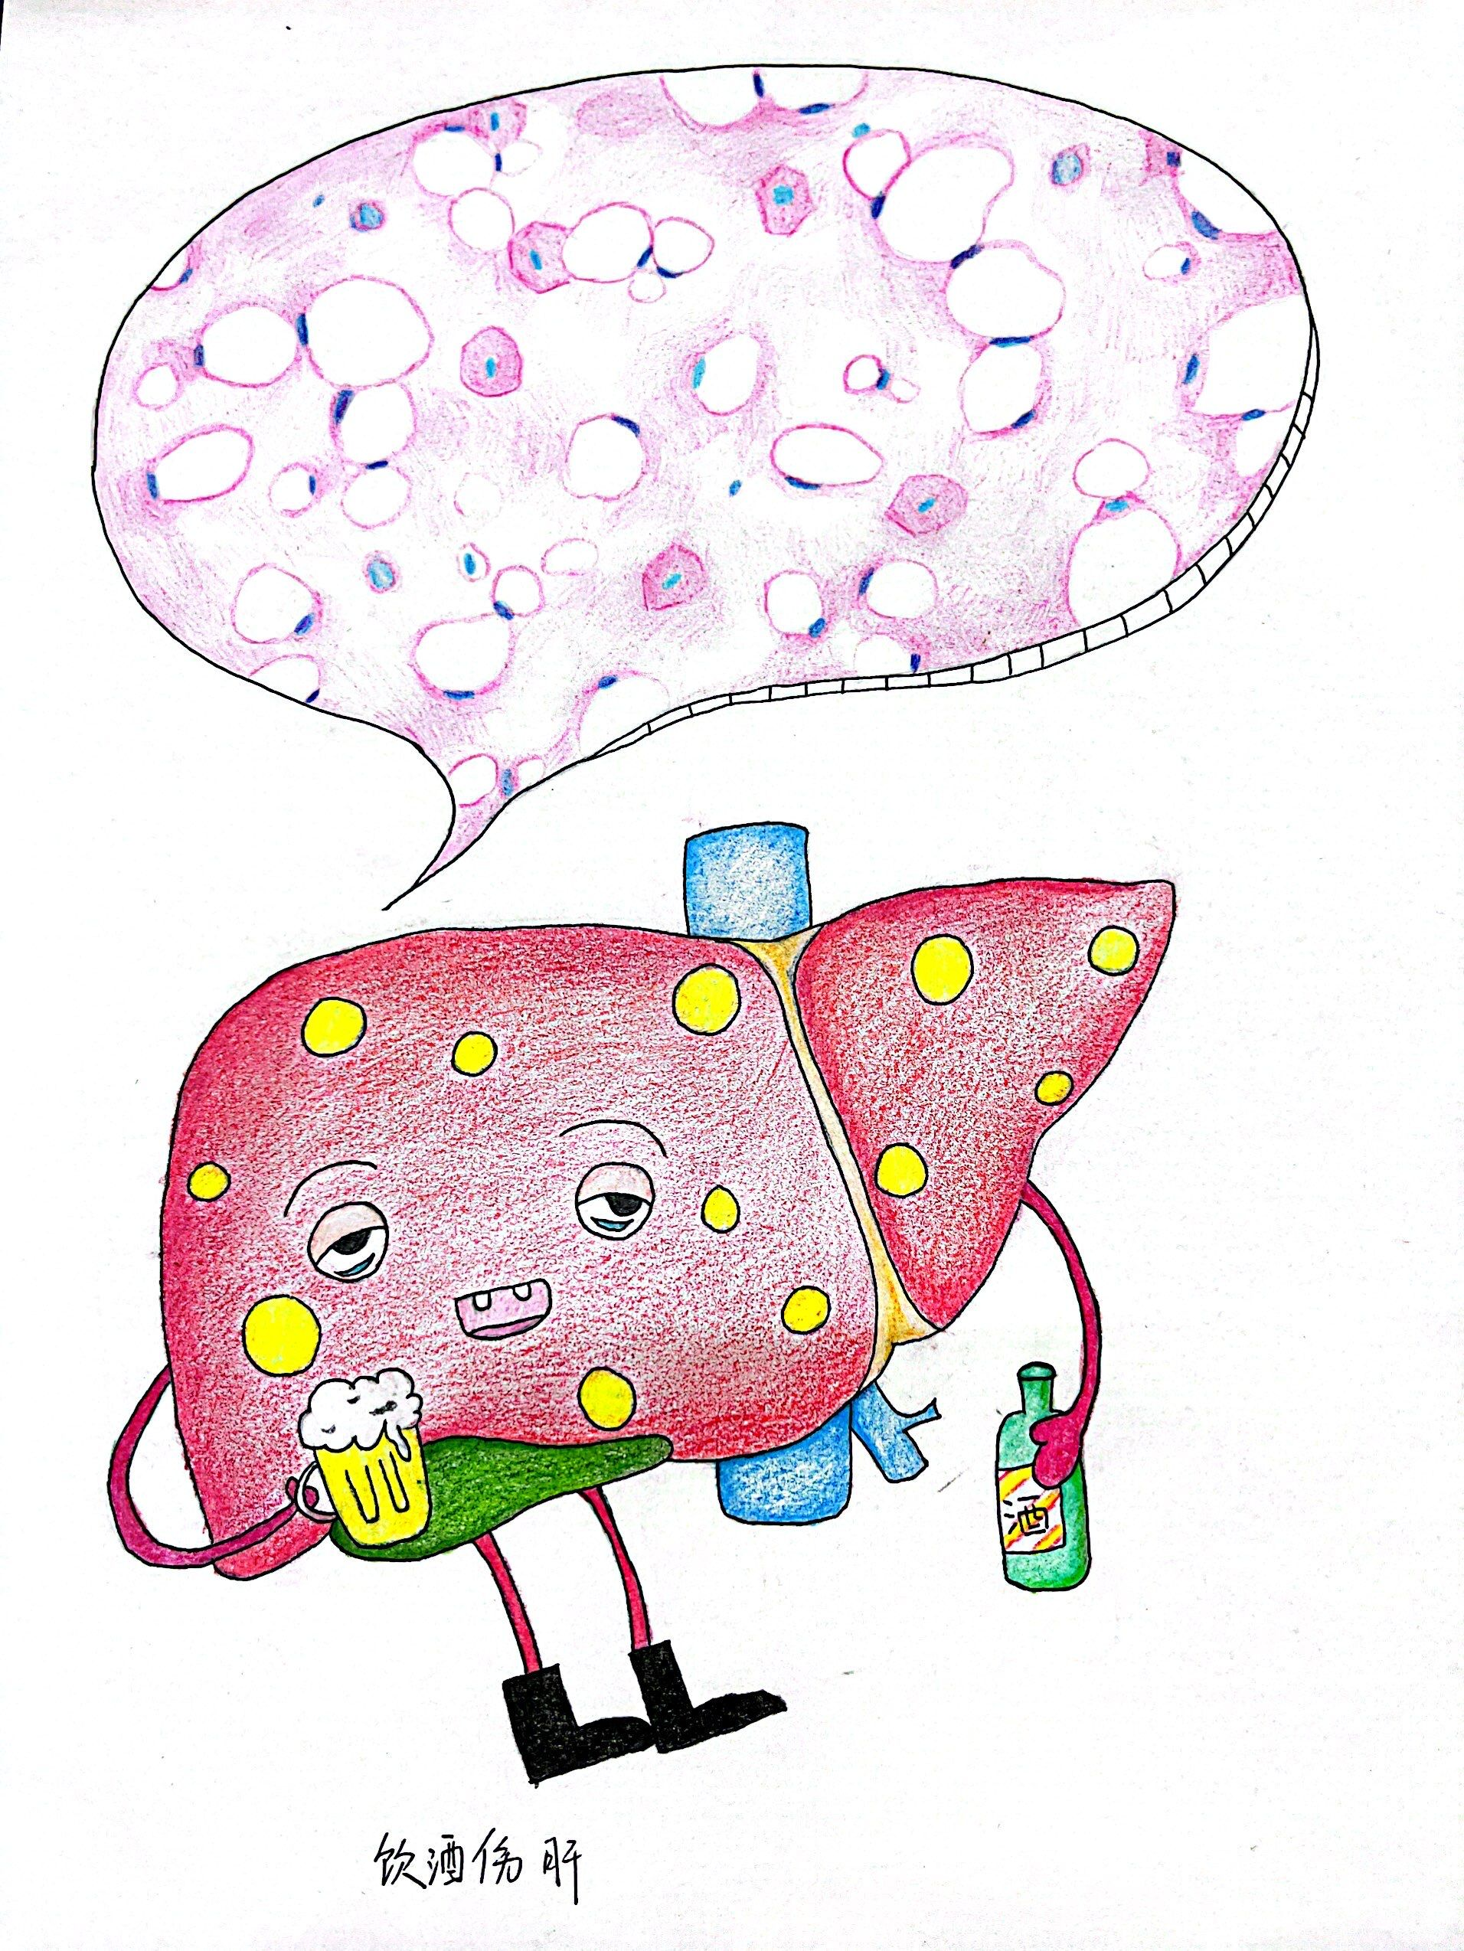 | 