Table S1 Phenotypes of 12 salt-tolerant spelt wheat accessions under a preliminary salt stress gradient experiment (0, 50, 100, 150, 200 mM NaCl)
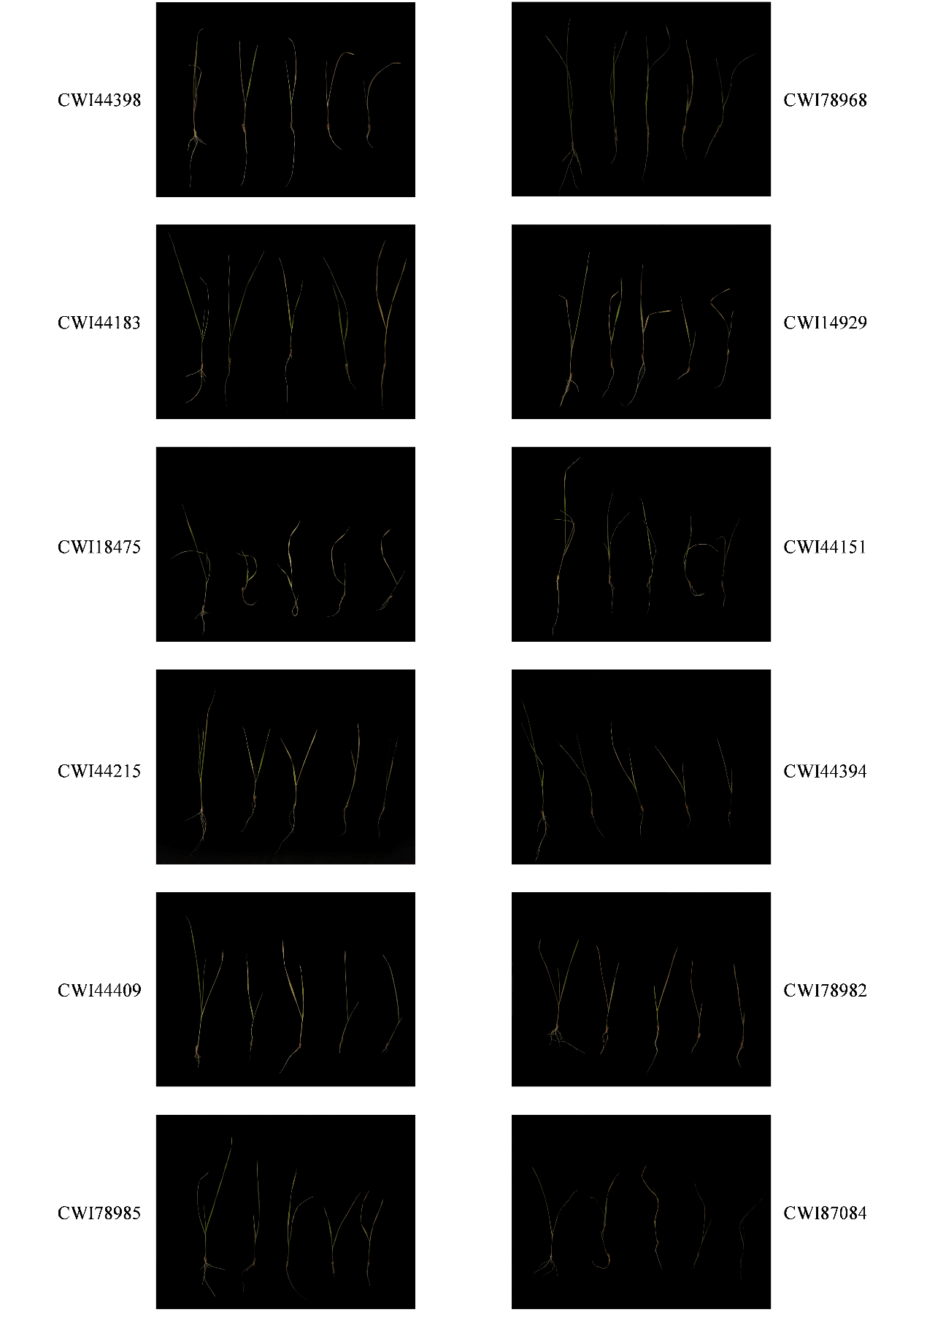
Note: The seedlings were subjected to NaCl treatments at concentrations of 0, 50, 100, 150, and 200 mM from left to right, among which CWI44398, CWI78968, and CWI44183 exhibited superior phenotypes compared with the other lines, Using distilled water as the blank control (0 mM)

