Supplementary data

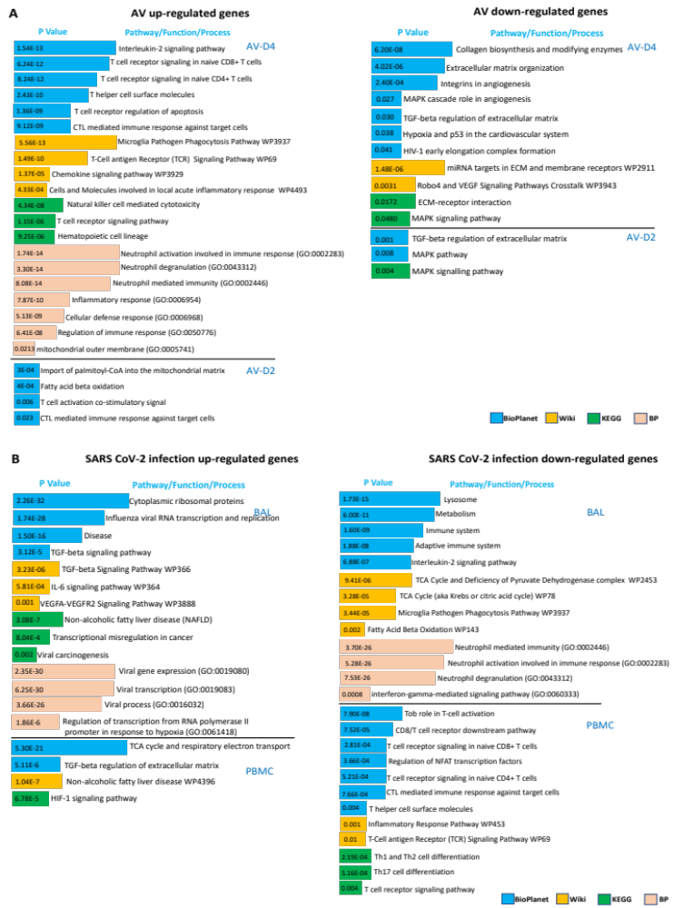
Figure S1. Functional enrichment analysis of differentially expressed genes in the lungs of mice treated with AV and in the BAL and PBMC samples of SARS-CoV2 infected patients. (A) Enriched pathways and biological process in up-regulated and down-regulated genes after AV treatment compared to vehicle mice group. (B) Enriched pathways and biological process in up-regulated and down-regulated genes in SARS-CoV2 infected patients compared to control.

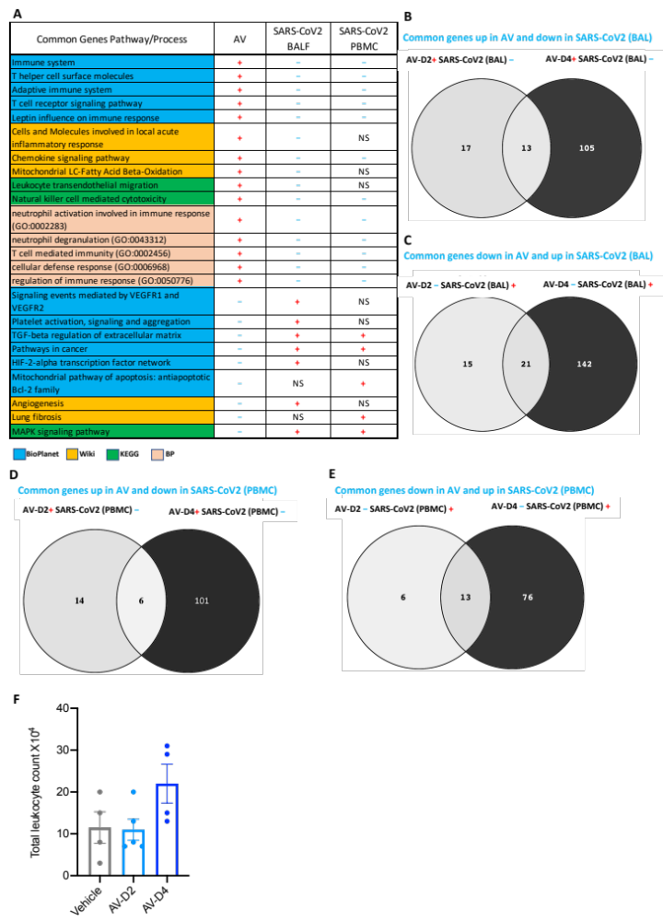
Figure S2. AV treatment favours the transcription of immune regulatory genes and prevents the hypoxia linked angiogenesis, fibrosis and inflammatory inducing genes. (A) Detail description of functional enrichment analysis of ‘common genes’ between AV (AV-D2 and D4 dose) and SARS-CoV2 patient sample. The + symbol indicates the up-regulation of denoted pathway/biological process in the mentioned group, whereas – symbol indicates the down-regulation pathway/biological process in the mentioned group. ‘NS’ represents the non-significant. Vein diagram showing a set of common genes which are (B) up-regulated in AV (both AV-D2 and D4 group) but same were down-regulated in BAL samples of SARS-CoV2 patient. (C)Set of common genes down-regulated in AV (both AV-D2 and D4 group), but same genes up-regulated in BAL samples of SARS-CoV2 patient. Similarly, vein diagram showing a set of common genes which are (D) up-regulated in AV (both AV-D2 and D4 dose) but same were down-regulated in PBMC samples of SARS-CoV2 patient and (E) Set of genes down-regulated in AV (both AV-D2 and D4 group). However, same gens up-regulated in PBMC samples of SARS-CoV2 patient. (F) levels of total leukocyte count in the BAL fluid of the mice treated with AV.
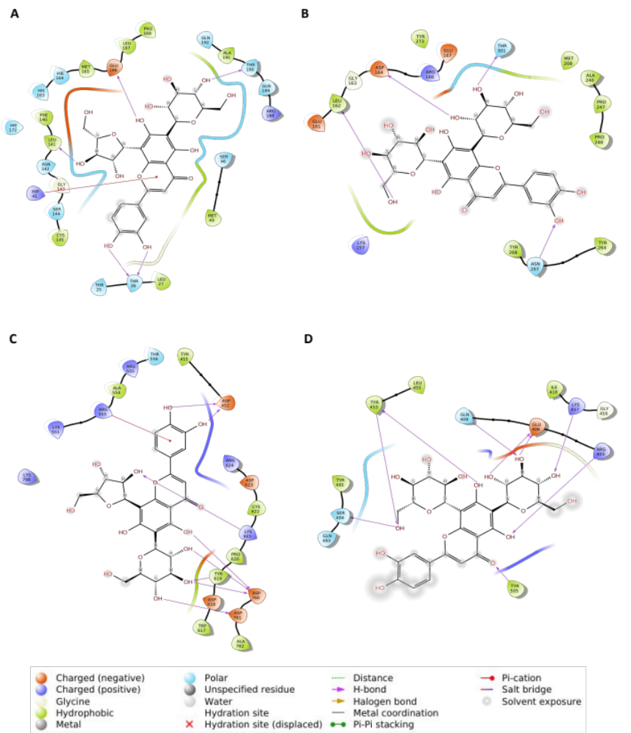

Figure S3: Interaction of lead compounds of Adhatoda Vasica with different target proteins of SARS -CoV-2 virus. (A) Interaction of Luteolin-6-C-glucoside-8-C-arabinoside with 3CLpro (B) Interaction of Luteolin-6,8-di-C-glucoside with PLpro (C) Interaction of Luteolin-6-C-glucoside-8-C-arabinoside with RdRp (D) Interaction of Luteolin-6,8-di-C-glucoside with S-protein.

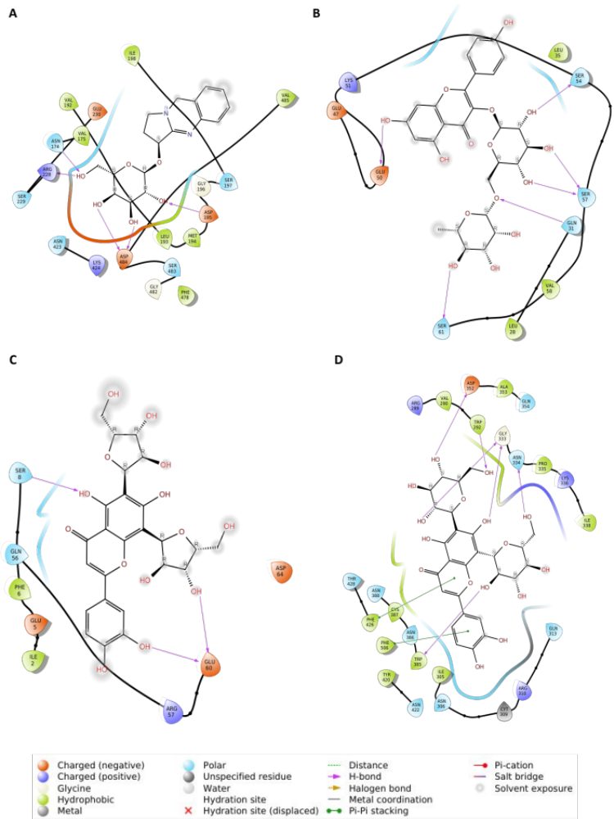
Figure S4: Interaction of lead compounds of Adhatoda Vasica with different target proteins of SARS -CoV-2 virus. (A) Interaction of Vasicinone glycoside with NSP4 (B) Interaction of Kaempferol-3-O-rutinoside with NSP7 (C) Interaction of Kaempferol-3-O-rutinoside with NSP8 (D) Interaction of Luteolin-6,8-di-C-glucoside with NSP14.

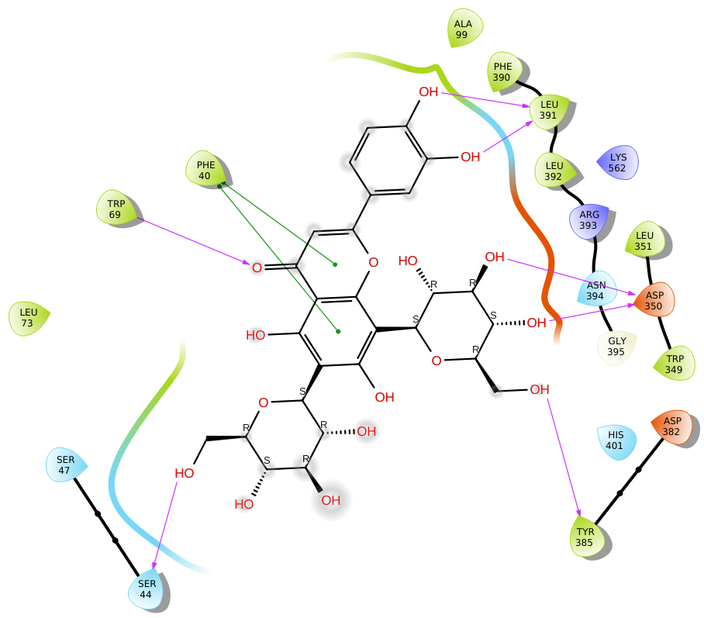

Figure S5: Interaction plot of Luteolin-6,8-di-C-glucoside with ACE2 receptor of human cell with binding affinity of -9.8 kcal/mol. The compound Luteolin-6,8-di-C-glucoside has 7 hydrogen bonding interactions with residues Ser44, Trp69, Asp350,Asp382 and Leu391. Notably, two π-π interactions with residue Phe40 of ACE2 protein of host cell.

Table S1: Liquid chromatography–electrospray ionization–mass spectroscopy of AV extract in positive-ion mode. Identification of quinazoline alkaloids from the water extract of Adhatoda Vasica, separated by mobile phase consist of 0.1% formic acid aqueous solution and acetonitrile. The various peaks obtained (fig. S1A) were analysed at different time intervals under a gradient program using (+)-ESI-MS.

S.No. | RT  (in min) | Molecular Formula | [M+H]⁺ m/z (calc) | [M+H]⁺ m/z (exp) | Error (Δppm) | Identification
1 | 2.4 | C₅H₁₄NO⁺ | 104.1073 | 104.1073 | 0 | Choline
2 | 2.9 | C₅H₁₁NO₂ | 118.0864 | 118.0864 | 0 | Betaine
3 | 8.0 | C₁₁H₁₂N₂O₂ | 205.0972 | 205.0974 | 0.98 | Vasicinol/ 5-hydroxy vasicine
4 | 8.2 | C₁₂H₁₂N₂O₃ | 233.0921 | 233.0921 | 0.00 | Adhavasicinone
5 | 10.0 | C₁₁H₁₂N₂O₂ | 205.0972 | 205.0974 | 0.98 | Vasicinol/ 5-hydroxy vasicine
6 | 10.4 | C₁₂H₁₂N₂O₂ | 217.0972 | 217.0969 | -1.38 | Linarinic acid
7 | 10.9 | C₁₁H₁₂N₂O | 189.1022 | 189.1022 | 0.00 | Vasicine
8 | 13.3 | C₁₁H₁₀N₂O₃ | 219.0764 | 219.0766 | 0.91 | Vasicinolone
9 | 13.7 | C₁₂H₁₄N₂O₂ | 219.1128 | 219.1131 | 1.37 | 5-methoxy vasicine
10 | 15.7 | C₁₇H₂₂N₂O₆ | 351.1551 | 351.1548 | -0.85 | Vasicine glycoside
11 | 15.7 | C₁₁H₁₀N₂O₂ | 203.0815 | 203.0812 | -1.48 | Vasicinone

Table S2: Liquid chromatography–electrospray ionization–mass spectroscopy of AV extract in negative-ion mode. Identification of flavonoids C- and O- glycosides from the water extract of Adhatoda Vasica, separated by mobile phase consist of 0.1% formic acid aqueous solution and acetonitrile. The various peaks obtained (fig. S1B) were analysed at different time intervals under a gradient program using (-)-ESI-MS.
S.No. | RT  (in min) | Molecular Formula | [M-H]⁻ m/z (calc) | [M-H]⁻ m/z (exp) | Error (Δppm) | Identification
1 | 14.8, 17.9 | C₂₇H₃₀O₁₆ | 609.1461 | 609.1464 | 0.49 | Luteolin-6,8-di-C-glucoside/ Quercetin-3-O-rutinoside
2 | 15.3, 15.8 | C₂₆H₂₈O₁₅ | 579.1355 | 579.1354 | -0.17 | Luteolin-6-C-glucoside-8-C-arabinoside/ Luteolin-6-C-arabinoside 8-C-glucoside
3 | 15.5, 18.8 | C₂₇H₃₀O₁₅ | 593.1512 | 593.151 | -0.34 | Kaempferol-3-O-rutinoside/ Apigenin-6,8-di-C-glucoside
4 | 15.8, 16.2, 16.5, 16.8, 17.3 | C₂₆H₂₈O₁₄ | 563.1406 | 563.1401 | -0.89 | Apigenin-6-C-glucoside-8-C-arabinoside/ Apigenin-6-C-arabinoside 8-C-glucoside/ Apigenin-6-C-arabinoside 7-O-glucoside
5 | 16.6 | C₂₅H₂₆O₁₄ | 549.125 | 549.1253 | 0.55 | Luteolin-6,8-di-C-arabinoside
6 | 16.7 | C₂₁H₂₀O₁₁ | 447.0933 | 447.0928 | -1.12 | Luteolin-8-C-glucoside/ Luteolin-6-C-glucoside/ Kaempferol-3-O-glucoside
7 | 16.8, 17.2, 17.5, 18.1, 18.5 | C₂₅H₂₆O₁₃ | 533.1301 | 533.1303 | 0.38 | Apigenin-6,8-di-C-arabinoside
8 | 18.1, 18.3 | C₂₁H₂₀O₁₀ | 431.0984 | 431.0983 | -0.23 | Apigenin-6-C-glucoside/ Apigenin-8-C-glucoside
9 | 18.6, 19.3 | C₂₀H₁₈O₁₀ | 417.0827 | 417.0831 | 0.96 | Luteolin-8-C-arabinoside/ Luteolin-6-C-arabinoside
10 | 18.7 | C₂₁H₂₀O₁₂ | 463.0882 | 463.0881 | -0.22 | Quercetin-3-O-glucoside
11 | 19.7, 20.1 | C₂₀H₁₈O₉ | 401.0878 | 401.0873 | -1.25 | Apigenin-8-C-arabinoside/ Apigenin-6-C-arabinoside

Table S3: Binding affinity of compounds of Adhatoda Vasica with different target proteins of SARS-CoV-2 virus in kcal/mol using AutoDock vina
Compounds | 3CLpro | PLpro | RdRp | S-pro | NSP9 | NSP13 | NSP14 | NSP15 | NSP16 | ACE2 | TMPRSS2 | JAK
Choline | -3.2 | -3.3 | -3.7 | -3.1 | -2.4 | -3.2 | -3.5 | -3.1 | -3.5 | -2.7 | -3.1 | -2.9
Betaine | -3.3 | -3.5 | -3.9 | -3.4 | -2.5 | -3.4 | -3.7 | -3.7 | -3.5 | -3.1 | -3.2 | -3
Vasicinol | -6.3 | -5.6 | -6.5 | -5.7 | -5 | -6.4 | -7.2 | -5.9 | -6.5 | -5.2 | -6 | -6.9
Adhavasicinone | -6.5 | -5.5 | -6.4 | -5.9 | -5.4 | -6.6 | -7.6 | -5.9 | -6.9 | -5.7 | -5.8 | -7.3
Linarinic_acid | -6.5 | -5.5 | -6.1 | -6.1 | -5.3 | -6.8 | -7.4 | -6.4 | -6.9 | -6.6 | -6.2 | -7.2
Vasicine | -6 | -5.4 | -6.2 | -5.6 | -5.3 | -6.3 | -7.7 | -6 | -6.3 | -6 | -5.7 | -6.7
Vasicinolone | -6.5 | -5.8 | -6.3 | -6 | -5 | -6.8 | -7.5 | -6.5 | -6.7 | -6.4 | -6.1 | -7.3
5_methoxyvasicine | -6.4 | -5.3 | -6.7 | -5.5 | -5 | -6.6 | -6.8 | -6 | -6.9 | -6.1 | -5.7 | -6.6
Vasicine_glycoside | -7.3 | -6.3 | -7.8 | -6.6 | -5.3 | -7.6 | -8.8 | -7 | -7.8 | -7.2 | -7.4 | -8.2
Vasicinone | -6.2 | -5.5 | -6.5 | -6 | -5.2 | -6.4 | -7.5 | -6.3 | -6.7 | -5.9 | -6.1 | -7.3
Luteolin_6_8_di_C_glucoside | -8.8 | -7 | -8.1 | -7.2 | -5.3 | -6.7 | -9.2 | -6.9 | -8.1 | -6.5 | -7.5 | -9
Luteolin_6C_glucoside_8C_arabinoside | -8.2 | -7 | -7.8 | -6.8 | -4.9 | -6.5 | -9.1 | -7 | -7.8 | -6.7 | -8.1 | -8.9
Kaempferol_3_O_rutinoside | -8.9 | -7.3 | -7.9 | -7.6 | -5.7 | -8.3 | -10.5 | -8.1 | -8.8 | -6.3 | -8.4 | -8.6
Apigenin_6C_glucoside_8C_arabinoside | -8.3 | -6.8 | -7.8 | -6.8 | -4.6 | -6.3 | -10.3 | -6.7 | -7.5 | -6.6 | -8.1 | -8.9
Luteolin-6_8-di-C-arabinoside | -7.4 | -6.6 | -8.2 | -7.1 | -5.1 | -6.4 | -9.9 | -7.4 | -8 | -6.5 | -7.6 | -8.2
Luteolin_6C_glucoside | -8.6 | -6.7 | -7.5 | -6.9 | -4.9 | -7.3 | -9.9 | -7.5 | -8.5 | -7.2 | -8.3 | -8.1
Apigenin-6_8-di-C-arabinoside | -7.5 | -6.5 | -7.9 | -6.8 | -5.1 | -6.1 | -10 | -7.1 | -8.1 | -6.2 | -7.6 | -8.1
Apigenin_6C_glucoside | -8.3 | -6.6 | -7.5 | -6.8 | -4.8 | -7.4 | -10.1 | -7.7 | -8.4 | -7.1 | -8.4 | -8
Luteolin-6-C-arabinoside | -8 | -6.9 | -7.7 | -6.4 | -4.8 | -8.4 | -9.3 | -7.7 | -8.8 | -6.7 | -8 | -7.8
Quercetin_3_O_glucoside | -8.1 | -6.9 | -7.8 | -6.3 | -4.9 | -7.9 | -9.4 | -7 | -7.8 | -6.4 | -7.4 | -8.2
Apigenin-8-C-arabinoside | -7.4 | -6.4 | -7.2 | -7.2 | -5.4 | -8.6 | -9.4 | -6.8 | -8.3 | -6.3 | -7 | -8.8

Table S4: Interaction of active compounds of Adhatoda vasica with important target proteins of SARS-CoV-2 virus.
Proteins | Compounds | Interacting Residues | No. of H- bonds | Docking Score in kcal/mol
3CLpro | Luteolin-6-C-glucoside-8-C-arabinoside | Thr 26, Leu 141, Glu 166, Thr 190 & pi-cation (Hip 41) | 5 | -11.59
PLpro | Luteolin-6,8-di-C-glucoside | Leu 162, Asp 164, Asn 267, Thr 301 | 4 | -7.45
RdRp | Luteolin-6-C-glucoside-8-C-arabinoside | Asp 452, Thr 619, Lys 621, Asp 760, Asp 761 & pi-cation (Arg 553) | 8 | -10.6
S-protein | Luteolin-6,8-di-C-glucoside | Arg 403, Glu 406, Gln 409, Lys 417, Tyr 453, Ser 494, Tyr 505 | 9 | -9.43
NSP4 | Vasicinone glycoside | Asn 174, Asp 195, Arg 228, Asp 484 | 5 | -7.2
NSP7 | Kaempferol-3-O-rutinoside | Gln 31, Glu 50, Ser 54, Ser 57, Ser 61 | 6 | -3.91
NSP8 | Kaempferol-3-O-rutinoside | Ser 8, Glu 60 | 3 | -4.16
NSP14 | Luteolin-6,8-di-C-glucoside | Trp 292, Gly 333, Asn 334, Asp 352, Trp 385 & pi-pi stacking (Phe 426, Phe 506) | 6 | -15.25
NSP16 | Luteolin-6,8-di-C-arabinoside | Asp 6928, Tyr 6930, Asp 6873, Asp 6897, Leu 6898 | 7 | -10.86
TMPRSS2 | Luteolin-6,8-di-C-glucoside | Val 280, Hie 296, Asn 303, Glu 388, Gly 439 | 8 | -11.12
JAK2 | Luteolin-6,8-di-C-arabinoside | Glu 930, Leu 932, Asp 939, Arg 980, Asn 981 | 7 | -13.82

