4.2 Cost Analysis of Each Production Stage in the China Vanadium Industry’s Material-Product (M-P) Chain
The cost increases slightly from 0.013 million RMB in 2015 to 0.027 million RMB in 2022, with a small growth rate. This reflects a relatively stable cost structure at this stage, which likely involves low-cost operations. The production cost in the second stage fluctuates significantly, especially with a sharp increase between 2017 and 2018 (from 6.118 million RMB to 25.109 million RMB). This surge may be attributed to production expansion or increased investments in production technologies. In 2020 and 2021, the cost dropped to 9.461 million RMB and 11.023 million RMB, respectively, indicating that production optimization or cost control measures may have been implemented during this period. The production cost in the third stage shows a steady increase year-on-year, particularly between 2018 and 2019 (from 16.166 million RMB to 37.979 million RMB). The cost increase in this stage is likely due to the expansion of production scale or rising raw material prices. After 2020, the rate of cost increase slowed down, but the overall cost continued to rise. The cost in the fourth stage fluctuates significantly, particularly between 2017 and 2018 (from 10.181 million RMB to 40.979 million RMB). After reaching a peak in 2018, the cost gradually decreased and remained relatively low at 17.325 million RMB in 2020. This may suggest that the production of vanadium steel and related products was affected by market demand, production adjustments, or technological optimization. The production cost in the fifth stage exhibits a relatively stable increase. The cost rose from 3.836 million RMB in 2015 to 12.473 million RMB in 2022. Although the overall cost increased, the growth rate was relatively moderate, indicating that the recovery stage maintained high efficiency in technology or resource utilization.

4.3 Analysis of Carbon Emission Intensity at Each Production Stage of the Material-Product (M-P) Chain in China’s Vanadium Industry
This stage involves the extraction of mineral resources, and the production process is relatively fixed. Therefore, the fluctuation in carbon emission intensity may be related to factors such as the mining depth, extraction methods, and raw material transportation. From 2017 onward, the carbon emission intensity in the second stage shows a significant downward trend, especially after 2020, when the decline becomes more pronounced. This stage involves the production of raw materials, and the carbon emission intensity is likely closely related to factors such as production processes, equipment updates, changes in energy structure, and the adoption of emission reduction measures. More environmentally friendly production technologies or policy pushes may have been introduced after 2017. The third stage shows an overall downward trend, despite a brief increase in 2017. However, the overall fluctuation is not large. Production processes are likely the main factor influencing the carbon emission intensity in this stage. With technological advancements or the gradual implementation of policy requirements, carbon emission intensity has decreased. The carbon emission intensity in the fourth stage fluctuates significantly, especially between 2017 and 2018, with a noticeable increase. The fourth stage involves the deep processing of vanadium products such as vanadium steel, which may involve energy-intensive smelting and processing technologies, leading to higher carbon emission intensity. The fluctuation in 2017 may be related to intense production activities or the upgrading of production equipment. The carbon emission intensity in the fifth stage is relatively low, but there is a slight increase after 2020. The low carbon emission intensity in the recycling stage may be due to higher energy efficiency in the production process. However, the slight increase in carbon emissions after 2020 may be due to a decrease in recycling rates or an increase in the complexity of the recycling process. The fourth stage, with relatively high carbon emission intensity, should be a key focus, followed by the second and third stages. Consideration should be given to the adoption of more effective emission reduction technologies or alternative energy sources to reduce carbon emissions.

4.4 Analysis of Intra-industry vertical linkages in the China’s Vanadium Industry Materials-Products (M-P) Chain
This section quantifies the vertical linkages within the industry using the Materials-Products (M-P) chain model, and the Material Flow Analysis (MFA) model. First, we examine the forward linkages within the industry, as shown in Fig.S6(Supporting Information) and Table S1(Supporting Information). The linkage from the first stage to the second stage has increased from 0.042 in 2015 to a peak of 0.073 in 2021, before slightly decreasing to 0.07 in 2022. This indicates that, with increased industry investment and improvements in extraction technologies, the connection between the first and second stages has gradually optimized. The values were stable in the early years but saw significant improvement in recent years, reflecting progress in raw material supply and preprocessing technologies. Although there were annual fluctuations, the upstream driving effect remained relatively stable overall. The linkage from the second stage to the third stage has shown an almost continuous upward trend since 2015, starting at 0.0655 and reaching 0.1334 in 2022, nearly doubling. This stage likely represents the transition from preprocessing to chemical separation, with technological upgrades and process optimization significantly enhancing the quality and yield of intermediate products. Additionally, policy support, environmental regulations, and the growing market demand for high-quality intermediate products have likely driven this stage to strengthen, forming a positive cycle. The linkage from the third stage to the fourth stage has steadily increased from 0.0429 in 2015, reaching a peak of about 0.1039 in 2020. However, in 2021 and 2022, it experienced a slight decline, with values around 0.1016 and 0.0921, respectively.
As for the backward linkages of each stage, as shown in Fig.S7(Supporting Information) and Table S2(Supporting Information), the second stage driving the first stage shows an overall upward trend, particularly strengthening gradually after 2018, with notable increases in 2019 and 2021. This indicates that the performance or technological improvements of the second stage are becoming increasingly important in providing feedback to the first stage, potentially prompting the upstream to make more targeted adjustments in ore collection or resource distribution. The third stage driving the second stage shows a stable and noticeable upward trend, indicating that improvements in processes and technologies in the third stage are having a stronger feedback effect on the second stage. This trend may drive continuous optimization of preprocessing processes to meet the higher requirements for raw material quality and uniformity in chemical separation. The fourth stage driving the third stage gradually increased from 2015, reaching a peak in 2020, and then declined slightly in 2021 and 2022. This change indicates that the driving effect of the product stage was significant in the earlier years but has recently weakened due to factors such as technical bottlenecks, changes in market demand, or environmental policies. This suggests the need to focus on process integration and upgrades. The fifth stage driving the fourth stage remains stable, fluctuating between 0.069 and 0.076, with little variation. This suggests that the recycling stage has a steady impact on the product manufacturing stage, with product quality and market recognition being relatively balanced, and the feedback mechanism is more mature. Although the second stage driving the fifth stage has relatively small absolute values, the data shows a slow upward trend, reflecting that the influence of the second stage on the recycling stage is gradually increasing. This feedback likely involves product recycling, quality tracking, or customer demand information transmission. Although its influence is weak, it plays an important role in the closed-loop optimization of the entire M-P chain.

4.5 Stage-Specific Response Analysis to Unit-Time Production Shocks
The results of this section are provided in the Supporting Information, offering new insights into the structural issues of China’s vanadium production process from a production-efficiency perspective. Compared with previous studies that primarily rely on output scale or physical flow metrics, unit-time production shocks more directly capture changes in production pace and capacity utilization, thereby revealing efficiency constraints that are otherwise hidden behind aggregate indicators.
First, the prominent roles of the second and fourth stages in the system response highlight the “central-terminal” structure of the M-P chain in the vanadium industry. The stability of the second stage not only determines the supply of intermediate products but also affects the operational state of downstream high-value-added stages through vertical linkages. Although the fourth stage achieves the highest production efficiency, its high carbon emission intensity implies that efficiency gains may come at a substantial environmental cost, consistent with the commonly observed “efficiency-emission trade-off” in resource-based industries.
Second, the third stage exhibits relatively low unit-time production and high-cost sensitivity, reflecting substantial limitations in technological maturity and economies of scale within the high-value-added transformation stage. This finding supports the characterization of this stage as a “bottleneck for economic sustainability” and provides empirical evidence for targeted technological innovation and institutional design.
Third, the fifth stage shows limited response to shocks from preceding stages, indicating that under current technological and institutional conditions, the recycling stage has not yet established an effective feedback mechanism to the main production chain. This observation explains the “present but limited” role of the circular stage from the perspectives of efficiency and inter-stage linkage.
Overall, the stage-level shock-response analysis based on unit-time production demonstrates that structural issues in China’s vanadium production process exhibit pronounced efficiency-driven transmission characteristics. Policy or technological adjustments at a single stage may fail to achieve system-level coordinated optimization if vertical linkages are neglected.

Physical Flow Analysis of Each Production Stage in China’s Vanadium Industry Material-Product (M-P) Chain
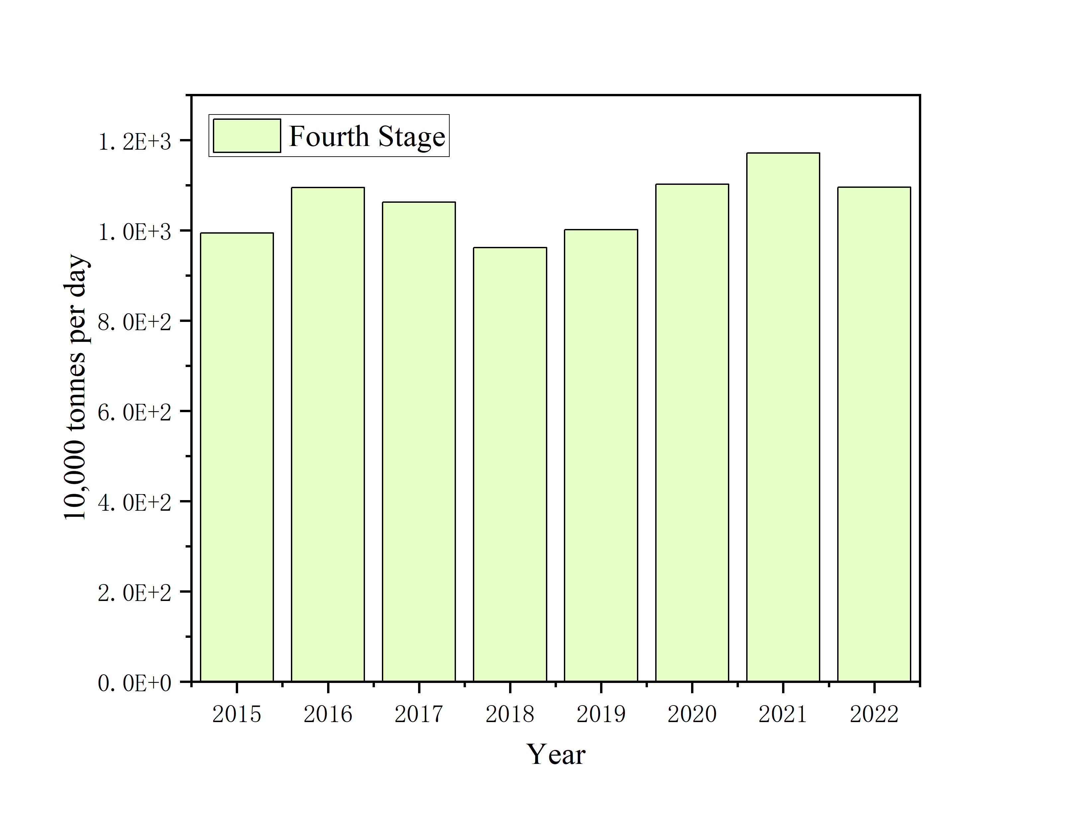
Fig. S1. Bar Chart of Unit Time Output in the Product Stage of China’s Vanadium Industry Material-Product (M-P) Chain

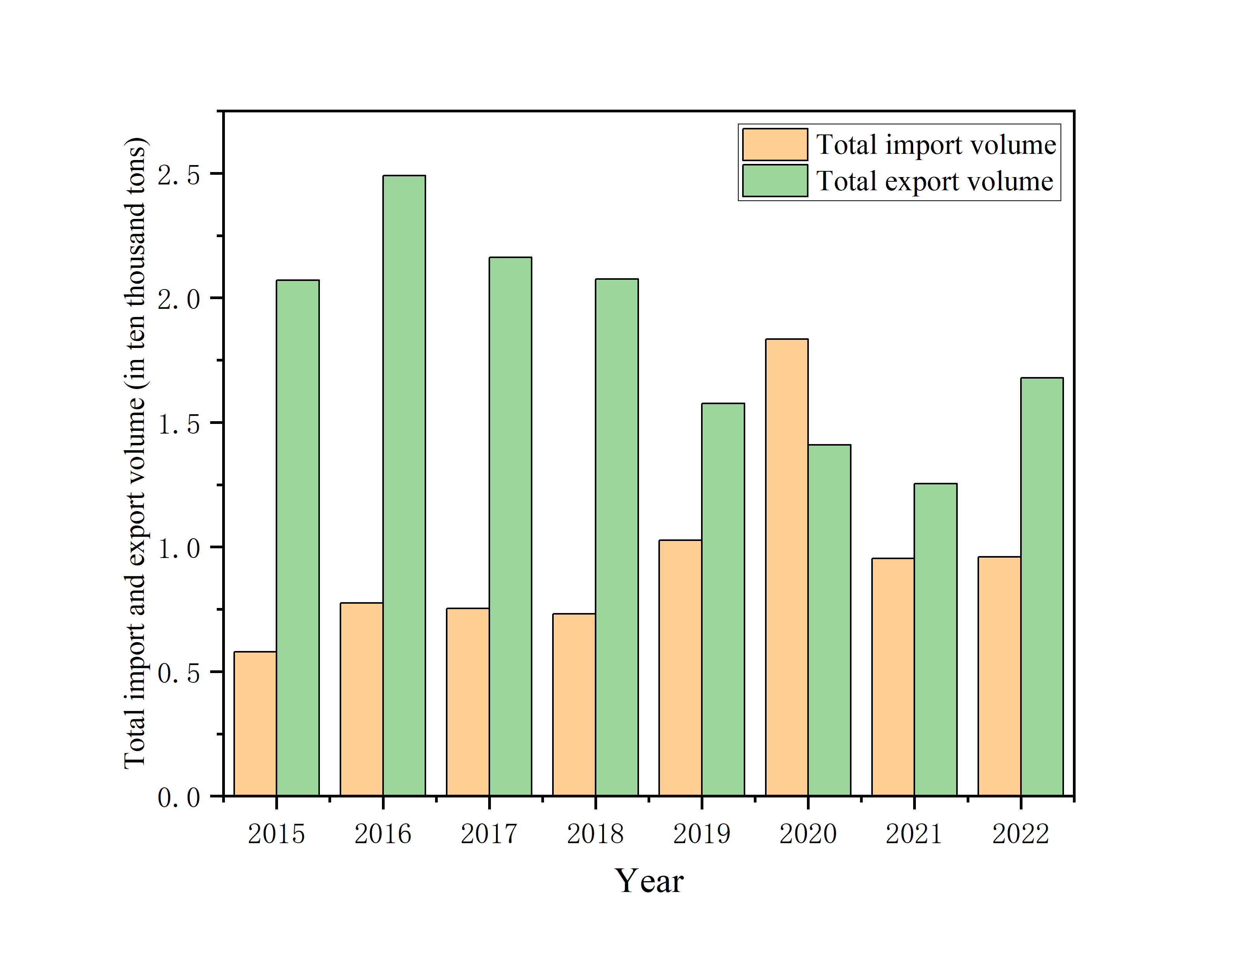
Fig. S2. Import and Export Volumes of Products in the Material-Product (M-P) Chain of China’s Vanadium Industry

Fig. S3. Import and Export Volumes at Each Stage of the Material-Product (M-P) Chain in China’s Vanadium Industry
It is noteworthy that the import volume in the first stage is significantly higher than the export volume, with the average import volume over the eight years being approximately 90 times that of exports. This suggests a considerable reliance of China’s vanadium industry on foreign upstream raw materials. In the second stage, both import and export volumes have increased significantly, indicating that this stage may be a key link in the vanadium industry’s external connections. The import volume in the third stage is relatively low, but the export volume remains stable, suggesting that more resources may be consumed by external demand. The fourth stage has the highest production volume, but its import and export volumes are relatively low and balanced, with exports slightly higher, indicating that more products from this stage are likely consumed domestically. In the fifth stage, the import volume is extremely low, with exports slightly higher, but overall changes are minimal, suggesting a relatively weak dependence on imports and exports in this stage.

Cost Analysis of Each Production Stage in the China Vanadium Industry’s Material-Product (M-P) Chain

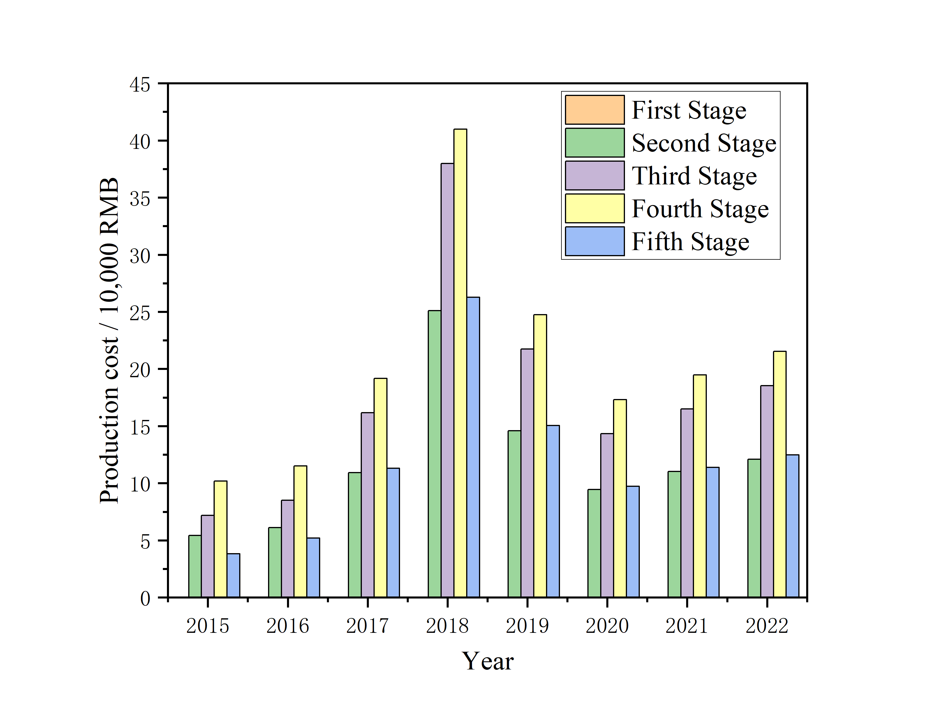
Fig. S4. Cost at Each Production Stage of the Material-Product (M-P) Chain in China’s Vanadium Industry
The first stage has relatively low and stable costs, with a small increase, indicating that production efficiency in this stage is well maintained. The second stage shows significant cost fluctuations but has decreased after 2020, suggesting that production capacity and cost control in this stage are subject to fluctuations, and cost optimization may need to be strengthened. The production cost of the third stage steadily rises, indicating that this stage may face pressures from higher raw material costs or production technology improvements. The cost in the fourth stage peaked in 2018 and gradually decreased afterward. This may indicate that technological innovation and improvements in production efficiency, particularly in vanadium steel production, are key to reducing costs. The production cost in the fifth stage has increased steadily, suggesting that the recovery stage's costs are relatively controllable, possibly due to the maturity of recovery technologies or the stable supply of recycled resources. The cost control in the second and third stages can be improved by optimizing production processes, enhancing raw material utilization, and increasing automation. Particularly during the period of significant cost increase between 2017 and 2018, a reassessment of the return on technological investments may be necessary. The cost reduction in vanadium steel production in the fourth stage can be attributed to production optimization, and further strengthening of technological innovation and equipment upgrades could enhance production efficiency and reduce costs. Although the fifth stage's cost growth remains stable, costs can be further reduced by improving recovery technologies and increasing recovery rates. The cost fluctuations between different stages reflect potential bottlenecks at each stage. It is recommended to conduct a collaborative optimization of the entire M-P chain to ensure that production and resource input at each stage are aligned, thereby achieving overall cost control.

Analysis of Carbon Emission Intensity at Each Production Stage of the Material-Product (M-P) Chain in China’s Vanadium Industry

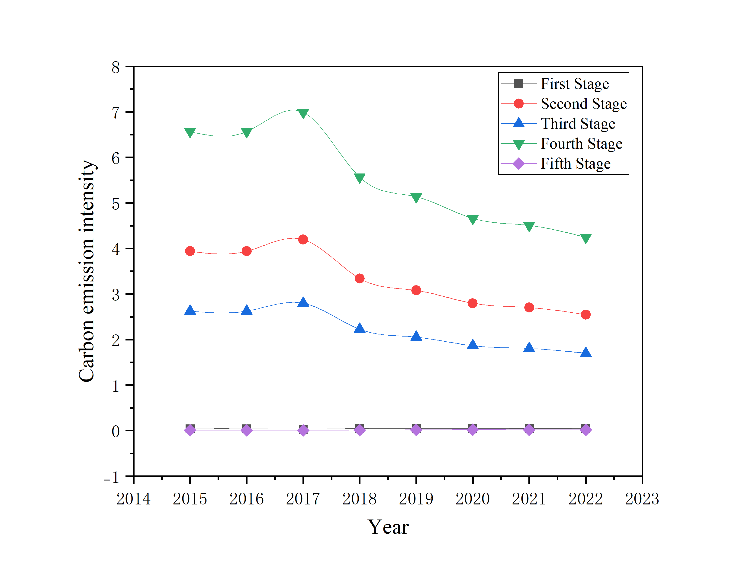
Fig. S5. Carbon Emission Intensity at Each Stage of the Material-Product (M-P) Chain in China’s Vanadium Industry

Analysis of Intra-industry vertical linkages in the China’s Vanadium Industry Materials-Products (M-P) Chain
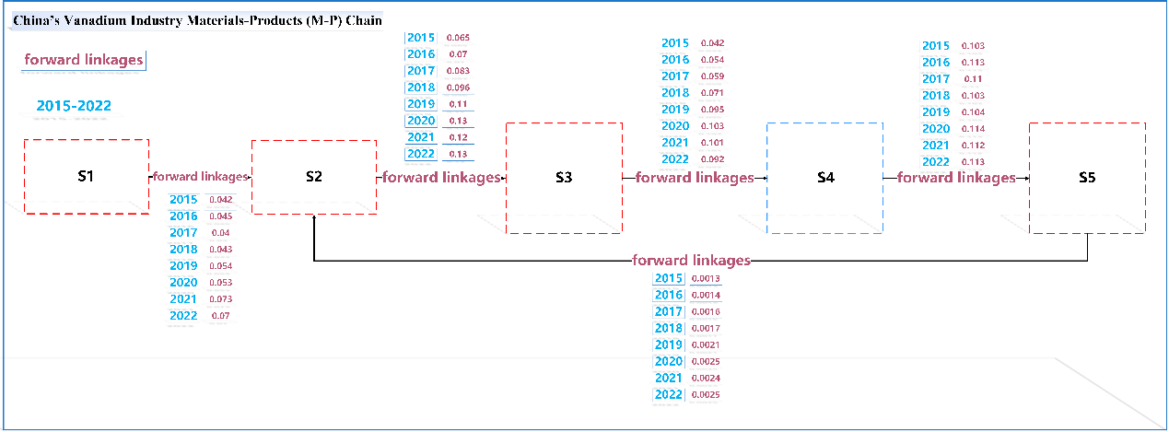
Fig. S6. Intra-industry forward linkages in the material-product (M-P) chain of China’s vanadium industry
The early-stage growth indicates that the chemical separation and purification processes have achieved stage-specific progress in transforming intermediate products into finished products. The later decline may reflect technical bottlenecks, capacity saturation, or the impact of policies related to environmental protection and energy consumption, leading to a slight reduction in conversion efficiency. The linkage from the fourth stage to the fifth stage has remained relatively stable, fluctuating within the range of 0.10-0.11. The stable values suggest that the product manufacturing or deep processing stages have matured, and the conversion rate of downstream products entering the market is stable. The stability in product quality and technical standards is conducive to continuously meeting market demand and application requirements. The linkage from the fifth stage to the second stage (recycling stage) is relatively low, ranging from 0.0013 to 0.0025, but shows a gradual upward trend over the years. Although the absolute values are small, this feedback loop indicates that the performance in the market application stage (such as product quality, application effects, and changes in market demand) is gradually influencing the upstream preprocessing processes. As companies increasingly focus on feedback from downstream markets, there may be future efforts to close the production loop through information feedback, product recycling, and process adjustments, thereby improving overall competitiveness.
Overall, from 2015 to 2022, the driving relationships between the various production stages in China’s vanadium industry show the following characteristics. The upstream (from the first to the second stage) and midstream (from the second to the third stage) both exhibit a significant positive upward trend, reflecting continuous progress in raw material supply and preliminary processing technologies within the vanadium industry. The transformation from the midstream to the downstream (from the third to the fourth stage) achieved breakthroughs but has recently shown a slight decline, indicating that the industry needs to pay attention to the dual impact of technological upgrades and market regulation. The feedback from the downstream (fifth stage driving the second stage) currently has a small impact but shows an upward trend, suggesting that the vanadium industry’s circular application is gradually providing information support for upstream process improvements and is expected to form a more efficient closed-loop management model in the future.
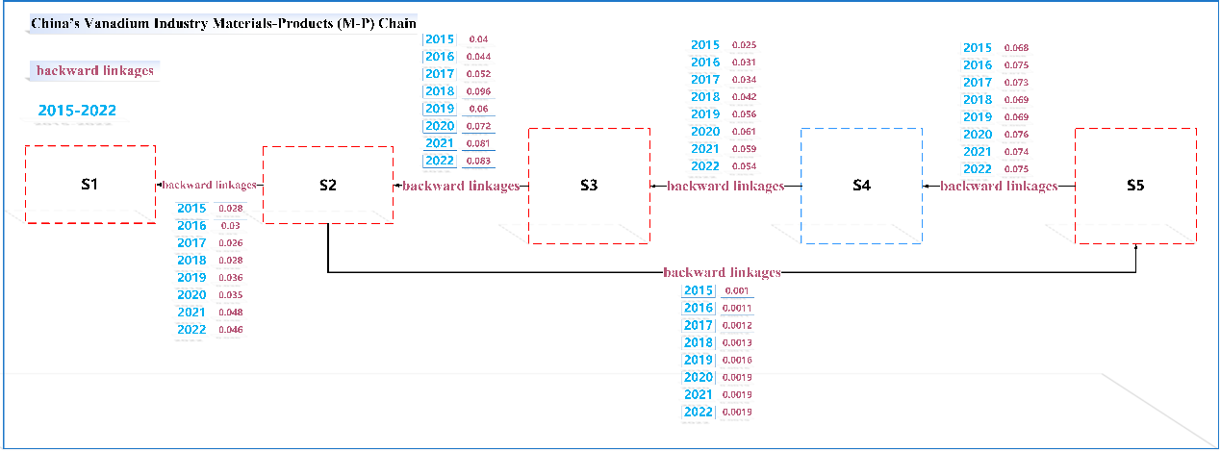
Fig. S7. Intra-industry backward linkages in the material-product (M-P) chain of China’s vanadium industry
The backward linkages demonstrate the driving relationships between the various stages of China's vanadium industry, reflecting the gradual strengthening of the overall feedback mechanism. Notably, the driving effect of the third stage on the second stage has significantly increased, suggesting that process requirements are continuously upgrading. Some links have shown fluctuations (e.g., the feedback from the fourth stage to the third stage declined after 2020), indicating that enterprises need to pay attention to the dual impact of technical bottlenecks and market changes. The market feedback mechanism is stable and is gradually guiding improvements upstream, providing strong data support for closed-loop management and the development of a circular economy within the industry.
Overall, both sets of data show that the positive transmission effect from raw material collection to market application in China's vanadium industry is strong, while the downstream feedback, although present, is relatively weak. This suggests that in the vanadium industry, forward linkages are currently the main driving force of the M-P chain. The steady improvement in forward data reflects the progress made in technology upgrades and production efficiency at each stage. Meanwhile, backward data suggest that the industry should focus on market feedback and changes in downstream applications, aiming to establish a more efficient closed-loop management system.
It is recommended that the vanadium industry and policymakers strengthen the construction of the feedback mechanism while maintaining the advantages of forward momentum. This would enhance information exchange and collaborative innovation between the various stages, thereby driving the vanadium industry toward green, sustainable, and efficient development. From the data perspective, the second and third stages play a central role in the entire industry chain and have a decisive impact on subsequent processes and product quality. The fourth stage (product stage) is crucial for conversion and marketization. Although raw material collection (first stage) and market application (fifth stage) are indispensable, they are relatively less significant in feedback and driving effects at present. Therefore, it is recommended to prioritize and optimize the technologies and management systems of the fourth, second and third stages while continually improving upstream processes through market feedback, gradually enhancing the overall competitiveness of the entire industry chain.

Table S1. Intra-industry forward linkages in the material-product (M-P) chain of China
Year | S1 drives S2 | S2 drives S3 | S3 drives S4 | S4 drives S5 | S5 drives S2
2015 | 0.042 | 0.065 | 0.042 | 0.103 | 0.00133
2016 | 0.045 | 0.070 | 0.054 | 0.113 | 0.00143
2017 | 0.04 | 0.083 | 0.059 | 0.110 | 0.00165
2018 | 0.043 | 0.096 | 0.071 | 0.103 | 0.00178
2019 | 0.054 | 0.116 | 0.095 | 0.104 | 0.00219
2020 | 0.053 | 0.130 | 0.103 | 0.114 | 0.00252
2021 | 0.073 | 0.129 | 0.101 | 0.112 | 0.00249
2022 | 0.07 | 0.133 | 0.092 | 0.113 | 0.00253

Table S2. Intra-industry backward linkages in the material-product (M-P) chain of China
Year | S2 pulls S1 | S3 pulls S2 | S4 pulls S3 | S5 pulls S4 | S2 pulls S5
2015 | 0.028 | 0.040 | 0.025 | 0.068 | 0.00103
2016 | 0.03 | 0.044 | 0.031 | 0.075 | 0.00110
2017 | 0.026 | 0.052 | 0.034 | 0.073 | 0.00127
2018 | 0.028 | 0.060 | 0.042 | 0.069 | 0.00137
2019 | 0.036 | 0.072 | 0.056 | 0.069 | 0.00168
2020 | 0.035 | 0.081 | 0.061 | 0.076 | 0.00194
2021 | 0.048 | 0.081 | 0.059 | 0.074 | 0.001916
2022 | 0.046 | 0.083 | 0.054 | 0.075 | 0.001953
The output, cost, and carbon emissions of the first stage (vanadium mining) show a consistent upward trend from 2015 to 2022. The output of the first stage remains relatively low, contributing limited value to the entire industry chain. Import volumes significantly exceed export volumes, indicating a weaker responsiveness to external demand. The unit production cost is the lowest, with an average of 0.019 million RMB. The carbon emissions stand at 18,200 tons, which is relatively low, and the carbon emission intensity has an average of 0.04. The first stage mainly represents the initial resource input stage, where vertical linkages play a crucial role. A key issue is trade balance, as it directly impacts the safety and stability of China’s vanadium industry. Its contribution to the overall industry chain’s value addition and internationalization is relatively weak, ranking as the fourth priority.
The output of the second stage has grown rapidly (13.34 ten thousand tons in 2022), although it is still lower than that of the fourth stage, its upward trend and potential are significant. Both import and export volumes are large, demonstrating strong resource integration and international trade capabilities. The cost reaches 12.46 million RMB/ton, ranking third. Carbon emissions stand at 4.37 ten thousand tons, with a carbon emission intensity of 3.31, ranking second, just behind the fourth stage. Additionally, the second stage is influenced by two types of vertical linkages: one from the first stage and the other from the fifth stage. The second stage is the core link for imports and exports, achieving a good balance between economic performance and carbon emissions. The most urgent issue here is carbon emission intensity, which, second only to the fourth stage, becomes a key focus for the low-carbon development of the entire industry. Based on these factors, the second stage ranks second in priority, just behind the fourth stage.
The output trends and carbon emissions trends for vanadium nitride and vanadium ferroalloy in the third stage are generally consistent and stable, though their economic values fluctuate significantly. The output of the third stage is moderate (9.2 ten thousand tons in 2022), with a unit time output of 0.1 ten thousand tons per day, serving as the transition stage for the entire industry chain. Import and export volumes are smaller than those in the second stage, indicating a weaker role in the international market compared to the second stage, but it still has some influence. The production cost is approximately 17.34 million RMB/ton, with a stable growth rate but an overall moderate performance. Carbon emissions are 3.27 ten thousand tons, with a carbon emission intensity of 2.21, ranking better than the other stages, and the vertical linkages in the third stage are particularly notable. The most pressing issue in the third stage is production cost, which ranks second only to the fourth stage, making it a key area for cost reduction in the entire industry. This stage primarily serves as the transition stage for resource integration, with slightly lower influence than the second and fourth stages, but a clear positive impact. Thus, the third stage ranks third in priority.
The fourth stage is the product stage, with extremely high output (113,947 tons in 2022), and a unit time output of 1,060 tons per day, making it the core production stage of the entire industry. Although the import and export volumes are moderate, the balance between them is relatively good, ensuring the stability of both domestic production and international trade. The production cost reaches approximately 20.34 million RMB/ton, ranking first among all stages. This stage plays a key role in the vertical linkages, achieving transformation and commercialization. The carbon emission intensity is 5.53, and the most urgent issue in the fourth stage is carbon emissions, which are significantly higher than in the other stages, making it the top priority for the entire industry’s low-carbon development. The fourth stage is the primary contributor to the output in the vanadium industry’s M-P chain and plays a decisive role in adding value and maintaining balance in imports and exports. Its influence on the overall competitiveness of the industry is the strongest, making it the highest priority.
The output in the fifth stage is relatively low, but it relies on higher value-added products, resulting in better economic benefits compared to other stages. The import volume is 0.004 ten thousand tons, and the export volume is 0.012 ten thousand tons, meaning that its direct impact on the overall industry is limited, but its export growth potential is still noteworthy. The production cost is about 11.55 million RMB/ton, and carbon emissions are 0.04 ten thousand tons, the lowest absolute value, aligning with the industry’s low-carbon development goals. Moreover, the vertical linkages in the fifth stage are less pronounced, with the most pressing issue being the unit time output, which lags significantly behind other stages. This makes it part of the industry’s efforts to improve efficiency. The fifth stage is the recycling stage, which, due to technical limitations and other factors, has a limited contribution to output and imports/exports, positioning it as the fifth priority.

Stage-Specific Response Analysis to Unit-Time Production Shocks
Based on the stage-wise Material-Product (M-P) chain framework and the stage-level shock-response analysis of unit-time production, the results indicate pronounced stage heterogeneity and vertical transmission characteristics in China’s vanadium production process.
First, from a production-efficiency perspective, substantial differences exist in unit-time production levels across stages. In the first stage, unit-time production remains relatively high despite resource acquisition constraints, although production pace is heavily dependent on imports. The second stage exhibits a medium level of unit-time production, but due to its pivotal position within the M-P chain, changes in production pace exert a significant amplifying effect on both upstream and downstream stages. The third stage has relatively low unit-time production and is highly sensitive to efficiency shocks. The fourth stage achieves the highest unit-time production, reflecting pronounced scale and continuous production characteristics. Finally, the fifth stage shows generally low unit-time production and a relatively delayed response to changes in preceding stages, as detailed in Table S3.
Table S3. Stage-specific system responses in the material-product (M-P) chain of China
Stage | $$R^{AP}$$ | $$R^{MP}$$ | $$R^{EF}$$
S1 | 0.006 | 0.048 | 0.055
S2 | 0.0072 | 0.062 | 0.073
S3 | 0.0118 | 0.85 | 0.068
S4 | 0.0091 | 0.071 | 0.88
S5 | 0.0054 | 0.039 | 0.044
Second, the stage-level shock-response results reveal that unit-time production shocks exhibit pronounced cumulative effects along the production chain. Adjustments in production pace at upstream stages not only affect adjacent stages but also propagate downstream through the vertical linkage structure, with the second and fourth stages making particularly notable contributions to the overall system response. This indicates that changes in production efficiency are not confined to individual stages but generate systemic effects through the Material-Product chain structure.
Third, the responses of cost and carbon emission intensity demonstrate that production-pace adjustments exert asymmetric impacts on economic and environmental performance. Increases in unit-time production are accompanied by reductions in unit costs in some stages, yet they may lead to higher carbon emission intensity in energy-intensive stages, most prominently in the fourth stage. The third stage exhibits characteristics of “constrained efficiency improvement and rapidly rising costs,” making it a critical bottleneck for overall economic sustainability. Overall, these results suggest that the high-cost and high-emission features of China’s vanadium production process stem not only from intrinsic stage properties but also from the inter-stage linkage of production pace and the amplification of shocks.

