Supporting Information
Huajian Yu ª, Liuchun Zheng ^{a, b,} *, Tao Zhang ª, Jingjing Ren ª, Peipei Meng ^{c}
ª School of Environment, South China Normal University, Guangzhou Higher Education Mega Center, Guangzhou, 510006, PR China
^{b} Guangdong Provincial Key Laboratory of Chemical Pollution and Environmental Safety & MOE Key Laboratory of Theoretical Chemistry of Environment, South China Normal University, Guangzhou 510006, PR China
^{c} College of Environment, Jinan University, Guangzhou, 510632, PR China
*Corresponding Author
* Phone: +86 20 39310250; Fax: +86 20 39380187; E-mail address: lczhengscnu1@163.com (L.C.Z.)

19 pages, including 10 figures and 6 tables
Fig. S1. SEM images (left), EDS images (right) and elemental mappings of (a) RCS, (b) TNOCS, (c) TNOCS + Cd, (d) TNOCS + Cd-CA, and (e) TNOCS + Cd-PA. Furthermore, the SEM image with 50.00 k magnification and the particle size distribution of the red frame are also shown in (b).
Fig. S2. AFM images of TNOCS (a) and RCS (b).
Fig. S3. BET analysis result about TNOCS and RCS.
Fig. S4. FTIR spectra (a) and XRD spectra (b) of RCS, TNOCS and adsorbed TNOCS; zeta potential results for TNOCS and RCS (c).
Fig. S5. XPS C1s spectra of RCS (a), TNOCS (b), TNOCS + Cd (c), TNOCS + Cd-CA (d) and TNOCS + Cd-PA (e) and O1s spectra of RCS (f), TNOCS (g), TNOCS + Cd (h), TNOCS + Cd-CA (i) and TNOCS + Cd-PA (J).
Fig. S6. The adsorption capacity of Cd and [Cd-CA] in pH from 2 to 8.
Fig. S7. Species evolution of (a) CA, (b) Cd-CA, (c) PA, (d) Cd-PA as a function of pH.
Fig. S8. The adsorption capacity of different adsorbents for Cd.
Fig. S9. The adsorption binding energy of (a) [Cd-CA] complex, (b) [Cd-PA] complex, (c) TNOCS + Cd, (d) TNOCS + Cd-CA and (e) TNOCS + Cd-PA.
Fig. S10. The Mulliken atomic charge distributions of (a) [Cd-CA] and [Cd-PA] complexes, (b) TNOCS + Cd, (c) TNOCS + Cd-PA and (d) TNOCS + Cd-CA.

Table S1. Compositions and concentrations of synthetic seawater.
Table S2. The XPS elemental analysis and peaks composition analysis of the materials.
Table S3. Species content of CA solution with different molar ratio at pH 7.
Table S4. Isotherm fitting parameters of selected non-linear isotherms.
Table S5. The comparison to state of the art technologies for the removal of heavy metal in complex waters
Table S6. HOMO and LUMO orbital energy values of the TNOCS and contaminants and their energy gaps (Eg₁ and Eg₂).

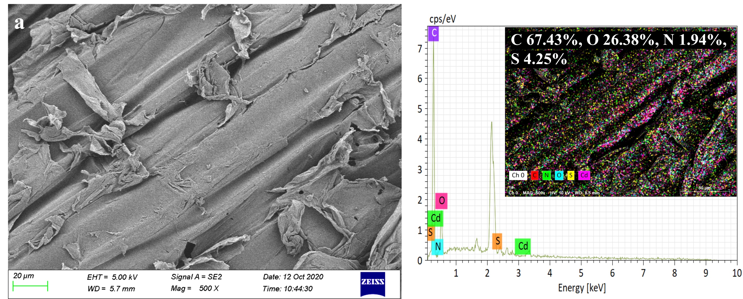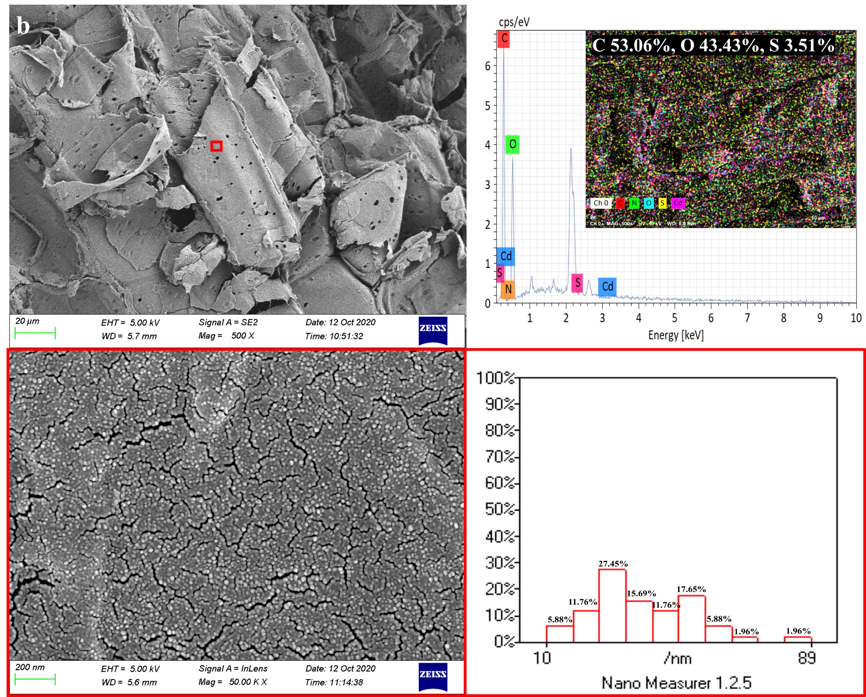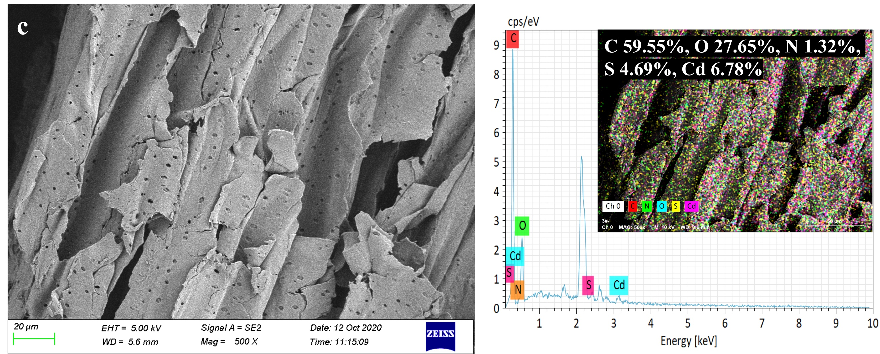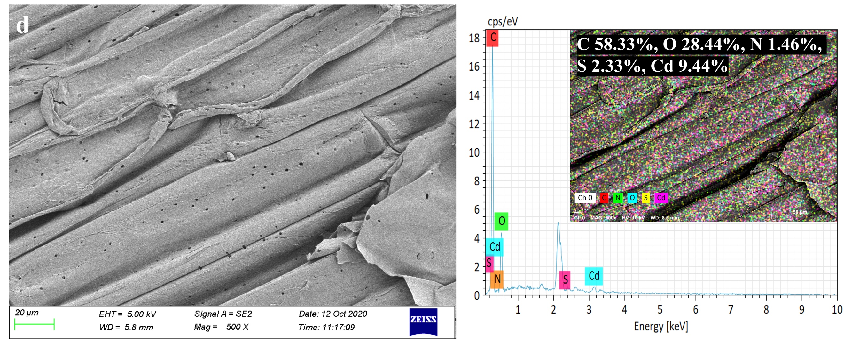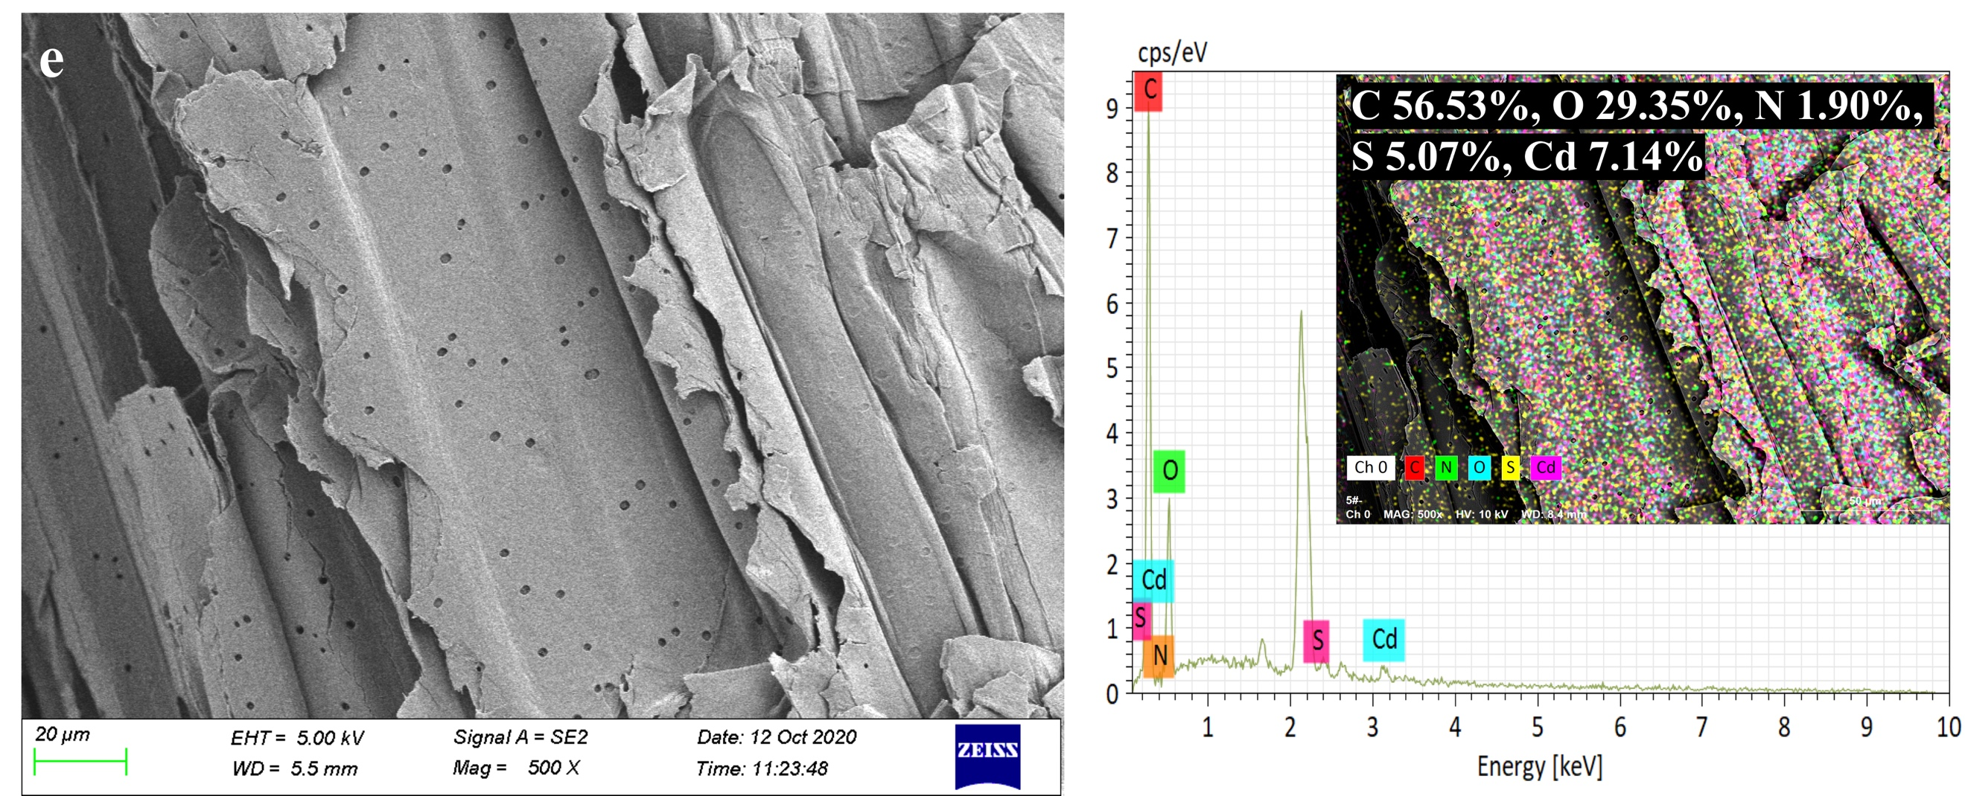
Fig. S1. SEM images (left), EDS images (right) and elemental mappings of (a) RCS, (b) TNOCS, (c) TNOCS + Cd, (d) TNOCS + Cd-CA, and (e) TNOCS + Cd-PA. Furthermore, the SEM image with 50.00 k magnification and the particle size distribution of the red frame are also shown in (b).

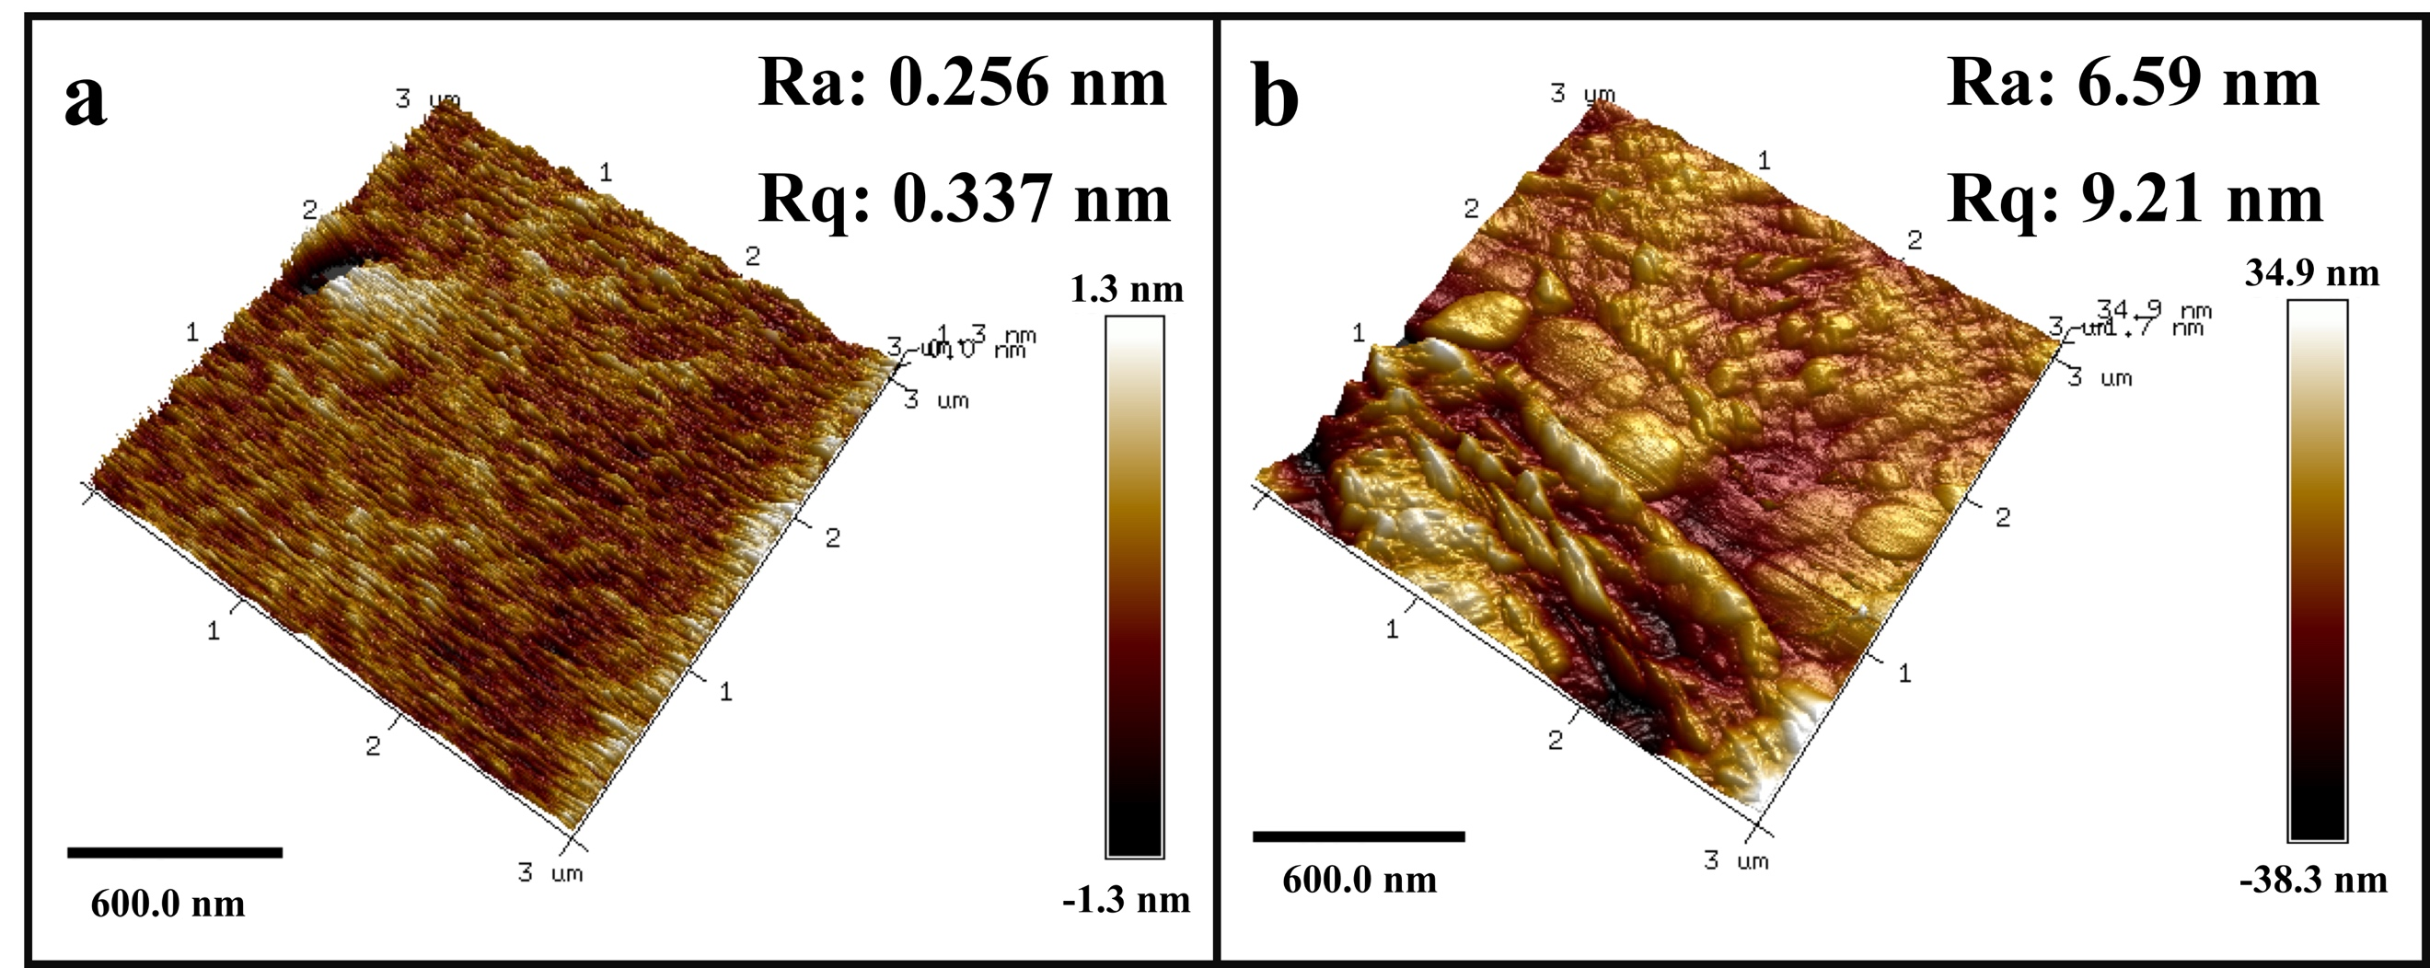

Fig. S2. AFM images of TNOCS (a) and RCS (b).

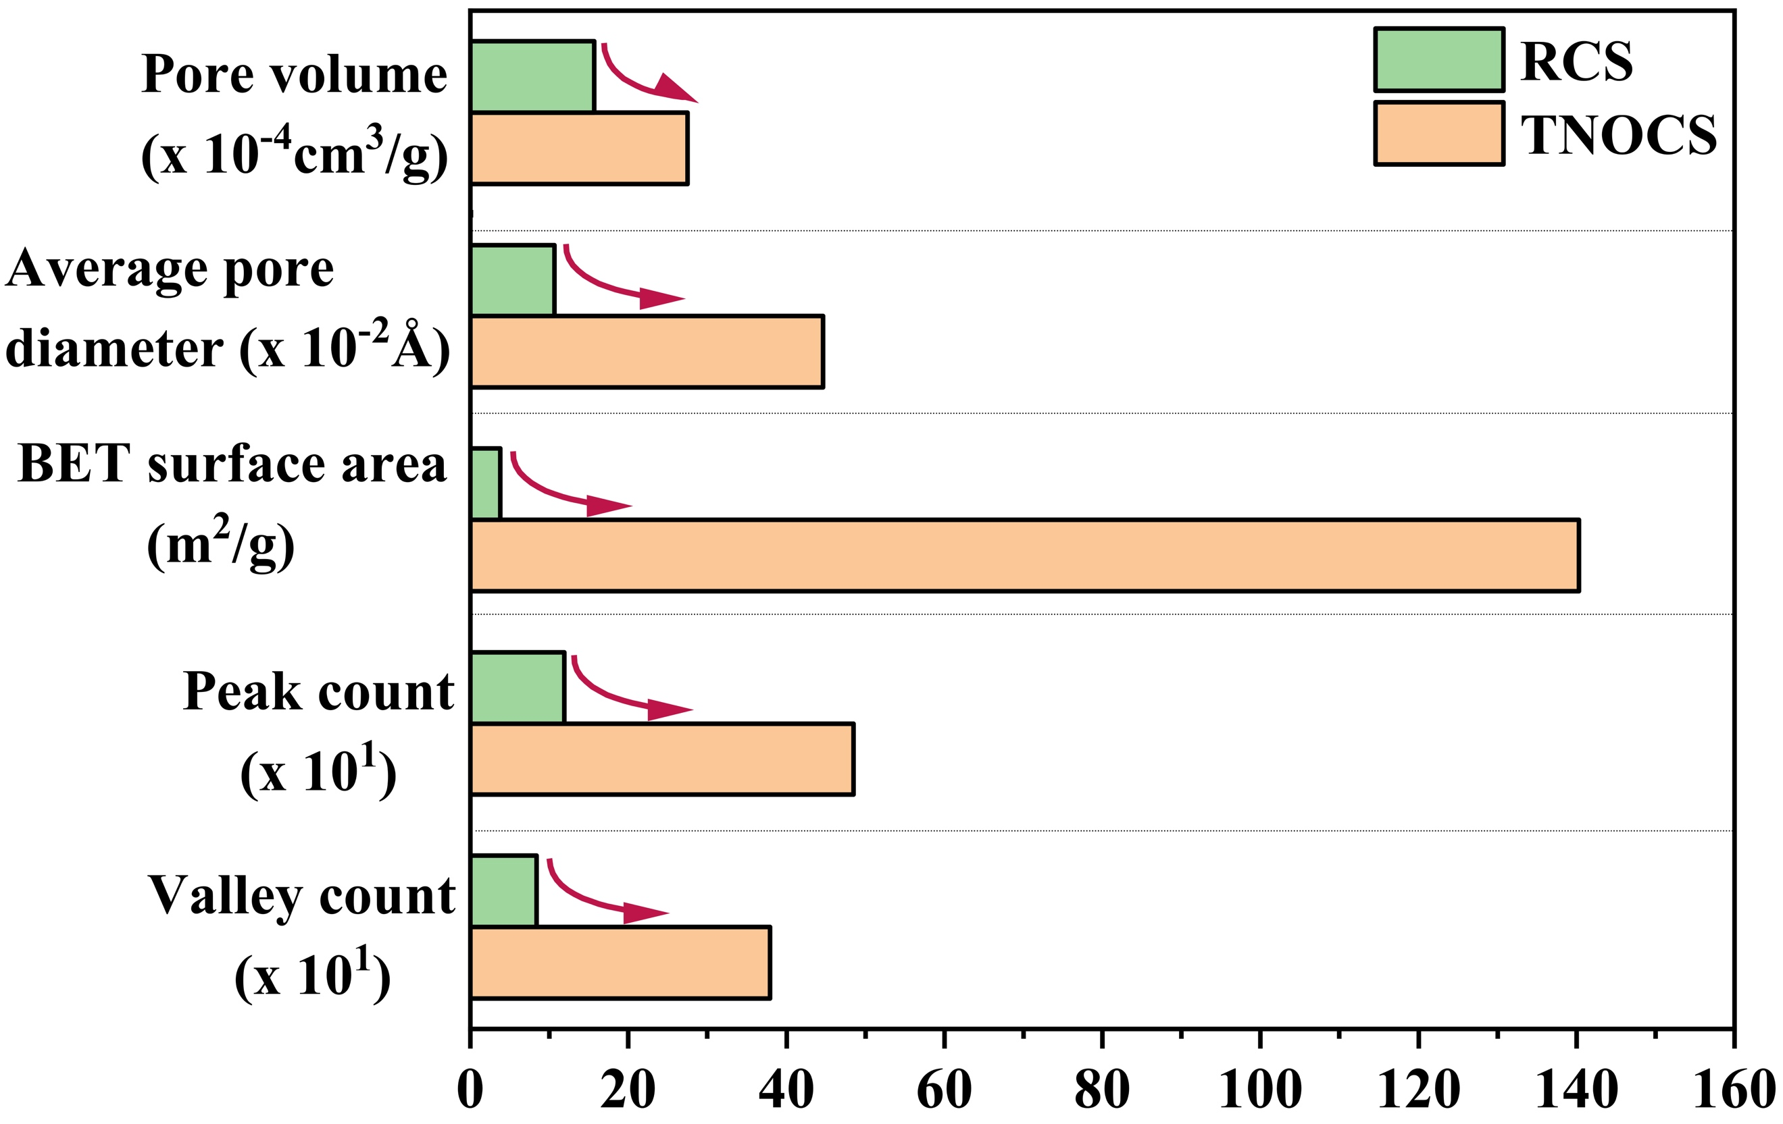
Fig. S3. BET analysis result about TNOCS and RCS.

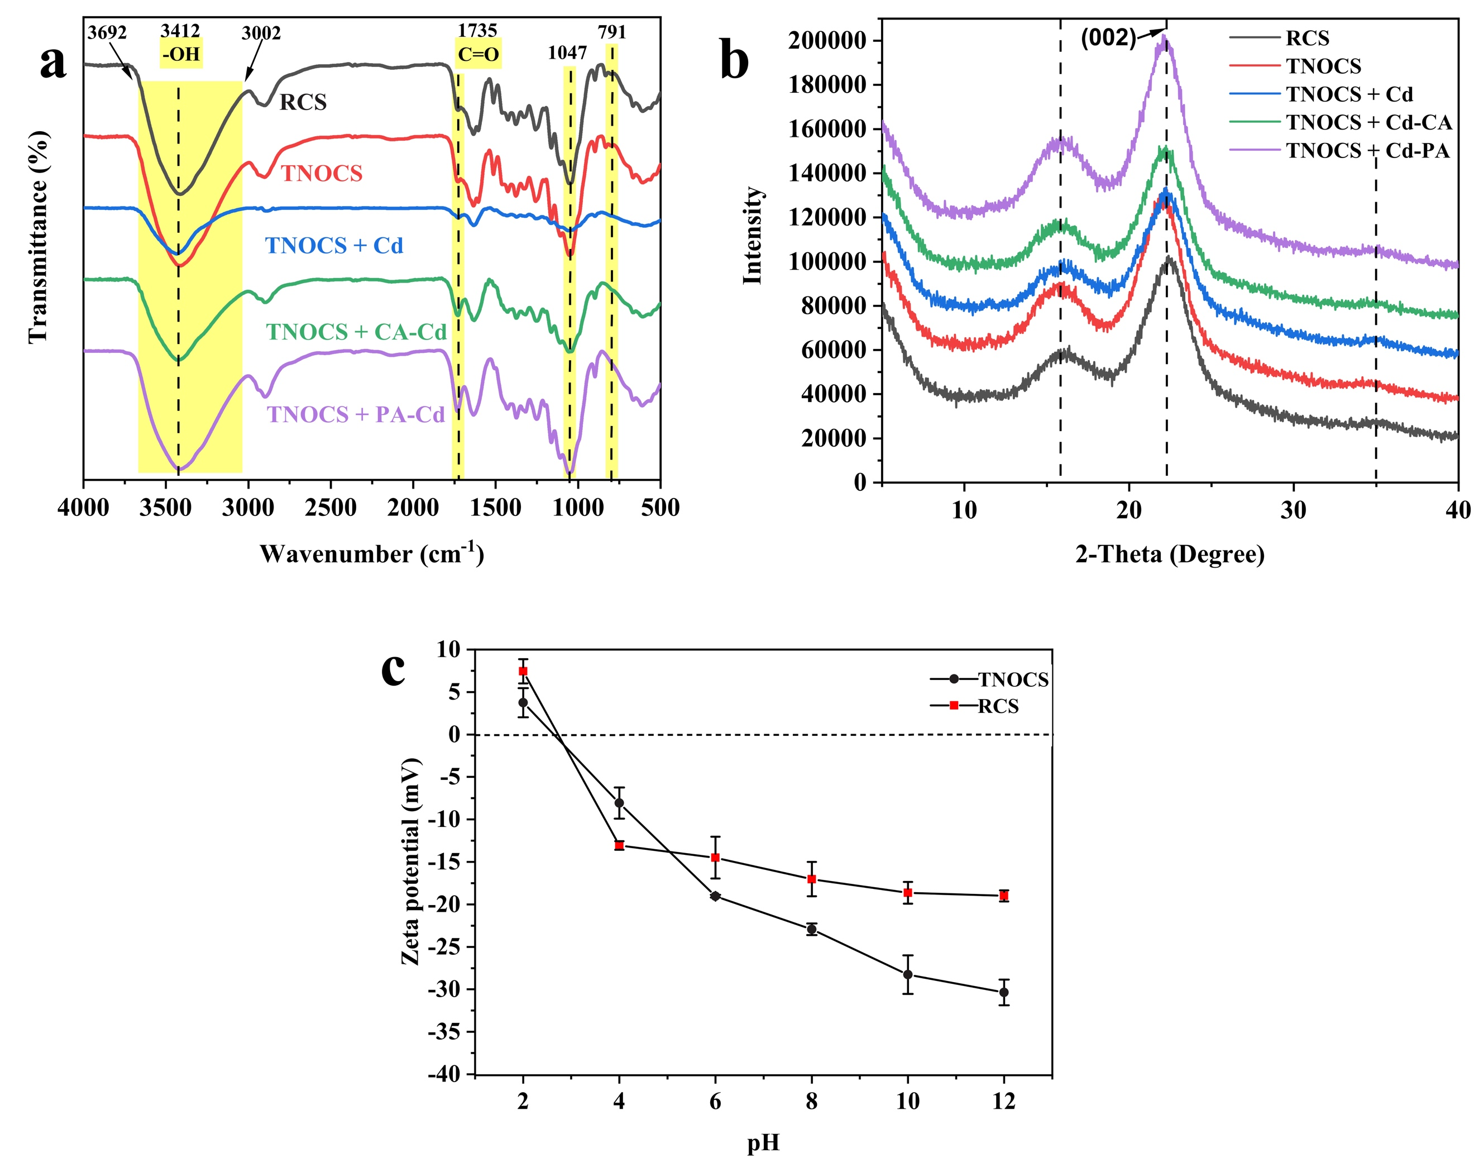

Fig. S4. FTIR spectra (a) and XRD spectra (b) of RCS, TNOCS and adsorbed TNOCS; zeta potential results for TNOCS and RCS (c).

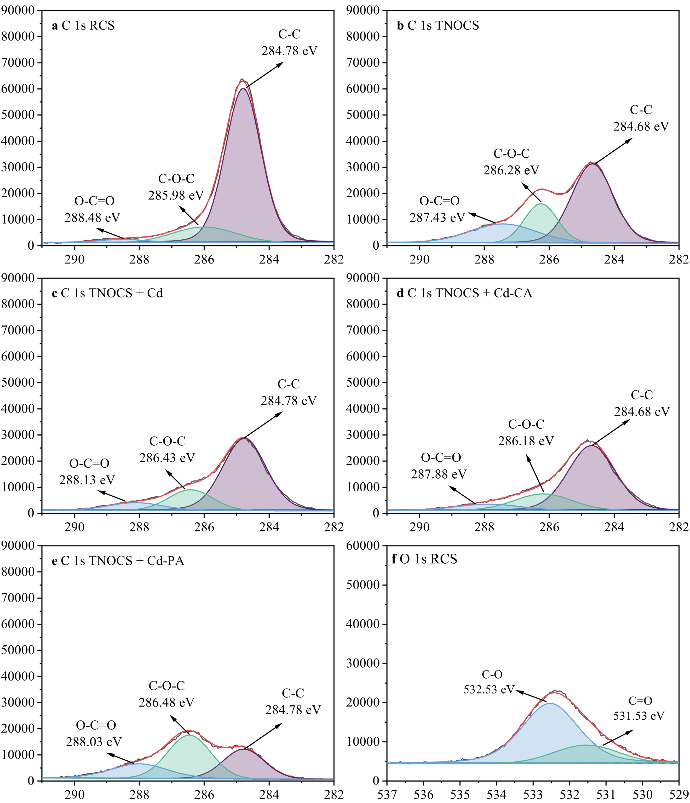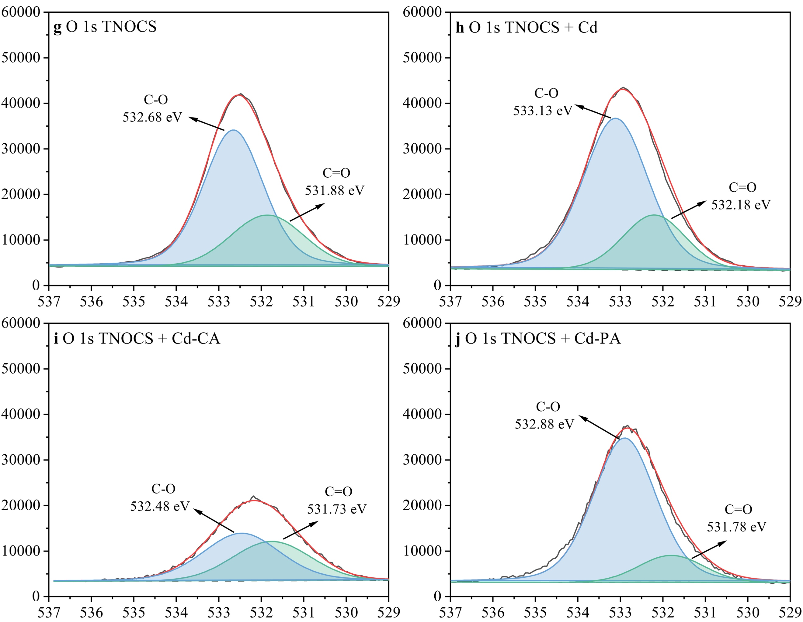

Fig. S5. XPS C1s spectra of RCS (a), TNOCS (b), TNOCS + Cd (c), TNOCS + Cd-CA (d) and TNOCS + Cd-PA (e) and O1s spectra of RCS (f), TNOCS (g), TNOCS + Cd (h), TNOCS + Cd-CA (i) and TNOCS + Cd-PA (J).

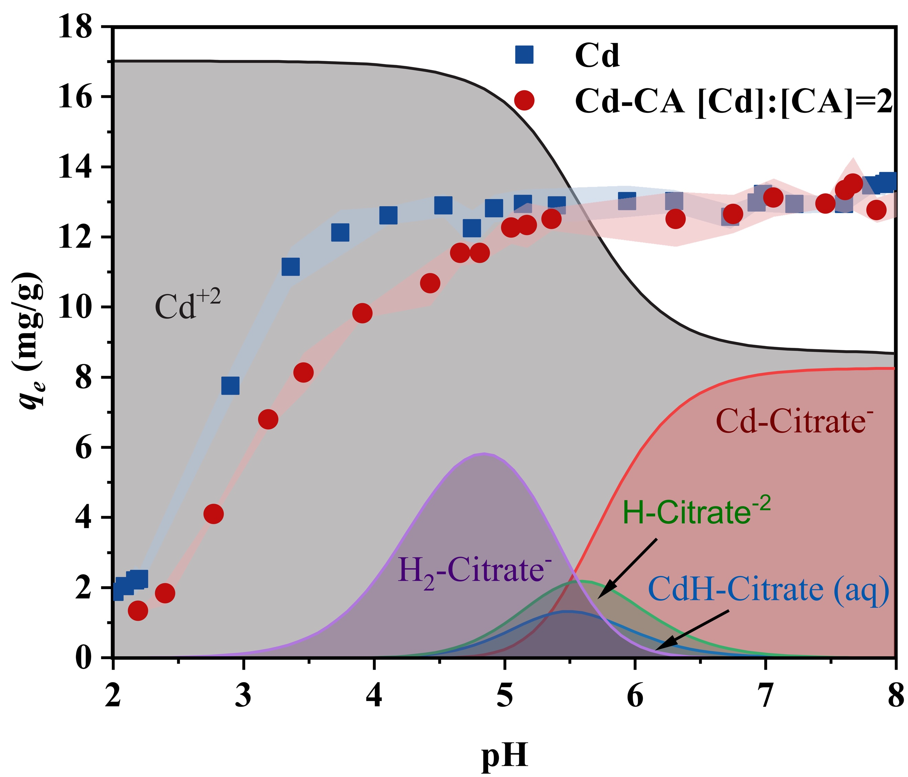

Fig. S6. The adsorption capacity of Cd and [Cd-CA] in pH from 2 to 8.

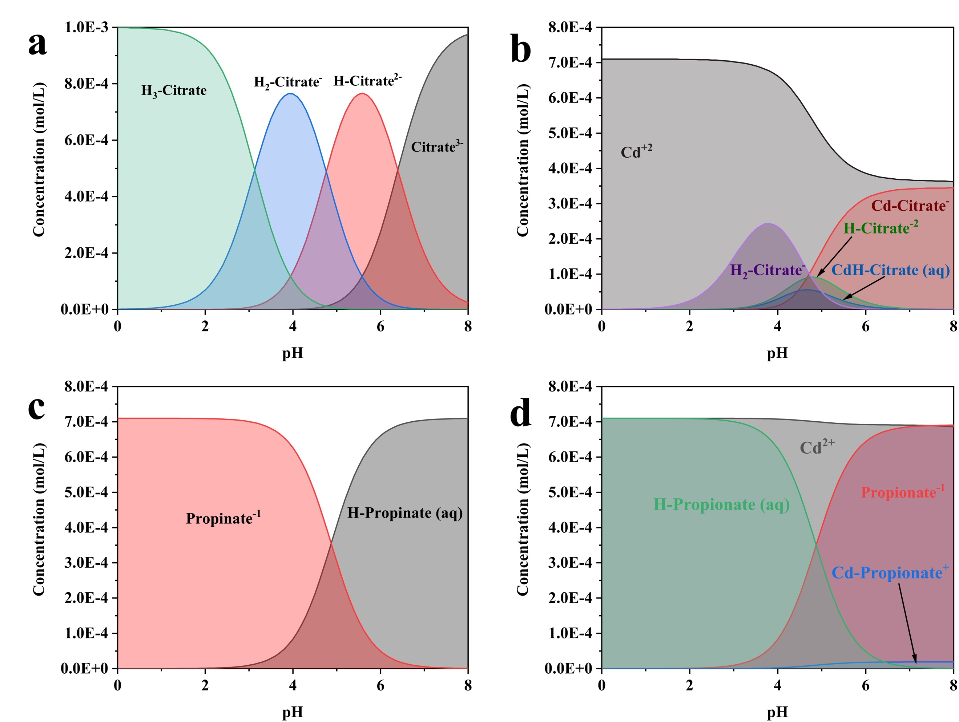

Fig. S7. Species evolution of (a) CA, (b) Cd-CA, (c) PA, (d) Cd-PA as a function of pH.

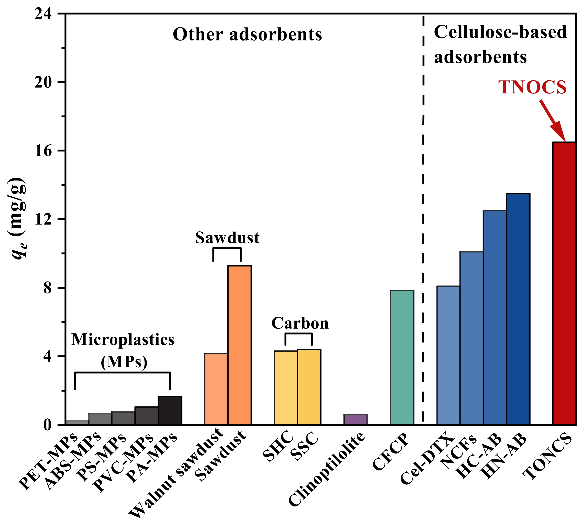

Fig. S8. The adsorption capacity of different adsorbents for Cd.

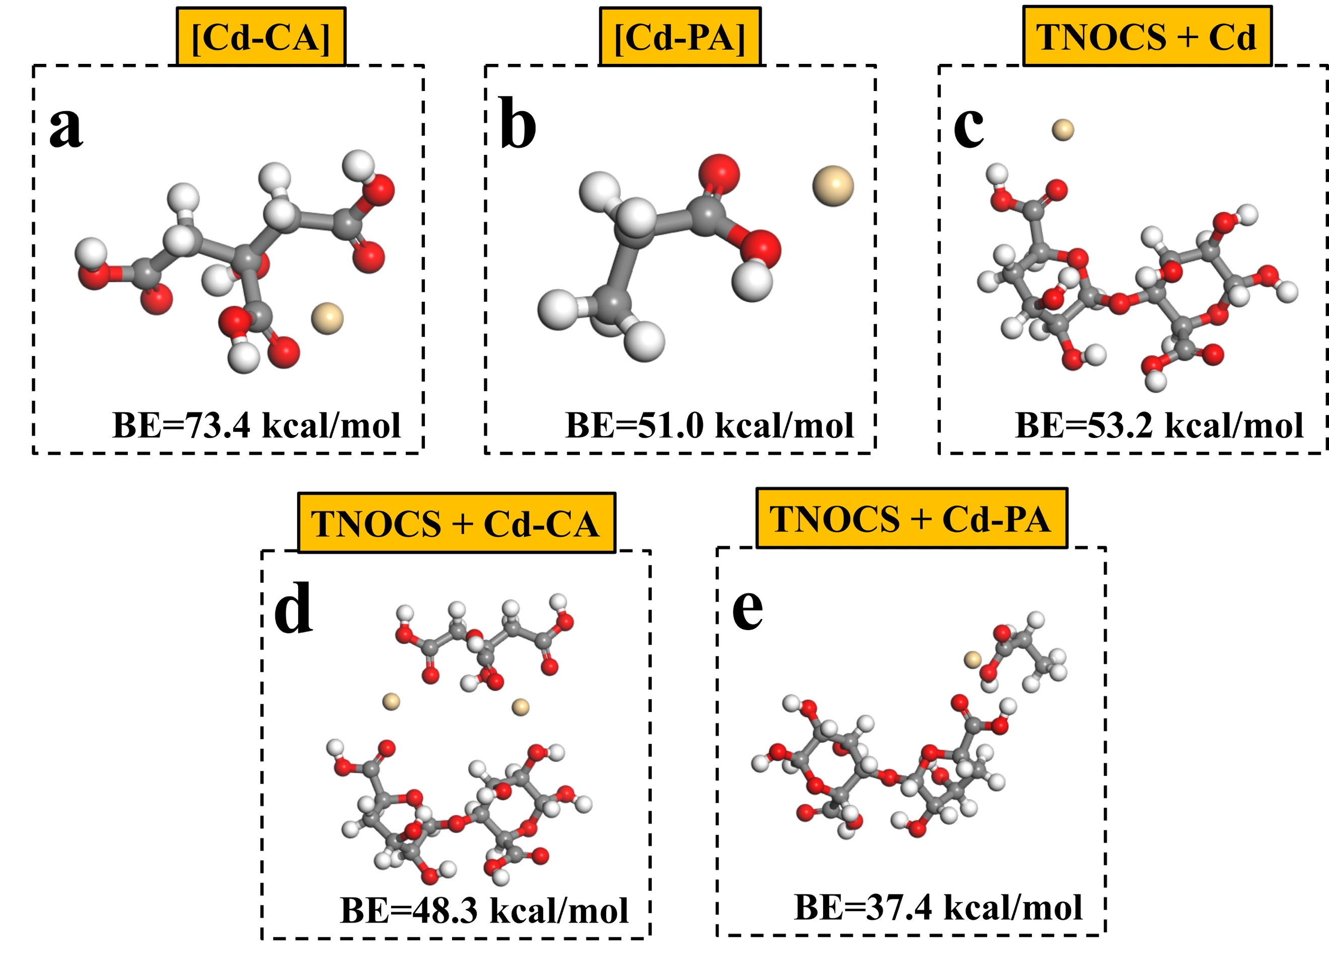

Fig. S9. The adsorption binding energy of (a) [Cd-CA] complex, (b) [Cd-PA] complex, (c) TNOCS + Cd, (d) TNOCS + Cd-CA and (e) TNOCS + Cd-PA.

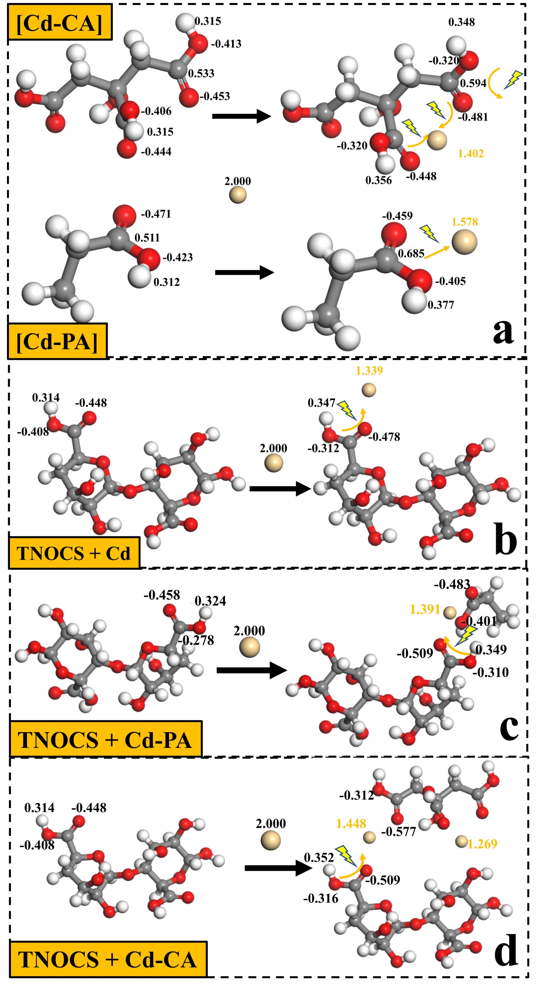

Fig. S10. The Mulliken atomic charge distributions of (a) [Cd-CA] and [Cd-PA] complexes, (b) TNOCS + Cd, (c) TNOCS + Cd-PA and (d) TNOCS + Cd-CA.

Table S1. Compositions and concentrations of synthetic saewater¹
Salt | Concentration(g/Kg) | Concentration(mM)
NaCl | 23.926 | 409.392
Na₂SO₄ | 4.008 | 28.217
KCl | 0.677 | 9.081
KBr | 0.098 | 0.823
H₃BO₃ | 0.026 | 0.420
NaF  MgCl₂  CaCl₂  NaHCO₃ | 0.003  5.027  1.141  0.196 | 0.071  52.978  10.281  2.333
¹kester, D. R.; Duedall, I. W.; Connors, D. N.; Pytkowicz, R. M. Preparation of artificial Seawater. Limnol. Oceanogr. 1967, 12 (1), 176-179.

Table S2. The XPS elemental analysis and peaks composition analysis of the materials.
Sample | C1s |  |  | O1s
 | C-C (%) | C-O-C (%) | O-C=O (%) | C=O (%) | O-C (%)
RCS | 71.9% | 18.6% | 9.5% | 40.2% | 59.8%
TNOCS | 51.0% | 24.6% | 24.4% | 39.0% | 61.0%
TNOCS + Cd | 59.7% | 23.9% | 16.3% | 34.5% | 65.5%
TNOCS + Cd-CA | 58.5% | 25.0% | 16.5% | 50.0% | 50.0%
TNOCS + Cd-PA | 32.0% | 43.0% | 25.0% | 29.1% | 70.9%

Table S3. Species content of CA solution with different molar ratio at pH 7
Species name | m_{CA}:m_{Cd}=1:1 | m_{CA}:m_{Cd}=1:3 | m_{CA}:m_{Cd}=1:2
Citrate⁻³ | 12.472 % | 3.26 % | 4.071 %
Cd-(Citrate)₂⁻⁴ | 0.169 % | 0.017 % | 0.031 %
H-Citrate⁻² | 2.606 % | 0.672 % | 0.849 %
Cd-Citrate⁻ | 84.504 % | 95.781 % | 94.781 %
CdH-Citrate_{(aq)} | 0.235 % | 0.266 % | 0.264 %
H₂-Citrate⁻ | 0.014 % | - | -

Table S4. Isotherm fitting parameters of selected non-linear isotherms.
Sample | Langmuir |  | Freundich
 | Q_{max} | R² | K_{F} | 1/n | R²
Cd | 16.5 | 0.719 | 6.93 | 0.244 | 0.903
Cd-PA | 19.99 | 0.635 | 8.72 | 0.180 | 0.828
Cd-CA (1:2) | 20.34 | 0.866 | 8.22 | 0.189 | 0.981
Cd-CA (1:1) | 18.37 | 0.932 | 7.202 | 0.203 | 0.967
Cd-CA (2:1)  Cd-CA (3:1) | 22.15  14.82 | 0.764  0.584 | 10.02  8.756 | 0.130  1.130 | 0.959  0.863

Table S5. The comparison to state of the art technologies for the removal of heavy metal in complex waters
Technologies | Efficiency (%) | Total cost⁴ | Water recovery efficiency (%) | Advantages^{1,2} | Disadvantages^{1,2}
Reverse osmosis | 20 % - 99 %¹ | 197.4 ± 180.6¹ | 30 % - 60 %¹ | Able to remove smaller contaminants, High removal efficiency | Produce wastewater, Low water recovery efficiency, High cost, Low effluent speed
Nanofiltration | 47 % - 99.9 %¹ | 174 ± 162¹ | 60 % - 70 %¹ | Able to remove smaller contaminants, High removal efficiency
Ion exchange | 50 % - 99.9 %¹ | 105 ± 63¹ | 98 %¹ | High removal efficiency | Complicated operation, Low regeneration capacity, High cost
Adsorption | 30 % - 99.9 %¹ | 84 ± 42¹ | 100 %¹ | Efficient, Convenient, Simple operation, low cost | Low efficiency of pollutant recovery
This Research | 47 % - 99.9 %³ | 45 ± 10 | 100 % | Efficient, Convenient, Simple operation, low cost | Low efficiency of pollutant recovery

¹ Bolisetty, Sreenath, Mohammad Peydayesh, and Raffaele Mezzenga. "Sustainable technologies for water purification from heavy metals: review and analysis." Chemical Society Reviews 48.2 (2019): 463-487.
² Jiménez, S., et al. "State of the art of produced water treatment." Chemosphere 192 (2018): 186-208.

³ C₀= 50 - 200 mg/L

⁴ € per one million liters of treated water

Table S6. HOMO and LUMO orbital energy values of the TNOCS and contaminants and their energy gaps (Eg₁ and Eg₂)
 | HOMO (Ha) | LUMO  (Ha) | Eg₁ (Ha) | Eg₂ (Ha) | Electron donor
TNOCS + Cd | -0.2402 | -0.2230 | -0.0759 | 0.6334 | TNOCS
TNOCS + Cd-CA | -0.2367 | -0.1876 | 0.0383 | 0.2371 | TNOCS
TNOCS + Cd-PA | -0.2332 | -0.1716 | -0.0041 | 0.2811 | TNOCS

