Supplementary Materials

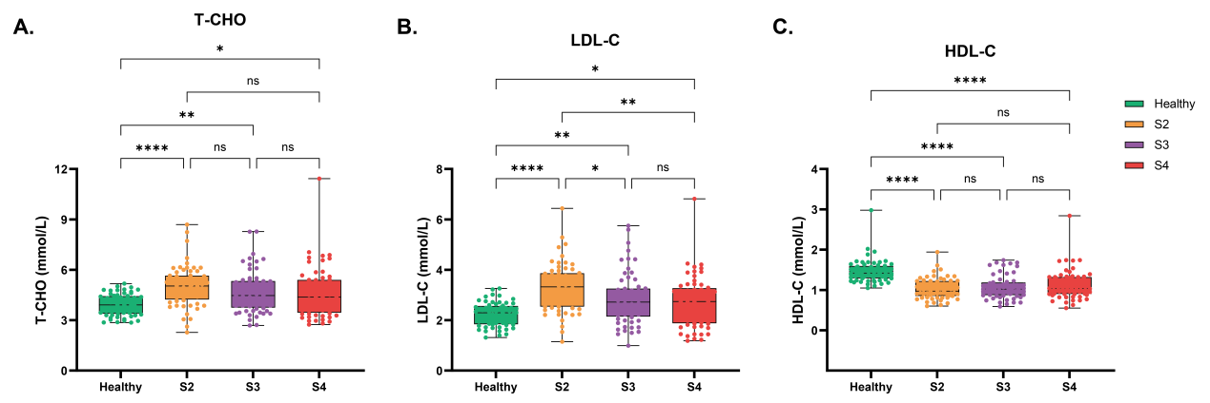
Box-and-whisker plots showing the distribution of T-CHO (A), LDL-C (B), and HDL-C (C) across CKM stages (Healthy, S2, S3, and S4; n = 60 per group). The central line represents the median, boxes indicate the interquartile range (IQR), and whiskers represent the minimum and maximum values. Statistical significance is indicated as p < 0.05 (*), p < 0.01 (**), p < 0.001 (***), and p < 0.0001 (****); ns indicates not significant. All p values are two-sided.
Supplementary Figure 1. Distribution of additional lipid parameters across CKM stages

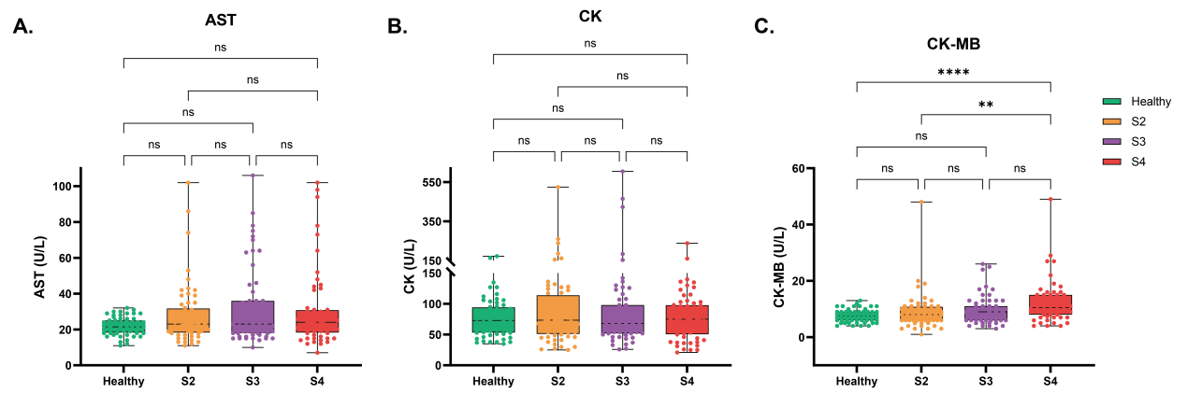
Box-and-whisker plots showing the distribution of AST (A), CK (B), and CK-MB (C) across CKM stages (Healthy, S2, S3, and S4; n = 60 per group). The central line represents the median, boxes indicate the interquartile range (IQR), and whiskers represent the minimum and maximum values. Statistical significance is indicated as p < 0.05 (*), p < 0.01 (**), p < 0.001 (***), and p < 0.0001 (****); ns indicates not significant. All p values are two-sided.
Supplementary Figure 2. Distribution of additional myocardial biomarkers across CKM stages

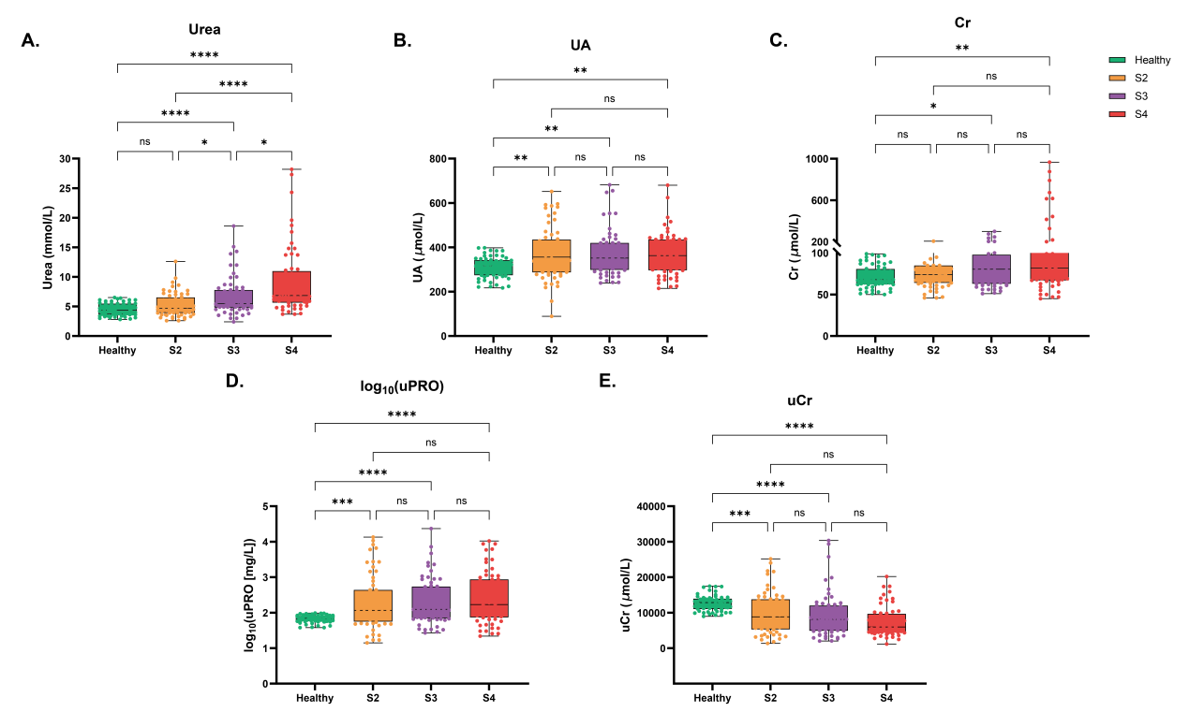
Box-and-whisker plots showing the distribution of serum urea (A), UA (B), serum Cr (C), log₁₀-transformed uPRO (D), and uCr (E) across CKM stages (Healthy, S2, S3, and S4; n = 60 per group). The central line represents the median, boxes indicate the interquartile range (IQR), and whiskers represent the minimum and maximum values. Statistical significance is indicated as p < 0.05 (*), p < 0.01 (**), p < 0.001 (***), and p < 0.0001 (****); ns indicates not significant. All p values are two-sided.
Supplementary Figure 3. Distribution of additional renal biomarkers across CKM stages

Supplementary Table 1. Pairwise Spearman correlation coefficients among inflammatory, metabolic, and cardiorenal biomarkers
Biomar-kers | hs-  CRP | PCT | FPG | HbA1c | TG | Lp(a) | CK-  MB | hs-  cTnT | NT-proBNP | eGFR | uPRO | uCr | mALB
hs-  CRP | 1 | 0.453 | 0.471 | 0.457 | 0.354 | 0.224 | 0.088 | 0.346 | 0.205 | -0.292 | 0.313 | -0.254 | 0.390
PCT | 0.453 | 1 | 0.206 | 0.166 | 0.172 | 0.079 | 0.055 | 0.490 | 0.217 | -0.294 | 0.240 | -0.273 | 0.248
FPG | 0.471 | 0.206 | 1 | 0.847 | 0.385 | 0.068 | 0.043 | 0.360 | 0.042 | -0.110 | -0.006 | -0.438 | 0.125
HbA1c | 0.457 | 0.166 | 0.847 | 1 | 0.352 | 0.125 | 0.040 | 0.291 | 0.038 | -0.102 | 0.049 | -0.462 | 0.141
TG | 0.354 | 0.172 | 0.385 | 0.352 | 1 | 0.102 | 0.034 | 0.181 | -0.011 | -0.114 | 0.237 | -0.272 | 0.321
Lp(a) | 0.224 | 0.079 | 0.068 | 0.125 | 0.102 | 1 | 0.188 | 0.119 | 0.267 | -0.137 | 0.255 | -0.090 | 0.280
CK-  MB | 0.088 | 0.055 | 0.043 | 0.040 | 0.034 | 0.188 | 1 | 0.177 | 0.302 | -0.225 | 0.133 | -0.093 | 0.202
hs-  cTnT | 0.346 | 0.490 | 0.360 | 0.291 | 0.181 | 0.119 | 0.177 | 1 | 0.490 | -0.494 | 0.326 | -0.245 | 0.377
NT-proBNP | 0.205 | 0.217 | 0.042 | 0.038 | -0.011 | 0.267 | 0.302 | 0.490 | 1 | -0.590 | 0.393 | -0.162 | 0.420
eGFR | -0.292 | -0.294 | -0.110 | -0.102 | -0.114 | -0.137 | -0.225 | -0.494 | -0.590 | 1 | -0.357 | 0.235 | -0.395
uPRO | 0.313 | 0.240 | -0.006 | 0.049 | 0.237 | 0.255 | 0.133 | 0.326 | 0.393 | -0.357 | 1 | 0.181 | 0.873
uCr | -0.254 | -0.273 | -0.438 | -0.462 | -0.272 | -0.090 | -0.093 | -0.245 | -0.162 | 0.235 | 0.181 | 1 | 0.052
mALB | 0.390 | 0.248 | 0.125 | 0.141 | 0.321 | 0.280 | 0.202 | 0.377 | 0.420 | -0.395 | 0.873 | 0.052 | 1
Data are presented as Spearman correlation coefficients (ρ) describing pairwise associations among inflammatory, metabolic, and cardiorenal biomarkers. The corresponding p values for each correlation are provided in Supplementary Table 2. All correlations were evaluated using two-sided Spearman rank correlation tests.

Supplementary Table 2. Corresponding p values for pairwise Spearman correlations among inflammatory, metabolic, and cardiorenal biomarkers
Biomar-kers | hs-  CRP | PCT | FPG | HbA1c | TG | Lp(a) | CK-  MB | hs-  cTnT | NT-proBNP | eGFR | uPRO | uCr | mALB
hs-  CRP | - | < 0.001 | < 0.001 | < 0.001 | < 0.001 | < 0.001 | 0.176 | < 0.001 | < 0.01 | < 0.001 | < 0.001 | < 0.001 | < 0.001
PCT | < 0.001 | - | < 0.01 | < 0.05 | < 0.01 | 0.224 | 0.397 | < 0.001 | < 0.001 | < 0.001 | < 0.001 | < 0.001 | < 0.001
FPG | < 0.001 | < 0.01 | - | < 0.001 | < 0.001 | 0.293 | 0.510 | < 0.001 | 0.514 | 0.089 | 0.925 | < 0.001 | 0.054
HbA1c | < 0.001 | < 0.05 | < 0.001 | - | < 0.001 | 0.054 | 0.538 | < 0.001 | 0.562 | 0.114 | 0.446 | < 0.001 | < 0.05
TG | < 0.001 | < 0.01 | < 0.001 | < 0.001 | - | 0.115 | 0.595 | < 0.01 | 0.864 | 0.078 | < 0.001 | < 0.001 | < 0.001
Lp(a) | < 0.001 | 0.224 | 0.293 | 0.054 | 0.115 | - | < 0.01 | 0.066 | < 0.001 | < 0.05 | < 0.001 | 0.164 | < 0.001
CK-  MB | 0.176 | 0.397 | 0.510 | 0.538 | 0.595 | < 0.01 | - | < 0.01 | < 0.001 | < 0.001 | < 0.05 | 0.149 | < 0.01
hs-  cTnT | < 0.001 | < 0.001 | < 0.001 | < 0.001 | < 0.01 | 0.066 | < 0.01 | - | < 0.001 | < 0.001 | < 0.001 | < 0.001 | < 0.001
NT-proBNP | < 0.01 | < 0.001 | 0.514 | 0.562 | 0.864 | < 0.001 | < 0.001 | < 0.001 | - | < 0.001 | < 0.001 | < 0.05 | < 0.001
eGFR | < 0.001 | < 0.001 | 0.089 | 0.114 | 0.078 | < 0.05 | < 0.001 | < 0.001 | < 0.001 | - | < 0.001 | < 0.001 | < 0.001
uPRO | < 0.001 | < 0.001 | 0.925 | 0.446 | < 0.001 | < 0.001 | < 0.05 | < 0.001 | < 0.001 | < 0.001 | - | < 0.01 | < 0.001
uCr | < 0.001 | < 0.001 | < 0.001 | < 0.001 | < 0.001 | 0.164 | 0.149 | < 0.001 | < 0.05 | < 0.001 | < 0.01 | - | 0.423
mALB | < 0.001 | < 0.001 | 0.054 | < 0.05 | < 0.001 | < 0.001 | < 0.01 | < 0.001 | < 0.001 | < 0.001 | < 0.001 | 0.423 | -
Data are presented as p values corresponding to the pairwise Spearman correlation coefficients (ρ) reported in Supplementary Table 1. All correlations were evaluated using two-sided Spearman rank correlation tests. Diagonal elements represent self-correlations and are therefore not applicable (-).

Supplementary Table 3. Multivariable linear regression analysis of factors independently associated with PTX3 levels
Variable | β (SE) | Standardized β | 95% CI | VIF | p value
Age | 0.494 (0.161) | 0.191 | 0.177 to 0.811 | 1.377 | 0.002
Sex | 13.291 (3.695) | 0.194 | 6.011 to 20.571 | 1.034 | < 0.001
BMI | 0.227 (0.578) | 0.022 | -0.912 to 1.365 | 1.154 | 0.695
SBP | 0.198 (0.115) | 0.100 | -0.029 to 0.425 | 1.217 | 0.087
FPG | 3.198 (0.642) | 0.281 | 1.933 to 4.464 | 1.137 | < 0.001
hs-cTnT | 0.073 (0.037) | 0.124 | 0.001 to 0.146 | 1.381 | 0.048
eGFR | -0.203 (0.086) | -0.163 | -0.373 to -0.034 | 1.712 | 0.019
PTX3 was treated as the dependent variable. Age, Sex, BMI, SBP, FPG, hs-cTnT and eGFR were entered simultaneously as independent variables in the multivariable linear regression model. β represents the unstandardized regression coefficient, and SE indicates the standard error. Standardized β represents the standardized regression coefficient. VIF, variance inflation factor. All VIF values were < 5, indicating no evidence of problematic multicollinearity.

