Supplementary Methods
Dissociation of thyroid cancer tissue for scRNA-seq
Thyroid cancer tissues were processed immediately after their removal from the patient. The dissected tissues were washed with DMEM (catalog no. SH30243.01, Hyclone, Rogan, UT, USA), leaving only sufficient medium to cover the tissue. Subsequently, tissues were carefully chopped using scissors. To facilitate further cell dissociation, 2 ml of papain solution (catalog no. NC0435282; Brainbits LLC, Springfield, IL, USA) was added to the thyroid cancer tissue and incubated at 37 °C for 20 minutes. After removing the papain solution without disturbing the tissue, the medium was added to the tissue, and the cell suspension was carefully passed through a 100 μm strainer to remove clumps. The cells were then centrifuged at 1200rpm for 3 minutes, and the RBC were lysed. A dead cell removal kit (catalog no. 130-090-101; Miltenyi Biotec, North Rhine-Westphalia, Germany) was used to eliminate dead cells. Live cells were immediately sent to Theragen Bio (Seoul, South Korea) for library preparation and scRNA-seq analysis.

Identification of gene modules
The Python package Hotspot (version 1.1.1) was used to infer informative genes and gene modules based on graph structures. To create the hotspot object, the raw count matrix and PCA-reduced dimensions were used, applying a negative binomial model. Subsequently, k-nearest neighbor (knn) graphs with a neighborhood size of 30 were constructed. Informative genes were identified by calculating the autocorrelation for each gene in the PCA-reduced dimensions. Gene modules were then generated by determining significant local correlations (FDR < 0.05) between genes within the same neighborhood.
Bulk RNA-seq data analysis of PTC cell line
RNA-seq reads were aligned to the human reference genome (hg38) using Hisat2 (RRID:SCR_015530) [1]. The aligned reads were assembled into transcripts with annotations from GRCh38.p13 using StringTie (RRID:SCR_016323) [2]. The gene expression levels were estimated using the prepDE.py script provided by StringTie. Differential expression analysis was subsequently performed using the count matrix in the R package DESeq2 (version 1.38.3; RRID:SCR_000154) [3].

Analysis of ChIP sequencing data for C/EBPβ
ChIP-Seq data for the C/EBPβ antibody in the K562 cell line (RRID:CVCL_0004), derived from the ENCODE project (ENCSR000EHE), were visualized using the UCSC Genome Browser. The C/EBPβ TF ChIP-Seq fold-change over the control pool (ENCSR000EHE - ENCFF513ZML) was displayed on the reference human genome hg19. Histone modifications marking active regulatory regions (e.g., H3K27ac) in K562 from ENCODE were co-visualized to contextualize candidate promoter/enhancer regions.

Trajectory inference using Partition-based graph abstraction (PAGA)
PAGA reconstructs a trajectory as a graph with estimated connectivity of manifold partitions. Functions for creating a graph, calculating connectivity, and visualization are available in the Python package Scanpy (version 1.9.5). A neighborhood graph was constructed using 30 mutual nearest neighbors (MNNs), and the size of the local neighborhood was set to 30. Edges for weights below 0.08 were not drawn in the graph.

Nuclear fractionation
The nuclear fractionation was conducted using a nuclear extraction kit (catalog no. 40010, Active Motif, Carlsbad, CA, USA).

RNA-sequencing
The RNeasy Mini Kit (catalog no. 74104, Qiagen, Hilden, Germany) was used to isolate total RNA samples.

Xenograft
All animal care procedures and experimental protocols were approved by the Institutional Animal Care and Use Committee Yonsei University Health System (No. 2023-0249), being conducted strictly in line with the appropriate guidelines and regulations. BALB/c nude mice were subjected to subcutaneous injections of 1 × 107 either control or TPC-1 cells with inducible C/EBPβ expression each suspended in matrigel (catalog no. 354234, Corning Life Sciences, Corning, NY, USA) (n = 10). Following a twelve-day period for tumor establishment, we administered doxycycline directly through feed (catalog no. 2018, Harlan-Teklad, Madison, WI, USA) to mice with xenografts to guarantee efficient induction while preventing dehydration. We measured the tumor sizes with a caliper and calculated the volumes based on the formula: length (mm) × width (mm)2/2.

Supplementary Figures
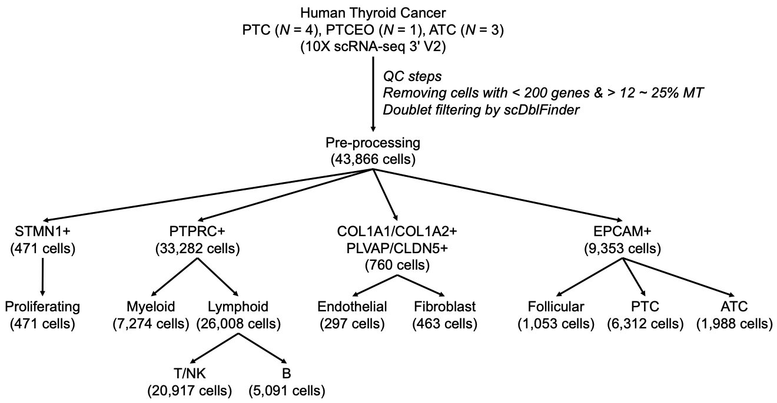
Supplementary Fig. 1 Diagram representing data processing, cell type annotation and subsetting. After quality control, 43,866 single-cell transcriptomes from patients with PTC (n = 4), PTCEO (n = 1), and ATC (n = 3) were obtained. These transcriptomes were sub-phenotyped based on lineage-specific markers.

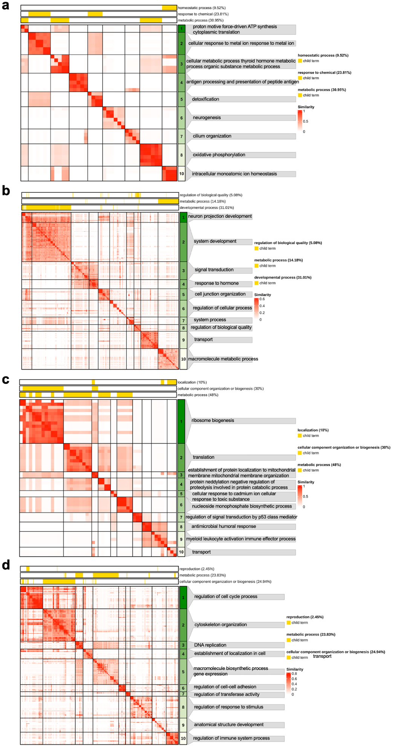
Supplementary Fig. 2 GOBP pathways significantly enriched in each epithelial subpopulation. a-d Heatmaps illustrating the representative GOBP terms enriched in each epithelial subpopulation (a for follicular cells; b for PTC type1; c for PTC type2; d for ATC).

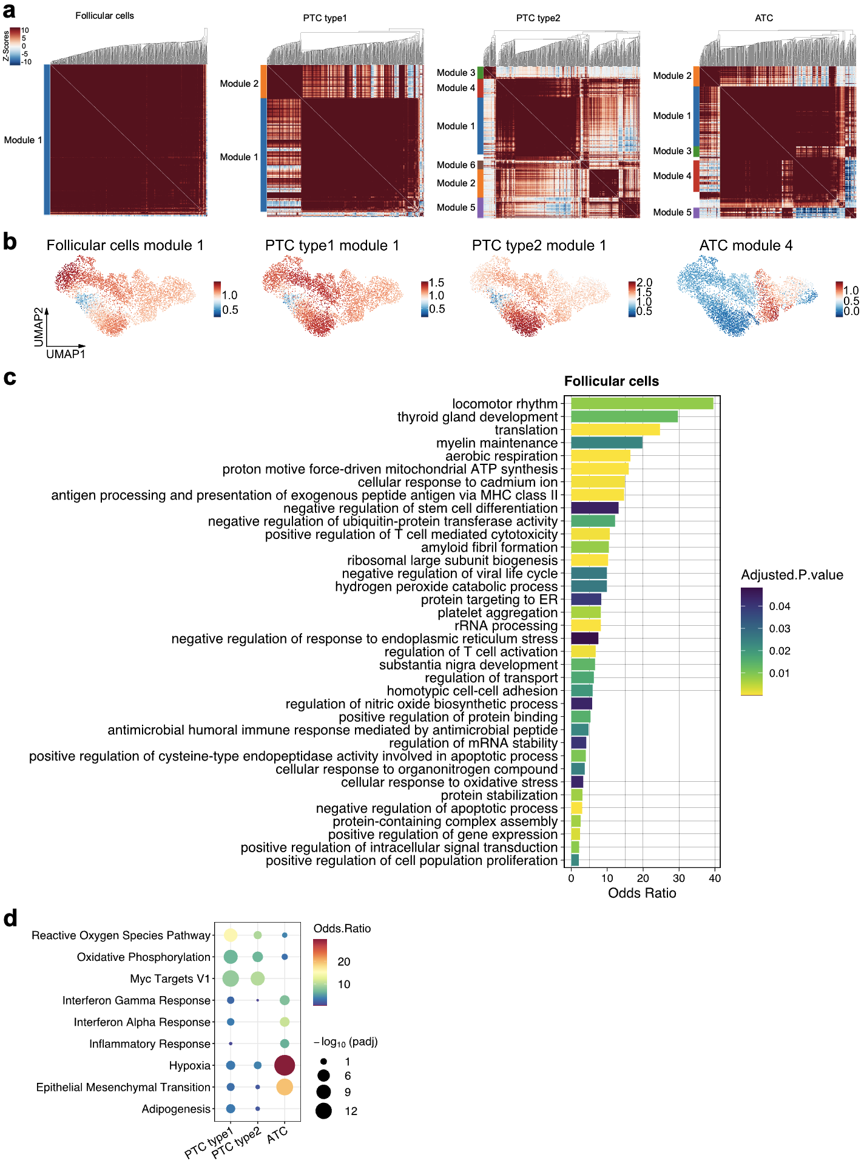
Supplementary Fig. 3 Gene modules activated in each epithelial subpopulation. a Heatmap representing the correlation between gene modules of each epithelial subpopulation. b Feature plot showing the expression levels of gene module in each epithelial subpopulation. c Barplot illustrating the representative GOBP terms significantly enriched in gene module 1 of follicular cells. d Dotplot depicting the hallmark pathways enriched in the highly expressed gene module of each tumor cell subpopulation.
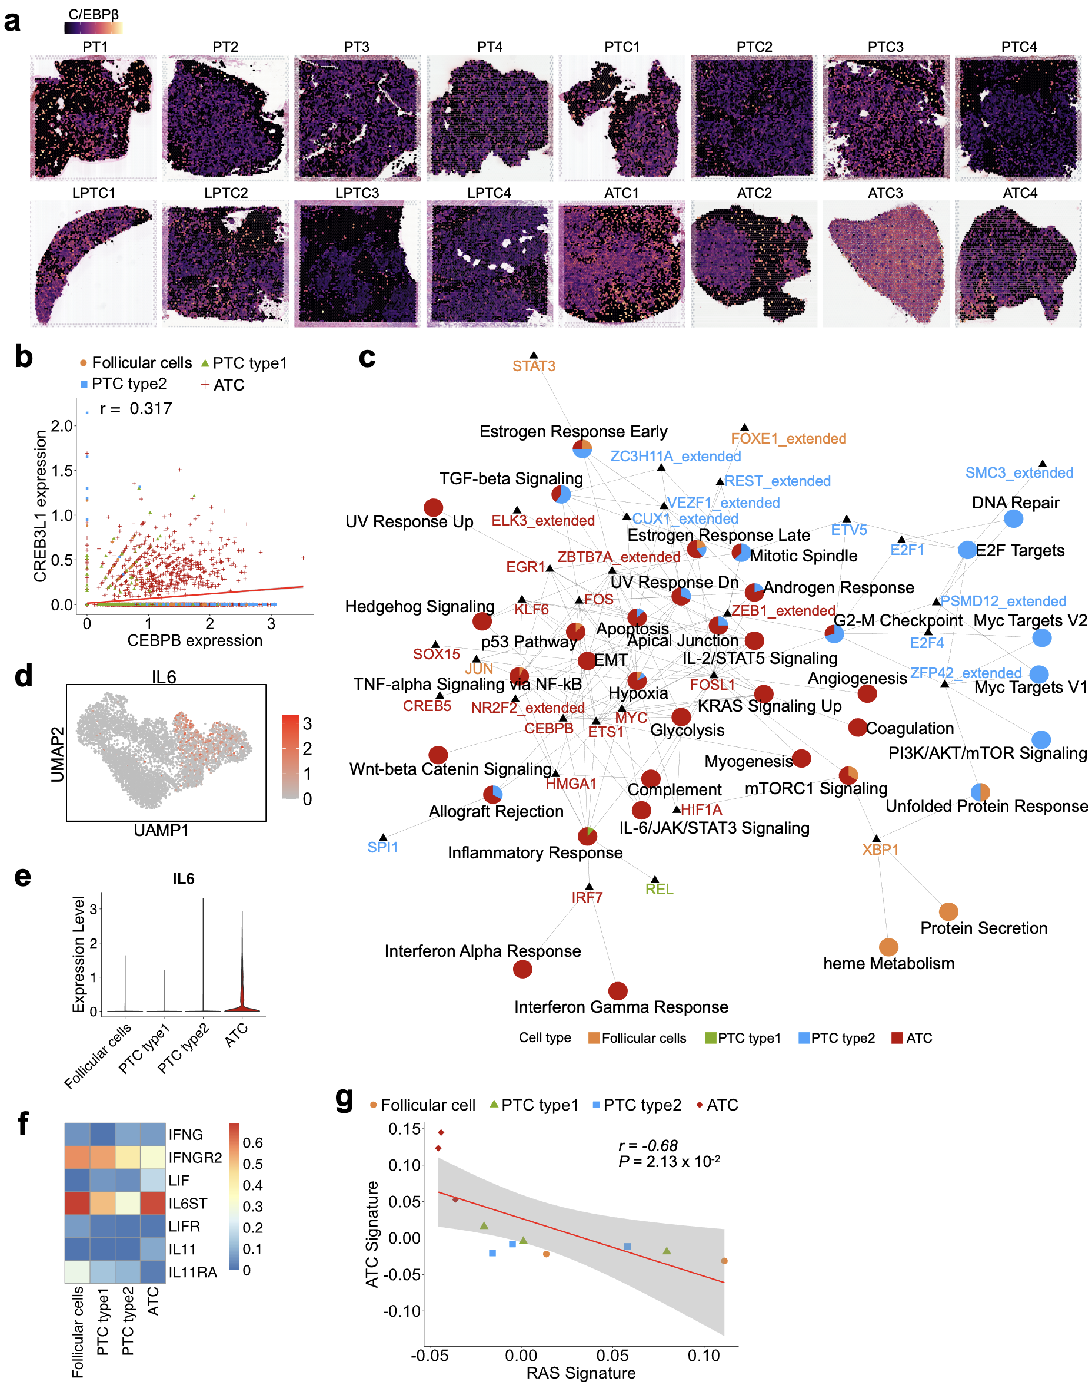
Supplementary Fig. 4 C/EBPβ is a master regulator of inflammatory response, IL-6/JAK/STAT signaling, and EMT pathways driving ATC progression. a Visium slides showing CEBPB expression across all samples. b A scatterplot showing the correlation between CEBPB and CREB3L1 expression levels. Spearman's correlation was calculated to assess their association. c Regulatory network delineating pathways (pie nodes) regulated by TFs (triangle nodes). Pie charts display the ratio of TFs specific to the activity pattern among TFs regulating the corresponding pathway. d UMAP displaying the expression levels of IL6 in epithelial cells. e Violin plot showing the expression levels of IL6 across epithelial subpopulations. f Heatmap representing the expression of CEBPB target genes involved in JAK/STAT signaling, including ligands and receptors. The x-axis represents epithelial subpopulations. g Scatter plots showing the correlations between the ATC signature and the RAS signature in epithelial cells.

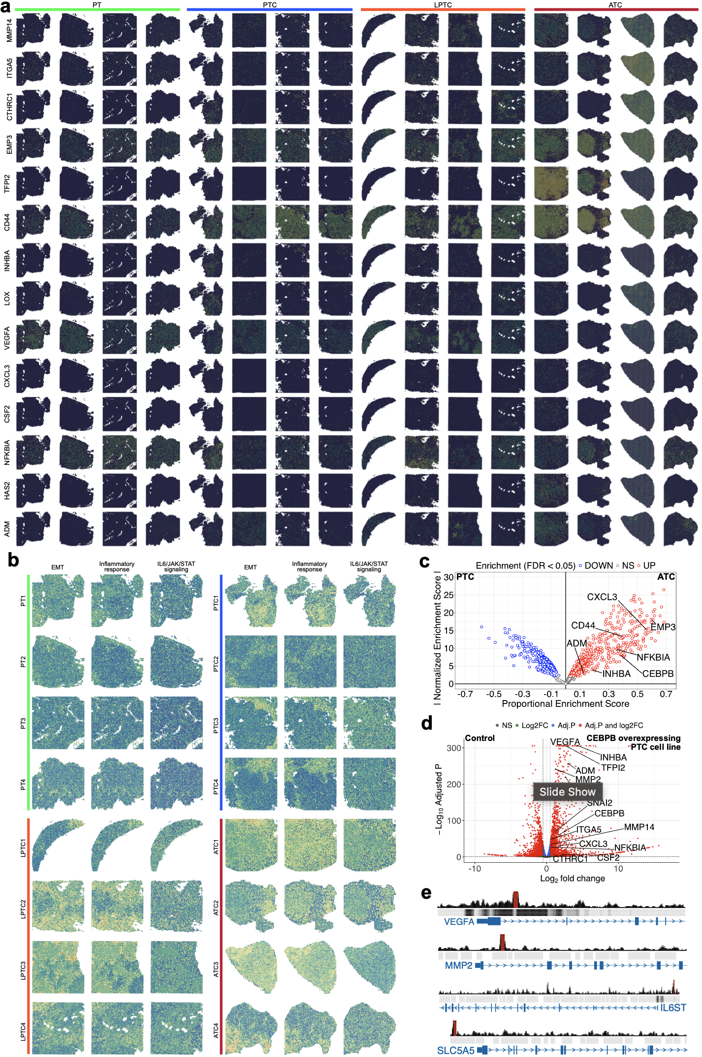
Supplementary Fig. 5 Multi-omics evidence supporting C/EBPβ-mediated EMT, inflammatory response, and IL-6/JAK/STAT signaling in ATC. a Spatial visualization of CEBPB target gene expression associated with EMT, inflammatory response, and IL-6/JAK/STAT signaling across all Visium samples. b Spatial distribution of signature scores for EMT, inflammatory response, and IL-6/JAK/STAT signaling across all Visium samples. c Volcano plot showing the differences in protein activities between PTC cells and ATC cells. The x-axis represents the proportional enrichment score, while the y-axis denotes the absolute value of the normalized enrichment score. Blue dots indicate proteins with significantly enriched activity in PTC cells, and red dots represent proteins with significantly enriched activity in ATC cells (FDR < 0.05). d Volcano plot displaying DEGs between PTC cell line overexpressing C/EBPβ and control. The dashed lines indicate the threshold for significant DEGs [adjusted P < 0.05 and abs(log2 fold change) > 0.5]. e C/EBPβ ChIP-seq binding signals and TF binding regions across target gene loci. Significant binding peaks are highlighted in red.

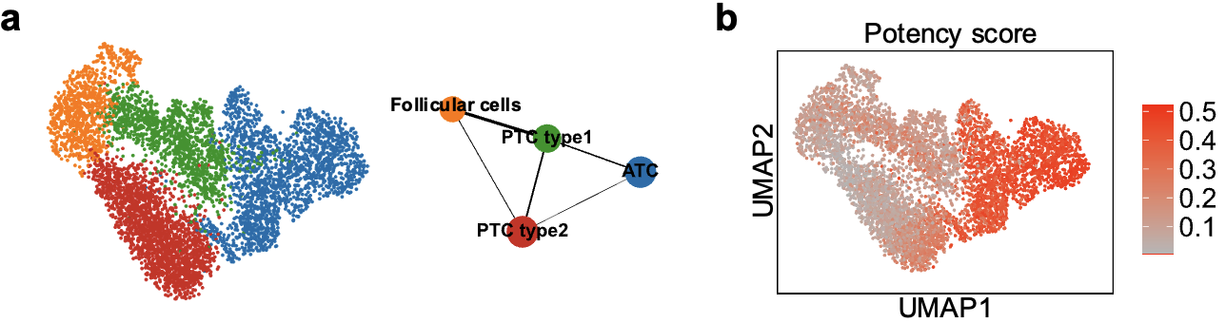
Supplementary Fig. 6 Trajectory delineating the transformation from PTC to ATC. a Connectivity visualization between epithelial subpopulations is shown, with the width of the edges representing the connectivity weight between populations. b UMAP visualization of potency scores in epithelial cells.

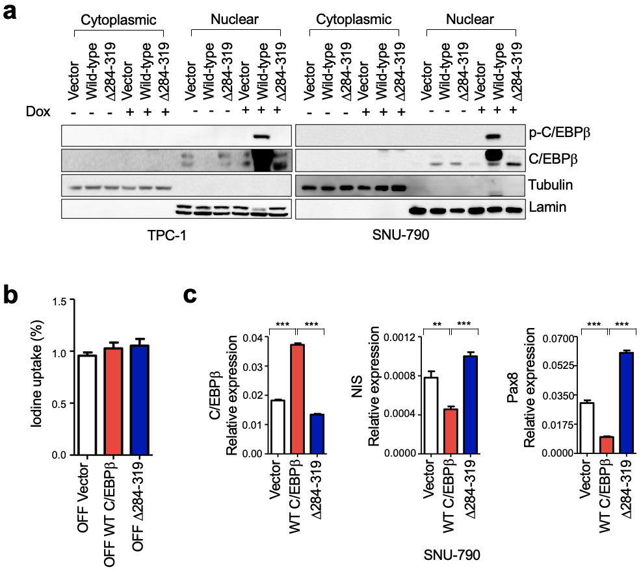
Supplementary Fig. 7 C/EBPβ instigates aggressive features, similar to ATC, in PTC cells. a Immunoblots for p-C/EBPβ, C/EBPβ, tubulin, and lamin were carried out on samples from either TPC-1 or SNU-790 cells, which were expressing inducible wild-type C/EBPβ or C/EBPβ (Δ284-319) after nuclear fractionation. Tubulin was used for cytoplasmic marker and lamin was used for nuclear marker. b Iodine uptake on TPC-1 cells expressing inducible vector, wild-type C/EBPβ, or C/EBPβ (Δ284-319) without induction (n = 2). c qRT-PCR analysis of representative genes involved in iodine uptake, such as NIS and Pax8, in SNU-790 cells expressing vector, wild-type C/EBPβ, and C/EBPβ (Δ284-319) (n = 3).
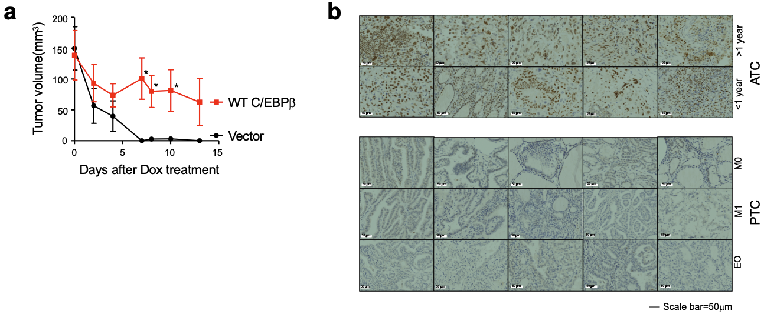
Supplementary Fig. 8 C/EBPβ instigates aggressive features, similar to ATC, in in vivo models. a The effect of inducible C/EBPβ expression on the growth of TPC-1 xenograft tumors in response to doxycycline administered via feed. b Representative immunohistochemical staining of C/EBPβ in ATC and PTC specimens. The images provide a comparison of C/EBPβ expression across all examined samples of both thyroid carcinoma types.

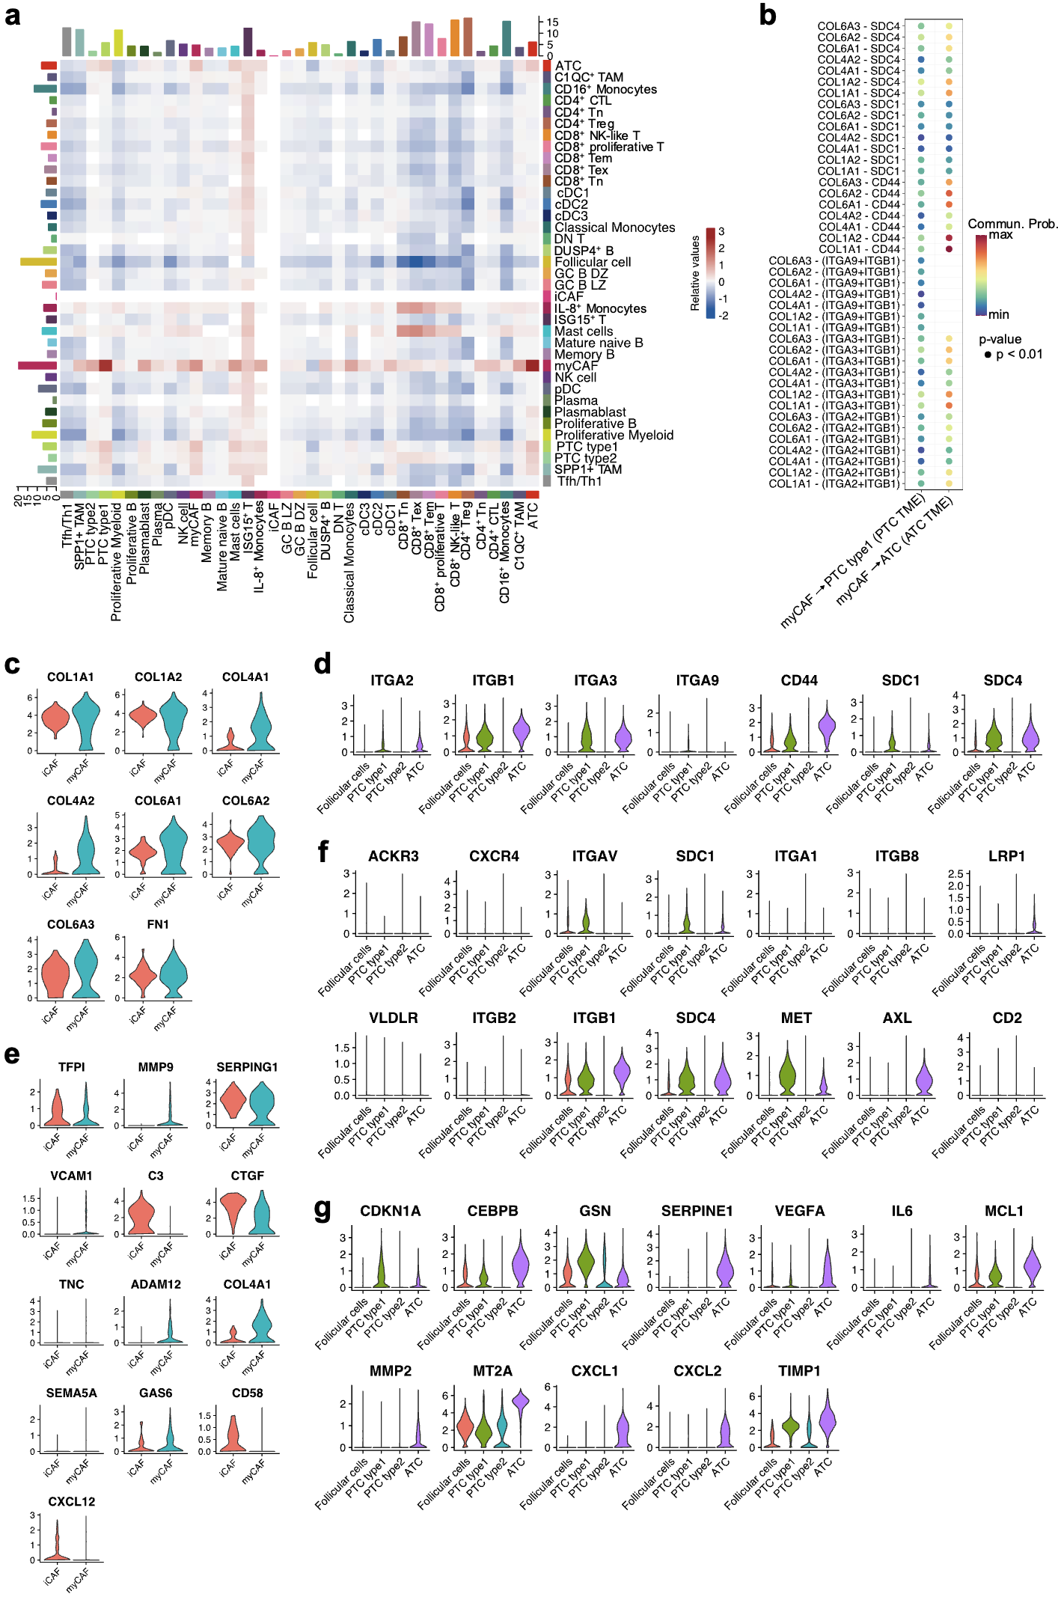
Supplementary Fig. 9 Interactions from myCAFs to tumor cells increase in ATC compared to PTC. a Heatmap showing the relative interaction strength among all cell types in PTC and ATC. Blue and red colors indicate relatively higher interaction strength in PTC and ATC, respectively. b Dot plot displaying the interactions of selected ligand and receptor pairs inferred using scRNA-seq data. The x-axis represents sender and receiver cell types, the y-axis represents ligand and receptor pairs, the color scale indicates communication probabilities, and the dot size represents the p-value. c-d Violin plots showing the expression levels of ligands (c) and receptors (d) identified by CellChat in fibroblast and epithelial cell populations, respectively. e-f Violin plots displaying the expression levels of ligands (e) and receptors (f) identified by NicheNet in fibroblast and epithelial cell populations, respectively. g Violin plots of expression levels of target genes from ATC cells inferred by NicheNet.

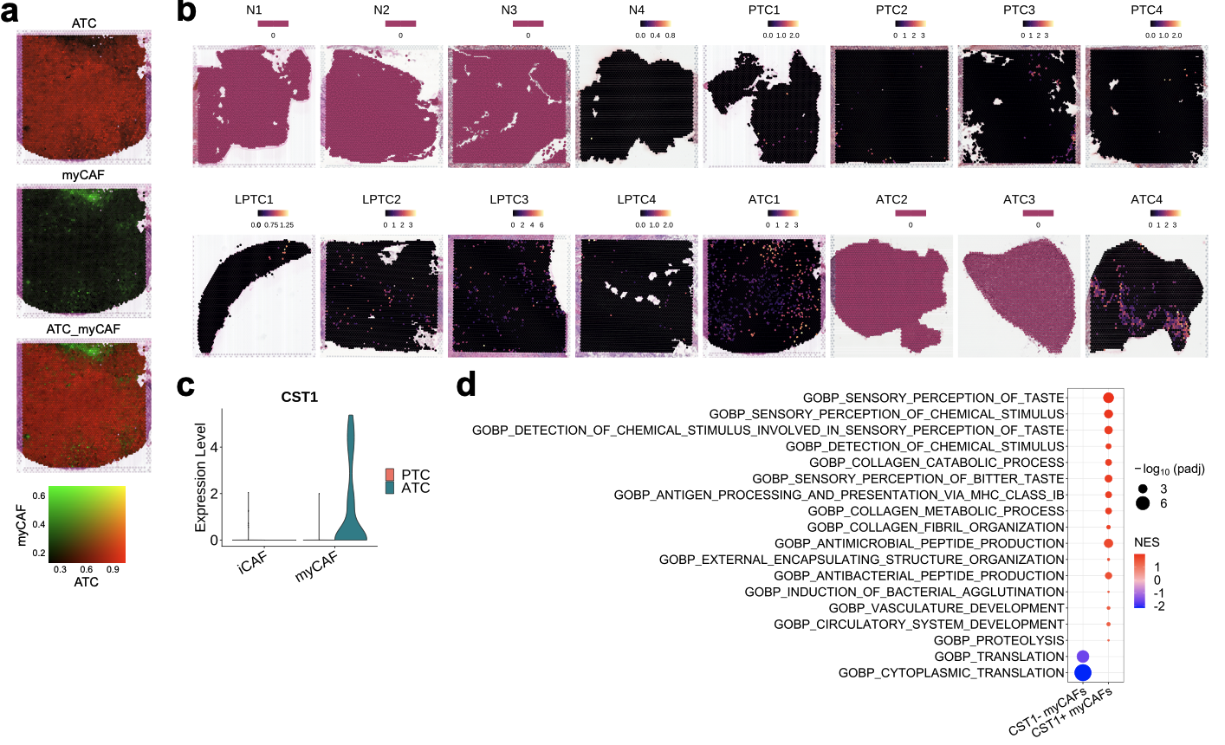
Supplementary Fig. 10 Spatially localized CST1⁺ myCAFs at tumor boundaries promote ECM remodeling in ATC. a Spatial distribution of RCTD-inferred likelihood weights for ATC cells and myCAFs in the ATC1 Visium sample. b Spatial expression patterns of CST1 across all Visium samples. c Violin plot showing CST1 expression in fibroblast populations across PTC and ATC samples from scRNA-seq data. d GOBP terms significantly enriched in CST1⁻ and CST1⁺ myCAFs.

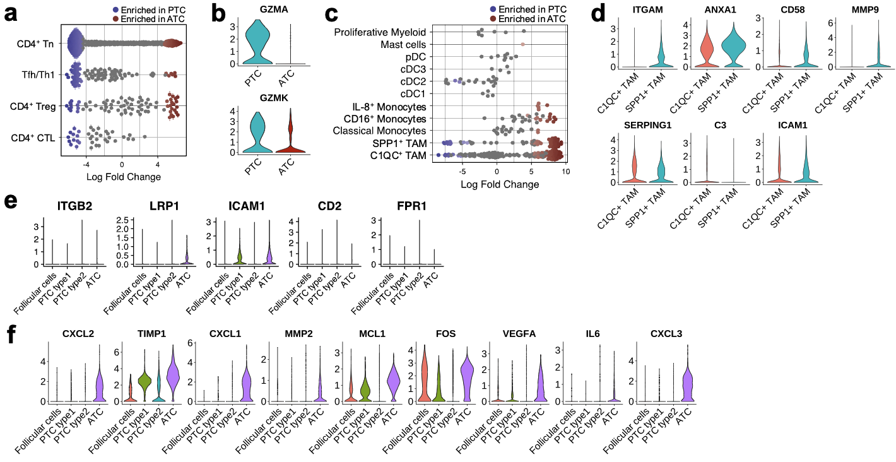
Supplementary Fig. 11 CD4⁺ T cells and TAMs neighborhood remodeling and signaling differences between PTC and ATC. a Beeswarm plot showing the distribution of log fold change in neighborhoods for each CD4⁺ T cell subtype between PTC and ATC. Neighborhoods meeting an 21% FDR threshold are colored. b Violin plots illustrating the expression levels of granzymes A and K (GZMA and GZMK) in CD4⁺ CTLs between PTC and ATC. c Beeswarm plot illustrating the distribution of log fold change in neighborhoods for each myeloid cell subtype between PTC and ATC. Neighborhoods meeting an 11% FDR threshold are colored. d Violin plots showing the expression levels of ligands from SPP1⁺ TAM in TAM subpopulations. e-f Violin plots showing the expression levels of receptors and target genes from ATC cells identified by NicheNet.
Supplementary Tables
Supplementary Table 1 Clinicopathological profiles of individual samples for scRNA-seq.
Index | THCA type | TNM stage | AJCC stage | Origin | Gender | Age | Tissue | Cells
PTC1 | PTC | T3bN1bM0 | I | Surgery | female | 26 | Lymph nodes | 10,016
PTC2 | PTC | T4aN1bM0 | I | Surgery | male | 28 | Thyroid glands | 2,334
PTC3 | PTC | T1N0M0 | I | Surgery | female | 51 | Thyroid glands | 6,760
PTC4 | PTC | T3N1bM0 | I | Surgery | female | 40 | Thyroid glands | 3,063
PTCEO | PTC | T4aN1bM0 | I | Surgery | female | 17 | Thyroid glands | 5,826
ATC1 | ATC | T4aN1bM0 | IVa | Surgery | male | 59 | Lymph nodes | 2,691
ATC2 | ATC | T4bN1bM1 | IVc | Surgery | male | 60 | Thyroid glands | 7,220
ATC3 | ATC | T4bN1bM1 | IVc | Surgery | female | 56 | Thyroid glands | 5,956

Supplementary Table 2 Thyroid differentiation gene set used to calculate the module scores.
Thyroid differentiation
TG
TPO
SLC26A4
DIO2
TSHR
PAX8
DUOX1
DUOX2
NKX2-1
GLIS3
FOXE1
TFF3
FHL1

Supplementary Table 3 IL-6/JAK/STAT3 signaling gene set used to calculate the module scores.
IL-6/JAK/STAT3 signaling
CCR1
CSF2
LEPR
CXCL3
OSMR
IL6ST
CD44

Supplementary Table 4 Epithelial mesenchymal transition gene set used to calculate the module scores.
Epithelial mesenchymal transition
PRRX1
MMP2
TFPI2
FZD8
TNFAIP3
EMP3
INHBA
GEM
VEGFA
MMP14
DAB2
SLC6A8
LOX
COL7A1
PMP22
SNAI2
COL6A3
SPOCK1
ITGA5
FERMT2
CD44
FBN1
CTHRC1

Supplementary Table 5 BRAF and RAS signature gene set used to calculate the module scores.
Supplementary Table 5.xls

Supplementary Table 6 The oligo sequences for quantitative RT-PCR.
Gene | Forward primer | Reverse primer
GAPDH | 5’-AATCCCATCACCATCTTCCA-3’ | 5’-TGGACTCCACGACGTACTCA-3’
CEBPB | 5’-AAGCACAGCGACGAGTACAA-3’ | 5’-ACAGCTGCTCCACCTTCTTC-3’
Pax8 | 5’-AAGGTGGTGGAGAAGATTGG-3’ | 5’-AGGGAGGTTGAATGGTTGC-3’
SLC5A5 | 5’-GTTCTACACTGACTGCGACCCTC-3’ | 5’-GCAGCCGAGGTTTGATGAG-3’

Supplementary Table 7 Clinicopathological profiles of individual ATC samples for immunohistochemistry.
Index | Gender | Age | Survival date | H-score
ATC3 | female | 56 | 229 | 168.9
ATC4 | male | 68 | 504 | 207.6
ATC5 | male | 40 | 377 | 138.4
ATC6 | female | 61 | 397 | 175.2
ATC7 | male | 75 | 1795 | 142.1
ATC8 | female | 49 | 1070 | 159.9
ATC9 | female | 64 | 137 | 191.0
ATC10 | male | 74 | 62 | 155.2
ATC11 | male | 63 | 93 | 177.6
ATC12 | male | 77 | 150 | 151.2

Supplementary Table 8 Clinicopathological profiles of individual PTC samples for immunohistochemistry.
Index | Gender | Age | Metastasis (M) | H-score
PTC5 | female | 40 | 0 | 4.7
PTC6 | female | 38 | 0 | 32.0
PTC7 | male | 49 | 0 | 75.2
PTC8 | male | 56 | 0 | 28.5
PTC9 | female | 41 | 0 | 29.1
PTC10 | female | 50 | 1 | 26.3
PTC11 | male | 40 | 1 | 6.0
PTC12 | female | 30 | 1 | 9.4
PTC13 | female | 29 | 1 | 1.0
PTC14 | male | 57 | 1 | 18.8
PTC15 | female | 12 | 0 | 3.3
PTC16 | female | 17 | 1 | 2.0
PTC17 | male | 15 | 1 | 14.4
PTC18 | female | 18 | 1 | 23.1
PTC19 | male | 19 | 1 | 0.2

Supplementary Table 9 Top 100 DEGs for each epithelial subpopulation identified in scRNA-seq.
Supplementary Table 9.xls

Supplementary Table 10 A list of transcription factors by cluster according to the expression pattern changes during the ATC transformation process.
Supplementary Table 10.xls

Supplementary Table 11 Hallmark pathways significantly enriched in the regulons of each cluster of TFs.
Supplementary Table 11.xls

