Electronic supplementary material
Supplementary Figure 1. Locations that participants were recruited using street-intercept survey methodology outside of supermarkets in all 11 sub-cities within Addis Ababa, Ethiopia

Supplementary Table 1: Sugar, sodium/salt, and/or saturated fat thresholds for solid and liquid foods associated with FoPL systems (for complete nutrient thresholds/scoring systems see references associated with each FoPL)

Thresholds for application of the Nutrient Warning Label
- Sugar
  - ≥10% of total energy (solid)
  - ≥5% of total energy (liquid)
- Sodium/salt
  - 1 mg sodium/kcal (solid and liquid)
  - 0.003 g salt/kcal (solid and liquid)

Thresholds for Color Coding of the Multiple Traffic Light Label
Text |  | Low | Medium | High
Color code |  | Green | Amber | Red
 |  |  |  | >25% of RIs | >30% of RIs
Total Sugar | Solid | ≤5.0 g/100g | >5 to  ≤22.5 g/100g | >22.5 g/100g | >27 g/portion
Total Sugar | Liquid | ≤2.5 g/100mL | >2.5 to  ≤11.25 g/100mL | >11.25 g/100mL | >13.5 g/portion
Salt | Solid | ≤0.3 g/100g | >0.3 to  ≤1.5 g/100g | >1.5 g/100g | >1.8 g/portion
Salt | Liquid | ≤0.3 g/100mL | >0.3 to  ≤0.75 g/100mL | >0.75 g/100mL | >0.9 g/portion
Fat | Solid | ≤3.0 g/100g | >3.0 to  ≤17.5 g/100g | >17.5 g/100g | >21 g/portion
Fat | Liquid | ≤1.5 g/100mL | >1.5 to  ≤8.75 g/100mL | >8.75 g/100mL | >10.5 g/portion
Saturated Fat | Solid | ≤1.5 g/100g | >1.5 to  ≤5.0 g/100g | >5.0 g/100g | >6.0 g/portion
Saturated Fat | Liquid | ≤0.75 g/100mL | >0.75 to  ≤2.5 g/100mL | >2.5 g/100mL | >3 g/portion

Thresholds for Letter Grade of the Nutri-Score Label
- Sum of points (0–5) allocated for content per 100 g (per 100 ml for beverages) of nutrients for which the consumption should be promoted, i.e. dietary fibers (g), proteins (g), and fruits, vegetables, legumes, and nuts (%), subtracted from sum of points (0–10) allocated for content of nutrients that should be consumed in limited amounts, i.e. total sugars (g), saturated fatty acids (g), sodium (mg), and energy (kJ).
  - Sugar: points attributed for each 4.5g/100g in the interval 0-31g/100g, to a maximal 6 points. Thereafter as follows: >31-36g/100g=7 points, >36-40g/100g=8 points, >40-45g/100g=9, and >45g/100g=10 points (solid foods); points attributed for each 1.5g/100ml (liquid foods)
  - Sodium: points attributed for each 90mg/100g (or ml) of foods (or beverages)

Supplementary Table 2: Nutrient Profiles and FoPL applied for chips, savory snack, sugar-sweetened beverage, and sweet biscuits

Nutrient profile for each product
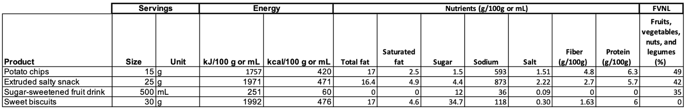
FoPL applied to each product

Supplementary Table 3. Participant characteristics by randomization assignment: Recruitment sub-city in Addis Ababa, Ethiopia
Characteristic | Overall  n=1,200 | Arms
Characteristic | Overall  n=1,200 | Warning Label  n=299 | No label  n=303 | Multiple Traffic Light  n=301 | Nutri-Score  n=297
Recruitment sub-city of participant (n, %)
Bole | 304 (25.3) | 76 (25.4) | 82 (27.1) | 69 (22.9) | 77 (25.9)
Yeka | 83 (6.92) | 14 (4.68) | 26 (8.58) | 22 (7.31) | 21 (7.07)
Lemi Kura | 255 (21.3) | 65 (21.7) | 63 (20.8) | 66 (21.9) | 61 (20.5)
Arada | 98 (8.17) | 19 (6.35) | 26 (8.58) | 26 (8.64) | 27 (9.09)
Lideta | 74 (6.17) | 20 (6.69) | 15 (4.95) | 23 (7.64) | 16 (5.39)
Gulele | 26 (2.17) | 7 (2.34) | 5 (1.65) | 9 (2.99) | 5 (1.68)
Kolfe Keranio | 27 (2.25) | 12 (4.01) | 4 (1.32) | 4 (1.33) | 7 (2.36)
Nifas-Silk Lafto | 68 (5.67) | 15 (5.02) | 21 (6.93) | 19 (6.31) | 13 (4.38)
Akaki-Kality | 152 (12.7) | 43 (14.4) | 38 (12.5) | 32 (10.6) | 39 (13.1)
Kirkos | 74 (6.17) | 18 (6.02) | 16 (5.28) | 18 (5.98) | 22 (7.41)
Addis Ketema | 39 (3.25) | 10 (3.34) | 7 (2.31) | 13 (4.32) | 9 (3.03)

Supplementary Table 4. Mean (95% CI) intent to purchase four packaged foods containing excess sugar or sodium on a 7-point Likert Scale by Front-of-Package Label type, crude and adjusted models

The models (crude and adjusted) not included the variable product type.
 |  | Difference compared to Nutrient Warning Label
 |  | Crude model* |  | Adjusted model**
 | Mean (95%CI) | Difference (95% CI) | p-value | Difference (95% CI) | p-value
Nutrient Warning Label | 4.37 (4.16, 4.59) | Ref | Ref | Ref | Ref
No Label | 4.73 (4.52, 4.94) | 0.35 (0.12, 0.59) | 0.003 | 0.35 (0.12, 0.58) | 0.003
Multiple Traffic Light Label | 4.75 (4.53, 4.96) | 0.37 (0.14, 0.61) | 0.002 | 0.43 (0.20, 0.66) | <0.001
Nutri-Score Label | 4.75 (4.54, 4.96) | 0.37 (0.14, 0.61) | 0.002 | 0.34 (0.11, 0.57) | 0.004
*Assessed in a linear mixed effect model including Likert Scale score for Intent to Purchase as dependent variable, treatment arm as a fixed effects, and participant ID as random effects.
**Assessed in a linear mixed effect model including Likert Scale score for Intent to Purchase as dependent variable, treatment arm, age, gender, education, and presence of children in the household as a fixed effects, and participant ID as random effects.

Supplementary Table 5. Proportion (95% CI) of participants correctly identifying sugar or sodium in excess in four packaged foods by label type
Label type | N | N for all four answers correct | Proportion (95% CI) | Difference (95% CI)
Nutrient Warning Labels | 299 | 185 | 0.62 (0.56, 0.67) | Reference
No Label | 303 | 109 | 0.36 (0.31, 0.42) | -0.26 (-0.34, -0.18)
Multiple Traffic Light Label | 301 | 146 | 0.49 (0.43, 0.54) | -0.13 (-0.22, -0.05)
Nutri-Score Label | 297 | 100 | 0.34 (0.28, 0.39) | -0.28 (-0.36, -0.20)

Supplementary Table 6. Label acceptability and opinion responses
 | Question | Overall  N = 897 | Group |  |  | Statistical Tests
 | Question | Overall  N = 897 | Nutrient Warning Labels  N = 299 | Multiple Traffic Light Label¹  N = 301 | Nutri-Score Label  N = 297 | Nutrient Warning Labels  vs  Multiple Traffic Light Label | Nutrient Warning Labels  vs  Nutri-Score Label
 |  | Mean (SD)
Label Acceptability Questions  (1 - totally disagree; 7 - totally agree) | This label will help Ethiopians decide whether or not to buy a product | 5.0 (2.4) | 6.2 (1.6) | 6.2 (1.3) | 2.5 (1.9) | p=0.62 | p=<0.001*
 | This label draws my attention | 4.9 (2.2) | 5.7 (1.8) | 5.8 (1.7) | 3.0 (2.0) | p=0.42 | p=<0.001*
 | I trust the information on this label | 4.7 (2.2) | 5.8 (1.6) | 5.7 (1.6) | 2.6 (1.8) | p=0.20 | p=<0.001*
 | I think this label will be easy for my neighbors to understand | 4.5 (2.4) | 5.8 (1.7) | 5.6 (1.7) | 2.1 (1.6) | p=0.10 | p=<0.001*
Label Opinion Question  (1 - I would not be worried at all; 7 - I would be very worried) | How worried would you be if your children consumed food and drinks that displayed this label? | 4.3 (2.2) | 4.8 (2.2) | 4.0 (2.3) | 4.1 (2.1) | p=<0.001* | p=0.0001*
¹The Multiple Traffic Light Label was incorrectly color-coded red instead of amber for sugar content.
*Significant difference from Nutrient Warning Labels

Supplementary Material: Ethiopia FoPL RCT Questionnaire- English version

Module: Consent & Eligibility (ሞጁል: ብቁነት/የፈቃደኝነት ቅጽ/የስምምነት ቅጽ)
- Data Collector use only: Data Collector

- Data Collector use only: Select current location (sub-city)
- Bole
- Yeka
- Lemi Kura
- Arada
- Lideta
- Gulele
- Kolfe Keranio
- Nifas Silk-Lafto
- Akaki-Kality
- Kirkos
- Addis Ketema
- Other (please indicate in Data Collector Notes at end of survey)

- Data Collector use only: Select type of market
- Supermarket
- Souq
- Other (please indicate in Data Collector Notes at end of survey)

- Data Collector use only: Name of market

- Data Collector use only: Longitude [automatically collected]
- Data Collector use only: Latitude [automatically collected]

[CONSENT FORM/የፈቃደኝነት ቅጽ/የስምምነት ቅጽ] Please see separate document for form
Form ends with: Data Collector: please read questions and record responses in this section.]

- Do you agree to take the survey?
  - Yes
  - No [SURVEY ENDS]

Thank you for your interest in participating in our research study. Please answer the following questions so we can find out if you are eligible to participate.

- Do you typically purchase packaged foods at a hypermarket, supermarket, minimarket, kiosk, or suq?
  - Yes
  - No [SURVEY ENDS]

- Age _ _ _ [IF AGE <18, SURVEY ENDS]

[If ineligible]: Thank you for your interest. Unfortunately, you are not eligible to complete our survey.

[If eligible]: You are eligible to participate in our survey. It will only take 20 minutes of your time and no identifying information will be collected. You will receive a reimbursement for participating in our survey. You will be shown images of food products and asked your opinions about them. The information collected in this survey will be used to improve the labels for packaged foods.

Module: Showcard (ሞጁል: ሾው ካርድ)
Data Collector use only: Please get the showcard displaying the symbol on the front that matches the symbol displayed on the screen below.


Once you have the showcard, please check again that the symbol on the front of the showcard matches the symbol displayed on the screen.

Data Collector use only: please enter the showcard confirmation code.
- Showcard code is correct. Please hand the showcard to the participant and continue the survey.
- Showcard code is incorrect. Please check and re-enter the code. Please check that the symbol on the front of the showcard matches the symbol displayed on the screen. These must match to ensure the participant is seeing the correct set of images on the showcard. If these do not match, DO NOT CONTINUE THE SURVEY. Please speak to a supervisor.
Module: Sample Question (ሞጁል: የናሙና ጥያቄ)
Data Collector: please read survey and record responses while participant looks at Showcard deck.

Please listen to each question carefully and answer to the best of your ability. We will start with a sample question to get started. Please look closely at the product before responding to the question.

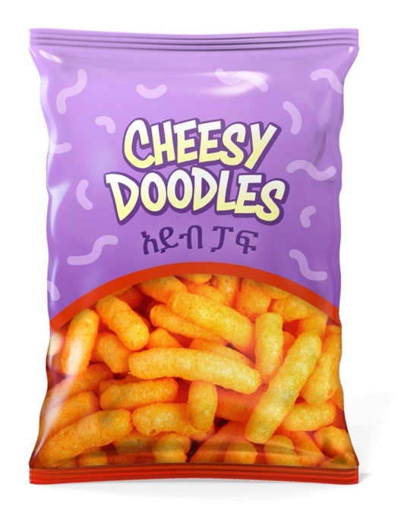
Sample image: snack

Imagine you were looking to buy a packaged snack. Would you buy this product for yourself or your family?

We have provided a scale, and you can say or point to any number on the scale as your response. We will be using this same scale throughout the survey.

Imagine you were looking to buy a packaged snack. Would you buy this product for yourself or your family? You can select any number in between 1 and 7. 1 means I would certainly not buy, and 7 means I would definitely buy.

Would you buy this snack for yourself or your family?

1 | 2 | 3 | 4 | 5 | 6 | 7
I would certainly not buy this product |  |  | I may or may not buy this product |  |  | I would definitely buy this product
Module: Single products (ሞጁል: ነጠላ ምርቶች)

High sodium products

Please look closely at the product before responding to the next questions.
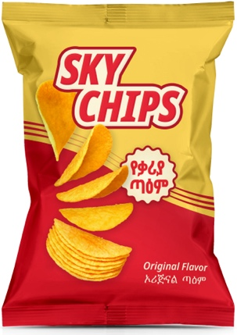 | 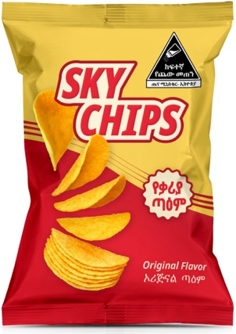 | 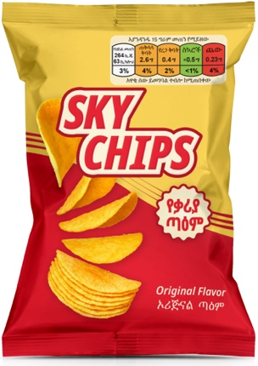 | 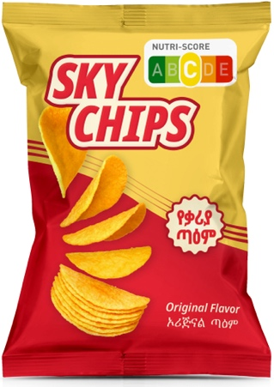
Shown for Arm A only | Shown for Arm B only | Shown for Arm C only | Shown for Arm D only

- Imagine you were looking to buy chips. Would you buy this product for yourself or your family?

1 | 2 | 3 | 4 | 5 | 6 | 7
I would certainly not buy this product |  |  | I may or may not buy this product |  |  | I would definitely buy this product
- Which of the following statements is true about the product? Select all that apply.
  - The product is high in sugar
  - The product is high in protein
  - The product is high in salt
  - None of the above
  - I don’t know

Please look closely at the product before responding to the next questions.
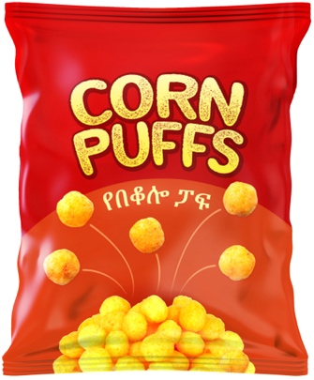 | 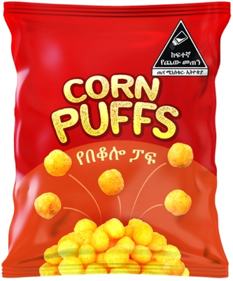 | 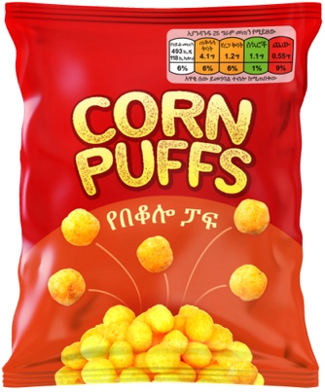 | 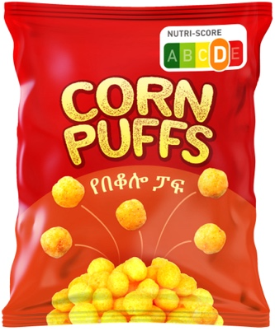
Shown for Arm A only | Shown for Arm B only | Shown for Arm C only | Shown for Arm D only

- Imagine you were looking to buy snacks. Would you buy this product for yourself or your family?

1 | 2 | 3 | 4 | 5 | 6 | 7
I would certainly not buy this product |  |  | I may or may not buy this product |  |  | I would definitely buy this product

- Which of the following statements is true about the product? Select all that apply.
  - The product is high in sugar
  - The product is high in protein
  - The product is high in salt
  - None of the above
  - I don’t know

High sugar products

Please look closely at the product before responding to the next questions.
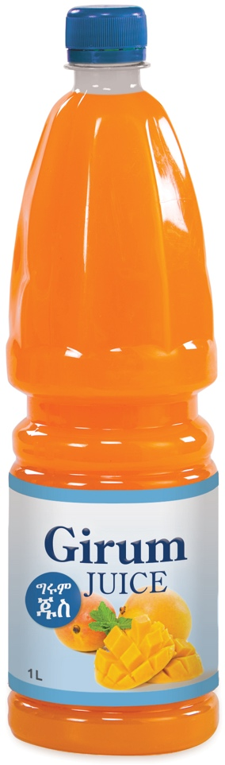 | 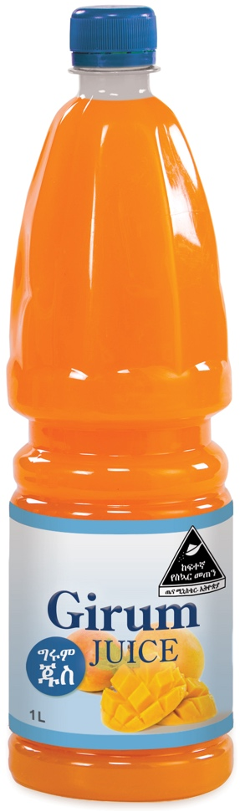 | 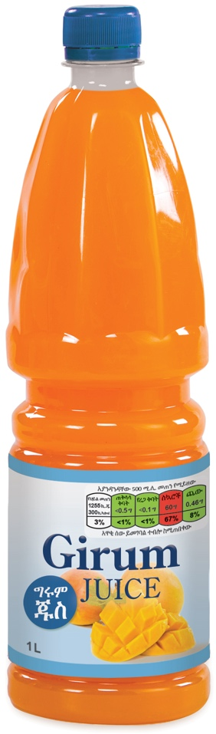 | 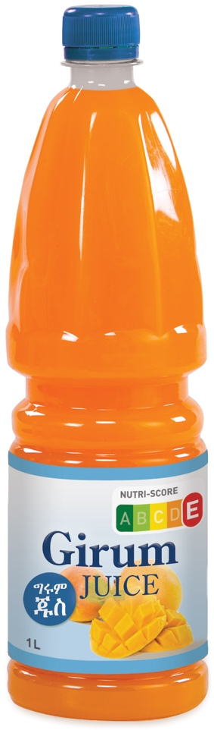
Shown for Arm A only | Shown for Arm B only | Shown for Arm C only | Shown for Arm D only

- Imagine you were looking to buy juice. Would you buy this product for yourself or your family?

1 | 2 | 3 | 4 | 5 | 6 | 7
I would certainly not buy this product |  |  | I may or may not buy this product |  |  | I would definitely buy this product

- Which of the following statements is true about the product? Select all that apply.
  - The product is high in sugar
  - The product is high in protein
  - The product is high in salt
  - None of the above
  - I don’t know

Please look closely at the product before responding to the next questions.

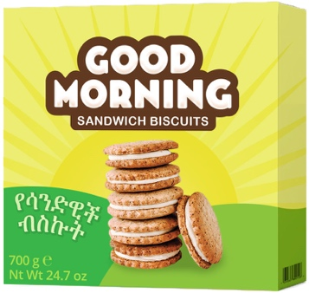 | 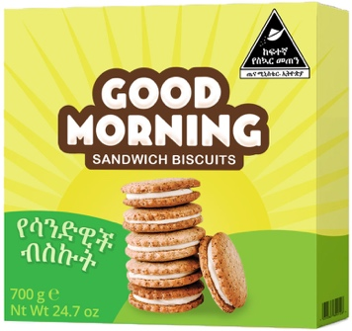 | 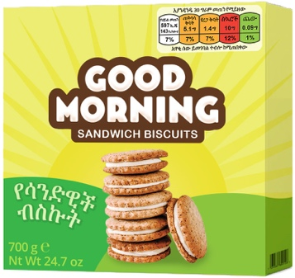 | 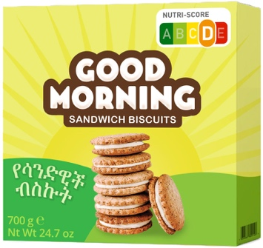
Shown for Arm A only | Shown for Arm B only | Shown for Arm C only | Shown for Arm D only

- Imagine you were looking to buy cookies or biscuits. Would you buy this product for yourself or your family?

1 | 2 | 3 | 4 | 5 | 6 | 7
I would certainly not buy this product |  |  | I may or may not buy this product |  |  | I would definitely buy this product

- Which of the following statements is true about the product? Select all that apply.
  - The product is high in sugar
  - The product is high in protein
  - The product is high in salt
  - None of the above
  - I don’t know

Module: Product comparison tasks (ሞጁል: ምርቶችን ማነፃፀር)
Please look closely at these products before responding to the next questions.
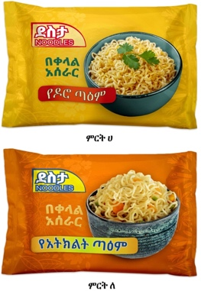 | 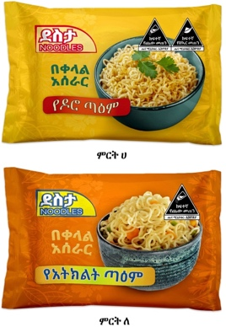 | 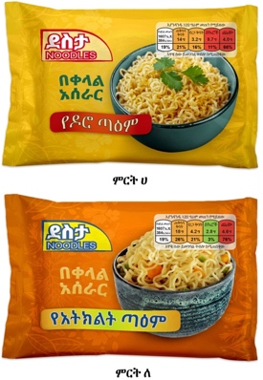 | 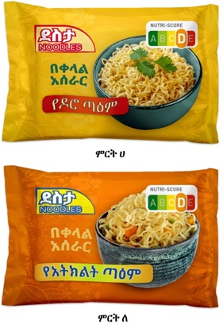
Shown for Arm A only | Shown for Arm B only | Shown for Arm C only | Shown for Arm D only

- Imagine you were looking to buy instant noodles. Would you buy one of these products for yourself or your family?
  - I would buy Product A only
  - I would buy Product B only
  - I would buy both products
  - I would buy neither product

- Which of these products has more salt?
  - Product A
  - Product B
  - Both products have equal levels of salt
  - Neither have salt
  - I don’t know

- Which of these products has more sugar?
  - Product A
  - Product B
  - Both products have equal levels of sugar
  - Neither have sugar
  - I don’t know

- Which product is healthier?
  - Product A is healthier
  - Product B is healthier
  - They are equal
  - I don’t know

Please look closely at these products before responding to the next questions.

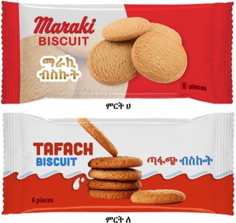 | 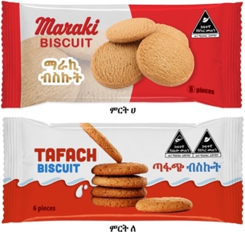 | 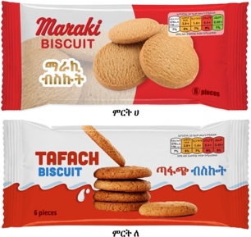 | 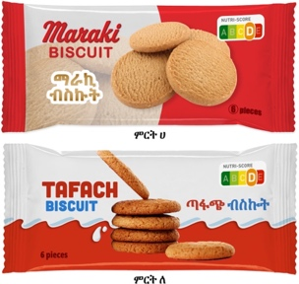
Shown for Arm A only | Shown for Arm B only | Shown for Arm C only | Shown for Arm D only

- Imagine you were looking to buy biscuits. Would you buy one of these products for yourself or your family?
  - I would buy Product A only
  - I would buy Product B only
  - I would buy both products
  - I would buy neither product

- Which of these products has a more salt?
  - Product A
  - Product B
  - Both products have equal levels of salt
  - Neither have salt
  - I don’t know

- Which of these products has a more sugar?
  - Product A
  - Product B
  - Both products have equal levels of sugar
  - Neither have sugar
  - I don’t know

- Which product is healthier?
  - Product A is healthier
  - Product B is healthier
  - They are equal
  - I don’t know

Please look closely at these products before responding to the questions.
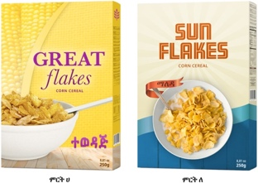 | 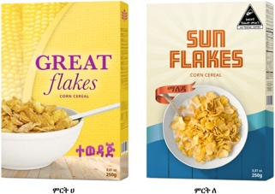 | 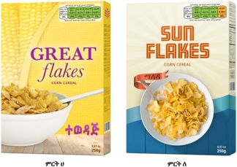 | 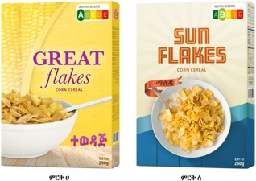
Shown for Arm A only | Shown for Arm B only | Shown for Arm C only | Shown for Arm D only

- Imagine you were looking to buy cereal. Would you buy one of these products for yourself or your family?
  - I would buy Product A only
  - I would buy Product B only
  - I would buy both products
  - I would buy neither product

- Which of these products has a more salt?
  - Product A
  - Product B
  - Both products have equal levels of salt
  - Neither have salt
  - I don’t know

- Which product is healthier?
  - Product A is healthier
  - Product B is healthier
  - They are equal
  - I don’t know

[SKIP to Question 28 if participant is in “no label” group]

Module: Label acceptability (ሞጁል: የምልክቶች ተቀባይነት)
Please look closely at the label before responding to the statements below.
 | 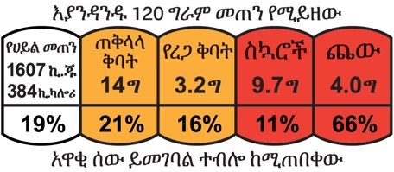 | 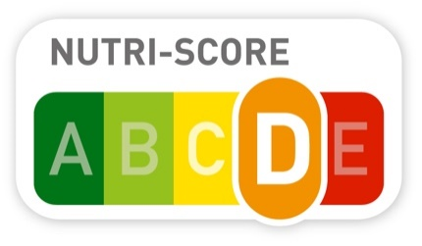
Shown for Arm B only | Shown for Arm C only | Shown for Arm D only
Note added after questionnaire was administered: The Multiple Traffic Light label was incorrectly color-coded red instead of amber for sugar.
- This label will help Ethiopians decide whether or not to buy a product.

1 | 2 | 3 | 4 | 5 | 6 | 7
I totally disagree with this statement |  |  |  |  |  | I totally agree with this statement

- This label draws my attention.

1 | 2 | 3 | 4 | 5 | 6 | 7
I totally disagree with this statement |  |  |  |  |  | I totally agree with this statement

- I trust the information on this label.

1 | 2 | 3 | 4 | 5 | 6 | 7
I totally disagree with this statement |  |  |  |  |  | I totally agree with this statement

- I think this label will be easy for my neighbors to understand.

1 | 2 | 3 | 4 | 5 | 6 | 7
I totally disagree with this statement |  |  |  |  |  | I totally agree with this statement

- How worried would you be if your children or the children in your family consumed food and drinks that displayed this label?

1 | 2 | 3 | 4 | 5 | 6 | 7
I would not be worried at all |  |  |  |  |  | I would be very worried
Module: Non-experimental FOP label comparison (ሞጁል፡ የፊት ገፅ ምልክቶች ንፅፅር)

Please look closely at the labels before responding to the questions below.

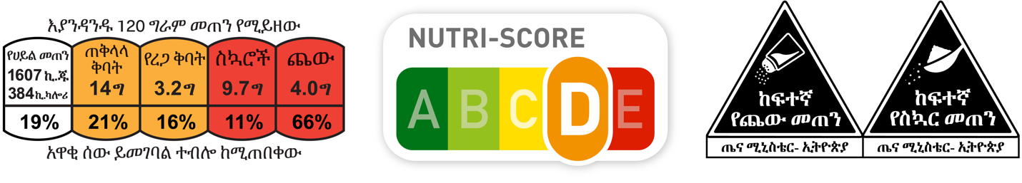
Label A | Label B | Label C
Note added after questionnaire was administered: The Multiple Traffic Light label was incorrectly color-coded red instead of amber for sugar.
- Which label will best help Ethiopians identify products high in salt and sugar? (Instruction: don’t read the response options and do not attempt to explain the labels)
  - Label A
  - Label B
  - Label C

- Could you tell us why you selected this label? [Free text response]

Module: Descriptive questions (ሞጁል፡ ገላጭ ጥያቄዎች)

We would like to end with just a few final questions.

- Gender
  - Man
  - Woman

- Enter the number of highest class completed in primary or secondary school (enter 0 if did not complete grade 1). __ [Data Collector fills in number up to 12]

- Select the highest level of education completed after primary school (if relevant).
  - Did not continue
  - Completed technical or vocational training (TVET)
  - Have college diploma
  - Have university/college degree or higher
  - Prefer not to answer

- How often do you purchase packaged foods, such as the ones you saw images of during this survey, for yourself?
  - Never
  - A few times per year
  - 1 time per month
  - 2-3 times per month
  - 1 time per week
  - 2-4 times per week
  - 5-6 times per week
  - 1 time per day
  - >1 time per day

- How often do you purchase packaged foods, such as the ones you saw images of during this survey, for your family members?
  - Never
  - A few times per year
  - 1 time per month
  - 2-3 times per month
  - 1 time per week
  - 2-4 times per week
  - 5-6 times per week
  - 1 time per day
  - >1 time per day

- How many people, including yourself, live in your household? _ _ _

- How many of the people living in your household are children under the age of 18?
- There are no people living in my household who are under the age 18.
- 1
- 2
- 3
- 4
- 5
- 6
- 7
- 8
- 9+

- Please list the ages of any household members below the age 18, starting with the youngest.
- Youngest child
  - I don’t know the age
  - 1 year old or younger
  - 2
  - 3
  - 4, etc.
- Child 2
  - I don’t know the age
  - 1 year old or younger
  - 2
  - 3
  - 4, etc.
- Child 3
  - I don’t know the age
  - 1 year old or younger
  - 2
  - 3
  - 4, etc.
- Child 4
  - I don’t know the age
  - 1 year old or younger
  - 2
  - 3
  - 4, etc.
- Child 5
  - I don’t know the age
  - 1 year old or younger
  - 2
  - 3
  - 4, etc.
- Child 6
  - I don’t know the age
  - 1 year old or younger
  - 2
  - 3
  - 4, etc.
- Child 7
  - I don’t know the age
  - 1 year old or younger
  - 2
  - 3
  - 4, etc.
- Child 8
  - I don’t know the age
  - 1 year old or younger
  - 2
  - 3
  - 4, etc.

Please write in the age of any additional children. Separate ages with a comma. All ages listed should be under the age of 18 years.

- Data Collector Notes

Thank you for completing the survey.

