Supplementary Information

Soil enzyme dynamics in arid and Mediterranean soils exposed to environmentally relevant PFAS concentrations
Juan C. Sanchez-Hernandez^{1,*}, Natividad I. Navarro Pacheco¹, Ximena Andrade Cares¹, Jaroslav Semerad^{2,3}, Tomas Cajthaml^{2,3} and Mallavarapu Megharaj⁴

¹Laboratory of Ecotoxicology, Institute of Environmental Sciences, University of Castilla-La Mancha, 45071 Toledo, Spain.
²Institute for Environmental Studies, Faculty of Science, Charles University, Benatská 2, CZ-128 01, Prague 2, Czech Republic.
³Institute of Microbiology of the Czech Academy of Sciences, Vídeňská 1083, CZ-142 20, Prague 4, Czech Republic.
⁴Global Centre for Environmental Remediation (GCER), School of Science, College of Engineering, Science and Environment, University of Newcastle, Callaghan NSW 2308, Australia.

Content

Table S1. Two-way RM ANOVA outcomes for enzyme activities in control (PFAS free) soils.
Table S2. Concentration of major elements and heavy metals in the Mediterranean and arid soils.
Figure S1. Mean concentrations of extractable NH₄⁺-N, NO₃⁻-N, inorganic phosphate (P_{i}), and total organic carbon in the Mediterranean and arid soils.
Figure S2. Pearson’s correlation matrix between enzyme activities of control (PFAS-free) Mediterranean (A) and arid (B) soils across the 210-d incubation period.
Figure S3. Pearson’s correlations between inorganic phosphate (P_{i}) concentrations and P-acquiring enzyme activities, vector length, and vector angle in the arid soil.
Figure S4. Time-variation of arylsulfatase activity in the Mediterranean (A) and arid (B) soils spiked with 0, 10, 50, and 250 ng g^{–1} dry soil.

Table S1. Two-way RM ANOVA outcomes for enzyme activities in control (PFAS free) soils.
Dependent variable¹ | Source of variation² | F value | d.f. | P value
EST | Soil | 5.70 | 1 | 0.127
 | Time | 5.70 | 3 | 0.127
 | Soil × time | 2.10 | 3 | 0.552
ALP | Soil | 25.4 | 1 | 0.002
 | Time | 2.95 | 3 | 0.60
 | Soil × time | 0.33 | 3 | 0.80
BG | Soil | 4.38 | 1 | < 0.001
 | Time | 0.40 | 3 | 0.10
 | Soil × time | 0.60 | 3 | 0.002
NAG | Soil | 262 | 1 | < 0.001
 | Time | 27.7 | 3 | < 0.001
 | Soil × time | 11.1 | 3 | < 0.001
PRO | Soil | 884 | 1 | < 0.001
 | Time | 7.45 | 3 | 0.002
 | Soil × time | 5.46 | 3 | 0.008
DEH | Soil | 216 | 1 | < 0.001
 | Time | 81.0 | 3 | < 0.001
 | Soil × time | 25.7 | 3 | < 0.001
CAT | Soil | 245 | 1 | < 0.001
 | Time | 417 | 3 | < 0.001
 | Soil × time | 54.0 | 3 | < 0.001
PDE | Soil | 1330 | 1 | < 0.001
 | Time | 56.6 | 3 | < 0.001
 | Soil × time | 35.1 | 3 | < 0.001
ARY | Soil | 354 | 1 | < 0.001
 | Time | 79.4 | 3 | < 0.001
 | Soil × time | 13.5 | 3 | < 0.001
¹ EST=esterase, BG=β-glucosidase, ALP=alkaline phosphomonoesterase, PDE=phosphodiesterase, NAG= N-acetyl-β-D-glucosaminidase, PRO=protease, DEH=dehydrogenase, CAT=catalase, ARY= arylsulfatase. ² Categorical independent variables: time = 3, 14, 60, and 210 days; soil type = Mediterranean-climate and arid-climate soils.
Table S2. Concentration of major elements and heavy metals in the Mediterranean and arid soils used in this study.ª

Variable | Mediterranean soil | Arid soil
Al (%) | 2.10 | 4.81
Fe (%) | 1.36 | 3.48
Ca (%) | 4.15 | 0.88
K (%) | 0.68 | 1.31
Mg (%) | 0.67 | 0.79
As (mg/kg) | 5.43 | 4.66
Cd (mg(kg) | 1.49 | 0.59
Co (mg/kg) | 5.51 | 14.2
Cr (mg/kg) | 25.5 | 78.5
Cu (mg/kg) | 27.1 | 18.4
Mn (mg/kg) | 208.8 | 666.4
Mo (mg/kg) | 0.12 | 0.05
Na (mg/kg) | 332.1 | 1,280
Ni (mg/kg) | 13.0 | 47.2
P (mg/kg) | 2,385 | 356.6
Pb (mg/kg) | 239.1 | 16.2
S (mg/kg) | 313.4 | 192
Se (mg/kg) | 1.83 | 4.34
Si (mg/kg) | 440.0 | 226.1
Zn (mg/kg) | 70.5 | 59.0
ª External service analysis by Servicio Universitario de Instrumentación Científica (University of Murcia).

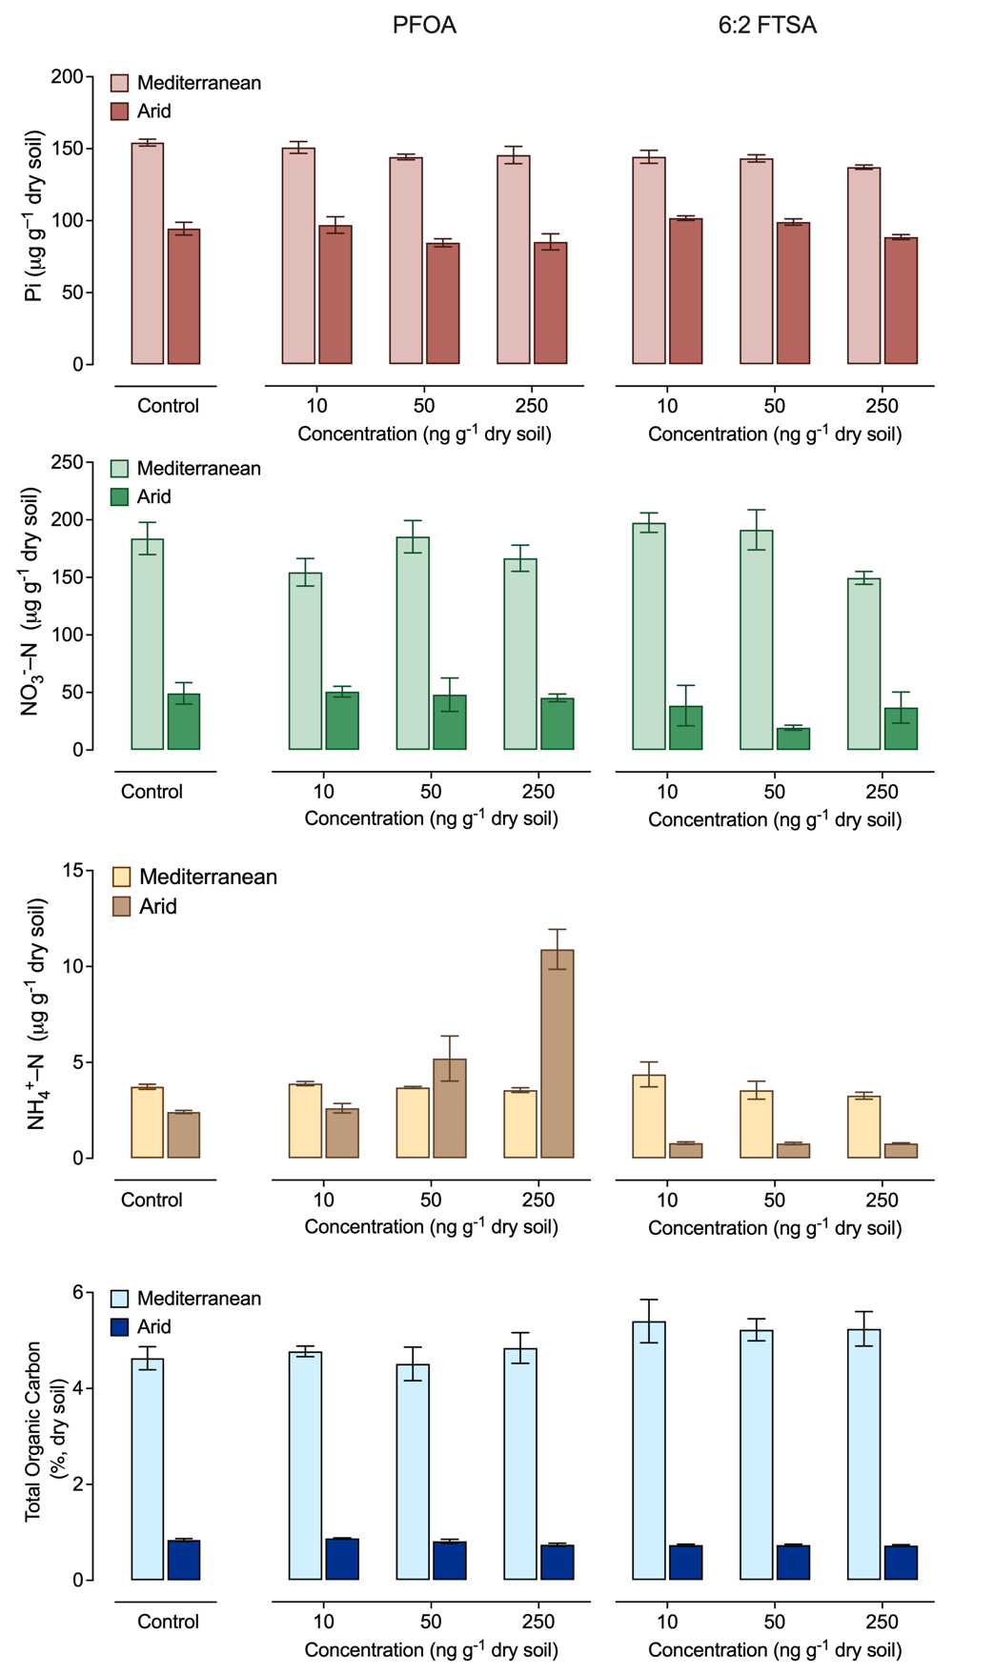
Figure S1. Mean (± SEM, n=4) concentrations of extractable NH₄⁺-N, NO₃⁻-N, inorganic phosphate (P_{i}), and total organic carbon in the Mediterranean and arid soils after 210 days of incubation with 0 (control), 10, 50, and 250 ng g^{–1} dry soil of PFOA and 6:2 FTSA.

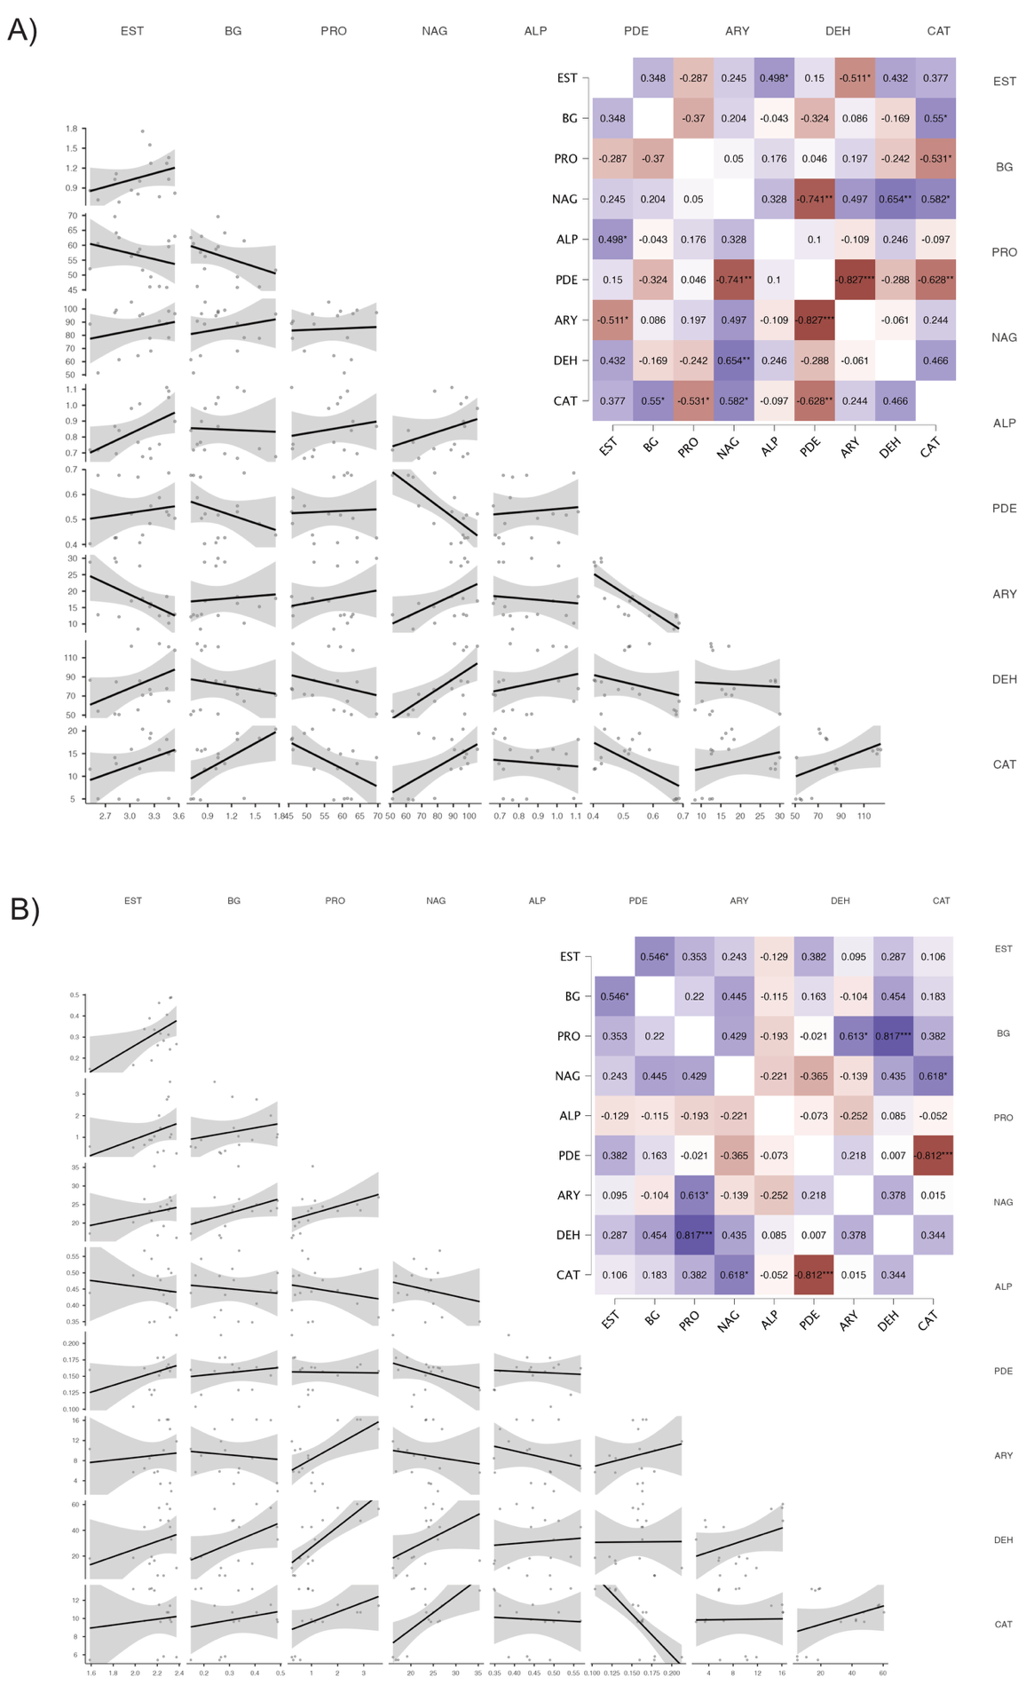
Figure S2. Pearson’s correlation matrix between enzyme activities of control (PFAS-free) Mediterranean (A) and arid (B) soils across the 210-d incubation period.
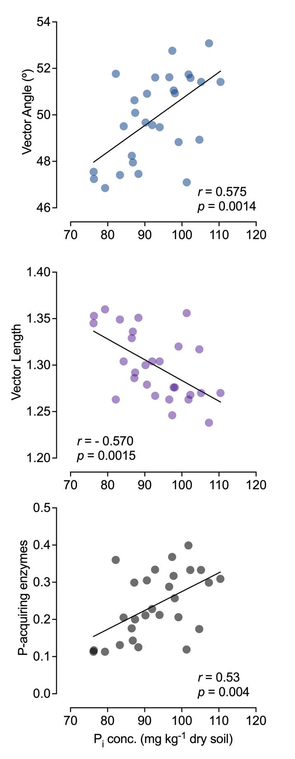

Figure S3. Pearson’s correlations between inorganic phosphate (P_{i}) concentrations and P-acquiring enzyme activities (average of alkaline phosphomonoesterase and phosphodiesterase activities), vector length, and vector angle in the arid soil after 210 days of incubation in the presence of PFOA and 6:2 FTSA.

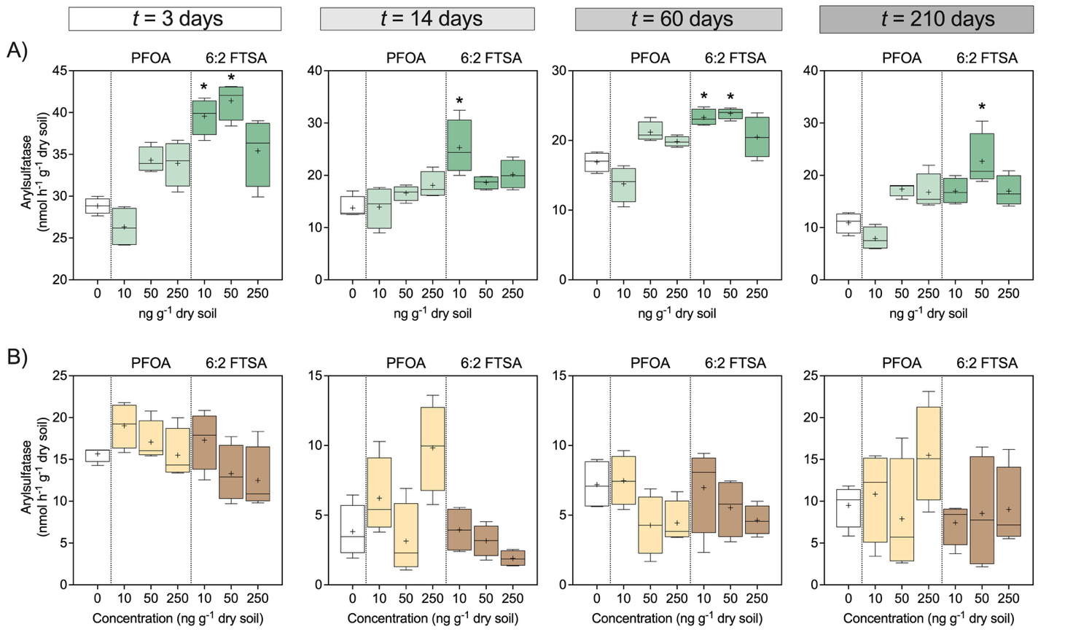

Figure S4. Time-variation of arylsulfatase activity in the Mediterranean (A) and arid (B) soils spiked with 0, 10, 50, and 250 ng g^{–1} dry soil. Tukey plots indicate the median, the 25th and 75th percentiles (box edges), the range (whiskers), and the mean (cross). Significant differences between treatments (PFAS concentrations) and control at each sampling time were detected by univariate ANOVAs (Welch’s correction) and indicated by asterisks (p<0.05, Dunnett’s post hoc test).

