Supplementary Materials
Modality | n | Patient population | Primary outcome | Age  mean, sd | Sex
TMS | 14 (139 stimulation sites) | Healthy participants | Heart rate deceleration as measured using heart-brain coupling | 36.4 (14.7) | 60% M, 40% F
DBS | 58 (392 stimulation sites) | Mild Alzheimer’s disease | Multiple categorical autonomic symptoms | 68.5 (7.9) | 55% M, 45% F
TFUS | 23 (46 stimulation sites) | Healthy participants | Heart rate variability as measured using standard deviation of normal sinus beats | 27 (5.5) | 30% M, 70% F
Supplementary Table 1: The convergent sympathetic arousal circuit was derived from three datasets that used different neuromodulation methods and measured transient changes in different autonomic arousal outcomes.

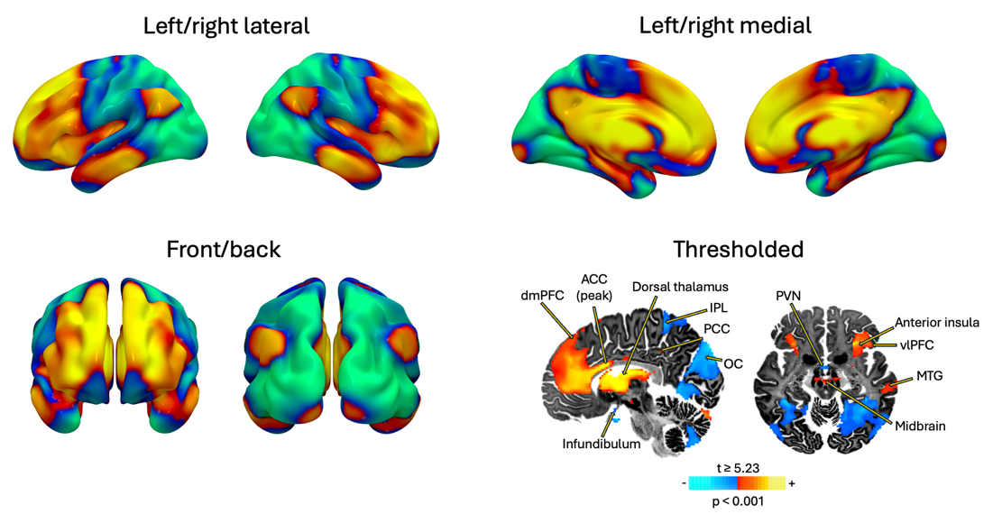
Supplementary Figure 1: Convergent sympathetic arousal circuit
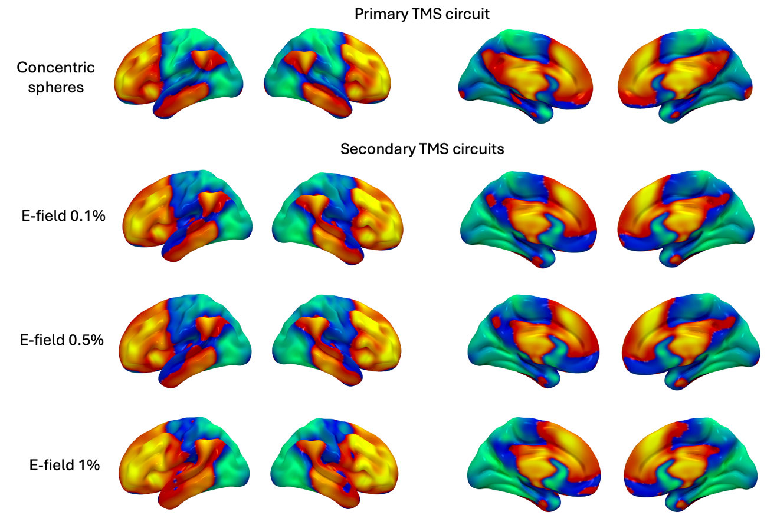
Supplementary Figure 2: TMS circuit variations
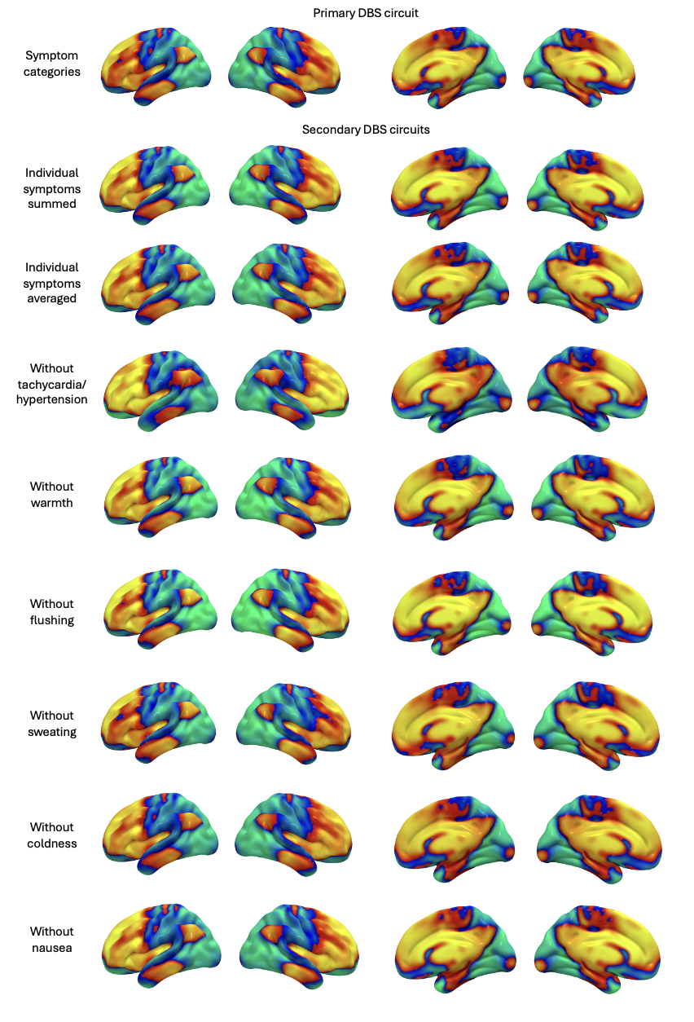
Supplementary Figure 3: DBS circuit variations
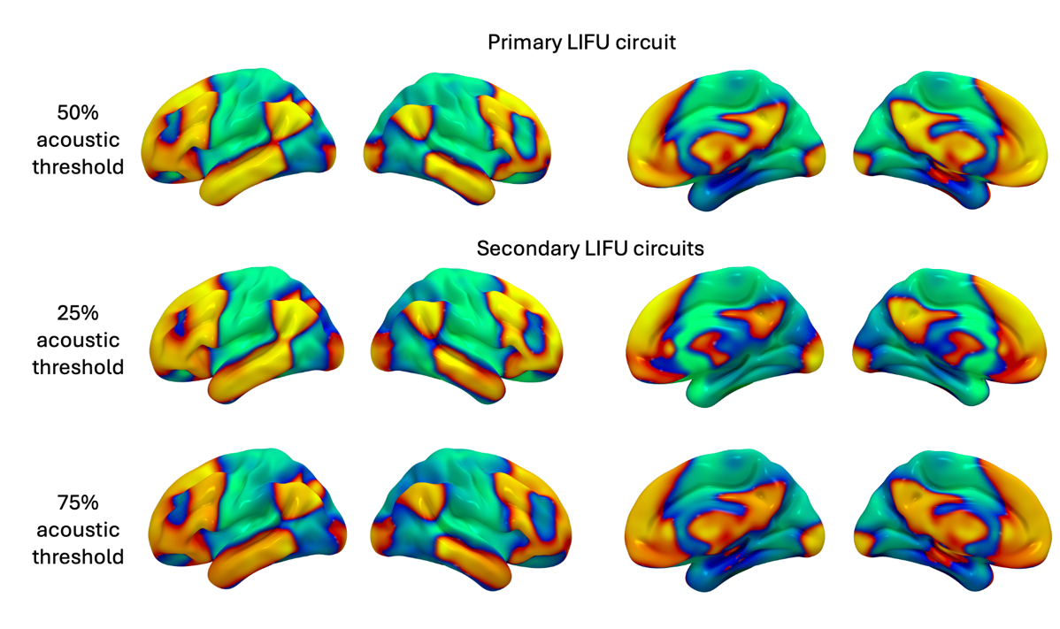
Supplementary Figure 4: LIFU circuit variations

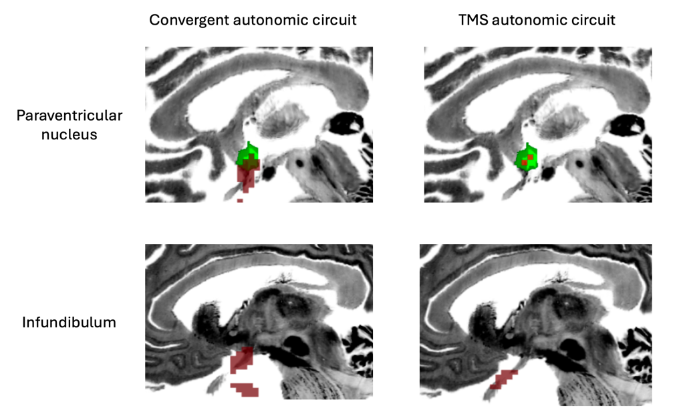
Supplementary Figure 5: The paraventricular nucleus of the hypothalamus is depicted in green. Significant convergent autonomic circuit (top left pane) and TMS autonomic circuit (top right pane) paraventricular nucleus locations are depicted in red. Significant infundibulum circuit locations are shown in the bottom panes.

