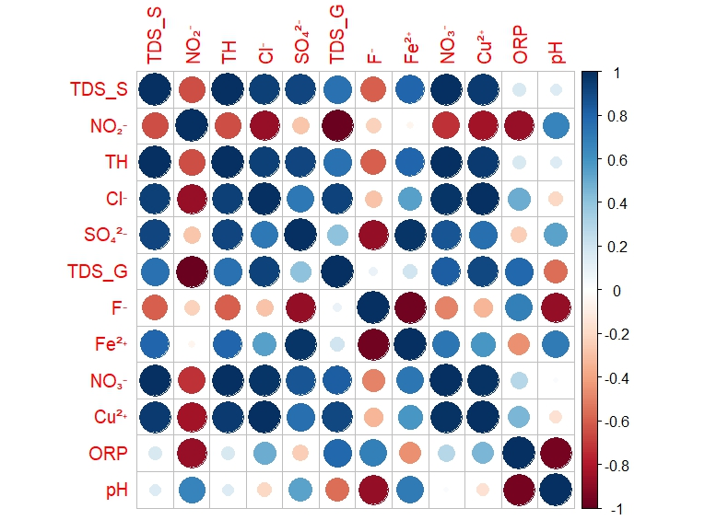
Fig. S1. Correlation matrix of hydrogeochemical parameters
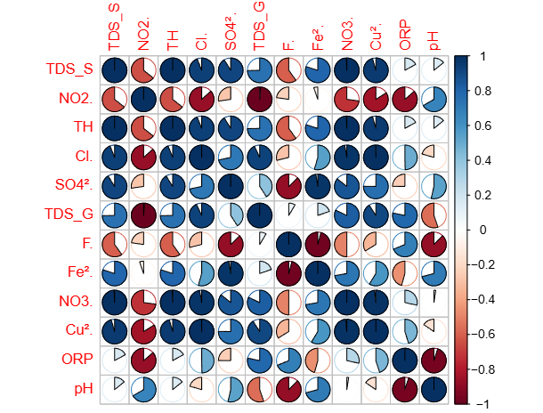
Fig. S2. Correlation matrix of hydrogeochemical parameters

