Supplementary Materials 2: Map of Saskatchewan

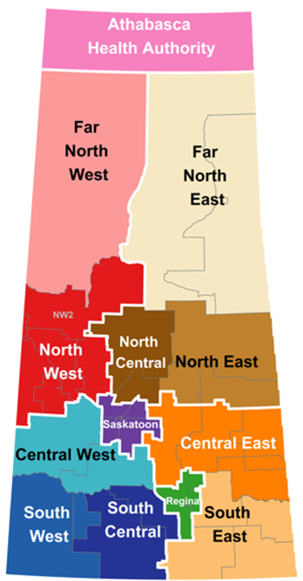

Note: Definition of urban, rural and remote as used in this research was taken from Young C, Grobelna A. Characteristics of remote and isolated health care facilities: an environmental scan. Ottawa: CADTH; 2018. (Environmental scan; no. 73).

