Title: Seasonality of Functional Distinctiveness in Global Avifauna

Authors: Reymond J. Miyajima¹, André M. Bellvé^{1,2}, Trevor S. Fristoe³, James C. Mouton¹, Marta A. Jarzyna^{1,4}
¹Department of Evolution, Ecology and Organismal Biology, The Ohio State University, Columbus, Ohio, USA
²School of Environment, University of Auckland, Auckland, New Zealand
³Department of Biology, University of Puerto Rico – Río Piedras, San Juan, Puerto Rico
⁴Translational Data Analytics Institute, The Ohio State University, Columbus, Ohio, USA

Supplementary Materials

Tables
Supplementary Table 1| Output from Welch’s t-test comparing between-group differences in species-level functional distinctiveness.
Functional distinctiveness (fdist) | Migrant mean | Resident mean | T-value | DF | p-value
Global fdist | 0.1370844 | 0.1153531 | 20.36 | 2402.7 | <0.01
Average local fdist | 0.1262623 | 0.1216204 | 5.5324 | 2890.4 | <0.01
Jun-Aug local fdist | 0.1258497 | 0.1213746 | 5.1959 | 2857.8 | <0.01
Dec-Feb local fdist | 0.1266748 | 0.1218662 | 5.7257 | 2864.2 | <0.01

Supplementary Table 2| Principal Coordinate Analysis was used to summarize the multidimensional trait space; shown are (top row) the proportion of variance explained by the first four principal coordinate (PC) axes. Improvement of the quality of the functional space (middle row), measured as the square root of the mean squared deviation, for the first four PC axes. Spearman rank correlation coefficients (subsequent rows) between all raw trait values and migratory and resident species trait values and each PC axis, with purple (positive) and blue (negative) showing correlations $≥$ |0.6|.
Variance Explained
 | PC1 | PC2 | PC3 | PC4
Proportion of variance explained | 0.383 | 0.197 | 0.166 | 0.110
Root mean squared deviation | 0.07 | 0.05 | 0.03 | 0.02
Correlations
 | All | Mig | Res | All | Mig | Res | All | Mig | Res | All | Mig | Res
Traits | PC1 | PC1 | PC1 | PC2 | PC2 | PC2 | PC3 | PC3 | PC3 | PC4 | PC4 | PC4
Beak culmen | -0.016 | -0.188 | 0.039 | -0.622 | -0.745 | -0.581 | -0.507 | -0.71 | -0.446 | -0.249 | -0.054 | -0.319
Beak nares | -0.025 | -0.162 | 0.022 | -0.515 | -0.675 | -0.463 | -0.515 | -0.72 | -0.453 | -0.248 | -0.048 | -0.319
Beak width | 0.093 | -0.097 | 0.148 | -0.398 | -0.506 | -0.374 | -0.579 | -0.703 | -0.548 | -0.438 | -0.212 | -0.507
Beak depth | 0.177 | -0.048 | 0.246 | -0.403 | -0.571 | -0.363 | -0.647 | -0.823 | -0.6 | -0.421 | -0.115 | -0.512
Tarsus length | 0.282 | 0.047 | 0.347 | -0.632 | -0.699 | -0.612 | -0.396 | -0.636 | -0.324 | -0.151 | -0.03 | -0.186
Wing length | 0.072 | -0.181 | 0.129 | -0.585 | -0.786 | -0.526 | -0.588 | -0.727 | -0.548 | -0.371 | -0.041 | -0.462
Kipps distance | -0.045 | -0.222 | -0.04 | -0.371 | -0.725 | -0.268 | -0.53 | -0.668 | -0.504 | -0.325 | 0.01 | -0.406
First secondary | 0.136 | -0.059 | 0.19 | -0.61 | -0.734 | -0.579 | -0.56 | -0.716 | -0.518 | -0.366 | -0.143 | -0.431
Hand wing index | -0.101 | -0.298 | -0.109 | -0.103 | -0.514 | 0.022 | -0.343 | -0.449 | -0.316 | -0.191 | 0.132 | -0.249
Tail length | 0.035 | -0.086 | 0.068 | -0.541 | -0.655 | -0.518 | -0.469 | -0.566 | -0.443 | -0.343 | -0.082 | -0.411
Body mass | 0.158 | -0.128 | 0.235 | -0.588 | -0.738 | -0.539 | -0.617 | -0.784 | -0.566 | -0.345 | -0.047 | -0.436
Invertebrate | -0.015 | -0.132 | 0.014 | -0.207 | 0.128 | -0.285 | 0.782 | 0.765 | 0.795 | 0.27 | 0.107 | 0.318
Vertebrate | -0.004 | -0.326 | 0.109 | -0.568 | -0.724 | -0.505 | -0.295 | -0.602 | -0.171 | -0.145 | 0.083 | -0.232
Carrion | 0.073 | 0.008 | 0.108 | -0.191 | -0.324 | -0.133 | -0.194 | -0.305 | -0.141 | 0 | 0.114 | -0.055
Fruits | -0.149 | 0.11 | -0.208 | 0.211 | 0.27 | 0.187 | -0.412 | 0.051 | -0.533 | -0.311 | -0.239 | -0.342
Seeds | -0.255 | -0.097 | -0.287 | 0.204 | 0.186 | 0.203 | -0.018 | 0.066 | -0.048 | 0.049 | -0.053 | 0.06
Nectar | 0.528 | 0.545 | 0.523 | 0.501 | 0.572 | 0.487 | -0.423 | -0.152 | -0.485 | -0.097 | -0.097 | -0.092
Other plant material | 0.246 | 0.25 | 0.241 | 0.095 | 0.195 | 0.074 | -0.363 | -0.261 | -0.385 | -0.262 | -0.285 | -0.255
Below water surface foraging | -0.222 | -0.53 | -0.05 | -0.193 | -0.346 | -0.067 | -0.261 | -0.461 | -0.134 | 0.037 | 0.232 | -0.112
Around water surface foraging | -0.042 | -0.298 | 0.067 | -0.283 | -0.452 | -0.17 | -0.286 | -0.508 | -0.156 | -0.08 | 0.041 | -0.155
Ground foraging | 0.892 | 0.913 | 0.886 | -0.335 | -0.078 | -0.396 | -0.012 | 0.105 | -0.028 | 0.171 | 0.129 | 0.203
Understory foraging | -0.143 | 0.003 | -0.17 | 0.264 | 0.486 | 0.193 | 0.3 | 0.485 | 0.244 | -0.054 | -0.257 | -0.009
Mid-canopy foraging | -0.58 | -0.249 | -0.662 | 0.323 | 0.407 | 0.286 | 0.057 | 0.37 | -0.036 | -0.238 | -0.336 | -0.237
Canopy foraging | -0.434 | -0.215 | -0.49 | 0.213 | 0.305 | 0.179 | -0.095 | 0.222 | -0.181 | -0.237 | -0.249 | -0.248
Aerial foraging | -0.17 | -0.186 | -0.173 | -0.055 | 0.002 | -0.064 | 0.112 | 0.181 | 0.098 | -0.077 | -0.139 | -0.056
Pelagic specialist | -0.253 | -0.546 | -0.067 | -0.245 | -0.468 | -0.069 | -0.242 | -0.468 | -0.071 | 0.261 | 0.569 | 0.051
Nocturnality | 0.001 | -0.036 | 0.011 | -0.262 | -0.147 | -0.287 | 0.307 | 0.249 | 0.319 | -0.257 | -0.196 | -0.27
Clutch size | 0.487 | 0.463 | 0.465 | 0.2 | 0.45 | 0.158 | -0.076 | 0.251 | -0.143 | -0.624 | -0.649 | -0.604
Generation length | -0.027 | -0.308 | 0.07 | -0.582 | -0.758 | -0.523 | -0.51 | -0.717 | -0.451 | -0.158 | 0.176 | -0.27

Figures

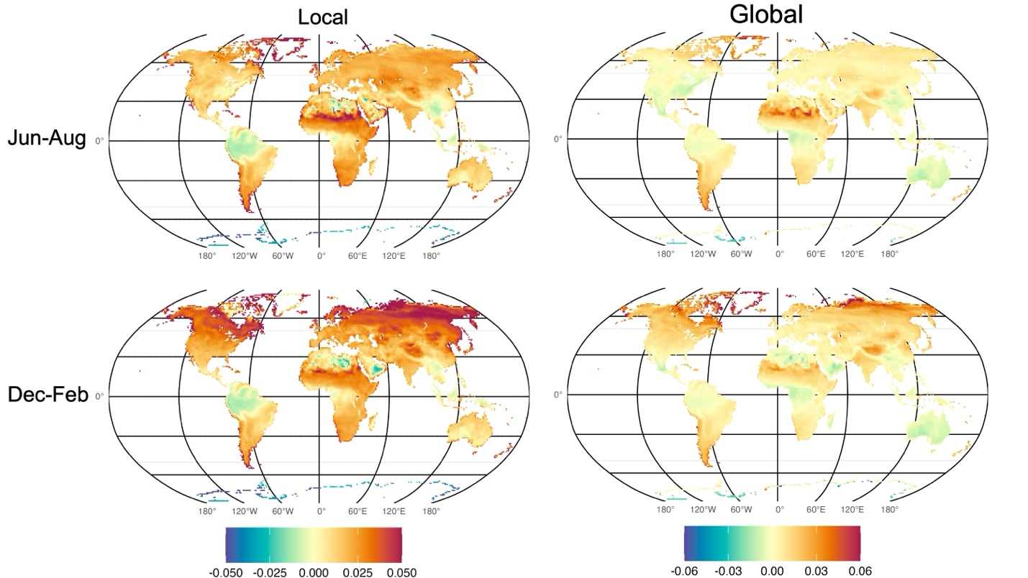
Supplementary Fig. 1| Null model output. Spatial distribution of expected values of local and global assemblage-level functional distinctiveness (FDist_{A}) resulting from null models for Jun-Aug (top panel) and Dec-Feb (bottom panel). Positive and negative values indicate higher and lower values, respectively, than expected under random assembly given species richness.

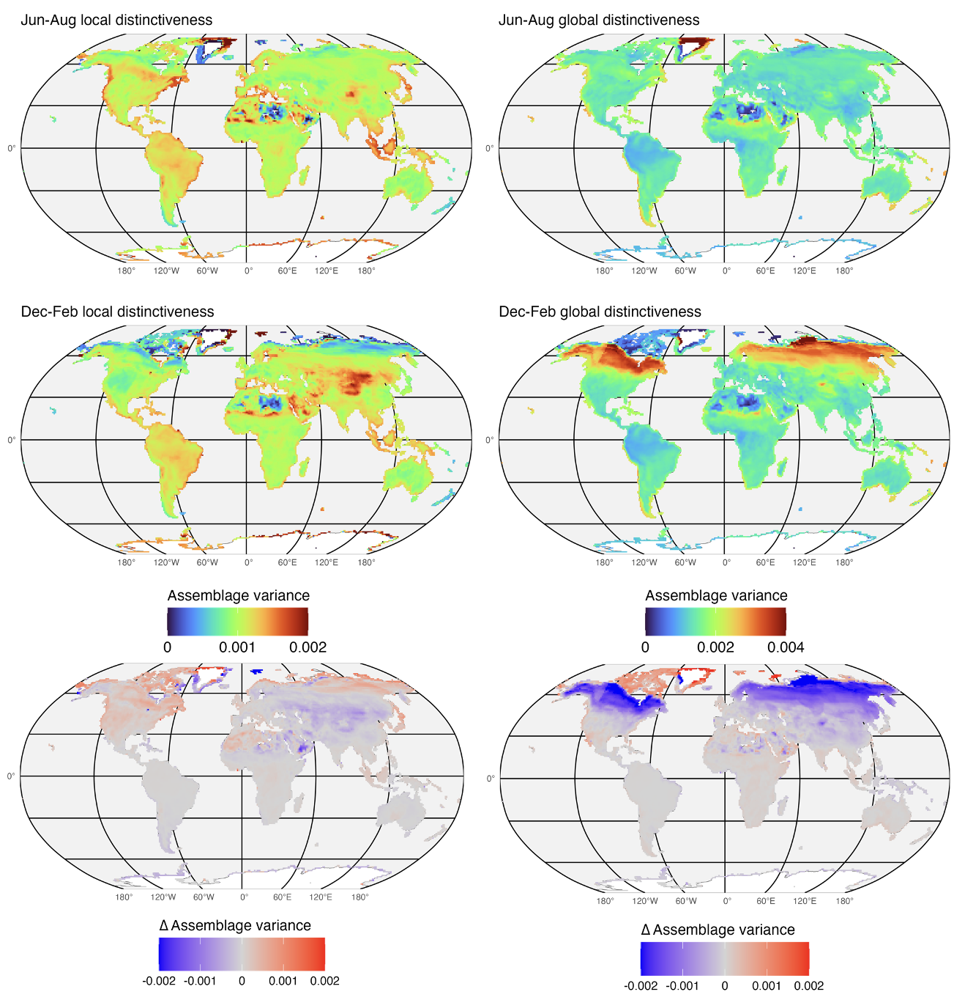
Supplementary Fig. 2| Spatial variation of variance in local (top panel) and global (middle panel) functional distinctiveness (FDist_{S}) values for all species in an assemblage. Higher values indicate greater spread of FDist_{S} values around the assemblage-level mean (FDist_{A}). Bottom panel shows the difference between variance during Jun-Aug and Dec-Feb, with red indicating regions where variance is higher in Jun-Aug and blue indicating regions where variance is higher in Dec-Feb.
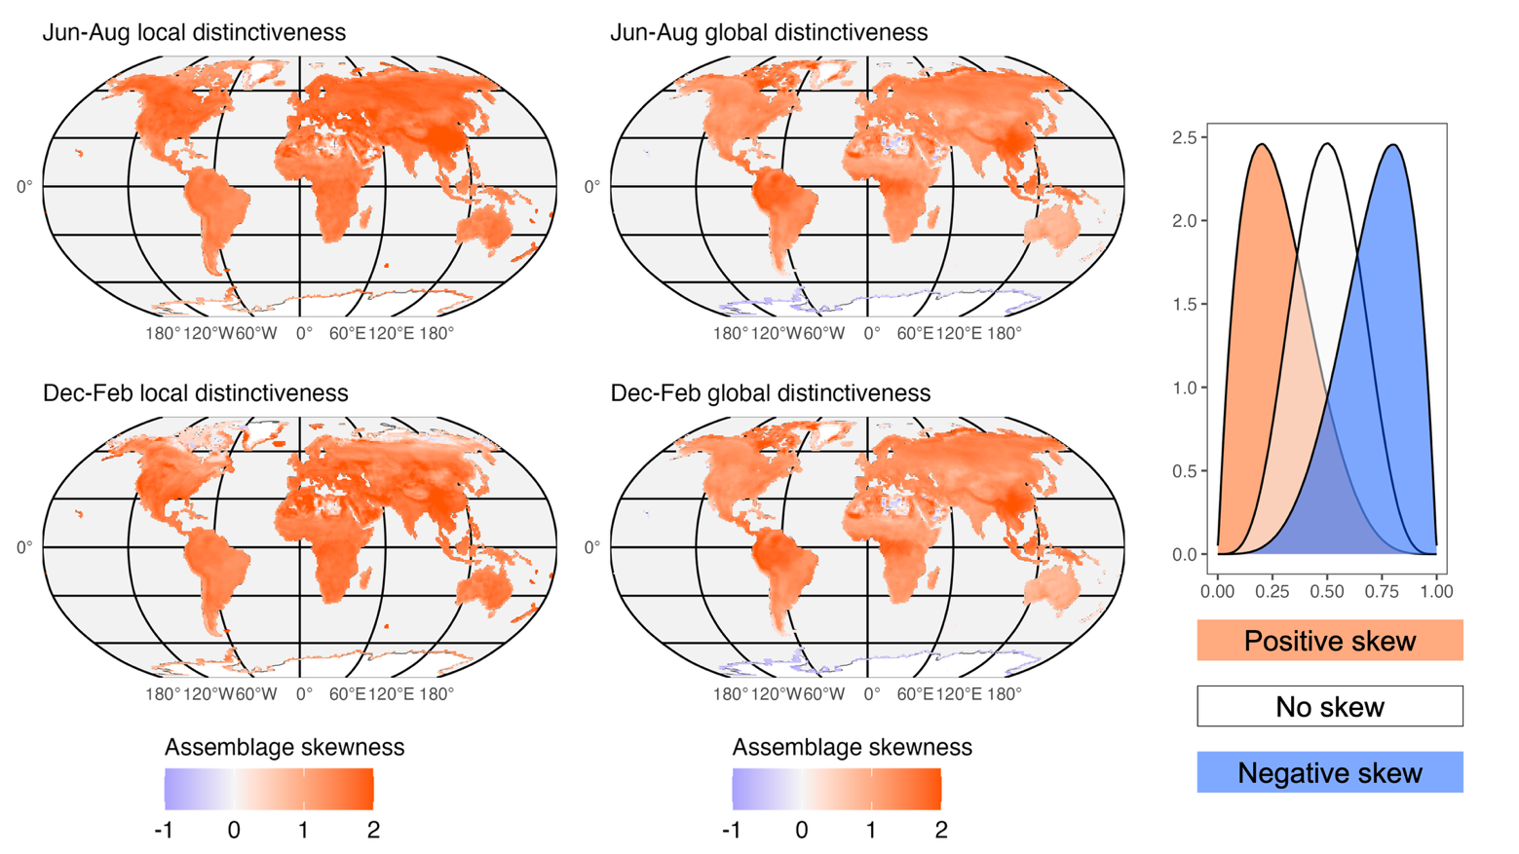
Supplementary Fig. 3| Spatial variation in skewness of the distribution of local (left panel) and global (right panel) functional distinctiveness (FDist_{S}) values for all species in an assemblage. Positive (red) values indicate distributions with a long right tail, negative (blue) values indicate distributions with a long left tail, values around zero (white) indicate normal distributions. Plot on the right illustrates the principles of skewness.

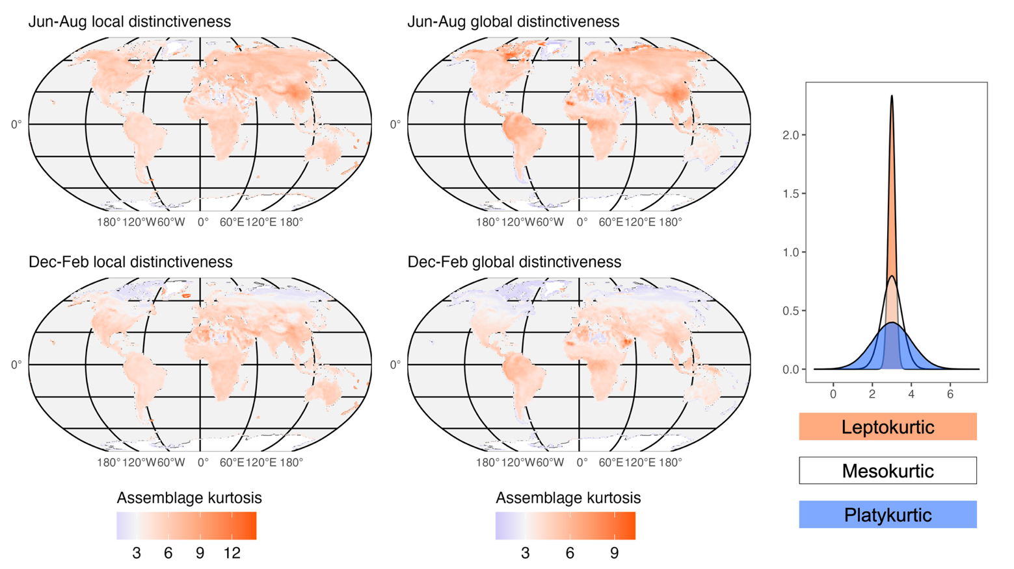
Supplementary Fig. 4| Spatial variation in kurtosis of the distribution of local (left panel) and global (right panel) functional distinctiveness (FDist_{S}) values for all species in an assemblage. High values (red) indicate leptokurtic distributions, low values (blue) indicate platykurtic distributions, white values indicate mesokurtic distributions. Plot on the right illustrates the principles of kurtosis.

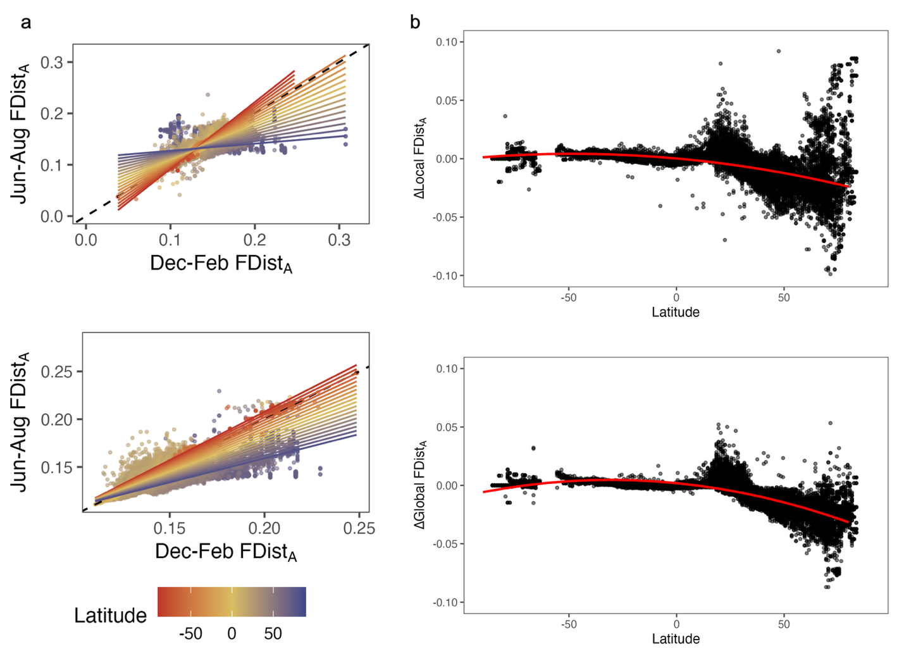

Supplementary Fig. 5| The effect of latitude on seasonal differences in assemblage-level functional distinctiveness (FDist_{A}). (a) Modelled relationships between Jun-Aug and Dec-Feb FDist_{A} at 10° latitudinal increments for local (top) and global (bottom) distinctiveness. The latitude × season interaction term is statistically significant for both local (P < 0.01) and global (P < 0.01) FDist_{A}. (b) Modelled relationships between the seasonal difference in local (top) and global (bottom) FDist_{A} as a function of latitude, fitted with a quadratic term to account for non-linearity. The quadratic term is statistically significant for both local (P < 0.01) and global (P < 0.01) FDist_{A}.

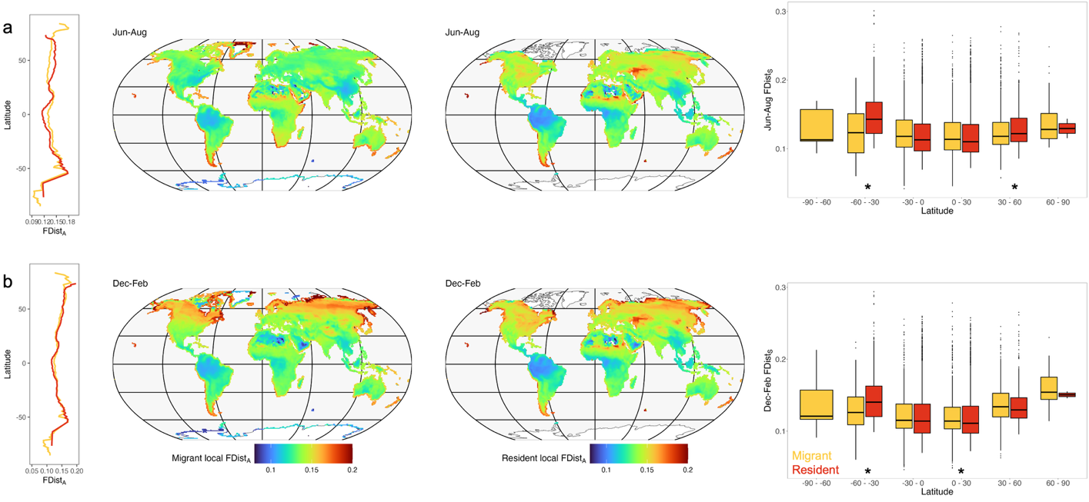
Supplementary Fig. 6| Comparison of local functional distinctiveness between migratory (yellow) and resident (red) assemblages across latitude. Map values and latitudinal gradients (far-left panels) represent assemblage-level averages calculated separately for resident and migratory species present at each location during Jun-Aug or Dec-Feb. In the far-right panel, species were assigned to a latitudinal band based on the centroid of their Jun-Aug or Dec-Feb range. Asterisks denote statistically significant differences between migratory and resident species within each latitudinal band (Jun-Aug Welch's t-test; P₃₀ ₋ ₆₀ = 0.016, P₋₆₀ ₋ ₋₃₀ < 0.01; Dec-Feb Welch's t-test P ₀₋₃₀ = 0.039, P₋₆₀ ₋ ₋₃₀ < 0.01).

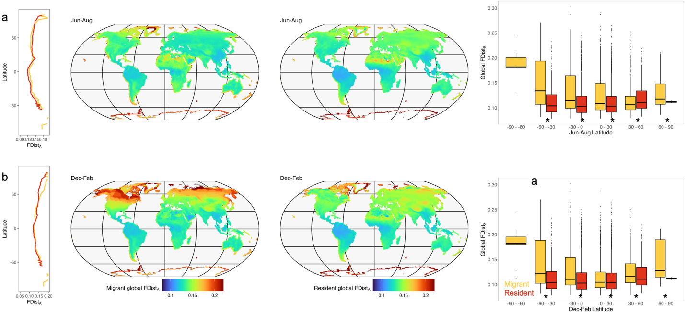
Supplementary Fig. 7| Comparison of global functional distinctiveness between migratory (yellow) and resident (red) assemblages across latitude. Map values and latitudinal gradients (far-left panels) represent assemblage-level averages calculated separately for resident and migratory species present at each location during Jun-Aug or Dec-Feb. In the far-right panel, species were assigned to a latitudinal band based on the centroid of their Jun-Aug or Dec-Feb range. Asterisks denote statistically significant differences between migratory and resident species within each latitudinal band (Jun-Aug Welch's t-test P₆₀ ₋ ₉₀ = 0.003, P₃₀ ₋ ₆₀ = 0.03, P₀ ₋ ₃₀ < 0.01, P₀ ₋ ₋₃₀ < 0.01, P₋₃₀ ₋ ₆₀ < 0.01; Jun-Aug Welch's t-test P₆₀ ₋ ₉₀ = 0.01, P₃₀ ₋ ₆₀ = 0.004, P₀ ₋ ₃₀ < 0.01, P₀ ₋ ₋₃₀ < 0.01, P₋₃₀ ₋ ₆₀ < 0.01).

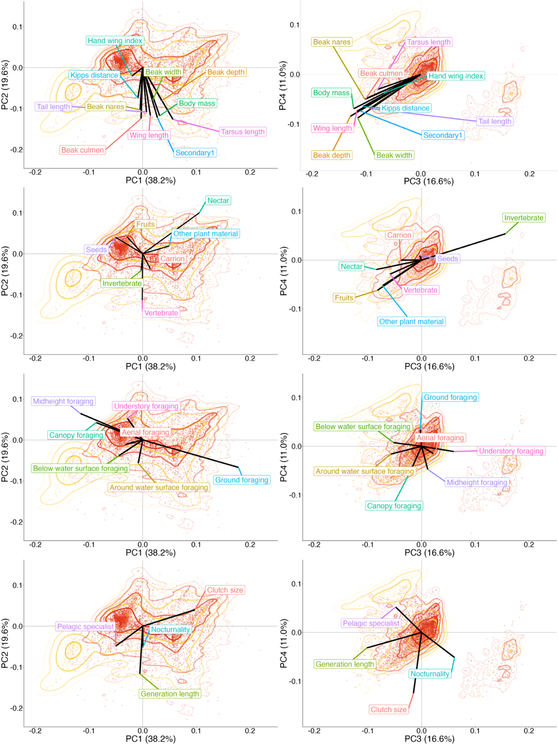
Supplementary Fig. 8| Trait space illustrating correlations between traits and each principal coordinate axis. Correlations are organized by trait group: morphological traits (top panel), diet and foraging strata (two middle panels), and life-history traits (bottom panel). Migrant and resident species are shown separately in yellow and red point, respectively.

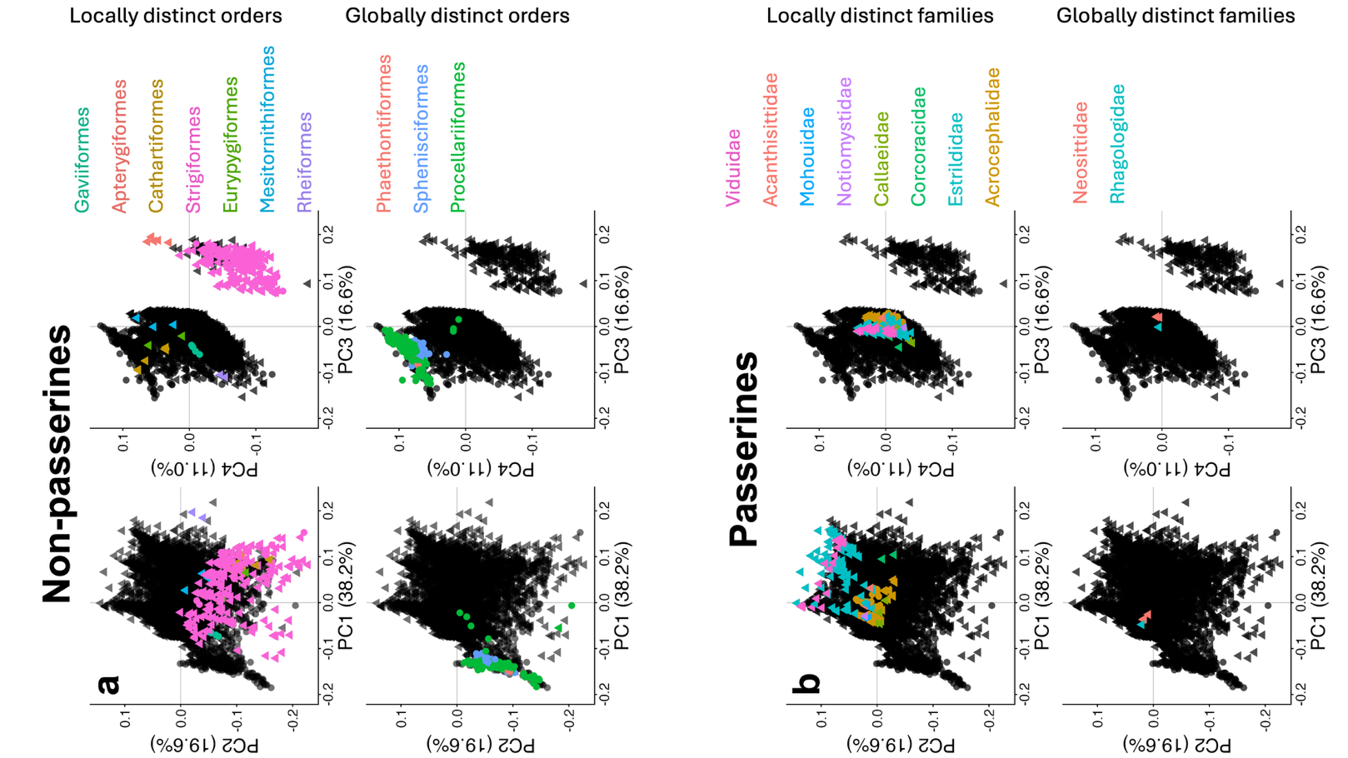
Supplementary Fig. 9| Distribution of distinct orders and families within trait space. (a) Positions of the top ten most locally and globally functionally distinct non-passerine orders position within trait space. (b) Positions of the top ten most locally and globally functionally distinct passerine families position within trait space.

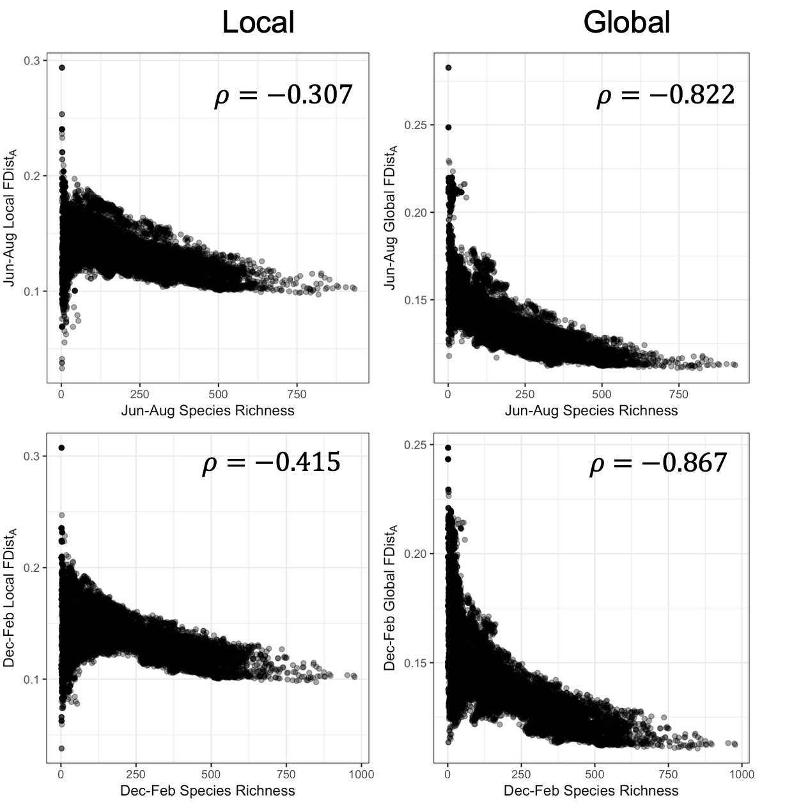
Supplementary Fig. 10| Relationship between species richness and assemblage-level local and global functional distinctiveness. For Jun-Aug and Dec-Feb time periods, Spearman rank correlation coefficient ($ρ$) was calculated to assess the strength of the relationships between species richness and assemblage-level functional distinctiveness.

