Table 1. List of the bee species and morphospecies found in the urban parishes of the DMQ with citations to the identification keys used. The table states whether or not each bee species was found while reviewing museum material (QCAZ), iNaturalist observations (iNat) and monitoring inside the Bicentenario park (BMP).
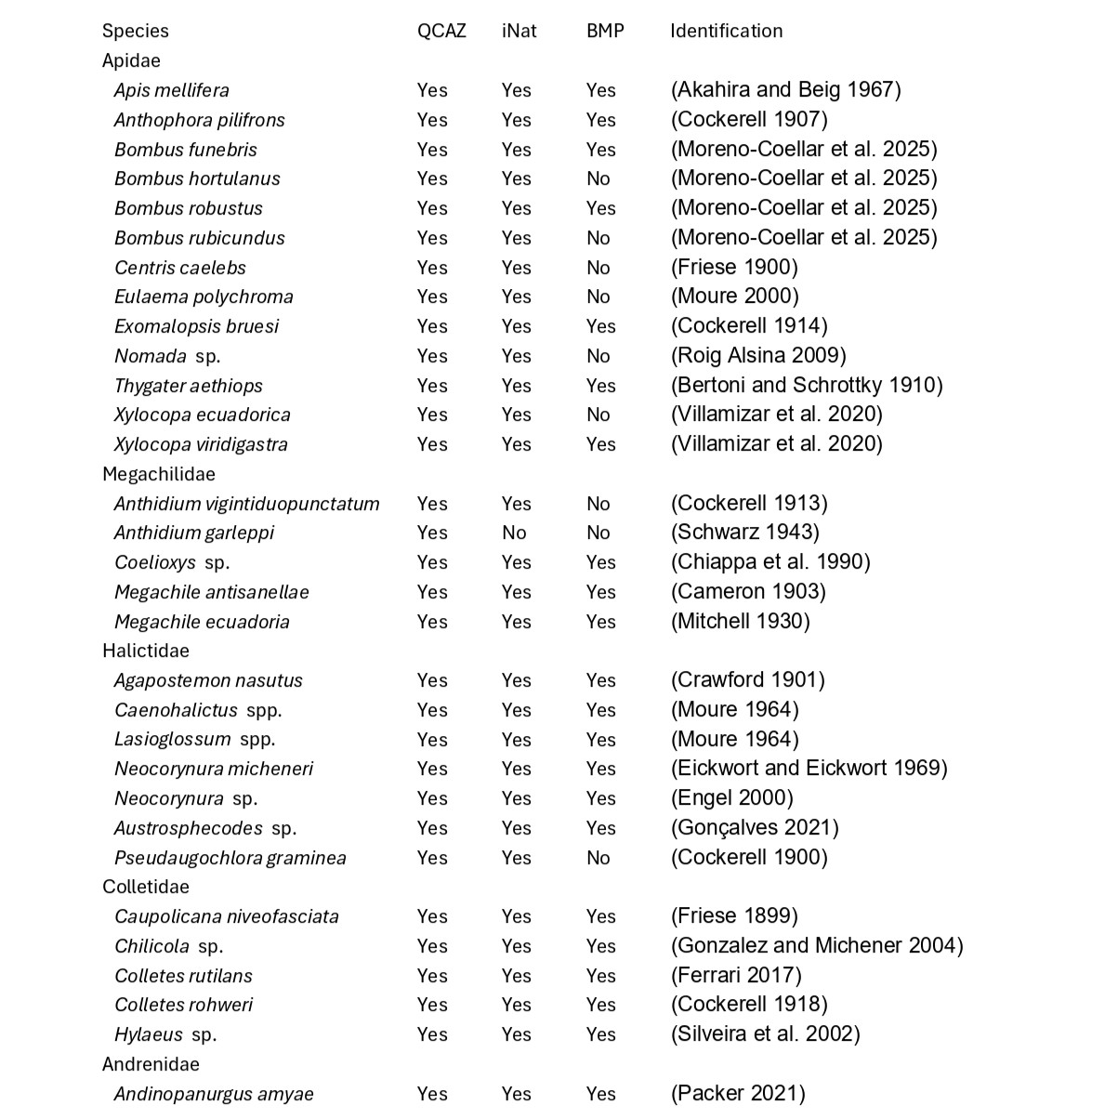

Table 2. Interactions between bee families and plant families inside the urban DMQ, obtained from citizen science data.
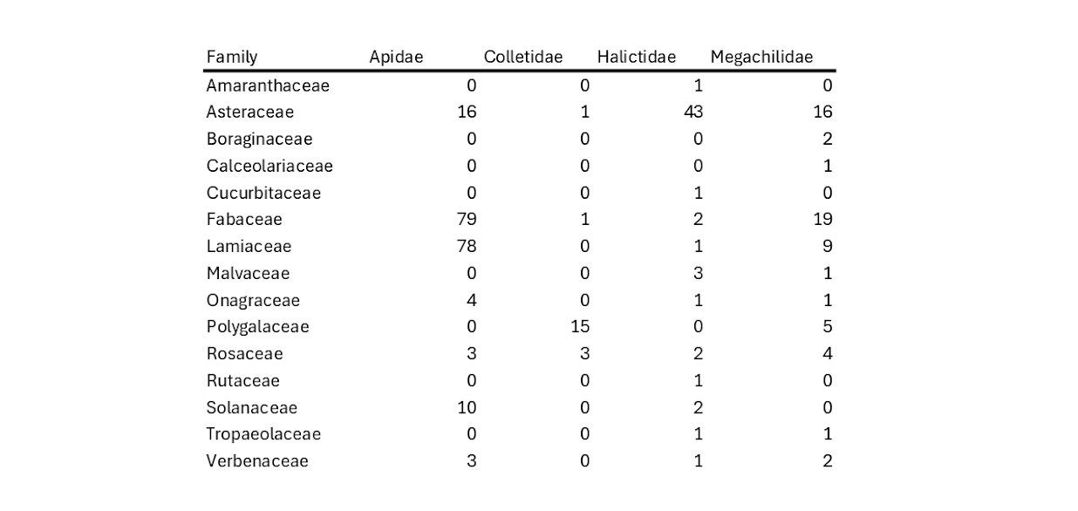
Table 3. Bee-plant interactions registered during the monitoring at the Bicentenario metropolitan park.
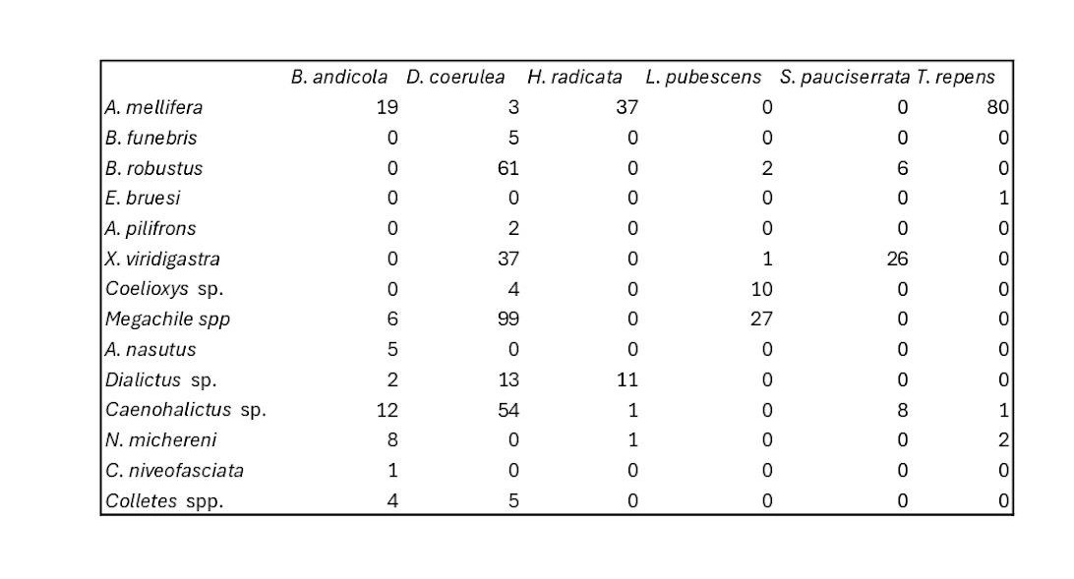
Table 4. Bee species richness at different plant hosts inside the Bicentenario metropolitan park. This table shows the total species richness documented throughout the monitoring conducted inside the urban park.
