Supplementary Information

MRI data acquisition and quality check

Participants
Clinically ascertained CNV carriers were recruited as either probands referred for genetic testing or as relatives. Controls were either non-carriers within the same families or individuals from the general population. We pooled data from 5 different cohorts: Cardiff University (Cardiff, UK), 16p11.2 European Consortium (Lausanne, Switzerland), University of Montreal (Canada), UCLA (Los Angeles, USA), and the Variation in Individuals Project (SVIP, USA). A subset of the participants with 16p11.2 proximal and 22q11.2 CNVs were included in prior publications (1–4). CNVs from non-clinical populations were identified in the UK Biobank (5,6). PennCNV and QuantiSNP were used, with standard quality control metrics, to identify CNVs (7–9).

16p11.2 European Consortium
MRI data of the EU participants were acquired on two 3T whole-body scanners. 14 carriers of a 16p11.2 proximal deletion and 17 duplication carriers, together with 59 controls (21 familial and 38 unrelated controls) were examined on a Magnetom TIM Trio (Siemens Healthcare, Erlangen, Germany), using a 12-channel RF receive head coil and RF body transmit coil. The remaining 16p11.2 proximal (13 deletions, 6 duplications), 1q21.2 distal (9 deletions, 7 duplications) carriers and controls (n=38) in the European cohort, were scanned on a Magnetom Prisma Syngo (Siemens Healthcare, Erlangen, Germany) using a 64-channel RF receive head coil and RF body transmit coil. T1-weighted (T1w) anatomical images acquired with the TIM Trio scanner used a Multi-Echo Magnetization Prepared RApid Gradient Echo sequence (ME-MPRAGE: 176 slices; 256×256 matrix; echo time (TE): TE1 = 1.64 ms, TE2 = 3.5 ms, TE3 = 5.36 ms, TE4 = 7.22 ms; repetition time (TR): 2530 ms; flip angle 7°). On the Prisma Syngo scanner, T1w images were acquired using a single-echo MPRAGE sequence (176 slices; 256×256 matrix; TE = 2.39 ms; TR = 2000 ms; flip angle 9°).

Simons Searchlight Consortium
Data were acquired using multi and single-echo sequences. 176 participants (38 del/ 34 dup 16p11.2 proximal carriers, 2 dup 1q21.1 distal carriers, and 102 familial controls) underwent the research MRI protocol at two imaging core sites on matched 3T Magnetom TIM Trio MRI scanners (Siemens Healthcare, Erlangen, Germany), using the vendor-supplied 32-channel phased-array radio-frequency head coils. 68 participants were scanned at University of California sites (UC) and 108 at the Children's Hospital of Philadelphia (CHOP). Structural MRI data included multi-echo T1w ME-MPRAGE using the following parameters: 176 slices, 256×256 matrix, TR = 2530 ms, TI = 1200 ms, TE = 1.64 ms, and flip angle 7°. Clinical MRI images (single-echo) obtained at the phenotyping core sites were also analyzed. The remaining 79 subjects (19 del/ 13 dup 16p11.2 proximal carriers, 12 del/8 dup 1q21.1 distal carriers and 27 familial controls) were scanned at the University of Washington Medical Center, Baylor University Medical Center, and Boston Children’s Hospital on two matched 3T Philips Achieva (Philips Healthcare, United States of America) and one unmatched Magnetom TIM Trio scanner (Siemens Healthcare, Erlangen, Germany), respectively. T1w images were acquired using a single-echo MPRAGE sequence and the following parameters: 160 slices; 256×256 matrix; TE = 2.98 ms; TR = 2300 ms; flip angle 9°. All multi-echo images were averaged following a Root-Mean Square (RMS) averaging method.

Brain Canada (BC, University of Montreal)
MRI scans for the Brain Canada cohort have been performed at the Montreal Neurological Institute with the same 3T scanner: Magnetom Prisma Syngo (Siemens Healthcare, Erlangen, Germany). Data included 16p11.2 proximal (3 deletions, 3 duplications), 1q21.2 distal (5 deletions, 1 duplication), 22q11.2 (1 duplication) carriers, and controls (n=26) T1w images were acquired using MPRAGE sequences, scanning protocol description is detailed on this website: http://www.bic.mni.mcgill.ca/users/jlewis/BrainCanada/MCIN/.

UCLA
Imaging data of 22q11.2 CNV carriers and typically developing (TD) controls were acquired at the University of California, Los Angeles (UCLA). Patients were ascertained from UCLA or Children's Hospital, Los Angeles Pediatric Genetics, Allergy/Immunology, and/or Craniofacial Clinics. We excluded 11 individuals from the analysis due to the insufficient quality of the imaging data. The final 22q11.2 sample includes 144 individuals (71 deletions, 19 duplications, and 54 controls). Demographically comparable TD comparison subjects were recruited from the same communities as patients via web-based advertisements and by posting flyers and brochures at local schools, pediatric clinics, and other community sites. Exclusion criteria for all study participants included significant neurological or medical conditions (unrelated to 22q11.2 mutation) that might affect brain structure, history of head injury with loss of consciousness, insufficient fluency in English, and/or substance or alcohol abuse or dependence within the past 6 months. The UCLA Institutional Review Board approved all study procedures and informed consent documents. Scanning was conducted on an identical 3 Tesla Siemens Trio MRI scanner with a 12-channel head coil at the University of California at Los Angeles Brain Mapping Center or at the Center for Cognitive Neuroscience.

Cardiff
Imaging acquisition in Cardiff was performed on a 3 T General Electric HDx MRI system (GE Medical Systems, Milwaukee, WI) using an eight-channel receive-only head RF coil. T1-weighted structural images were acquired with a 3D fast spoiled gradient echo (FSPGR) sequence (TR = 7.8 ms, TE = 3.0 ms, voxel size = 1 mm³ isomorphic). Data included 1 16p11.2 proximal deletion, 1q21.2 distal (3 deletions, 1 duplication), 22q11.2 (3 deletions, 2 duplications) carriers and 15 controls.

MRI quality control
All MRI T1w NIfTI images were visually inspected by the same rater (CM) for head coverage, ghosting, and susceptibility artifacts. Images were also screened after segmentation to ensure good tissue classification accuracy. From the clinically ascertained dataset, 55 subjects were excluded for insufficient image quality or artifacts while from the non-clinically ascertained dataset 52 subjects were excluded following the same criteria. Quality assurance protocol for Freesurfer based cortical reconstructions led to the exclusion of an additional 34 scans. Numbers reported in Table 1 are after exclusion.

List of abbreviations
CNV: copy number variants; DEL: deletion; DUP: duplication; NPD: neurodevelopmental and psychiatric disorders; Corr: Pearson correlation; ASD: autism spectrum disorder; ADHD: attention deficit hyperactivity disorder; BD: bipolar disorder; MDD: major depressive disorder; OCD: obsessive-compulsive disorder; SCZ: schizophrenia; PC: principal component; L: left hemisphere; Dim: dimension; ICV: Intracranial Volume; PCA: Principal components analysis.

Supplementary Figures
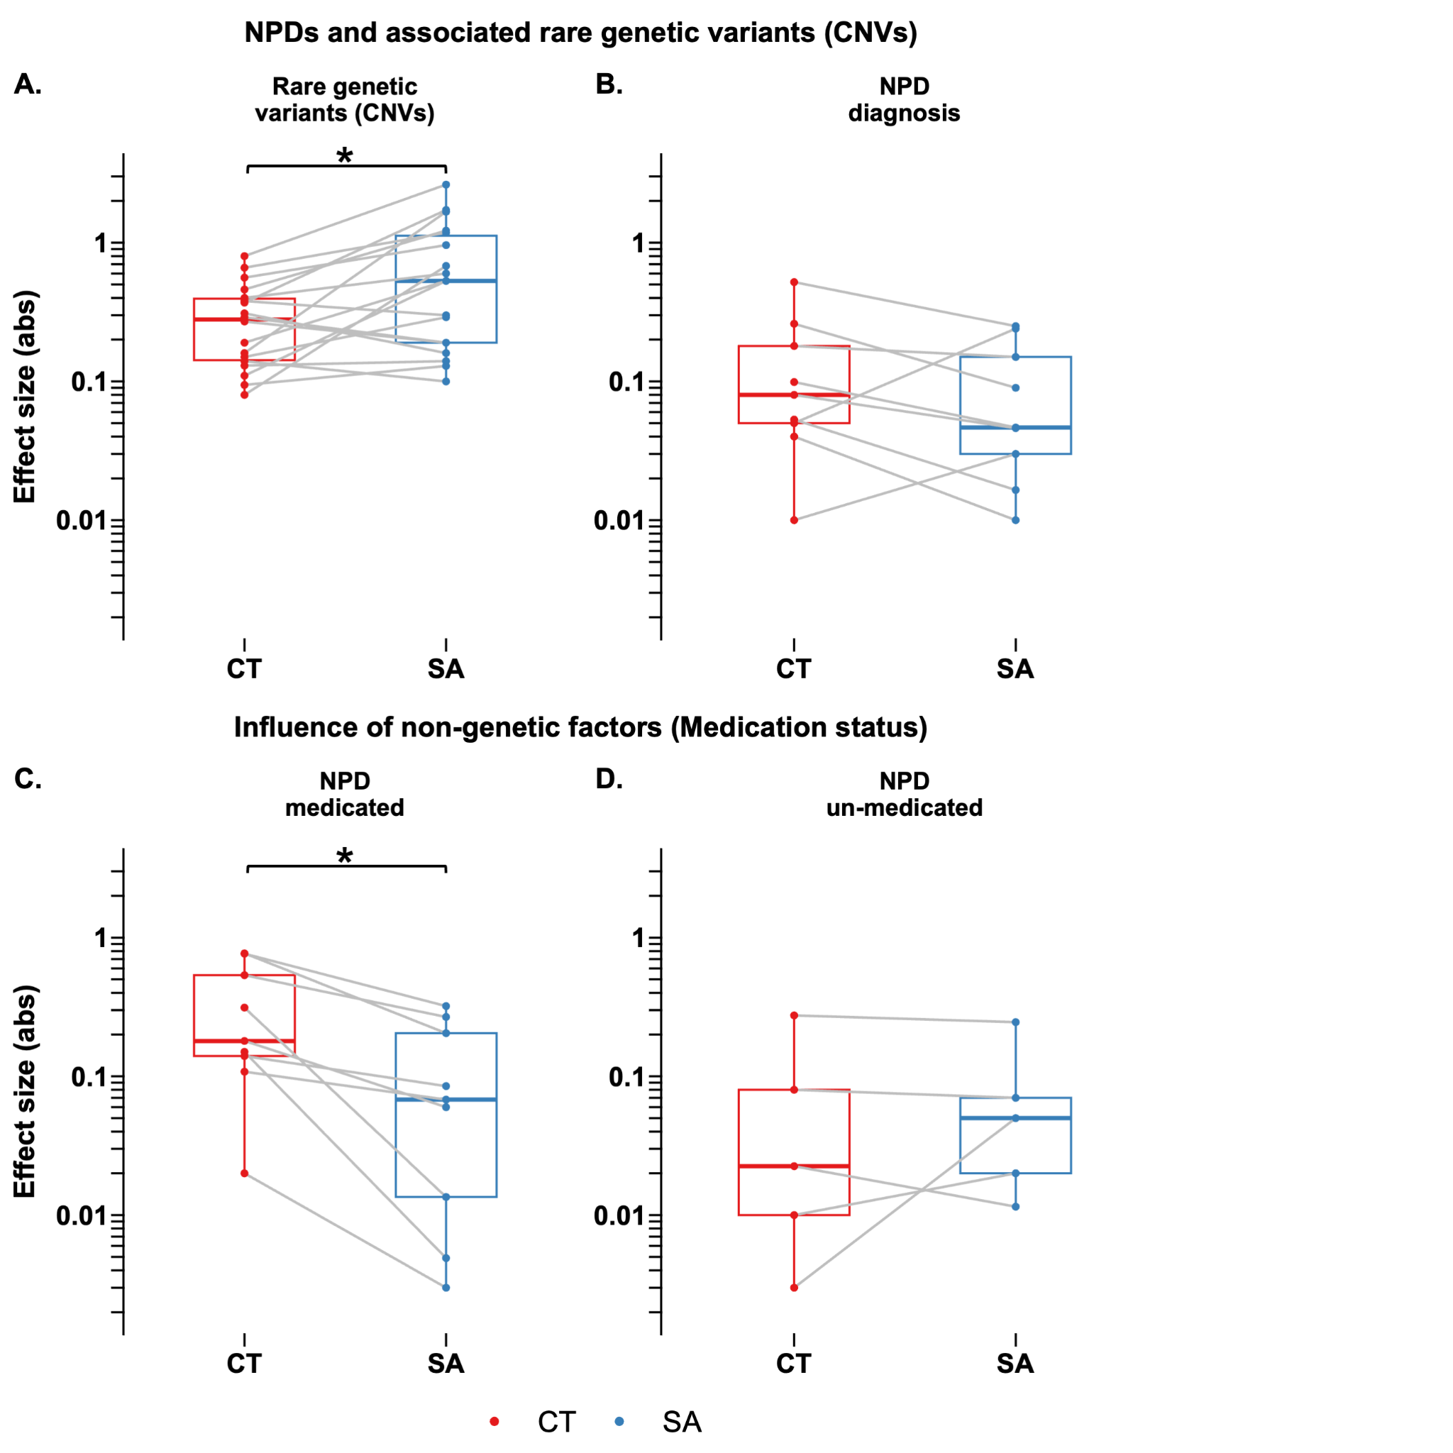

Supplementary Figure 1. Paired comparison of CT and SA effect sizes
Legend: A-B) Paired boxplots comparing absolute effect sizes of mean cortical thickness (CT) and total surface area (SA) for A) rare genetic variants (CNVs, paired Wilcoxon FDR q=2E-2); and B) neurodevelopmental and psychiatric disorders (NPDs, paired Wilcoxon FDR q=1.6E-1). C-D) Comparison of absolute CT and SA effect sizes for NPD diagnostic sub-groups stratified by medication status: C) Medicated (paired Wilcoxon FDR q=1.6E-2); and D) Un-medicated (paired Wilcoxon FDR q=1). Case-control differences were calculated after adjusting for age, sex, and site. Individual points represent specific CNVs or disorders, with gray lines connecting paired values to visualize the within-disorder relationship between metrics. Boxplots represent the median and interquartile range (IQR). Red indicates CT and blue indicates SA. The y-axis represents absolute Cohen’s d values plotted on a log10 scale.
Abbreviations: CNV=copy number variant; CT=cortical thickness; NPD=neurodevelopmental and psychiatric disorders; SA=surface area.
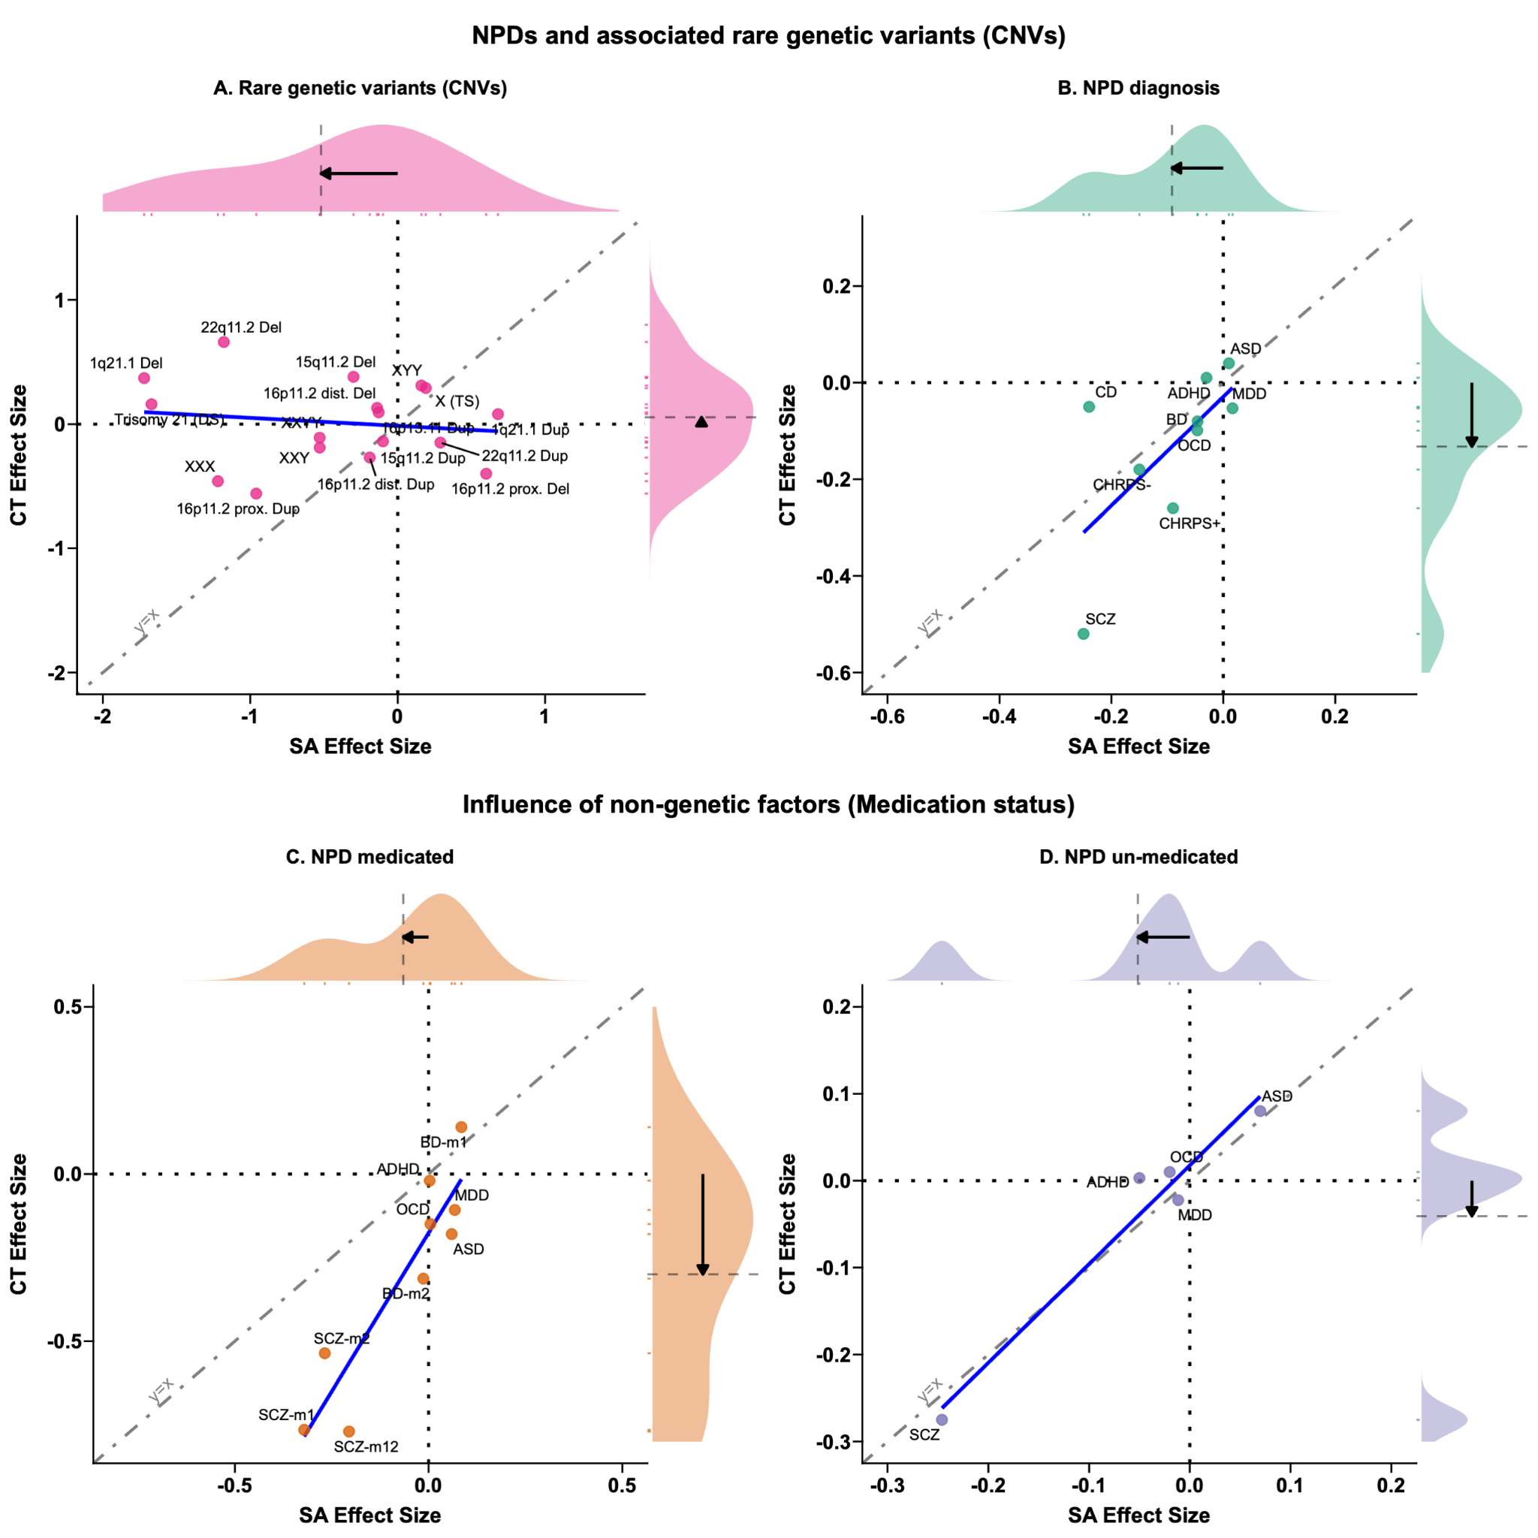

Supplementary Figure 2. Concordance between CT and SA effect sizes across NPDs, genetic variants, and medication status
Legend: A-B) Scatter plots comparing mean cortical thickness (CT) and total surface area (SA) effect sizes for A) rare genetic variants (CNVs); and B) neurodevelopmental and psychiatric disorders (NPDs). C-D) Comparison of CT and SA effect sizes for NPD diagnostic sub-groups split by medication status: C) Medicated; and D) Un-medicated. Each point represents the signed Cohen's d value, where positive and negative values indicate increased and decreased metrics in cases compared to controls, respectively. The blue solid line represents the linear regression fit. The gray dot-dash line (y=x) indicates the line of perfect concordance where CT and SA effect sizes are equal. Dotted lines at x=0 and y=0 delineate the quadrants of directionality. Marginal density plots (top and right) visualize the distribution of effect sizes for SA and CT, respectively. Arrows within the marginal plots indicate the direction and magnitude of the mean effect size shift from zero. Case-control differences were adjusted for age, sex, and site. Axes represent signed effect sizes.
Abbreviations: ADHD=attention deficit hyperactivity disorder; ASD=autism spectrum disorder; BD=bipolar disorder; CD: conduct disorder; CHR-PS: clinical high risk for psychosis; CHR-PS-: CHR who did not develop a psychotic disorder; CHR-PS+: CHR who later developed a psychotic disorder; CNV=copy number variant; CT=cortical thickness; Del=deletion; Dup=duplication; MDD=major depressive disorder; NPD=neurodevelopmental and psychiatric disorders; OCD=obsessive-compulsive disorder; prox.=proximal; SA=surface area; SCZ=schizophrenia; TS=Turner syndrome; WBS=Williams-Beuren syndrome;
Medication abbreviations: -m=medicated; -u=un-medicated; BD-m1=lithium medication; BD-m2=antiepileptics medication; SCZ-m1=1st generation antipsychotic; SCZ-m2=2nd generation antipsychotic; SCZ-m12=1st & 2nd generation antipsychotic;

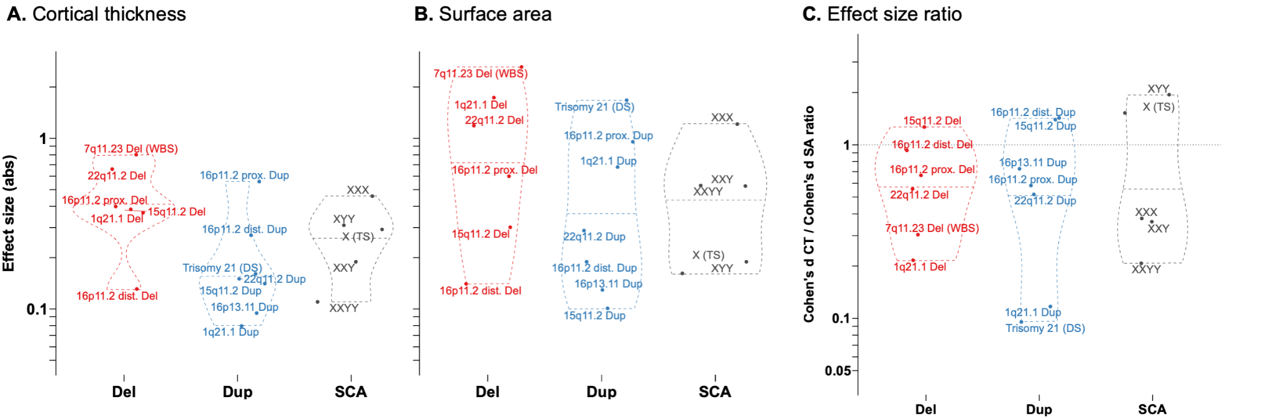

Supplementary Figure 3. Deletion-Duplication-SCA stratifications
Legend: Violin plots comparing the absolute effect sizes for A) mean CT and B) total SA; for deletions (Del), duplications (Dup), sex chromosome aneuploidies (SCA); and C) CT/SA effect size ratios.
Abbreviations, Abs=absolute; ADHD=attention deficit hyperactivity disorder; ASD=autism spectrum disorder; BD=bipolar disorder; CD: conduct disorder; CHR-PS: clinical high risk for psychosis; CNV=copy number variant; CT=cortical thickness; Del=deletion; Dup=duplication; MDD=major depressive disorder; NPD=neurodevelopmental and psychiatric disorders; OCD=obsessive-compulsive disorder; SA=surface area; SCZ=schizophrenia; TS=Turner syndrome;

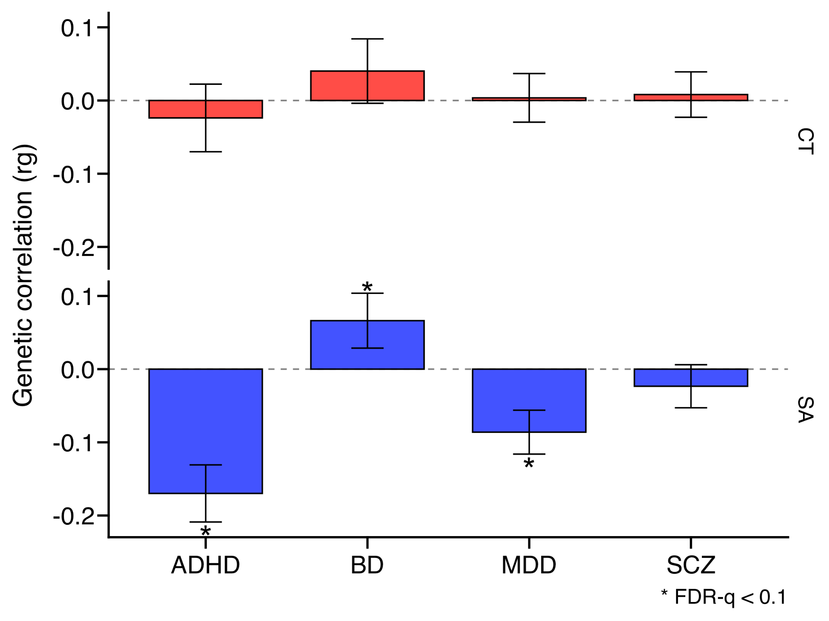

Supplementary Figure 4. Genetic correlations between global cortical metrics and NPDs from Grasby et al. 2020.
Legend: Genetic correlations (rg) between neurodevelopmental and psychiatric disorders (NPDs) and global cortical metrics: mean cortical thickness (CT) and total surface area (SA). Correlations and standard errors were derived using summary statistics from Grasby et al. (10). * indicates FDR significant (q<0.1). Note: We used the lenient FDR q < 0.1 threshold, as these values come from Grasby et al. (2020), where FDR was applied across multiple psychiatric disorders and MRI metrics.
Abbreviations: ADHD=attention deficit hyperactivity disorder; BD=bipolar disorder; CT=cortical thickness; FDR=false discovery rate; MDD=major depressive disorder; NPD=neurodevelopmental and psychiatric disorders; SA=surface area; SCZ=schizophrenia.

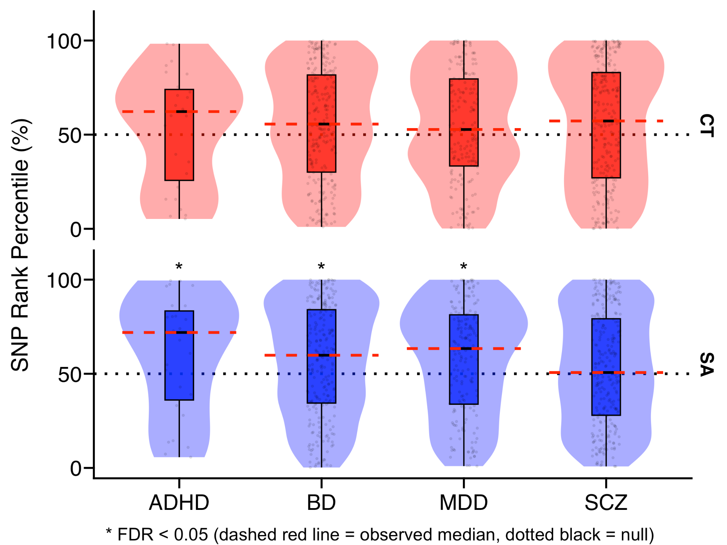

Supplementary Figure 5. Enrichment of NPD-associated SNPs within global cortical morphology GWAS signals.
Legend: Enrichment of NPD-associated single-nucleotide polymorphisms (SNPs) within global cortical morphology GWAS signals. The y-axis displays the percentile ranking of NPD risk variants. The dotted black line at 50% represents the null hypothesis (random distribution). The dashed red line indicates the observed median rank. Statistical significance was assessed using permutation testing (10,000 permutations). Red violin plots indicate CT, and blue violin plots indicate SA. * indicates significant enrichment (FDR q<0.05).
Abbreviations: ADHD=attention deficit hyperactivity disorder; BD=bipolar disorder; CT=cortical thickness; FDR=false discovery rate; GWAS=genome-wide association study; MDD=major depressive disorder; NPD=neurodevelopmental and psychiatric disorders; SA=surface area; SCZ=schizophrenia; SNP=single nucleotide polymorphism.

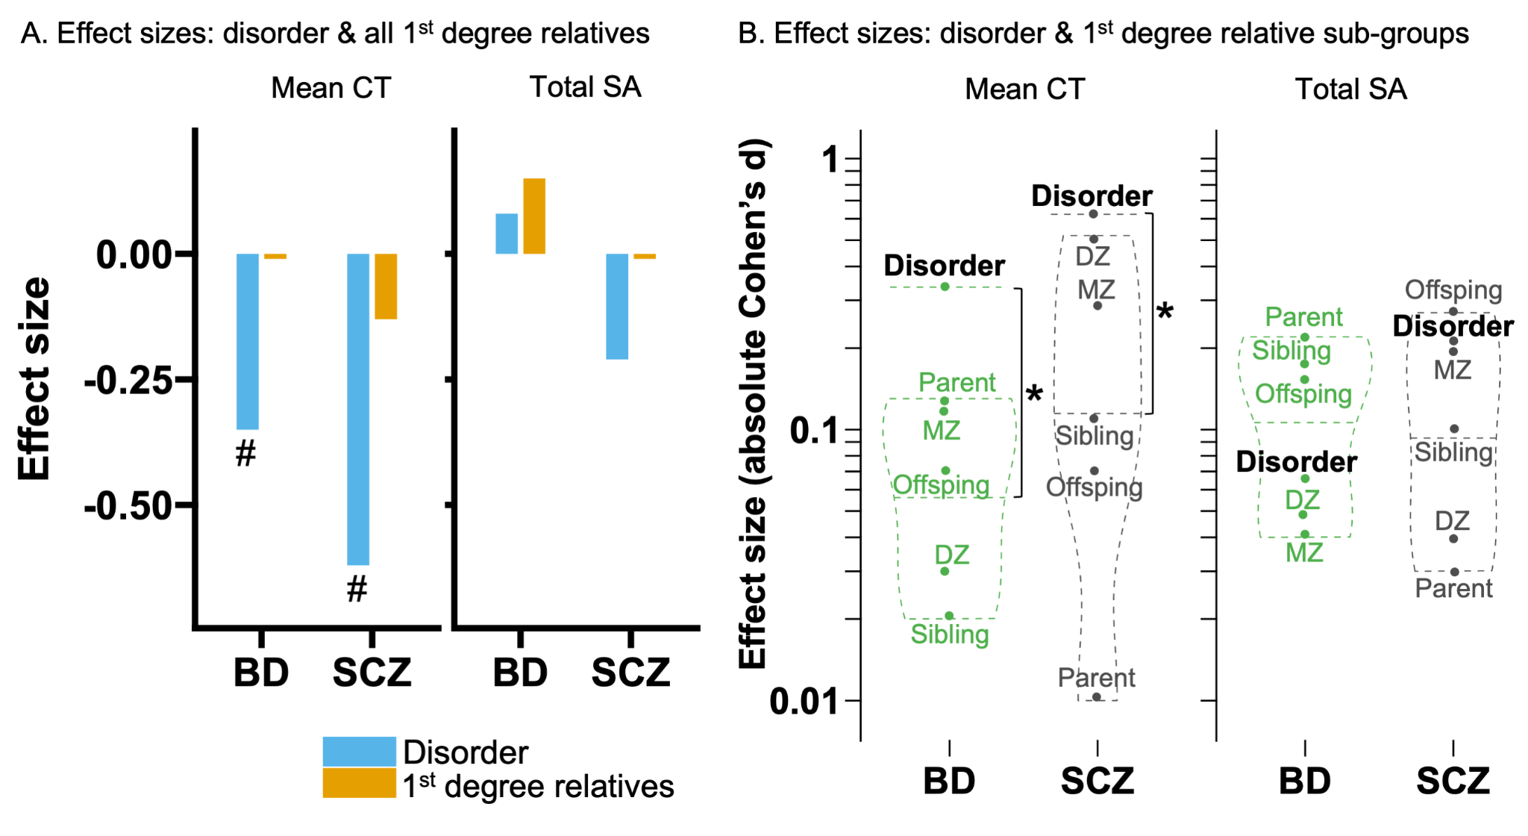
Supplementary Figure 6. Cortical alterations in psychiatric disorders versus 1st-degree relatives.
Legend: A) Bar plots comparing mean cortical thickness (CT) and total surface area (SA) effect sizes for individuals with bipolar disorder (BD) or schizophrenia (SCZ) versus their unaffected first-degree relatives. Data are derived from the ENIGMA Relatives study(11). Blue bars indicate the disorder group, and orange bars indicate first-degree relatives. # indicates significant case-control differences as reported in the original study. B) Violin plots comparing absolute effect sizes of relative sub-groups against the disorder group (BD / SCZ). The dashed horizontal lines indicate the effect size of the disorder group. Labeled points represent specific relative categories. * indicates that the median effect size of the relative sub-groups is significantly lower than the disorder effect size (FDR q<0.05; one-sample Wilcoxon signed-rank test). The y-axis in panel B represents absolute Cohen’s d plotted on a log10 scale.
Abbreviations: BD=bipolar disorder; CT=cortical thickness; DZ=dizygotic twin; MZ=monozygotic twin; SA=surface area; SCZ=schizophrenia.

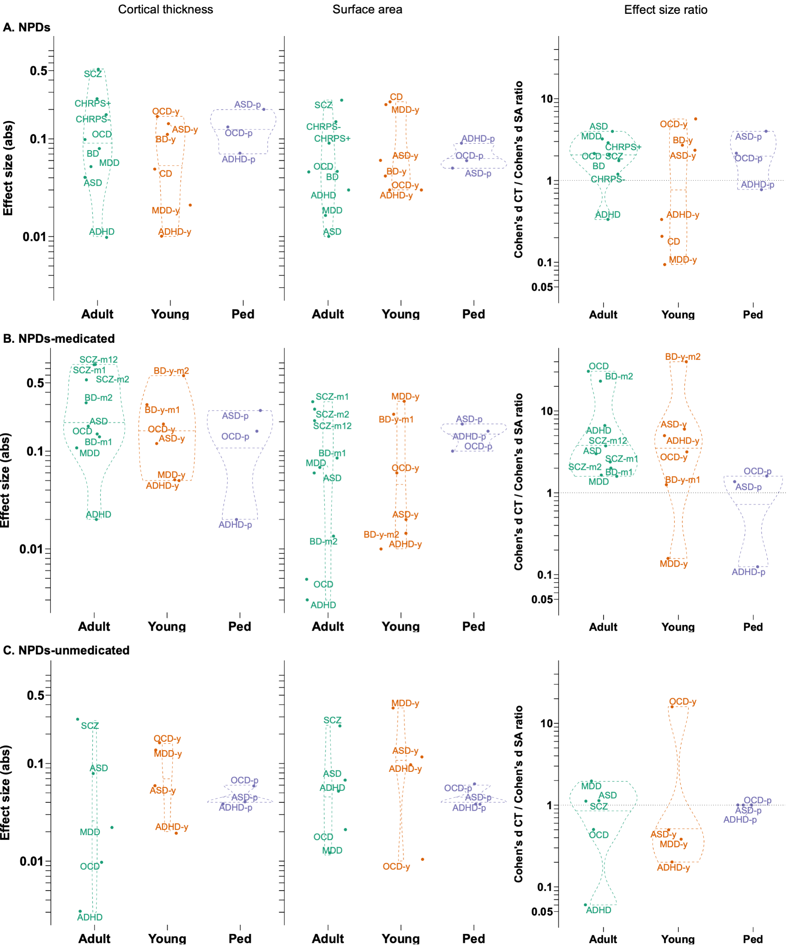
Supplementary Figure 7. Adult-young-pediatric age sub-groups
Legend: Violin plots comparing the absolute effect sizes for mean CT, total SA, and CT/SA effect size ratios for A) NPDs (top row), B) NPDs-medicated (middle row), and C) NPDs-unmedicated (bottom row);
Abbreviations, Abs=absolute; ADHD=attention deficit hyperactivity disorder; ASD=autism spectrum disorder; BD=bipolar disorder; CD: conduct disorder; CHR-PS: clinical high risk for psychosis; CNV=copy number variant; CT=cortical thickness; Del=deletion; Dup=duplication; MDD=major depressive disorder; NPD=neurodevelopmental and psychiatric disorders; OCD=obsessive-compulsive disorder; SA=surface area; SCZ=schizophrenia; TS=Turner syndrome;
Adult-Adolescence-Pediatric abbreviations: -y=adolescence/young; -p=pediatric).

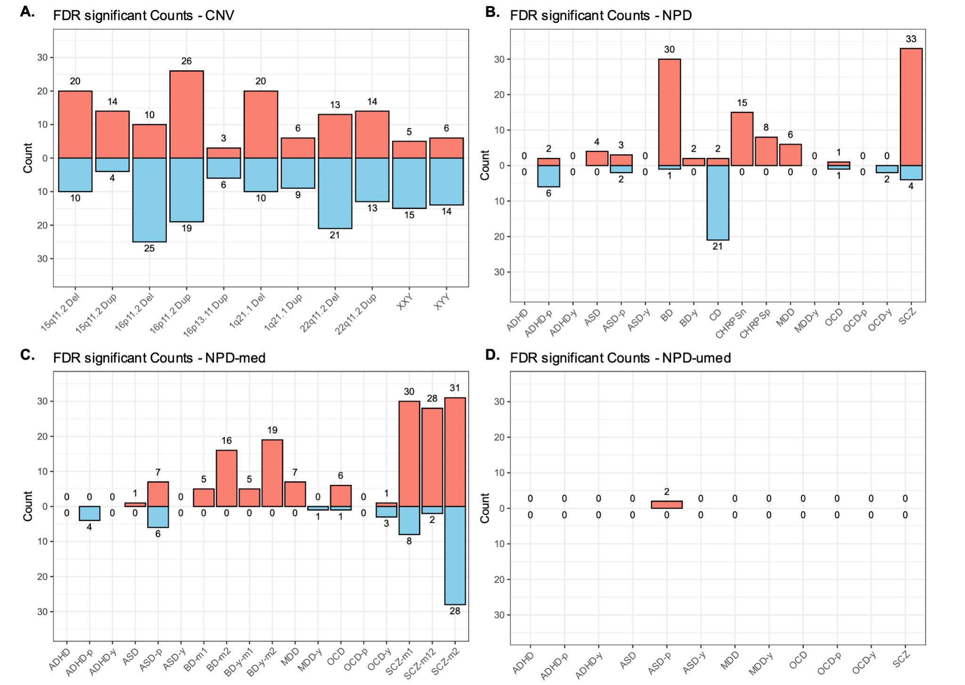

Supplementary Figure 8. Number of FDR significant regions per cortical map
Legend: Number of FDR significant cortical regions (out of 34) per CNV/NPD for cortical thickness (up, red) and surface area (down, blue) for A) CNVs; B) NPDs; C) NPD medication; and D) NPD-unmedicated.

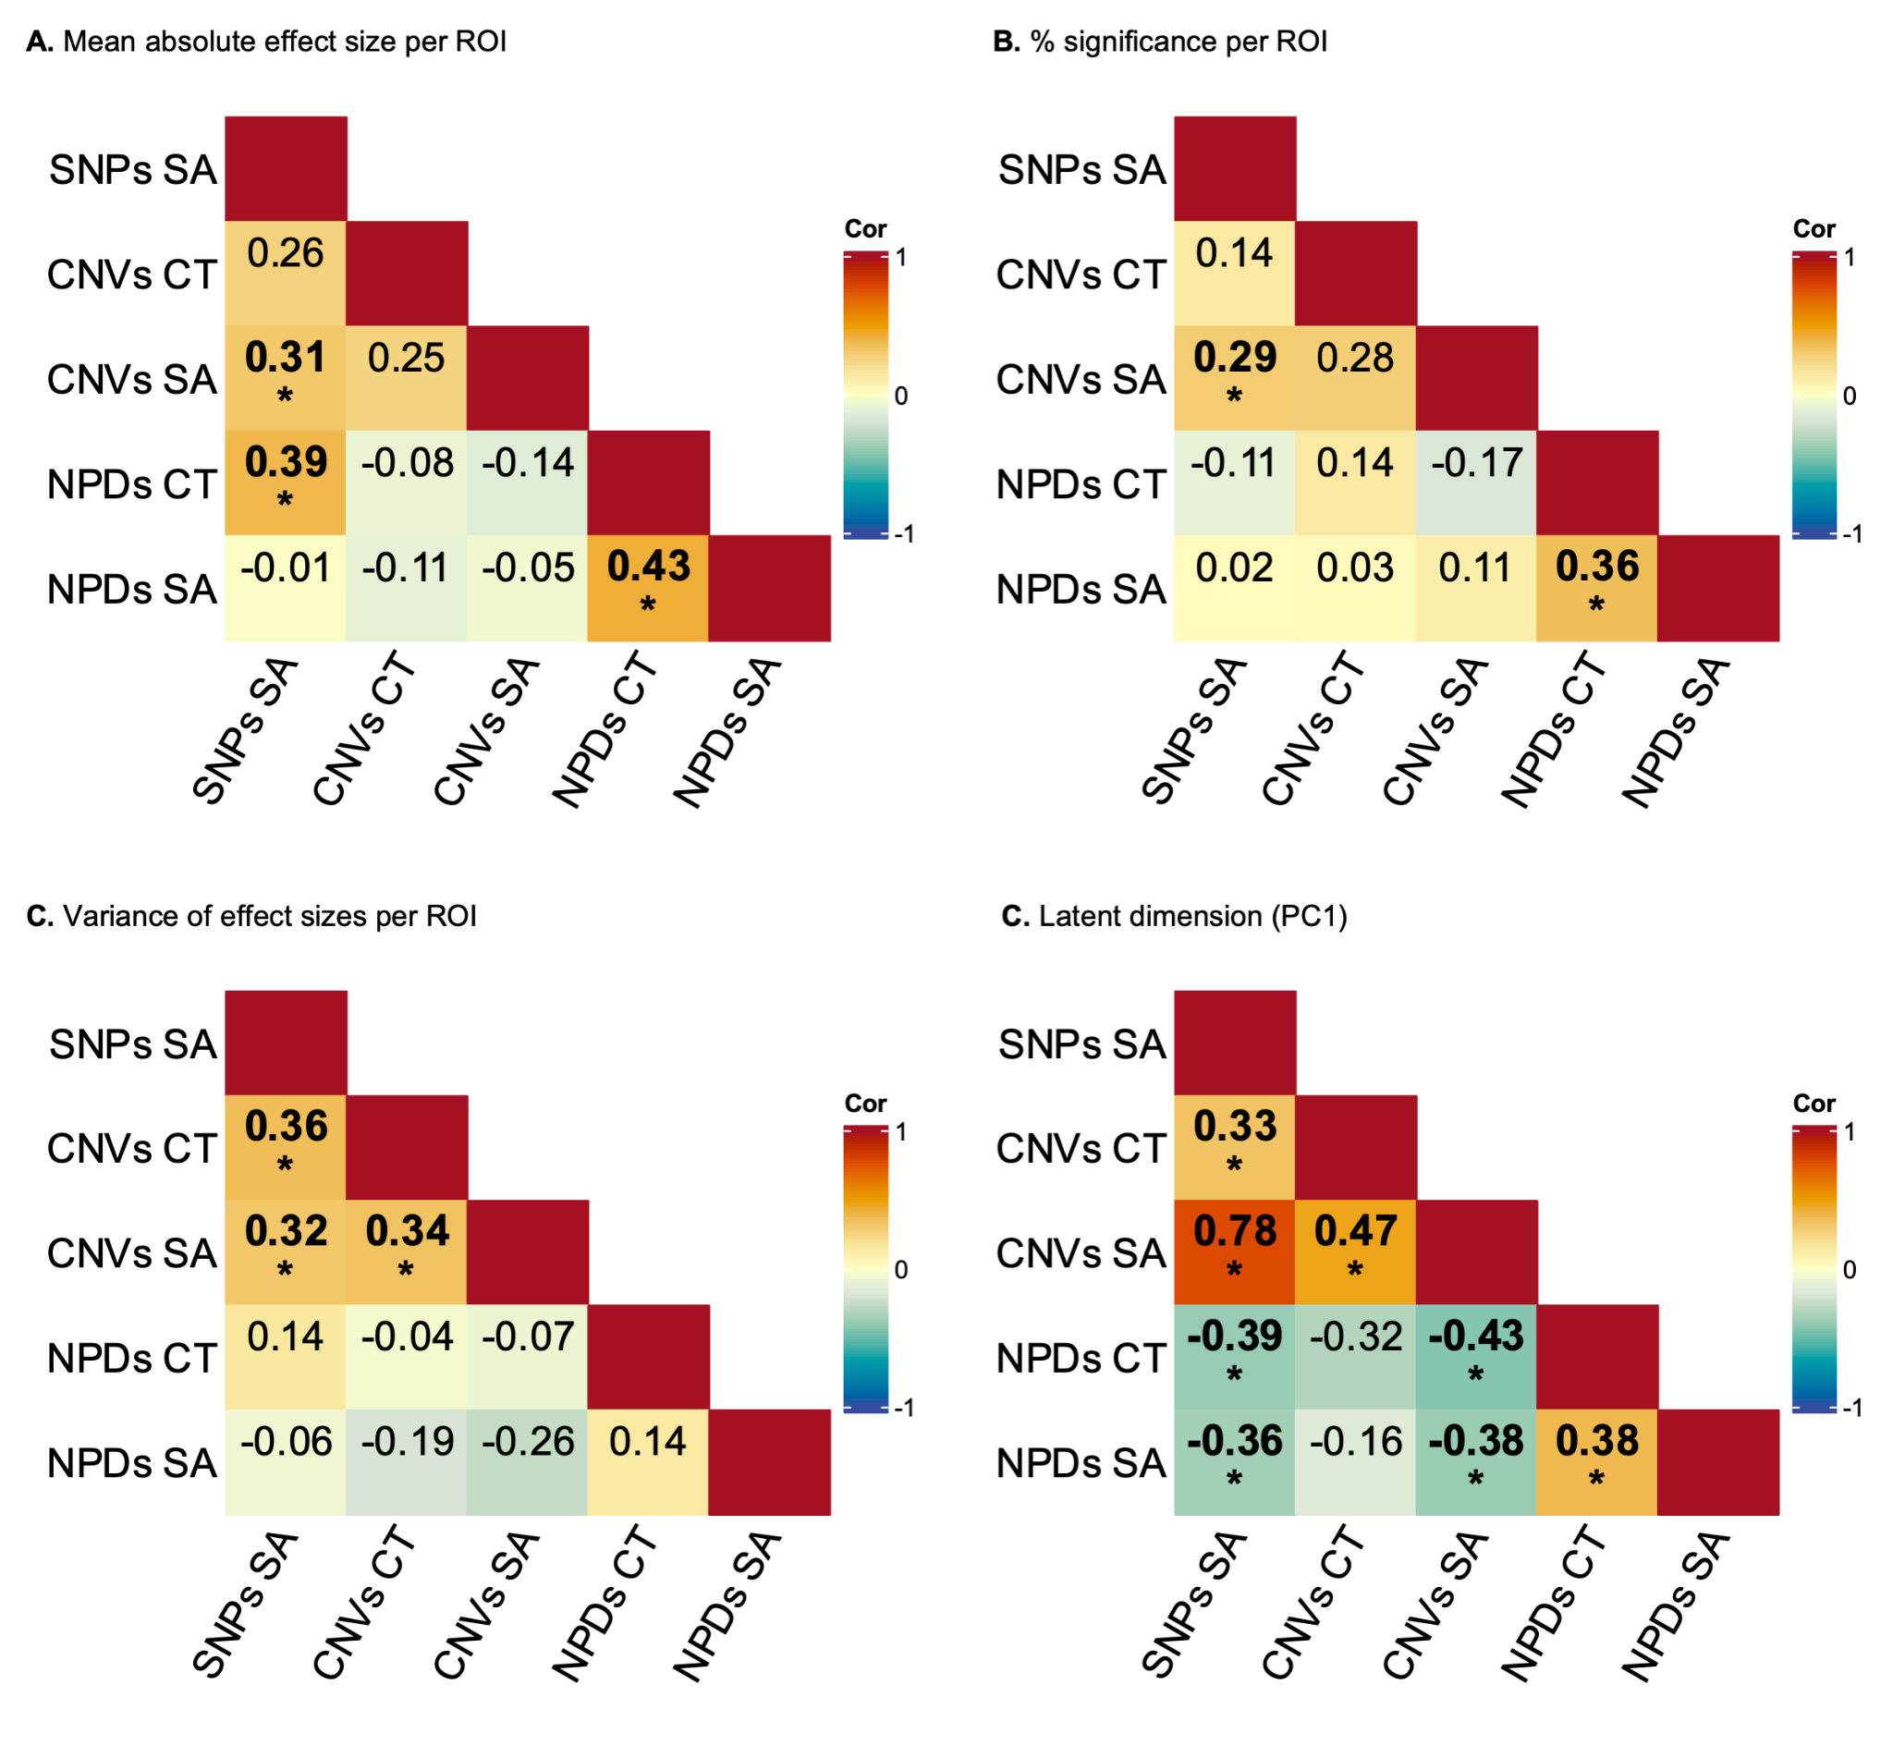

Supplementary Figure 9. Correlations between consensus maps
Legend: Correlation between pairs of consensus maps for A) mean absolute effect sizes, B) % significance, C) variance of effect sizes, and D) principal component 1 (PC1). *: spin permutation p-value < 0.05, which preserves the spatial structure of the cortex while generating null distributions to account for spatial autocorrelation.
Abbreviations. CNV=copy number variants; Cor.=correlation; CT: cortical thickness; SA=surface area;

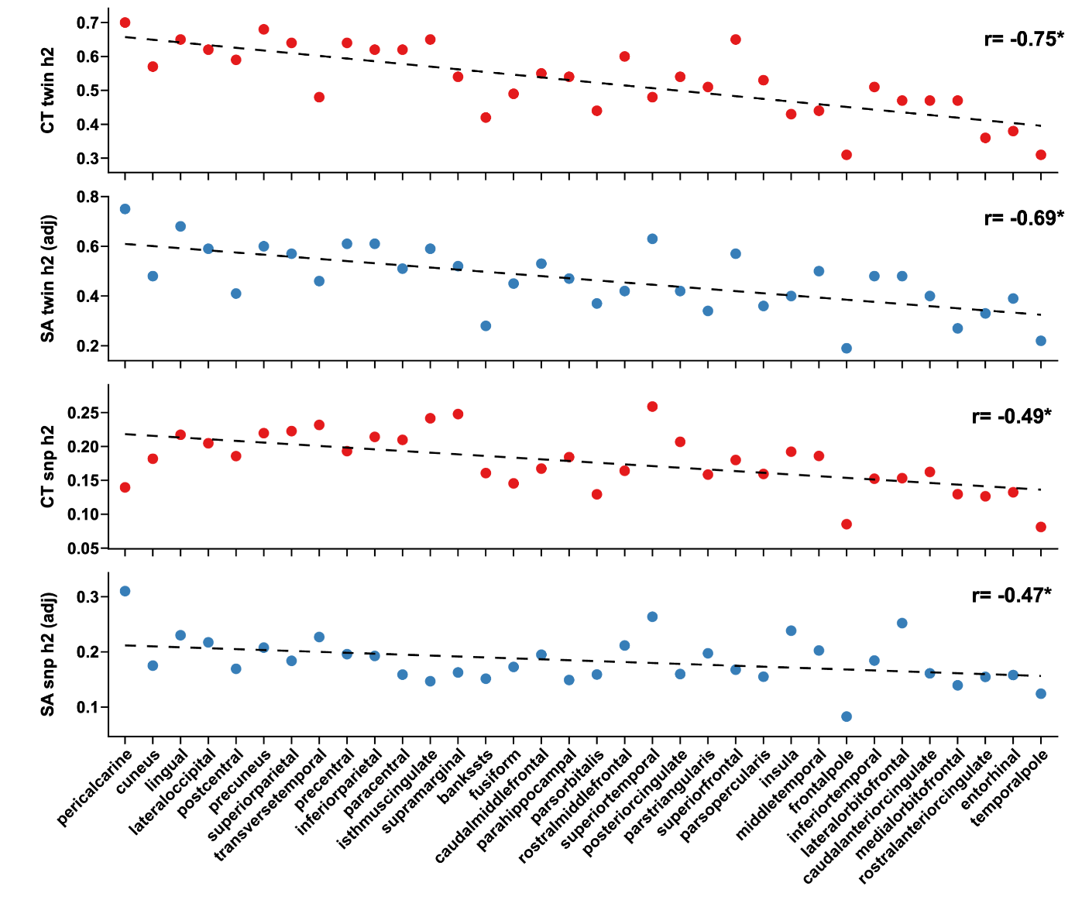

Supplementary Figure 10. Correlations between cortical gradient and regional twin and SNP heritability estimates
Legend: Regional profiles of twin and SNP heritability estimates for cortical thickness and surface area across 34 Desikan cortical regions from Grasby et al. (10), plotted against cortical gradient (sensorimotor-to-association regions). Each point represents heritability estimates. The surface area estimates are adjusted (adj) for Total SA.
X-axis: cortical regions ordered according to the cortical gradient from sensorimotor to association regions. Dotted line: correlation with the cortical gradient. Each panel displays Pearson correlation and *:spin-permutation significant, p-spin < 0.05.

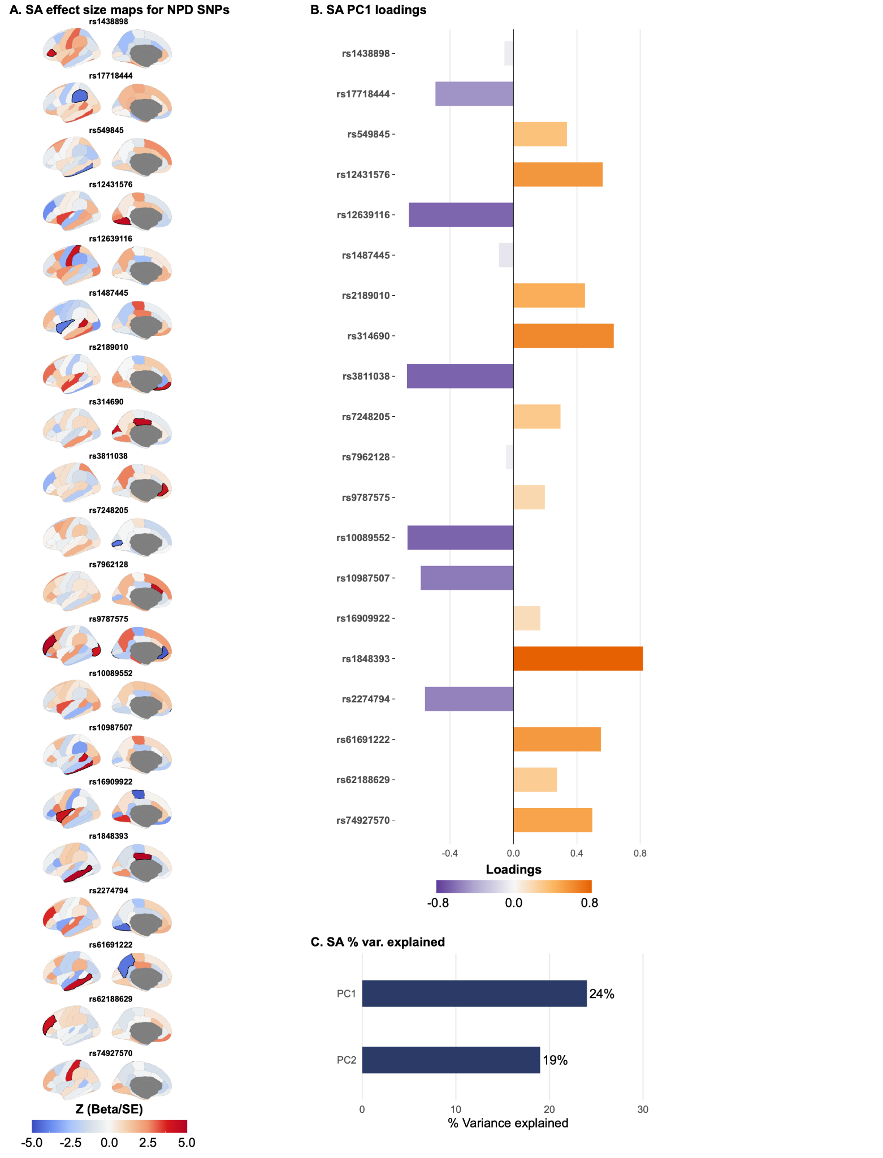
Supplementary Figure 11. Regional cortical alterations across NPD-associated common variants (SNPs)
Legend: A) Surface area (SA) cortical GWAS (10) regression estimate maps (Z = Beta/SE) for 20 NPD-associated genetic variants (SNPs). FDR (q<0.05) significant regions are shown in black boundaries. B-C) Principal component analysis across SNP regional profiles. B) PC1 variable loadings for SA. C) The variance explained by the first two principal components (PC1 and PC2).

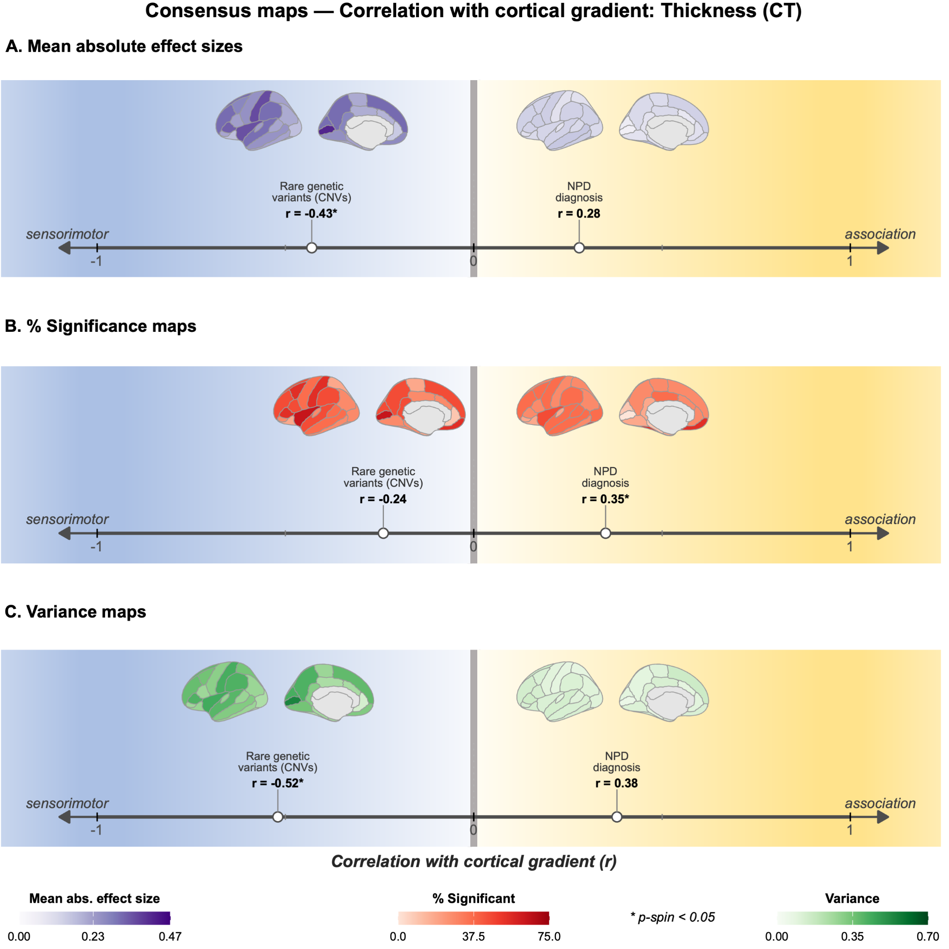

Supplementary Figure 12. Correlations between cortical gradient and CT consensus maps
Legend: Correlation between cortical gradient and cortical thickness (CT) consensus maps for A) mean absolute effect sizes, B) % significance, and C) variance of effect sizes. *: spin permutation p-value < 0.05, which preserves the spatial structure of the cortex while generating null distributions to account for spatial autocorrelation.

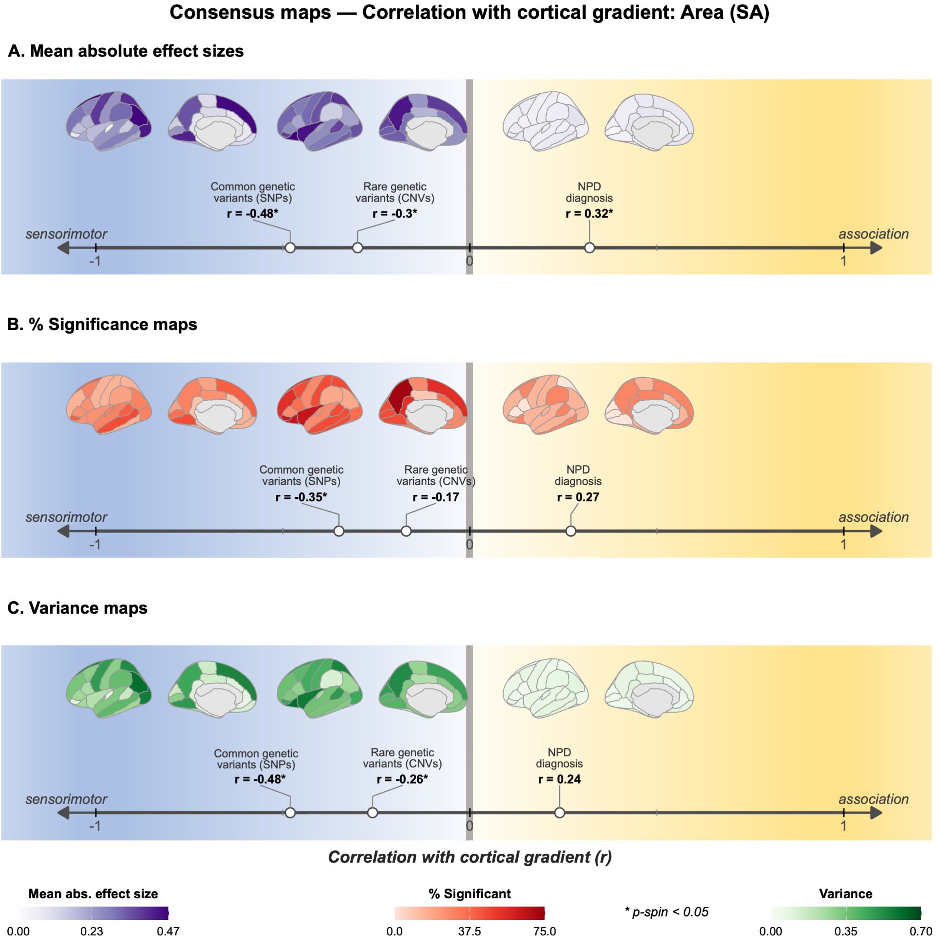

Supplementary Figure 13. Correlations between cortical gradient and SA consensus maps
Legend: Correlation between cortical gradient and surface area (SA) consensus maps for A) mean absolute effect sizes, B) % significance, and C) variance of effect sizes. *: spin permutation p-value < 0.05, which preserves the spatial structure of the cortex while generating null distributions to account for spatial autocorrelation.

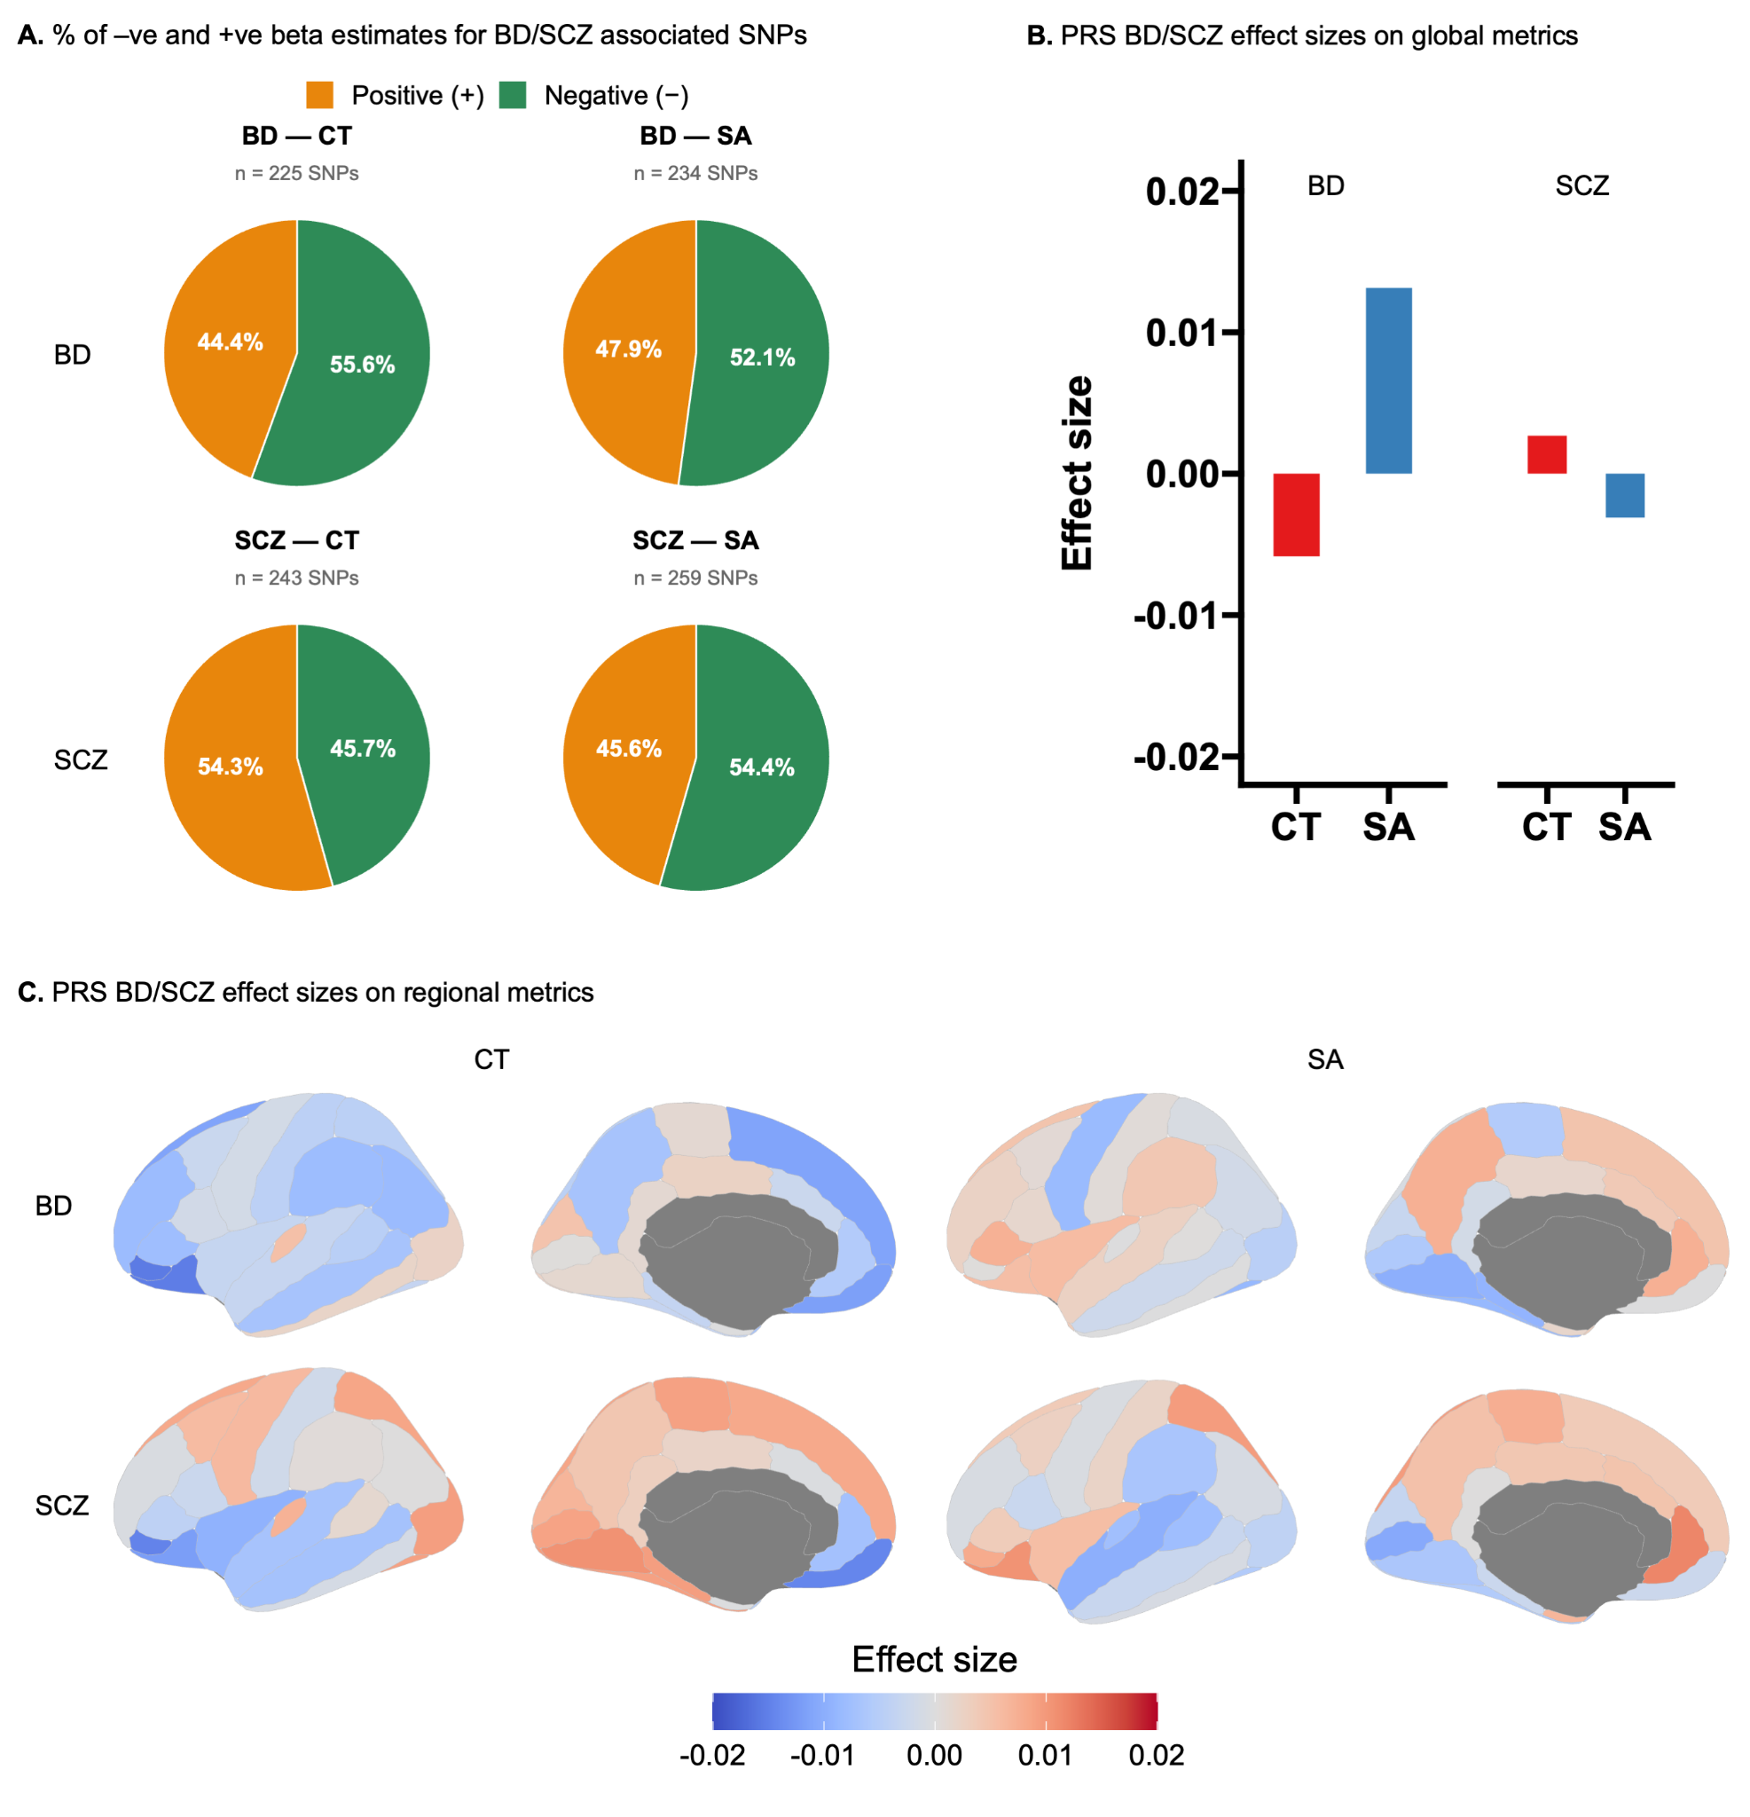

Supplementary Figure 14. Cortical alterations across NPD-associated common variants and polygenic risk scores.
Legend: A) Percentage of negative (-ve) and positive (+ve) regression estimates (derived from cortical structure GWAS for mean CT and total SA (10)) for BD/SCZ genome-wide associated SNPs. B-C) CT and SA effect sizes for BD and SCZ polygenic risk scores (PRS) for B) global, and C) regional measures. Notably, none of the PRS effect sizes were FDR significant (panels B and C). Effect sizes for PRS were derived using a linear regression in 31,000 UK Biobank participants, adjusting for age, sex, site, and ancestry principal components. Analyses were restricted to 31,000 UK Biobank participants of European ancestry who did not carry any of the recurrent CNVs examined in this study. Regional SA effect sizes were adjusted for total SA.
Abbreviations: BD=bipolar disorder; CT=cortical thickness; PRS=polygenic risk scores; SA: surface area; SCZ=schizophrenia.

References
1. Lin A, Ching CRK, Vajdi A, Sun D, Jonas RK, Jalbrzikowski M, et al. Mapping 22q11.2 Gene Dosage Effects on Brain Morphometry [Internet]. Vol. 37, The Journal of Neuroscience. 2017. p. 6183–99. Available from: http://dx.doi.org/10.1523/jneurosci.3759-16.2017
2. Martin-Brevet S, Rodríguez-Herreros B, Nielsen JA, Moreau C, Modenato C, Maillard AM, et al. Quantifying the Effects of 16p11.2 Copy Number Variants on Brain Structure: A Multisite Genetic-First Study. Biol Psychiatry. 2018 Aug 15;84(4):253–64.
3. Maillard AM, 16p11. 2 European Consortium, Ruef A, Pizzagalli F, Migliavacca E, Hippolyte L, et al. The 16p11.2 locus modulates brain structures common to autism, schizophrenia and obesity [Internet]. Vol. 20, Molecular Psychiatry. 2015. p. 140–7. Available from: http://dx.doi.org/10.1038/mp.2014.145
4. Qureshi AY, Mueller S, Snyder AZ, Mukherjee P, Berman JI, Roberts TPL, et al. Opposing Brain Differences in 16p11.2 Deletion and Duplication Carriers [Internet]. Vol. 34, Journal of Neuroscience. 2014. p. 11199–211. Available from: http://dx.doi.org/10.1523/jneurosci.1366-14.2014
5. Miller KL, Alfaro-Almagro F, Bangerter NK, Thomas DL, Yacoub E, Xu J, et al. Multimodal population brain imaging in the UK Biobank prospective epidemiological study. Nat Neurosci. 2016 Sep 19;19(11):1523–36.
6. Sudlow C, Gallacher J, Allen N, Beral V, Burton P, Danesh J, et al. UK biobank: an open access resource for identifying the causes of a wide range of complex diseases of middle and old age. PLoS Med. 2015 Mar;12(3):e1001779.
7. Huguet G, Schramm C, Douard E, Tamer P, Main A, Monin P, et al. Genome-wide analysis of gene dosage in 24,092 individuals estimates that 10,000 genes modulate cognitive ability. Mol Psychiatry [Internet]. 2021 Jan 7; Available from: http://dx.doi.org/10.1038/s41380-020-00985-z
8. Douard E, Zeribi A, Schramm C, Tamer P, Loum MA, Nowak S, et al. Effect Sizes of Deletions and Duplications on Autism Risk Across the Genome. Am J Psychiatry. 2021 Jan 1;178(1):87–98.
9. Wainberg M, Merico D, Huguet G, Zarrei M, Jacquemont S, Scherer SW, et al. Deletion of Loss-of-Function–Intolerant Genes and Risk of 5 Psychiatric Disorders. JAMA Psychiatry. 2022 Jan 1;79(1):78–81.
10. Grasby KL, Jahanshad N, Painter JN, Colodro-Conde L, Bralten J, Hibar DP, et al. The genetic architecture of the human cerebral cortex. Science [Internet]. 2020 Mar 20;367(6484). Available from: http://dx.doi.org/10.1126/science.aay6690
11. de Zwarte SMC, Brouwer RM, Agartz I, Alda M, Aleman A, Alpert KI, et al. The association between familial risk and brain abnormalities is disease specific: An ENIGMA-relatives study of schizophrenia and bipolar disorder. Biol Psychiatry. 2019 Oct 1;86(7):545–56.

