SUPPLEMENTARY MATERIAL

SDS–Chitosan Flocculant Systems in Oily Produced Water Treatment: Performance and Influence of Chitosan Properties
Anny Marry Teixeira Marques^{1,2} · Gabriele Braz Anhalo^{1,3} · Allan da Silva Santos¹ · Claudia Regina Elias Mansur^{1,2}

¹ Laboratório de Macromoléculas e Coloides na Indústria de Petróleo (LMCP), Instituto de Macromoléculas Professora Eloisa Mano (IMA), Universidade Federal do Rio de Janeiro (UFRJ), Rio de Janeiro, RJ, Brazil
² Programa de Engenharia Metalúrgica e de Materiais (PEMM/COPPE), Universidade Federal do Rio de Janeiro (UFRJ), Rio de Janeiro, RJ, Brazil
³ Universidade do Estado do Rio de Janeiro (UERJ), Rio de Janeiro, RJ, Brazil

Corresponding author: Claudia Regina Elias Mansur – E-mail: celias@ima.ufrj.br – ORCID: 0000-0001-8736-7363 - Address: Laboratório de Macromoléculas e Coloides na Indústria de Petróleo (LMCP), Instituto de Macromoléculas Professora Eloisa Mano (IMA), Universidade Federal do Rio de Janeiro (UFRJ), Rua Moniz Aragão, 360, Bloco 8G-CT2, LIMC, Cidade Universitária, Rio de Janeiro, RJ, CEP 21941-594, Brazil

Table S1 Composition of the saline solution used in the study
Brine (proportion 90% injection water/ 10% formation water)
Salt | Concentration (mg/L)
NaCl | 41621
Anhydrous CaCl₂ | 4171
MgCl₂.6H₂O | 3184
KCl | 1159
Na₂(SO)₄ | 65
SrCl₂.6H₂O | 851
TDS | 49014

Figure S1 Calibration curve of 14° API crude oil in distilled toluene
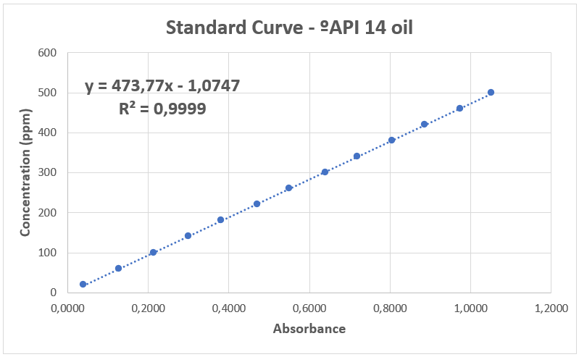

Figure S2 ¹H NMR spectrum of low-molecular-weight chitosan (LC)

Figure S3 ¹H NMR spectrum of high-molecular-weight chitosan (HC)

Figure S4 Reduced Viscosity as a function of LC Concentration
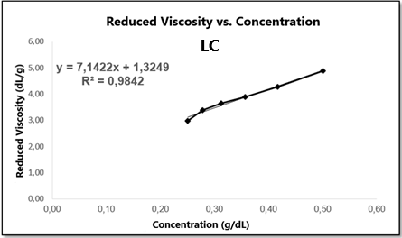

Figure S5 Reduced Viscosity as a function of QH concentration
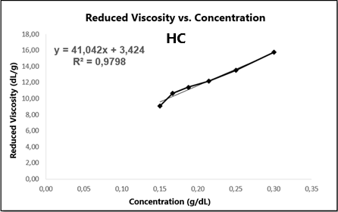

Figure S6 Surface tension as a function of SDS concentration for CMC determination
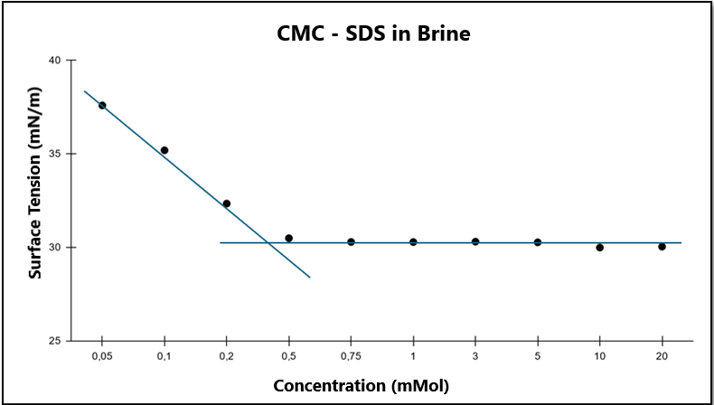

Table S2 Matrix of coded variables, real variables and responses obtained from design of experiments using the SDS and LC flocculant system
Experiments | SDS Concentration  (ppm) | Flocculant Concentration (LC)  (ppm) | pH of Flocculant System  (LC) | Residual Oil Concentration  (ppm) | Oil Removal Efficiency  (%)
1 | 87 (−1) | 65.2 (−1) | 4 (-1) | 74,5 | 0
2 | 261 (+1) | 65.2 (−1) | 4 (-1) | 88,6 | 0
3 | 87 (−1) | 195.7 (+1) | 4 (-1) | 69,3 | 0
4 | 261 (+1) | 195.7 (+1) | 4 (-1) | 16,0 | 75,4
5 | 87 (−1) | 65.2 (−1) | 5 (1) | 73,7 | 0
6 | 261 (+1) | 65.2 (−1) | 5 (1) | 84,4 | 0
7 | 87 (−1) | 195.7 (+1) | 5 (1) | 65,4 | 0
8 | 261 (+1) | 195.7 (+1) | 5 (1) | 65,4 | 0
9 | 27.7 (−1.68) | 130.5 (0) | 4,5 (0) | 83,9 | 0
10 | 320.3 (+1.68) | 130.5 (0) | 4,5 (0) | 23,3 | 68,9
11 | 174 (0) | 20.8 (−1.68) | 4,5 (0) | 73,7 | 0
12 | 174 (0) | 240.2 (+1.68) | 4,5 (0) | 75,5 | 0
13 | 174 (0) | 130.5 (0) | 3,7 (-1,68) | 79,5 | 0
14 | 174 (0) | 130.5 (0) | 5,3 (1,68) | 79,6 | 0
15 | 174 (0) | 130.5 (0) | 4,5 (0) | 70,6 | 0
16 | 174 (0) | 130.5 (0) | 4,5 (0) | 63,0 | 0
17 | 174 (0) | 130.5 (0) | 4,5 (0) | 77,6 | 0
18 | 174 (0) | 130.5 (0) | 4,5 (0) | 72,2 | 0

Table S3 Matrix of coded variables, real variables and responses obtained from design of experiments using the SDS and HC flocculant system
Experiments | SDS Concentration  (ppm) | Flocculant Concentration (HC)  (ppm) | pH of Flocculant System  (HC) | Residual Oil Concentration  (ppm) | Oil Removal Efficiency  (%)
1 | 87 (−1) | 65.2 (−1) | 4 (-1) | 45,3 | 34,5
2 | 261 (+1) | 65.2 (−1) | 4 (-1) | 26,5 | 61,7
3 | 87 (−1) | 195.7 (+1) | 4 (-1) | 73,2 | 0
4 | 261 (+1) | 195.7 (+1) | 4 (-1) | 7,2 | 89,6
5 | 87 (−1) | 65.2 (−1) | 5 (1) | 57,9 | 0
6 | 261 (+1) | 65.2 (−1) | 5 (1) | 78,0 | 0
7 | 87 (−1) | 195.7 (+1) | 5 (1) | 57,1 | 0
8 | 261 (+1) | 195.7 (+1) | 5 (1) | 13,5 | 75,0
9 | 27.7 (−1.68) | 130.5 (0) | 4,5 (0) | 60,9 | 0
10 | 320.3 (+1.68) | 130.5 (0) | 4,5 (0) | 5,0 | 91,0
11 | 174 (0) | 20.8 (−1.68) | 4,5 (0) | 68,8 | 0
12 | 174 (0) | 240.2 (+1.68) | 4,5 (0) | 53,0 | 5,7
13 | 174 (0) | 130.5 (0) | 3,7 (-1,68) | 26,5 | 62,5
14 | 174 (0) | 130.5 (0) | 5,3 (1,68) | 69,0 | 2,5
15 | 174 (0) | 130.5 (0) | 4,5 (0) | 40,8 | 41,1
16 | 174 (0) | 130.5 (0) | 4,5 (0) | 38,2 | 48,9
17 | 174 (0) | 130.5 (0) | 4,5 (0) | 47,1 | 16,2
18 | 174 (0) | 130.5 (0) | 4,5 (0) | 36,5 | 48,5

Figure S7 Contour plot for removal efficiency as a function of SDS and HC concentrations
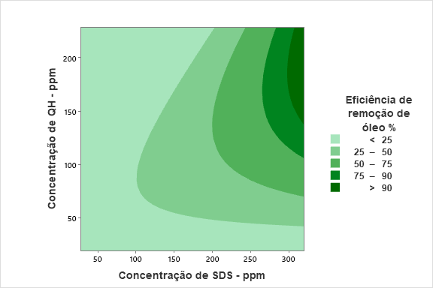

Figure S8 Contour plot for removal efficiency as a function of HC solution pH and SDS concentration
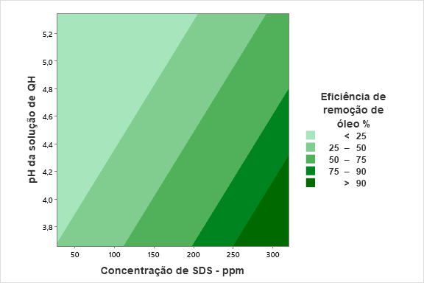

Table S4 Responses obtained for optimization CCRD using the SDS and LC flocculant system
Experiments | SDS Concentration  (ppm) | Flocculant Concentration LC  (ppm) | Residual Oil Concentration  (ppm) | Oil Removal Efficiency  (%) | Ratio Between Charges of Dosed Concentrations
1 | 261 (−1) | 195.7 (−1) | 22,9 | 69,1 | 0.75
2 | 435 (+1) | 195.7 (−1) | 73,3 | 1,5 | 0.45
3 | 261 (−1) | 326.2 (+1) | 30,2 | 59,4 | 1.24
4 | 435 (+1) | 326.2 (+1) | 12,8 | 82,7 | 0.75
5 | 225 (−1.41) | 261 (0) | 64,2 | 0 | 1.15
6 | 471 (+1.41) | 261 (0) | 12,3 | 74,0 | 0.55
7 | 348 (0) | 168.7 (−1.41) | 15,9 | 66,3 | 0.48
8 | 348 (0) | 353.2 (+1.41) | 46,5 | 1,7 | 1.01
9 | 348 (0) | 261 (0) | 13,9 | 81,3 | 0.75
10 | 348 (0) | 261 (0) | 14,5 | 69,7 | 0.75
11 | 348 (0) | 261 (0) | 9,5 | 78,1 | 0.75
12 | 348 (0) | 261 (0) | 14,3 | 85,6 | 0.75

Table S5 Responses obtained for optimization planning using the SDS and HC flocculant system
Experiments | SDS Concentration  (ppm) | Flocculant Concentration HC  (ppm) | Residual Oil Concentration  (ppm) | Oil Removal Efficiency  (%) | Ratio Between Charges of Dosed Concentrations
1 | 261 (−1) | 195.7 (−1) | 9,5 | 83,8 | 0.75
2 | 435 (+1) | 195.7 (−1) | 30,3 | 48,2 | 0.45
3 | 261 (−1) | 326.2 (+1) | 30,7 | 47,8 | 1.24
4 | 435 (+1) | 326.2 (+1) | 3,4 | 94,2 | 0.75
5 | 225 (−1.41) | 261 (0) | 64,9 | 22,8 | 1.15
6 | 471 (+1.41) | 261 (0) | 6,9 | 91,8 | 0.55
7 | 348 (0) | 168.7 (−1.41) | 6,7 | 92,4 | 0.48
8 | 348 (0) | 353.2 (+1.41) | 24,8 | 70,5 | 1.01
9 | 348 (0) | 261 (0) | 3,1 | 87,2 | 0.75
10 | 348 (0) | 261 (0) | 8,5 | 91,7 | 0.75
11 | 348 (0) | 261 (0) | 5,5 | 94,6 | 0.75
12 | 348 (0) | 261 (0) | 5,2 | 93,8 | 0.75

