SUPPLEMENTARY FIGURES
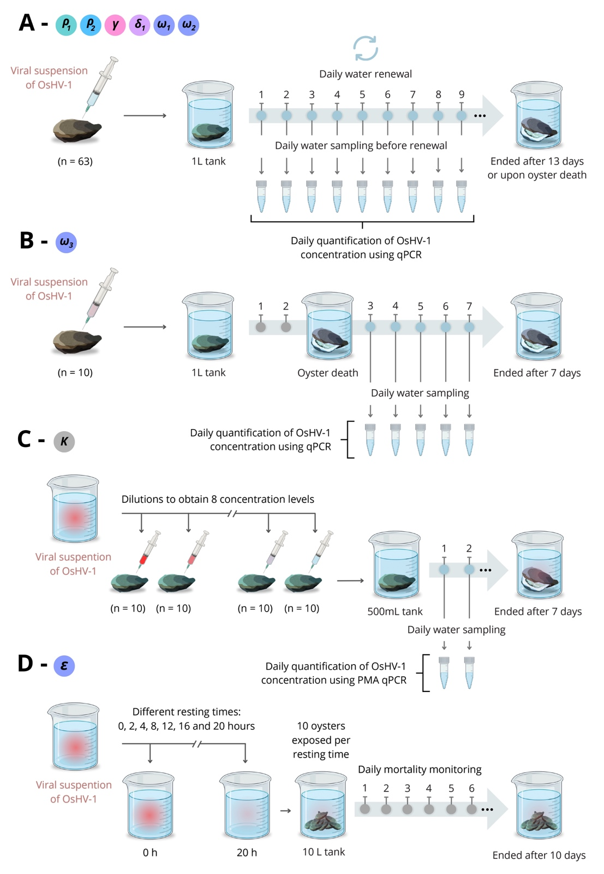
Supplementary Fig.1: Experimental setups for calibrating model parameters.
Experimental design to estimate: (A) latent periods (ρ₁ and ρ₂), infectious periods (γ and δ₁), and shedding rates of living oysters (ω₁ and ω₂); (B) shedding rate of dead oysters (ω₃); (C) viral concentration required to infect 50% of individuals (K); (D) inactivation rate of viral particles (ε).
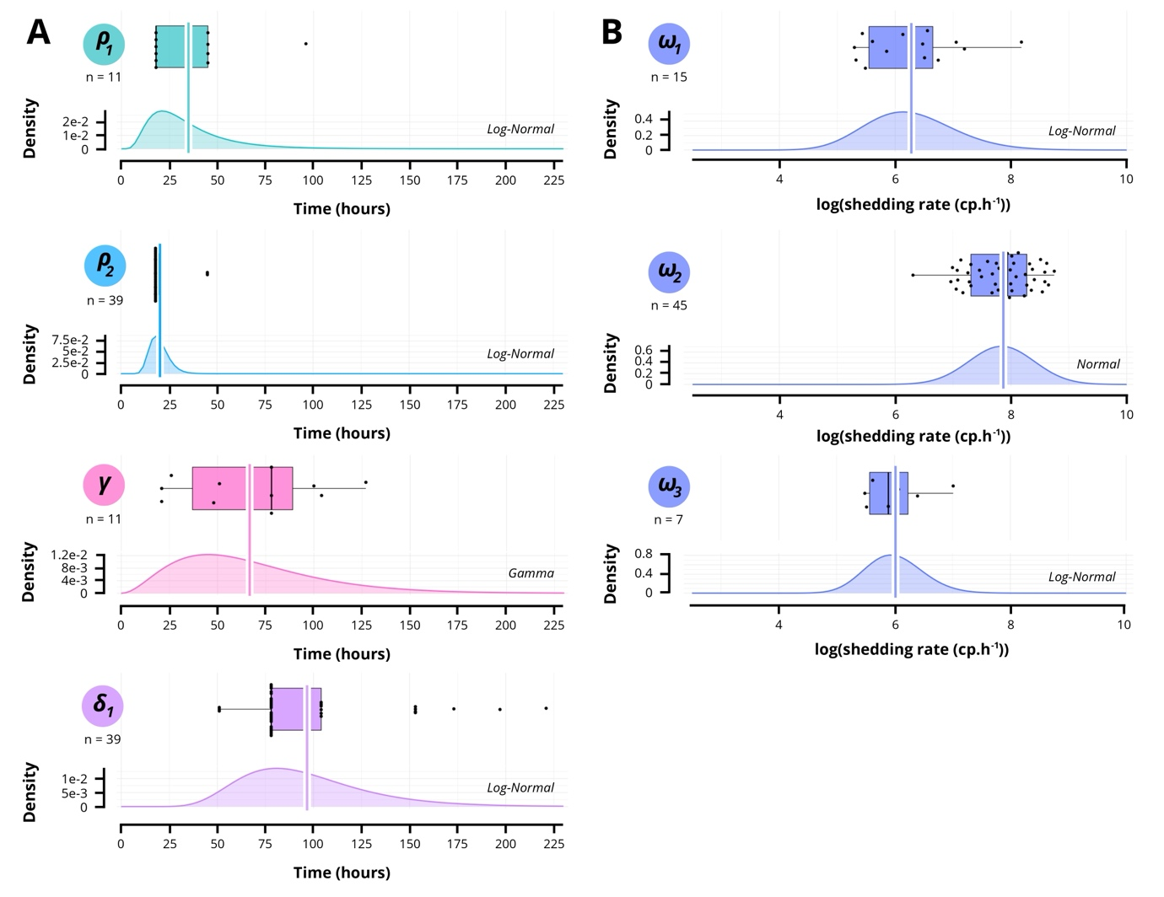
Supplementatry Fig.2: Distribution of latent periods, infectious periods and shedding rates for both oysters that survived and succumbed to infection.
(A) Distribution of parameters associated with oyster transition rates: ρ₁ (mean = 34.9 h), ρ₂ (mean = 20.1 h), γ (mean = 66.5 h) and δ₁ (mean = 96.7 h). (B) Distribution of parameters associated with shedding rates: ω₁ (mean = 6.3 log(cp.h⁻¹)), ω₂ (mean = 7.8 log(cp.h⁻¹)) and ω₃ (mean = 6.0 log(cp.h⁻¹)).

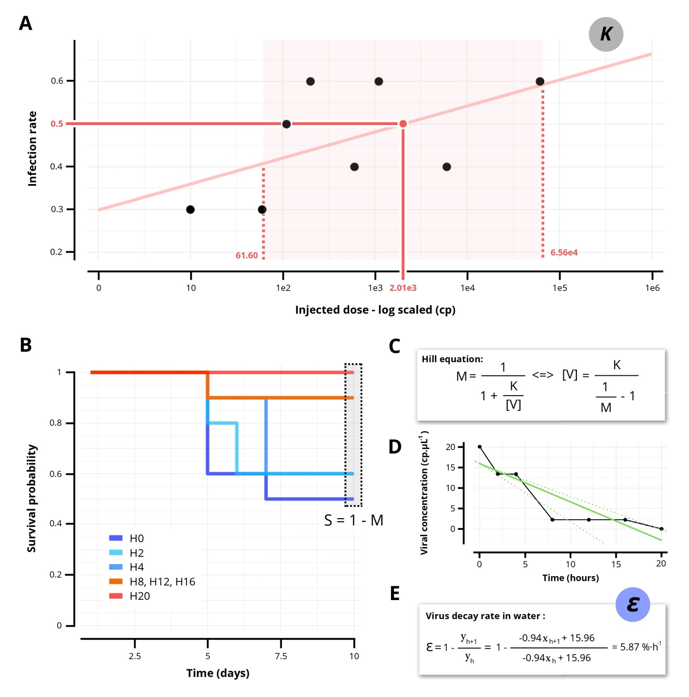
Supplementary Fig.3: Estimation of the 50% infectious concentration and virus decay rate in seawater.
(A) Linear regression (R² = 3.12 × 10⁻¹, slope = 6.10 × 10⁻² and intercept = 2.98 × 10⁻¹) to estimate the 50% infectious dose (K). (B) The survival rates (S) observed after 10 days of exposure used to estimate the concentration of active viral particles in seawater rested for varying durations before exposure. (C) Concentrations estimated using the Hill equation with the estimation of the 50% infectious concentration (K) and mortality rates (M). (D and E) Linear regression (R² = 8.01 × 10⁻¹, slope = - 9.38 × 10⁻¹ and intercept = 15.96) to estimate the viral particles inactivation rate and its confidence interval.
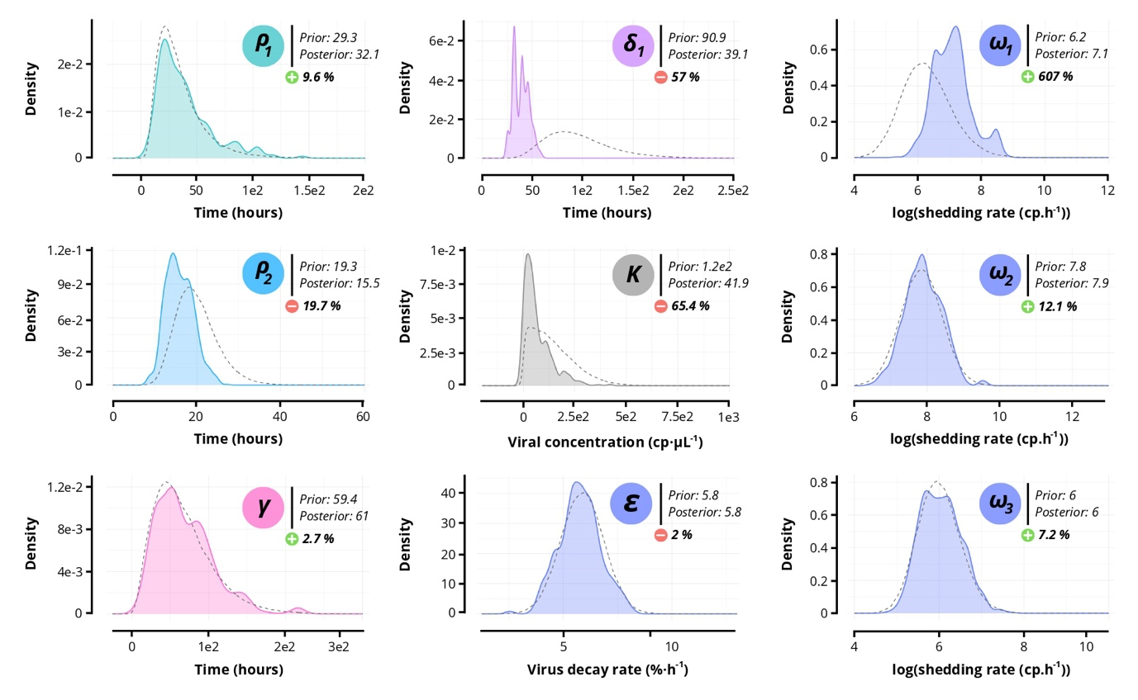
Supplementary Fig.4: Impact of ABC calibration on model performance.
Prior (dotted lines) and posterior (solid lines) density of the model parameters from the ABC approach. Medians were compared to estimate the percentage change between prior and posterior (calculated using back-transformed values for ω₁, ω₂ and ω₃).

