Supplementary information of NiL
Table S1 Important bond lengths (Å) and bond angles (°) of NiL
 | XRD |  | XRD
Ni1—O3 | 1.8375 (14) | O3—Ni1—O1 | 83.96 (6)
Ni1—O1 | 1.8437 (15) | O3—Ni1—N2 | 95.25 (7)
Ni1—N2 | 1.8530 (17) | O1—Ni1—N2 | 177.55 (8)
Ni1—N1 | 1.8633 (17) | O3—Ni1—N1 | 176.21 (7)
O1—C12 | 1.304 (3) | O1—Ni1—N1 | 95.01 (7)
O2—C8 | 1.368 (3) | N2—Ni1—N1 | 85.93 (7)
O2—C7 | 1.430 (3) | C12—O1—Ni1 | 126.94 (13)
O3—C27 | 1.306 (2) | C8—O2—C7 | 120.47 (19)
O4—C25 | 1.370 (2) | C27—O3—Ni1 | 127.71 (13)
O4—C28 | 1.434 (3) | C25—O4—C28 | 116.44 (16)
N1—C14 | 1.307 (3) | C14—N1—C15 | 120.77 (17)
N1—C15 | 1.424 (3) | C14—N1—Ni1 | 125.90 (14)
N2—C21 | 1.308 (3) | C15—N1—Ni1 | 113.18 (13)
N2—C20 | 1.424 (3) | C21—N2—C20 | 121.04 (18)

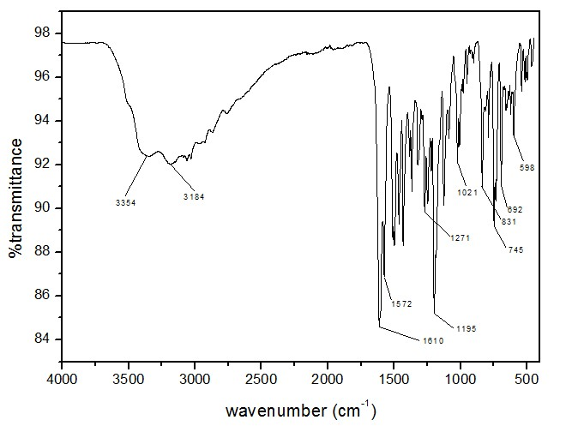

Figure S1 The FT-IR spectrum of the title compound.
Figure S2 ¹H NMR spectrum of the title compound.

