Supplementary Figures
Fig. S1 Explore the effects of using Neo and LaCl₃ alone on hyphal growth (A), Ca²⁺ content (B), biomass (C), and DTTAs production (D).Within each set of experiments, asterisks and hashtags indicate significant differences according to a multiple-comparison one-way ANOVA (*P < 0.05 and **P < 0.01 vs. CK)
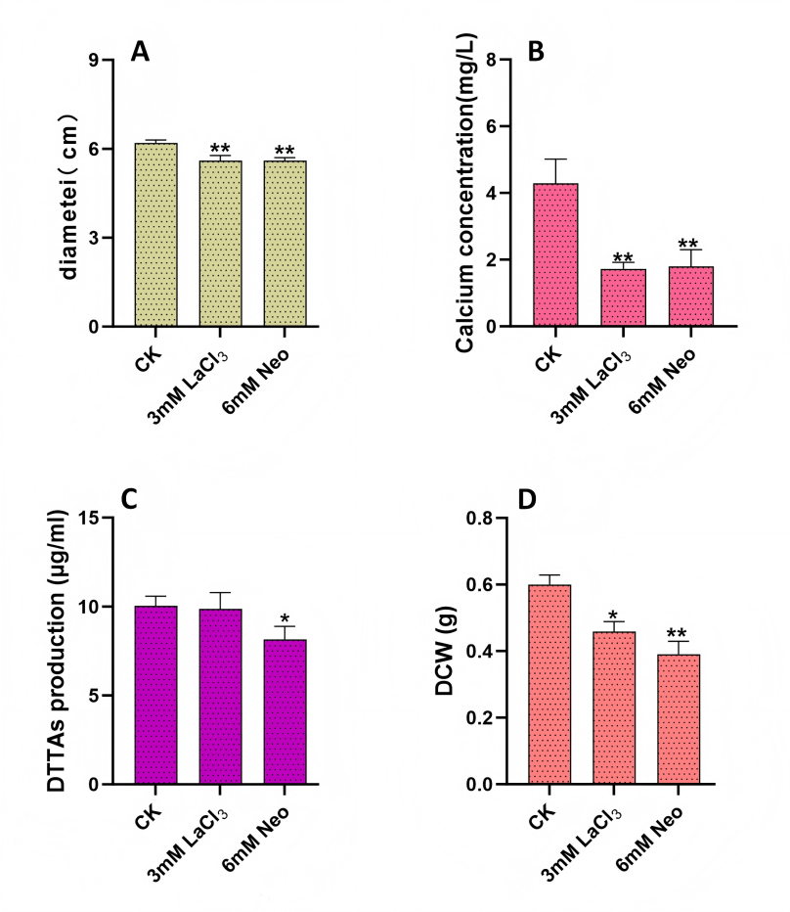

Fig. S2 Exogenous H₂O₂ treatment further promotes fungal biomass and DTTAs production under cobalt stress. (A) The effect of adding 6mM H₂O₂ alone on mycelial growth. (B) Changes in H₂O₂ content in UN32 hyphae treated with ROS scavenger, H₂O₂ or 0.28mM CoCl₂. The Y-axis represents the H₂O₂ concentration of the H₂O₂ content detection kit, and the x-axis represents different treatments. (C) Measure the production of DTTAs after treatment with ROS scavenger, H₂O₂ or 0.28mM CoCl₂. (D) Measure the biomass in mycelium treated with ROS scavenger, H₂O₂ or 0.28mM CoCl₂.Within each set of experiments, asterisks and hashtags indicate significant differences according to a multiple-comparison one-way ANOVA (*P < 0.05 and **P < 0.01 vs. CK; #P < 0.05 vs. 0.28 mM CoCl₂ group)
