Factors Affecting Purchase Intention of Electric Vehicles with Tax Incentives as a Moderator
Felicia Stella¹, Ka Tiong²
1(Accounting Department, Bina Nusantara University, Jakarta, Indonesia
Email: felicia.stella001@binus.ac.id)

Abstract:
This study examines the factors influencing Electric Vehicle (EV) purchase intention in Indonesia, with Tax Incentives as a moderating variable. It adopts a quantitative approach by collecting data through questionnaires and analyzing the data using Stata software, the study tests the effects of Price Value, Technology Awareness, and Charging Infrastructure on EV purchase interest. Results show that Technology Awareness is the most dominant driver (coefficient 0.610, P=0.005), followed by Price Value (coefficient 0.323, P=0.020). Charging Infrastructure and Tax Incentives did not show significant direct effects on purchase interest. Although Tax Incentives significantly strengthened the perception of Technology Awareness (P=0.002), their mediating role on purchase interest was insignificant (P=0.137). These findings suggest that strategies to accelerate EV adoption should focus on technology education and product value enhancement rather than relying solely on fiscal incentive policies.
Keywords — Electric Vehicles, Purchase Intention, Tax Incentives, Technology Awareness, Price Value
2 (Accounting Department, Bina Nusantara University, Jakarta, Indonesia
Email: ka.tiong@binus.ac.id)

- INTRODUCTION
The number of internal combustion engine (ICE) vehicles in Indonesia is projected to exceed 160 million units by 2024-2025, despite the significant environmental challenges posed by the transportation sector. Although electric vehicles (EVs) currently account for well below 1% of the total vehicle population, the government has set a target of reaching at least 600,000 EV units by 2025, including both electric motorcycles and electric cars [1]. With approximately 24.3 million motor vehicles, internal combustion engine (ICE) vehicles continue to dominate Jakarta's vehicle population, despite the city's reputation as a leading hub for electric vehicle (EV) usage. Jakarta has also emerged as a focal point for the development of charging infrastructure to support national EV adoption goals [2].
In line with the government's objective to develop 1,000 public electric vehicle charging stations nationwide in the near term, the number of Public Electric Vehicle Charging Stations (SPKLU) and Public Electric Vehicle Battery Swapping Stations (SPBKLU) is expected to continue increasing at a pace exceeding one thousand units. By the end of 2024, the number of home charging service facilities in Indonesia alone totaled 28,356 [3]. It is expected that the availability of supporting infrastructure and fiscal incentives will help address key barriers to electric vehicle adoption. However,

a critical question remains as to how these
enabling. factors can mitigate negative consumer perceptions related to price value and technological awareness, thereby transforming purchase intentions into actual buying decisions within a market still dominated by conventional vehicles at both the capital city and national levels.
The main objective of this study is to analyze and test the influence of variable factors such as Price Value, Technology Awareness, and Charging Infrastructure on Electric Vehicle (EV) Purchase Intentions, as well as to specifically test the role of Tax Incentives as a moderation variable in strengthening these relationships. Through this approach, the study seeks to deliver meaningful practical contributions for policymakers, by providing insights to support the design of more effective fiscal policies and the infrastructure initiatives to accelerate EV adoption for the automotive industry, by informing adaptive pricing and marketing strategies and for consumers, by enhancing awareness and literacy regarding the key determinants of EV purchasing decisions.
This study will discuss in greater depth the factors that influence the intention to purchase electric vehicles with tax incentives as moderator, with the following research questions:
1. How does the perception of price value affect people's interest in purchasing electric vehicles?
2. What extent does technological awareness (knowledge and understanding of EV technology) influence people's interest in purchasing electric vehicles?
3. How does charging infrastructure (availability and ease of access to charging stations) influence public interest in purchasing electric vehicles?
4. How tax incentives moderate (strengthen or weaken) the relationship between perceived price value and interest in purchasing electric vehicles?
5. How the tax incentives moderate (strengthen or weaken) the relationship between technology awareness and the public’s interest in purchasing electric vehicle?
6. How the tax incentives moderate (strengthen or weaken) the relationship between charging infrastructure and the public’s interest in purchasing electric vehicle?

II. LITERATURE REVIEW
2.1. Price Value
The perception of price value among EV consumers reflects the belief that the perceived long-term benefit such as emotional, social, environmental, and performance value are commensurate with the relatively high price of EVs. Most studies, including research by Gunawan et al. (2022) and Sasmita and Madiawati (2021), found that price value has a positive and significant influence on EV purchase interest and usage in Indonesia. Indicating that consumer attitudes become more positive as price and benefits align. Consumers conduct a benefit risk analysis, where financial gains and environmental impact are drivers, while risks to safety and vehicle performance are proven to have a negative impact on price value. Although the high initial purchase cost of EVs is often a major obstacle, the selling price of EVs has been proven to be highly sensitive to purchase interest. Therefore, price value remains a crucial factor that strongly influences consumers' intentions and decisions to purchase electric vehicles [4].
2.2. Technology Awareness
The Technology Acceptance Model (TAM) is a theoretical framework developed to analyze and predict the factors underlying the level of acceptance, adoption, and use of technology by individuals. This model argues that a technology, including electric vehicles, will be accepted if it is considered useful and easy to use. TAM has two main constructs that determine acceptance: Perceived Usefulness (PU), this is the consumer’s belief that using the product or service will provide real benefits or added value in line with their expectations. In the context of EV, PU includes benefits such as savings in operating costs, efficiency, and positive environmental impacts. Consumers who feel that a product meets their needs will increase their purchase intention. PU can be measured by indicators such as improved performance, productivity and work effectiveness. Perceived Ease of Use (PEOU) refers to consumers' belief that using a product or service is easy and hassle-free, and makes their work easier. In the context of EV, PEOU includes ease of charging, maintenance, and everyday use. PEOU greatly influences a person’s intention to adopt technology and can be measured by the ease with the system can be learned, controlled, and understood. [5].
2.3. Charging Infrastructure
Infrastructure is defined as a set of essential physical systems designed to meet the social and economic needs of society. In the context of electric vehicles, SPKLU plays a crucial role as infrastructure that supports EV operations. enabling users to recharge their battery practically. the availability of adequate EV charging stations is vital to ensure comfort, reliable mobility, and address concerns about daily power limitations [6]. The availability of charging stations refers to the number and locations of available stations which reflects the ease of access to charging. This availability is measured by two main indicators: (1) the number of EV charging stations in strategic locations, which indicates physical infrastructure and (2) the utilization rate of EV charging stations, which reflects the effectiveness of these facilitates the adoption of electric vehicles by making them more convenient and practical for everyday use. In addition to encouraging the growth of the electric vehicle market, increasing the availability of SPKLU also contributes to reducing greenhouse gas emissions and air pollution, thereby supporting environmental sustainability goals. [7].
2.4. Tax Incentives
The use of electric vehicle in Indonesia is growing in popularity, driven by government appeals aimed at reducing dependence on oil and curbing rising emissions caused by the surge in the number of vehicles. Although the adoption of EVs is an important solution to the problem of carbon emissions, the high purchase price of EVs is a major obstacle for the public. Therefore, the government has responded by establishing as tax incentive policies such as lower local taxes (e.g. transfer fees and vehicle registration taxes), reductions in VAT , sales tax on luxury goods, vehicle registration tax, or financial assistance to lower the cost of purchasing and using EVs. This policies have proven effective in increasing EV sales because significantly reduce the financial burden on consumers. This incentives applied to various types of electric vehicle available, including Battery Electric Vehicle (BEVs), Hybrids, and Plug-In Hybrid Electric Vehicle (PHEVs), as a strategic effort to accelerate the transition to more environmentally friendly transportation.[8].
2.5. Purchase Intention
Purchase intent is defined as part of consumer behavior that arises in response to a particular product, which can predict an individual's tendency to make a purchase in the future, even though the actual purchase may not necessarily be made. High purchase interest is an indicator that consumers have the potential to make actual purchases, so marketers need to identify the driving factors. Purchase interest can be influenced by macro factors such as energy crises or high interest rates, as well as internal factors (such as employment affecting income, lifestyle, and motivation) and external factors (such as social influence, relatively low prices but good quality, and the quality of the product itself). In the context of electric vehicles, purchase interest refers to consumer behavior in considering the decision to buy an EV. Although there is a positive perspective that electric vehicle are are more environmentally friendly, which is predicted to increase the EV market in Indonesia, the growth of interest in purchasing electric cars in Indonesia is still not as fast as in developed coutries that are fully committed to environmental transition. [9].
2.6. Research Hypotheses
Based on previous research, the researcher formulated the following hypotheses in this study:
H1: Price value perception has a positive effect on interest in purchasing electric vehicles.
H2: Technology awareness has a positive effect on interest in purchasing electric vehicles.
H3: Charging Infrastructure Availability has a positive effect on Interest in Purchasing Electric Vehicles.
H4: Tax Incentives positively moderate the relationship between Price Value Perception and Interest in Purchasing Electric Vehicles.
H5: Tax Incentives positively moderate the relationship between Technology Awareness and Interest in Purchasing Electric Vehicles.
H6: Tax incentives positively moderate the relationship between the availability of charging infrastructure and interest in purchasing electric vehicles.
3. METHOD
This study uses a quantitative approach with questionnaires to examine complex causal relationships. The main objective is to analyze the influence of independent variables (price value, technology awareness, and charging infrastructure) on the intention to purchase electric vehicles, as well as to examine the role of tax incentives as a moderating variable that has the potential to strengthen this relationship.[10]. The target population is potential consumers of electric vehicles in Indonesia. To obtain data, purposive sampling was applied to respondents who met specific criteria, including having an interest in and plans to purchase a vehicle in the near future. The sample size in this study was determined based on Partial Least Squares- Structural Equation Modeling (PLS-SEM) guidelines. rather than classical statistical formulas, to ensure the stability and strength of the complex model. Technically, the absolute minimum limit was set using the "10-Times Rule" Given that the model has 6 of the most complex structural paths (3 direct effects and 3 moderating effects), the theoretical minimum is 60 respondents (10 x 6). However, to guarantee adequate Statistical Power to detect actual effects and to overcome model complexity and potential missing data, the minimum sample size was increased to approximately 140-150 respondents (based on Power Analysis). Therefore, this study set the ideal and statistically robust final sample target at between 200 and 300 respondents, a number that significantly exceeds the minimum limit, thereby ensuring the accuracy and stability of the hypothesis testing results. Primary data was collected through the distribution of an online questionnaire using a 5-point Likert scale [11].
Data analysis will be conducted using the Partial Least Squares - Structural Equation Modeling (PLS-SEM) method with Stata software. PLS-SEM was chosen for its ability to test complex, prediction-oriented structural models, which are well suited for testing moderating variables. The analysis process is divided into two parts: first, Measurement Model Evaluation (Outer Model) to verify validity (AVE, HTMT) and reliability (Composite Reliability, Cronbach's Alpha) of the instruments. Second, Structural Model Evaluation (Inner Model) to test hypotheses, including testing direct effects and moderating roles through the Bootstrapping procedure. Hypothesis testing to determine the significance of the relationship between variables in the research model was conducted based on the results of the Bootstrapping procedure, which produced t-values and p-values. To test the hypothesis at a commonly used significance level, namely alpha = 5% (two-tailed test), the decision criteria are set as follows: the hypothesis stating that there is a significant relationship between variables (direct or moderating effect) will be accepted if the p-value generated by Bootstrapping is less than or equal to 0.05 (p <= 0.05). An equivalent alternative criterion is to compare the t-value with the critical value (t-tabel); where the hypothesis is accepted if the t-value is greater than 1.96 (t-value >=1.96). If both criteria are not met, then the relationship is considered statistically insignificant, and the hypothesis is rejected. [11].
4. RESULTS AND DISCUSSION
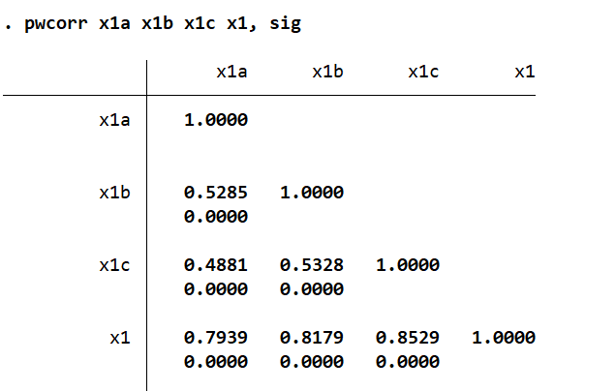
Figure 1. Research Model Overview
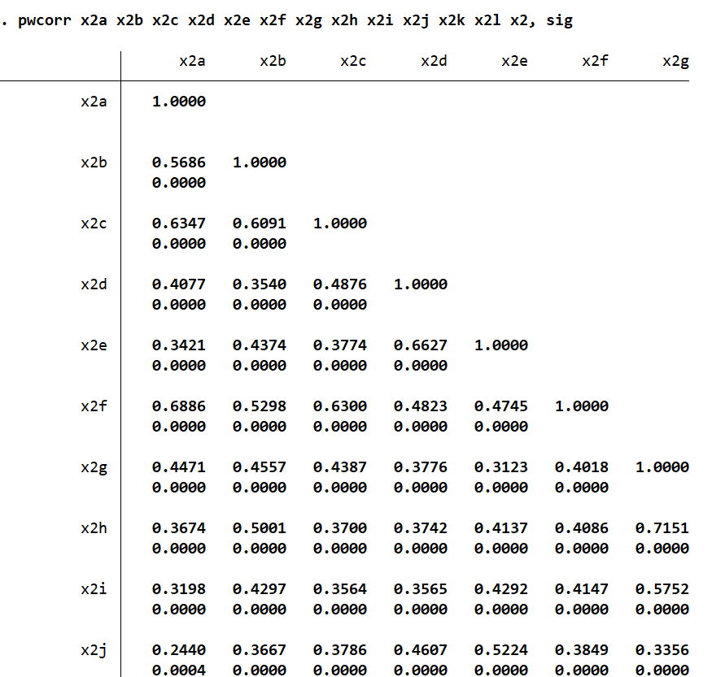
Figure 2. Validity Test Results (Pairwise Correlations)

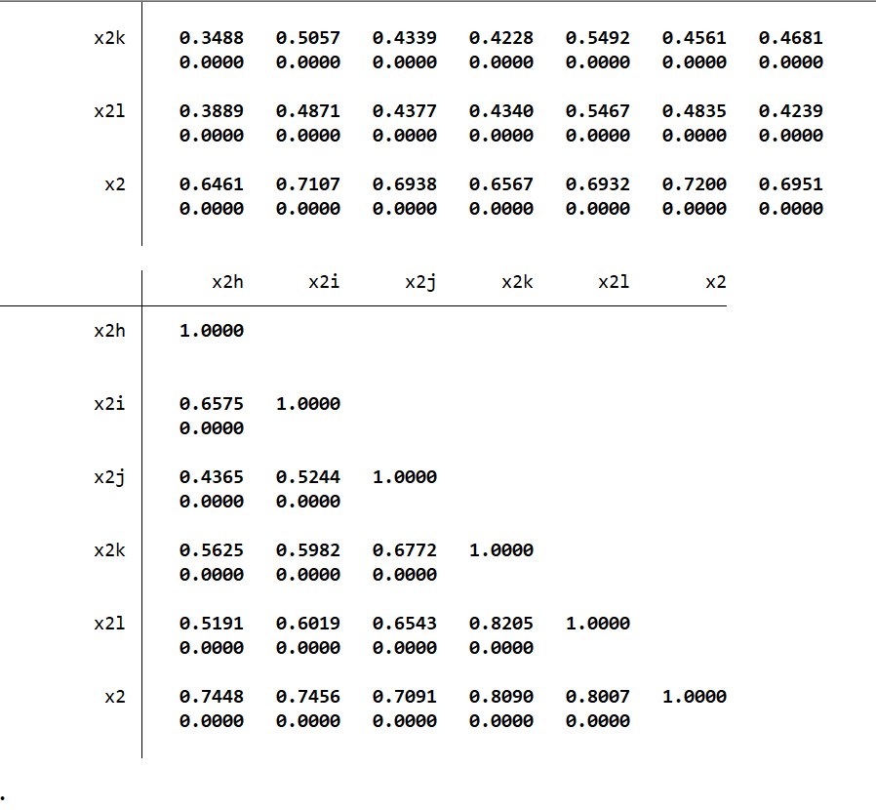
Figure 3. Outer Model – Path Coefficients
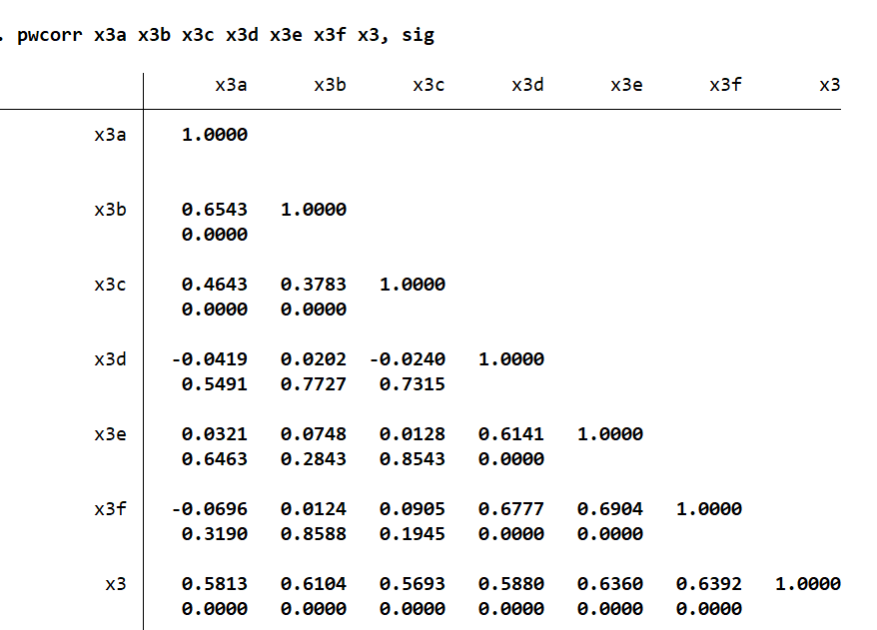
Figure 4. Structural Model (PLS-SEM)
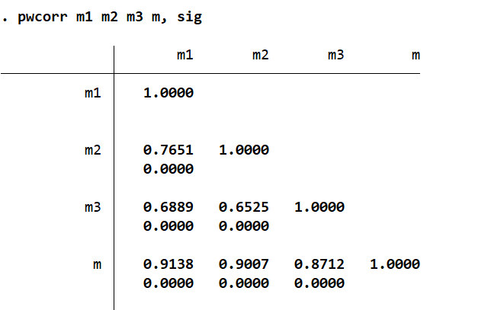
Figure 5. Bootstrapping Results
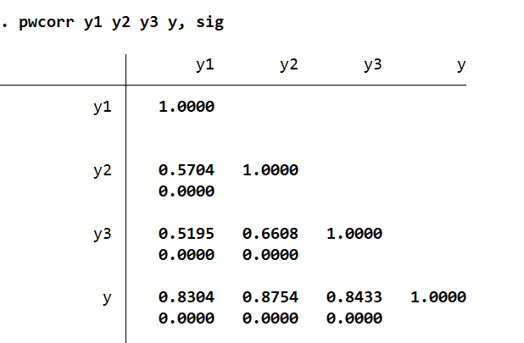
Figure 6. Hypothesis Testing Summary
Based on the results of validity testing with pairwise correlations, the variables used in this test were proven to be valid because the sig results were less than 0.05. This indicates that each question item in the questionnaire was appropriate and relevant to its latent variable.
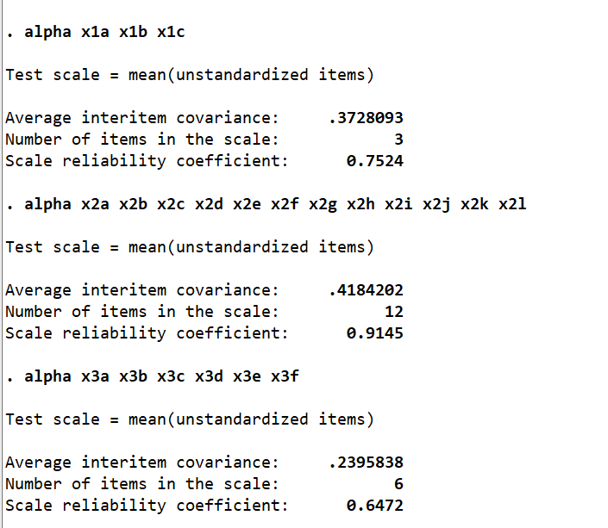
Figure 7. Cronbach's Alpha Reliability Test
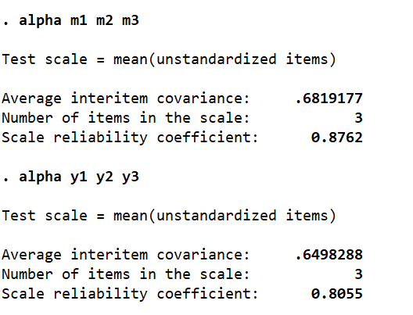
Figure 8. Composite Reliability Test

Figure 9. PLS-SEM Structural Model Results
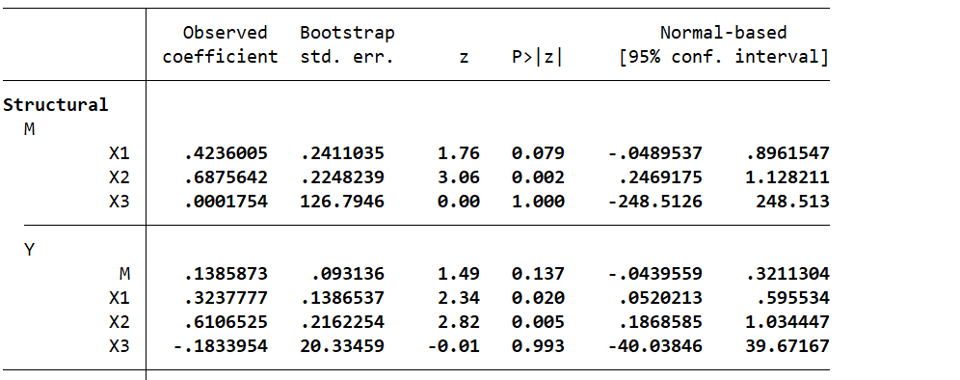
Figure 10. Summary of Hypothesis Testing Results
The results of Cronbach's alpha testing show that all variables X1: (Price Value, X2: Technology Awareness, X3: Charging Infrastructure, M: Tax Incentives, Y: Public Purchase Interest) are reliable because the test results are above the standard threshold of 0.60. This indicates that the variables used provide consistent and stable results when repeated measurements are conducted. The analysis was conducted on data from 207 respondents using Structural Equation Modeling (SEM) with a Bootstrapping approach (50 replications). This method was chosen to ensure that the estimation results remained robust despite the potential abnormality of the questionnaire data distribution.
4.1. Relationship with Mediator Variables (M – Tax Incentives)
• X1 → M: Coefficient 0.423 with a P-value of 0.079. The effect is not significant because P > 0.05.
• X2 → M: Coefficient 0.687 with a P-value of 0.002. The effect is highly significant in a positive direction.
• X3 → M: Coefficient 0.0001 with a P-value of 1.000. There is no effect at all.
4.2. Relationship with Dependent Variable (Y – Public Purchasing Interest)
• X1 → Y: Coefficient 0.323 with P=0.020. The effect is significantly positive.
• X2 → Y: Coefficient 0.610 with P=0.005. The effect is highly significant and positive and is the main driver.
• X3 → Y: Coefficient -0.183 with a P-value of 0.993. The effect is insignificant.
• M → Y: Coefficient 0.138 with a P-value of 0.137. The effect is statistically insignificant at the 5% level.
Structural model testing using Bootstrap SEM on 207 respondents revealed that Technology Awareness (X2) and Price Value (X1) play a crucial role in shaping consumer behavior. Technology Awareness was found to be the most dominant driver of Public Purchase Interest (Y) with a coefficient of 0.610 and a very strong significance value (P = 0.005). This indicates that the higher the public's understanding of the benefits of technology, the higher their interest in making purchases. In addition, Price Value also had a significant positive influence of 0.323 (P = 0.020), confirming that consumers continue to make rational evaluations between costs incurred and benefits received. Conversely, Charging Infrastructure (X3) did not show a significant effect on purchase interest (P = 0.993), indicating that the availability of physical facilities is not yet a major consideration for respondents at the current stage of purchase intention formation.
Regarding the role of intermediate variables, the results show that tax Incentives (M) has not been able to perform their mediating function effectively in this model. Although Technological Awareness has been proven to significantly increase public perception of Tax Incentives (P = 0.002), the relationship between Tax Incentives and Public Purchasing Interest was found to be insignificant (P = 0.137). This finding implies that the government's fiscal incentive policy does not automatically increase public purchasing interest if it is not accompanied by massive technology education and product affordability in the market. Therefore, strategies to increase technology adoption should focus more on strengthening the value of the poduct and direct understanding of the technology to consumers.
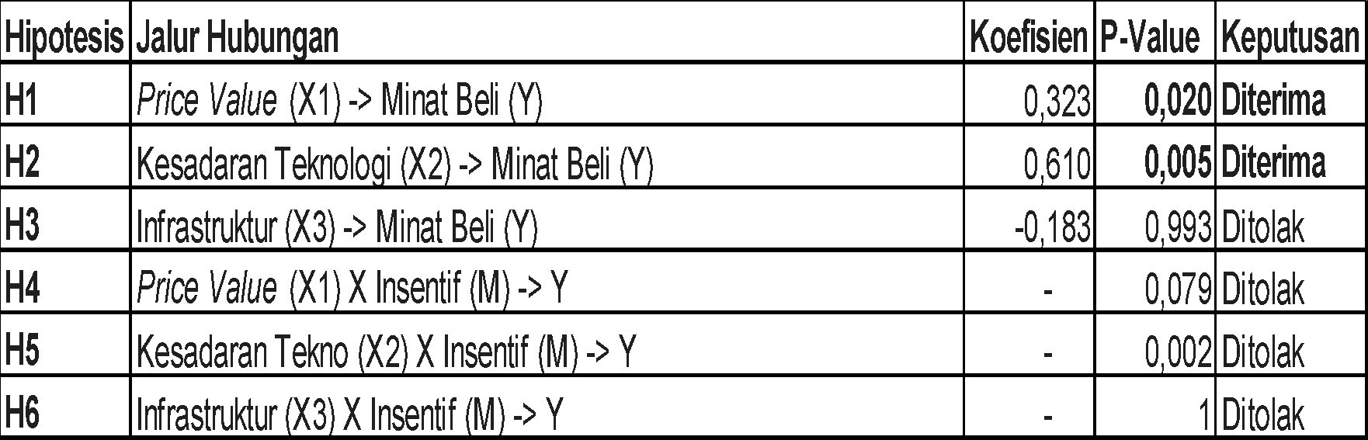
Figure 11. Moderation Effect Summary
Based on the results of the study, respondents are motivated to purchase electric vehicles due to the perception that these vehicles outperform conventional models and offer greater economic efficiency. Respondents find EVs highly appealing, specifically citing their technological sophistication and functional benefits. The environmentally friendly nature of EVs also serves as a key driver for adoption. However, concerns persist regarding the perceived short lifespan of electric vehicles and the long-term durability of the batteries. This factors remind significant consideration for individuals when deciding whether to transition to electric mobility. Although electric vehicles are considered to be more environmentally friendly than conventional vehicles, a new problem has arisen in relation to environmental pollution—namely waste from the batteries themselves. Waste from electric vehicle batteries can cause environmental pollution, both to soil and water, because it contains hazardous components such as heavy metals and chemicals like lithium, nickel, and cobalt. This is certainly very dangerous and could become a new problem that must be faced in the development of electric vehicle in Indonesia.
CONCLUSION
First, Technology Awareness was found to be the most dominant and significant driving factor behind consumer purchasing interest, followed by Price Value. This finding indicates that the greater consumers' understanding of the technical and functional benefits of electric vehicles (EVs), the greater their purchasing interest will be. Consumers in this study tend to evaluate each purchasing decision based on the principle of rational utility, namely whether the value of the item is worth the cost incurred or not. Second, the variables of charging infrastructure and tax incentives do not have a significant effect on consumer purchasing interest at the current stage of intention formation. This reveals the phenomenon that consumer purchasing interest is driven more by the desire to follow trends or FOMO (fear of missing out), so that the availability of physical charging facilities is not yet a major consideration for respondents. Furthermore, tax incentives have not been able to perform their mediating function effectively; although technological awareness increases positive perceptions of tax incentives, this fiscal policy does not automatically increase purchasing interest if it is not balanced with massive technological education. Considering that electric vehicle taxes in Indonesia are actually very cheap. Third, despite strong motivation due to EVs being considered more economical, sophisticated, and environmentally friendly, the public still has fundamental concerns. The main obstacles identified are concerns related to the perceived short lifespan of vehicles, battery durability, and the risk of new environmental pollution resulting from battery waste such as lithium, nickel, and cobalt.
Limitation
Although this study provides in-depth insights into the factors that drive interest in purchasing electric vehicles, there are several limitations that need to be considered. The main limitation of this study is that it focuses exclusively on electric cars, so the findings cannot necessarily be generalized to other categories of electric vehicles, such as motorcycles or conventional vehicles. Furthermore, the analysis in this study is limited to the stage of forming public interest or purchase intention, which is an independent variable for measuring behavioral tendencies, does not cover the stage of actual purchasing behavior or real-world usage decisions.
Suggestion
For the Government and Manufacturers: It is recommended to shift the focus of the strategy from relying solely on fiscal incentive policies to strengthening product value and providing direct technology education to consumers. Explaining the long-term cost efficiency and safety of battery technology will be more effective in converting interest into purchasing decisions. For Marketing Practitioners: Considering the presence of FOMO (fear of missing out) in consumer purchasing interest, marketers can use communication strategies that emphasize modern lifestyles and technological sophistication to attract market segments that are responsive to trends. For Future Researchers: given the limitations of this study, are encouraged to expand the research scope to include two-wheeled electric vehicles (electric motorcycles) or electric public transportation, as well as use a broader sample area to improve the generalization of research results.
ACKNOWLEDGMENTS
The authors would like to thank all respondents who voluntarily participated in this study and contributed to the data collection process. Their participation provided valuable input that supported the completion of this research. The authors also appreciate the constructive feedback received during the research and manuscript preparation process. All individuals acknowledged have provided consent to be mentioned in this section.

REFERENCES
[1] E. Chrysnamurti, "168 Juta Kendaraan Beroperasi di Indonesia," Bisnis.com, Apr. 2025.
[2] Badan Pusat Statistik, "Jumlah Kendaraan Bermotor di DKI Jakarta," BPS, Feb. 2025. [Online]. Available: https://jakarta.bps.go.id
[3] PLN, "PLN Sukses Tambah Jumlah SPKLU hingga 299% di Seluruh Indonesia Sepanjang 2024," PLN, Feb. 2025. [Online]. Available: https://web.pln.co.id
[4] K. S. Ihwan, N. Revalina, G. R. Farius, A. K. Kanz, and A. C. Andhini, "The Effect of Government Incentives, Price Value and Environmental Awareness on Investment Interest in Electric Vehicles," J. Manag. Innov. Res., 2025.
[5] E. N. Laura and W. P. Handayani, "Purchase Intention of Electric Vehicles: Technology Acceptance Model Approach," E-Bis J.: Econ.-Bus., 2025.
[6] D. D. Ananda and A. Muslihat, "The Effect of Government Subsidies and Charging Infrastructure Availability on Electric Vehicle Purchase Decisions in Indonesia," JEMSI, 2025.
[7] A. J. Atthariq, D. Puspitasari, R. Panjaitan, and A. Anomsari, "The Influence of Price Perception, Government Incentives, and SPKLU Availability on Electric Vehicle Purchase Decisions in Semarang," J. Socio-Econ. Manag., 2024.
[8] A. K. Agustinus, A. Setiawan, and H. Djajadikerta, "Exploring the Dynamics of Electric Vehicle Purchase Interest: Environmental and Economic Concerns as Factors," J. Soc. Econ. Res., 2024.
[9] S. M. Ramadhani and L. Yuliana, "The Influence of Consumer Perceptions on Interest in Purchasing Mercedes Benz EQS Electric Cars," J. Bus. Orient. Entrep., 2023.
[10] J. W. Creswell, Research Design: Qualitative, Quantitative, and Mixed Methods Approaches, 6th ed. Sage, 2023.
[11] J. F. Hair Jr, G. T. Hult, C. M. Ringle, M. Sarstedt, and K. O. Thiele, Partial Least Squares Structural Equation Modeling (PLS-SEM): An Introductory Course, 3rd ed. Springer, 2024.

