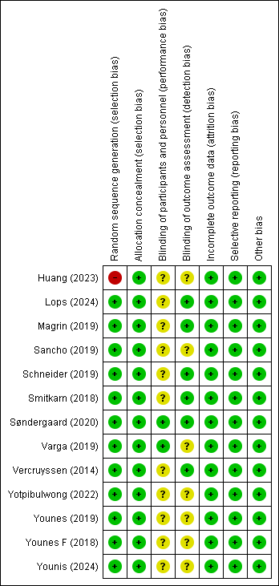
Appendix 1. Risk of bias

