Supporting Information
Polytetrafluoroethylene-Inspired Intrinsically Moisture-Resistant Semiconductor for Gas Sensing
Jie Chen^{1,3}, Ying-Xue Jin¹, Xiao-Liang Ye¹, Yi-Ming Xu¹, Yu Chang^{1,3}, Guan-E Wang^{*,1,2,3}, and Gang Xu^{*,1,2,3}
¹ State Key Laboratory of Structural Chemistry, Fujian Provincial Key Laboratory of Materials and Techniques toward Hydrogen Energy, Fujian Institute of Research on the Structure of Matter, Chinese Academy of Sciences (CAS), Fuzhou 350002, China
² Fujian Science & Technology Innovation Laboratory for Optoelectronic Information of China, Fuzhou, Fujian 350108, PR China
³ University of Chinese Academy of Sciences (UCAS), Beijing 100049, PR China
Correspondence and requests for materials should be addressed to Gang Xu and Guan-E Wang.
(email: gxu@fjirsm.ac.cn) (email: gewang@fjirsm.ac.cn)
Table of Contents
Supplementary Experimental Procedures 3
Figure. S1. Packing structure of Cd-NTP. 5
Figure. S2. Fourier-transform infrared (FT-IR) spectra of Cd-NTP and NTP. 5
Figure. S3. X-ray photoelectron spectroscopy (XPS) spectra of O 1s and S 2p for Cd-NTP. 5
Figure. S4. Thermogravimetric analysis (TGA) of Cd-NTP. 6
Figure. S5. I-V curves of Cd-NTP under different temperatures. 6
Figure. S6. Ultraviolet photoelectron spectroscopy (UPS) spectrum of Cd-NTP. 6
Figure. S7. Calculated projected density of states (PDOS). 7
Figure. S8. Water contact angle patterns of Cd-NTP and NTP at different time. 7
Figure. S9. Resonant microcantilever measurements of Cd-NTP. 7
Figure. S10. Adsorption enthalpy of Cd-NTP on water at different adsorption amounts. 8
Figure. S11. Scanning electron microscope (SEM) and Atomic Force Microscope (AFM) image of Cd-NTP nanowires. 8
Figure. S12. Powder X-ray diffraction (PXRD) pattern of Cd-NTP. 8
Figure. S13. Humidity sensitivity test of Cd-NTP. 9
Figure. S14. Resonant microcantilever measurements of Cd-NTP. 9
Figure. S15. Adsorption enthalpy of Cd-NTP on NH₃ at different adsorption amounts. 9
Figure. S16. PXRD of Cd-NTP after exposure to NH₃. 10
Figure. S17. Long-term stability of Cd-NTP device to 50 ppm NH₃. 10
Figure. S18. Ammonia response variation of different moisture-resistant materials under humidity. 10
Figure. S19. Response and recovery time of Cd-NTP to ammonia at different humidity (calculated as the time to reach 90% response or recovery). 11
Figure. S20. A response comparison of Cd-NTP towards NH₃ and interfering gases of 100 ppm. 11
Figure. S21. Quantitative capacity measurements of Cd-NTP towards 200 ppm H₂O. 11
Figure. S22. Homemade gas sensing test system. 12
Table S1. High-symmetry k-point coordinates in the Brillouin zone used for the band-structure calculations of Cd-NTP. 13
Table S2. Calculated and measured (with EA and ICP-AES) elemental mass percentage of Cd-NTP. 14
Table S3. Reported NH₃ gas-sensing materials working at room temperature. 15
Table S4. Ammonia response variation of different moisture-resistant materials under humidity. 16
Table S5. Crystallographic information of Cd-NTP. 17
Table S6. Unit cell parameters of Cd-NTP after Pawley refinement of XRD data. 18
References 19

Supplementary Experimental Procedures
Single-crystal structure analysis
The single crystal diffraction data was collected on a Rigaku XtaLAB Synergy R diffractometer equipped with a HyPix hybrid pixel array detector using Cu Kα radiation (λ = 1.54184 Å) at 100 K (ω scans). Data reduction and an empirical multi-scan absorption correction were performed with CrysAlisPro 1.171.42.93a (Rigaku Oxford Diffraction). The structure was solved by intrinsic phasing using SHELXT and refined by full-matrix least-squares on F² with SHELXL-2018/3 within Olex2 1.5^{1, 2}. All non-hydrogen atoms were refined anisotropically; hydrogen atoms were placed in calculated positions and refined using a riding model. PXRD data were collected on a Rigaku SmartLab XE diffractometer using Cu Kα radiation (λ₁ = 1.540593 Å, λ₂ = 1.544414 Å) in Bragg–Brentano geometry. Whole-pattern fitting was performed by Pawley refinement, in which the atomic coordinates were kept fixed and only the unit-cell parameters (a, b, c, α, β, γ) together with instrumental parameters were refined. The crystal information and refinement information collected from the single crystal are shown in Tables S5 and S6, respectively.
Gas adsorption test
The Cd-NTP nanowires were dispersed in ethanol and then loaded onto the front of the micro-cantilever of the chip using a micro-cantilever microscope. The testing was performed using a chip-based resonant micro-cantilever molecular adsorption analyzer (LoC-TGA 3000, resolution of 1 Hz/pg). After thorough drying, the amount of NH₃ or H₂O adsorbed by the sample was measured by detecting the vibration frequency of the cantilever beam at different concentrations, ranging from 5 ppm to 200 ppm for NH₃ and 10-90% RH for H₂O. The adsorption enthalpy ($∆H^{θ}$) was calculated by the Clausius-Clapeyron equation. The partial pressure at different temperatures for the same coverage (θ) was calculated by taking the partial pressure at the same adsorption amount from two adsorption isotherms.
The Clausius-Clapeyron equation is expressed as:
$$\begin{aligned}\frac{dlnp}{dT}=\frac{∆H^{θ}}{RT^{2}}\#\left(1\right)\end{aligned}$$
Integration:
$$\begin{aligned}∆H^{θ}=\frac{RT_{1}T_{2}}{T_{2}-T_{1}}ln\left(\frac{p_{2}}{p_{1}}\right)\#\left(2\right)\end{aligned}$$
The adsorption enthalpy is the average value calculated under five different adsorption amounts (Figure S10 and Figure S15).
In situ diffuse reflectance infrared Fourier transform spectroscopy collection
DRIFTS spectra were collected using a Nicolet 6700 FT-IR spectrometer equipped with an MCT/A detector cooled by liquid nitrogen. To monitor real test conditions, all spectra were collected under synthetic air (79% nitrogen, 21% oxygen) using OMNIC software for data collection.
Before testing, a raw diffuse reflectance infrared absorption spectrum of KBr was acquired as a background for sample testing. This was done by passing high purity argon gas at 80 °C for 1 hour to remove adsorbed moisture and other gas molecules. After the sample and sample chamber had cooled to room temperature for 30 minutes, synthetic air was passed through to purge the chamber. Next, Cd-NTP nanowires (60 mg) were loaded into the sample compartment, and the synthetic air purging operations were repeated. The sample was then treated with a xenon arc lamp (PLS-SXE300D) at a light intensity of 360 klx, filtered to 420-760 nm, and the initial spectrum of the sample was collected as a background. Following this, 100 ppm of NH₃ was injected, and its spectrum was collected.
DFT calculation
Density-functional theory (DFT) calculations were conducted using the Cambridge Serial Total Energy Package (CASTEP) module within the Materials Studio software suite. The Perdew-Burke-Ernzerhof (PBE) exchange-correlation functional with the generalized gradient approximation (GGA) was employed for all calculations. Orbital calculations utilized a plane-wave basis set along with OTFG ultrasoft pseudopotentials. The plane-wave cutoff energy was set at 571.4 eV, and a Monkhorst-Pack mesh of 4×2×1 k-points was used for sampling. Convergence thresholds were 1 × 10⁻⁵ eV per atom for total energy and 0.03 eV Å⁻¹ for forces. After optimizing bulk Cd-NTP, a 1 × 3 × 1 supercell slab exposing surface nitro groups with a 15 Å vacuum along the c-axis was constructed and fully relaxed. Electron-density-difference maps were obtained from the converged wavefunctions to visualize gas-surface charge redistribution. The dipole moment and electrostatic potential of Cd-NTP were calculated on the minimal repeating unit using the Density Functional Theory Molecular Orbital Package 3 (DMol³) module in the Materials Studio package. All geometry optimizations and electrostatic calculations used the PBE functional within the GGA framework and the DNP basis set (basis set file version 3.5), with an energy convergence threshold of 1 × 10⁻⁵ Ha per atom and a force threshold of 0.002 Ha Å⁻¹. The orbital cutoff quality was set to fine and a 4 × 2 × 1 Monkhorst-Pack grid was used.

Supporting Figures
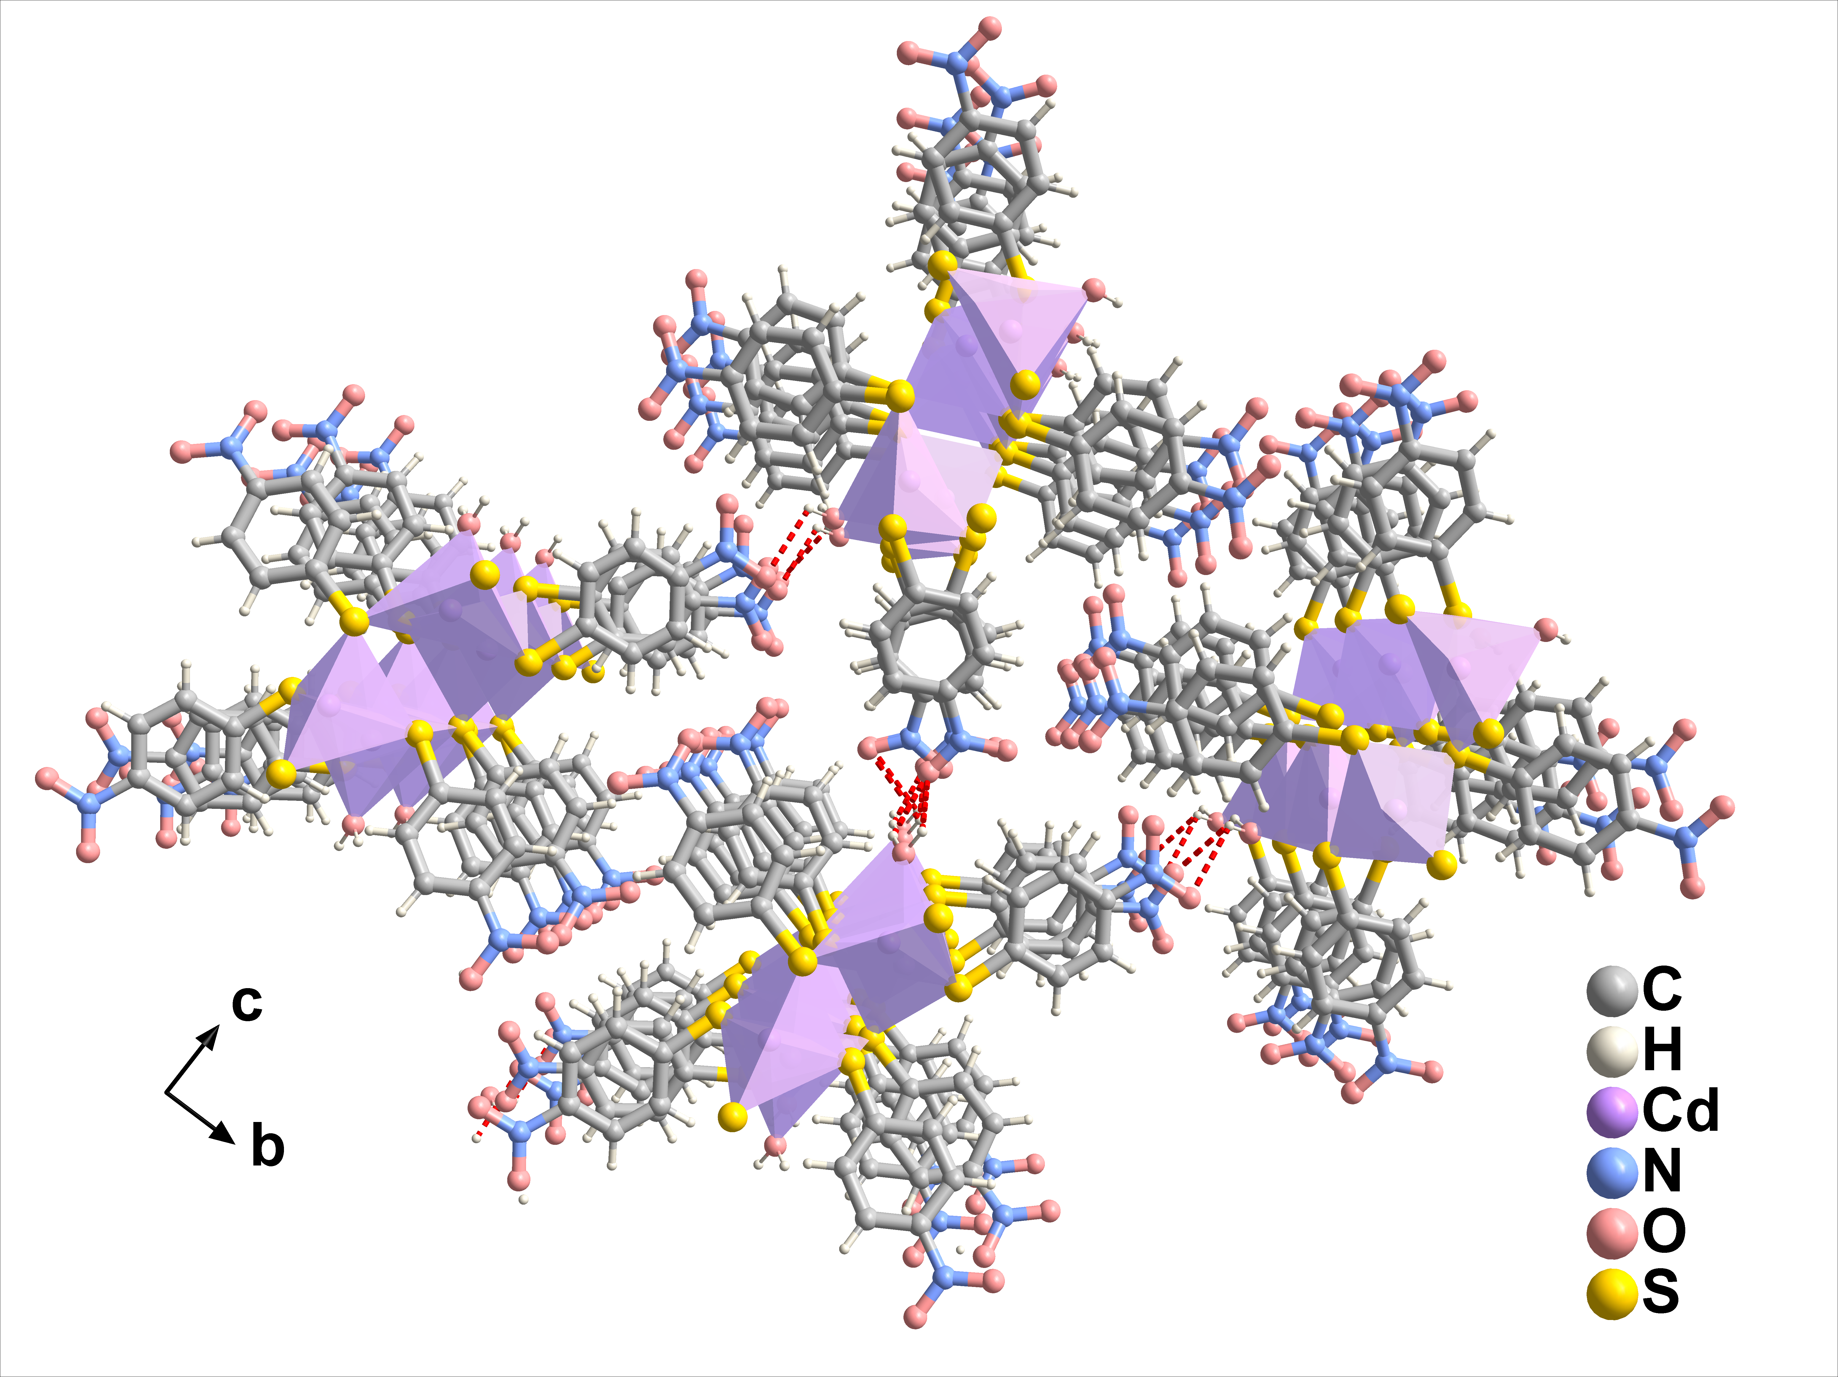

Figure. S1. Packing structure of Cd-NTP.

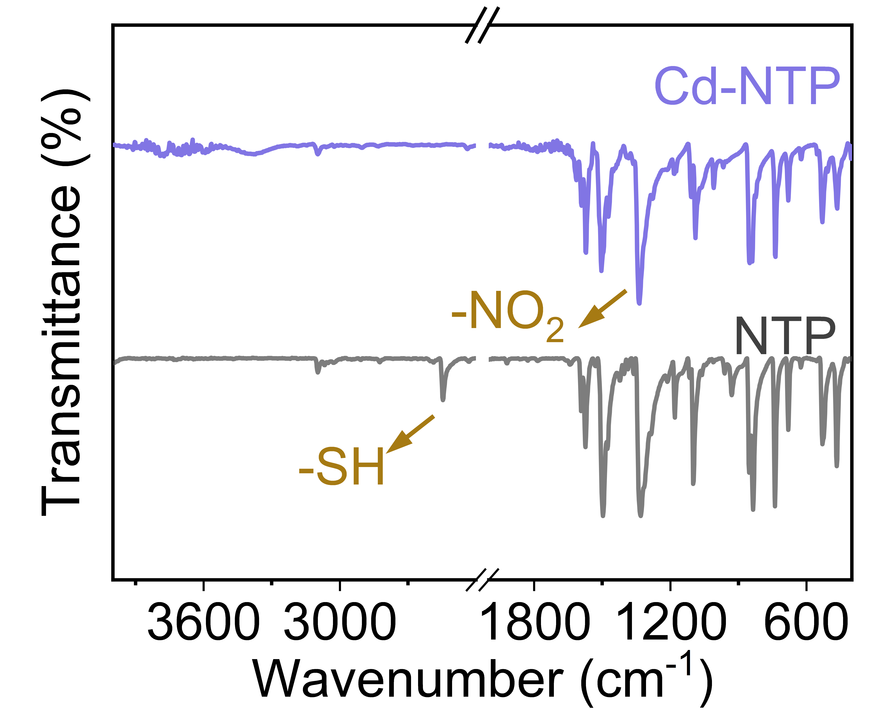

Figure. S2. Fourier-transform infrared (FT-IR) spectra of Cd-NTP and NTP.

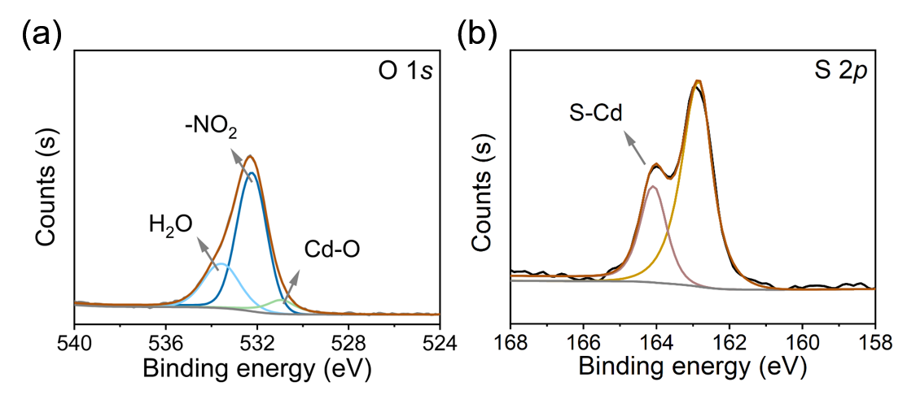

Figure. S3. X-ray photoelectron spectroscopy (XPS) spectra of (a) O 1s and (b) S 2p for Cd-NTP.

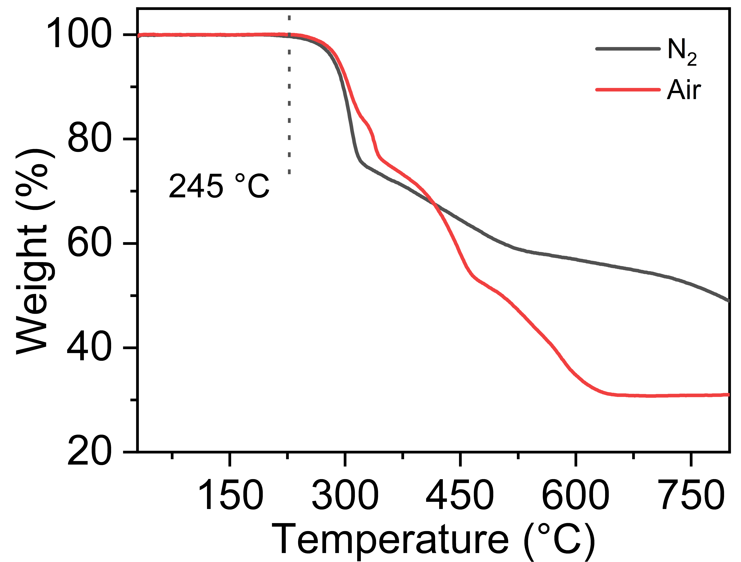

Figure. S4. Thermogravimetric analysis (TGA) of Cd-NTP.

Figure. S5. I-V curves of Cd-NTP under different temperatures.

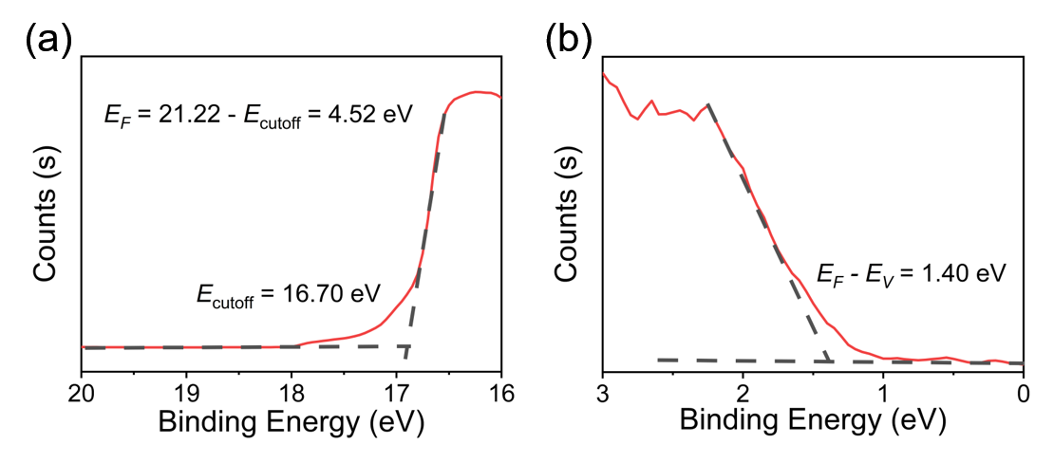

Figure. S6. Ultraviolet photoelectron spectroscopy (UPS) spectrum of Cd-NTP. (a) the secondary electron cut off edge measured with He I (hν = 21.22 eV). (b) Valence band of Cd-NTP with respect to the Fermi level (E_{F} = 0).

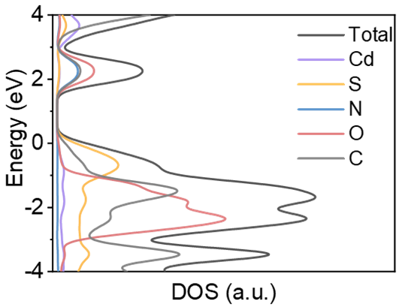

Figure. S7. Calculated projected density of states (PDOS).

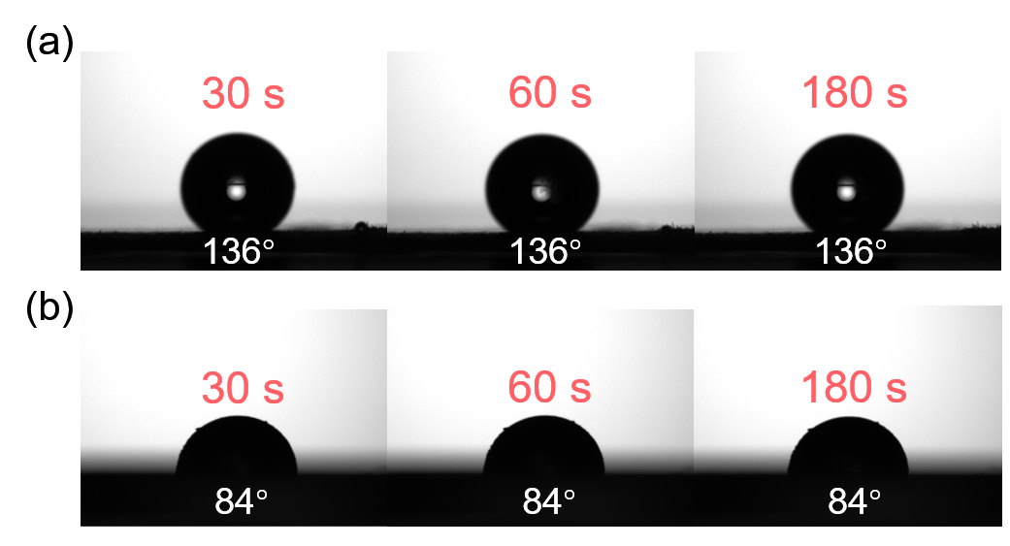

Figure. S8. Water contact angle patterns of (a) Cd-NTP and (b) NTP at different time.

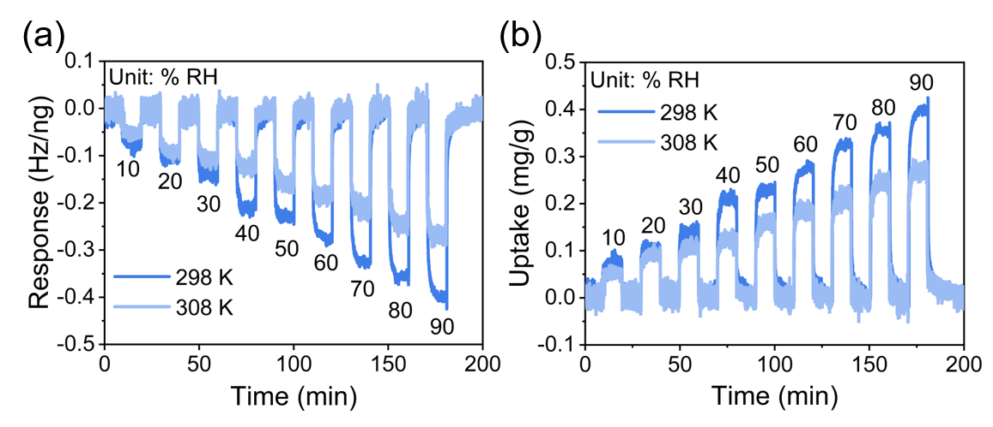

Figure. S9. Resonant microcantilever measurements of Cd-NTP: (a) response to H₂O and (b) corresponding uptake at 298 K and 308 K.

Figure. S10. Adsorption enthalpy of Cd-NTP on water at different adsorption amounts.

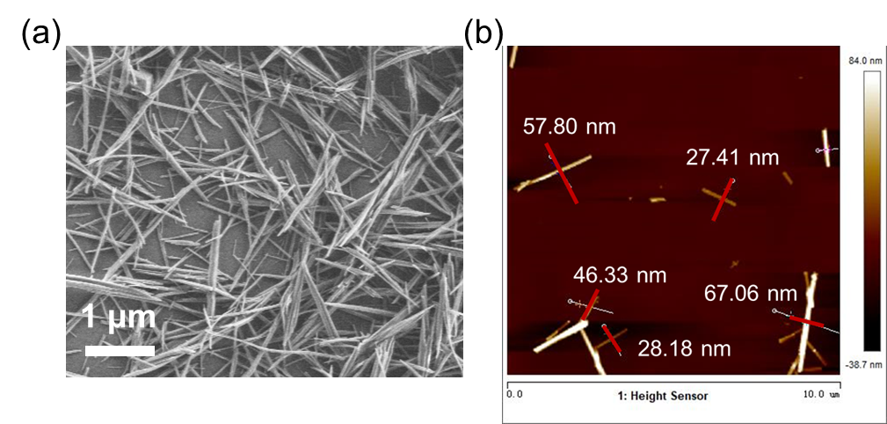、

Figure. S11. (a) Scanning electron microscope (SEM) and (b) Atomic Force Microscope (AFM) image of Cd-NTP nanowires.

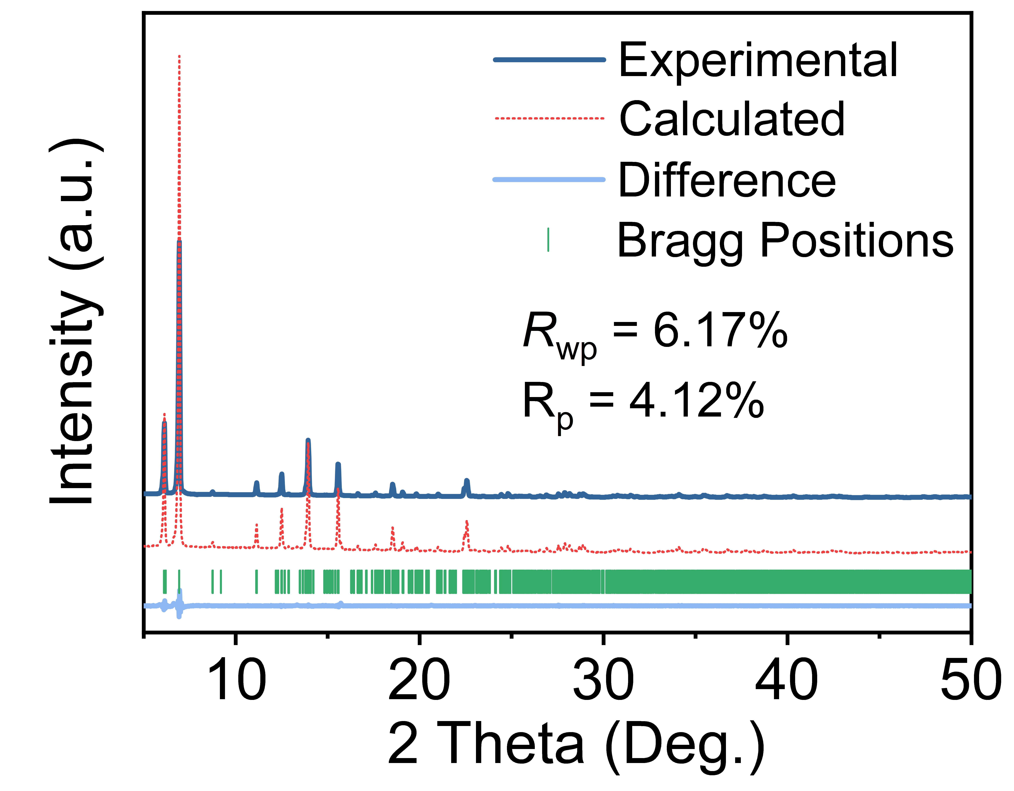

Figure. S12. Powder X-ray diffraction (PXRD) pattern of Cd-NTP.

Figure. S13. Humidity sensitivity test of Cd-NTP.
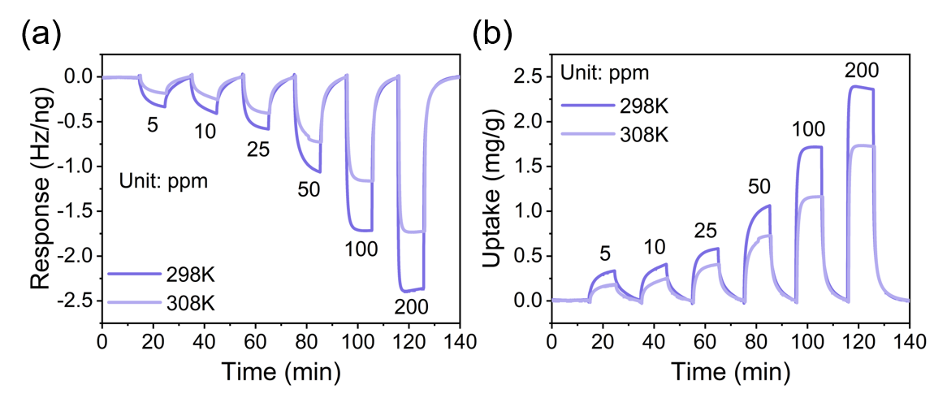

Figure. S14. Resonant microcantilever measurements of Cd-NTP: (a) response to NH₃ and (b) corresponding uptake at 298 K and 308 K.

Figure. S15. Adsorption enthalpy of Cd-NTP on NH₃ at different adsorption amounts.

Figure. S16. PXRD of Cd-NTP after exposure to NH₃.

Figure. S17. Long-term stability of Cd-NTP device to 50 ppm NH₃.

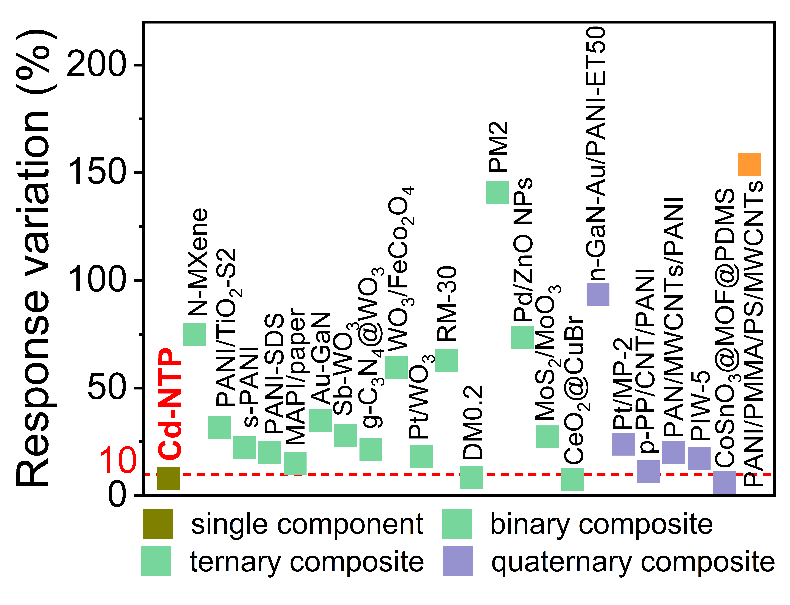

Figure. S18. Ammonia response variation of different moisture-resistant materials under humidity³⁻²⁵.

Figure. S19. Response and recovery time of Cd-NTP to ammonia at different humidity (calculated as the time to reach 90% response or recovery).

Figure. S20. A response comparison of Cd-NTP towards NH₃ and interfering gases of 100 ppm.

Figure. S21. Quantitative capacity measurements of Cd-NTP towards 200 ppm H₂O.

Figure. S22. Homemade gas sensing test system.

Table S1. High-symmetry k-point coordinates in the Brillouin zone used for the band-structure calculations of Cd-NTP.
k-point | Coordinates
Γ | (0, 0, 0)
Y | (0, 0.5, 0)
S | (0, 0.5, 0.5)
Z | (0, 0, 0.5)
R | (0.5, 0, 0.5)
U | (0.5, 0.5, 0.5)
T | (0.5, 0.5, 0)
X | (0.5, 0, 0)

Table S2. Calculated and measured (with EA and ICP-AES) elemental mass percentage of Cd-NTP.
Element | Calculated weight percentage/% | measured weight percentage/%
Cd | 26.2 | 26.8
C | 33.5 | 33.1
S | 14.9 | 14.6
N | 6.5 | 6.4
H | 2.1 | 2.3

Table S3. Reported NH₃ gas-sensing materials working at room temperature.
Materials | Response range (ppm) |  | Concentration (ppm) | Response value (%) |  | Ref.
Cd-NTP | 10–1000 | 100 |  | 852 | This work
FZU-2 | 0.01–1 | 100 |  | 1200 | ²⁶
NDI-A | 2–50 | 50 |  | 66 | ²⁷
NiPc-Cu | 2–80 | 40 |  | 29 | ²⁸
Cu-BHT | 1–100 | 100 |  | 15 | ²⁹
Cu₃HHTT₂ | 5–60 | 60 |  | 5500 | ³⁰
ST-2BP | 1–40 | 20 |  | 787 | ³¹
Cu-HHTP | 0.005–100 | 100 |  | 161 | ³²
CuTCNQ | 10–99 | 99 |  | 5 | ³³
Cu₃HITP₂ | 0.5–10 | 10 |  | 3 | ³⁴
rGO | 5–40 | 40 |  | 22 | ³⁵
MnO₂ | 1–100 | 100 |  | 20 | ³⁶
Dy₂O₃ | 0.1–100 | 100 |  | 1337 | ³⁷
MoS₂ | 0.3–30 | 8 |  | 30 | ³⁸
Cu(HHTP)(THQ) | 1–100 | 10 |  | 12 | ³⁹
Polypyrrole | 0.00005–2 | 2 |  | 200 | ⁴⁰
pDPPBu-BT | 0.01–1000 | 1000 |  | 45 | ⁴¹

Table S4. Ammonia response variation of different moisture-resistant materials under humidity.
Materials | Response variation (%) | Concentration of NH₃ (ppm) | Number of composite materials | Ref.
Cd-NTP | 8 | 100 | 1 | This work
FZU-2 | 991 | 1 | 1 | ²⁶
NDI-A | 16.7 | 50 | 1 | ²⁷
NiPc-Cu | 17.3 | 40 | 1 | ²⁸
CuBHT | 49 | 20 | 1 | ²⁹
Cu₃HHTT₂ | 194 | 60 | 1 | ³⁰
ST-2BP | 11 | 20 | 1 | ³¹
N-MXene | 75 | 1 | 2 | ³
PANI/TiO₂-S2 | 31.8 | 40 | 2 | ⁴
s-PANI | 22.2 | 5 | 2 | ⁵
PANI-SDS | 20 | 40 | 2 | ⁶
MAPI/paper | 15 | 20 | 2 | ²¹
Au-GaN | 34.9 | 100 | 2 | ⁷
Sb-WO₃ | 27.9 | 50 | 2 | ⁸
g-C₃N₄@WO₃ | 21.5 | 10 | 2 | ⁹
WO₃/FeCo₂O₄ | 59.7 | 100 | 2 | ¹⁰
Pt/WO₃ | 18.1 | 1000 | 2 | ¹¹
RM-30 | 62.8 | 10 | 2 | ¹²
DM0.2 | 8.3 | 10 | 2 | ¹³
PM2 | 140.9 | 40 | 2 | ¹⁴
Pd/ZnO NPs | 73.4 | 40 | 2 | ¹⁵
MoS₂/MoO₃ | 27.3 | 50 | 2 | ¹⁶
CeO₂@CuBr | 7.4 | 5 | 2 | ¹⁷
n-GaN-Au/PANI-ET50 | 93.3 | 100 | 3 | ¹⁸
Pt/MP-2 | 24 | 50 | 3 | ¹⁹
p-PP/CNT/PANI | 11.1 | 70 | 3 | ²⁵
PAN/MWCNTs/PANI | 20 | 100 | 3 | ²²
PIW-5 | 17.3 | 100 | 3 | ²³
CoSnO₃@MOF@PDMS | 6.2 | 100 | 3 | ²⁴
PANI/PMMA/PS/MWCNTs | 153.8 | 5 | 4 | ²⁰

Table S5. Crystallographic information of Cd-NTP.
Crystal data | Cd-NTP
Empirical formula | C₂₄H₁₈Cd₂N₄O₉S₄
Formula weight | 859.46
Temperature/K | 100.15
Crystal system | triclinic
Space group | P-1
a/Å | 7.2736(1)
b/Å | 14.0708(2)
c/Å  α/°  β/° | 28.4118(7)  89.135(2)  88.052(2)
γ/° | 89.067(1)
V/Å³ | 2905.44(9)
Z | 4
ρ_{calc}/gcm⁻³ | 1.965
μ/mm^{‑1} | 14.934
F (000) | 1688.0
Radiation | Cu-Kα (λ = 1.54184)
Reflections collected | 11630
Independent reflections | 11630 [R_{sigma} = 0.0840]
Data/restraints/parameters | 11630/31/781
2theta range for data collection/° | 6.226 to 152.218
Index ranges | -9 ≤ h ≤ 9, -17 ≤ k ≤ 17, 0 ≤ l ≤ 35
GOF on F² | 1.228
Final R indexes [I>=2σ (I)] | R₁ = 0.1058, wR₂ = 0.2910
Final R indexes [all data] | R₁ = 0.1108, wR₂ = 0.2933
Largest diff. peak/hole / eÅ⁻³ | 6.10/-3.61

Table S6. Unit cell parameters of Cd-NTP after Pawley refinement of XRD data.
Crystal data | Cd-NTP
a/Å | 7.14081
b/Å | 13.91176
c/Å  α/°  β/° | 28.28670  89.90238  88.19641
γ/° | 89.27287

References
1. Dolomanov, O. V., Blake, A. J., Champness, N. R. & Schröder, M. OLEX: new software for visualization and analysis of extended crystal structures. J. Appl. Crystallogr. 36, 1283-1284 (2003).
2. Sheldrick, G. M. SHELXT - integrated space-group and crystal-structure determination. Acta Cryst. A 71, 3-8 (2015).
3. Zhou, Y. et al. MXene Ti₃C₂T_{x}-derived nitrogen-functionalized heterophase TiO₂ homojunctions for room-temperature trace ammonia gas sensing. ACS Appl. Mater. Interfaces 13, 56485-56497 (2021).
4. Safe, A. M., Nikfarjam, A. & Hajghassem, H. UV enhanced ammonia gas sensing properties of PANI/TiO₂ core-shell nanofibers. Sensor Actuat. B-Chem. 298, 126906 (2019).
5. Xu, L. et al. Two-birds-one-stone: Flexible PANI film with bionic microstructures for multifunctional sensing of physical and chemical stimuli. Chem. Eng. J. 451, 138820 (2023).
6. Zhu, C. et al. Self-assembly polyaniline films for the high-performance ammonia gas sensor. Sensor Actuat. B-Chem. 365, 131928 (2022).
7. Han, D. et al. Au nanoparticles decorated GaN nanoflowers with enhanced NH₃ sensing performance at room temperature. Sensor Actuat. B-Chem. 394, 134320 (2023).
8. Yao, G. et al. P-type Sb doping hierarchical WO₃ microspheres for superior close to room temperature ammonia sensor. Sensor Actuat. B-Chem. 359, 131365 (2022).
9. Zou, Z. et al. Room-temperature optoelectronic gas sensor based on core-shell g-C₃N₄@WO₃ heterocomposites for efficient ammonia detection. Anal. Chem. 95, 2110-2118 (2023).
10. Yuan, Z., Lei, Y., Li, X., Meng, F. & Gao, H. WO₃ nanosheets/FeCo₂O₄ nanoparticles heterostructures for highly sensitive and selective ammonia sensors. IEEE Sens. J. 21, 26515-26525 (2021).
11. Chao, J. F., Liu, Z. D., Xing, S. M., Gao, Q. & Zhao, J. Z. Enhanced ammonia detection of gas sensors based on square-like tungsten oxide loaded by Pt nanoparticles. Sensor Actuat. B-Chem. 347, 130621 (2021).
12. Gasso, S., Carrier, J., Radu, D. & Lai, C. Y. Novel gas sensing approach: ReS₂/Ti₃C₂T_{x} heterostructures for NH₃ detection in humid environments. ACS Sens. 9, 4788-4802 (2024).
13. Ou, Y. et al. 2D/2D Dy₂O₃ nanosheet/MoO₃ nanoflake heterostructures for humidity-independent and sensitive ammonia detection. ACS Sens. 8, 4253-4263 (2023).
14. Zhu, C., Zhou, T., Xia, H. & Zhang, T. Flexible room-temperature ammonia gas sensors based on PANI-MWCNTs/PDMS film for breathing analysis and food safety. Nanomaterials 13, 1158 (2023).
15. Mhlongo, G. H., Motaung, D. E., Cummings, F. R., Swart, H. C. & Ray, S. S. A highly responsive NH₃ sensor based on Pd-loaded ZnO nanoparticles prepared via a chemical precipitation approach. Sci. Rep. 9, 9881 (2019).
16. Singh, S., Deb, J., Sarkar, U. & Sharma, S. MoS₂/MoO₃ nanocomposite for selective NH₃ detection in a humid environment. ACS Sustainable Chem. Eng 9, 7328-7340 (2021).
17. Li, H. Y., Lee, C. S., Kim, D. H. & Lee, J. H. Flexible room-temperature NH₃ sensor for ultrasensitive, selective, and humidity-independent gas detection. ACS Appl. Mater. Interfaces 10, 27858-27867 (2018).
18. Han, D. et al. Machine-learning-assisted n-GaN-Au/PANI gas sensor array for intelligent and ultra-accurate ammonia recognition. Chem. Eng. J. 495, 153705 (2024).
19. Tian, X., Cui, X., Xiao, Y., Chen, T., Xiao, X. & Wang, Y. Pt/MoS₂/polyaniline nanocomposite as a highly effective room temperature flexible gas sensor for ammonia detection. ACS Appl. Mater. Interfaces 15, 9604-9617 (2023).
20. Saad Ali, S., Pauly, A., Brunet, J., Varenne, C. & Ndiaye, A. L. MWCNTs/PMMA/PS composites functionalized PANI: electrical characterization and sensing performance for ammonia detection in a humid environment. Sensor Actuat. B-Chem. 320, 128364 (2020).
21. Maity, A., Raychaudhuri, A. K. & Ghosh, B. High Sensitivity NH₃ Gas Sensor with Electrical Readout Made on Paper With Perovskite Halide as Sensor Material. Sci. Rep. 9, 7777 (2019).
22. Dong, H. et al. Ultra-flexible, breathable, and robust PAN/MWCNTs/PANI nanofiber networks for high-performance wearable gas sensor application. ACS Sens. 9, 3085-3095 (2024).
23. Gao, W. et al. Humidity-tolerant Ammonia Gas Sensors Based on PrO_{x}/In₂O₃/WO₃ Heterostructure Films. Chem. Eng. J. 509, 161482161482 (2025).
24. Qu, F. et al. Surface Functionalized Sensors for Humidity-Independent Gas Detection. Angew. Chem. Int. Ed. 60, 6561-6566 (2021).
25. Wu, G. et al. A wearable mask sensor based on polyaniline/CNT nanocomposites for monitoring ammonia gas and human breathing. Sensor Actuat. B-Chem. 375, 132858 (2023).
26. Guo, Z. W. et al. An all-inorganic three-dimensional polyoxoniobate framework with ppb-level chemiresistive sensing for ammonia. Nat. Commun. 16, 6379 (2025).
27. Ali, S., Jameel, M. A., Gupta, A., Shafiei, M. & Langford, S. J. A room temperature functioning ammonia sensor utilising a bis-phenylalanine naphthalene diimide. Sensors and Actuators A: Physical 348, 114008 (2022).
28. Meng, Z., Aykanat, A. & Mirica, K. A. Welding metallophthalocyanines into bimetallic molecular meshes for ultrasensitive, low-power chemiresistive detection of gases. J Am Chem Soc 141, 2046-2053 (2019).
29. Chen, X. et al. Ultrafast in situ synthesis of large-area conductive metal-organic frameworks on substrates for flexible chemiresistive sensing. ACS Appl. Mater. Interfaces 12, 57235-57244 (2020).
30. Jo, Y. M., Kim, D. H., Wang, J., Oppenheim, J. J. & Dinca, M. Humidity-mediated dual ionic-electronic conductivity enables high sensitivity in MOF chemiresistors. J. Am. Chem. Soc. 146, 20213-20220 (2024).
31. Wang, B., Xing, Y., Zhang, K., Wang, Z., Xia, Y. & Long, X. Electron-Deficient Organic Molecules Based on B←N Unit: A N-Type Room-Temperature Chemiresistive Sensors with Moisture Resistance. Adv. Sci. 11, 2409890 (2024).
32. Lin, Y., Li, W. H., Wen, Y., Wang, G. E., Ye, X. L. & Xu, G. Layer-by-layer growth of preferred-oriented MOF thin film on nanowire array for high-performance chemiresistive sensing. Angew. Chem. Int. Ed. 60, 25758-25761 (2021).
33. Shafiei, M., Hoshyargar, F., Lipton-Duffin, J., Piloto, C., Motta, N. & O'Mullane, A. P. Conversion of n-type CuTCNQ into p-type nitrogen-doped CuO and the Implication for room-temperature gas sensing. J. Phys. Chem. C 119, 22208-22216 (2015).
34. Campbell, M. G., Sheberla, D., Liu, S. F., Swager, T. M. & Dinca, M. Cu₃(hexaiminotriphenylene)₂: an electrically conductive 2D metal-organic framework for chemiresistive sensing. Angew. Chem. Int. Ed. 54, 4349-4352 (2015).
35. Duy, L. T. et al. Flexible transparent reduced graphene gxide sensor coupled with organic dye molecules for rapid dual‐mode ammonia gas detection. Adv. Funct. Mater. 26, 4329-4338 (2016).
36. Kumar, R., Kumar, R., Kushwaha, N. & Mittal, J. Ammonia gas sensing using thin film of MnO₂ nanofibers. IEEE Sens. J. 16, 4691-4695 (2016).
37. Dong, X. et al. A novel coral-shaped Dy₂O₃ gas sensor for high sensitivity NH₃ detection at room temperature. Sensor Actuat. B-Chem. 255, 1308-1315 (2018).
38. Lee, K., Gatensby, R., McEvoy, N., Hallam, T. & Duesberg, G. S. High-performance sensors based on molybdenum disulfide thin films. Adv. Mater. 25, 6699-6702 (2013).
39. Yao, M. S. et al. A dual-ligand porous coordination polymer chemiresistor with modulated conductivity and porosity. Angew. Chem. Int. Ed. 59, 172-176 (2020).
40. Xue, M., Li, F., Chen, D., Yang, Z., Wang, X. & Ji, J. High-oriented polypyrrole nanotubes for next-generation gas sensor. Adv. Mater. 28, 8265-8270 (2016).
41. Yang, Y., Zhang, G., Luo, H., Yao, J., Liu, Z. & Zhang, D. Highly sensitive thin-film field-effect transistor sensor for ammonia with the DPP-bithiophene conjugated polymer entailing thermally cleavable tert-butoxy groups in the side chains. ACS Appl. Mater. Interfaces 8, 3635-3643 (2016).

