Supplementary Information - Appendix

Sample details
Seventy-seven participants were European (including 18 British, 17 Polish, and 15 Portuguese), 19 North/South American, and 15 African. The majority of participants had a university degree (N=99, including 45 women); 16 were students. Four participants were unemployed; the rest had some type of employment or owned their own business. Among participants who reported musculoskeletal pain, the most common was back/shoulder pain (N=9), followed by the leg/knee pain (N=5), and fibromyalgia (N=2), with seven participants reporting more than one type of pain.
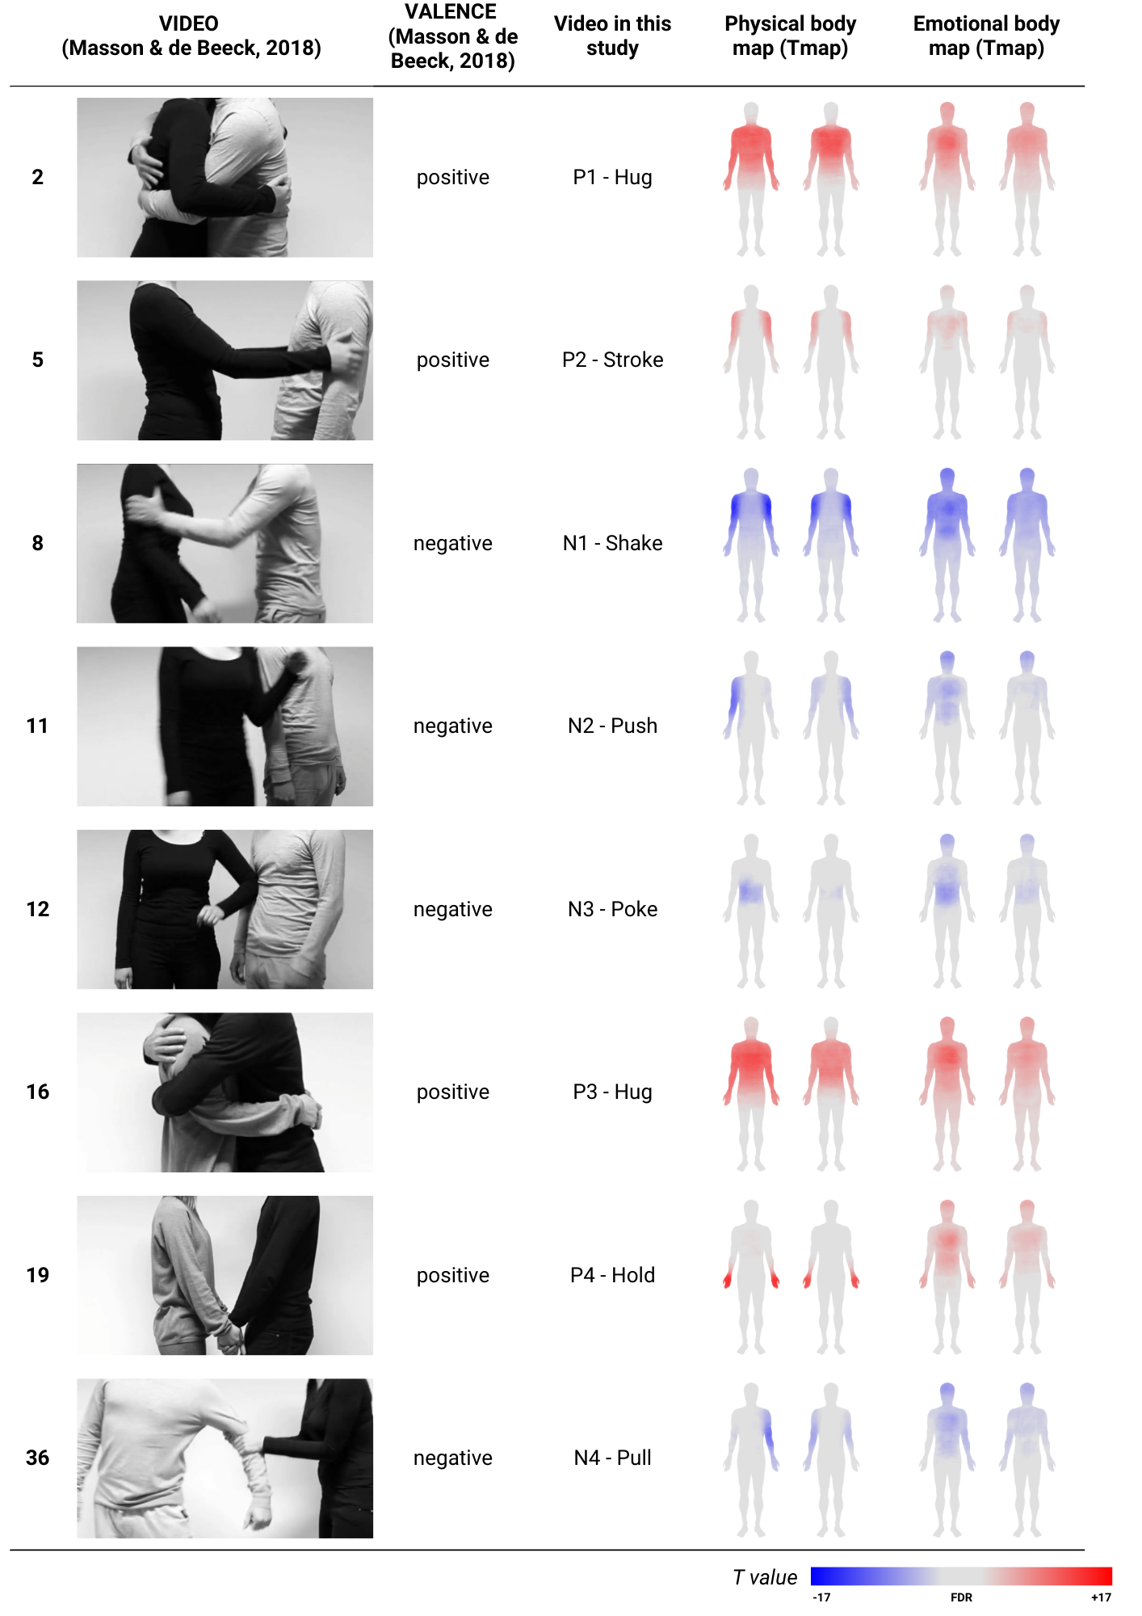
Figure S1. T-maps for physical and emotional body maps for the positive and negative video stimuli.
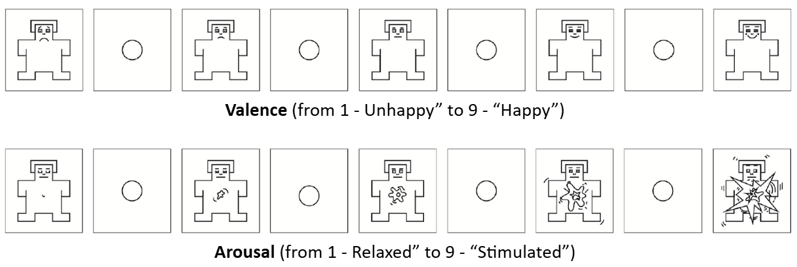
Figure S2. Self-Assessment Manikins (Bradley and Lang, 1994).

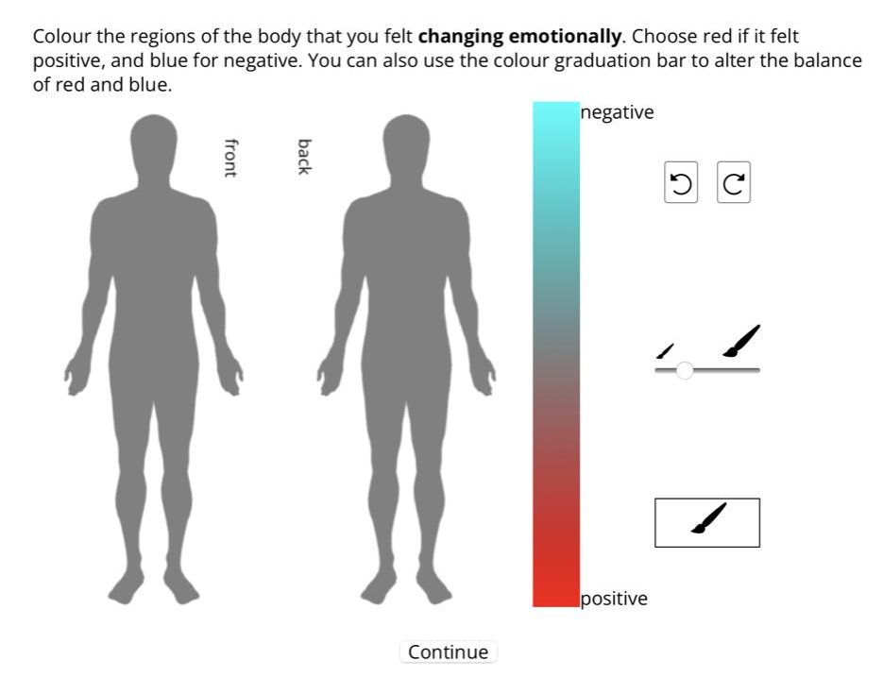
Figure S3. The body map tool.

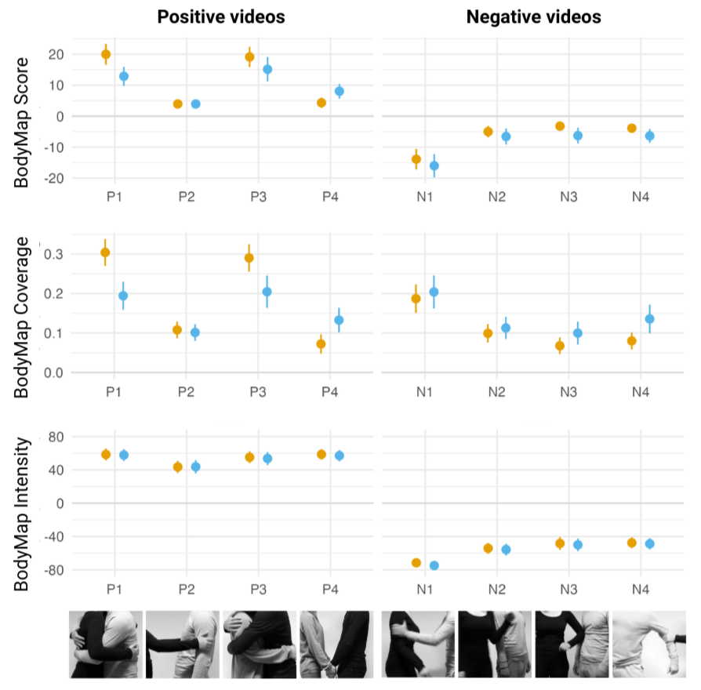Figure S4. TI measures by video.

Table S1. Mean and SD values for BodyMap Score, BodyMap Intensity, BodyMap Coverage for physical and emotional body maps by video.
 | BodyMap Score
 | Physical |  | Emotional
 | Mean | SD | Mean | SD
P1 - Hug | 19.979 | 20.490 | 12.879 | 18.719
P2 - Stroke | 3.947 | 8.482 | 3.941 | 8.802
P3 - Hug | 19.127 | 19.923 | 15.137 | 24.311
P4 - Hold | 4.346 | 10.159 | 8.061 | 14.572
N1 - Shake | -13.894 | 20.469 | -15.996 | 22.792
N2 - Push | -4.989 | 11.234 | -6.570 | 15.425
N3 - Poke | -3.204 | 8.827 | -6.276 | 15.386
N4 - Pull | -3.875 | 7.498 | -6.368 | 13.309
 | BodyMap Intensity
 | Physical |  | Emotional
 | Mean | SD | Mean | SD
P1 - Hug | 58.471 | 42.364 | 57.783 | 43.328
P2 - Stroke | 43.499 | 43.777 | 43.756 | 46.463
P3 - Hug | 55.147 | 42.857 | 53.640 | 47.110
P4 - Hold | 58.629 | 37.316 | 57.055 | 40.006
N1 - Shake | -71.552 | 32.355 | -74.893 | 27.805
N2 - Push | -54.095 | 38.777 | -55.672 | 41.661
N3 - Poke | -48.357 | 45.597 | -49.973 | 44.324
N4 - Pull | -47.500 | 38.964 | -48.722 | 39.457
 | Coverage
 | Physical |  | Emotional
 | Mean | SD | Mean | SD
P1 - Hug | 0.304 | 0.207 | 0.194 | 0.220
P2 - Stroke | 0.108 | 0.132 | 0.101 | 0.125
P3 - Hug | 0.290 | 0.211 | 0.205 | 0.251
P4 - Hold | 0.072 | 0.151 | 0.133 | 0.190
N1 - Shake | 0.187 | 0.222 | 0.204 | 0.257
N2 - Push | 0.099 | 0.142 | 0.113 | 0.168
N3 - Poke | 0.068 | 0.131 | 0.100 | 0.175
N4 - Pull | 0.080 | 0.132 | 0.136 | 0.217

Table S2. Mean and SD values for subjective ratings of valence and arousal for each video.
 | Subjective Valence |  | Subjective Arousal
 | Mean | SD | Mean | SD
P1 - Hug | 7.331 | 1.793 | 4.453 | 2.716
P2 - Stroke | 6.378 | 2.062 | 4.473 | 2.299
P3 - Hug | 7.257 | 1.811 | 3.899 | 2.476
P4 - Hold | 7.270 | 1.717 | 4.203 | 2.545
N1 - Shake | 1.750 | 1.200 | 7.480 | 1.991
N2 - Push | 2.615 | 1.373 | 6.007 | 2.062
N3 - Poke | 3.095 | 2.008 | 6.041 | 2.102
N4 - Pull | 2.980 | 1.473 | 6.196 | 1.772

Table S3. Results from mixed effect linear regression, predicting body map score with body map type, video valence, with random intercepts for participant and video.
lmer: body map score ~ body map type + video valence + (1|ID) + (1|video)
 | Estimate | Std. Error | df | t value | Pr(>|t|)
(Intercept) | -6.614 | 3.003 | 6.242 | -2.202 | 0.068 | .
body map type - emotional | -2.087 | 0.657 | 2142.486 | -3.178 | 0.002 | **
video valence - positive | 18.567 | 4.205 | 6.002 | 4.415 | 0.004 | **
---
Conditional R2: | 0.349
Marginal R2: | 0.230

Table S4. Results from mixed effect linear regression, predicting body map score with body map type, and subjective ratings of valence and arousal, with random intercepts for participant and video.
lmer: body map score ~ body map type + subjective valence + subjective arousal + (1|ID) + (1|video)
 | Estimate | Std. Error | df | t value | Pr(>|t|)
(Intercept) | -5.730 | 2.279 | 17.997 | -2.514 | 0.022 | *
body map type - emotional | -1.976 | 0.627 | 2135.126 | -3.153 | 0.002 | **
subjective valence | 2.669 | 0.195 | 1065.576 | 13.715 | < 2e-16 | ***
subjective arousal | -0.837 | 0.150 | 1688.486 | -5.588 | 0.000 | ***
---
Conditional R2: | 0.329
Marginal R2: | 0.239

Table S5. Results from linear mixed-effects regression predicting body map scores from body map type, video valence, touch aversion (STQ), MAIA score, pain status, and gender, including interactions between video valence and STQ, MAIA score, and pain status, with random intercepts for participants and videos.
lmer: body map score ~ body map type + video valence * touch aversion + valence * MAIA + pain status+ gender + (1 | ID) + (1 | video)
 | Estimate | Std. Error | df | t value | Pr(>|t|)
(Intercept) | -8.459 | 4.607 | 32.147 | -1.836 | 0.076 | .
body map type - emotional | -2.055 | 0.666 | 2094.921 | -3.087 | 0.002 | **
video valence - positive | 27.863 | 5.986 | 23.605 | 4.655 | 0.000 | ***
touch aversion | 0.041 | 0.045 | 364.522 | 0.905 | 0.366
MAIA | -0.153 | 0.826 | 362.151 | -0.186 | 0.853
pain - yes or unsure | -3.688 | 1.265 | 361.019 | -2.915 | 0.004 | **
gender - male | 1.882 | 0.845 | 137.390 | 2.226 | 0.028 | *
video valence - positive : touch aversion | -0.212 | 0.056 | 2087.302 | -3.768 | 0.000 | ***
video valence - positive : MAIA | 0.152 | 1.027 | 2095.063 | 0.148 | 0.882
video valence - positive : pain - yes or unsure | 3.116 | 1.576 | 2089.694 | 1.976 | 0.048 | *
---
Conditional R2: | 0.356
Marginal R2: | 0.242

