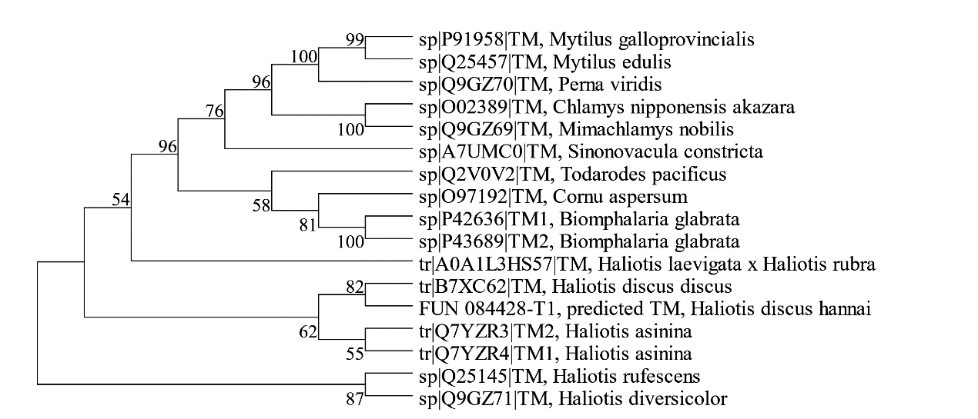
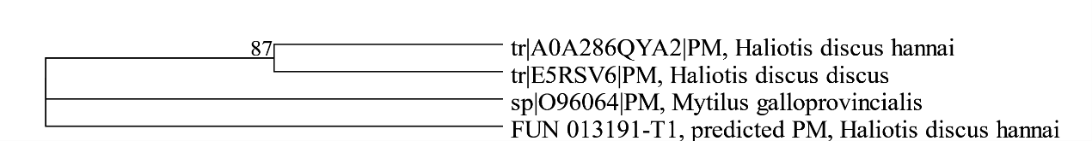
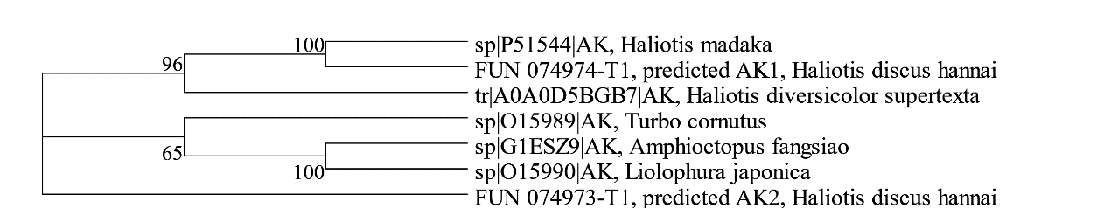
A
B
C
Supplementary Figure 1. Evolutionary analysis for three high-abundance predicted allergens of Haliotis discus hannai (HDH) with other Mollusca species. (A) Phylogenetic tree constructed using amino acids of HDH tropomyosin with sixteen Molluscan tropomyosins. (B) Phylogenetic tree constructed using amino acids of HDH paramyosin with three Molluscan paramyosin. (C) Phylogenetic tree constructed using amino acids of HDH arginine kinase with five Molluscan arginine kinase. Bootstrap consensus trees were constructed by MEGA 12 program using the Maximum Likelihood method based on the JTT matrix-based model with 1000 replicates. The multiple sequence alignments were primarily conducted using protein sequences sourced from the UniProt database, encompassing both abalone (Haliotis genus) and other peer-reviewed mollusk sequences.

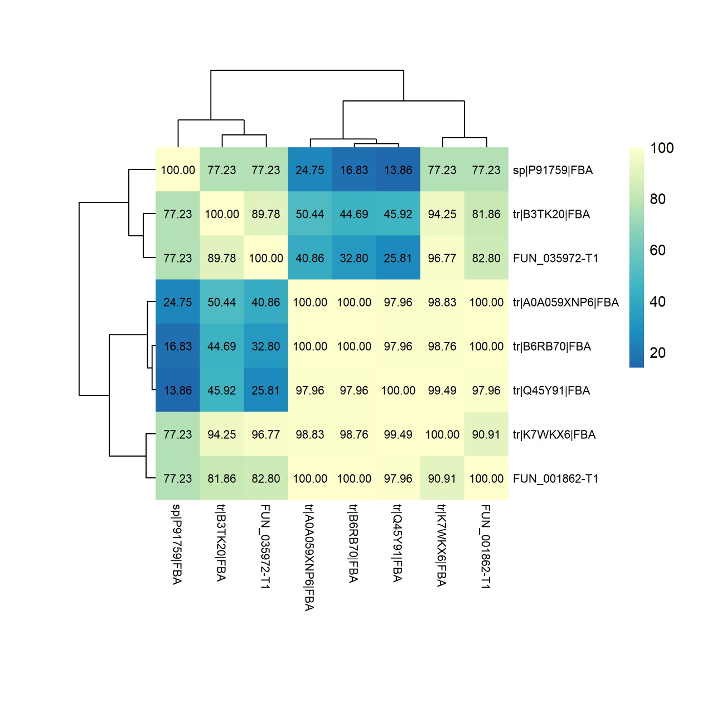
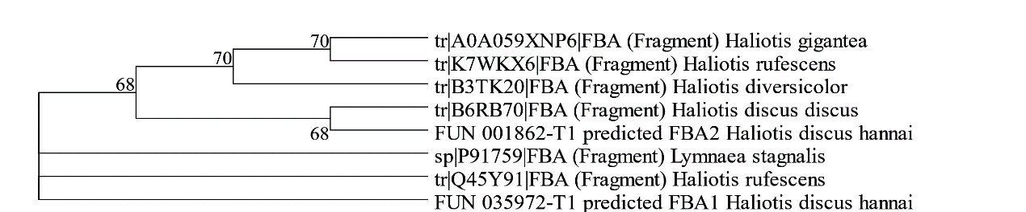
Supplementary Figure 2. Evolutionary analysis for Fructose-bisphosphate aldolase (FBA) of Haliotis discus hannai (HDH) with other Mollusca species. (A) Phylogenetic tree constructed using amino acids of HDH FBA with five Molluscan FBA. (B) Multiple sequence alignment results (shown as identity matrix) of amino acid sequence of HDH FBA with other Molluscs. Bootstrap consensus trees were constructed by MEGA 12 program using the Maximum Likelihood method based on the JTT matrix-based model with 1000 replicates.
B
A

