e-Table 1. Comparison of demographics, pulmonary function, transthoracic echocardiography, stress echocardiography, and exercise hemodynamics in patients with normal and mildly elevated resting pulmonary artery pressure.
Variables | Rest mPAP ≤ 20mmHg  (N=67) | 20＜Rest mPAP＜25mmHg  (N=19) | P
Demographics
Sex, male | 23 (34.3%) | 12 (63.2%) | 0.046
Diagnosis
CTEPD | 21 (31.3%) | 0 (0.0%) | 0.002
CTEPH | 34 (50.7%) | 19 (100.0%) | 0.002
CTD-PAH | 4 (6.0%) | 0 (0.0%) | 0.002
Resting TRV ≥ 2.8 m/s | 8 (11.9%) | 0 (0.0%) | 0.002
WHO-FC
Class I | 30 (44.8%) | 1 (5.3%) | 0.005
Class II | 36 (53.7%) | 18 (94.7%)
Class III | 1 (1.5%) | 0 (0.0%)
Age, years | 62.00 (48.50 , 69.50) | 58.00 (48.00 , 68.00) | 0.542
BMI, kg/m² | 25.14 ± 3.57 | 26.47 ± 3.76 | 0.161
BSA, m² | 1.74 ± 0.18 | 1.86 ± 0.19 | 0.012
6MWD, m | 461.86 ± 67.18 | 484.28 ± 61.36 | 0.195
NT-proBNP, pmol/L | 64.60 (41.20 , 94.75) | 48.10 (38.90 , 75.85) | 0.423
HR, bpm | 69.00 (63.00 , 81.50) | 75.00 (68.50 , 84.00) | 0.221
sBP, mmHg | 76.00 (71.00 , 85.00) | 77.00 (71.50 , 84.50) | 0.588
dBP, mmHg | 93.00 (87.00 , 98.50) | 93.00 (86.00 , 98.50) | 0.963
SpO_{2,} % | 96.00 (95.00 , 98.00) | 96.00 (94.00 , 97.50) | 0.511
Pulmonary Function Test
FVC, % pred | 109.19 ± 15.25 | 102.29 ± 19.07 | 0.104
FEV_{1,} % pred | 98.76 ± 14.70 | 91.68 ± 15.38 | 0.07
FEV₁%FVC, % | 89.99 ± 7.55 | 87.62 ± 9.45 | 0.258
DLCOc SB, mL/min/mmHg | 83.90 (77.75 , 89.90) | 82.10 (69.50 , 95.70) | 0.414
DLCOc/VA, mL/min/mmHg/L | 89.00 (81.00 , 93.56) | 90.59 (80.81 , 101.00) | 0.31
TLC, % pred | 99.41 ± 12.80 | 94.82 ± 13.85 | 0.179
Transthoracic Echocardiography
EDV, mL | 97.65 ± 15.22 | 100.05 ± 13.12 | 0.533
ESV, mL | 30.79 ± 6.56 | 33.16 ± 6.30 | 0.165
LVEF, % | 68.48 ± 4.70 | 66.84 ± 4.63 | 0.183
E’, cm/s | 7.00 (6.10 , 8.00) | 6.50 (5.65 , 9.00) | 0.867
RV basal diameter, mm | 33.00 (31.00 , 35.00) | 35.00 (30.50 , 36.50) | 0.649
MPA, mm | 26.00 (24.00 , 28.50) | 29.00 (25.00 , 31.50) | 0.123
RVEDA, cm² | 22.04 ± 4.93 | 22.42 ± 4.32 | 0.759
RVESA, cm² | 13.77 ± 3.78 | 14.19 ± 3.11 | 0.663
FAC, % | 0.37 ± 0.11 | 0.37 ± 0.06 | 0.811
MPI | 0.48 (0.40 , 0.56) | 0.52 (0.45 , 0.57) | 0.525
Stress Echocardiography
Resting TAPSE, mm | 21.20 (19.82 , 23.00) | 20.79 (19.82 , 21.50) | 0.715
Resting S’, cm/s | 13.00 (11.95 , 15.95) | 12.80 (12.00 , 14.35) | 0.531
Resting TRV, m/s | 223.50 ± 55.84 | 179.70 ± 50.47 | 0.003
Resting RVFWSL, % | -21.89 ± 4.15 | -23.05 ± 3.68 | 0.271
Resting RV4CSL, % | -18.60 (-20.55 , -15.60) | -19.15 (-23.95 , -17.45) | 0.079
Resting RASr, % | 20.30 (17.90 , 25.70) | 24.00 (21.70 , 35.30) | 0.018
Resting RAScd, % | -11.40 (-18.25 , -8.65) | -14.00 (-16.65 , -11.70) | 0.096
Resting RASct, % | -9.48 ± 4.36 | -12.66 ± 5.19 | 0.009
Resting TAPSE/PASP, mm/mmHg | 1.04 (0.77 , 1.60) | 1.74 (0.99 , 2.41) | 0.009
Peak TAPSE, mm | 23.83 ± 3.18 | 23.64 ± 3.49 | 0.823
Peak S’, cm/s | 19.56 ± 4.34 | 18.88 ± 4.38 | 0.551
Peak TRV, m/s | 343.00 (250.35 , 379.50) | 307.00 (270.77 , 363.15) | 0.929
Peak RVFWSL, % | -24.56 ± 5.03 | -23.17 ± 5.01 | 0.292
Peak RV4CSL, % | -20.38 (-24.15 , -17.30) | -20.60 (-23.15 , -17.70) | 1
Peak RASr, % | 25.90 (20.95 , 30.25) | 26.30 (21.30 , 33.70) | 0.815
Peak RAScd, % | -14.30 (-16.10 , -10.50) | -12.50 (-14.10 , -10.30) | 0.423
Peak RASct, % | -11.80 (-15.00 , -9.80) | -13.02 (-17.85 , -9.35) | 0.371
Peak TAPSE/PASP, mm/mmHg | 0.51 (0.40 , 0.96) | 0.65 (0.40 , 0.78) | 0.967
ΔTRV, m/s | 95.30 (62.00 , 124.15) | 128.00 (85.05 , 189.05) | 0.024
ΔTAPSE, mm | 3.00 (-0.20 , 5.00) | 2.76 (1.27 , 4.73) | 0.929
ΔRASct, % | -3.36 ± 5.74 | -1.53 ± 7.82 | 0.262
ΔRAScd, % | -0.52 ± 8.81 | 1.98 ± 6.17 | 0.251
ΔRASr, % | 5.10 (0.10 , 8.25) | 4.00 (-4.70 , 5.15) | 0.07
ΔRV4CSL, % | -1.50 (-6.40 , 2.10) | -1.08 (-3.90 , 3.05) | 0.385
ΔRVFWSL, % | -2.67 ± 6.05 | -0.12 ± 6.04 | 0.108
ΔTAPSE/PASP, mm/mmHg | -0.39 (-0.82 , -0.24) | -0.87 (-1.56 , -0.54) | 0.003
ΔS’, cm/s | 5.82 ± 4.44 | 5.76 ± 4.54 | 0.956
Cardiopulmonary Exercise Testing
PRP, % | 98 (83 , 107) | 80 (73 , 95) | 0.023
VO₂max, mL/min | 1048.00 (905.00 , 1314.50) | 1159.00 (989.00 , 1342.00) | 0.441
VO₂ peak %pred, % | 72.85 ± 12.79 | 62.84 ± 12.65 | 0.003
VO₂(AT) %pred, % | 45.70 ± 10.84 | 40.79 ± 10.26 | 0.081
Peak HR, bpm | 132.54 ± 20.99 | 132.53 ± 27.43 | 0.999
VE/VCO₂ | 38.54 ± 4.75 | 38.68 ± 4.14 | 0.908
VE/VO₂ | 52.30 (47.20 , 59.45) | 51.50 (47.70 , 67.95) | 0.338
Rest and Exercise Right Heart Catheterization
SvO2 | 72.79 ± 5.52 | 72.51 ± 5.11 | 0.607
TPR, Wood Units | 2.30 (1.76 , 2.83) | 3.15 (2.26 , 3.53) | 0.016
CVP, mmHg | 3.00 (2.00 , 4.00) | 5.00 (3.50 , 5.00) | 0.006
RAP, mmHg | 3.00 (2.00 , 4.00) | 3.00 (2.50 , 4.50) | 0.099
RVP, mmHg | 9.79 ± 2.11 | 12.47 ± 1.58 | <0.001
Resting mPAP, mmHg | 16.00 (15.00 , 18.50) | 23.00 (21.50 , 23.00) | <0.001
PCWP, mmHg | 7.00 (5.00 , 8.00) | 7.00 (6.00 , 9.00) | 0.381
CO, L/min | 5.43 (4.59 , 6.29) | 5.90 (5.37 , 6.55) | 0.115
CI, L/min/m² | 3.09 (2.70 , 3.63) | 3.04 (2.75 , 3.56) | 0.673
Peak mPAP, mmHg | 37.33 ± 9.42 | 48.79 ± 7.02 | <0.001
ΔmPAP/ΔCO, mmHg/L/min | 2.89 (2.13 , 3.32) | 3.30 (2.68 , 4.14) | 0.013
mPAP/CO Slope, mmHg/L/min | 2.61 (1.89 , 3.19) | 3.10 (2.53 , 4.00) | 0.017
6MWD: 6-minute walk distance; %pred: percentage of predicted; AT: anaerobic threshold; BMI: body mass index; BSA: body surface area; CI: cardiac index; CO: cardiac output; CVP: central venous pressure; CTD-PAH: Connective Tissue Disease-associated Pulmonary Arterial Hypertension; CTEPD: Chronic Thromboembolic Pulmonary Disease; CTEPH: Chronic Thromboembolic Pulmonary Hypertension; dBP: diastolic blood pressure; DLCOc SB: diffusing capacity of the lung for carbon monoxide corrected for hemoglobin, single breath; DLCOc/VA: transfer coefficient of the lung for carbon monoxide corrected for hemoglobin; E’: early diastolic mitral annular velocity; EDV: end-diastolic volume; ESV: end-systolic volume; FAC: fractional area change; FEV1: forced expiratory volume in 1 second; FVC: forced vital capacity; HR: heart rate; LVEF: left ventricular ejection fraction; mPAP: mean pulmonary artery pressure; mPAP/CO slope: slope of the mean pulmonary artery pressure–cardiac output relationship; MPA: main pulmonary artery; MPI: myocardial performance index; NT-proBNP: N-terminal pro-brain natriuretic peptide; PASP: pulmonary artery systolic pressure; PCWP: pulmonary capillary wedge pressure; PRP: predicted work rate percentage; RAP: right atrial pressure; RAScd: right atrial conduit strain; RASct: right atrial contractile strain; RASr: right atrial reservoir strain; RV: right ventricular; RV4CSL: right ventricular 4-chamber longitudinal strain; RVEDA: right ventricular end-diastolic area; RVESA: right ventricular end-systolic area; RVFWSL: right ventricular free wall longitudinal strain; RVP: right ventricular pressure; S’: peak systolic tricuspid annular velocity; sBP: systolic blood pressure; SpO2: peripheral oxygen saturation; SvO₂: Mixed Venous Oxygen Saturation; TAPSE: tricuspid annular plane systolic excursion; TLC: total lung capacity; TPR: total pulmonary resistance; TRV: tricuspid regurgitation velocity; VE/VCO2: ventilatory equivalent for carbon dioxide; VE/VO2: ventilatory equivalent for oxygen; VO2max: maximal oxygen consumption; WHO-FC: World Health Organization functional class; Δ: change from rest to peak exercise.
e-Table 2. Logistic regression equations and optimal cutoff values for the different diagnostic models.
Model | Optimal Cutoff Value | Calculate Probability (P)
Clinical | 0.571 | Step 1: Logit(P) = －2.878 + 0.0 × Age－0.001 × VO2max  Step 2: P = 1 / (1＋exp(－Logit(P)))
Echo | 0.618 | Step 1: Logit(P) = 1.083－1.850 × Peak TAPSE/PASP + 0.002 × ΔTRV  Step 2: P = 1 / (1＋exp(－Logit(P)))
CPET | 0.544 | Step 1: Logit(P) = 4.047－0.060 × Peak HR + 0.076 × VE/VO2  Step 2: P = 1 / (1＋exp(－Logit(P)))
Clinical+Echo | 0.601 | Step 1: Logit(P) = －1.714 + 0.067 × Age－0.002 × VO2max－0.947 × Peak TAPSE/PASP + 0.005 × ΔTRV  Step 2: P = 1 / (1＋exp(－Logit(P)))
Clin+Echo+CPET | 0.539 | Step 1: Logit(P) = 0.840 + 0.045 × Age－0.661 × Peak TAPSE/PASP + 0.010 × ΔTRV + 0.001 × VO2max + 0.075 × VE/VO2 －0.048 × Peak HR  Step 2: P = 1 / (1＋exp(－Logit(P)))
Δ: change from rest to peak exercise; CPET: cardiopulmonary exercise testing; Echo: echocardiography; exp: exponential function; HR: heart rate; Logit(P): natural logarithm of the odds of EiPH; PASP: pulmonary artery systolic pressure; TAPSE: tricuspid annular plane systolic excursion; TRV: tricuspid regurgitation velocity; VE/VO2: ventilatory equivalent for oxygen; VO2max: maximal oxygen consumption.
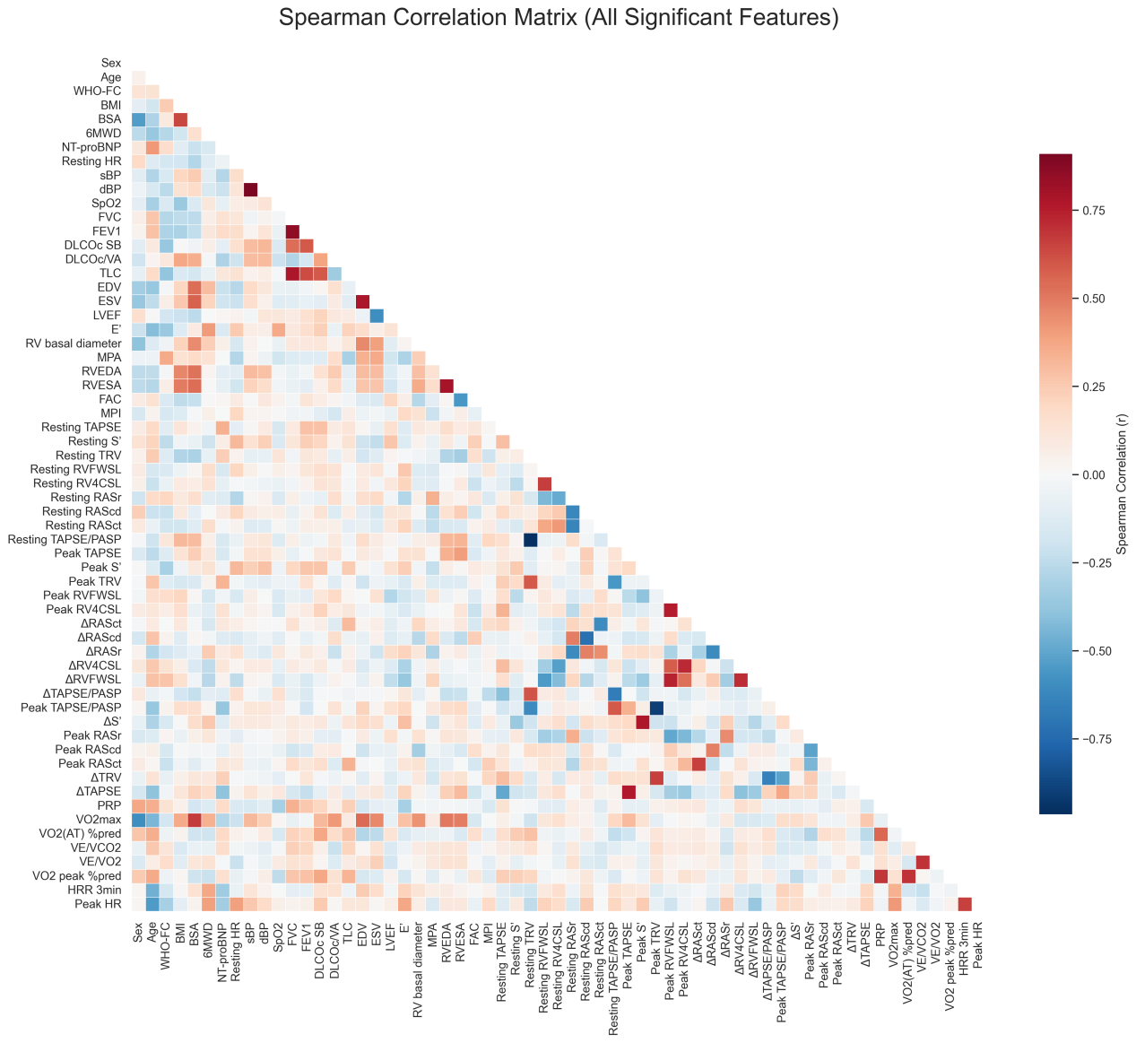
e-Figure 1. Spearman correlation matrix of all significant features. Color intensity and hue reflect correlation strength (red: positive, blue: negative; scale from –0.75 to +0.75). Features include clinical, echocardiographic, and cardiopulmonary exercise testing variables. Δ: change from rest to peak exercise; %pred: percentage of predicted; 6MWD: 6-minute walk distance; AT: anaerobic threshold; BMI: body mass index; BSA: body surface area; dBP: diastolic blood pressure; E': early diastolic mitral annular velocity; EDV: end-diastolic volume; ESV: end-systolic volume; FAC: fractional area change; HR: heart rate; LVEF: left ventricular ejection fraction; MPA: main pulmonary artery; MPI: myocardial performance index; NT-proBNP: N-terminal pro-brain natriuretic peptide; PASP: pulmonary artery systolic pressure; RAScd: right atrial conduit strain; RASct: right atrial contractile strain; RASr: right atrial reservoir strain; RV4CSL: right ventricular 4-chamber longitudinal strain; RVEDA: right ventricular end-diastolic area; RVESA: right ventricular end-systolic area; RVFWSL: right ventricular free wall longitudinal strain; S': peak systolic tricuspid annular velocity; sBP: systolic blood pressure; TAPSE: tricuspid annular plane systolic excursion; TRV: tricuspid regurgitation velocity; VE/VCO2: ventilatory equivalent for carbon dioxide; VE/VO2: ventilatory equivalent for oxygen; VO2max: maximal oxygen consumption; WHO-FC: World Health Organization functional class.
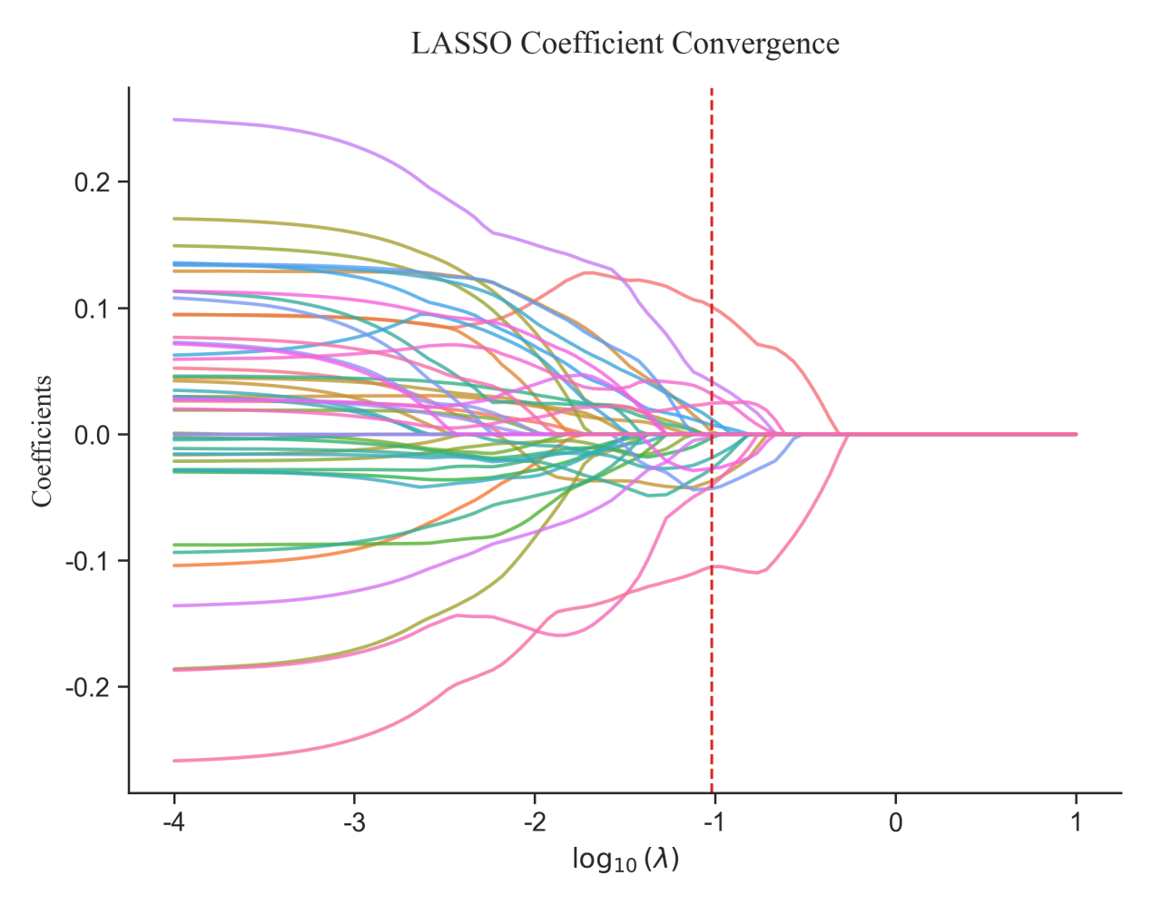
e-Figure 2. LASSO coefficient convergence plot showing how feature coefficients shrink toward zero as regularization parameter λ increases (log₁₀(λ) on x-axis). Vertical dashed line indicates optimal λ selected via cross-validation. Each colored line represents a different predictor variable’s coefficient path.
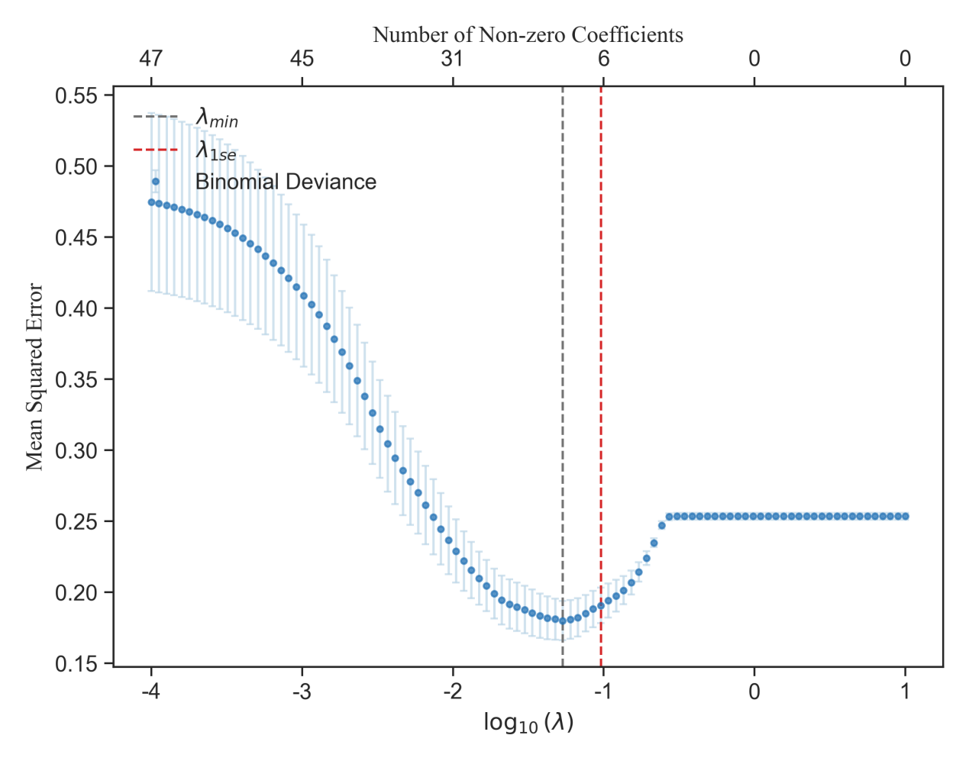
e-Figure 3. LASSO regularization path showing mean squared error (binomial deviance) across log₁₀(λ) values. Vertical dashed lines indicate λmin (minimum error) and λ1se (one standard error rule). Top axis shows number of non-zero coefficients at each λ. Shaded area represents standard error around the mean deviance curve.
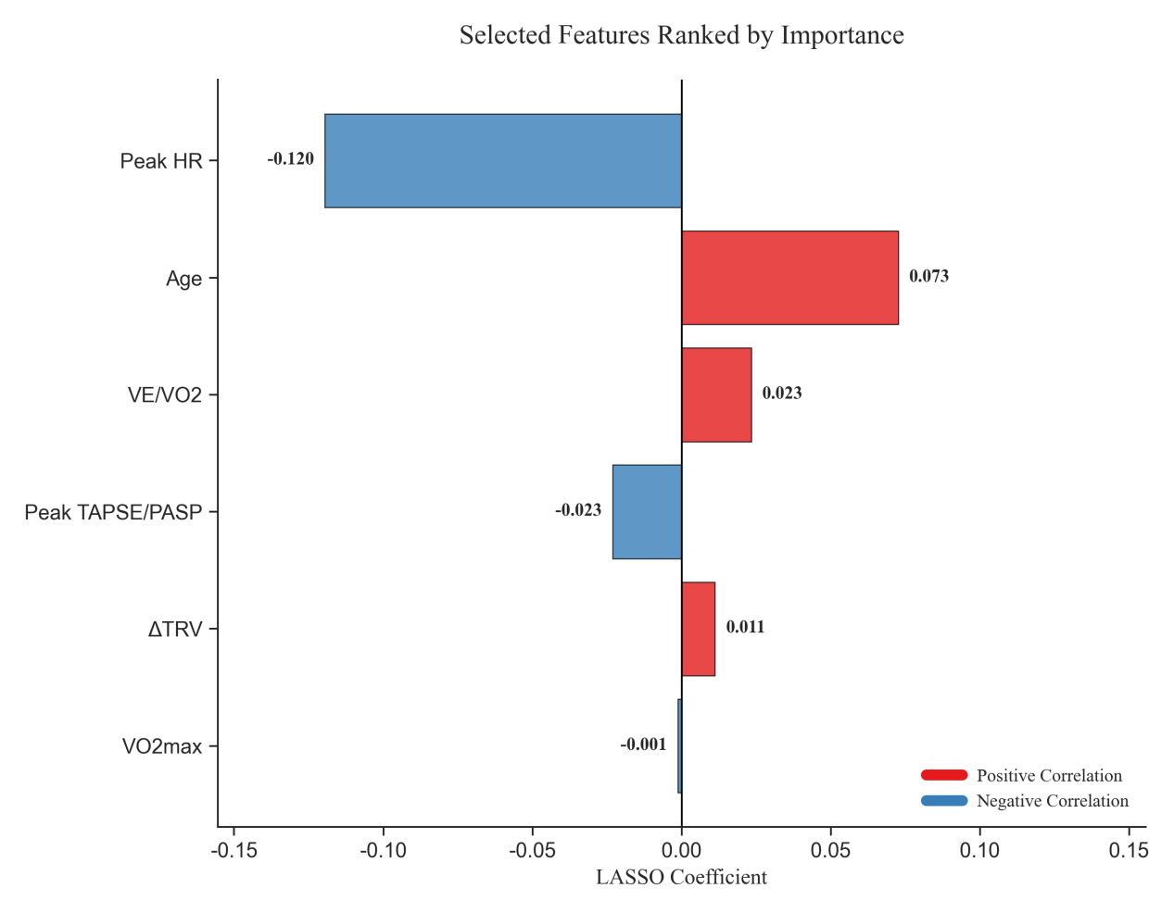
e-Figure 4. Bar chart of LASSO-selected features ranked by coefficient magnitude. Blue bars indicate negative correlation with outcome; red bars indicate positive correlation. Values shown are final LASSO coefficients. Δ: change from rest to peak exercise; HR: heart rate; LASSO: least absolute shrinkage and selection operator; PASP: pulmonary artery systolic pressure; TAPSE: tricuspid annular plane systolic excursion; TRV: tricuspid regurgitation velocity; VE/VO2: ventilatory equivalent for oxygen; VO2max: maximal oxygen consumption.
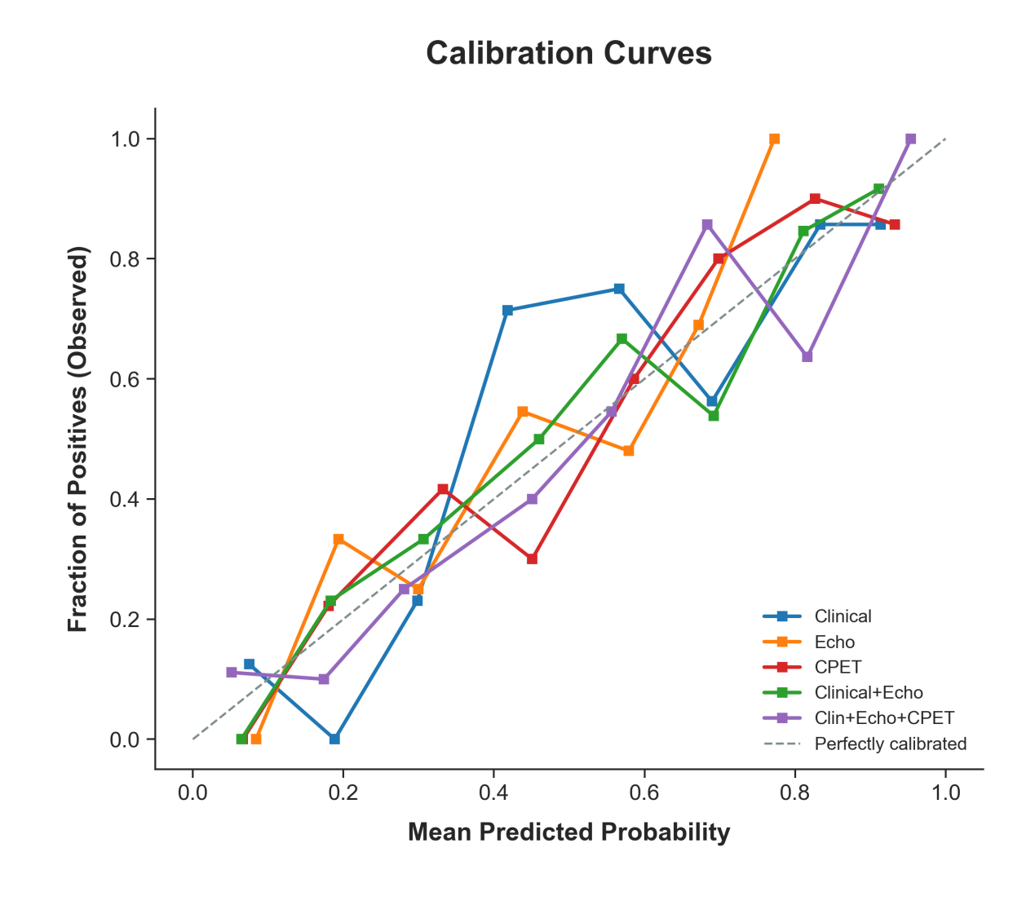e-Figure 6. Calibration curves for five diagnostic models, plotting mean predicted probability (x-axis) against observed fraction of positives (y-axis). Dashed gray line represents perfect calibration. Models: Clinical, Echo, CPET, Clinical+Echo, Clin+Echo+CPET. Deviation from the diagonal indicates miscalibration; closer alignment reflects better predictive accuracy.

