Supplementary Information

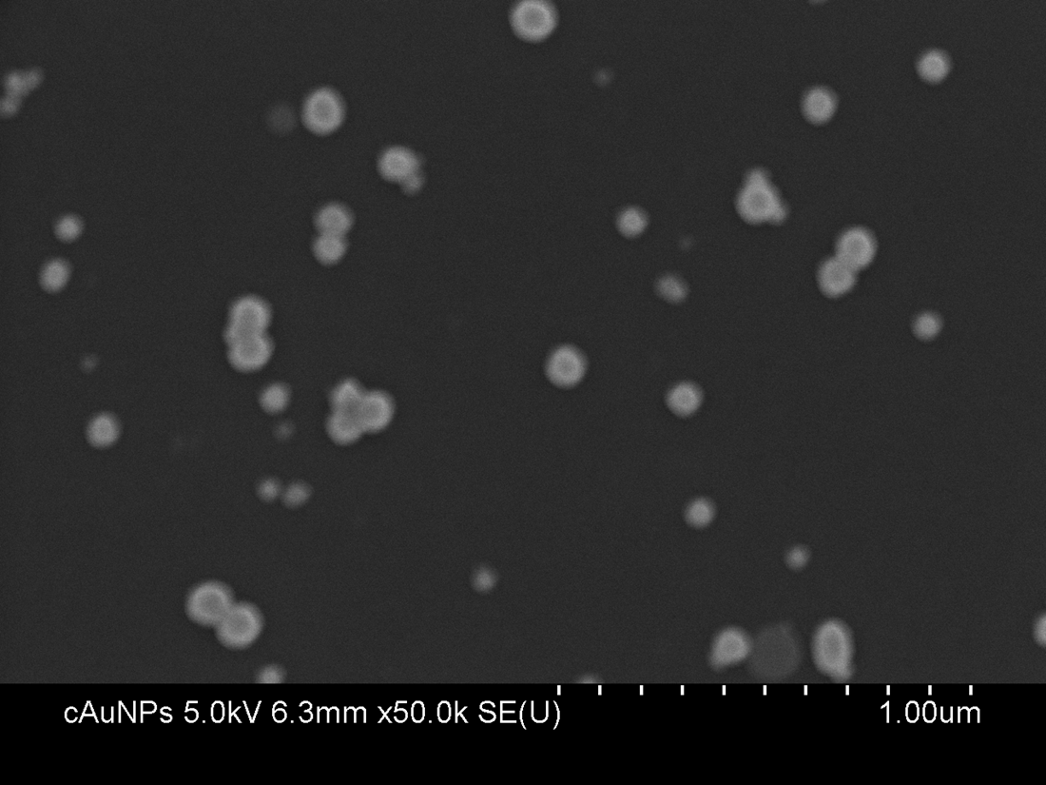
Supplementary Figure SI1. SEM images of citrate-reduced gold nanoparticles. The nanoparticles were deposited on to Si wafers and imaged using a Hitachi S-4800 SEM.
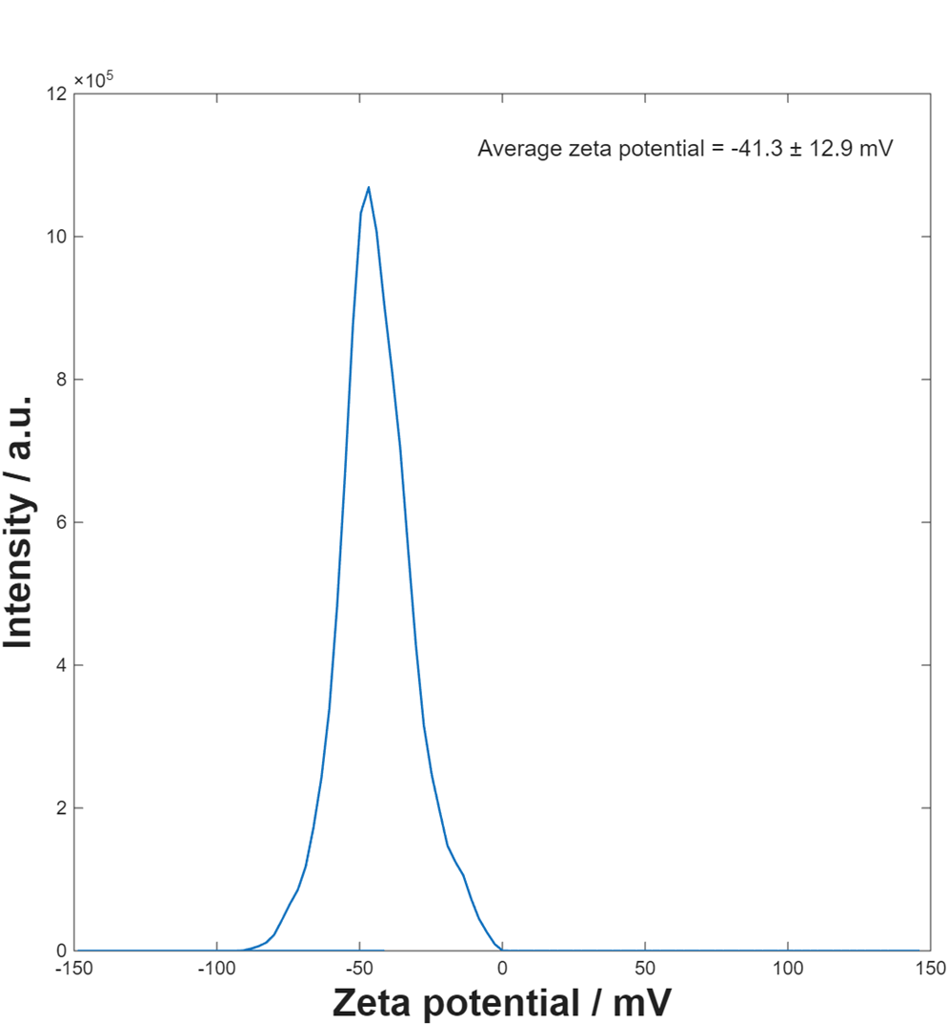
Supplementary Figure SI2. Zeta potential distribution of citrate-reduced gold nanoparticles measured using the Malvern Zetasizer Nano ZS (Malvern Panalytical, Malvern, UK) fitted with a 532 nm laser.
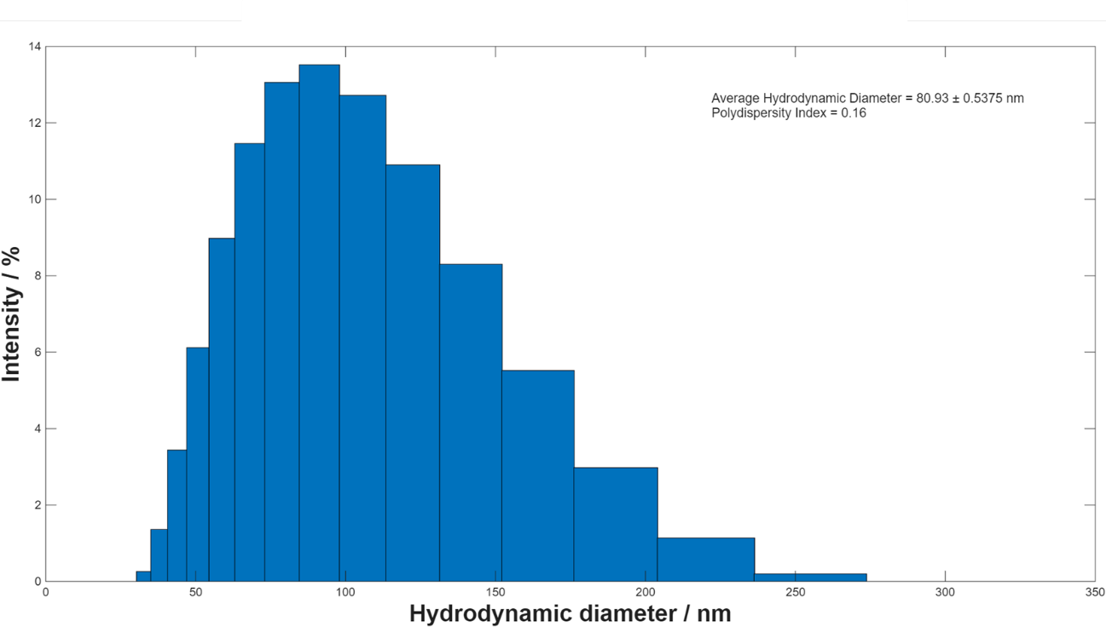
Supplementary Figure SI3. Results from a Zetasizer of the average hydrodynamic diameter of citrate-reduced gold nanoparticles measured using the Malvern Zetasizer Nano ZS (Malvern Panalytical, Malvern, UK) fitted with a 532 nm laser. Histograms display size distribution from intensity.

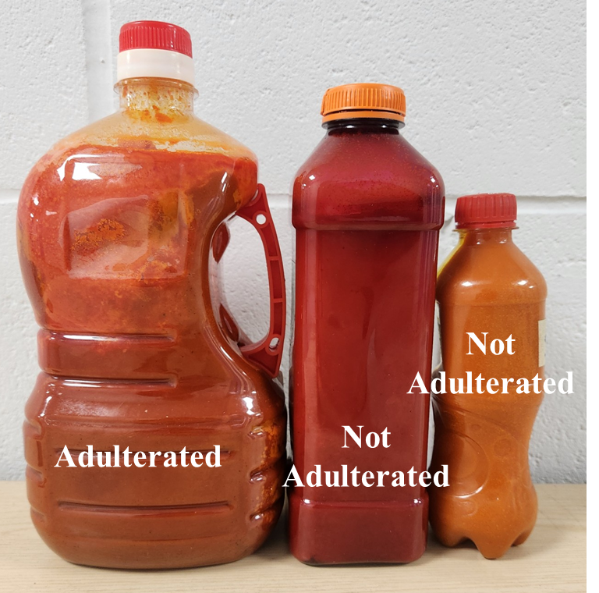
Supplementary Figure SI4. Image of three palm oil samples from the study, highlighting the variation in colour between samples.
Palm oil naturally ranges in colour from pale orange to deep red, a variation largely driven by its differing levels of β-carotene. This natural variability means that two legitimate, unadulterated oils can look strikingly different from one another. When colourant dyes such as Sudan IV are added, they generally intensify the redness of the oil. Yet the effect is not always dramatic: low levels of added dye may shift the appearance only slightly - from light orange toward a somewhat deeper hue - making visual inspection unreliable. Complicating matters further, an oil that is naturally rich in β-carotene may appear redder than an oil that has been adulterated but contains relatively little dye. These overlapping colour ranges highlight the limitations of colour-based assessments and underscore the need for analytical techniques capable of reliably detecting the presence of Sudan dyes in palm oil. As shown, even though the sample on the left has been adulterated, it still presents a paler appearance compared with the middle sample. This highlights the overlap between natural colour variability and dye-induced colour changes.
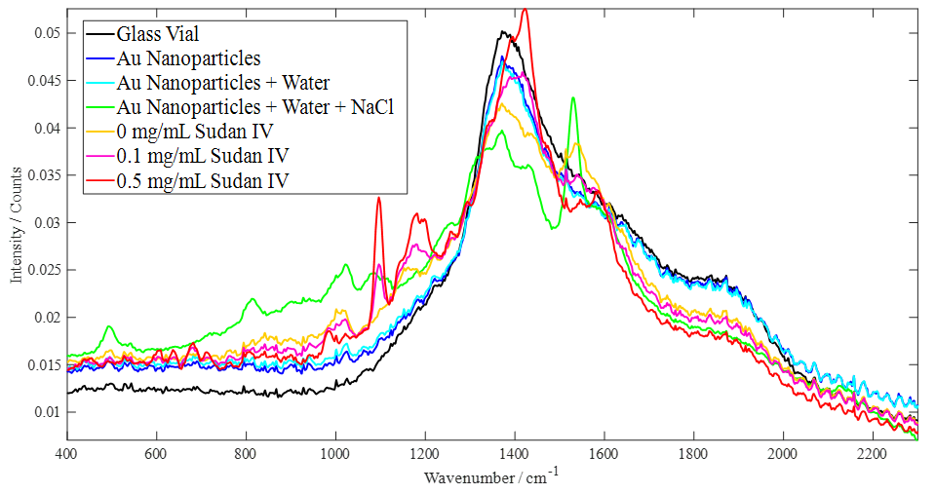
Supplementary Figure SI5. Raman and SERS spectra of negative and positive control samples are shown for the glass vial, citrate-reduced gold nanoparticles, aggregated nanoparticles (water + NaCl), and extracted palm oil samples spiked with Sudan IV at three concentrations, including a dye-free control. The spectra of the 3 different levels of spiked Sudan dye were taken after extraction and drying.

Table SI1. Predicted concentrations from SERS analysisof Sudan IV dye (mg/mL) for each sample from Cameroon, as well as the average and standard deviation.
Samples | Predicted Concentration (mg/mL) | Predicted Concentration (mg/mL)
 | Repeats | Averages (standard deviation)
 | 0.0009
1 | 0.0012 | 0.0010 (0.0002)
 | 0.0009
 | 0.0006
2 | 0.0009 | 0.0007 (0.0002)
 | 0.0006
 | 0.0011
3 | 0.0005 | 0.0012 (0.0008)
 | 0.0021
 | 0.0003
4 | 0.0004 | 0.0006 (0.0005)
 | 0.0012
 | 0.0012
5 | 0.0008 | 0.0011 (0.0003)
 | 0.0013
 | 0.0005
6 | 0.0007 | 0.0009 (0.0006)
 | 0.0015
 | -0.0006
7 | 0.0004 | –0.0002 (0.0005)
 | -0.0004
 | 0.0006
8 | 0.0011 | 0.0010 (0.0004)
 | 0.0013
 | 0.0020
9 | 0.0014 | 0.0014 (0.0006)
 | 0.0008
 | 0.0012
10 | 0.0005 | 0.0009 (0.0004)
 | 0.0011
 | 0.0014
11 | 0.0015 | 0.0015 (0.0001)
 | 0.0015
 | 0.0005
12 | 0.0010 | 0.0009 (0.0004)
 | 0.0013
 | 0.0013
13 | 0.0006 | 0.0009 (0.0004)
 | 0.0008
 | 0.0001
14 | 0.0021 | 0.0007 (0.0013)
 | 0.0000
 | 0.0012
15 | 0.0004 | 0.0009 (0.0005)
 | 0.0011
 | 0.0003
16 | 0.0013 | 0.0010 (0.0006)
 | 0.0013
 | 0.0010
17 | 0.0010 | 0.0009 (0.0002)
 | 0.0007
 | 0.0004
18 | 0.0015 | 0.0009 (0.0006)
 | 0.0008
 | 0.0012
19 | 0.0012 | 0.0011 (0.0001)
 | 0.0010
 | 0.0006
20 | 0.0017 | 0.0011 (0.0006)
 | 0.0011
 | 0.0005
21 | 0.0019 | 0.0011 (0.0008)
 | 0.0008
 | 0.0005
22 | 0.0008 | 0.0008 (0.0003)
 | 0.0011
 | 0.0023
23 | 0.0015 | 0.0014 (0.0010)
 | 0.0004
 | 0.0000
24 | 0.0005 | 0.0003 (0.0003)
 | 0.0004
 | 0.0012
25 | −0.0001 | 0.0007 (0.0008)
 | 0.0011
 | 0.0012
26 | 0.0010 | 0.0010 (0.0002)
 | 0.0008
 | 0.0011
27 | 0.0010 | 0.0013 (0.0004)
 | 0.0017
 | 0.0008
28 | 0.0004 | 0.0011 (0.0009)
 | 0.0021
 | 0.0021
29 | 0.0018 | 0.0017 (0.0004)
 | 0.0013
 | 0.0004
30 | 0.0011 | 0.0007 (0.0004)
 | 0.0006
 | 0.0010
31 | 0.0014 | 0.0010 (0.0004)
 | 0.0006
 | 0.0010
32 | 0.0006 | 0.0007 (0.0002)
 | 0.0006
 | 0.0003
33 | 0.0006 | 0.0005 (0.0002)
 | 0.0006
 | 0.0010
34 | 0.0019 | 0.0012 (0.0006)
 | 0.0007
 | 0.0008
35 | -0.0003 | 0.0006 (0.0008)
 | 0.0013
 | 0.0009
36 | 0.0007 | 0.0008 (0.0001)
 | 0.0007
 | -0.0002
37 | 0.0007 | 0.0002 (0.0005)
 | 0.0001
 | 0.0007
38 | 0.0004 | 0.0006 (0.0002)
 | 0.0007
 | 0.0005
39 | 0.0007 | 0.0006 (0.0001)
 | 0.0005
 | -0.0007
40 | 0.0014 | 0.0004 (0.0011)
 | 0.0004
 | 0.0009
41 | 0.0005 | 0.0008 (0.0003)
 | 0.0009
 | 0.0006
42 | 0.0017 | 0.0014 (0.0007)
 | 0.0019
 | 0.0005
43 | 0.0011 | 0.0007 (0.0003)
 | 0.0006
 | -0.0002
44 | 0.0002 | -0.0002 (0.0004)
 | -0.0005
 | 0.0014
45 | 0.0004 | 0.0008 (0.0005)
 | 0.0005
 | 0.0019
46 | 0.0005 | 0.0010 (0.0008)
 | 0.0006
 | 0.0009
47 | 0.0011 | 0.0011 (0.0003)
 | 0.0014
 | 0.0011
48 | 0.0017 | 0.0014 (0.0003)
 | 0.0013
 | 0.0011
49 | 0.0008 | 0.0012 (0.0005)
 | 0.0017
 | 0.0005
50 | 0.0009 | 0.0009 (0.0005)
 | 0.0014
 | 0.0004
51 | 0.0003 | 0.0004 (0.0001)
 | 0.0004
 | 0.0016
52 | 0.0015 | 0.0015 (0.0001)
 | 0.0013
 | 0.0017
53 | 0.0019 | 0.0016 (0.0003)
 | 0.0013
 | 0.0008
54 | -0.0008 | 0.0000 (0.0008)
 | 0.0001
 | 0.0004
55 | 0.0010 | 0.0011 (0.0003)
 | 0.0008
 | 0.0023
56 | 0.0012 | 0.0015 (0.0008)
 | 0.0009
 | 0.0012
57 | 0.0002 | 0.0004 (0.0007)
 | -0.0001
 | 0.0008
58 | 0.0001 | 0.0006 (0.0004)
 | 0.0008
 | 0.0006
59 | 0.0005 | 0.0006 (0.0001)
 | 0.0007
 | 0.0005
60 | 0.0011 | 0.0006 (0.0004)
 | 0.0003
 | 0.0003
61 | 0.0016 | 0.0012 (0.0008)
 | 0.0016
 | 0.0004
62 | 0.0013 | 0.0012 (0.0007)
 | 0.0018
 | 0.0008
63 | 0.0009 | 0.0006 (0.0004)
 | 0.0002
 | 0.0014
64 | 0.0005 | 0.0009 (0.0005)
 | 0.0008

