Supplementary Material
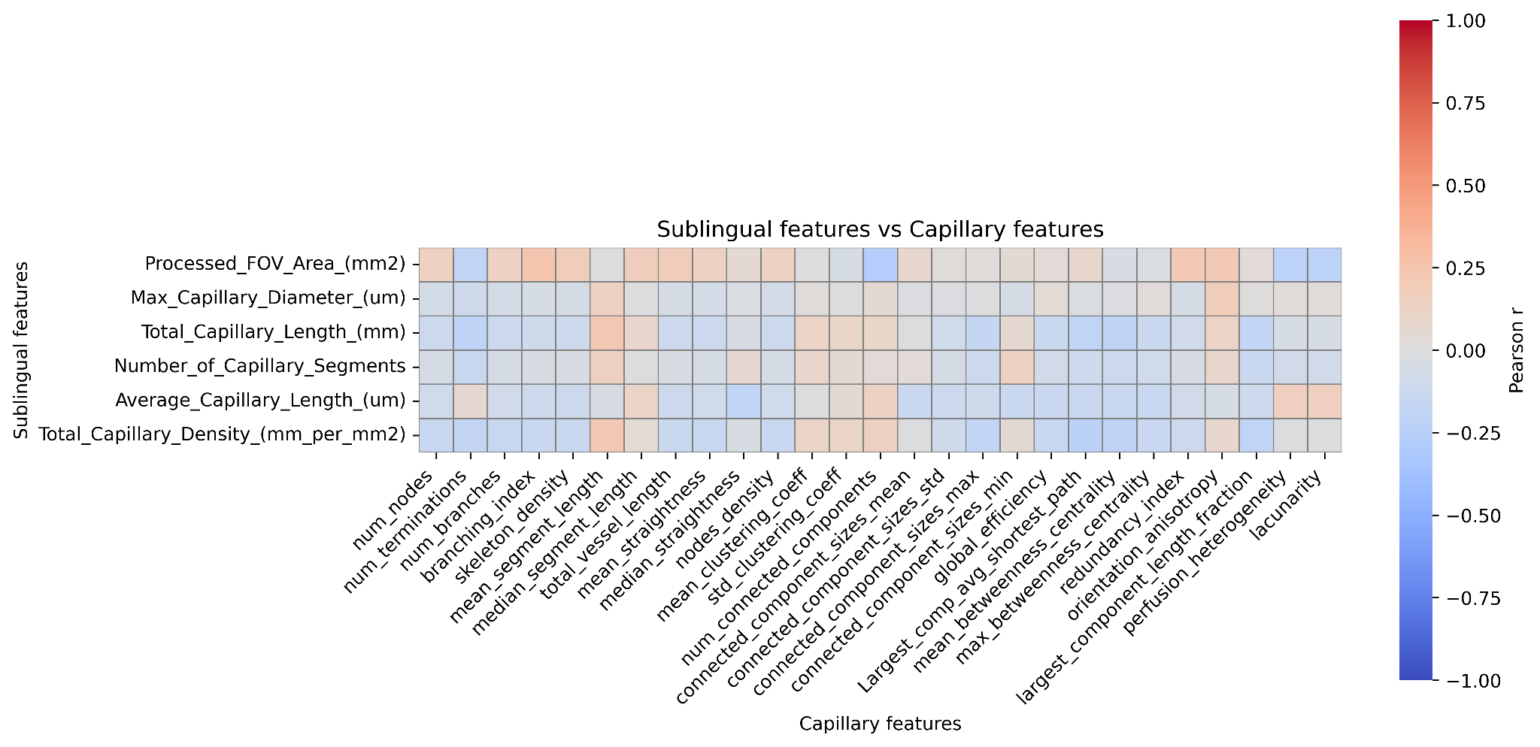
Supplementary Figure S1. Pearson correlation matrix between sublingual and capillary-derived features. Pairwise Pearson correlation coefficients between sublingual-derived features (rows) and capillary-derived features (columns). The matrix shows the pattern of association between oral microcirculatory phenotypes and capillary network-level descriptors.
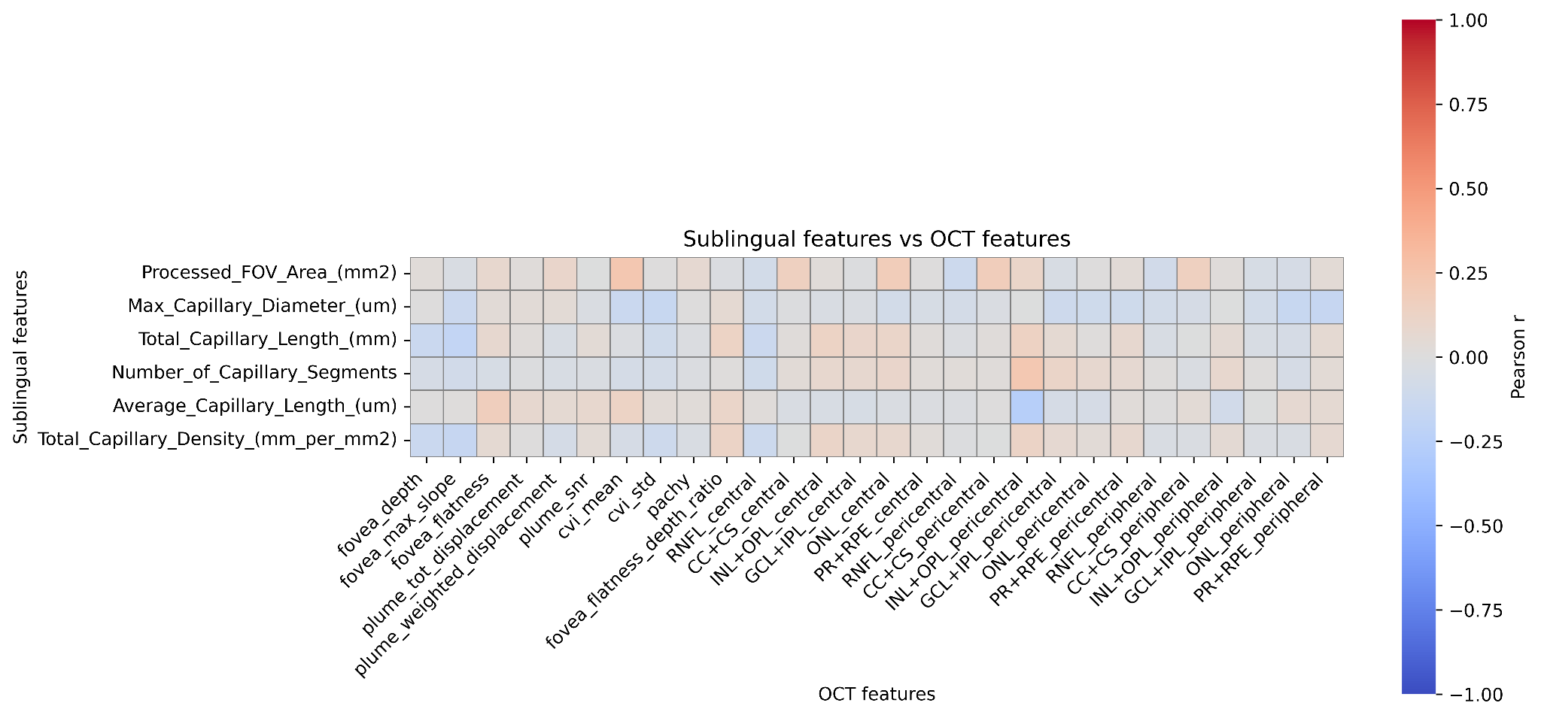
Supplementary Figure S2. Pearson correlation matrix between sublingual and structural OCT-derived features. Pairwise Pearson correlation coefficients between sublingual-derived features (rows) and structural OCT-derived features (columns). The matrix illustrates associations between oral microcirculatory measures and retinal structural phenotypes.
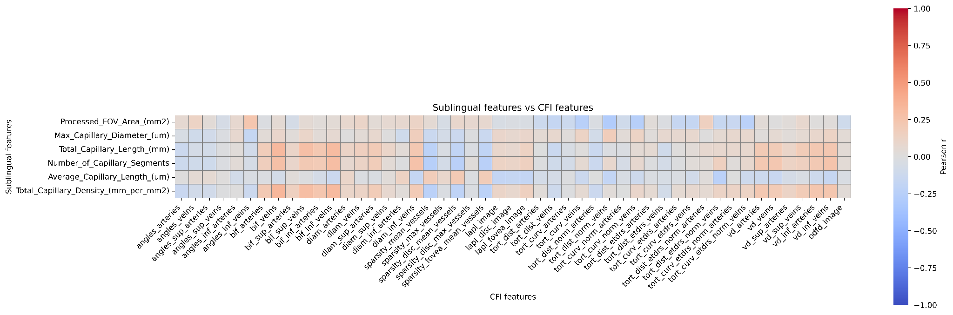
Supplementary Figure S3. Pearson correlation matrix between sublingual and colour fundus image-derived vascular features. Pairwise Pearson correlation coefficients between sublingual-derived features (rows) and colour fundus image-derived vascular features (columns). The matrix illustrates associations between oral microcirculatory phenotypes and fundus-derived vascular architecture.
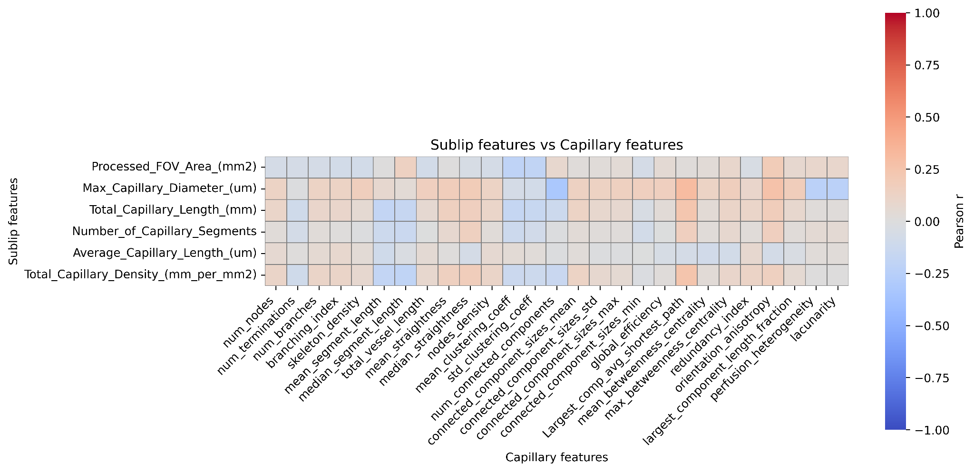
Supplementary Figure S4. Pearson correlation matrix between sublabial and capillary-derived features. Pairwise Pearson correlation coefficients between sublabial-derived features (rows) and capillary-derived features (columns). The matrix shows the pattern of association between sublabial microcirculatory phenotypes and capillary network-level descriptors.
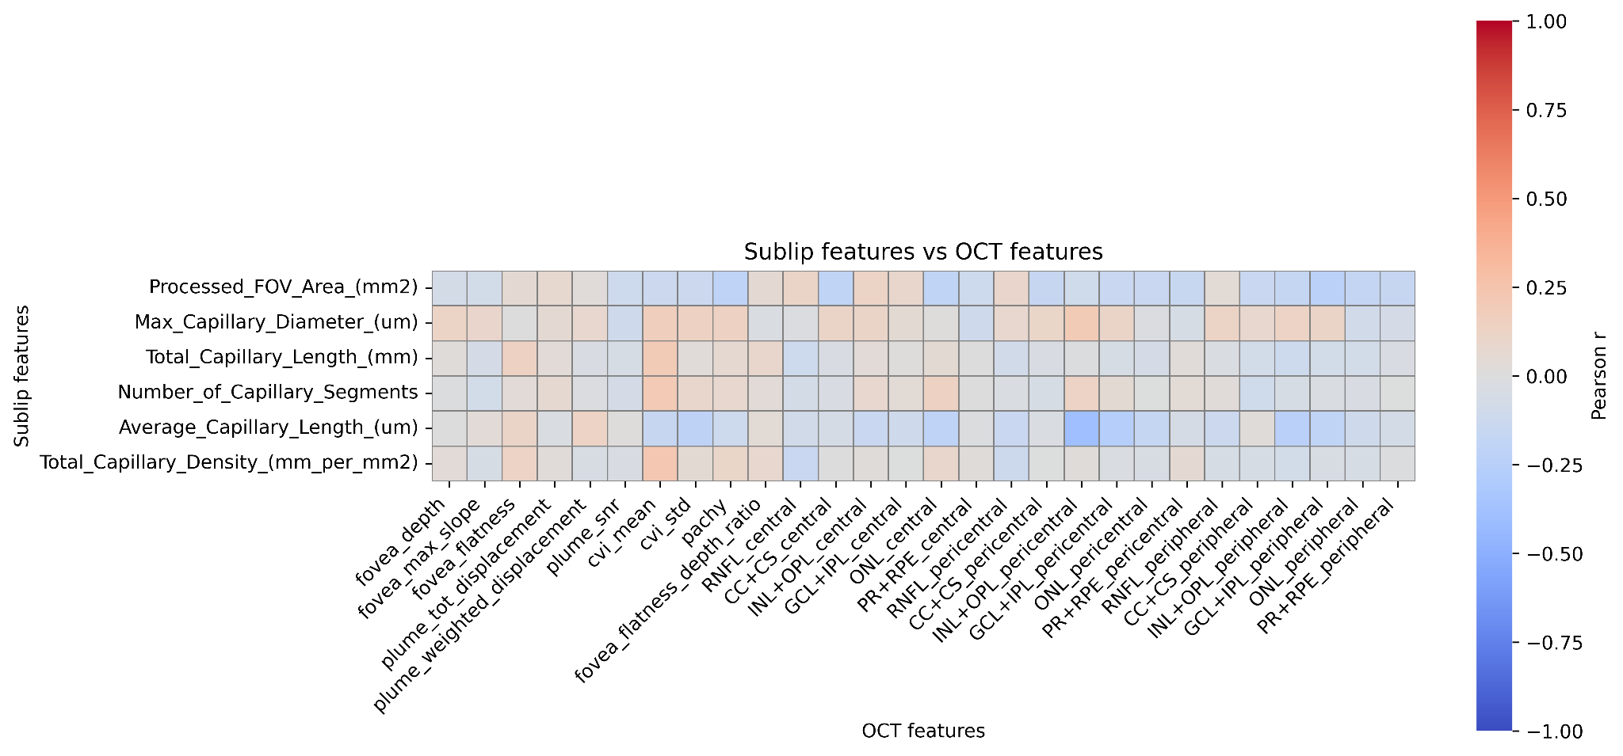
Supplementary Figure S5. Pearson correlation matrix between sublabial and structural OCT-derived features. Pairwise Pearson correlation coefficients between sublabial-derived features (rows) and structural OCT-derived features (columns). The matrix illustrates associations between sublabial microcirculatory measures and retinal structural phenotypes.
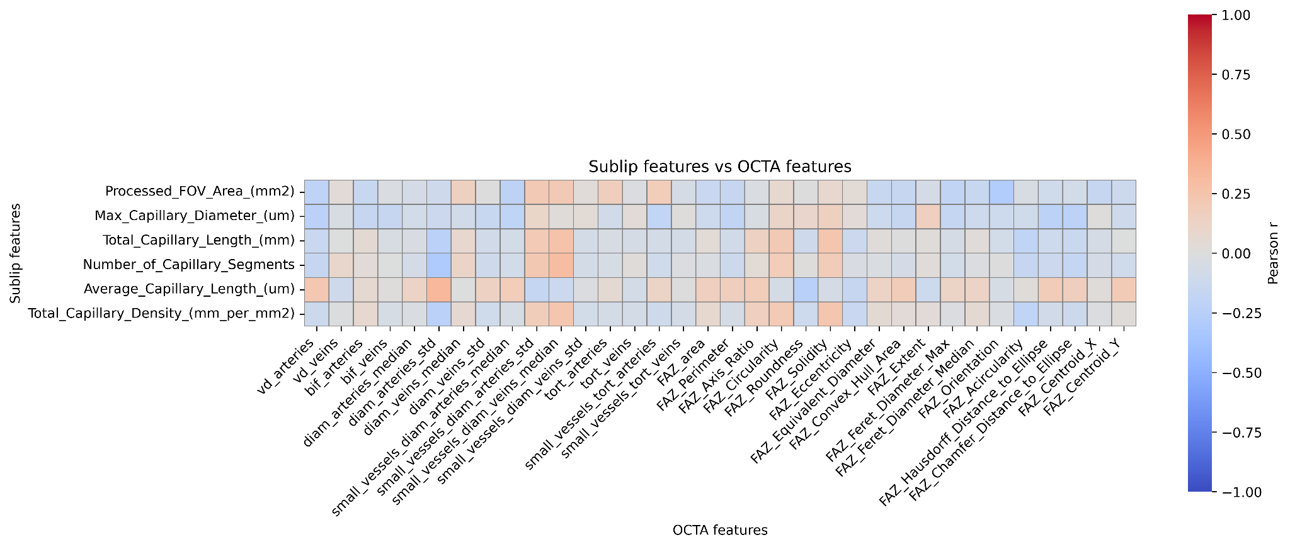
Supplementary Figure S6. Pearson correlation matrix between sublabial and OCTA-derived features. Pairwise Pearson correlation coefficients between sublabial-derived features (rows) and OCTA-derived features (columns). The matrix shows the pattern of association between sublabial microcirculatory phenotypes and retinal perfusion- and capillary network-related traits.
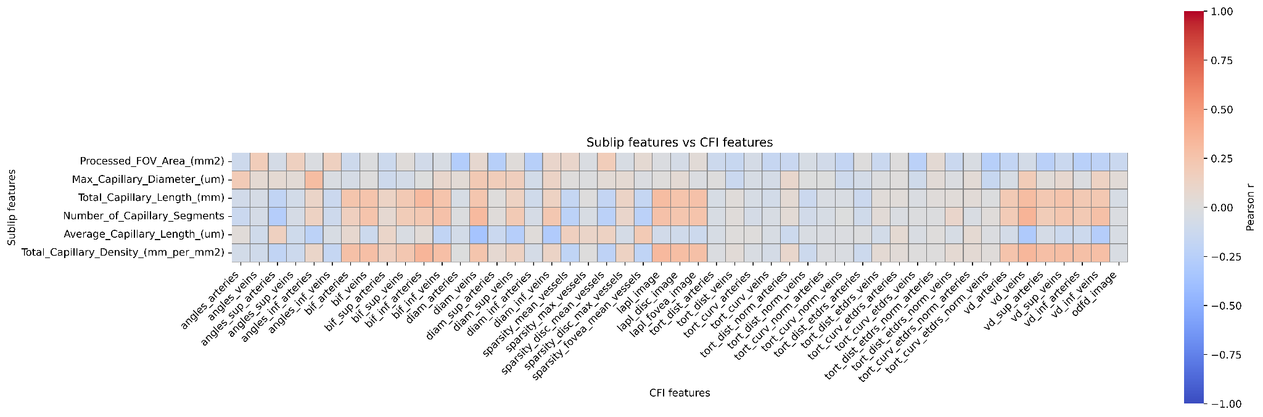
Supplementary Figure S7. Pearson correlation matrix between sublabial and colour fundus image-derived vascular features. Pairwise Pearson correlation coefficients between sublabial-derived features (rows) and colour fundus image-derived vascular features (columns). The matrix illustrates associations between sublabial microcirculatory phenotypes and fundus-derived vascular architecture.
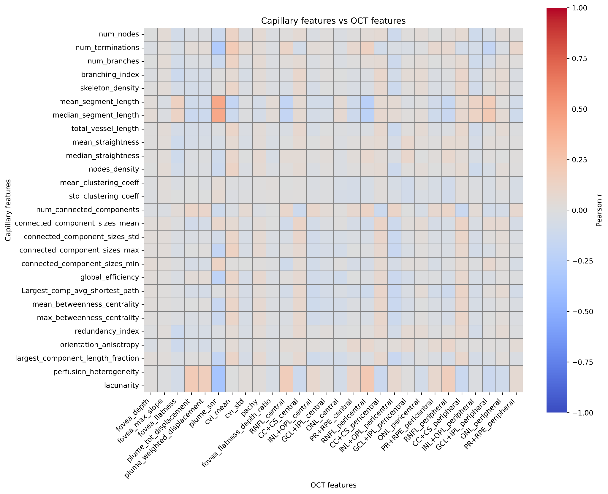
Supplementary Figure S8. Pearson correlation matrix between capillary-derived and structural OCT-derived features. Pairwise Pearson correlation coefficients between capillary-derived features (rows) and structural OCT-derived features (columns). The matrix shows the relationship between capillary network-level descriptors and retinal structural phenotypes.
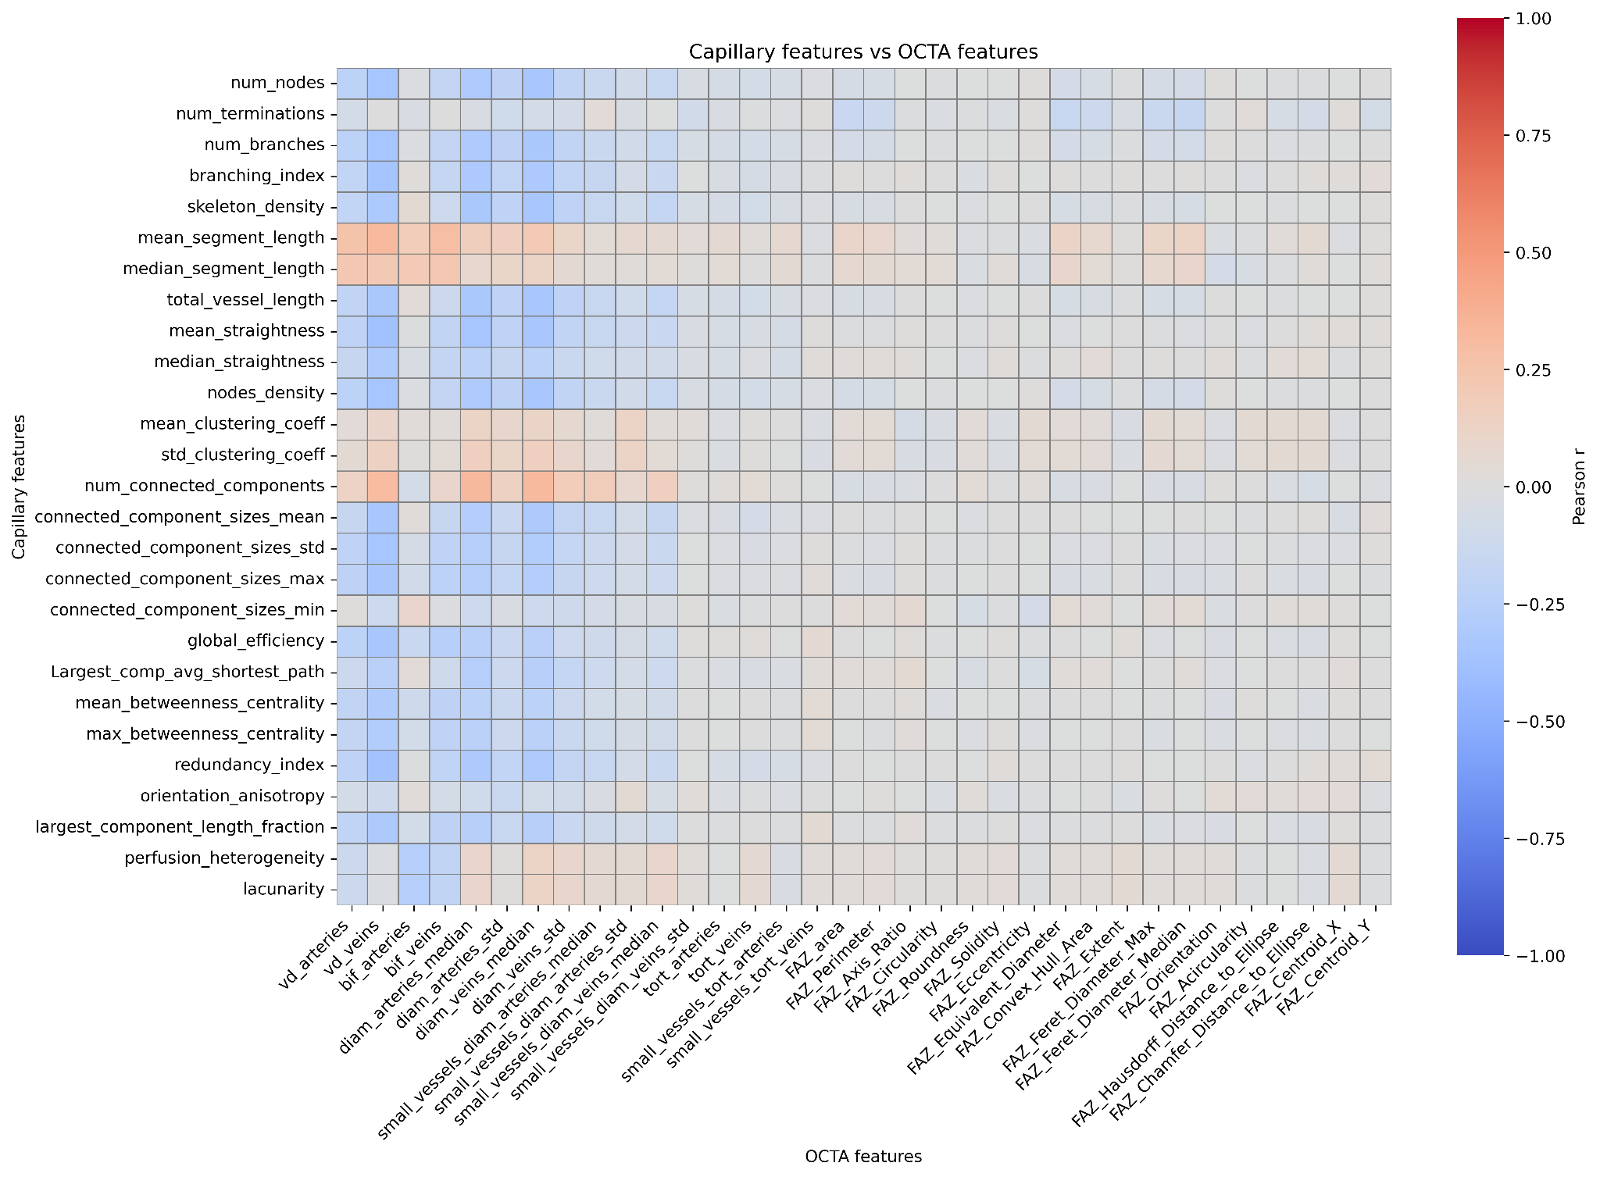
Supplementary Figure S9. Pearson correlation matrix between capillary-derived and OCTA-derived features. Pairwise Pearson correlation coefficients between capillary-derived features (rows) and OCTA-derived features (columns). The matrix illustrates associations between capillary network-level descriptors and retinal perfusion- and capillary network-related traits.
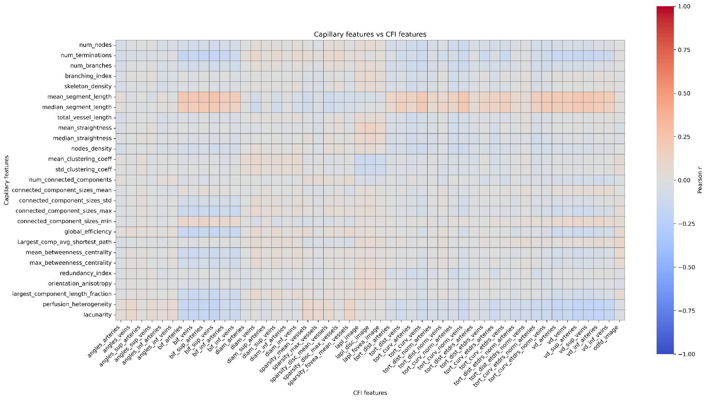
Supplementary Figure S10. Pearson correlation matrix between capillary-derived and colour fundus image-derived vascular features. Pairwise Pearson correlation coefficients between capillary-derived features (rows) and colour fundus image-derived vascular features (columns). The matrix shows the pattern of association between capillary network-level descriptors and fundus-derived vascular architecture.
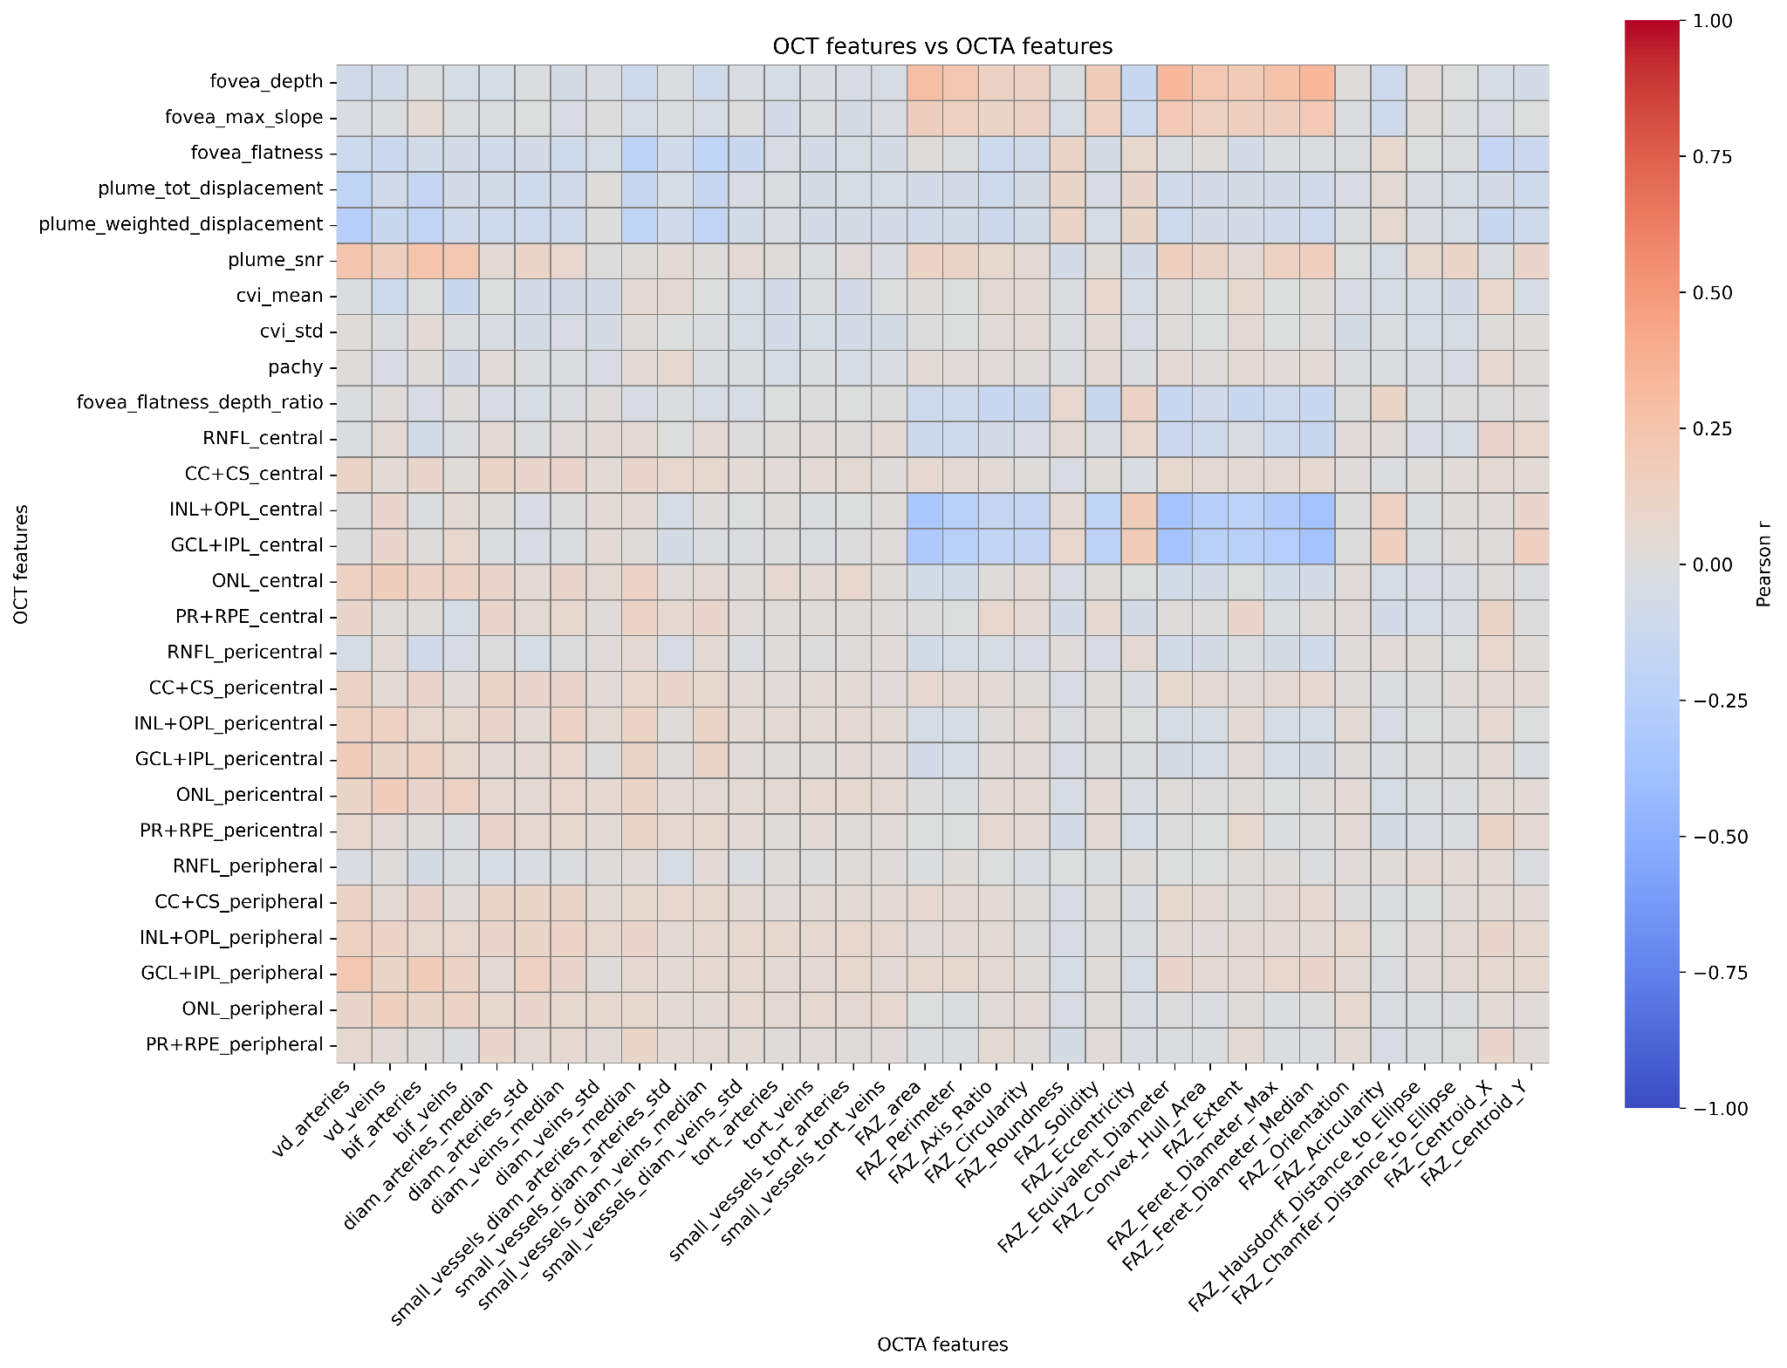
Supplementary Figure S11. Pearson correlation matrix between structural OCT-derived and OCTA-derived features. Pairwise Pearson correlation coefficients between structural OCT-derived features (rows) and OCTA-derived features (columns). The matrix illustrates the relationship between retinal structural phenotypes and retinal perfusion- and capillary network-related traits.
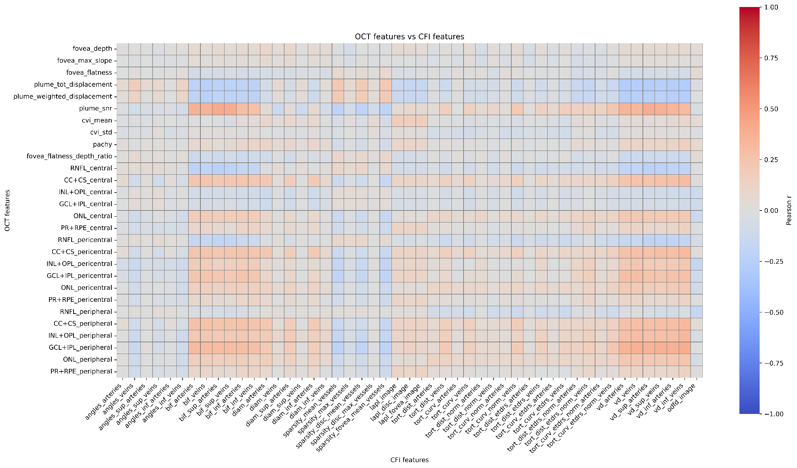
Supplementary Figure S12. Pearson correlation matrix between structural OCT-derived and colour fundus image-derived vascular features. Pairwise Pearson correlation coefficients between structural OCT-derived features (rows) and colour fundus image-derived vascular features (columns). The matrix shows associations between retinal structural phenotypes and fundus-derived vascular architecture.
Annex 1
The VascX Research Consortium (in alphabetical order):
Ciara Bergin ¹; Sven Bergmann ^{2,3,4}; Michael Beyeler ^{2,3,5}; Dennis Bontempi ^{2,3}; Sacha Bors ^{2,3}; Leah Böttger ^{2,3}; Bogdan Draganski ^{6,7,8}; Adham Elwakil ^{1,9}; Györgyi V. Hamvas ^{5,10}; Janna Hastings ^{11,12}; Ilaria Iuliani ^{2,3}; Caroline C.W. Klaver ^{13,14,15,16}; Ihor Kuras ⁶; Bart Liefers ^{13,14}; Ilenia Meloni ^{1,9}; Sofia Ortin Vela ^{2,3}; David Presby ^{2,3}; Ian Quintas ^{2,3}; José Vargas Quiros ^{13,14,}; Marc Schindewolf ^{5,10}; Reinier O. Schlingemann ^{1,17}; Mattia Tomasoni ^{1,9}; Olga Trofimova ^{2,3}.

¹ Department of Ophthalmology, University of Lausanne, Fondation Asile des Aveugles, Jules Gonin Eye Hospital, Lausanne, Switzerland.
² Department of Computational Biology, University of Lausanne, Lausanne, Switzerland.
³ Swiss Institute of Bioinformatics, Lausanne, Switzerland.
⁴ Department of Integrative Biomedical Sciences, University of Cape Town, Cape Town, South Africa.
⁵ Division of Angiology, Swiss Cardiovascular Center, Inselspital, Bern University Hospital, University of Bern, Bern, Switzerland.
⁶ Department of Neurology and University Institute for Diagnostic and Interventional Neuroradiology, Inselspital, University Hospital Bern, University of Bern, Bern, Switzerland.
⁷ Department of Neurology, Max Planck Institute for Human Cognitive and Brain Sciences, Germany.
⁸ Department of Clinical Neuroscience, Lausanne University Hospital and University of Lausanne, Switzerland.
⁹ Platform for Research in Ocular Imaging, Fondation Asile des Aveugles, Jules Gonin Eye Hospital, Lausanne, Switzerland.
¹⁰ Department for BioMedical Research, Bern University Hospital, University of Bern, Switzerland.
¹¹ Institute for Implementation Science in Health Care, Faculty of Medicine, University of Zurich, Zürich, Switzerland.
¹² School of Medicine, University of St Gallen, St. Gallen, Switzerland.
¹³ Department of Ophthalmology, Erasmus University Medical Center, Rotterdam, The Netherlands.
¹⁴ Department of Epidemiology, Erasmus University Medical Center, Rotterdam, The Netherlands.
¹⁵ Department of Ophthalmology, Radboud University Medical Center, Nijmegen, the Netherlands.
¹⁶ Institute of Molecular and Clinical Ophthalmology, University of Basel, Switzerland.
¹⁷ University Medical Centres, Amsterdam, The Netherlands.

Annex 2
The OphtalmoLaus Research Consortium (in alphabetical order):
Daniel Bach ^{1,2}; Lionel Bagatella ²; Ciara Bergin ²; Adham Elwakil ^{1,2,*}; Torrecillos Flavie ²; Edwige Forestier ²; Aurélia Gryczka ²; Fanny Jeunet ²; Lazaros Konstantinidis ²; Ilenia Meloni ^{1,2,*}; Aurélie Navarro ²; Flore Racodon ²; Reinier Schlingemann ^{2,3}; Sophie Strebel ^{1,2}; Mattia Tomasoni ^{1,2}; Bao Tran ²; Thomas J. Wolfensberger ²

¹ Platform for Research in Ocular Imaging, Fondation Asile des Aveugles, Jules Gonin Eye Hospital, Lausanne, Switzerland.
² Department of Ophthalmology, University of Lausanne, Fondation Asile des Aveugles, Jules Gonin Eye Hospital, Lausanne, Switzerland. ³ Ikerian AG, Bern, Switzerland.
³ Amsterdam UMC, University of Amsterdam, Department of Ophthalmology, Amsterdam, The Netherlands.

