Supplementary File
Phytochemicals can counteract breast cancer by restoring autophagic flux and disrupting the LC3B–p62–Nrf2 feedback loop
Author & Coauthors: Mehreen Aftab^{1,2*}, Kamran Waidha³, Shagufta Khan¹,Sandeep Sisodiya¹, Avi Golan-Goldhirsh³, Jacob Gopas⁴, Showket Hussain¹
¹Division of Cellular and Molecular Diagnostics (Molecular Biology Group), ICMR- National Institute of Cancer Prevention and Research, Sector- 39, Noida. Uttar Pradesh, India.
²Department of Molecular Medicine, School of Interdisciplinary Science, Jamia Hamdard, New Delhi, India
³The Jacob Blaustein Institutes for Desert Research (BIDR), French Associates Institute for Agriculture and Biotechnology of Drylands, Sede Boqer Campus, Ben Gurion University of the Negev, 84990 Israel.
⁴The Shraga Segal Department of Microbiology, Immunology and Genetics Faculty of Health Sciences, Ben-Gurion University of the Negev, Beer Sheva 8410501, Israel.
*Corresponding authors
Showket Hussain
showket.hussain@gov.in
Mehreen Aftab
mehreen@jamiahamdard.ac.in

Table S1: Quantitative PCR (qPCR) human primer nucleotide sequences
Gene symbol | Nucleotide sequence (5' to 3')
LC3 (NM_022818) | Forward | GAGAAGCAGCTTCCTGTTCTGG
LC3 (NM_022818) | Reverse | GTGTCCGTTCACCAACAGGAAG
NRF2 (NM_006164) | Forward | CACATCCAGTCAGAAACCAGTGG
NRF2 (NM_006164) | Reverse | GGAATGTCTGCGCCAAAAGCTG
p62 (NM_003900) | Forward | TGTGTAGCGTCTGCGAGGGAAA
p62 (NM_003900) | Reverse | AGTGTCCGTGTTTCACCTTCCG
Beta-actin (NM_001101) | Forward | CACCATTGGCAATGAGCGGTTC
 | Reverse | AGGTCTTTGCGGATGTCCACGT

Table S2: Primary and secondary antibody details

Target protein | Company | Application
LC3 | Cell Signaling #3868 | Immunoblot
LC3 | Cell Signaling #3868 | Immunofluorescence
NRF2 | Sigma #L7543 | Immunoblot
NRF2 | Sigma #L7543 | Immunofluorescence
p62 | Santacruz, #sc-28359 | Immunoblot
p62 | Santacruz, #sc-28359 | Immunofluorescence
Beta-actin | mAbcam 8226 | Immunoblot
Anti-mouse IgG-HRP | Cell Signaling #7074 | Immunoblot
Anti-rabbit IgG-HRP | Cell Signaling #7076 | Immunoblot
Anti-rabbit Alexa Fluor™ 488 Antibody | Invitrogen, # A11008 | Immunofluorescence
Anti-mouse Alexa Fluor™ 564 Antibody | Invitrogen, # A-11030 | Immunofluorescence

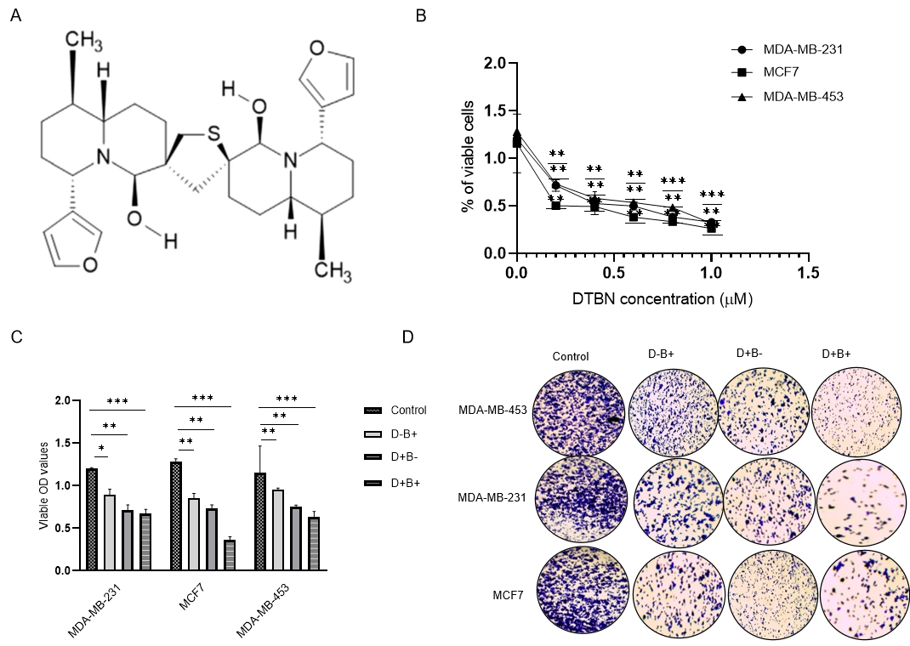
Figure S1;(A) Structure of DTBN: Purified extract from Nuphar lutea, 6,6′-dihydroxythiobinupharidine . DTBN decreases breast cancer cells (different Tp53 status) viability dose dependently. (B) MTT-based viability assay of breast cancer cells with various DTBN concentrations after 24 hours of treatment. IC50 value calculated using non-linear regression. (C-D) Cell viability of cells after the treatment of brusatol (0.2&0.5µM) and DTBN (0.2 & 0.5µM) for 24 hours.

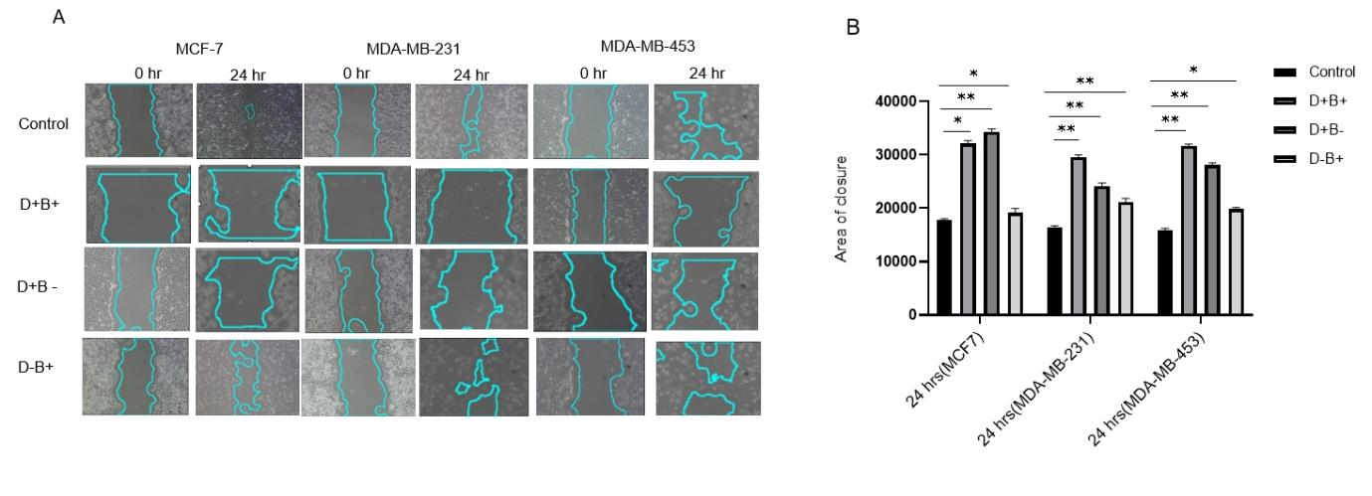
Figure S2: Scratch wound healing assay to determine the effect of DTBN and Brusatol on the migration of breast cancer cells (MCF7, MDA-MB-231 &MDA-MB-453)

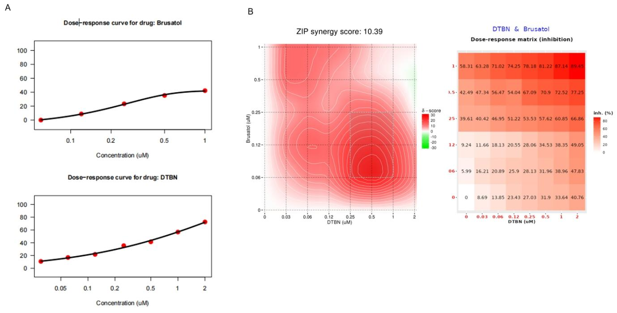
Figure S3: DTBN and Brusatol synergism was predicted by synergy combination index/scores

(A)
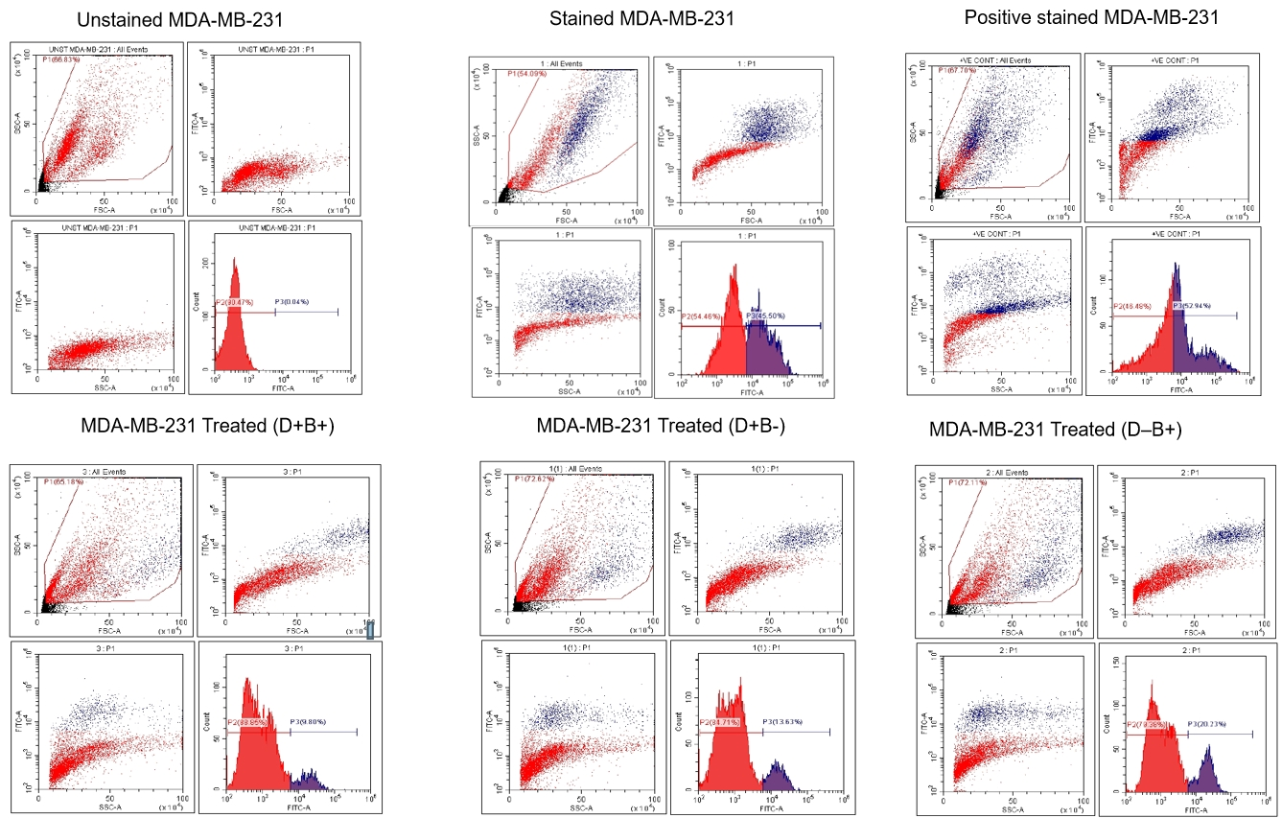

(B)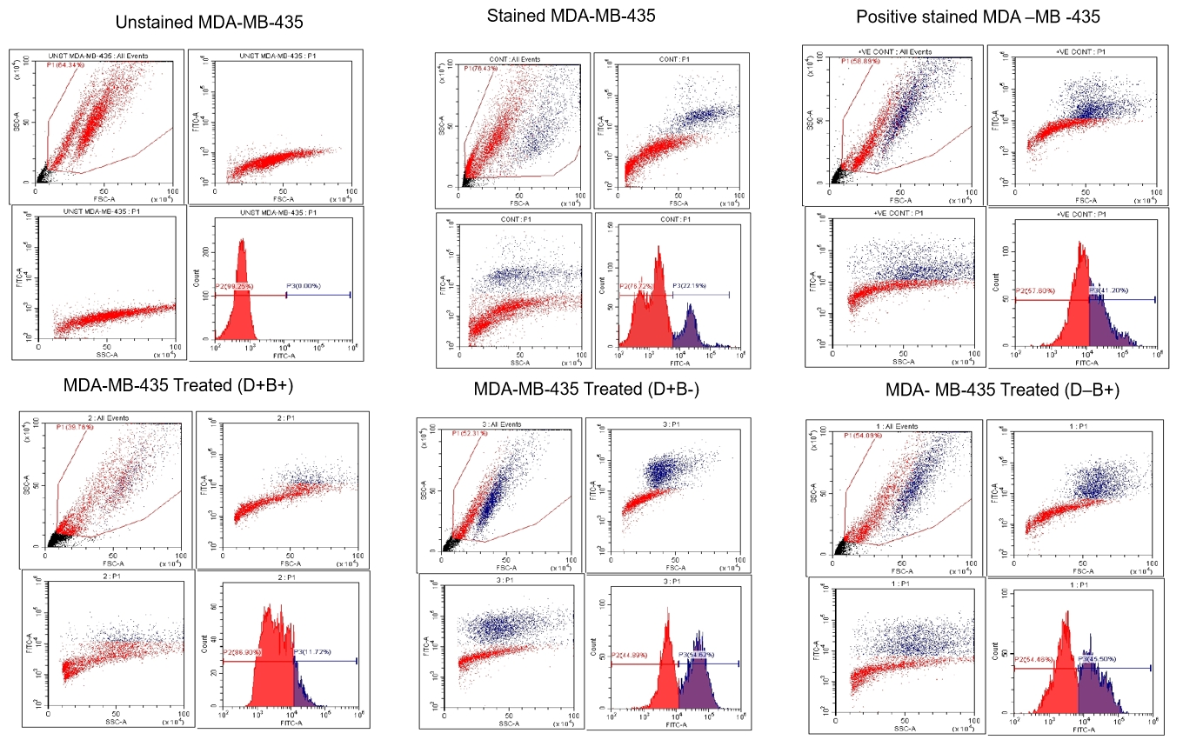

(C )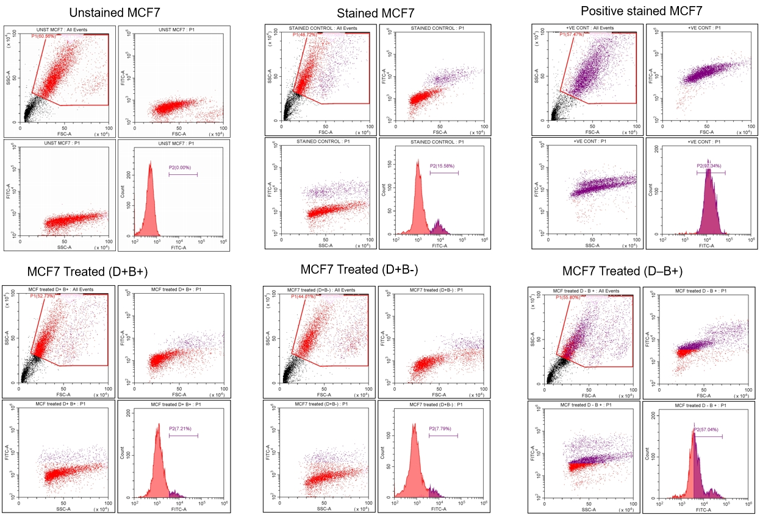

Figure S4; Representative FACS images showing reactive oxygen species levels in control samples, DTBN-treated samples, and samples treated with both DTBN and brusatol.(A) MCF7,(B)MDA-MB-231& (C)MDA-MB-453.

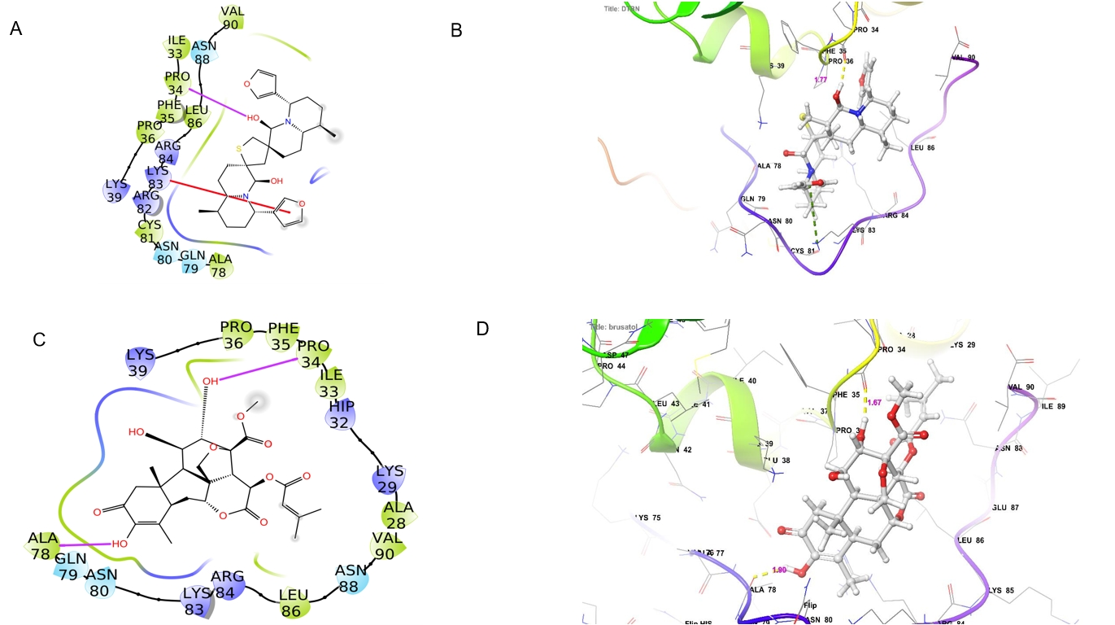
Figure S5; Molecular docking analysis and score of NRF2 against (A) DTBN and (B) Brusatol (NRF2 inhibitor)

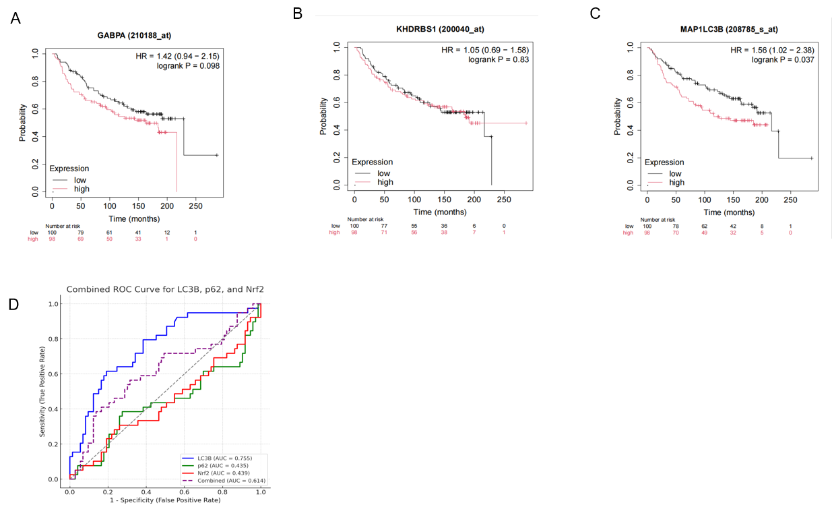
Figure S6: Publicly available data analysis to find out the prognosis and diagnosis of Nrf2, p62 & LC3 (A-C) Survival plot by kaplan Meier plotter (D) Combined Reciever operating curve (ROC)

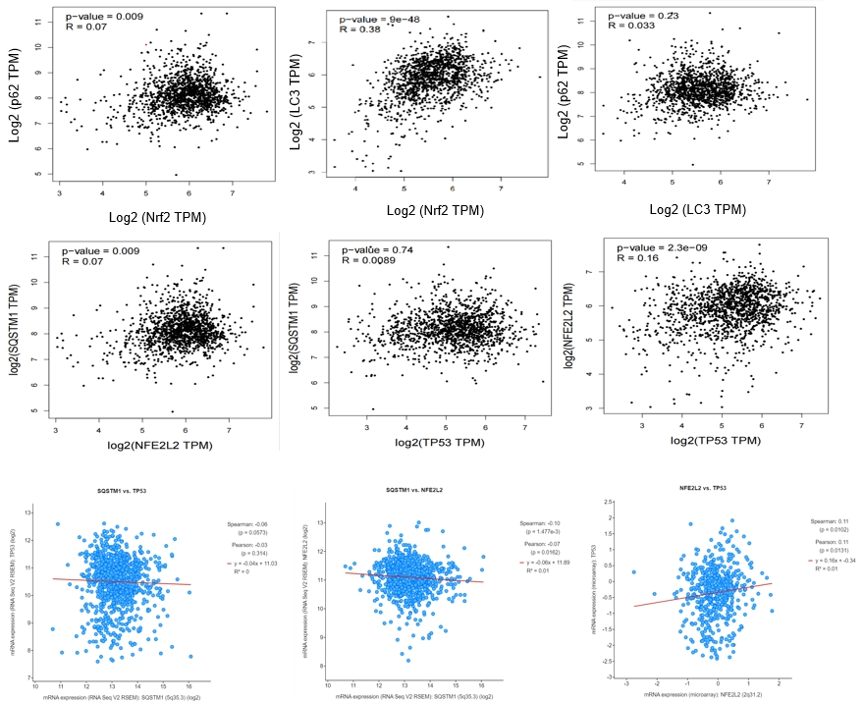
Figure S7; Plots of Pearson's correlation between (A)p62 and Nrf2 (B) LC3 and Nrf2 (C) p62&LC3

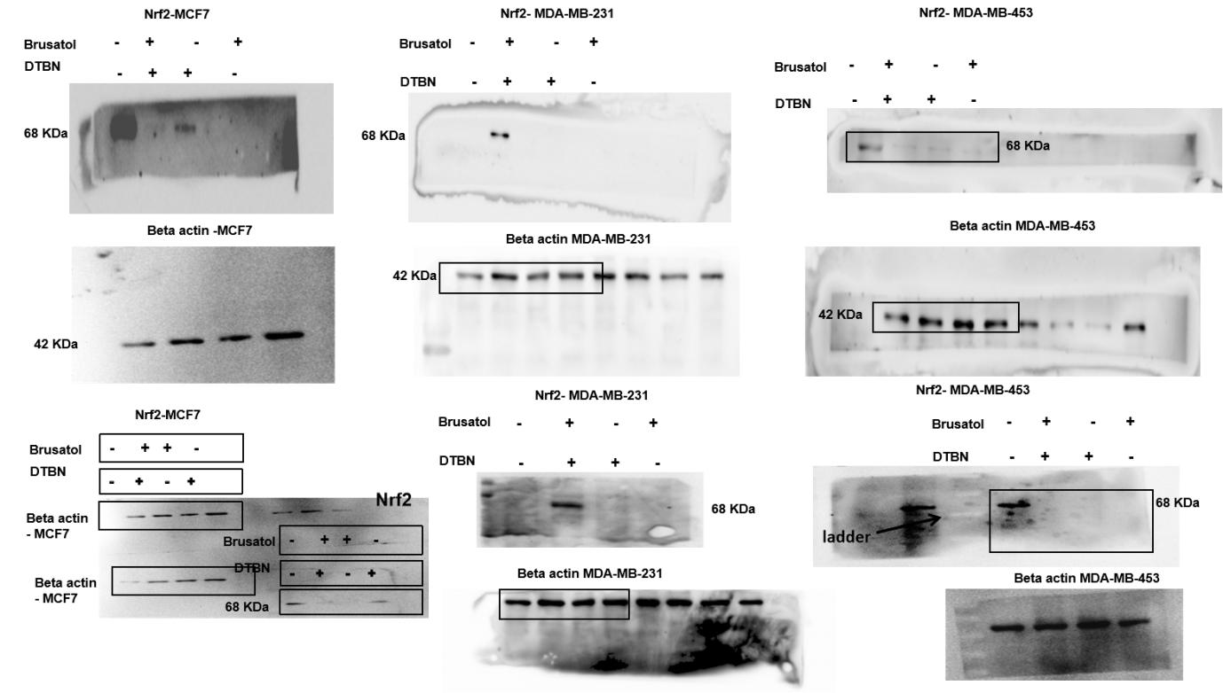

Original images of fig. 3B.
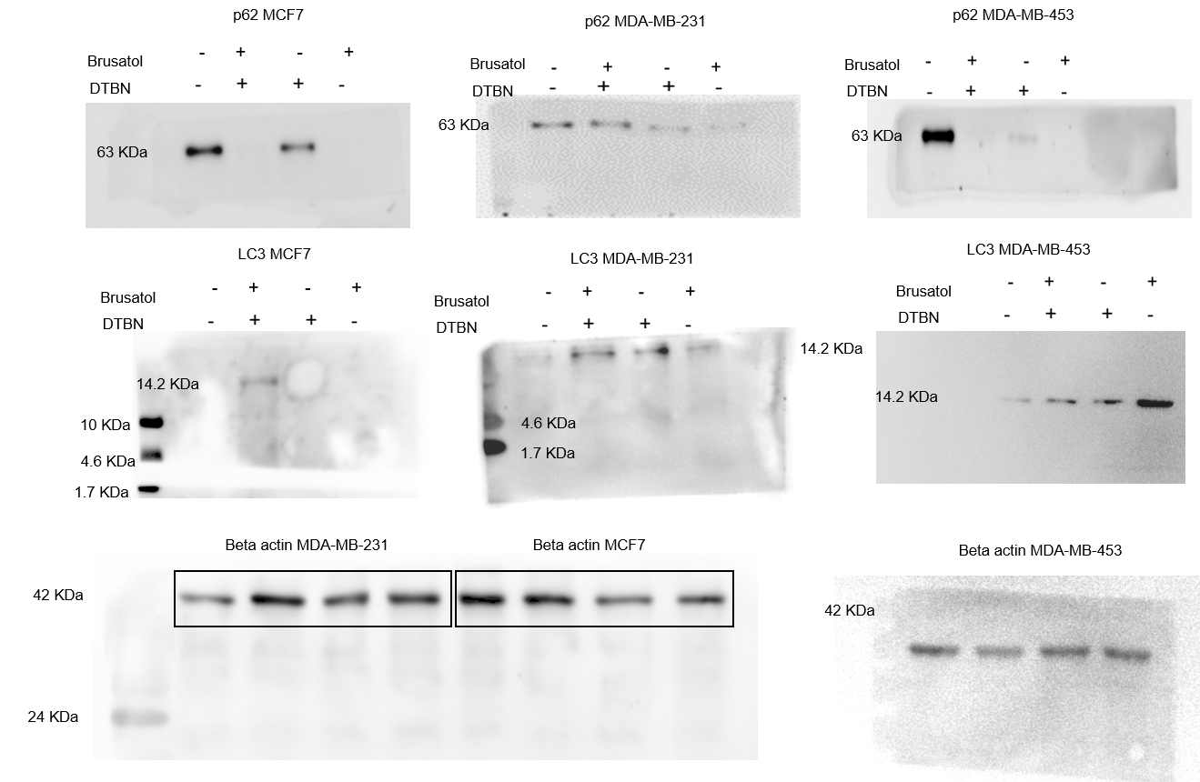

Original images of fig. 4B.
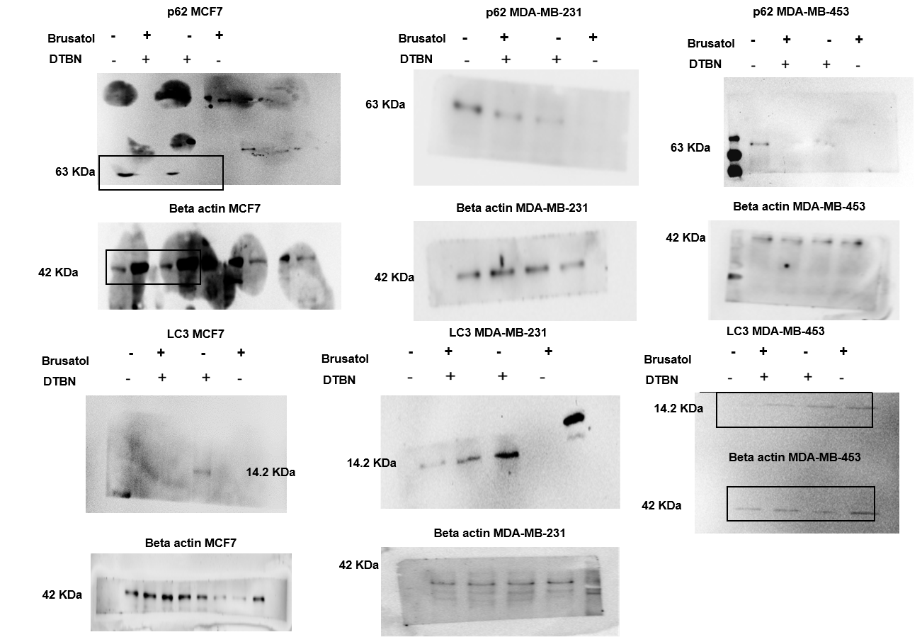

Original images of fig. 4B.

