Supplementary material 1
Edge Weight Accuracy for the Gender-Based Networks
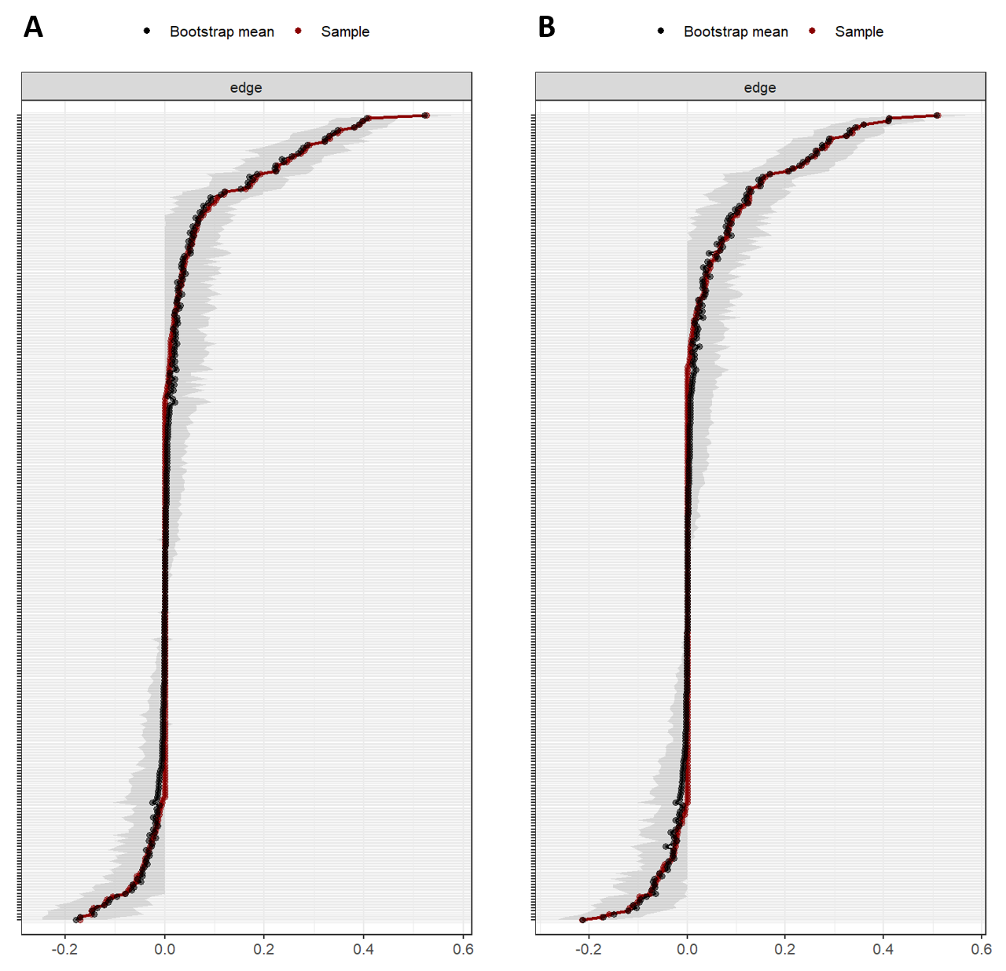
Note. This figure presents the results of a non-parametric bootstrap analysis (n = 2500) conducted to assess the accuracy of edge weight estimation in the gender-based networks. The X-axis represents edge weights, and the Y-axis ranks the edges by weight magnitude. Black dots indicate the bootstrap mean values for each edge, red dots indicate the observed edge weights, and the shaded areas represent the 95% confidence intervals. Panel A displays the results for the male network. The average width of the 95% confidence intervals for edge weights was 0.11, with the narrowest interval being 0.04 (Feeling for the Person Suffering_S–Stress; edge weight = 0.003) and the widest being 0.21 (Describing–Nonreactivity to Inner Experience; edge weight = 0.28). Panel B presents the results for the female network. The average width of the 95% confidence intervals was 0.12, with the narrowest interval being 0.05 (Empathic Concern–Stress; edge weight = -0.004) and the widest being 0.19 (Acting with Awareness–Nonjudging of Inner Experience; edge weight = 0.17).

Supplementary material 2
Edge Weight Accuracy for the Age-Based Networks
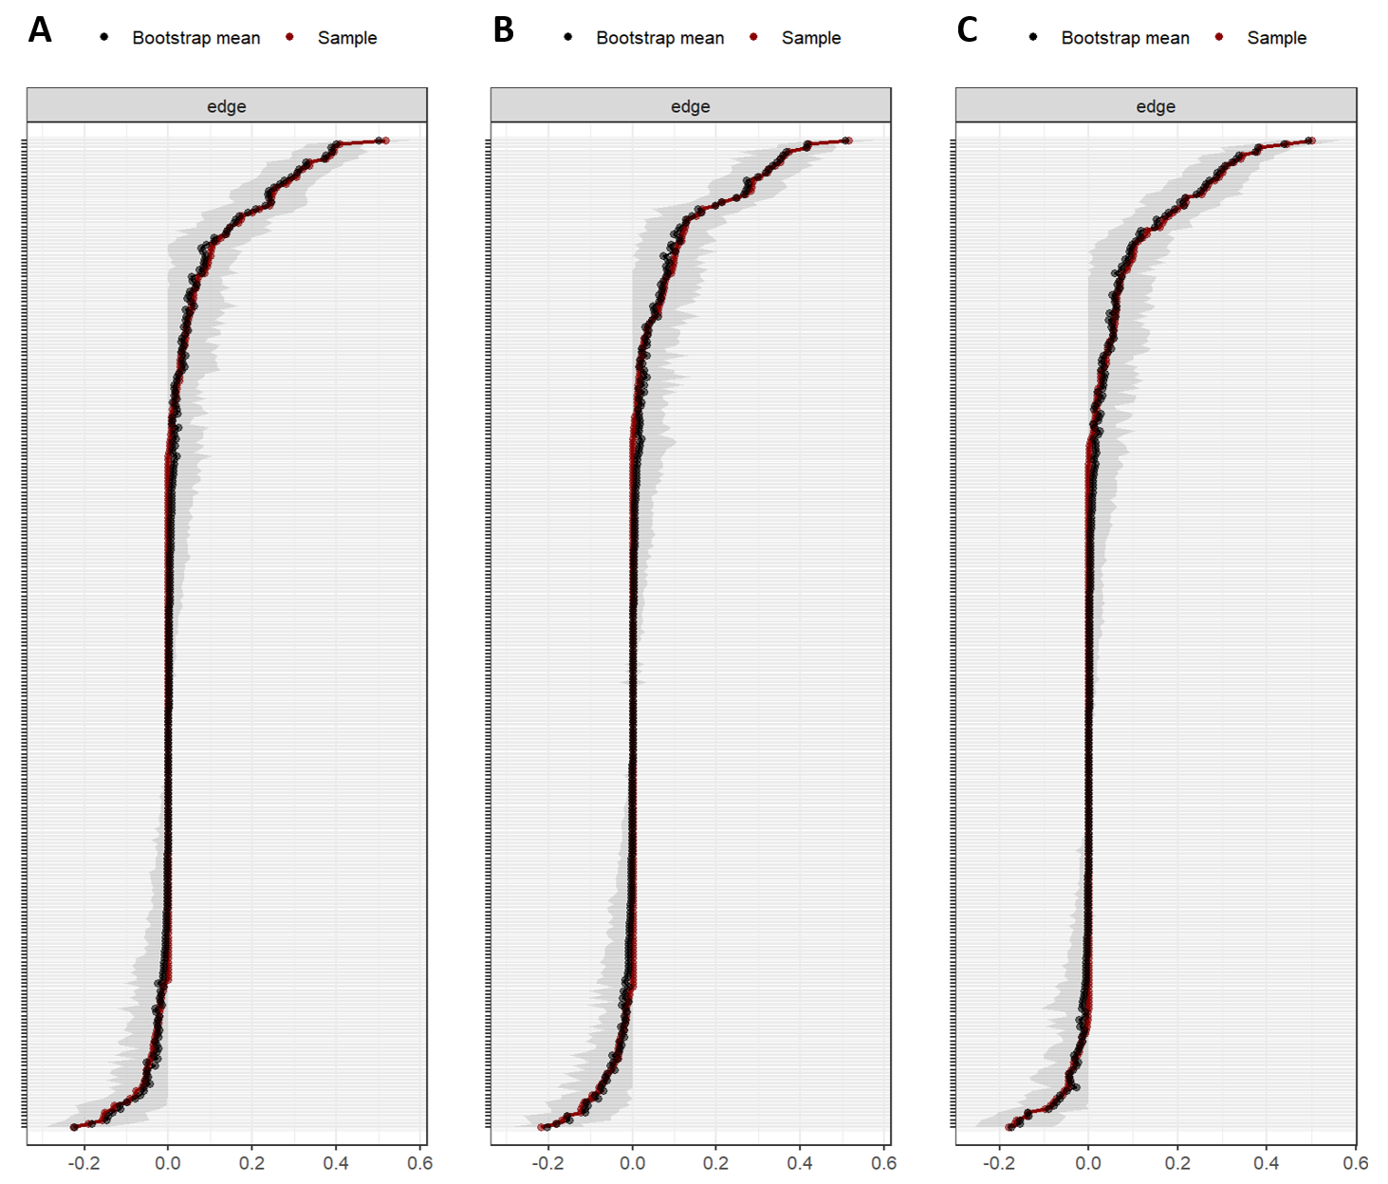
Note. This figure presents the results of a non-parametric bootstrap analysis (n = 2500) conducted to assess the accuracy of edge weight estimation in the age-based networks. The X-axis represents edge weights, and the Y-axis orders the edges by weight magnitude. Black dots indicate the bootstrap mean values for each edge, red dots indicate the observed edge weights, and the shaded areas represent the 95% confidence intervals. Panel A presents the results for the young adult network. The average width of the 95% confidence intervals for edge weights was 0.13, with the narrowest interval being 0.05 (Motivation to Act to Alleviate Suffering_O–Isolation; edge weight = 0.007) and the widest being 0.23 (Describing–Nonreactivity to Inner Experience; edge weight = 0.14). Panel B displays the results for the middle-aged adult network. The average width of the 95% confidence intervals for edge weights was 0.13, with the narrowest interval being 0.05 (Tolerating Uncomfortable Feelings_S–Stress; edge weight = -0.01) and the widest being 0.22 (Describing–Nonreactivity to Inner Experience; edge weight = 2.55). Panel C presents the results for the older adult network. The average width of the 95% confidence intervals for edge weights was 0.12, with the narrowest interval being 0.05 (Tolerating Uncomfortable Feelings_S–Isolation–; edge weight = -0.002) and the widest being 0.22 (Acting with Awareness–Nonjudging of Inner Experience; edge weight = 0.25).

