[Supplementary information]
High-Throughput Quantification of XPS Spectra using Explainable 1D-Convolutional Neural Network
Mina Lim¹, Sooyeon Lim ¹, Byeong-hyeon Lee^{1,2}, Jae-Pyoung Ahn¹, Hong-kyu Kim ^{1,*}, and Soohyung Park ^{1,*}
¹Advanced Analysis Center, Korea Institute of Science and Technology (KIST), Seoul 02792, Republic of Korea
²Department of Materials Science and Engineering, Seoul National University, Seoul 08826, Republic of Korea

Section 1. Architectural Configuration and Performance Benchmarking of Deep Learning Models

Table1. Comparison Results of Vanilla CNN, DNN, GoogleNet, ResNet in terms of RMSE and Customized Accuracy.
 | Train acc | Test acc  (experimental dataset) | Train RMSE | Test RMSE  (experimental dataset)
1D-CNN | 99.28% | 90.6% | 0.0018 | 0.0166
DNN | 64% | 30% | 0.0031 | 0.0058
GoogleNet | 94% | 75% | 0.002 | 0.023
ResNet | 93% | 72% | 0.0021 | 0.022

In this study, we designed a 1D-CNN model specifically optimized for feature extraction from XPS spectrum and conducted benchmarking against various deep learning architectures, including DNN, GoogleNet, and ResNet, for performance comparison. The proposed 1D-CNN consists of four sequential 1D convolutional layers and accepts an input array of 1,300 spectral data points. These layers utilize 64, 128, 256, and 1 convolutional filters with kernel sizes of 41, 21, and 11, respectively, to effectively extract local spectroscopic features. We adopted the Rectified Linear Unit (ReLU) as the activation function and Mean Squared Error (MSE) as the loss function. Optimal convergence performance was achieved using the Adam optimizer with a learning rate ranging from 0.0005 to 0.0001. As summarized in Table 1, the 1D-CNN demonstrated superior quantitative analysis capabilities, achieving an outstanding test accuracy of 90.6% and the lowest Root Mean Square Error (RMSE) of 0.0166 on the practical experimental dataset, significantly outperforming the alternative architectures.

Section 2. Comprehensive Reference Library of Elemental XPS Survey Spectra and Corresponding Feature Importance Spectra (FIS)
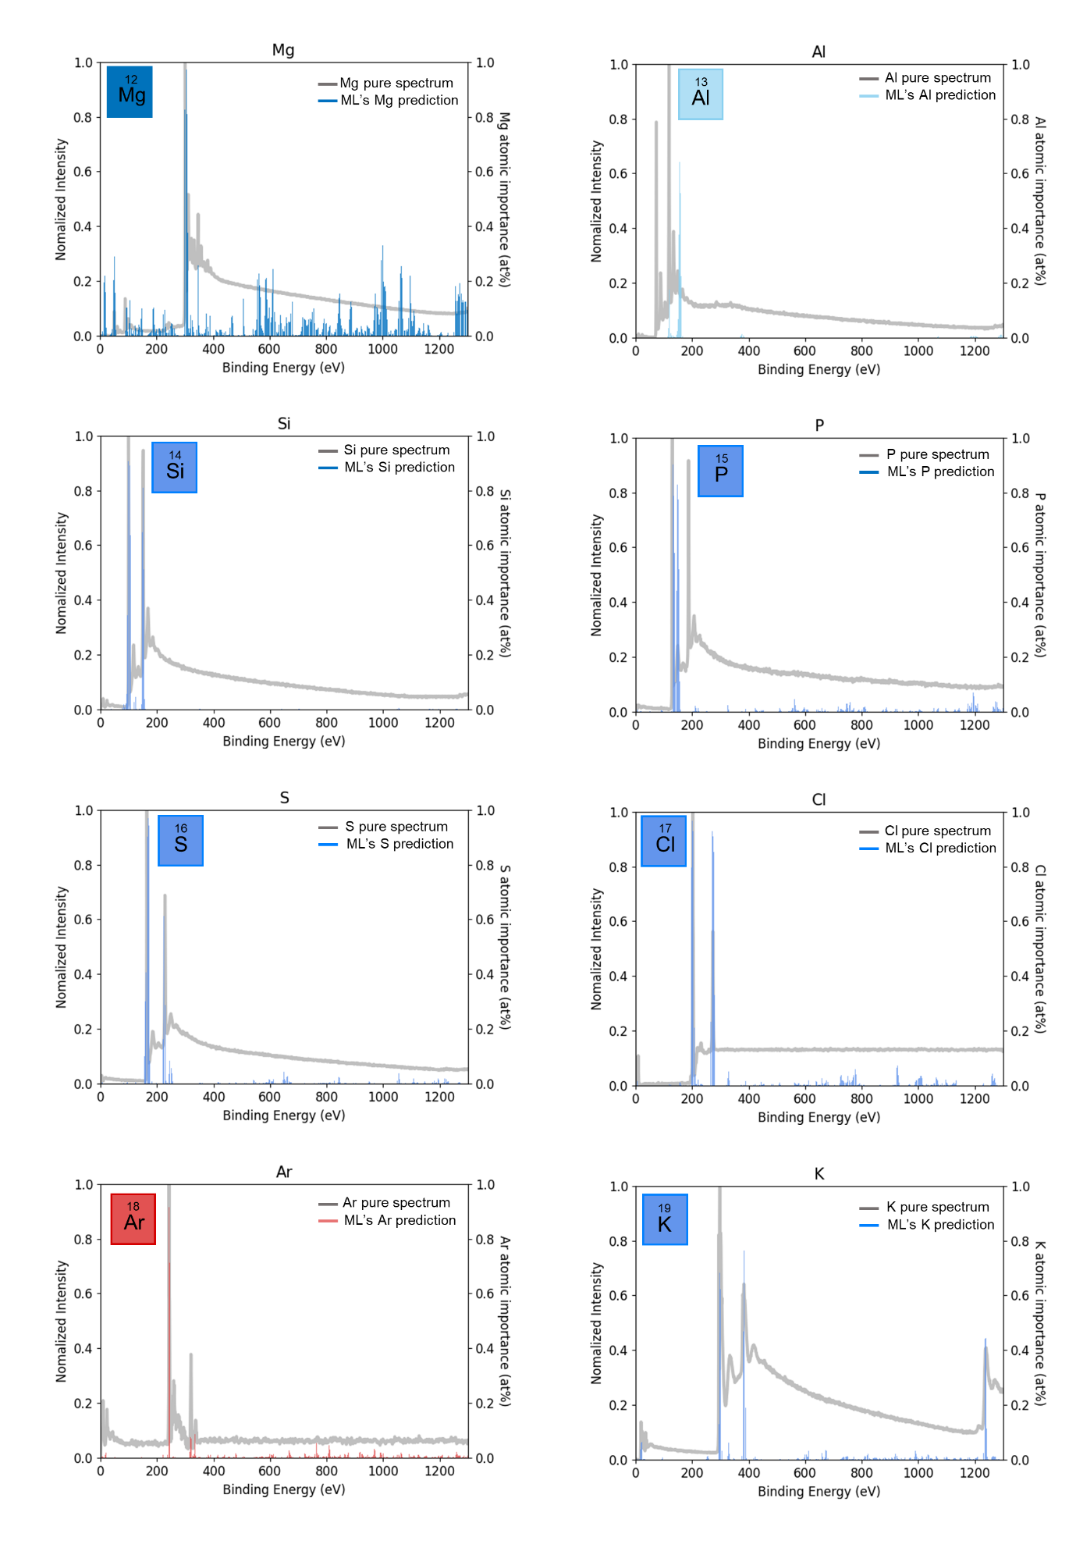
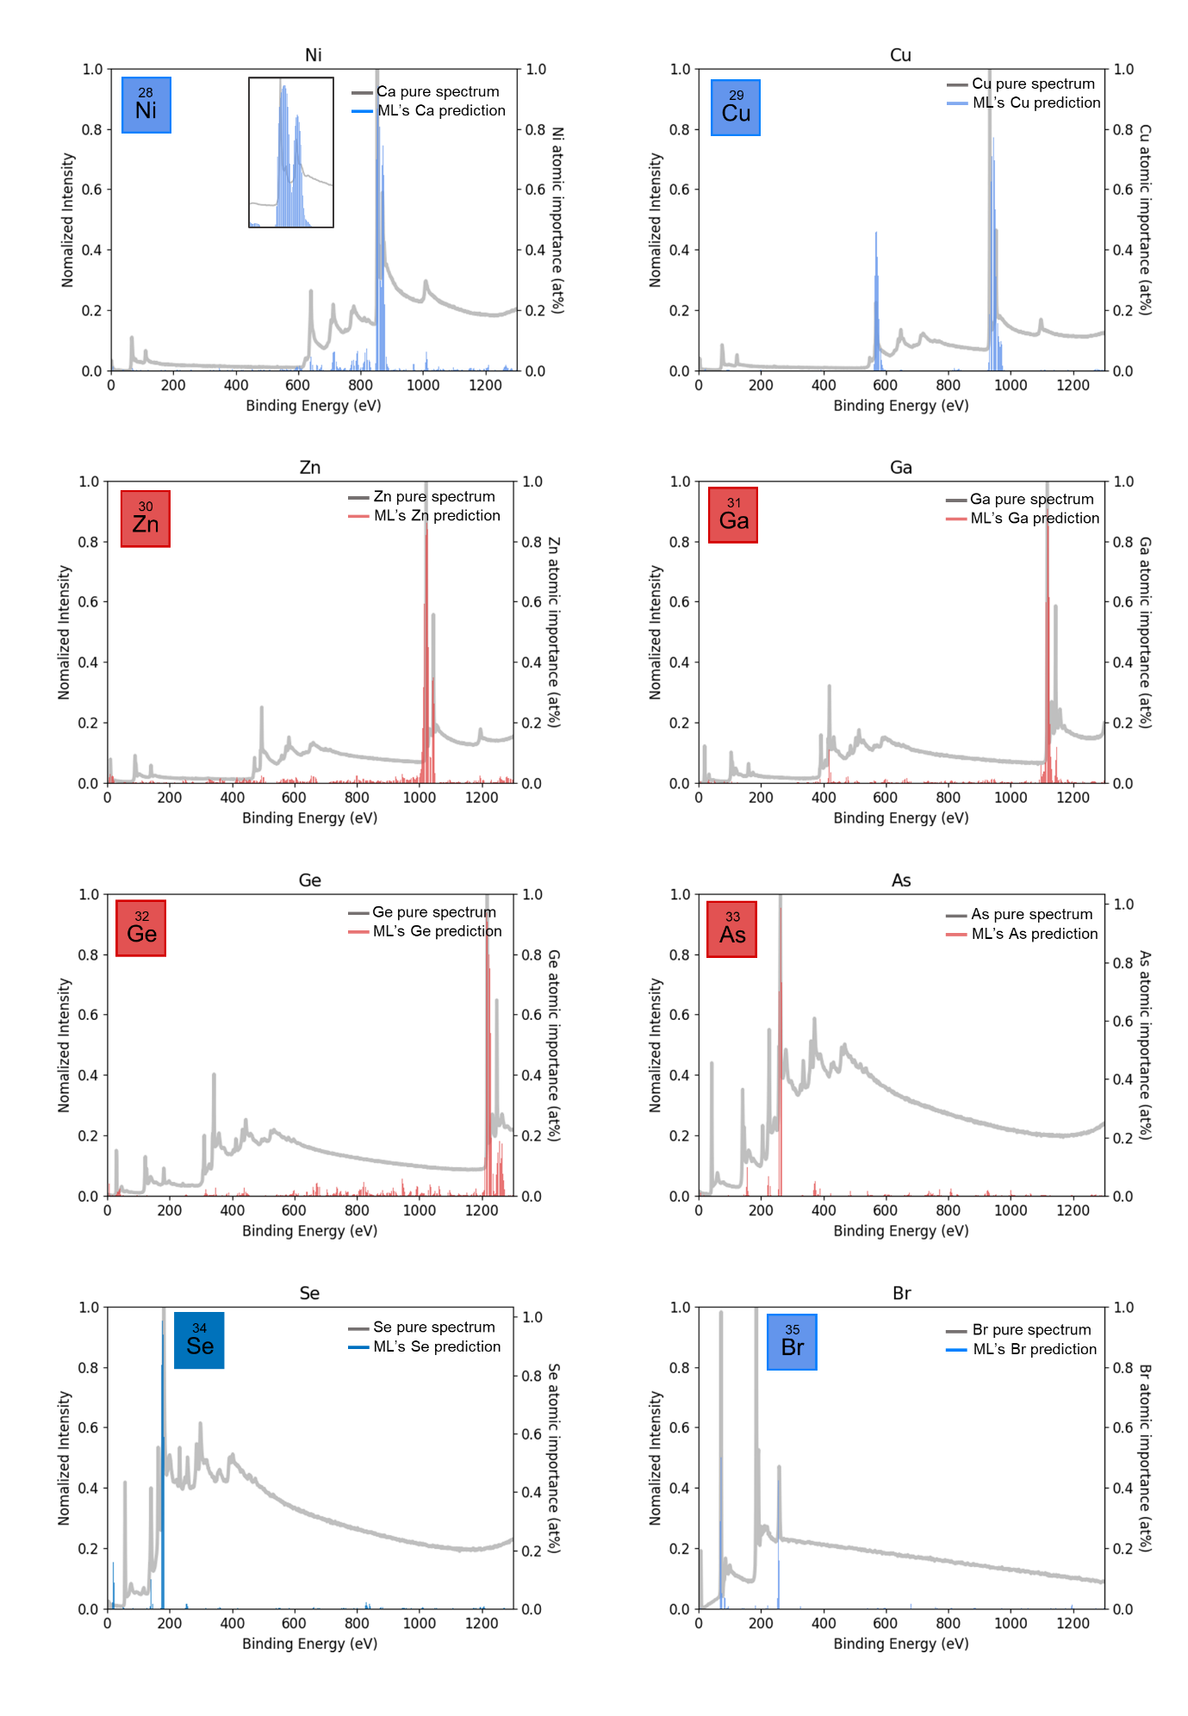
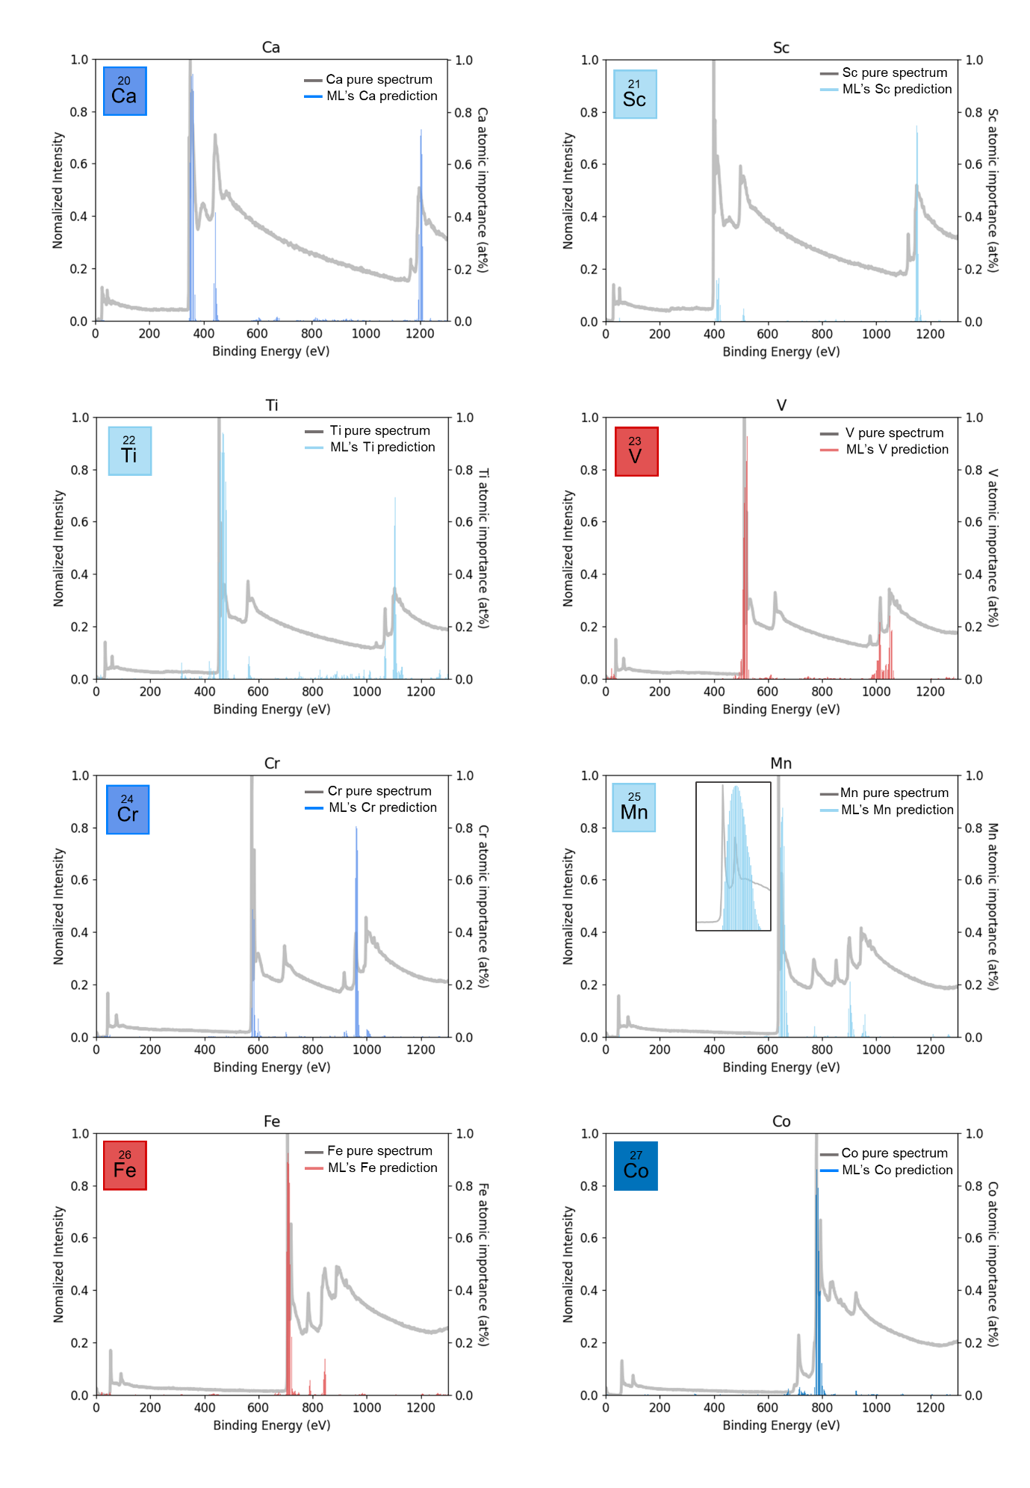

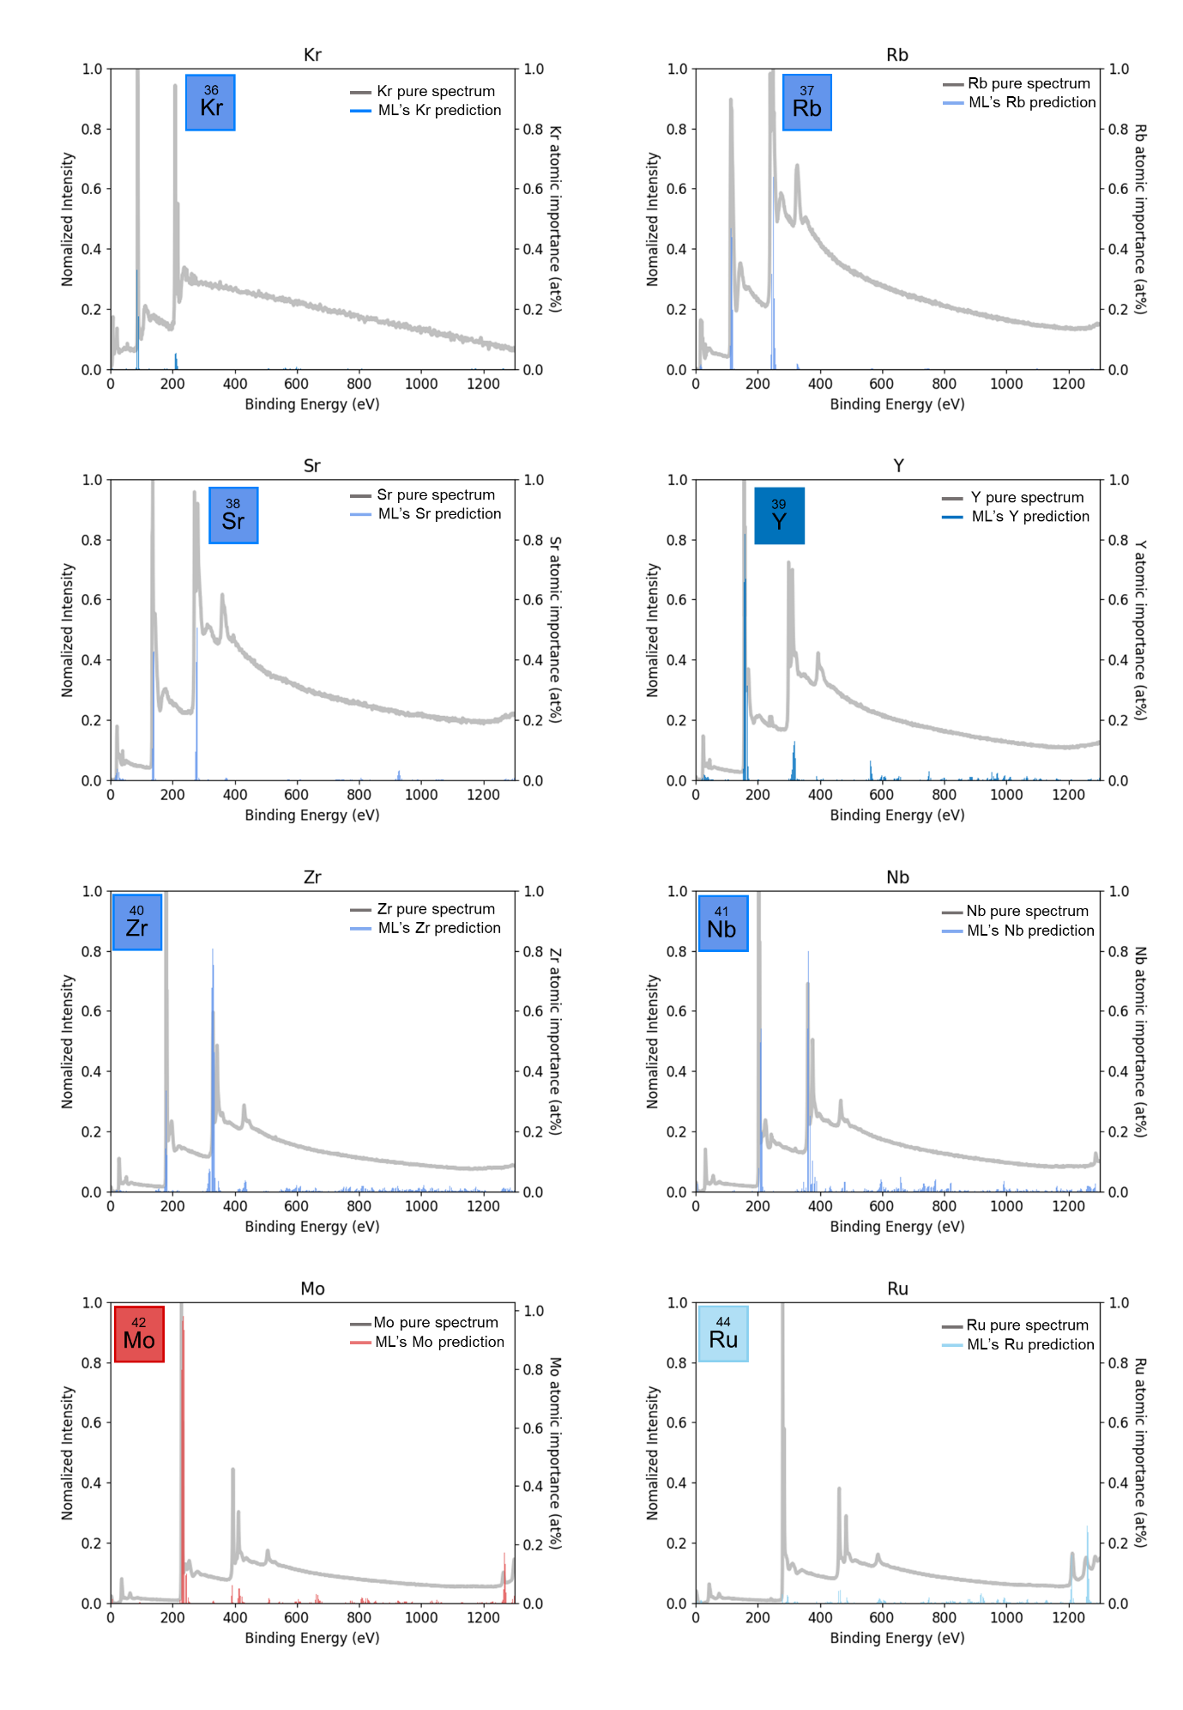

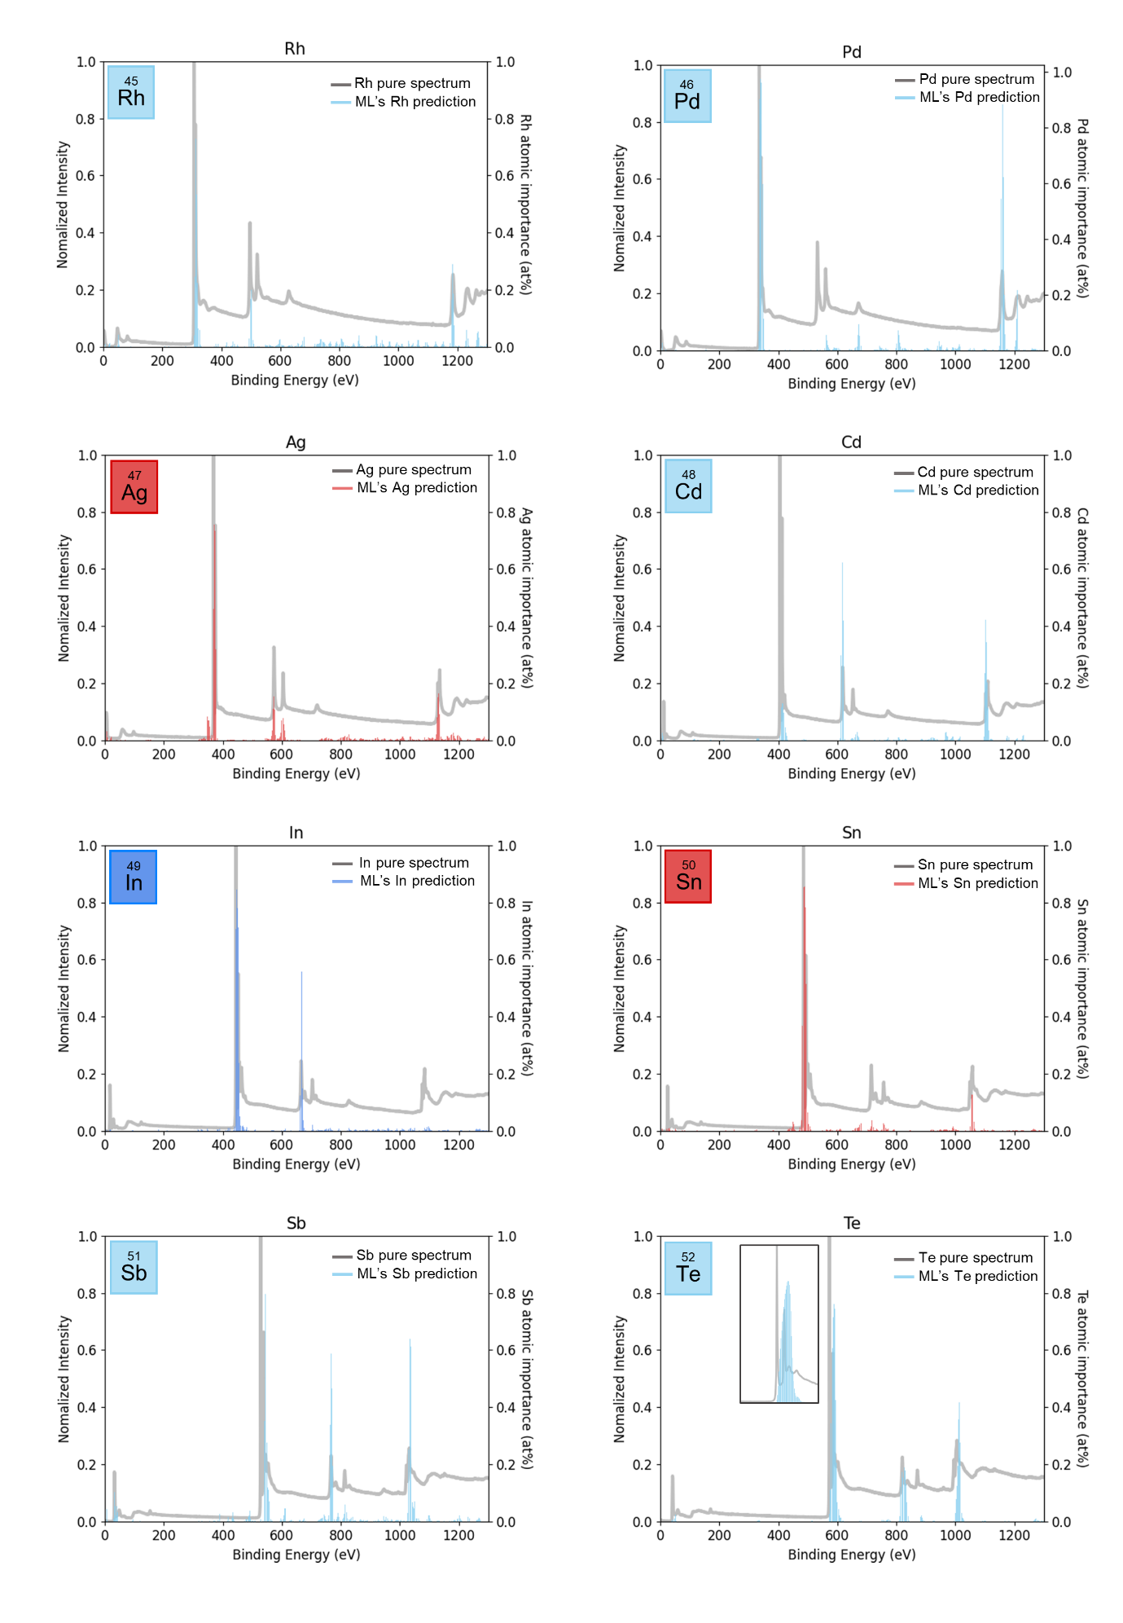

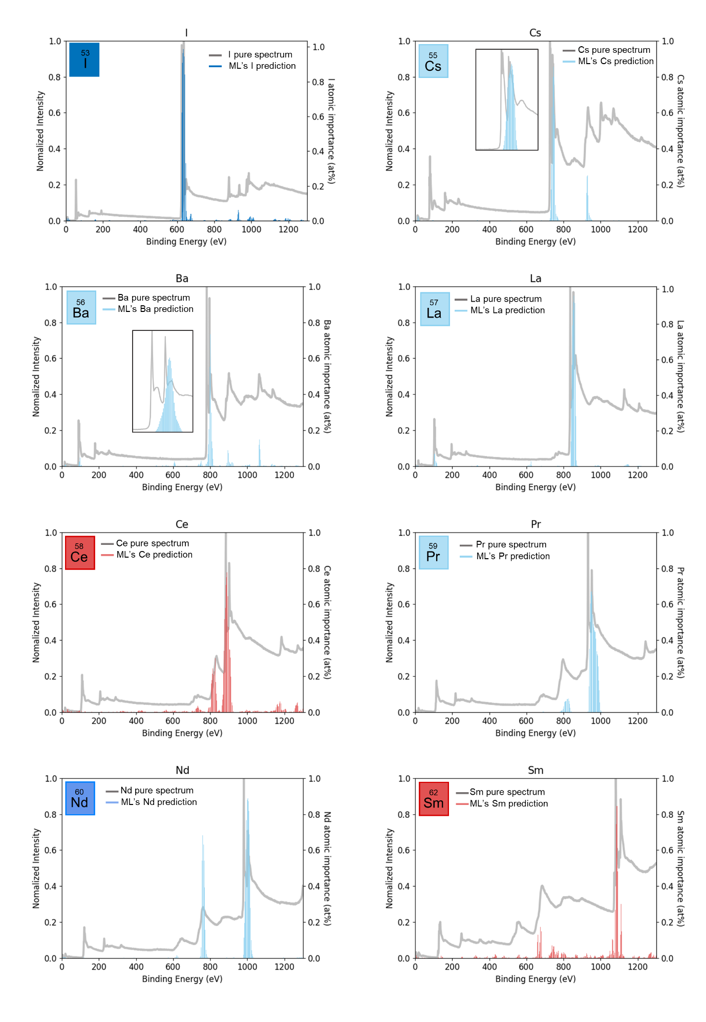

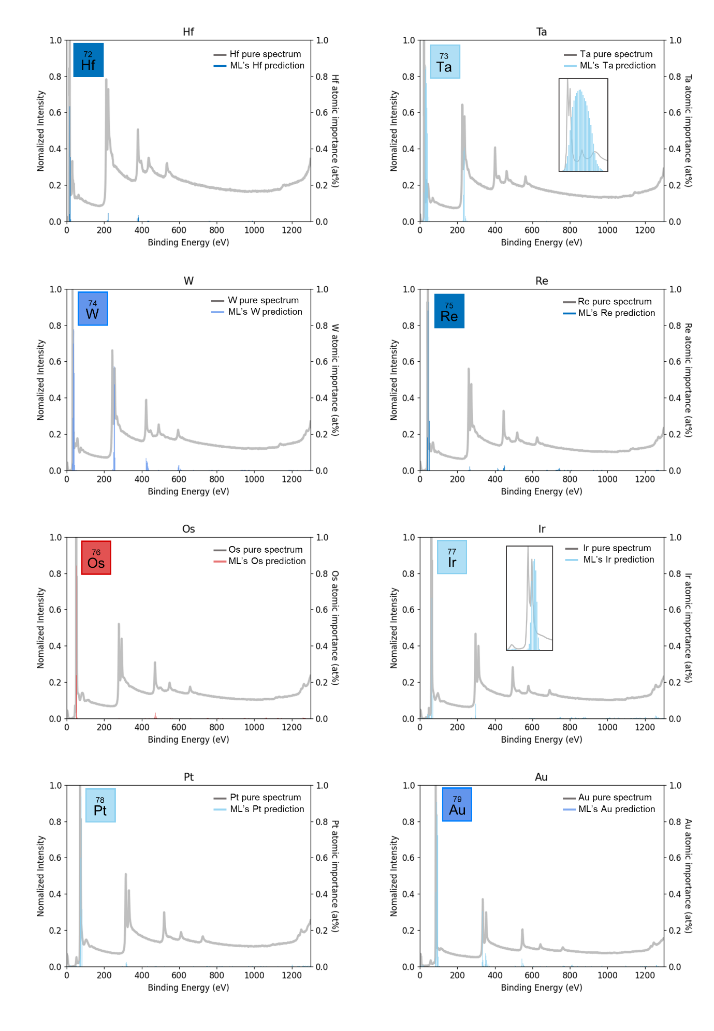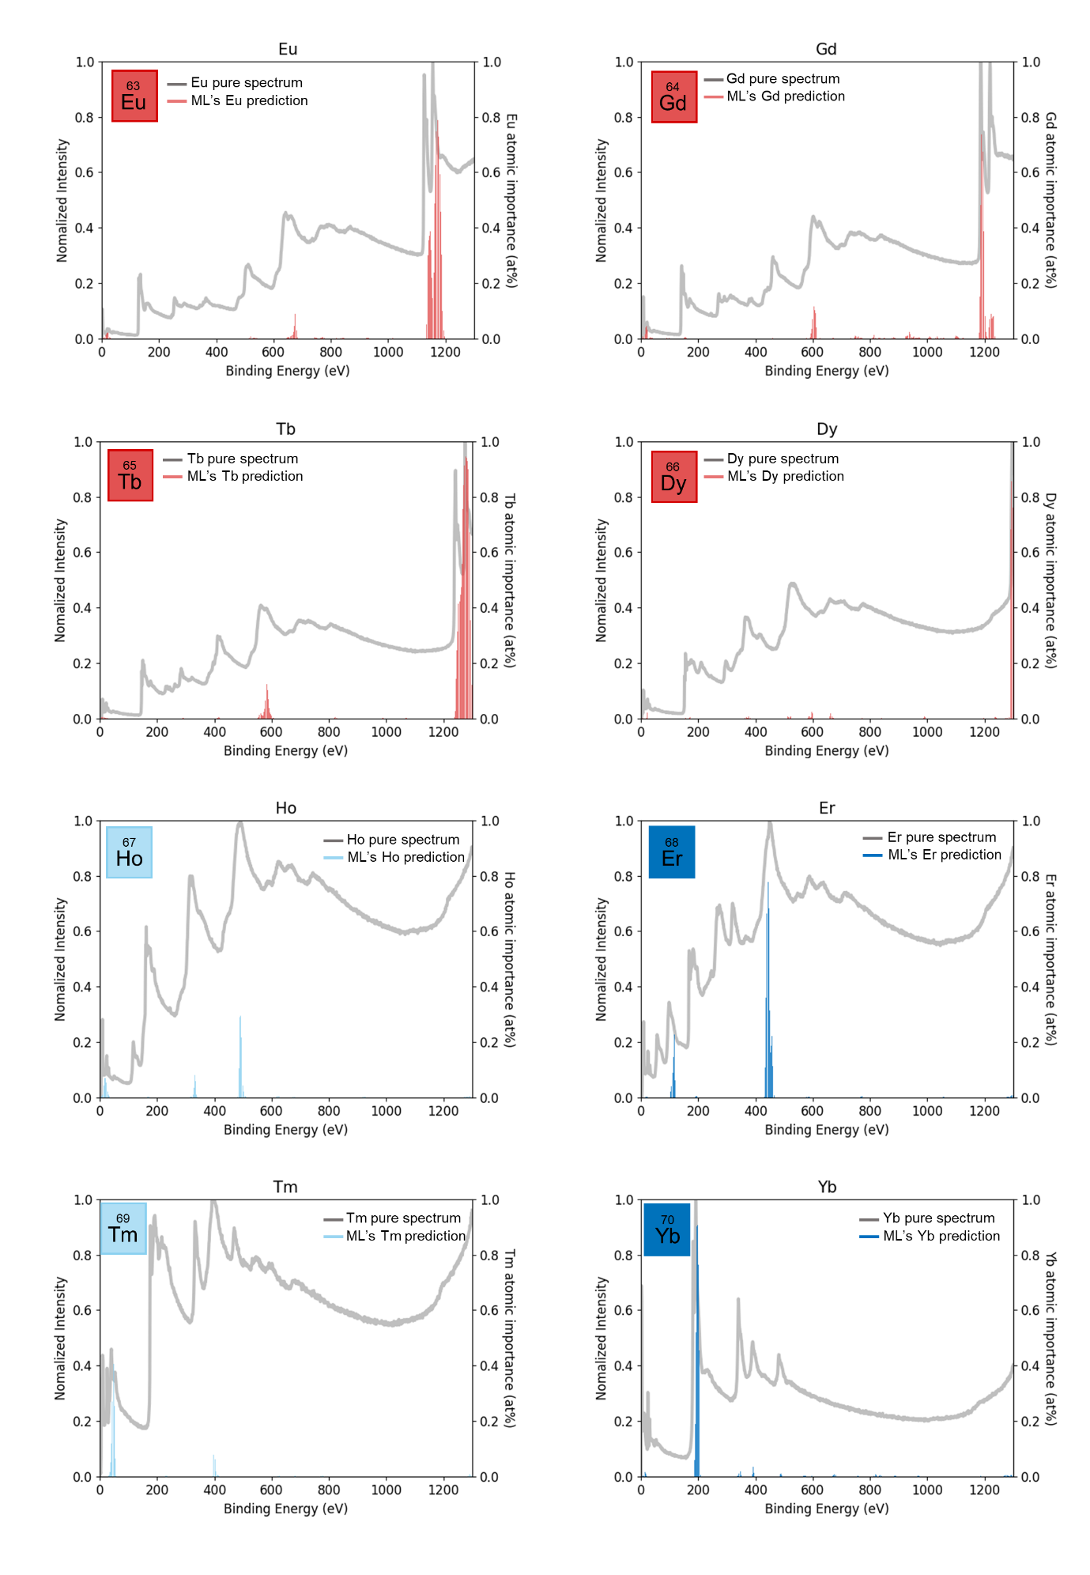

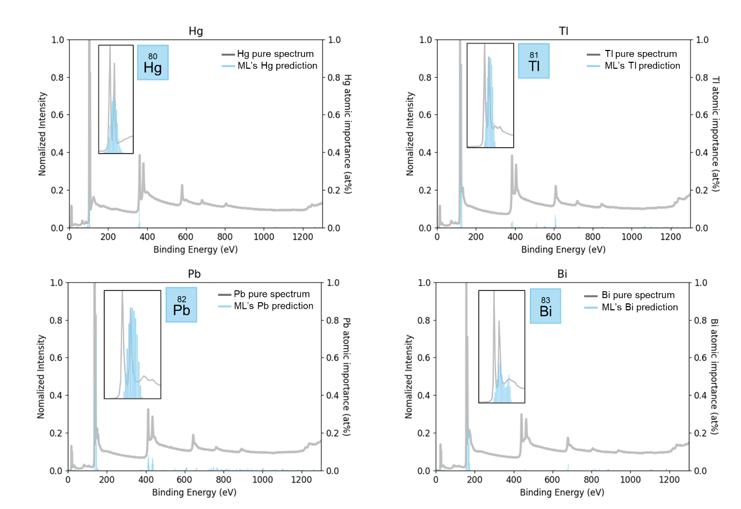

Figure S1 | Comprehensive Library of Reference XPS Survey Spectra and Corresponding Feature Importance Spectra (FIS). This figure presents the experimentally measured reference spectra for the 76 elements (from Li to Tl) utilized in this study, alongside their respective Feature Importance Spectra (FIS) generated by the 1D-CNN model. The consistent alignment between the physical photoemission peaks (e.g., core levels and Auger transitions) and the importance peaks in the FIS validates that the model identifies elements based on objective physical signatures rather than mere numerical patterns

Section 3. Strategic Classification and Periodic Mapping based on HIP Position and Peak Overlap Figure S2 | Systematic Classification of Elements Arranged by HIP Binding Energy. This comprehensive mapping illustrates the distribution of the four elemental identification strategies (Class 1-1 to 3) in the order of the binding energy of the Highest Intensity Peak (HIP). It highlights the correlation between the energy regions and the complexity of peak overlaps used by the 1D-CNN model for objective quantification.

Section 4. Statistical Analysis and Elemental Bias of Dataset 1
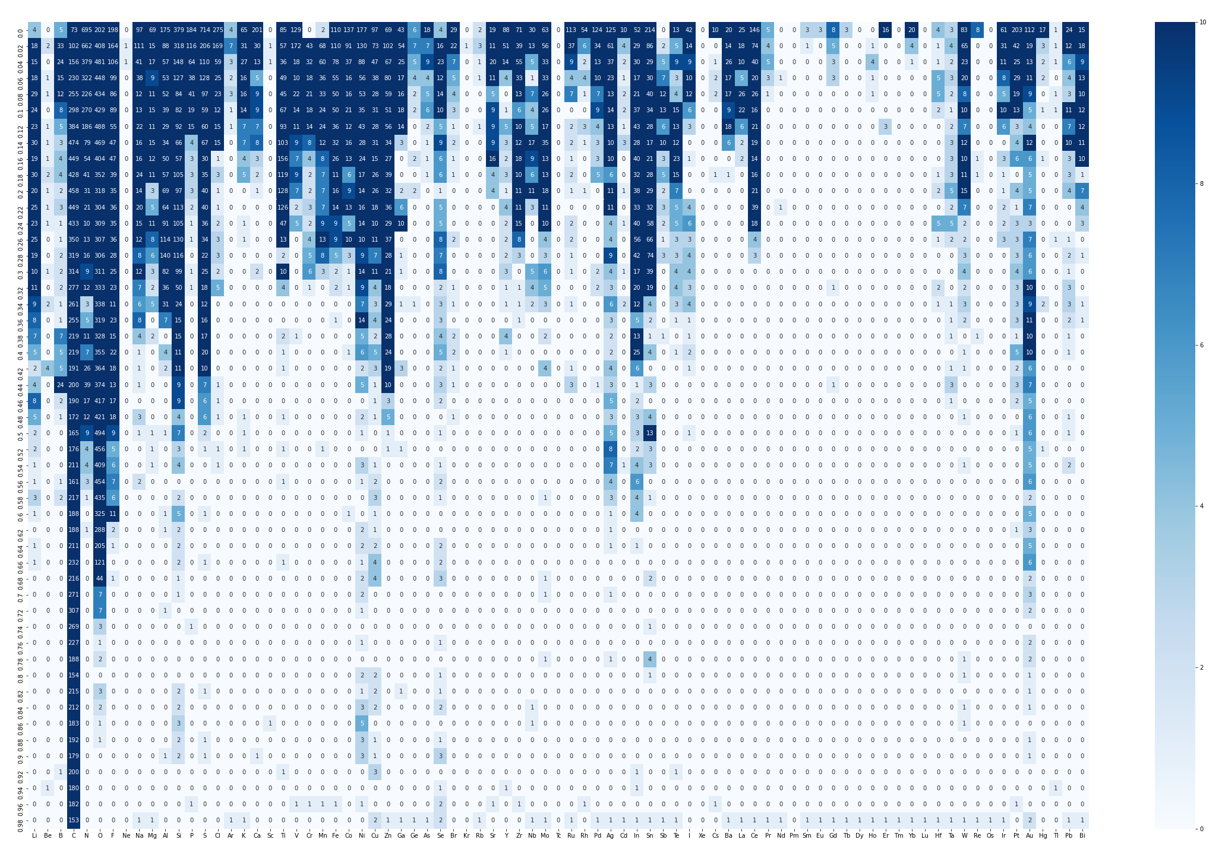
Figure S3 | Elemental frequency distribution within the practical experimental dataset (Dataset 1). This heat map illustrates the count of occurrences of each chemical element, ordered by atomic number, identified within the accumulated 10 years of real XPS measurement data (Dataset 1, approx. 100,000 spectra) from various research fields. The distribution exhibits a significant elemental bias, dominated by Carbon (C) and Oxygen (O), followed by Silicon (Si), Iron (Fe), Copper (Cu), and Zinc (Zn), among others. This heterogeneous distribution directly reflects the actual frequency of element usage across diverse research fields.

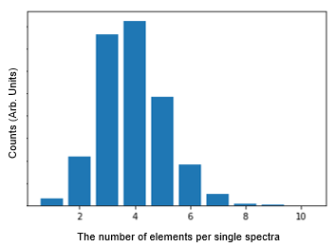
Figure S4 | Bar chart depicting the distribution of the number of atoms per single spectrum (Dataset 1). The statistical analysis reveals that the majority of real-world research samples consist of three to five constituent elements. This finding served as a critical statistical basis for determining the elemental composition range during the data augmentation process to ensure the model's robustness and practical reliability.

Section 5. Comprehensive Correlation Analysis of Quantitative Results across All Elements
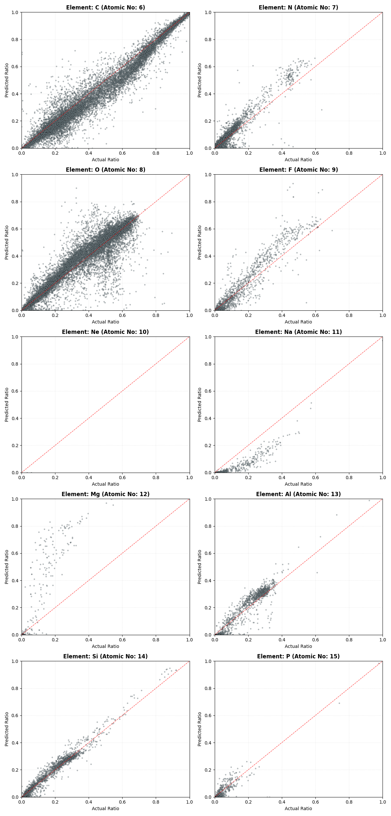
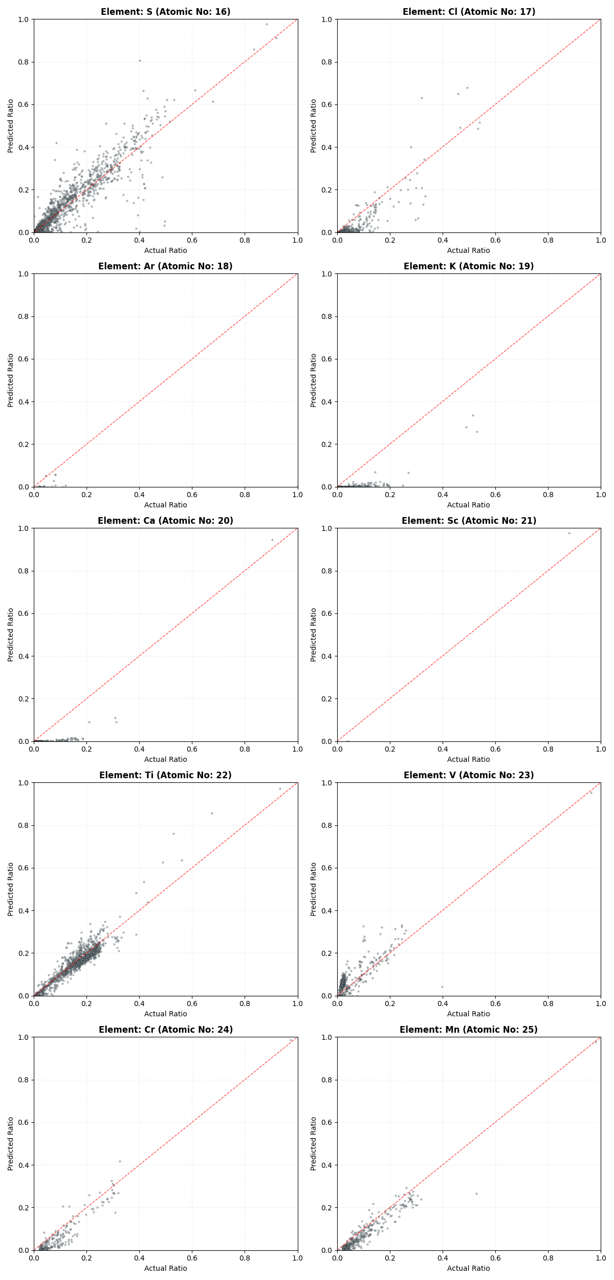
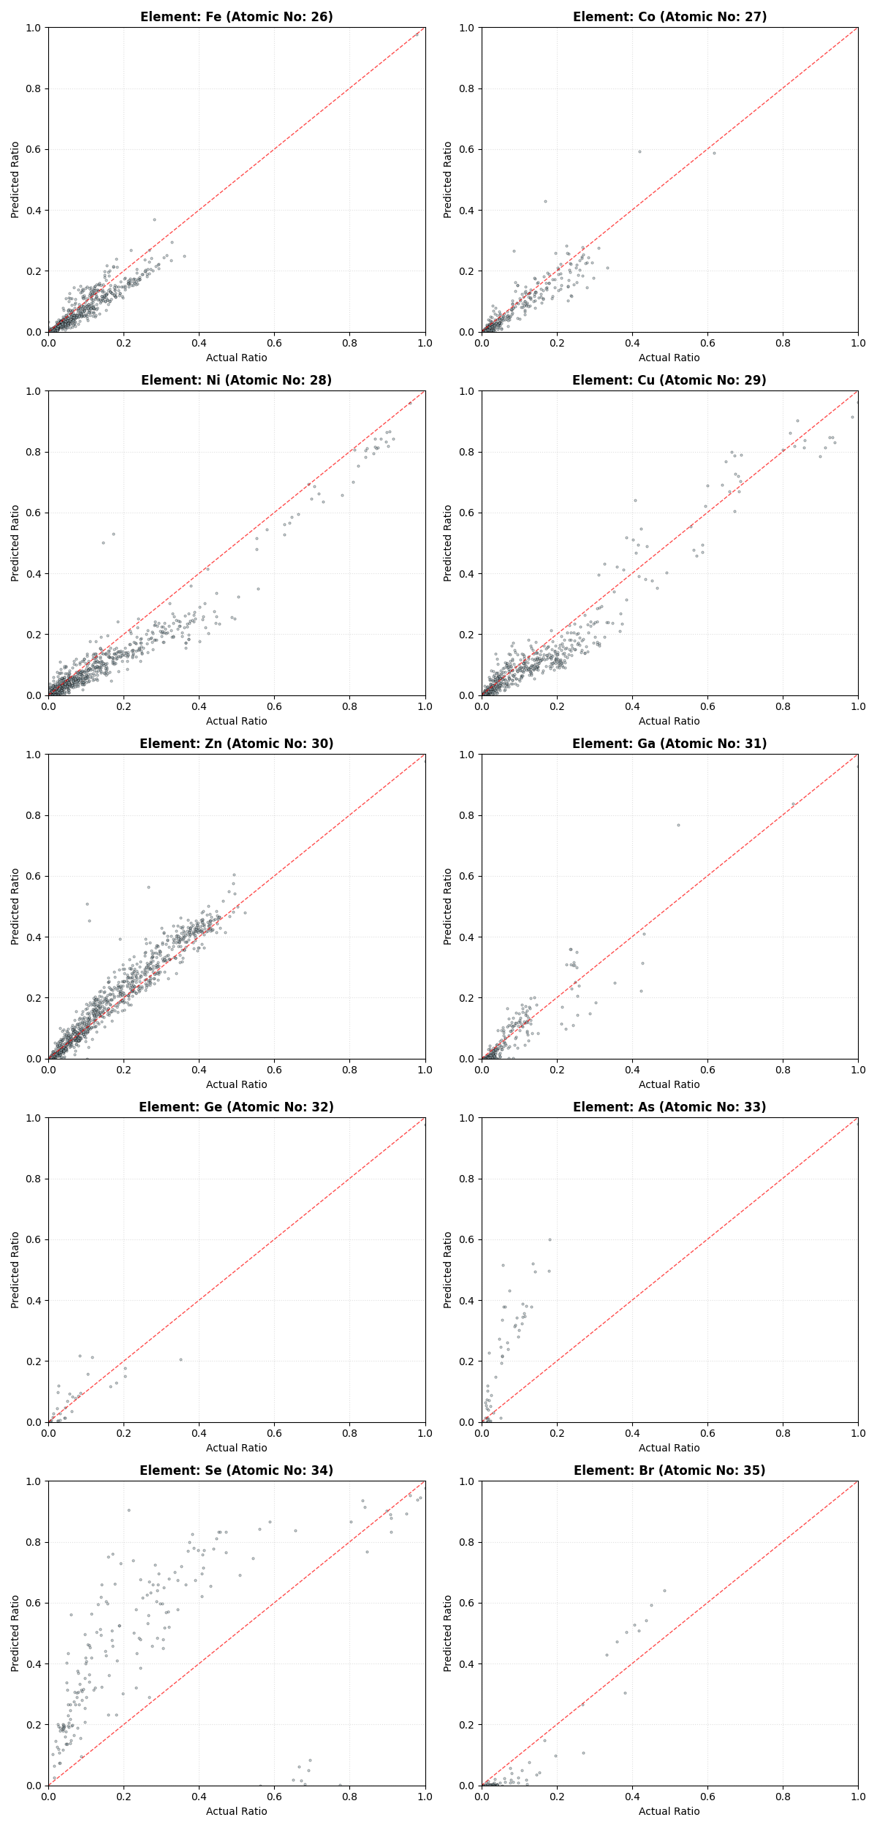
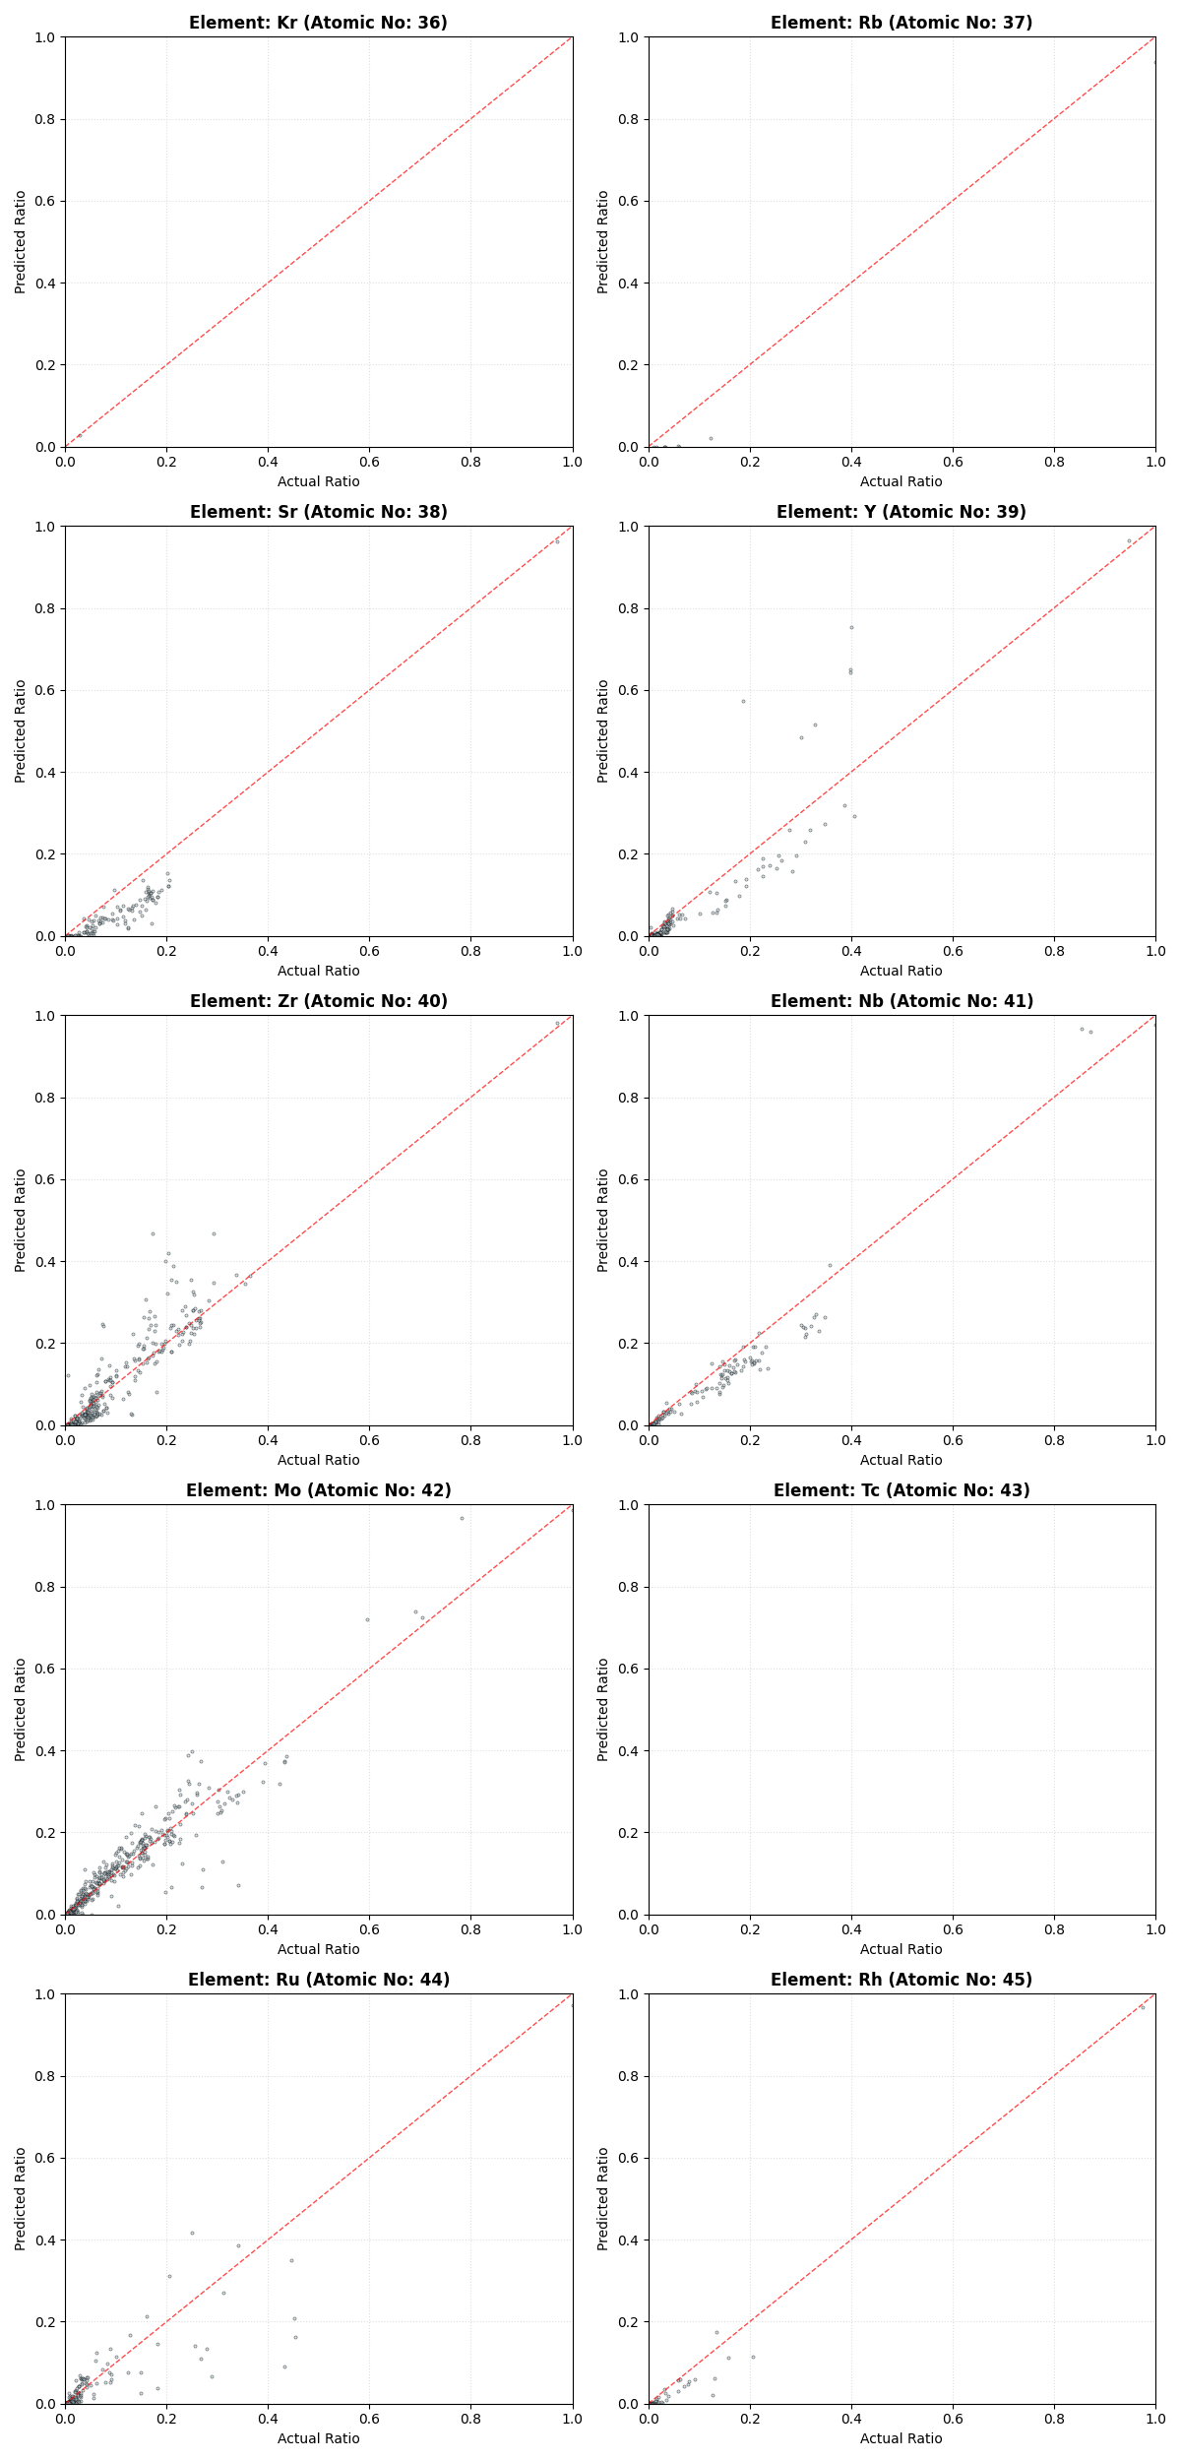
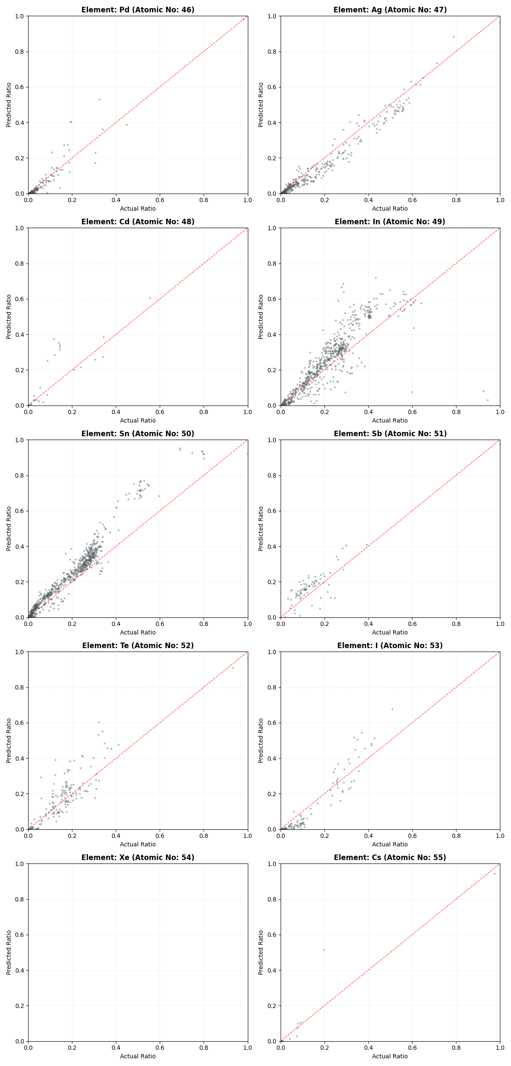
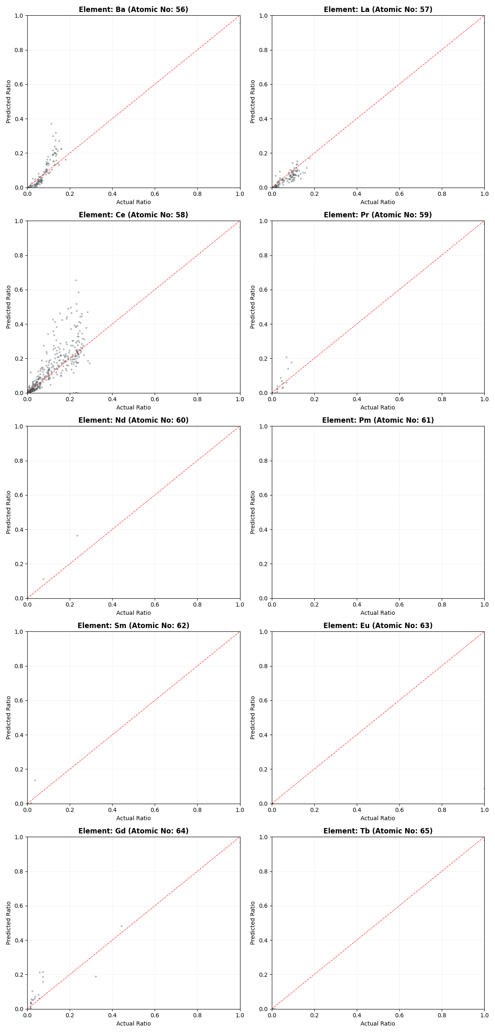
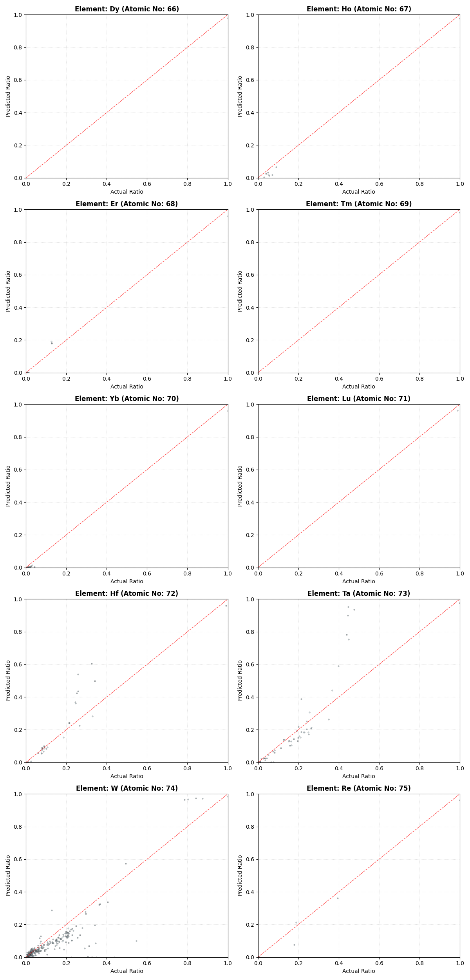

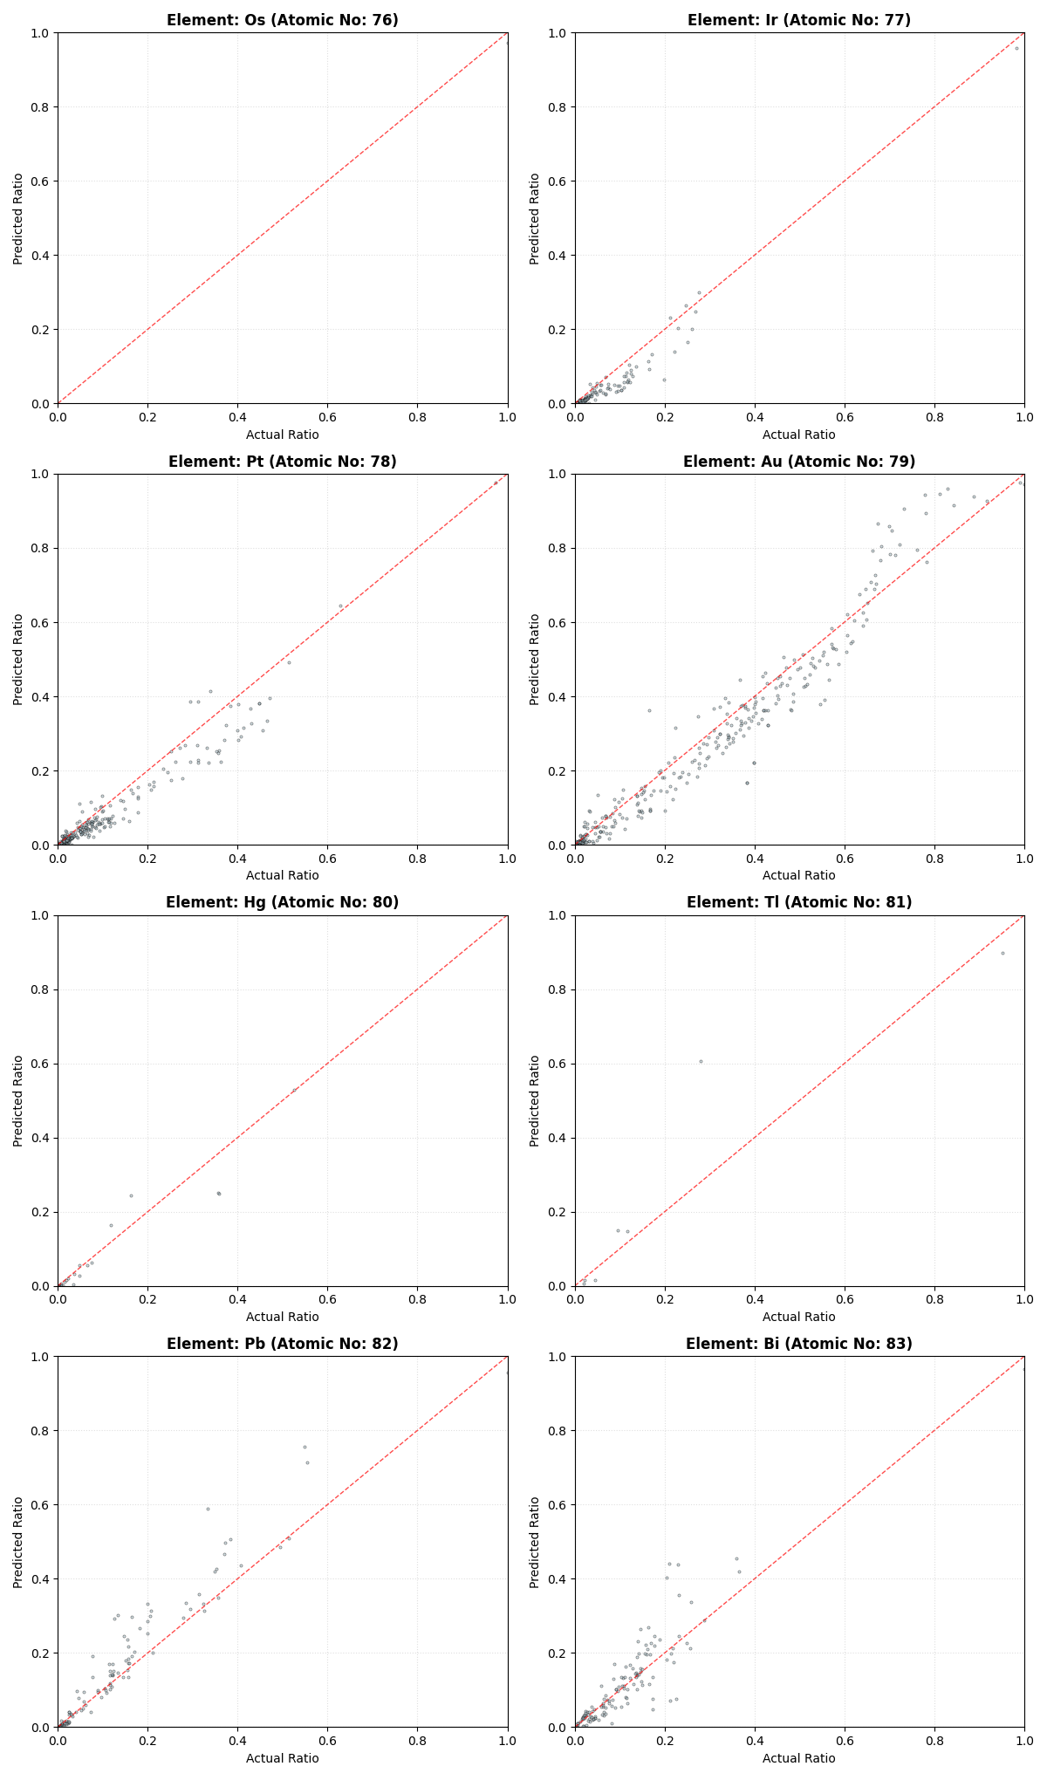

Figure S5 | Comprehensive Parity Plots for Quantitative Analysis across the Entire Elemental Library. This figure presents the individual correlation plots for all 76 elements (from Li to Tl) utilized in this study, comparing the actual atomic ratios from Dataset 1 with the values predicted by the 1D-CNN model. The dashed red lines represent the ideal y=x correlation.

