Supporting informations
Text S1 Details of field experiment water management 2
Text S2 Field implementation strategies for water management 2
Text S3 Detailed procedures for sequencing and bioinformatic analysis 3
Fig. S1 The cadmium accumulation amounts in different parts of rice 5
Table S1 The basic physical and chemical properties of the pot soil 6
Table S2 Soil properties the field site 6
Table S3 Determination of Cd content in irrigation water of the field test 7
Table S4 Determination of Cd Content in dry and wet atmospheric deposition 8

Text S1 Details of field experiment water management
The conventional irrigation (CK) treatment adopted the traditional water management method for rice cultivation, which involved draining and sun-drying the soil during the peak tillering stage and the rice maturation period, while keeping the fields flooded at a depth of 2-3 cm throughout the rest of the growth period. The specific water management groups (WMG) comprised three distinct treatments, each with specific implementation protocols: WMG1 involved initiating natural drying during the late seedling stage until the soil exhibits initial cracking, followed by replenishing moisture to achieve a soil water content of 40%-45%, this cycle was repeated until the late heading and grain-filling stage, after which drainage was implemented until rice maturity. WMG2 followed a similar procedure, commencing natural drying at the post-seedling stage until initial soil cracking, followed by rehydration to maintain 40%-45% soil moisture content, with this cycle repeated until maturity. WMG3 implemented natural drying post-seedling stage until leaf shrinkage occurs, followed by rehydration to maintain 40%-45% soil moisture content, with this cycle repeated until maturity.

Text S2 Field implementation strategies for water management
(1) Conventional practice (CK), simulating local farming practices—fields were flooded during the early growth stage, drained at the tillering stage, re-flooded thereafter, and finally drained again from the late grain-filling stage to maturity; (2) Continuous flooding (FI)—maintaining a 2–5 cm standing water layer throughout the entire growth period, with water depth adjusted according to plant height; and (3) Improved water management (WM) consisted of two phases. From the post‑transplanting seedling recovery stage to the late grain‑filling stage, alternating wetting and drying cycles were implemented: during each drying phase, the soil was allowed to develop visible cracks while ensuring normal rice growth; during each flooding phase, a 1–2 cm surface water layer was maintained, after which the next drying cycle commenced. From the late grain‑filling stage to maturity, continuous drainage was applied until rice reached maturity.

Text S3 Detailed procedures for sequencing and bioinformatic analysis
Total DNA was extracted from soil samples collected at the grain-filling stage across all treatments using the TGuide S96 Magnetic Universal DNA Kit (DP812, Tiangen, Beijing, China) following the manufacturer’s protocol. The V3–V4 hypervariable regions of bacterial 16S rRNA genes were amplified with primers 338F (5′-ACTCCTACGGGAGGCAGCA-3′) and 806R (5′-GGACTACHVGGGTWTCTAAT-3′). Each 10-μL PCR reaction contained 2.5–4 ng of genomic DNA, 0.3 μL each of 10 μM forward and reverse primers, 5 μL of KOD FX Neo Buffer (2×), 2 μL of dNTPs (2 mM), 0.2 μL of KOD FX Neo DNA polymerase, and ddH₂O to adjust the final volume. The PCR cycling program consisted of an initial denaturation at 95 °C for 5 min, followed by 25 cycles of denaturation at 95 °C for 30 s, annealing at 50 °C for 30 s, and extension at 72 °C for 30 s, with a final extension at 72 °C for 7 min. All amplified products were subsequently used for library construction by Beijing Biomarker Technologies Co., Ltd., and sequenced on an Illumina NovaSeq 6000 platform.
For microbial diversity analysis, raw sequencing reads were quality-filtered using Trimmomatic (v0.33), followed by primer removal with Cutadapt (v1.9.1). Paired-end reads were merged using USEARCH (v10), and chimeric sequences were identified and removed with UCHIME (v8.1), yielding high-quality tags for downstream analyses. Sequences were clustered into operational taxonomic units (OTUs) at 97% similarity using USEARCH (v10.0) and filtered at a threshold of 0.005% of total reads per OTU. Taxonomic assignment of representative OTU sequences was performed against the Silva database. Principal coordinate analysis (PCoA) was conducted based on Bray–Curtis distance matrices. Permutational multivariate analysis of variance (PERMANOVA) was performed using the “vegan” package (v2.3-0) in R (v3.1.1). Differentially abundant taxa across treatments were identified via linear discriminant analysis effect size (LEfSe, version 1.1.1). Functional profiling of the rhizosphere bacterial community was predicted using BugBase (v0.1.0) and FAPROTAX (v1.2.6).

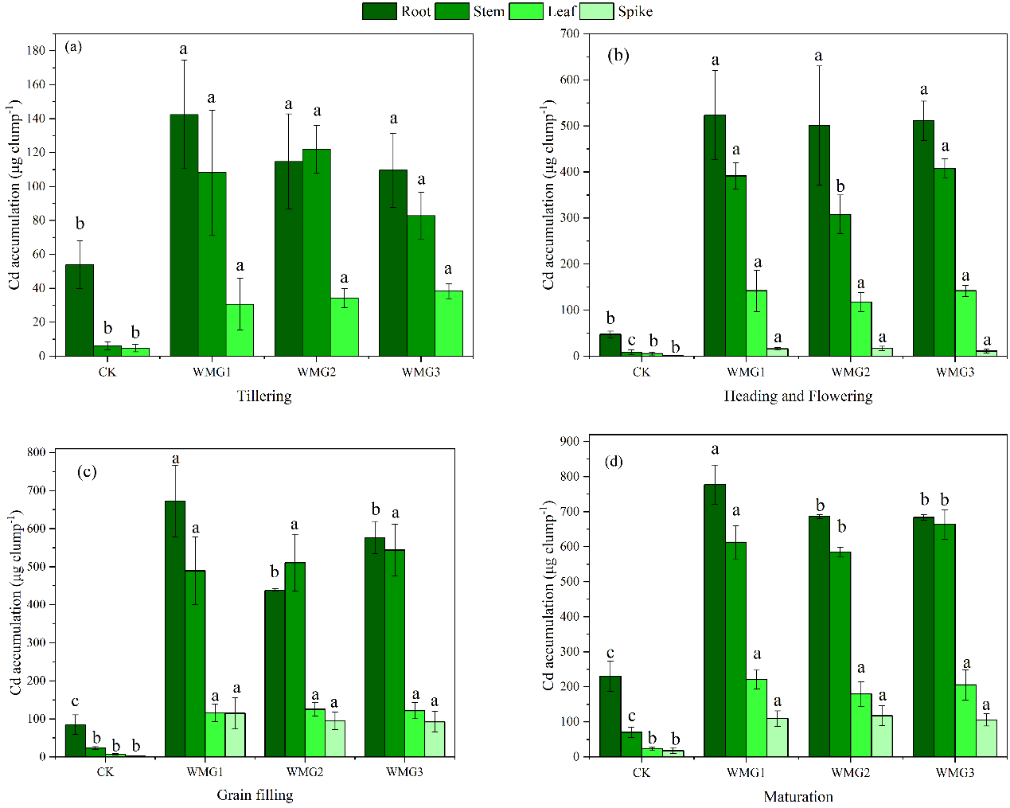
Fig. S1. The cadmium accumulation amounts in different parts of rice (root, stem, leaf and spike) during four growth stages under various water management conditions. Different letters indicate differences at P < 0.05 among treatments.

Table S1 The basic physical and chemical properties of the pot soil
soil sample | pH | Total Cd | Soil organic matter | Total nitrogen | Available phosphorus | Available potassium | Alkali-hydrolyzable nitrogen
soil sample | pH | mg/kg | g/kg | g/kg | mg/kg | mg/kg | mg/kg
pot experiment | 5.83 | 1.69 | 30.00 | 2.06 | 3.55 | 55.04 | 144.01

Table S2 Soil properties the field site
soil sample | pH | Total Cd | Soil organic matter | Total nitrogen | Available phosphorus | Available potassium | Alkali-hydrolyzable nitrogen
soil sample | pH | mg/kg | g/kg | g/kg | mg/kg | mg/kg | mg/kg
field site | 6.03 | 0.79 | 28.77 | 2.28 | 3.05 | 50.24 | 132.58
The study site exhibited a subtropical monsoon climate (mean temperature: 16.7 °C; annual precipitation: 1500 mm). The experimental paddy featured an optimized irrigation and drainage network to ensure consistent water management.

Table S3 Determination of Cd content in irrigation water of the field test
Sampling Date of Irrigation Water | Cd content  μg/L
June 20th | 0.235
June 21th | 0.058
July 4th | 0.135
July 6th | 0.133
July 8th | -0.034
July 12th | 0.298
July 18th | 0.574
July 29th | 1.15
July 30th | 0.457
August 1st | 0.83
August 5th | 3.039
August 10th | 1.603
September 8th | 1.183
September 14th | 1.132
September 20th | 0.996
September 23th | 0.775
September 25th | 0.658
October 2nd | 0.462
October 4th | 0.455
October 6th | 0.289
October 11th | 0.034
October 20th | 0.16
October 23th | 0.136
October 31th | 0.278
The maximum permissible concentration of Cd in irrigation water for Chinese paddy fields is 10 μg/L, as stipulated in the "Standards for Irrigation Water Quality in Agriculture" GB 5084-2021.

Table S4 Determination of Cd Content in dry and wet atmospheric deposition
Sampling date | Cd  μg/L | The volume of  the sampler  L | The cumulative amount of Cd  μg | The cumulative amount of Cd of dry and wet atmospheric deposition  mg/ha
June 20th | 0.00 | 18.37 | 0.01 | 1.07
July 2nd | 0.03 | 30.73 | 0.92 | 130.51
August 1st | 0.05 | 2.12 | 0.11 | 15.00
August 13th | 0.04 | 6.71 | 0.23 | 33.25
August 20th | 0.00 | 9.18 | 0.00 | 0.34
September 24th | 0.04 | 2.83 | 0.12 | 17.60
October 30th | 0.10 | 4.24 | 0.41 | 57.60

