Supplementary Material
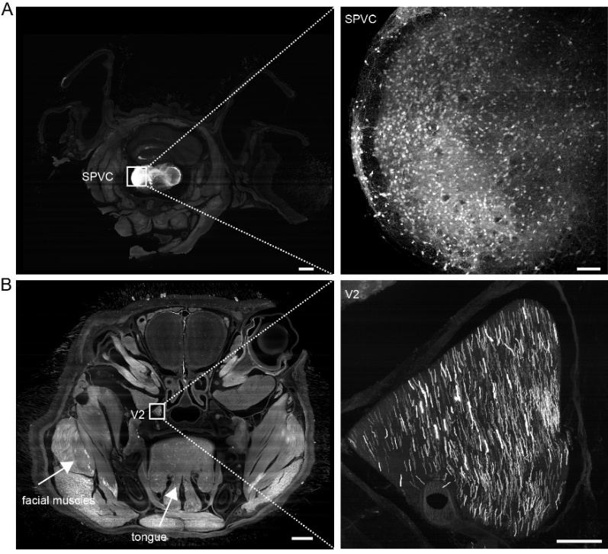
Figure S1. Distribution pattern of input of SPVC in the whole-head. (A) Display of injection sites in SPVC. (B) Coronal section of V2 with a local magnified view. Scale bar: 1 mm (overview); 100 μm (magnified).

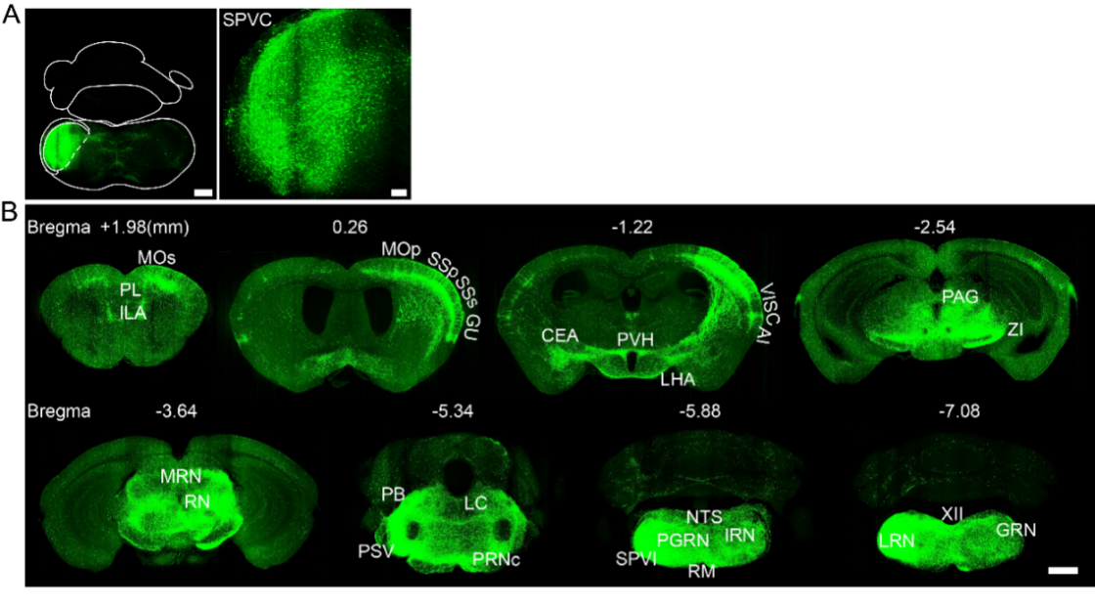
Figure S2. Distribution pattern of input of SPVC in the whole-brain. (A) Display of injection sites in SPVC. The left image showed a coronal view of the hemisphere, and the right image showed a higher-magnification view of the injection site. Scale bar: 500 μm (overview); 100 μm (magnified). (B) Representative images of input to SPVC in the whole brain. Scale bar: 1 mm.

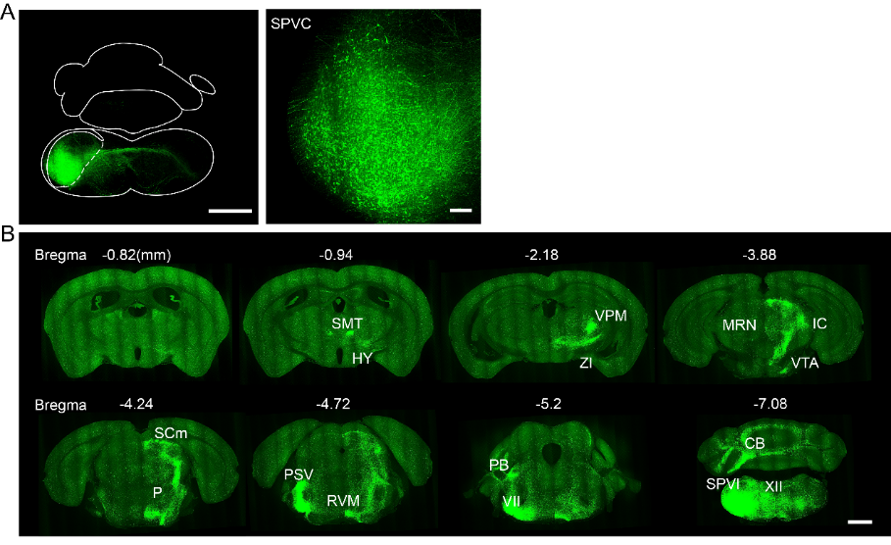
Figure S3. Distribution pattern of output of SPVC in the whole-brain. (A) Display of injection sites in SPVC. The left image showed a coronal view of the hemisphere, and the right image showed a higher-magnification view of the injection site. Scale bar: 1 mm (overview); 100 μm (magnified). (B) Representative images of output to SPVC in the whole brain. Scale bar: 1 mm.

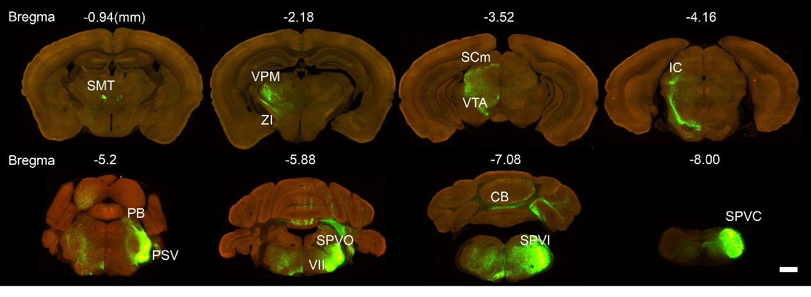
Figure S4. Whole-brain synaptic connectivity of SPVC. Whole-brain imaging of dual color-labeled was performed in mouse brain. The green channel represented axons, and the red channel represented presynaptic terminals. The projection was 70 μm. Scale bar: 1 mm.

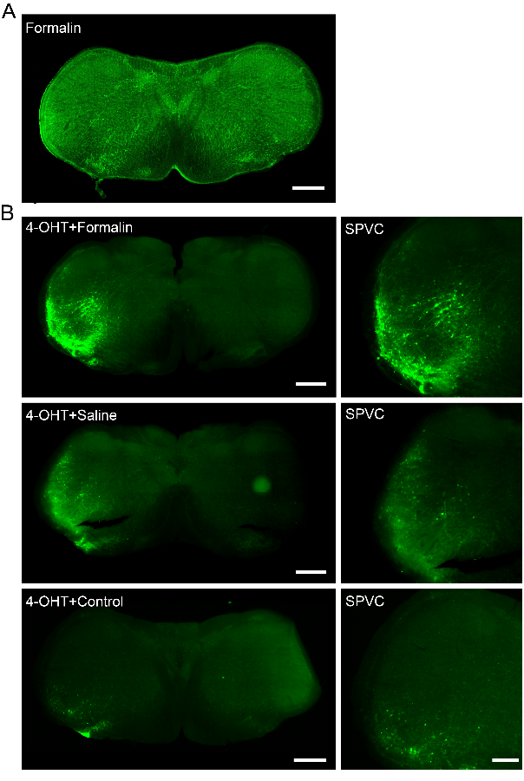
Figure S5. Validation of pain-activated neuronal labeling strategy at the SPVC injection site.
(A) Verification of 4-OHT efficacy. Following anterograde virus injection into the SPVC and formalin pain stimulation, but without 4-OHT administration, no neurons were labeled at the injection site. Scale bar: 500 μm. (B) Pain stimulation-activated neurons in the SPVC. Pain-activated neurons were detected at the injection site in the formalin-treated group, saline-treated group, and 4-OHT-only group. The formalin-treated group exhibited the highest number and brightest labeling of neuronal somata at the injection site, which were predominantly distributed in the ipsilateral superficial layers. The left images showed a coronal view of the hemisphere, and the right images showed a higher-magnification view of the injection site. Scale bar: 1 mm (overview); 500 μm (magnified).

