Supporting Information

A novel approach for significantly increasing cassava resistant starch (RS3) yields by using mechanical activation combined with enzymatic hydrolysis
Zexiong Huang^{a,#}, Tianyi Guo^{a,#}, Xiaohua Huangª, Chen Liangª, Mingyu Chen^{b}, Yanjuan Zhangª, Zuqiang Huangª, Huayu Hu^{a,*}, Tao Gan^{a,*}

ª School of Chemistry and Chemical Engineering, Guangxi University, Nanning 510004, China
^{b} State Key Laboratory of Non-Food Biomass Energy Technology, Guangxi State Farm Mingyang Biochemical Co., Ltd., Nanning 530226, China

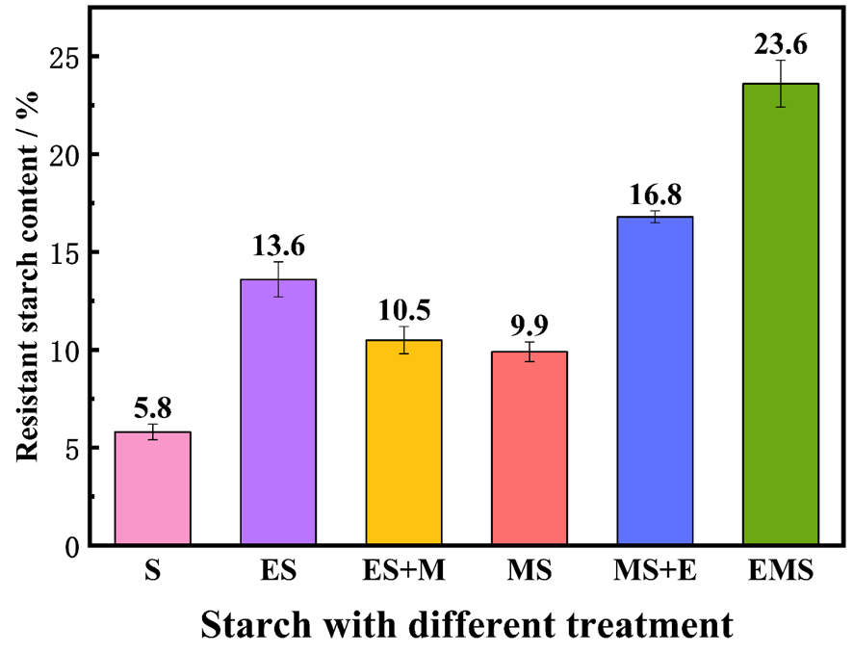
Figure 1. RS content under different treatment conditions.

Table S1 Representative examples of resistant starch.
Treatment | Material | Initial RS content(%) | Final RS content(%) | Reference
MA | Cassava starch | 3.8 | 13.5 | [1]
Pullulanase treatment | Waxy maize starch | 13.0 | 19.0 | [2]
High-solid method | High-amylose maize starch | 36.7 | 51.4 | [3]
Autoclaving and pullulanase | Sweet potato starch | 1.4 | 15.9 | [4]
Microwave-toughening treatment | Potato starch | 11.5 | 27.1 | [5]
MA combined with enzymatic hydrolysis | Cassava starch | 5.8 | 23.6 | This work

Table S2 LF-NMR relaxation spectrum parameters for starch-water system of different samples.
Samples | Time of relaxation (ms) |  |  | Normalized peak area
Samples | T_{21/b} | T₂₂ |  | A₂₁ | A₂₂
S | 1.92 | 42.78 |  | 20.59 | 153.28
ES | 0.74 | 25.77 |  | 32.17 | 219.87
ES-M | 0.84 | 15.52 |  | 21.92 | 196.01
MS | 1.08 | 33.21 |  | 31.63 | 222.11
MS-E | 0.71 | 12.83 |  | 22.58 | 234.33
EMS | 0.69 | 18.77 |  | 35.84 | 262.06

Table S3 Thermal properties of different starch samples.
Samples | T₀ (°C) | T_{p} (°C) | T_{c} (°C) | ΔH (J/g)
S | 60.32 | 66.31 | 71.96 | 7.38
ES | 63.35 | 70.83 | 76.98 | 11.48
ES+M | 62.48 | 69.46 | 75.44 | 10.20
MS | 61.17 | 66.81 | 73.12 | 12.22
MS+E | 67.12 | 70.11 | 77.76 | 13.26
EMS | 71.02 | 78.41 | 94.47 | 16.47

Table S4 Representative examples of resistant starch foods.
Reference | Material | RS type | RS content(%) | GI
[6] | Cowpea starch | RS₃ | 43.15±1.09 | 43.50±0.03
[7] | Potato starch | RS₄ | 29.02±0.80 | 58.60±0.99
[8] | Rice flour | RS₃ RS₅ | 10.39±0.37 | 93.36±0.35
[9] | Rice flour | RS₃ | 16.41±0.09 | 66.98±2.68
This work | Cassava starch | RS₃ | 23.61±0.91 | 53.29±1.05

References
[1] Liu, R., Sun, W., Zhang, Y., Huang, Z., Hu, H., Zhao, M., ... Li, W. (2019). Development of a novel model dough based on mechanically activated cassava starch and gluten protein: Application in bread. Food Chem., 300, 125196. DOI: 10.1016/j.foodchem.2019.125196
[2] Liu, W., Hong, Y., Gu, Z., Cheng, L., Li, Z., & Li, C. (2016). In structure and in-vitro digestibility of waxy corn starch debranched by pullulanase. Food Hydrocolloids, 67(JUN.), 104-110. DOI: 10.1016/j.foodhyd.2016.12.036
[3] Li, W., Zhou, Z., Fan, S., Cai, X., Chen, J., Zhang, Y., ... Liang, J. (2021). Formation of type 3 resistant starch from mechanical activation-damaged high-amylose maize starch by a high-solid method. Food Chem., 363, 130344. DOI: 10.1016/j.foodchem.2021.130344
[4] Sun, H., Fan, J., Tian, Z., Ma, L., Meng, Y., Yang, Z., ... Nan, X. (2022). Effects of treatment methods on the formation of resistant starch in purple sweet potato. Food Chem., 367, 130580. DOI: 10.1016/j.foodchem.2021.130580
[5] Li, Y., Xu, T., Xiao, J., Zong, A., Qiu, B., Jia, M., ... Liu, W. (2018). Efficacy of potato resistant starch prepared by microwave–toughening treatment. Carbohyd. Polym., 192, 299-307. DOI: 10.1016/j.carbpol.2018.03.076
[6] Khongsak, Srikaeo, Janya, & Sangkhiaw. (2014). Effects of amylose and resistant starch on glycaemic index of rice noodles. Lwt Food Sci. Technol., 59, (2), 1129-1135. DOI: 10.1016/j.lwt.2014.06.012
[7] Ratnaningsih, N., Suparmo, Harmayani, E., & Marsono, Y. (2020). Physicochemical properties, in vitro starch digestibility, and estimated glycemic index of resistant starch from cowpea (Vigna unguiculata) starch by autoclaving-cooling cycles. Int. J. Biol. Macromol., 142, 191-200. DOI: 10.1016/j.ijbiomac.2019.09.092
[8] Remya, R., Jyothi, A. N., & Sreekumar, J. (2017). Comparative study of RS4 type resistant starches derived from cassava and potato starches via octenyl succinylation. Starch ‐ Strke, 1600264. DOI: 10.1002/star.201600264
[9] Yun, P., Devahastin, S., & Chiewchan, N. (2020). In vitro glycemic index, physicochemical properties and sensory characteristics of white bread incorporated with resistant starch powder prepared by a novel spray-drying based method. J. Food Eng., 294. DOI: 10.1016/j.jfoodeng.2020.110438

*Corresponding authors. Telephone: +86-771-3233718 Fax: +86-771-3233718 E-mail addresses: gant@gxu.edu.cn (T. Gan), huhuayu@gxu.edu.cn (H. Hu)

