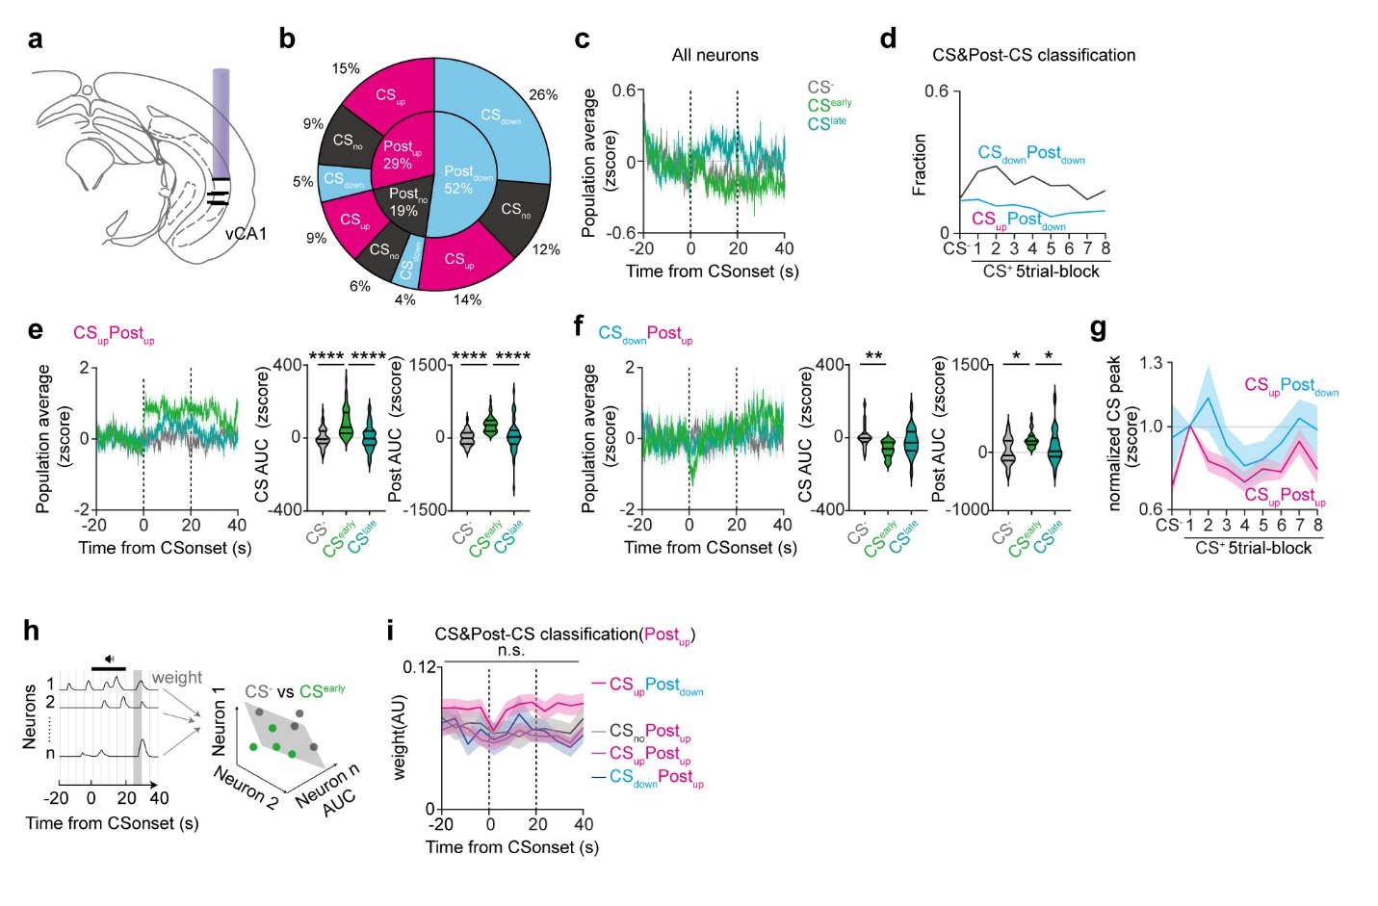

Extended Data Fig. 1: Functional classification and response profiles of vCA1 neurons (Related to Figure 1).
(a) Histological validation of GRIN lens implantation in vCA1 (n = 5). (b) Fractions of CS and Post-CS classes during CS^{early}. The majority of neurons showed inhibition in response to expected shock omission. (c) Population activity of all cells during CS⁻, CS^{early} and CS^{late}. Mean ± SEM. (d) CS&Post-CS classes across extinction. The fraction of Post_{down} neurons gradually decreased across extinction session, which may reflect an extinction-associated switching. (e) Population activity of CS_{up}Post_{up} cells during CS⁻, CS^{early} and CS^{late}(left). Mean ± SEM. Mean Z-score AUC of CS_{up}Post_{up} cells during CS (middle) and post-CS (right) periods in extinction. CS and post-CS responses increased during CS^{early} compared to CS⁻. Lines, median, 25th and 75th percentiles. (f) Population activity of CS_{down}Post_{up} cells during CS⁻, CS^{early} and CS^{late}(left). Mean ± SEM. Mean Z-score AUC of CS_{down}Post_{up} cells during CS (middle) and post-CS (right) periods in extinction. CS responses decreased but post-CS responses increased during CS^{early} compared to CS⁻. Lines, median, 25th and 75th percentiles. (g) Mean peak of CS_{up}Post_{up} and CS_{up}Post_{down} cells during CS trial-blocks across extinction. Peaks were normalized to CS^{early}. Peaks of CS_{up}Post_{down} were higher than CS_{up}Post_{up} at late phase of extinction. (h) Schematic of population decoding using SVM. (i) Weights of CS_{up}Post_{down}, CS_{up}Post_{up}, and CS_{down}Post_{up} cells. Weight of CS_{up}Post_{down} cells was significantly higher than that of CS_{up}Post_{up} or CS_{down}Post_{up} at post-CS period. Mean ± SEM. n.s. not significant; *P < 0.05; For statistical details, see Table S1. *P < 0.05; **P < 0.01; ****P < 0.0001; For statistical details, see Supplementary Table 1.

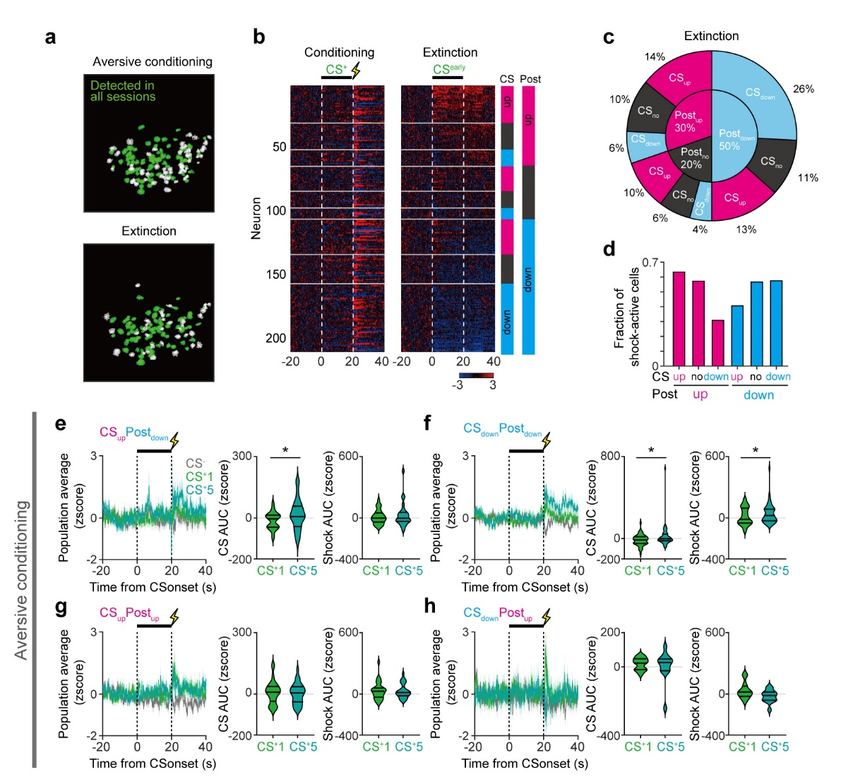

Extended Data Fig. 2: Across-session imaging and response profiles of vCA1 neurons during aversive conditioning (related to Figure 1).
(a) Registration of cells between aversive conditioning and extinction session. (b) Heat maps aligned to CS⁺ onset during aversive conditioning (left) and CS^{early} during extinciton (right) (n = 211 cells, 5 mice). Neurons are sorted based on CS^{early} response categories during extinction, shown in magenta and blue squares. CS_{up}Post_{up} (n = 30), CS_{no}Post_{up} (n = 21), CS_{down}Post_{up} (n = 13), CS_{up}Post_{no} (n = 20), CS_{no}Post_{no} (n = 13), CS_{down}Post_{no} (n = 9), CS_{up}Post_{down} (n = 28), CS_{no}Post_{down} (n = 23), and CS_{down}Post_{down} (n = 54) groups. (c) Fraction of functional cell types in longitudinal registration. (d) Fraction of shock-active cells within CS and post-CS groups. Statistical analysis revealed no significant differences across subgroups. (e-h) Population activity of CS_{up}Post_{down} (e), CS_{down}Post_{down} (f), CS_{up}Post_{up} (g), and CS_{down}Post_{up} (h) cells during CS⁻, the first CS⁺ trial (CS⁺1) and the last trial (CS⁺5) of aversive conditioning (left). Mean ± SEM. AUC of those cells during the CS (middle) and post-CS (left) period of CS⁺1 and CS⁺5. CS_{up}Post_{down} cells developed CS responses during aversive conditioning (e). Also, CS_{down}Post_{down} cells increased CS responses (f). Lines, median, 25th and 75th percentiles. *P < 0.05; For statistical details, see Supplementary Table 1.

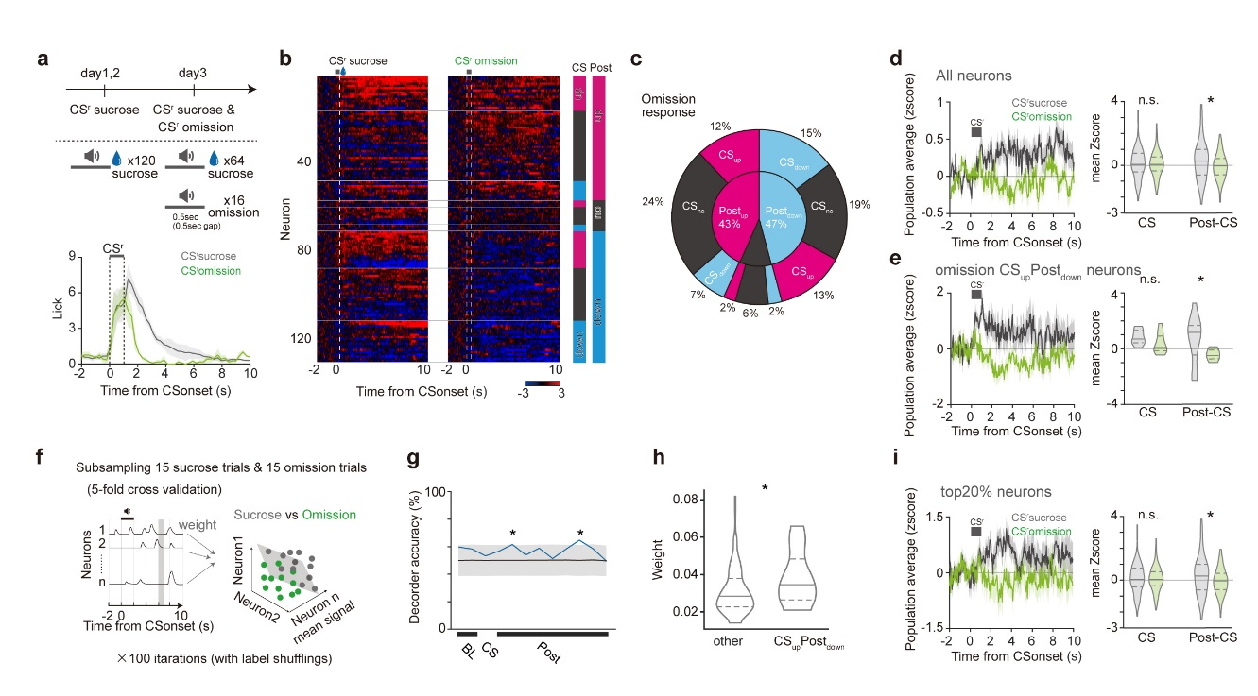Extended Data Fig. 3: vCA1 neurons exhibit reduced responses to the omission of expected appetitive outcomes. (related to Figure 1).
(a) Reward conditioning and omission paradigm (top). Lick counts during sucrose and omission trials. Data represent group mean values (bottom). (b) Heat map during sucrose (left) or omission (right) trials (n = 131 cells, 3 mice). (c) Fractions of CS and Post-CS classes during omission. The majority of neurons showed inhibition in response to expected sucrose omission. (d, e) Population activity during sucrose and omission trials. The bar denotes the CS period (right). Mean signal of all cells at sucrose or omission trials (left). All neurons and CS_{up}Post_{down} cells showed reduced Post-CS response during omission trials compared to sucrose trials. (f) Schematic of population decoding using SVM with subsampling comparable reward trials. (g) Time-resolved decoding accuracy of sucrose and omission trial-identity. Decoding accuracy exceeded that of label-shuffled data (gray line) at two post-CS points. (h) Weights of CS_{up}Post_{down} and the other cells in linear decoder at the post-CS period, when decoding accuracy was significant. CS_{up}Post_{down} cells showed higher classifier weights. (i) Population activity during sucrose and omission trials in top20% high-weight cells. The bar denotes the CS period (right). Mean signals during CS and Post-CS periods at sucrose or omission trials (left). These cells also exhibited reduced Post-CS response during omission trials compared to sucrose trials. n.s., not significant; *P < 0.05; For statistical details, see Supplementary Table 1.

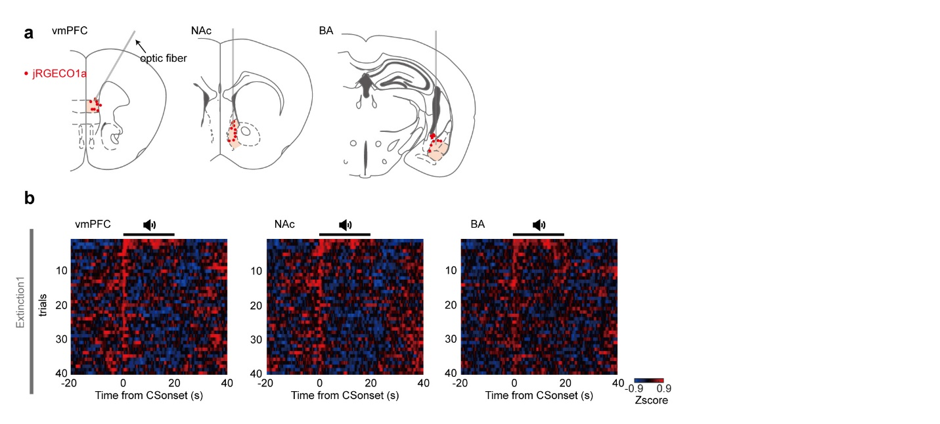

Extended Data Fig 4: Trial-by-trial responses at individual axon terminals (related to Figure 2).
(a) Histological validation of fiber implantation in vmPFC (left), NAc (middle), and BA (right). (b) Heat maps of each CS⁺ trial of extinction session in vmPFC (left), NAc (middle), and BA (right) across all mice.

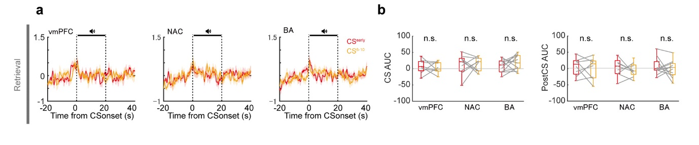. Extended Data Fig. 5: Post-CS responses were diminished during extinction retrieval (related to Figure 2).
(a) Mean terminal activities during CS^{early} and 6-10 trials of CS⁺ (CS⁶⁻¹⁰) during retrieval. Small CS-evoked responses but no inhibition at post-CS period. Mean ± SEM. (b) Mean AUC during the CS and post-CS period of retrieval. No significant differences between CS^{early} and CS⁶⁻¹⁰. n.s. not significant; For statistical details, see Supplementary Table 1.

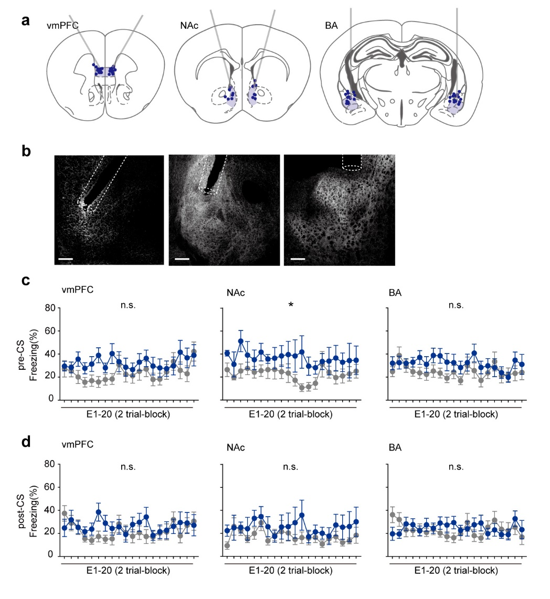

Extended Data Fig. 6: Pre- and post-CS freezing levels in optogenetic inactivation (related to Figure 2).
(a) Histological validation of fiber implantation in vmPFC (left, Jaws, n = 12), NAc (middle, Jaws, n = 7), and BA (right, Jaws, n = 14). (b) Representative Jaws expression and fiber implantation in vmPFC (left), NAc (middle), and BA (right). Scale bar, 200 μm. (c, d) Freezing behavior during the pre-CS (c) and post-CS (d) periods in inhibition (blue) and control (gray) groups. Optogenetic inhibition of NAc terminals increased pre-CS freezing. Mean ± SEM. n.s. not significant; *P < 0.05; For statistical details, see Supplementary Table 1.

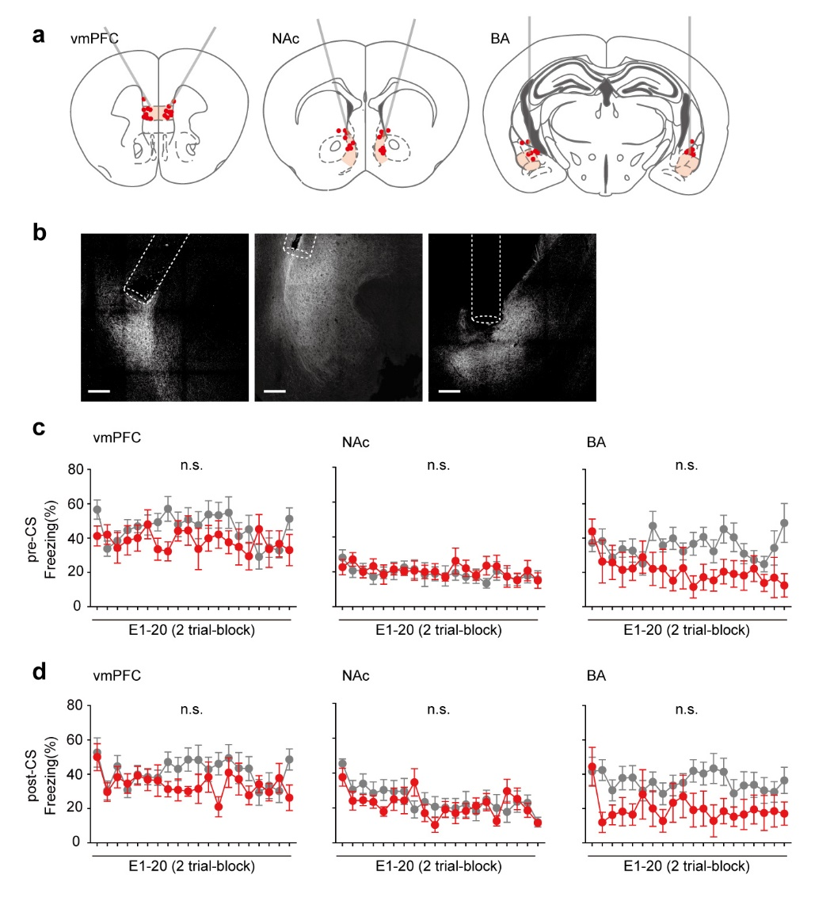

Extended Data Fig. 7: Pre- and post-CS freezing levels in optogenetic activation (related to Figure 2).
(a) Histological validation of fiber implantation in vmPFC (left, Chrimson, n = 8), NAc (middle, Chrimson, n = 8), and BA (right, Chrimson, n = 7) (b) Representative Chrimson expression and fiber implantation in vmPFC (left), NAc (middle), and BA (right). Scale bar, 200 μm. (c, d) Freezing levels during the pre-CS (c) and post-CS (d) periods in activation (red) and control (gray) groups. Optogenetic activation didn’t affect pre- or post-CS freezing. Mean ± SEM. n.s. not significant; For statistical details, see Supplementary Table 1.

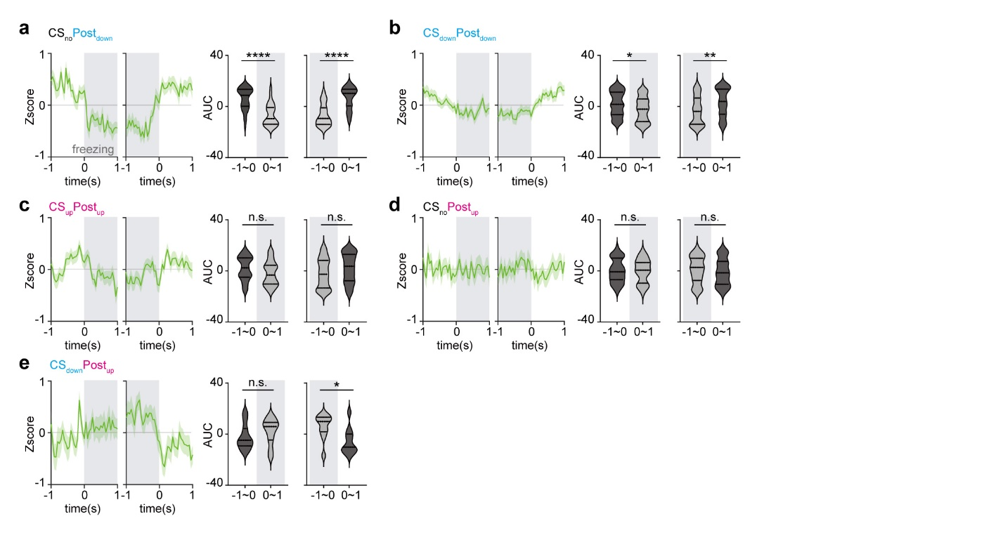

Extended Data Fig. 8: Freezing-aligned activity across the functionally-defined cell types (related to Figure 4).
(a-e) Population activity of CS and post-CS subclasses aligned to post-CS freezing onset and offset (left) in single cell experiments. Gray area indicates freezing period. CS_{no}Post_{down} (a) and CS_{down}Post_{down} (b) cells reduced responses after freezing onset and before freezing offset. CS_{down}Post_{up} reduced responses after freezing offset (e). CS_{up}Post_{up} (c) and CS_{no}Post_{up} (d) responses were not affected by freezing. Lines in violin plots, median, 25th and 75th percentiles. Mean ± SEM. n.s. not significant; *P < 0.05; **P < 0.01; ****P < 0.0001; For statistical details, see Supplementary Table 1.

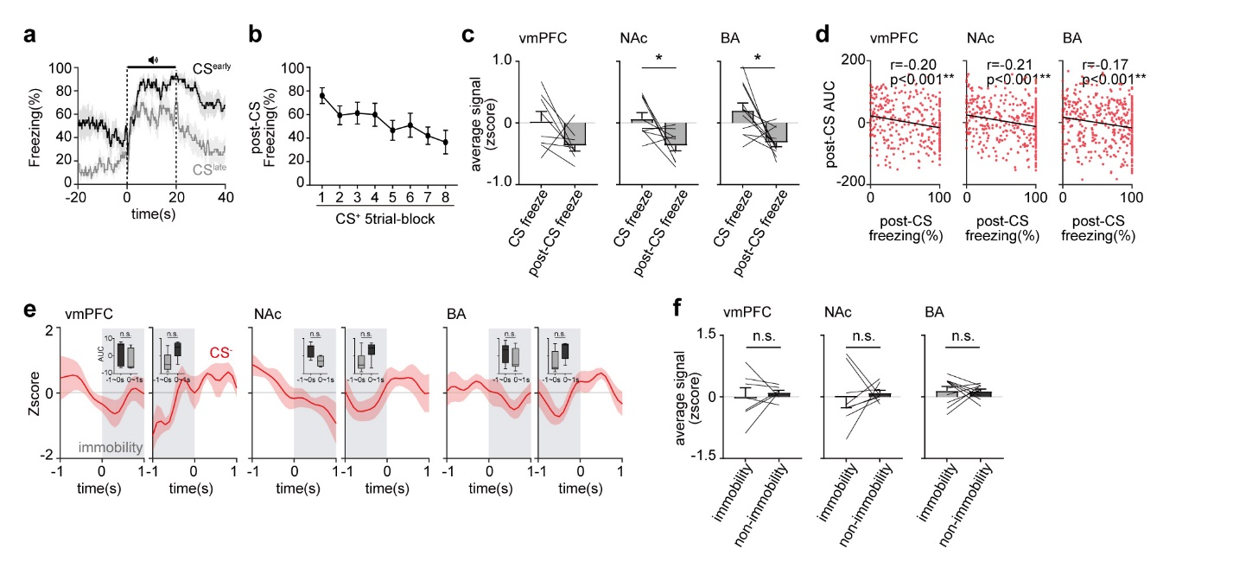

Extended Data Fig. 9: Freezing- and immobility-aligned activity in multifiber photometry (related to Figure 4).
(a) Time-resolved freezing levels during CS^{early} and CS^{late} of extinction1 across all mice. (b) Freezing levels during the post-CS period of extinction1 in multifiber photometry. Mean ± SEM. (c) Mean terminal activities during the CS or post-CS freezing period of CS^{early} of extinction1 in vmPFC (left), NAc (middle), and BA(right). Mean ± SEM. (d) Correlation between freezing levels and AUCs during the post-CS period of extinction1 session in vmPFC (left), NAc (middle), and BA (right). All terminal activities were negatively correlated with freezing during post-CS period. (e) Mean Z-scored activity aligned to onset and offset of immobility (1sec) during the CS⁻ period of aversive conditioning. Insets display mean AUC during 1sec before and after immobility onset and offset. No significant differences were observed. Mean ± SEM. (f) Mean activity during entire immobility or non-immobility period of CS⁻ in aversive conditioning. No significant differences were observed in vmPFC, NAc, and BA. These results indicate that freezing-specific, but not immobility-specific, reduction in vCA1 terminal activity. Mean ± SEM. n.s. not significant; *P < 0.05; **P < 0.01; For statistical details, see Supplementary Table 1.

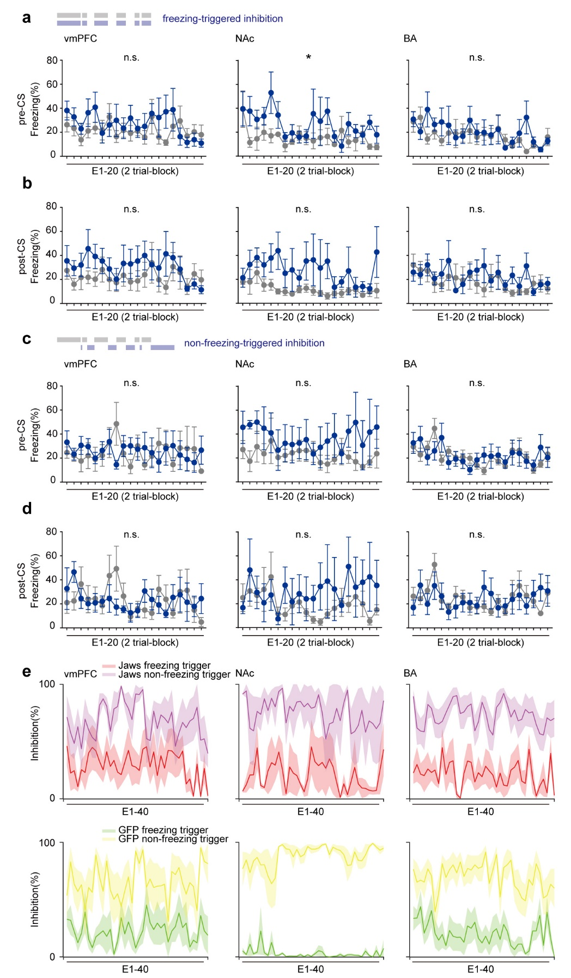

Extended Data Fig. 10: Pre- and post-CS freezing levels in closed-loop optogenetic inactivation (related to Figure 4).
(a-d) Freezing levels during the pre-CS (a, c) and post-CS (b, d) periods of extinction in closed-loop optogenetic inhibition. Blue and gray lines represent Jaws and control, respectively. Freezing-triggered (a, b) or non-freezing-triggered (c, d) groups. Freezing-triggered inhibition at NAc terminals during post-CS period increased freezing during pre-CS, consistent with entire post-CS inhibition (Extended Data Fig. 6). (e) Inhibition duration of freezing-triggered and non-freezing-triggered conditions in Jaws (top) and control (bottom) groups. The duration of post-CS laser delivery was significantly shorter in freezing-triggered group than in non-freezing group, indicating that the observed effect on freezing in freezing-triggered group was not due to prolonged inhibition. Mean ± SEM. n.s. not significant; *P < 0.05; For statistical details, see Supplementary Table 1.

