Supplementary Figure 1. Expression patterns and prognostic significance of integrins in cervical cancer.

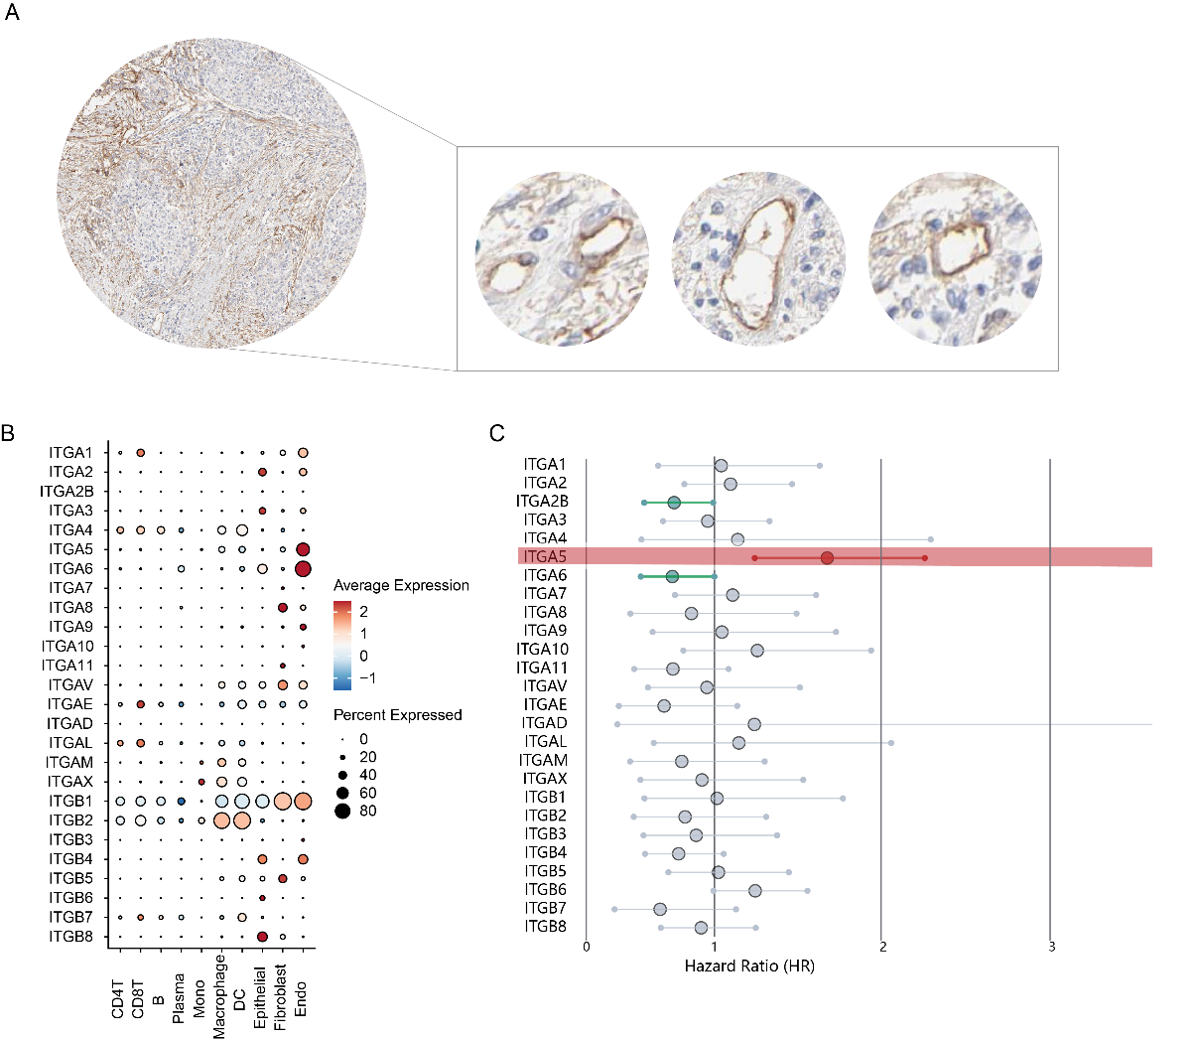

(A) Immunohistochemical staining of ITGA5 in tumor and stromal compartments, including vascular endothelial cells, as shown in the Human Protein Atlas. (B) Single-cell transcriptomic analysis revealed integrin expression across major cell types, including endothelial cells, immune cells and stromal cells. (C) Kaplan-Meier survival analysis from the GEPIA3 database identified ITGA5 as the only integrin significantly associated with poor prognosis.

Supplementary File. The full uncropped Gels and Blots image(s) of Figure 3D.





ITGA5
β-actin
115kDa
42kDa
sgNC
sgITGA5#1
sgITGA5#2
sgNC
EA.hy926

