Supporting information for
Nano‑Ni-Based Multi-Channel Recyclable Thermal Interface Material with Dual-Mode Interface Adaptability

Xinbei Zhu# ^{b, c}, Yuan Liu# ^{a*}, Jingkai Liu ^{b*}, Xiaoqin Feng ª, Ziyu Liu^{b},
Xiaoqing Liu ^{b*}

ª College of Chemistry and Chemical Engineering, Tarim University, Alar 843300, China
^{b} State Key Laboratory of Advanced Marine Materials, Ningbo Institute of Materials Technology and Engineering, Ningbo, 315201, China
^{c} University of Chinese Academy of Sciences, Beijing 100049, China

# These authors contributed equally to this work.

Corresponding author: Yuan Liu (120240011@taru.edu.cn); Jingkai Liu (liujingkai@nimte.ac.cn); Xiaoqing Liu (liuxq@nimte.ac.cn)

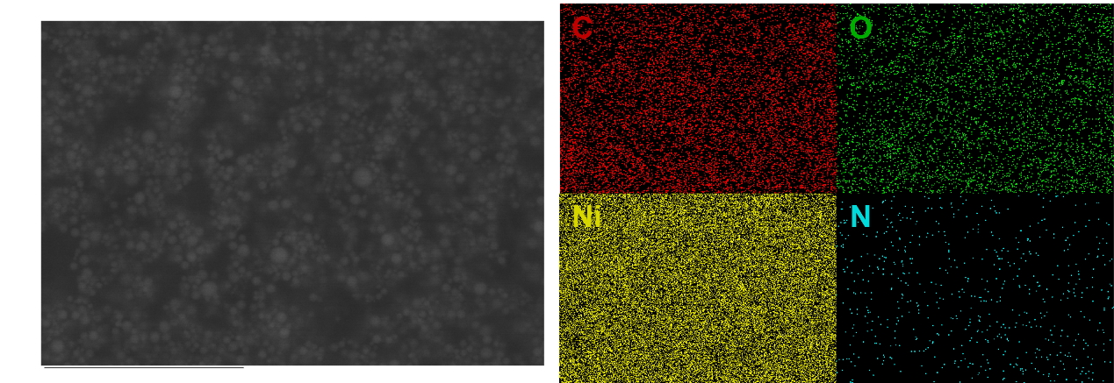
Fig. S1. SEM and elemental mapping of the f-Ni. From left to right: SEM, mapping C, O, Ni, and N.

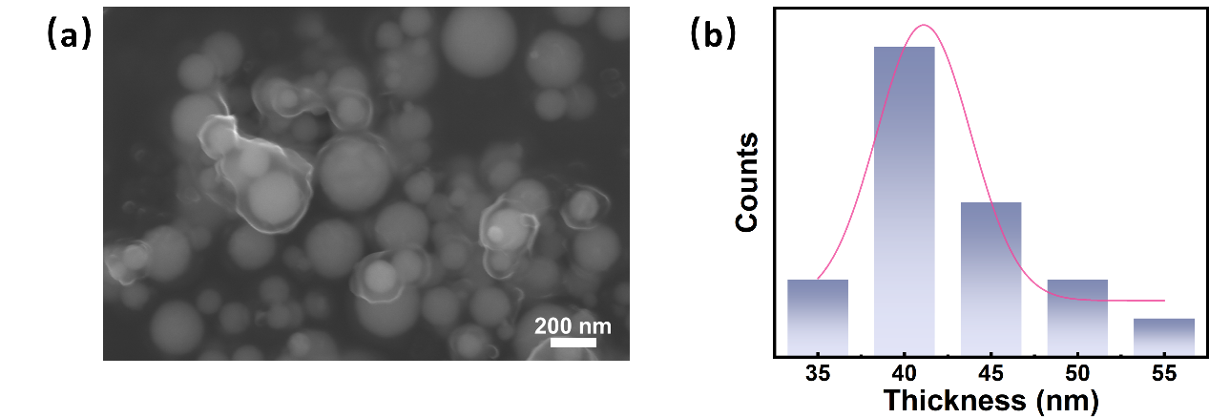
Fig. S2. (a) SEM image of the f-Ni in the InLens mode (b) thickness distribution of the organic layer.

Fig. S3. XPS spectra of the DAMF-Ni and f-Ni.

Fig. S4. O1s XPS spectra of f-Ni and DAMF-Ni

Fig. S5. TGA curves of the Ni, f-Ni, MIPEG, and DAMF-Ni.

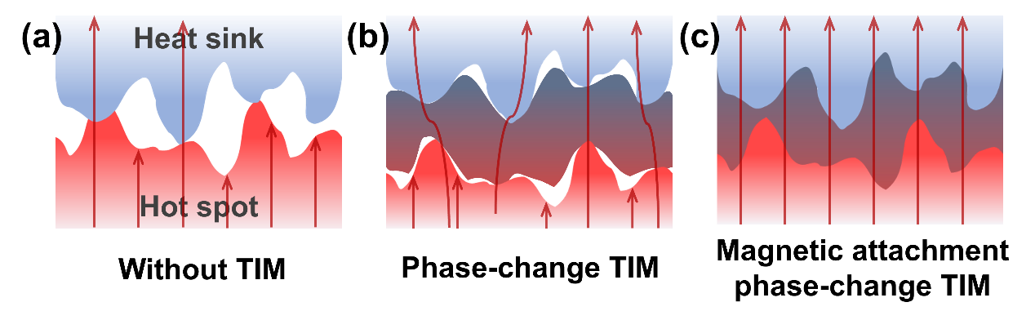
Fig. S6. Schematic illustration of the contact area of interface with (a) no TIM, (b) a phase-change TIM, and (c) a phase-change TIM with extra magnetic force.

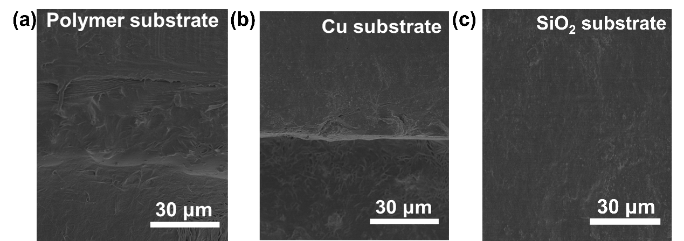
Fig. S7. SEM images of DAMF-Ni on different substrates: (a) polymer, (b) copper, (c) SiO₂.
Fig. S8. Total thermal resistance and contact thermal resistance as functions of pressure.

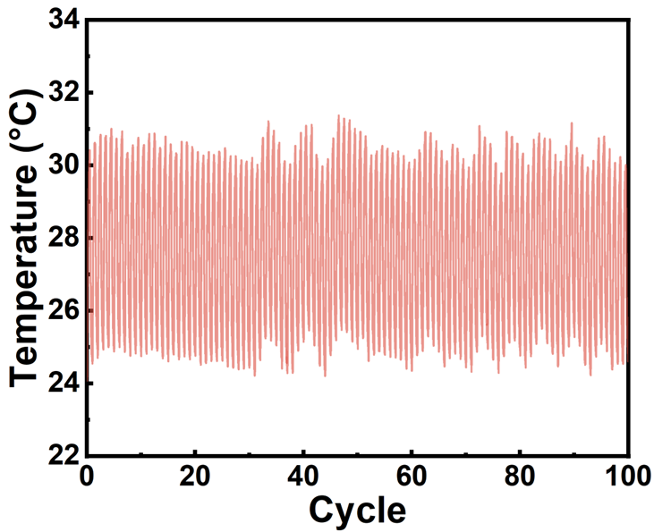
Fig. S9. Detailed cyclic stability of DAMF-Ni with a voltage of 3 V.

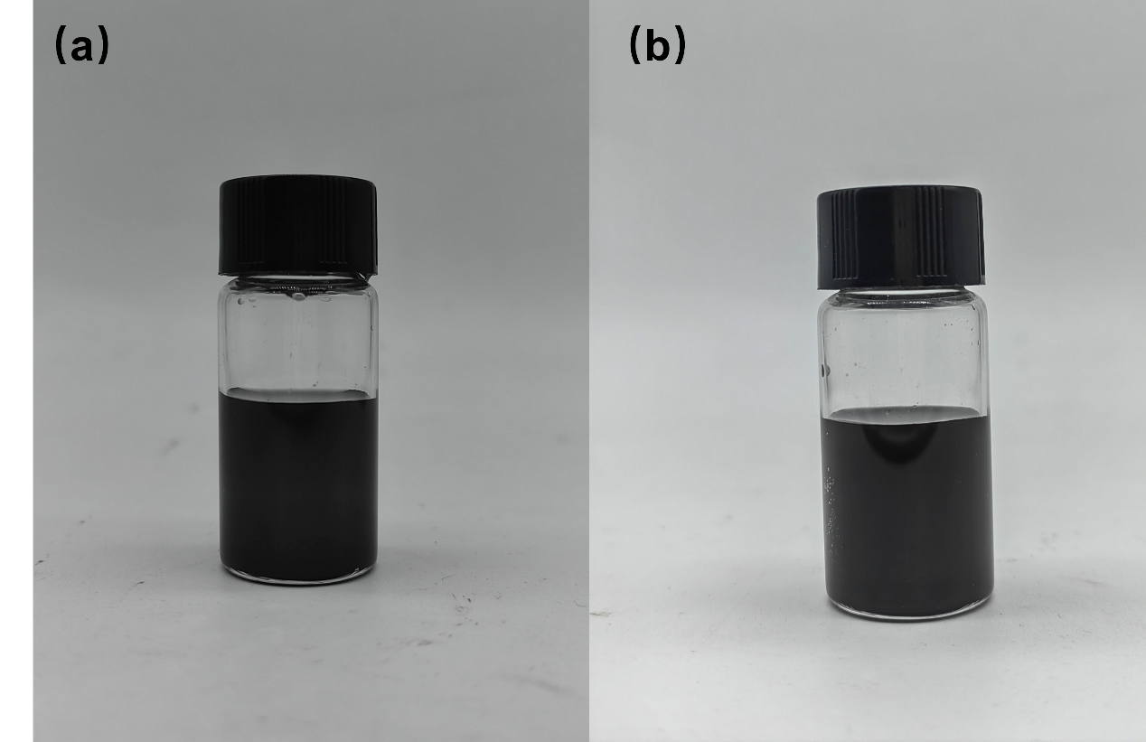
Fig. S10. Storage stability of the DAMF-Ni: (a) initial state of the DAMF-Ni, (b) After 14 days of storage.

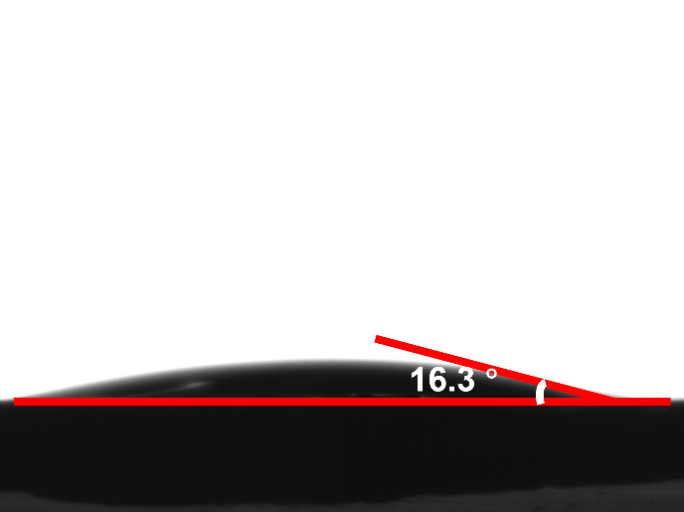
Fig. S11. Contact angle image of the DAMF-Ni.

Calculation of the contact thermal resistance
$$R_{TIM}=\frac{BLT}{k_{TIM}}+R_{c1}+R_{c2}$$
Where BLT represents the bond line thickness of a TIM, k is its out-of-plane thermal conductivity, R_{TIM} is the sum of material thermal impedance, and Rc is the contact thermal resistance.

2. Material and methods
2.1 Materials
Nickel nanoparticles (nano-Ni) and furfuryl mercaptan were obtained from Macklin Biochemical Co., Ltd. Dopamine hydrochloride, ethylene glycol, polyethylene glycol 6000 (PEG6000), tris (hydroxymethyl) aminomethane hydrochloride (Tris HCl), and methoxy polyethylene glycol maleimide (mPEG-MAL, M_{n}=6000) were purchased from Aladdin Biochemical Co., Ltd. All reagents were used as received.
2.2 Surface modification of nano-Ni and functionalization with furan group (f-Ni)
The nano-Ni (1 g, 0.017 mol) was uniformly dispersed in 200 mL of Tris HCl solution with a concentration of 6 mg/mL and pH 8.5.Then, 0.2 g of dopamine hydrochloride (0.001 mol) was added, and the reaction was maintained at 30 °C for 8 h. The polydopamine-modified nano-Ni was washed and centrifuged alternately with deionized water and ethanol three times. Subsequently, the as-obtained polydopamine-modified nano-Ni was dispersed in ethanol (pH 8.0), followed by the dropwise addition of a solution of furfuryl mercaptan (0.46 g) in ethanol. The reaction was kept at 70 °C for 60 h. Similarly, the furan group-functionalized nano-Ni was washed using the same procedure, and the final product was denoted as f-Ni (1.12 g).
2.3 Preparation of nano-Ni with long phase change chains (DAMF-Ni) through Diels-Alder reaction
To endow f-Ni with fluidity, we designed a Diels-Alder reaction between f-Ni and mPEG-MAL to reversibly graft PEG long chains, which further imparted thermal storage ability. 1 g of f-Ni and 1.78 g of mPEG-MAL were added into a flask and reacted at 80 °C for 8 h, after which the final product (1.12 g) was obtained.
2.4 Recycling of DAMF-Ni
There are various methods for recycling DAMF-Ni, including retrieving it directly from the interface in the liquid state, which can be further utilized as a TIM. Additionally, component recycling of DAMF-Ni can be realized through a reverse Diels-Alder reaction at 160 °C for 2 h to obtain f-Ni and mPEG-MAL. Subsequently, washing f-Ni in a dilute hydrochloric acid solution yields nano-Ni. Moreover, DAMF-Ni can be recycled in another way: by dispersing these functional nanoparticles uniformly in ethylene glycol to obtain nanofluids for an efficient liquid cooling module, or in PEG 6000 to form thermally enhanced phase change fluids applicable in efficient solar energy storage.
2.5 Characterization
The microstructures were captured by a cold field emission scanning electron microscope (SEM), S4800 (Hitachi, Japan), equipped with an energy dispersive spectrometer (EDS). Fourier transform infrared spectroscopy (FTIR) spectra were collected by micro-FTIR, Cary660 + 620 (Agilent, USA). The surface compositions and chemical states were obtained from X-ray photoelectron spectroscopy (XPS) analysis, Axis Ultra DLD (Kratos, UK). X-ray diffraction (XRD), D8 ADVANCE (BRUKER, Germany), was used for analyzing the crystalline properties of modified Ni products. The phase change behavior was analyzed in a temperature range from 5 °C to 65 °C at a heating rate of 10 °C·min⁻¹ using differential scanning calorimetry (DSC), Mettler Toledo TGA/DSC Ⅰ (Mettler, Germany), under a nitrogen atmosphere with a flow rate of 20 mL·min⁻¹. The magnetization curves and hysteresis loops were measured by a vibrating sample magnetometer (VSM), Lakeshore7410 (Lakeshore, USA). The thermal conductivity was tested using an LFA 467 (NETZSCH, Germany). The surface temperature and infrared images were recorded by an infrared thermal camera (FLIR A310) connected to a computer.

