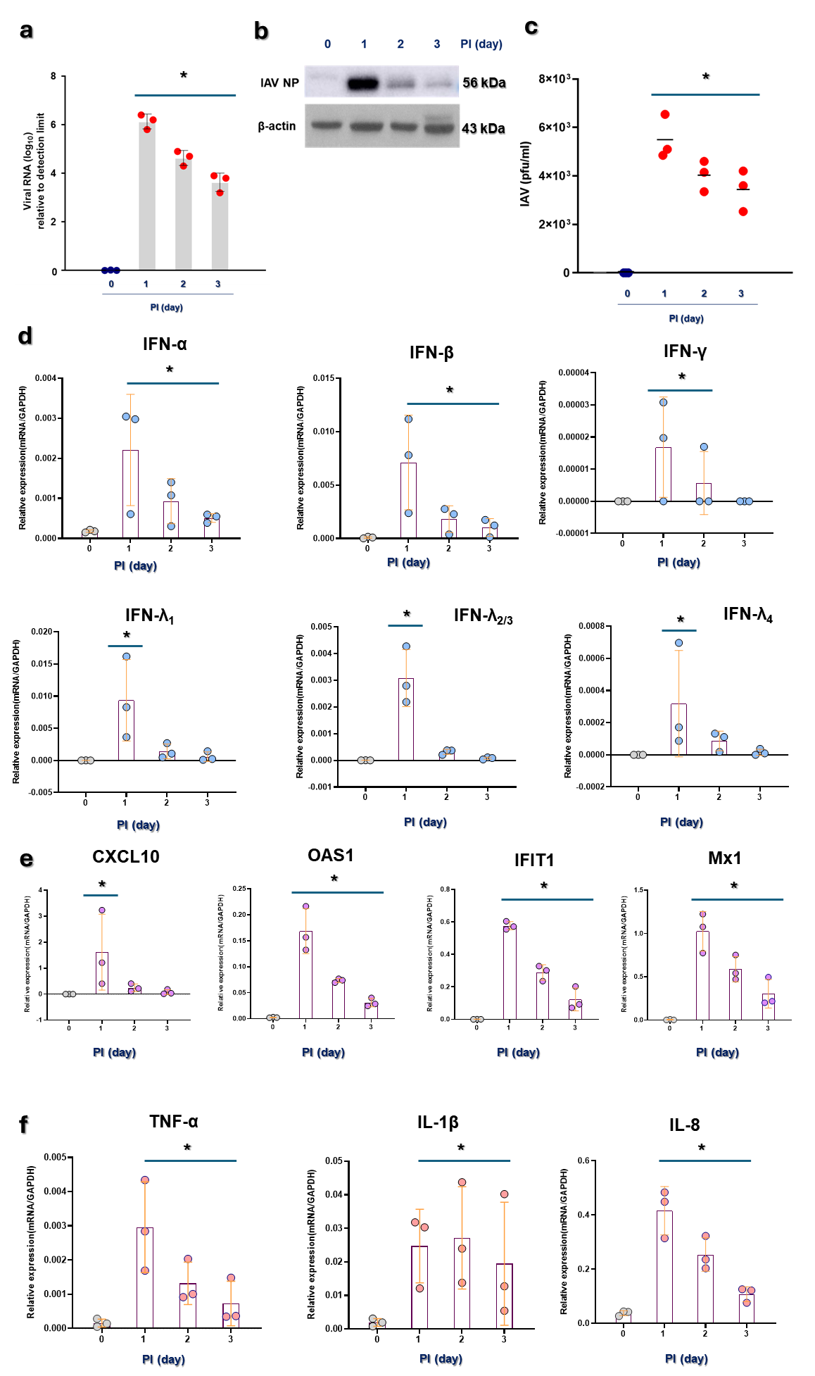
Supplementary fig. 1 Innate immune responses in NEC organoids following IAV infection.

P5 NEC organoids were inoculated with WSN/33 (H1N1) for 0 (no infection), 1, 2, and 3 days at an MOI of 1. a Real-time PCR showed that the IAV mRNA level was higher in NEC organoids from 1 day after infection, and the biggest difference in mRNA level was observed at 1 dpi. b Western blot analysis revealed that the level of IAV nucleoprotein (NP) was increased from 1 dpi in NEC organoid after IAV infection. c A plaque assay also showed that the viral titer in the supernatant of IAV-infected NEC organoid was significantly higher from 1 dpi. d Real-time PCR showed that e the IFN mRNA levels, e representative IFN-stimulated genes, and f inflammatory cytokines were increased in NEC organoids from 1 day after infection excepting IFN-Υ, and the biggest difference in mRNA level was observed at 1 dpi. Results are presented here as the mean ± standard deviation (SD) from 3 independent experiments (* p<0.05 comparing the levels with no infection). (PI: post of infection)

