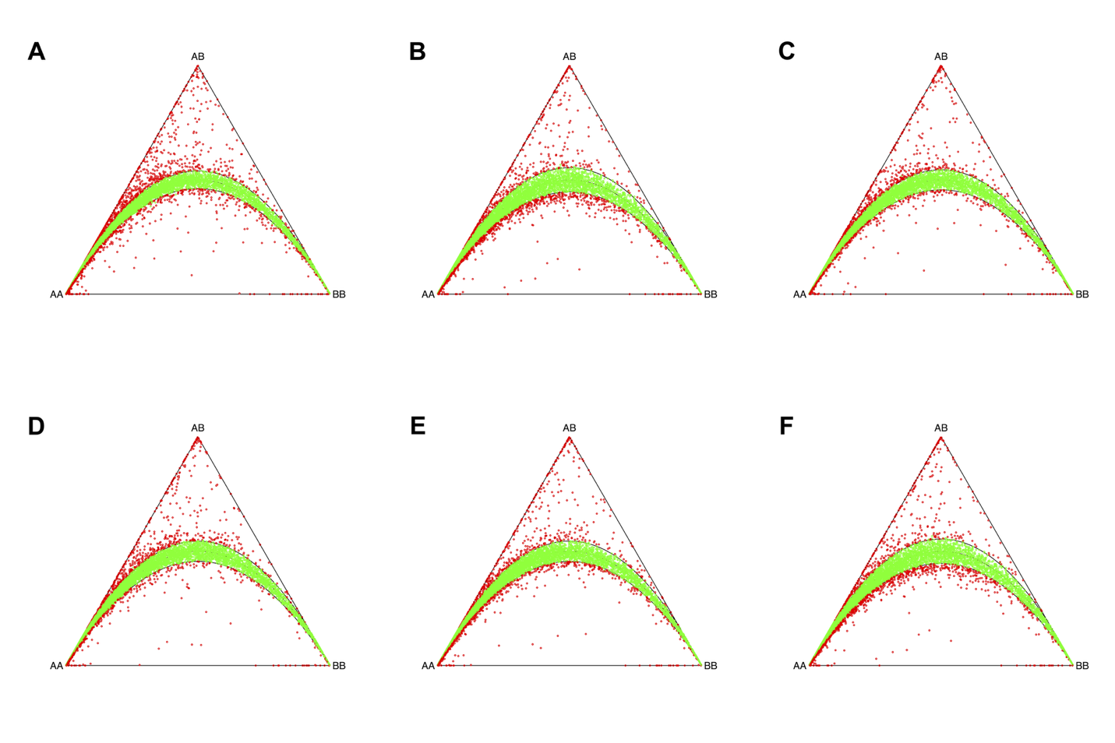Supplementary Figure 1. Hardy–Weinberg equilibrium (HWE) statistics were calculated for all biallelic structural variants on the autosomes. Deviations from HWE were tested using a chi-square goodness-of-fit approach with one degree of freedom. Genotype labels are indicated as follows: 0/0 for homozygous reference, 0/1 for heterozygous, and 1/1 for homozygous alternate. Each site is colored according to its chi-square P value. A. AFR, B. AMR, C. EAS, D. EUR, E. SAS, and F. NCBN

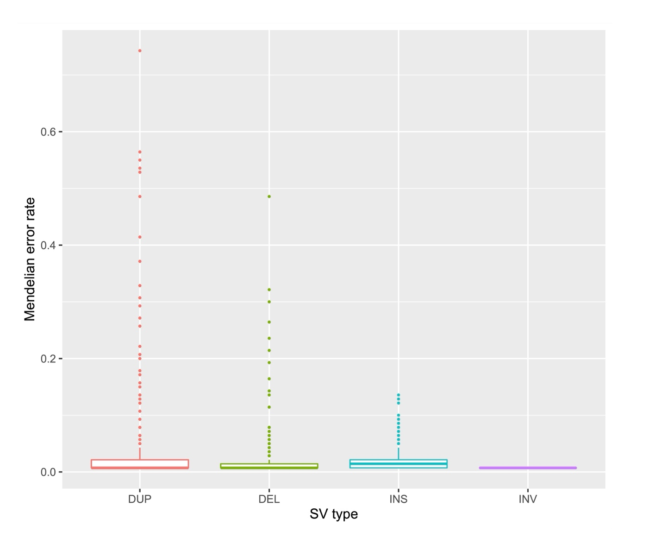
Supplementary Figure 2. Trio analysis was conducted for 142 trios available in our study. The Mendelian error rate for each SV type is shown in this figure.

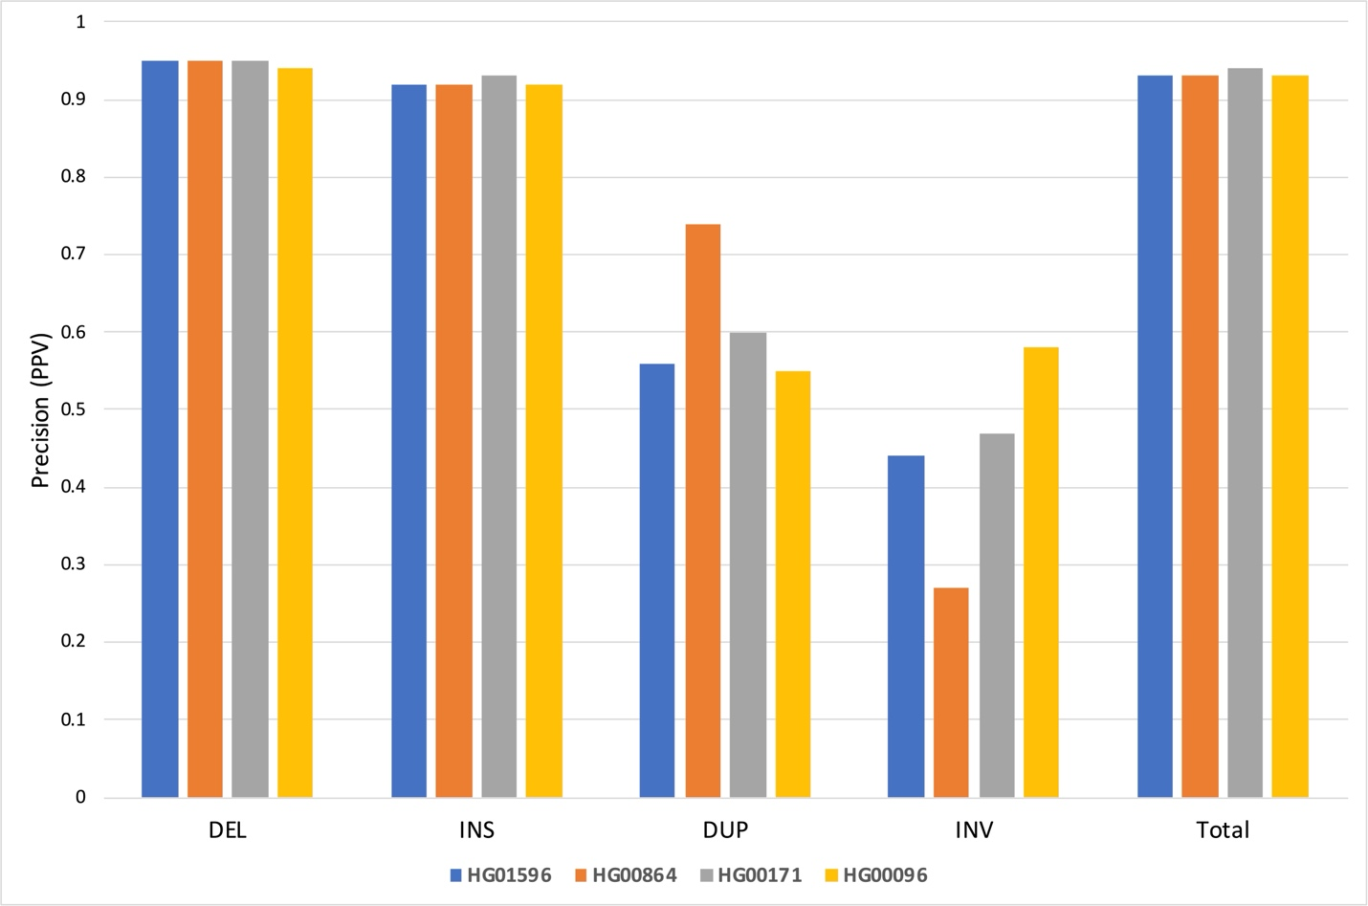
Supplementary Figure 3. Evaluation of positive predictive value for different SV types as well as all SV types (Total) using TT-MARS.

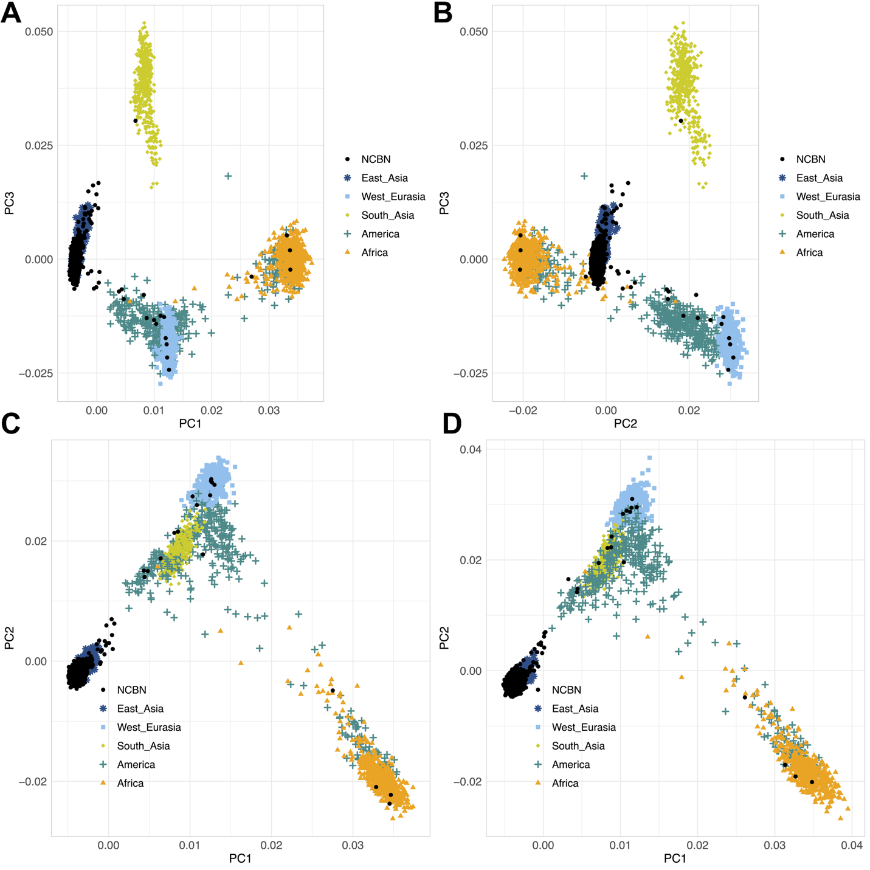

Supplementary Figure 4. Principal Component Analysis (PCA). The figure shows the segregation of population groups using PC1 and PC3 (A) as well as PC2 and PC3 (B). Panels C and D show the continental clustering based on PCA of either deletions or insertions, respectively.

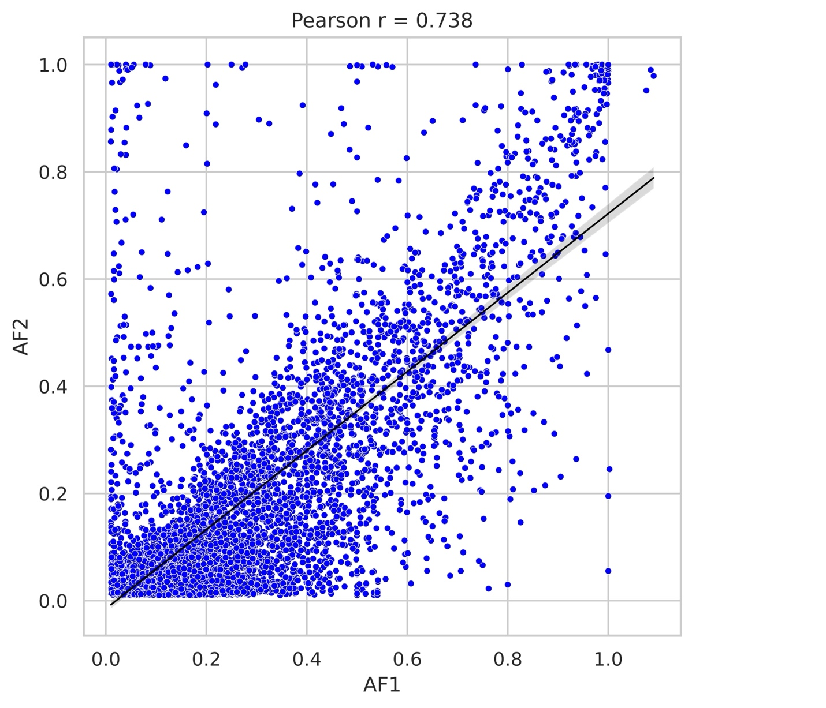
Supplementary Figure 5. The correlation coefficient of the allele frequency of SVs detected in our study (AF1) and the gnomAD study (AF2). The Pearson correlation coefficient between reported allele frequencies was 0.738.

