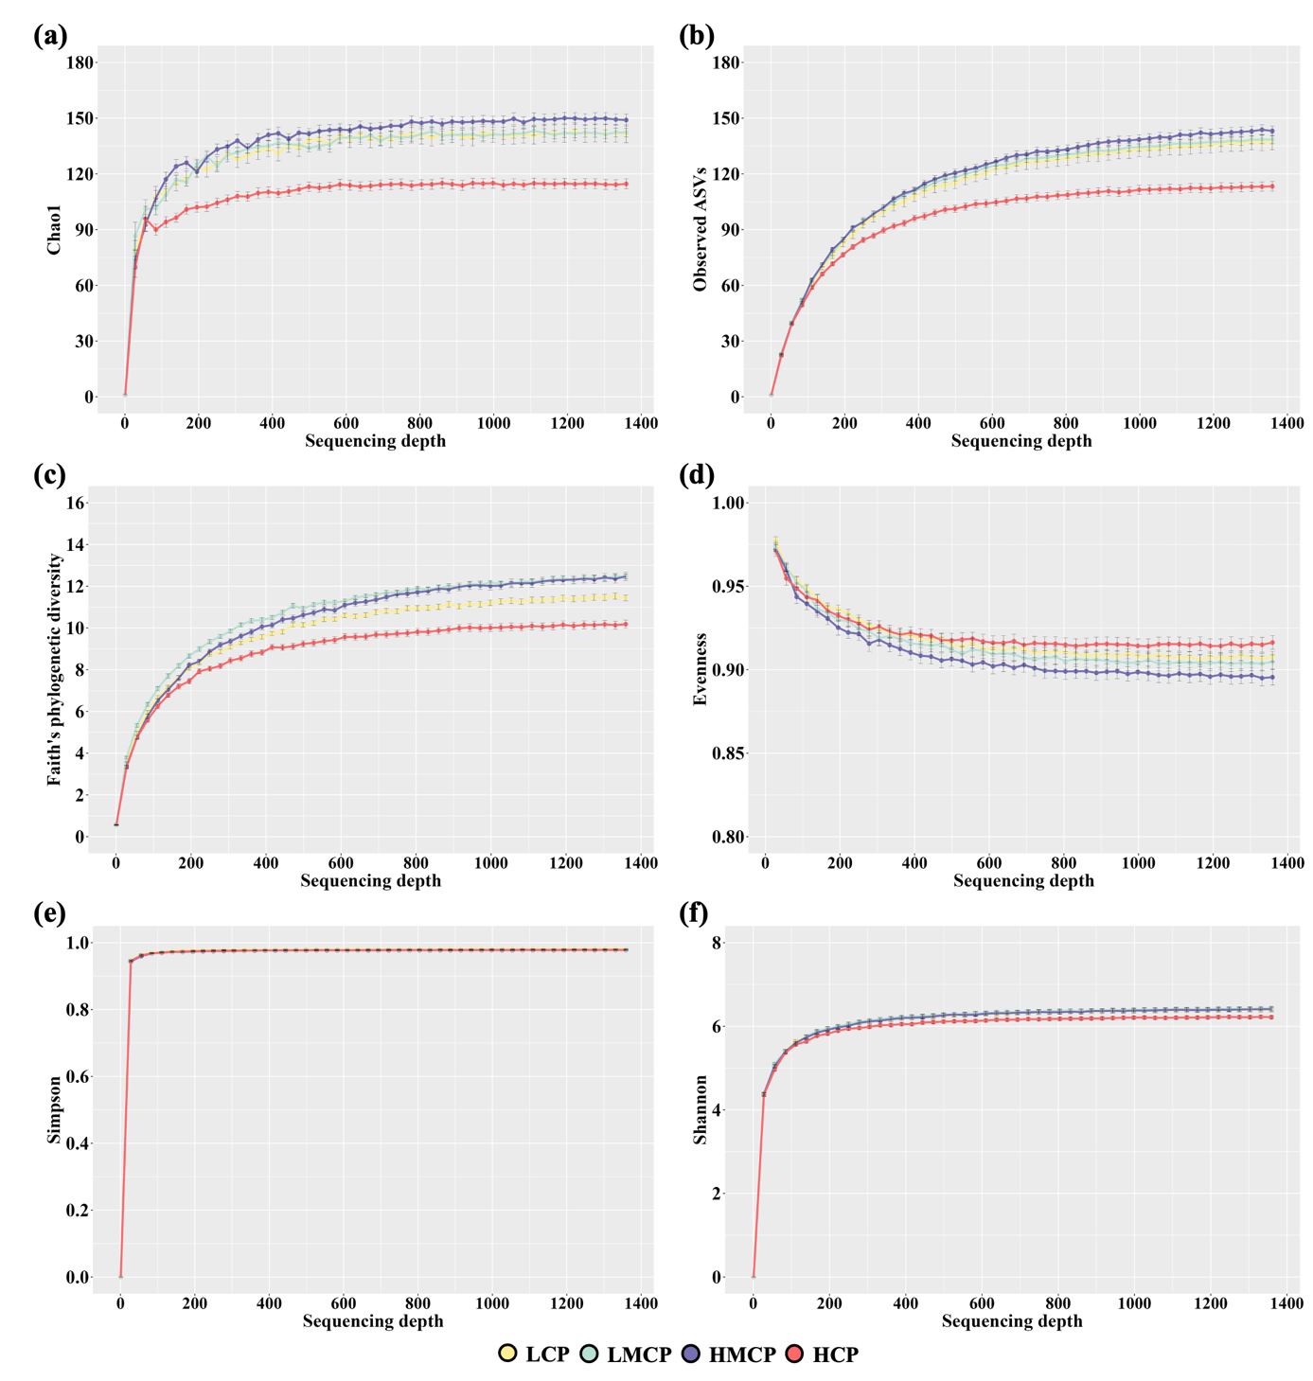
Supplementary Figure 1. Rarefaction curves showing microbial diversity metrics: (a) Chao1, (b) observed amplicon sequence variants (ASVs), (c) Faith’s phylogenetic diversity, (d) Pielou’s evenness, (e) Simpson index, and (f) Shannon index.
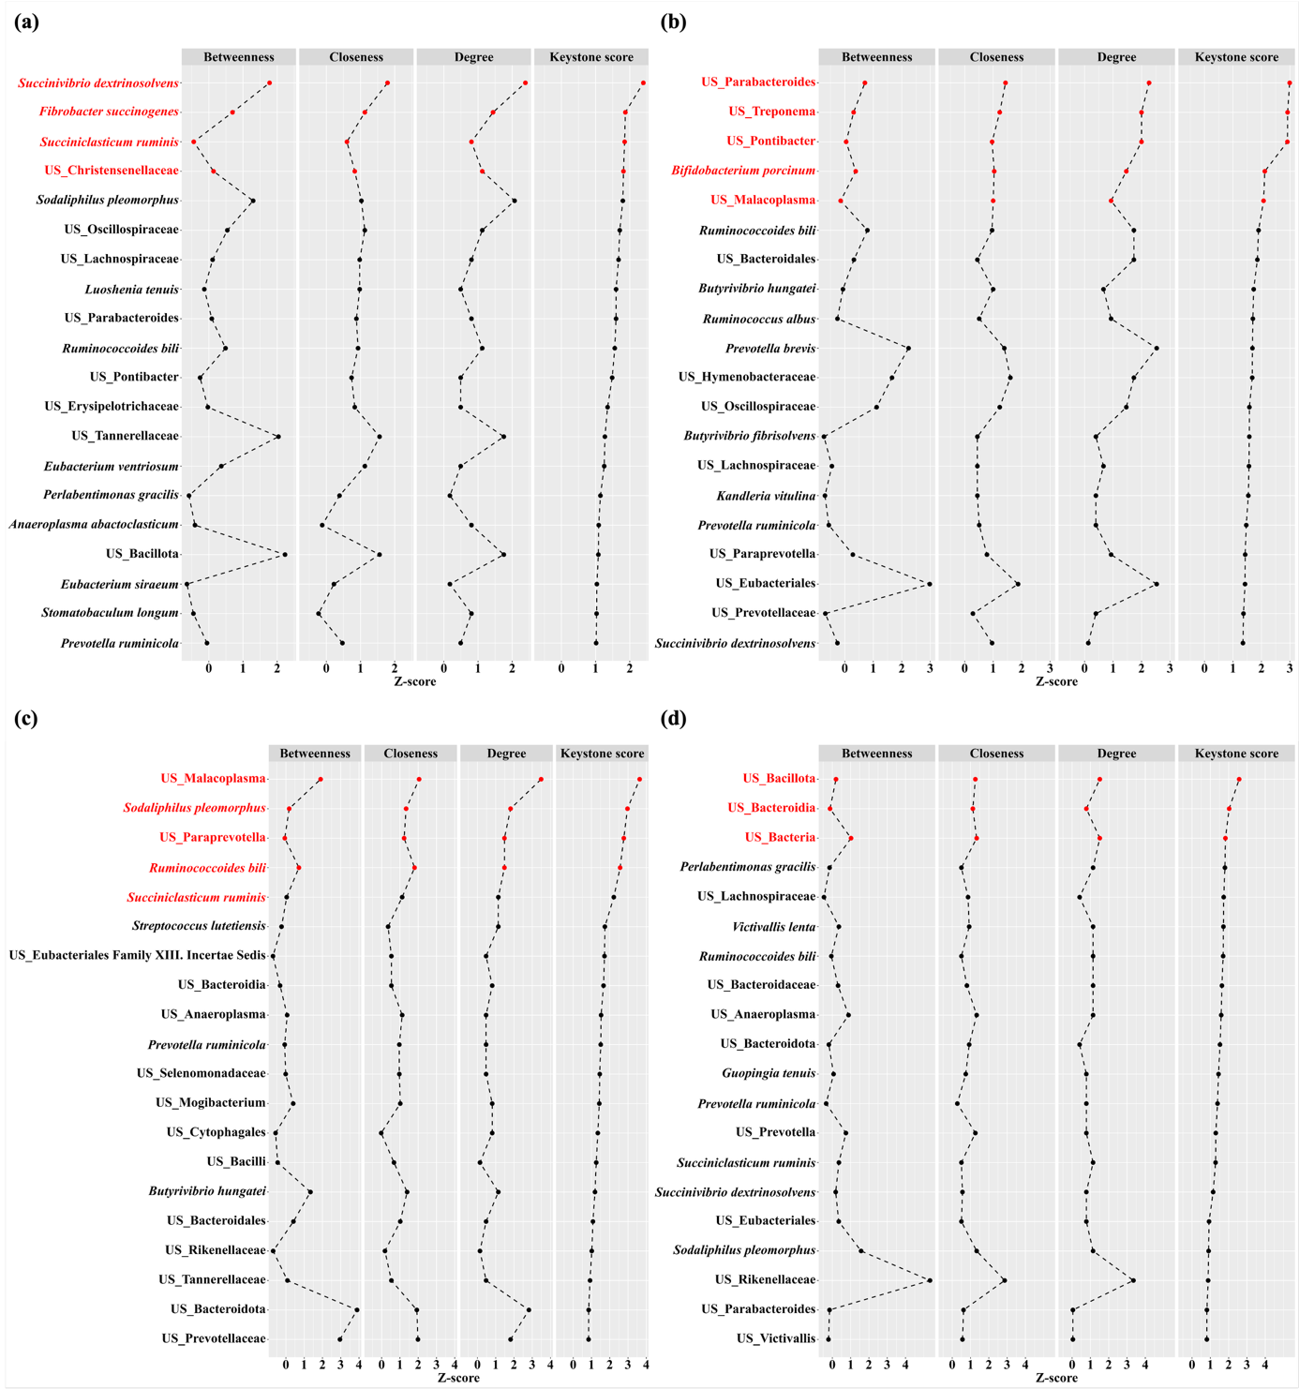
Supplementary Figure 2. Centrality distributions for detecting keystone species in the microbial networks of (a) LCP, (b) LMCP, (c) HMCP, and (d) HCP. Networks were constructed using the Sparse Correlations for Compositional data (SparCC) algorithm, including all species. Keystone scores were calculated based on high degree and closeness centralities and low betweenness centrality values after normalization. The top 20 species by keystone score were visualized, and the top 5% of species with the highest scores were identified as keystone species (highlighted in red). LCP, low crude protein; LMCP, low-moderate crude protein; HMCP, high-moderate crude protein; HCP, high crude protein.
Supplementary Table 1. Denoising statistics of full-length 16S rRNA gene sequencing using the Divisive Amplicon Denoising Algorithm 2 (DADA2)
N | Sample | Treatment¹ | Input reads | Filtered reads | Denoised reads | Non-chimeric reads
1 | CP_LF_3205 | LCP | 9,608 | 8,168 | 5,219 | 5,189
2 | CP_LF_3206 | LCP | 8,990 | 7,660 | 3,860 | 3,860
3 | CP_LF_3335 | LCP | 8,014 | 6,841 | 3,132 | 3,132
4 | CP_LF_3745 | LCP | 5,966 | 4,868 | 2,304 | 2,286
5 | CP_LF_4878 | LCP | 5,702 | 4,865 | 1,507 | 1,507
6 | CP_LF_9757 | LCP | 8,722 | 7,385 | 3,426 | 3,426
7 | CP_LF_3334 | LMCP | 7,145 | 5,935 | 3,102 | 3,102
8 | CP_LF_5950 | LMCP | 9,589 | 8,122 | 2,890 | 2,872
9 | CP_LF_7642 | LMCP | 7,474 | 6,277 | 2,639 | 2,639
10 | CP_LF_8597 | LMCP | 8,420 | 7,036 | 3,268 | 3,257
11 | CP_LF_9538 | LMCP | 7,810 | 6,630 | 3,404 | 3,392
12 | CP_LF_9577 | LMCP | 6,920 | 5,949 | 2,445 | 2,445
13 | CP_LF_3748 | HMCP | 7,918 | 6,666 | 3,344 | 3,344
14 | CP_LF_3891 | HMCP | 9,209 | 7,757 | 2,969 | 2,969
15 | CP_LF_3906 | HMCP | 8,861 | 7,455 | 3,260 | 3,260
16 | CP_LF_7457 | HMCP | 10,765 | 9,024 | 5,228 | 5,220
17 | CP_LF_8906 | HMCP | 6,002 | 5,110 | 2,484 | 2,484
18 | CP_LF_9085 | HMCP | 10,116 | 8,502 | 4,765 | 4,757
19 | CP_LF_3337 | HCP | 6,944 | 5,815 | 2,431 | 2,431
20 | CP_LF_3450 | HCP | 4,934 | 4,210 | 1,359 | 1,359
21 | CP_LF_3454 | HCP | 8,018 | 6,734 | 2,607 | 2,607
22 | CP_LF_3455 | HCP | 5,889 | 5,116 | 1,516 | 1,516
23 | CP_LF_8545 | HCP | 7,673 | 6,472 | 2,437 | 2,437
24 | CP_LF_9537 | HCP | 6,624 | 5,589 | 1,731 | 1,731
¹ LCP, concentrate mix consisting of low crude protein (CP, 15.0% on a DM basis); LMCP, concentrate mix consisting of low-moderate CP (16.2% on a DM basis); HMCP, concentrate mix consisting of high-moderate CP (17.5% on a DM basis); HCP, concentrate mix consisting of high CP (18.5% on a DM basis); N, sample number

Supplementary Table 2. Chemical composition (g/kg DM or as stated) of the experimental diets
Item¹ | Dietary Treatment² |  |  |  | Tall fescue
Item¹ | LCP | LMCP | HMCP | HCP | Tall fescue
Chemical composition
DM, g/kg as fed | 882 | 885 | 888 | 891 | 895
OM | 926 | 925 | 924 | 923 | 930
CP | 150 | 162 | 175 | 185 | 63
NDICP | 25 | 24 | 24 | 23 | 15
ADICP | 9 | 9 | 10 | 10 | 7
aNDF | 262 | 256 | 249 | 244 | 742
ADF | 106 | 106 | 107 | 107 | 439
ADL | 38 | 37 | 37 | 36 | 64
EE | 47 | 48 | 48 | 49 | 11
Ash | 74 | 75 | 76 | 77 | 70
Ca | 14 | 15 | 16 | 17 | 3
P | 5 | 5 | 6 | 6 | 1
NFC | 493 | 485 | 476 | 469 | 126
TDN | 740 | 743 | 746 | 748 | 518
NE_{m}, MJ/kg DM | 8.0 | 8.0 | 8.1 | 8.1 | 4.2
NE_{g}, MJ/kg DM | 5.3 | 5.3 | 5.4 | 5.4 | 1.9
¹ DM, dry matter; OM, organic matter; CP, crude protein; NDICP, neutral detergent fiber insoluble crude protein; ADICP, acid detergent insoluble crude protein; aNDF, neutral detergent fiber, analyzed with heat-stable amylase and expressed inclusive of residual ash; ADF, acid detergent fiber; ADL, acid detergent lignin; EE, ether extract; NFC, non-fiber carbohydrate; TDN, total digestible nutrients; NE_{m}, net energy for maintenance; NE_{g}, net energy for growth.
² LCP, concentrate mix consisting of low crude protein (CP, 15.0% on a DM basis); LMCP, concentrate mix consisting of low-moderate CP (CP, 16.2% on a DM basis); HMCP, concentrate mix consisting of high-moderate CP (CP, 17.5% on a DM basis); HCP, concentrate mix consisting of high CP (CP, 18.5% on a DM basis).

