Supplementary Material

Biomimetic Apoptotic Nanovesicles Derived from T Cells Target Neuroinflammation and Enhance Neural Regeneration via TGFBR2-Mediated Signaling for Spinal Cord Injury Repair
Ziqi Zhu^{1, #}, Beiduo Shen^{1, #}, Tianyu Li^{6, #}, Qingyue Yuan^{4, #}, Da Tan⁵, Yiyang Cheng⁵, Wenxin Liang⁵, Qiang Zhou^{5 *}, Xianzhen Chen^{4,5 *}, Mingran Luo^{3, *}, Xie Tao ^{2, *}
¹ Department of Spine Surgery, Shanghai East Hospital, School of Medicine, Tongji University, Shanghai, 200092, China.
² Department of Orthopedic Surgery, Affiliated Hangzhou First People’s Hospital, Westlake University, School of Medicine, Hangzhou, China.
³ Department of Orthopedics, the Affiliated Hospital of Xuzhou Medical University, Xuzhou, 221000, China.
⁴ Department of Neurosurgery, School of Clinical Medicine of Nanjing Medical University, Nanjing 211166, Jiangsu, China.
⁵ Department of Neurosurgery, Shanghai Tenth People’ s Hospital, Tongji University School of Medicine, Shanghai 200000, China.
⁶ Clinical college of Anhui medical university, Hefei, 230031, China.
# These authors contributed equally to this work.
* Corresponding authors: Qiang Zhou, zqreadmore@163.com; Xianzhen Chen, chenxianzheny@tongji.edu.cn; Mingran Luo, mingran_luo@sina.com; Xie Tao todxietao@163.com

Fig. S1. Hydrodynamic diameter distribution of Apo-nanovesicles as determined by nanoparticle tracking analysis (NTA).
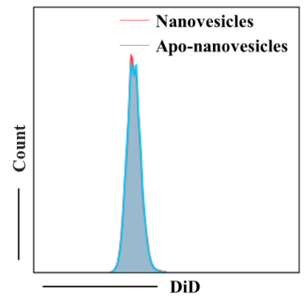
Fig. S2. Flow cytometry analysis of NSCs phagocytosed with nanovesicles.
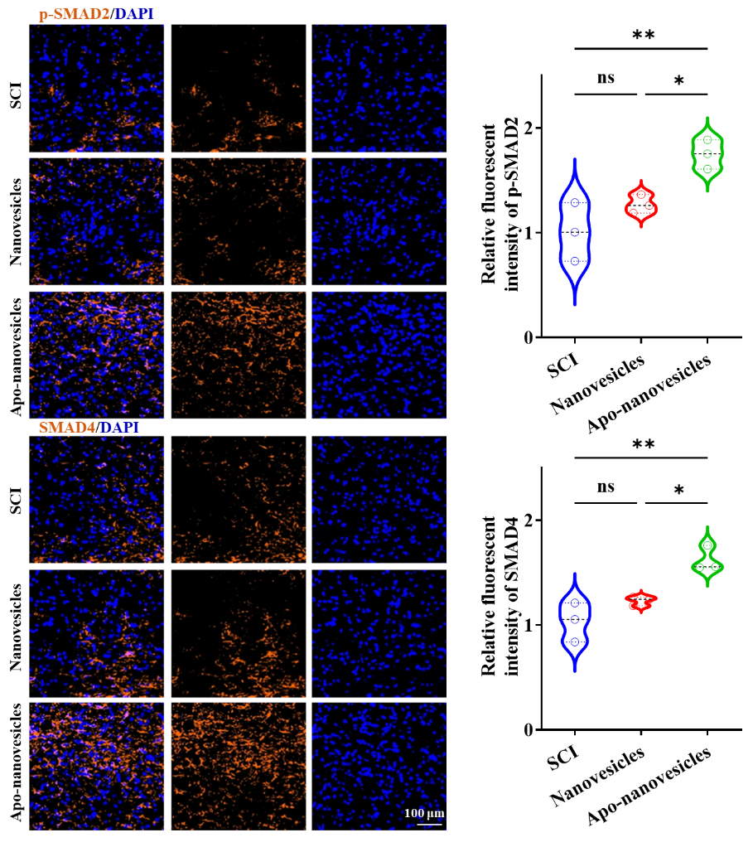
Fig. S3. Representative immunofluorescence images and quantitative analysis of immunofluorescence intensity for p-SMAD2 and SMAD4.

Table S1. qPCR primer.
Gene | Forward primer | Reverse primer
Tnf-α | ATGCTGGGACAGTGACCTGG | CCTTGATGGTGGTGCATGAG
Il-1β | TGGACCTTCCAGGATGAGGACA | GTTCATCTCGGAGCCTGTAGTG
Il-10 | GCTGGACAACATACTGCTAACC | ATTTCCGATAAGGCTTGGCAA
Tgf-β | TGATACGCCTGAGTGGCTGTCT | CACAAGAGCAGTGAGCGCTGAA
Iba1 | TCTGCCGTCCAAACTTGAAGCC | CTCTTCAGCTCTAGGTGGGTCT
iNOS | GAGACAGGGAAGTCTGAAGCAC | CCAGCAGTAGTTGCTCCTCTTC
Arg1 | CATTGGCTTGCGAGACGTAGAC | GCTGAAGGTCTCTTCCATCACC
Gfap | CCCTGGCTCGTGTGGATTT | GACCGATACCACTCCTCTGTC
Dcx | CTGACTCAGGTAACGACCAAGAC | TTCCAGGGCTTGTGGGTGTAGA
NeuN | AACCACGAACTCCACCCTTC | GACCTCAATTTTCCGTCCCTC
Map2 | GGTCACAGGGCACCTATTCA | TGTTCACCTTTCAGGACTGC
Tuj1 | TAGACCCCAGCGGCAACTAT | GTTCCAGGTTCCAAGTCCACC
Tgfbr2 | CCTACTCTGTCTGTGGATGACC | GACATCCGTCTGCTTGAACGAC
Gapdh | GTGTTCCTACCCCCAATGTGT | ATTGTCATACCAGGAAATGAGCTT

