Supplementary Information
Titles of the supplementary items submitted with this manuscript are listed below in the order provided for submission.
Additional file 1. Supplementary Table S1. Definitions and coding of candidate predictors and the outcome.
Variable | Definition | Coding / Unit
Sepsis (outcome) | Postoperative sepsis defined by Sepsis-3 criteria within 72 hours after surgery | Binary (Yes/No)
Sex | Patient sex | Male/Female
Age | Age at admission | Years
Residence | Registered residence | Urban/Rural
Primary surgery | Whether this was the first procedure for the stone episode | Yes/No/Unknown
Hypertension | History of hypertension | Yes/No
Diabetes mellitus | History of diabetes mellitus | Yes/No
Hypercalcemia | Hypercalcemia documented preoperatively | Yes/No
Coronary heart disease | History of coronary heart disease | Yes/No
Hyperuricemia | History of hyperuricemia | Yes/No
Operation time | Duration of surgery | Minutes
Preoperative WBC | White blood cell count before surgery | ×10⁹/L
Preoperative neutrophils | Neutrophil count before surgery | ×10⁹/L
Preoperative eosinophils | Eosinophil count before surgery | ×10⁹/L
Preoperative platelets | Platelet count before surgery | ×10⁹/L
Preoperative renal function stage | Renal function strata based on eGFR categories (KDIGO) | Stage 1 (≥90), 2 (60–89), 3 (30–59), 4 (15–29), 5 (<15) mL/min/1.73m²
Preoperative CRP | C-reactive protein before surgery | mg/L
Preoperative PCT | Procalcitonin before surgery | ng/mL
Urine pH | Preoperative urine pH | Unitless
Urine nitrite | Preoperative urine nitrite on routine urinalysis | Ordinal (negative to strong positive)
Urine leukocyte esterase | Preoperative leukocyte esterase on routine urinalysis | Ordinal (negative to strong positive)
Urine culture | Preoperative urine culture result | Negative/Positive (organism recorded when positive)
Surgical approach | Minimally invasive approach used for stone surgery | PCNL / URS / RIRS
Stone length | Maximum stone length on preoperative CT | mm
Stone width | Maximum stone width on preoperative CT | mm
Stone CT value | Mean stone attenuation on preoperative CT | Hounsfield units
Single vs multiple stones | Stone multiplicity | Single/Multiple/Unknown
Hydronephrosis | Hydronephrosis on preoperative imaging | Present/Absent
Preoperative antibiotic duration | Duration of preoperative antibiotic exposure | Days
BMI | Body mass index | kg/m²
Additional file 2. Supplementary Table S2. Missing data proportions by variable.
Variable | Missing count | Missing %
gender | 0 | 0
age | 0 | 0
urban_rural | 0 | 0
primary_surgery | 0 | 0
hypertension | 0 | 0
diabetes_mellitus | 0 | 0
hypercalcemia | 0 | 0
coronary_heart_disease | 0 | 0
hyperuricemia | 0 | 0
operation_time | 0 | 0
preoperative_wbc_count | 0 | 0
preoperative_neutrophil_count | 0 | 0
preoperative_eosinophil_count | 0 | 0
preoperative_platelet_count | 0 | 0
preoperative_renal_function | 0 | 0
preoperative_c_reactive_protein | 0 | 0
preoperative_procalcitonin | 0 | 0
urinary_p_h | 0 | 0
preoperative_nitrite | 0 | 0
preoperative_leukocyte_esterase | 0 | 0
urine_culture | 0 | 0
operation_approach | 0 | 0
stone_length | 0 | 0
stone_width_mm | 0 | 0
stone_ct_value | 0 | 0
single_multiple | 0 | 0
hydronephrosis | 0 | 0
preoperative_antibiotic_duration | 0 | 0
bmi | 0 | 0
sepsis | 0 | 0
Additional file 3. Supplementary Table S3. Discrimination and classification performance of candidate models in the training set (default threshold = 0.50).
Model | AUC (95% CI) | Sensitivity | Specificity | PPV | NPV | Accuracy (95% CI) | F1
Random forest | 1.000 (1.000–1.000) | 0.830 | 1.000 | 1.000 | 0.984 | 0.985 (0.976–0.991) | 0.907
XGBoost | 0.960 (0.940–0.980) | 0.540 | 0.992 | 0.871 | 0.957 | 0.952 (0.938–0.964) | 0.667
Gradient boosting | 0.952 (0.929–0.975) | 0.510 | 0.991 | 0.850 | 0.954 | 0.949 (0.934–0.961) | 0.638
SVM | 0.932 (0.903–0.962) | 0.400 | 1.000 | 1.000 | 0.945 | 0.947 (0.932–0.959) | 0.571
Neural network | 0.900 (0.870–0.930) | 0.370 | 0.985 | 0.712 | 0.942 | 0.931 (0.915–0.945) | 0.487
Logistic regression | 0.899 (0.869–0.929) | 0.360 | 0.985 | 0.706 | 0.941 | 0.930 (0.914–0.944) | 0.477
Naïve Bayes | 0.898 (0.865–0.931) | 0.110 | 1.000 | 1.000 | 0.921 | 0.922 (0.904–0.937) | 0.198
Additional file 4. Supplementary Table S4. Pairwise DeLong test results for test-set AUCs with multiple-comparison adjustment.
Model 1 | Model 2 | AUC 1 | AUC 2 | ΔAUC | P | P (FDR) | P (Bonferroni)
logistic | random_forest | 0.893 | 0.865 | 0.028 | 0.101 | 0.164 | 1.000
logistic | xgboost | 0.893 | 0.893 | -0.000 | 0.983 | 0.983 | 1.000
logistic | svm | 0.893 | 0.824 | 0.069 | 0.024 | 0.056 | 0.500
logistic | neural_network | 0.893 | 0.894 | -0.001 | 0.809 | 0.894 | 1.000
logistic | naive_bayes | 0.893 | 0.844 | 0.049 | 0.022 | 0.056 | 0.464
logistic | gradient_boosting | 0.893 | 0.887 | 0.006 | 0.736 | 0.859 | 1.000
random_forest | xgboost | 0.865 | 0.893 | -0.029 | 0.015 | 0.056 | 0.319
random_forest | svm | 0.865 | 0.824 | 0.040 | 0.099 | 0.164 | 1.000
random_forest | neural_network | 0.865 | 0.894 | -0.029 | 0.088 | 0.164 | 1.000
random_forest | naive_bayes | 0.865 | 0.844 | 0.021 | 0.357 | 0.500 | 1.000
random_forest | gradient_boosting | 0.865 | 0.887 | -0.022 | 0.014 | 0.056 | 0.300
xgboost | svm | 0.893 | 0.824 | 0.069 | 0.013 | 0.056 | 0.274
xgboost | neural_network | 0.893 | 0.894 | -0.000 | 0.981 | 0.983 | 1.000
xgboost | naive_bayes | 0.893 | 0.844 | 0.049 | 0.022 | 0.056 | 0.459
xgboost | gradient_boosting | 0.893 | 0.887 | 0.006 | 0.341 | 0.500 | 1.000
svm | neural_network | 0.824 | 0.894 | -0.069 | 0.021 | 0.056 | 0.438
svm | naive_bayes | 0.824 | 0.844 | -0.020 | 0.543 | 0.713 | 1.000
svm | gradient_boosting | 0.824 | 0.887 | -0.063 | 0.016 | 0.056 | 0.338
neural_network | naive_bayes | 0.894 | 0.844 | 0.050 | 0.018 | 0.056 | 0.379
neural_network | gradient_boosting | 0.894 | 0.887 | 0.007 | 0.706 | 0.859 | 1.000
naive_bayes | gradient_boosting | 0.844 | 0.887 | -0.043 | 0.040 | 0.084 | 0.843
Additional file 5. Supplementary Table S5. SHAP feature importance in the internal hold-out test set.
Rank | Feature | Mean |SHAP|
1 | operation_time | 0.0410
2 | preoperative_renal_function | 0.0404
3 | operation_approach_X3 | 0.0361
4 | stone_ct_value | 0.0347
5 | preoperative_wbc_count | 0.0264
6 | operation_approach_X2 | 0.0261
7 | preoperative_antibiotic_duration | 0.0228
8 | diabetes_mellitus_X1 | 0.0155
9 | stone_length | 0.0113
10 | urine_culture_CoNS | 0.0032
Additional file 6. Supplementary Table S6. Reference levels for categorical predictors in the final clinical logistic model.
Variable | Label | Levels | Reference
diabetes_mellitus | Diabetes (yes/no) | 0, 1 | 0
urine_culture | Urine culture | 0, E. coli , E. faecalis, Other, Others, VRE | 0
operation_approach | Approach (PCNL/URS/RIRS) | 1, 2, 3 | 1
Additional file 7. Supplementary Table S7. Coefficients and odds ratios of the final clinical logistic model; rare organism-specific urine-culture contrasts had wide confidence intervals and should be interpreted cautiously.
Predictor | β coefficient | OR (95% CI) | P value
Intercept | -8.754 | 0.000 (0.000–0.001) | <0.001
Operation time (min) | 0.051 | 1.052 (1.033–1.071) | <0.001
WBC (10^9/L) | 0.183 | 1.201 (1.112–1.297) | <0.001
CKD stage (I–V) | 0.742 | 2.099 (1.639–2.690) | <0.001
Stone length (mm) | 0.061 | 1.063 (1.016–1.113) | 0.008
Stone CT value (HU) | 0.002 | 1.002 (1.001–1.002) | <0.001
Preop antibiotics (days) | -0.172 | 0.842 (0.757–0.936) | 0.001
Diabetes (yes/no) | contrast: =1 | 1.435 | 4.199 (2.191–8.047) | <0.001
Urine culture | contrast: =E. coli | 0.257 | 1.293 (0.393–4.249) | 0.672
Urine culture | contrast: =E. faecalis | -1.068 | 0.344 (0.018–6.481) | 0.476
Urine culture | contrast: =Other | -0.241 | 0.786 (0.154–4.006) | 0.772
Urine culture | contrast: =Others | -0.219 | 0.803 (0.035–18.478) | 0.891
Urine culture | contrast: =VRE | 0.074 | 1.076 (0.170–6.799) | 0.938
Approach (PCNL/URS/RIRS) | contrast: =2 | -0.853 | 0.426 (0.221–0.820) | 0.011
Approach (PCNL/URS/RIRS) | contrast: =3 | -1.582 | 0.206 (0.097–0.438) | <0.001
Additional file 8. Supplementary Figure S1. Extended exploratory data analysis.
(A) Numeric density overview. (B) Categorical distribution overview. (C) Correlation heatmap among predictors. (D) Age density by outcome. (E) Sepsis rate by hypertension. (F) Sepsis rate by coronary heart disease. (G) CRP density by outcome. (H) Operation-time density by outcome. (I) PCT density by outcome.
Additional file 9. Supplementary Figure S2. Clinical plots and model-comparison details.
(A) CRP boxplot by outcome. (B) PCT boxplot by outcome. (C) Predicted-probability distributions across models. (D) Performance summary. (E) Adjusted DeLong q-value heatmap. (F) XGBoost tuning results.
Additional file 10. Supplementary Figure S3. Additional feature-selection and importance methods.
(A) LASSO cross-validation curve. (B) Permutation feature importance. (C) Boruta importance history. (D) Legacy model-specific importance comparison.
Additional file 11. Supplementary Figure S4. Development and legacy figures.
(A) Legacy nomogram. (B) Legacy calibration plot. (C) Legacy SHAP summary. (D) Legacy correlation plot.
Additional file 12. Supplementary Figure S5. Revised analytical framework for postoperative sepsis prediction.
Input data domains, the core analytic engine, and the output modules are shown in one integrated framework, aligning data preprocessing, feature selection, candidate-model development, performance assessment, explainability, and clinical translation. The K-nearest-neighbor imputation box represents a prespecified fallback step in the general workflow; after final cohort restriction to complete records, that branch was not activated in the locked analysis.
Additional file 13. Supplementary Figure S6. Revised study workflow for machine-learning-based prediction of postoperative sepsis.
Cohort assembly, exclusion criteria, preprocessing, training/test split, candidate-model comparison, internal test-set validation, SHAP-based interpretation, and downstream clinical translation are summarized as an end-to-end workflow. In this locked dataset, the workflow retained imputation as a prespecified option, but no imputation step was triggered because no residual missing values remained after cohort cleaning.

Embedded Supplementary Figures
Additional file 8. Supplementary Figure S1. Extended exploratory data analysis.
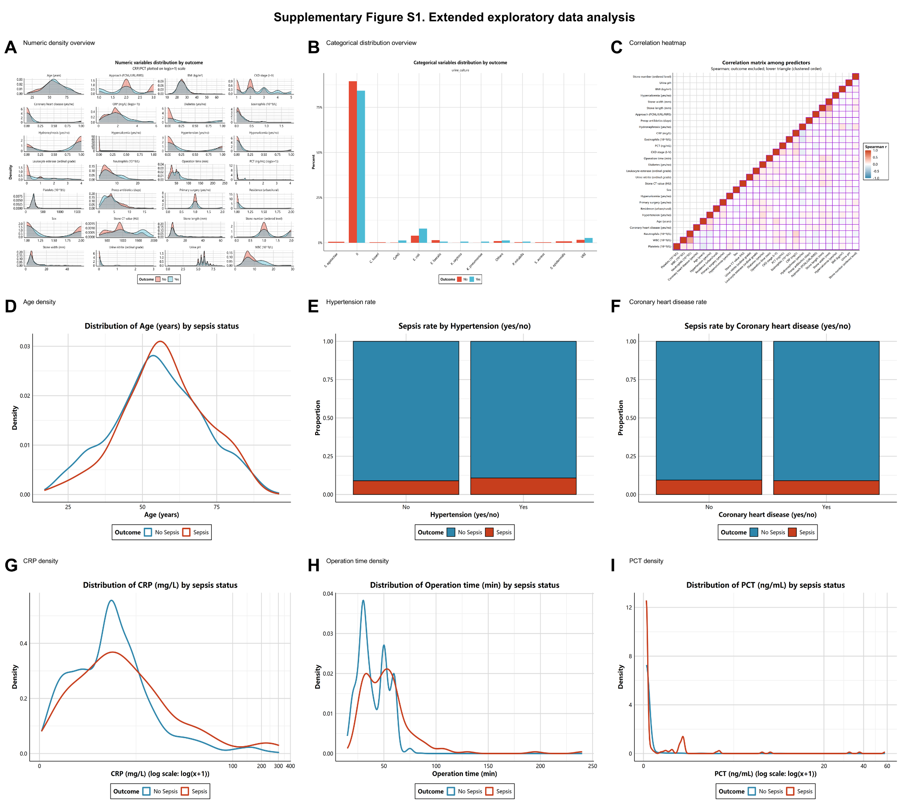

Additional file 9. Supplementary Figure S2. Clinical plots and model-comparison details.
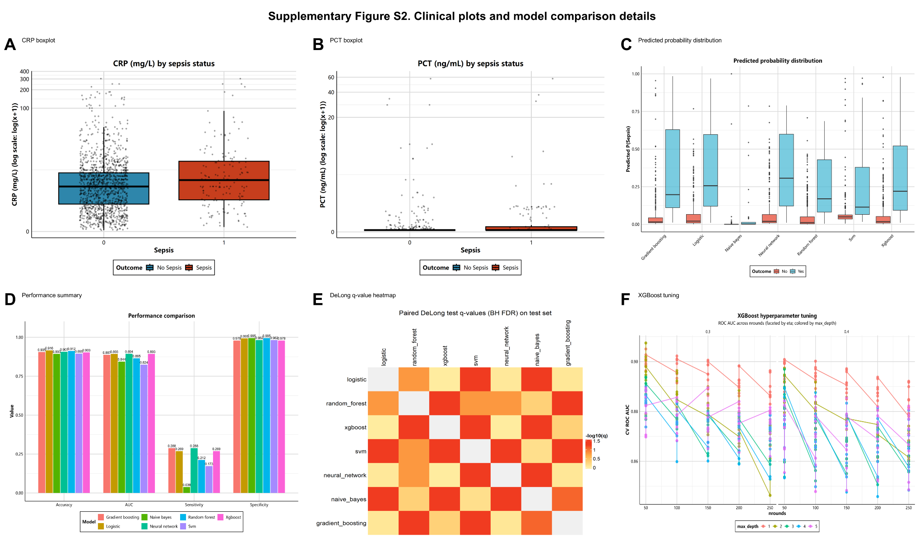

Additional file 10. Supplementary Figure S3. Additional feature-selection and importance methods.
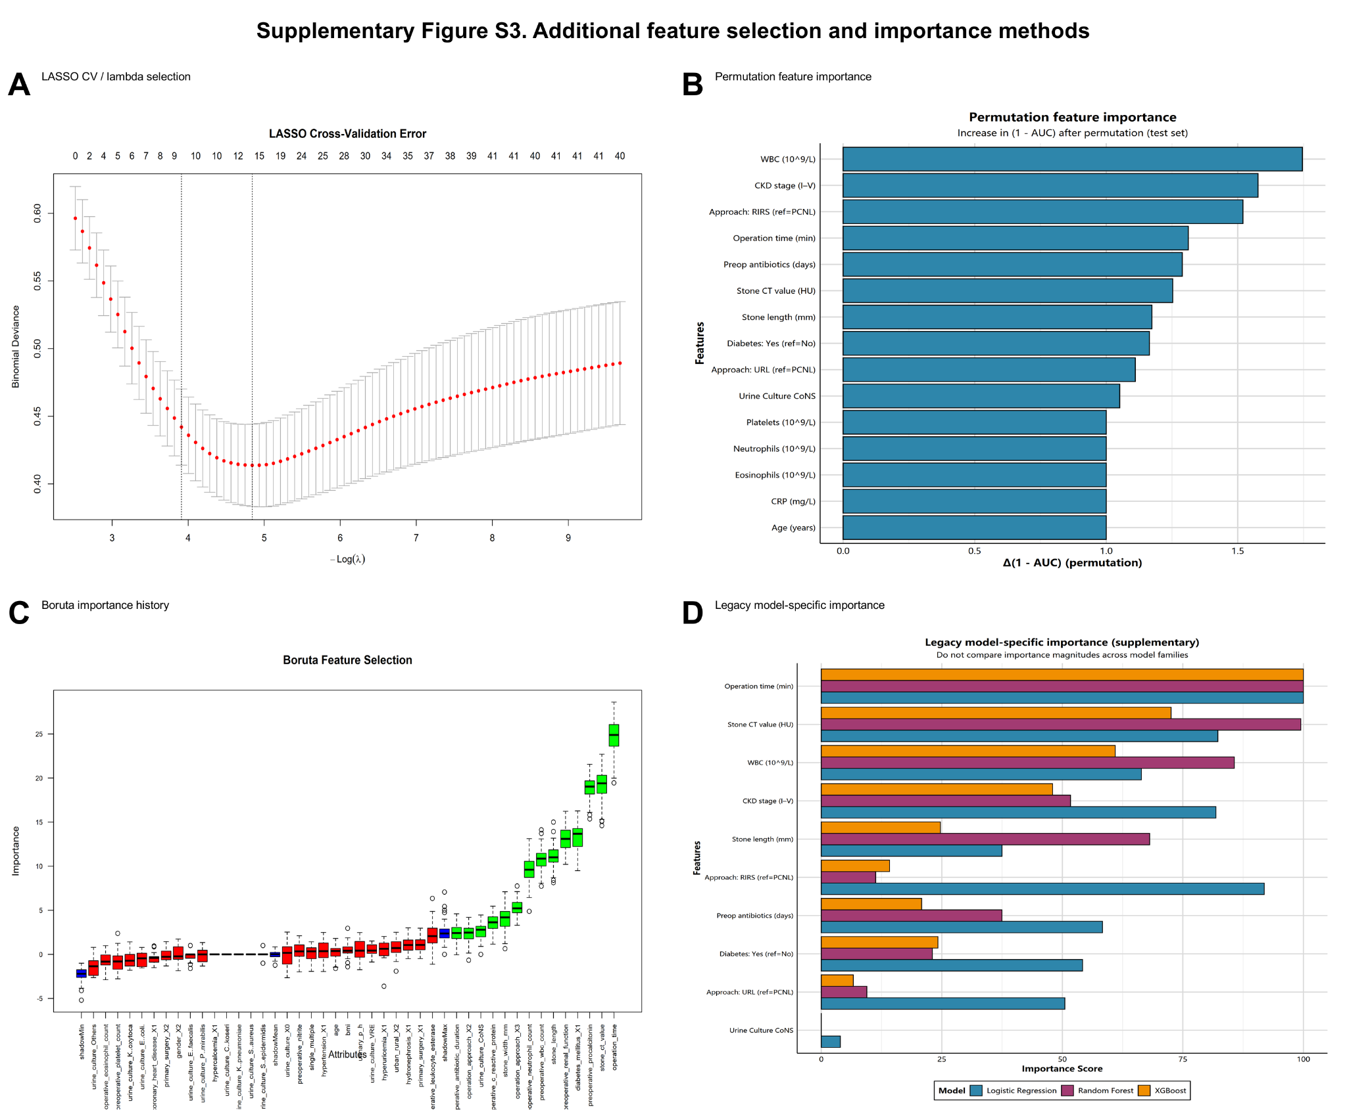

Additional file 11. Supplementary Figure S4. Development and legacy figures.
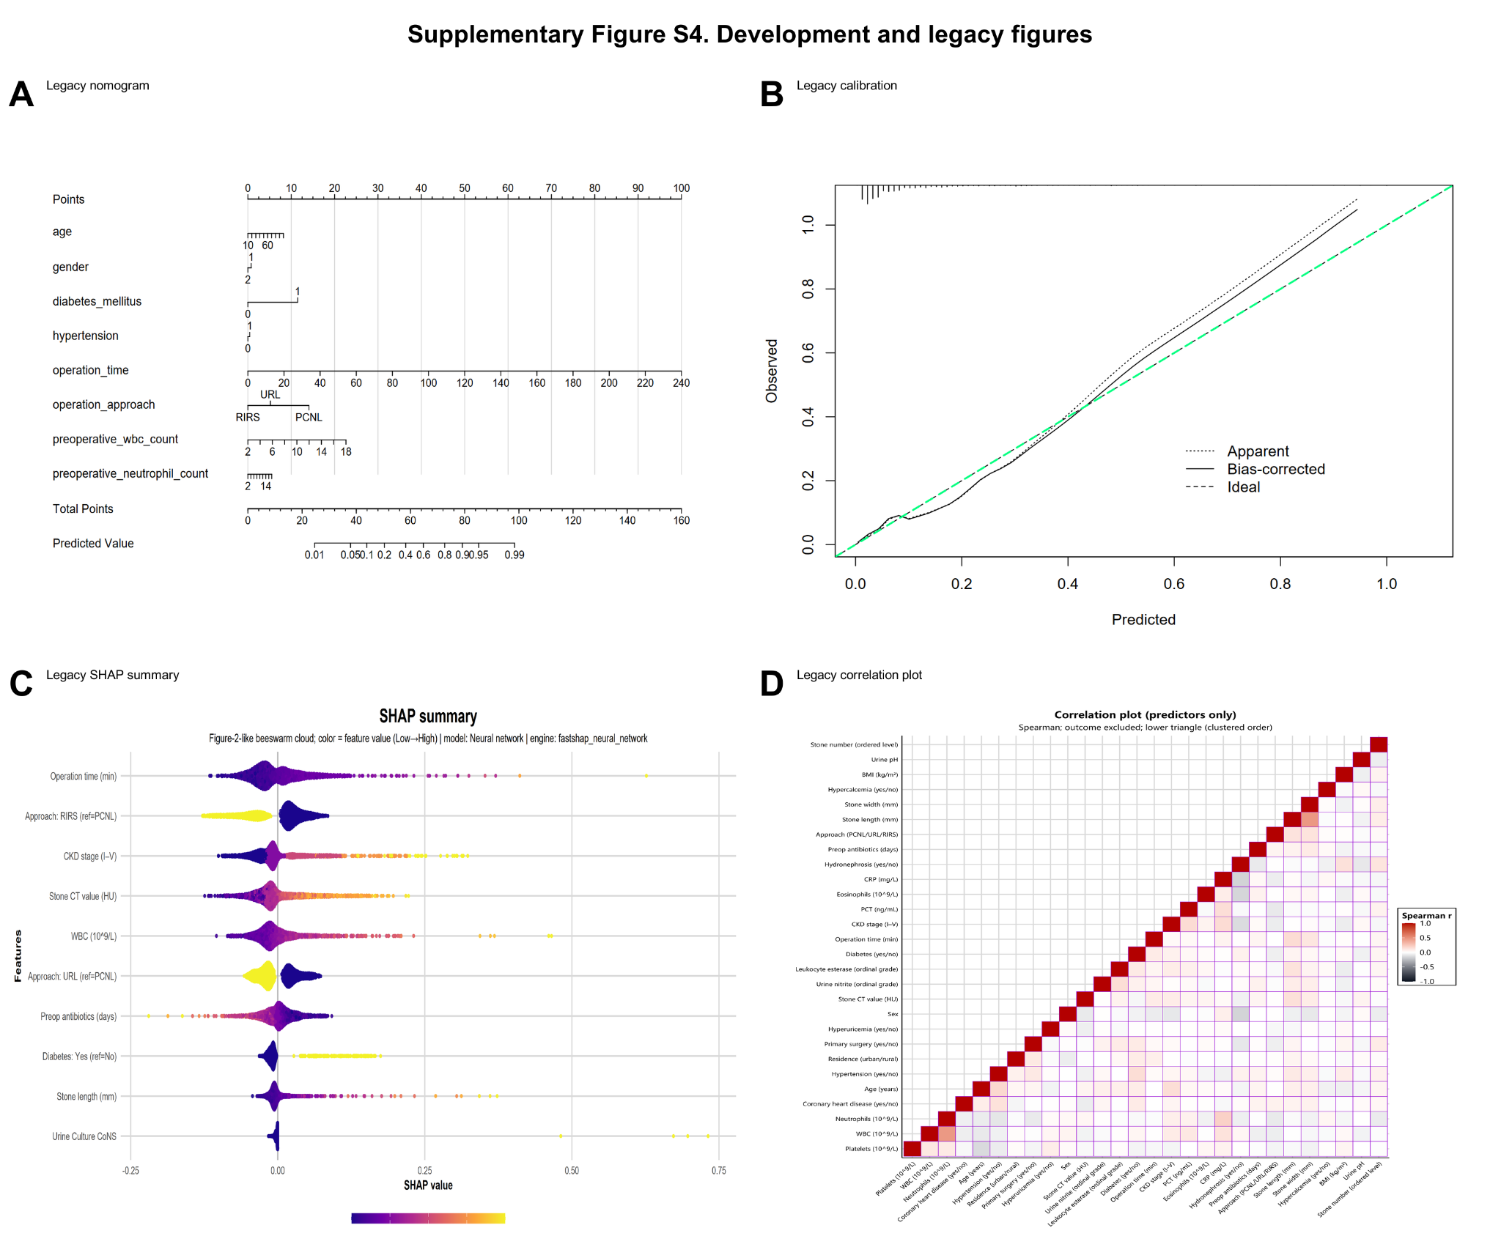

Additional file 12. Supplementary Figure S5. Revised analytical framework for postoperative sepsis prediction.
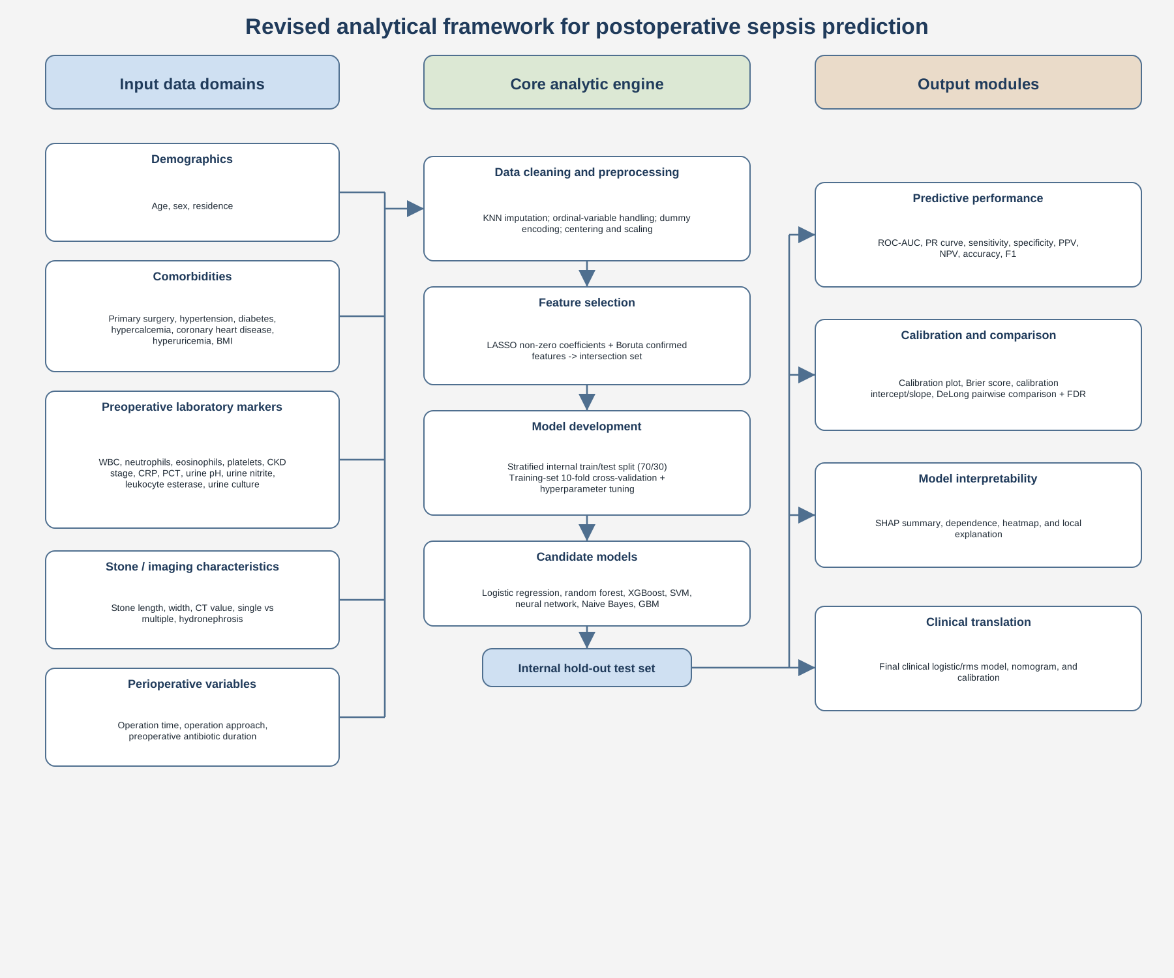

Additional file 13. Supplementary Figure S6. Revised study workflow for machine-learning-based prediction of postoperative sepsis.
