Title:
Modification of discarded PET molecular chains with methyl lactate endows the material with degradable properties

Author List:
Ruzheng Wu, Yunyun Sun, Pan Xu, Linqiang Mao, Bingying Gao*

Graphical Abstract and Text:
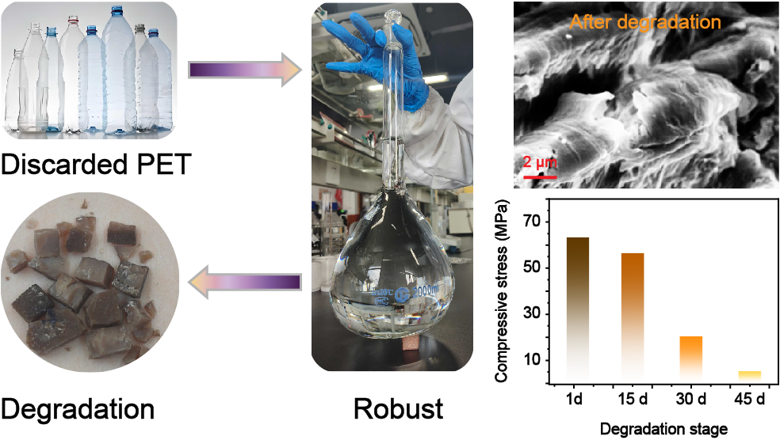
Summary: Discarded PET is upcycled into mechanically strong yet degradable polymers through methyl lactate-mediated phenolic esterification, balancing enhanced mechanical properties with three-stage bulk degradation enabled by structural amorphization and hydrophilic modification.

