Supplementary Information for
Code-Division Multiplexing Using Space-Time-Coding Metasurface

This supplementary information includes:
Supplementary Note 1. Amplitude-phase tunable metasurface for CDM communication
Supplementary Note 2. Calculation of the beam steering phase
Supplementary Note 3. Extended partition schemes for the STCM
Supplementary Note 4. Detailed analysis of the metasurface unit cell
Supplementary Note 5. Test results of 4 data streams for a single user in the proposed CDM system

Supplementary Note 1. Amplitude-phase tunable metasurface for CDM communication

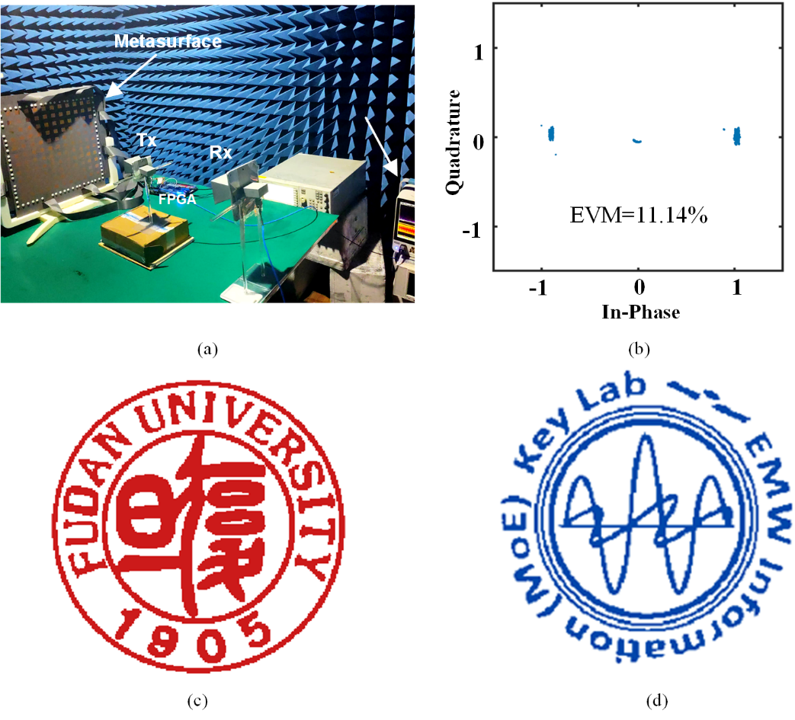
Fig. S1. (a) Schematic of the metasurface measurement setup. (b) Received constellation diagram obtained when the receiving horn antenna is positioned at 0°. (c) Recovered images corresponding to stream 1. (d) Recovered images corresponding to stream 2.

Table S1. State Configurations of APTM for Partition-Free Two-Stream Superposition Transmission
Stream 1 | Stream 2 | Reflection Amplitude | Reflection Phase
0 | 0 | high | 0°
0 | 1 | low | -
1 | 0 | low | -
1 | 1 | high | 180°

For implementing CDM communication, one feasible approach is to partition the metasurface into subarrays. However, increased partitioning introduces challenges in maintaining uniform reflection amplitude across all regions and consistent unit performance within each region, primarily attributed to fabrication tolerances. A more straightforward alternative is to enable metasurface unit cells to directly represent the composite state of multiple superimposed encoded streams.
Herein, we employ a metasurface with independently tunable 2-bit reflection and 1-bit transmission states. Since the reflection amplitude can be regarded as 0 when the unit operates in the transmission state, this metasurface can be equivalent to an amplitude-phase tunable metasurface with 1-bit amplitude tunability and 2-bit phase tunability in reflection mode. As illustrated in Table S2, this metasurface enables the transmission of the superposition of two encoded streams without the need for partitioning.
Fig. S1a illustrates the measurement setup of the metasurface, while Fig. S1b presents the received constellation diagram when the receiving horn antenna is positioned at 0°. Figs. S1c and S1d correspond to the recovered images of stream 1 and stream 2, respectively. The intact recovery of the images verifies the feasibility of the proposed communication system.

Supplementary Note 2. Implementation of the beam steering phase

When the STCM is illuminated by a normally incident plane wave, the phase distribution required for each region’s pattern points towards ${{\hat{u}}_{0}(θ}_{r},φ_{r})$ is given by:

$$\begin{aligned}ψ_{m,n}=-k_{0}{\vec{r}}_{mn}∙{\hat{u}}_{0}+ψ_{0}\#\text{(}\text{S}\text{1)}\end{aligned}$$

where ${\vec{r}}_{mn}$ is the position vector of the mnth element and $ψ_{0}$ is an optimized initial phase for beamforming performance. The calculated phase$ψ_{m,n}$ is subsequently wrapped into the range of 0° to 360°. With the 2-bit phase quantization implemented, the quantization phase is defined as

$$\begin{aligned}ψ_{m,n}^{2-bit}=\left\{\begin{aligned}\begin{matrix}0°, 0°≤ψ_{m,n}<45° or 315°≤ψ_{m,n}<360° \\ 90°, 45°≤ψ_{m,n}<135°\end{matrix} \\ \begin{matrix}180°, 135°≤ψ_{m,n}<225° \\ 270°, 225°≤ψ_{m,n}<315°\end{matrix}\end{aligned}\right.\#\text{(}\text{S}\text{2)}\end{aligned}$$

Table S2. Steering phase STCM Reflected Patterns to $θ_{r}$=0°–50°
$θ_{r}$($°$) | Beam steering phase ($°$)
0 | $0°$,$0°$,$0°$,$0°$
10 | $0°$,$0°$,$0°$,$90°$
20 | $0°$,$0°$,$90°$,$90°$
30 | $0°$,$90°$,$90°$,$180°$
40 | $0°$,$90°$,$180°$,$180°$
50 | $0°$,$90°$,$180°$,$270°$

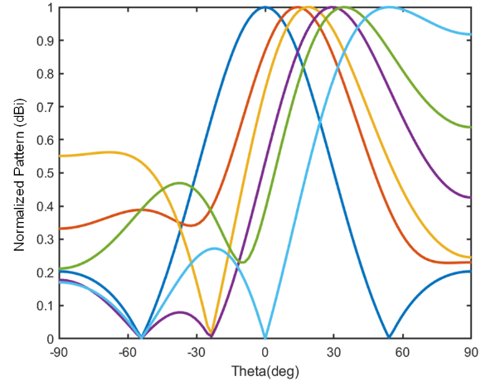
Fig. S2. Calculated reflected patterns at 5 GHz of the STCM region, corresponding to Table S2.

When a region comprises four columns with an inter-column spacing of 18.5 mm, the steering phase calculated to steer the reflected pattern to deflection angles of $φ_{r}$=0° and $θ_{r}$ ranging from 0° to 50° are presented in Table S2. The corresponding radiation patterns are illustrated in Fig. S2. In constructing the coding matrix, steering the beam to the desired direction can be achieved simply by superimposing the steering phase onto the phase associated with the encoded stream.

Supplementary Note 3. Extended partition schemes for the STCM

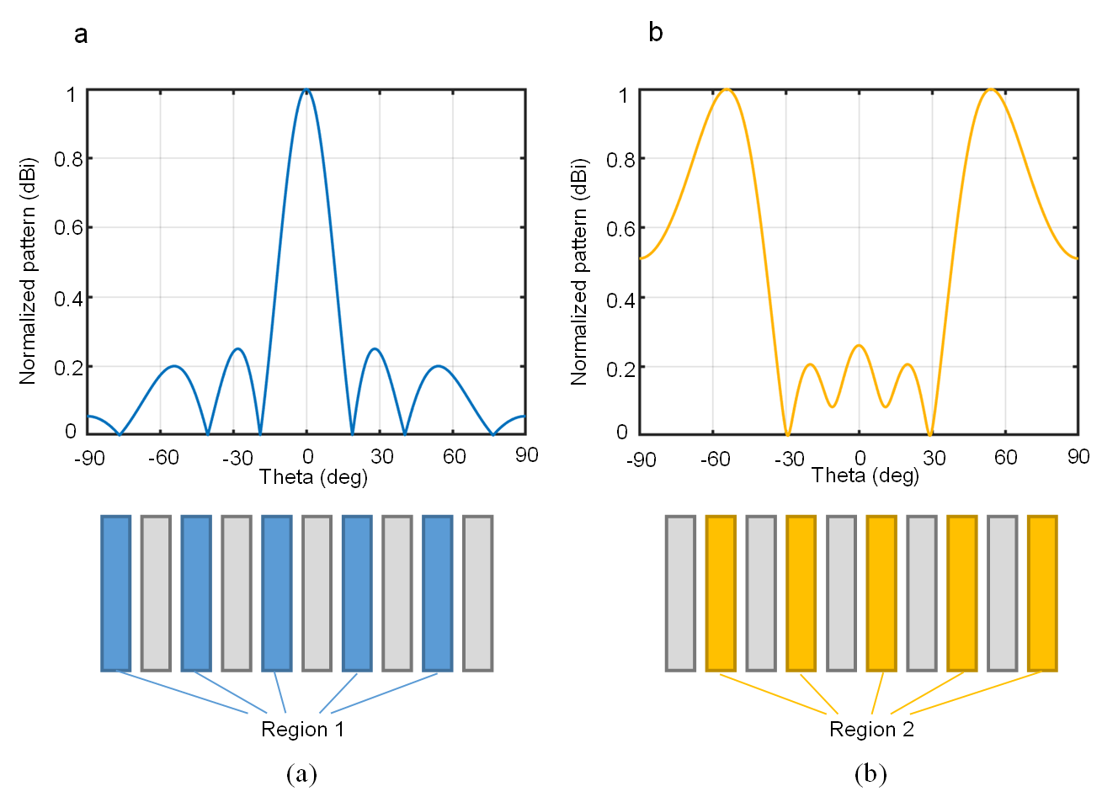
Fig. S3. Calculated reflection patterns at 5 GHz when (a) region 1 (the blue region) transmits encoded stream 1 and (b) region 2 (the yellow region) transmits encoded stream 2. The main lobes of the total pattern remain directed at 0° and ±54.2°.

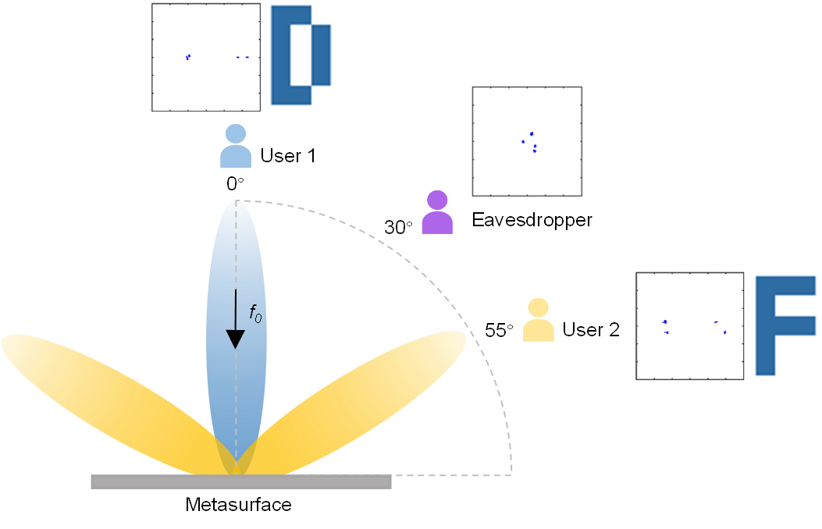
Fig. S4. Schematic of the SDM-CDM communication system. This figure illustrates the directional modulation capability of the metasurface in this operating mode, where only the target user in the main beam direction can successfully decode the information using the corresponding spread spectrum codes, while eavesdroppers at other locations experience complete information loss.

In addition to the previously mentioned approach of treating adjacent columns as a single region, metasurfaces can also adopt more diverse partitioning forms to achieve the desired pattern. Figure S3 illustrates a feasible partitioning scheme: the 1st, 3rd, 5th, 7th, and 9th columns (blue regions) of the metasurface are modulated by encoded stream 1, while the 2nd, 4th, 6th, 8th, and 10th columns (yellow regions) are modulated by encoded stream 2. According to the generalized Snell’s law, steering phases are introduced separately within the blue and yellow regions to control the angles of the scattered beams.
As a demonstration, Fig. S3a presents the reflection pattern when the blue regions are activated and exhibit a 0° phase difference between adjacent columns. The spacing between adjacent blue regions is twice the unit width (37 mm), and the pattern’s main lobe is directed at θr = 0° with a half-power beamwidth (HPBW) of 19°. This beamwidth is narrower than that when the units are contiguous (i.e., with a spacing of 18.5 mm), indicating better directivity. Fig. S3b presents the reflection pattern when the yellow regions are activated and maintain a 180° phase difference between adjacent columns. This configuration results in main lobes oriented at θr = ±54.2° and a HPBW of 30°.
To demonstrate the feasibility of the proposed partitioning scheme, a dual-user SDM experiment is performed. Specifically, Stream 1 is transmitted to 0°, while stream 2 is transmitted to 55°. The received waveforms at 0°, 30°, and 55° are measured, and the constellation diagrams are plotted while recovering the transmitted images. As shown in Fig. S4, legitimate users at 0° and 55° exhibit well-defined constellation patterns, successfully reconstructing the images corresponding to stream 1 and stream 2, respectively. In contrast, the eavesdropper at 30° received a scattered constellation diagram without clustering in the two 180° phase-separated regions, rendering information decoding impossible.

Supplementary Note 4. Detailed analysis of the metasurface unit cell
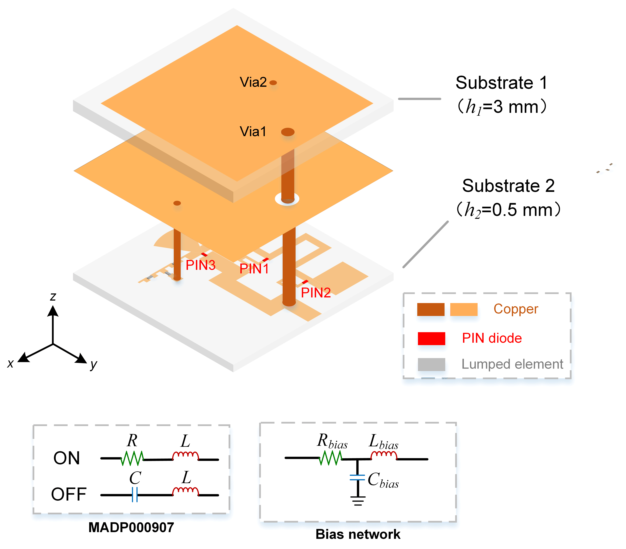
Fig. S5. The unit cell configuration of the metasurface. All diodes employed in the structure are MADP000907, with their equivalent circuit model presented in the bottom-left corner of the figure (R=5.2 Ω, L= 30 pH, C=25 fF). Two bias networks are integrated into the bottom layer of the unit cell, each composed of lumped components R_{bias}=8 Ω, L_{bias}= 100 nH, C_{bias}=100 pF. This configuration serves to implement a low-pass filtering function, thereby minimizing the interference of DC bias voltage on the metasurface’ s operational performance.

Fig. S5 illustrates the unit cell structure of the metasurface. As depicted, the metasurface unit cell comprises two substrate and three metal layers, with the dielectric material being F4B (εᵣ= 2.55). The side length of the unit cell is 18.5 mm. At the top of the metasurface, a patch antenna serves as the electromagnetic wave receiver and radiator. This patch antenna is connected to a reflective phase shifter at the bottom of the unit cell by via 1.
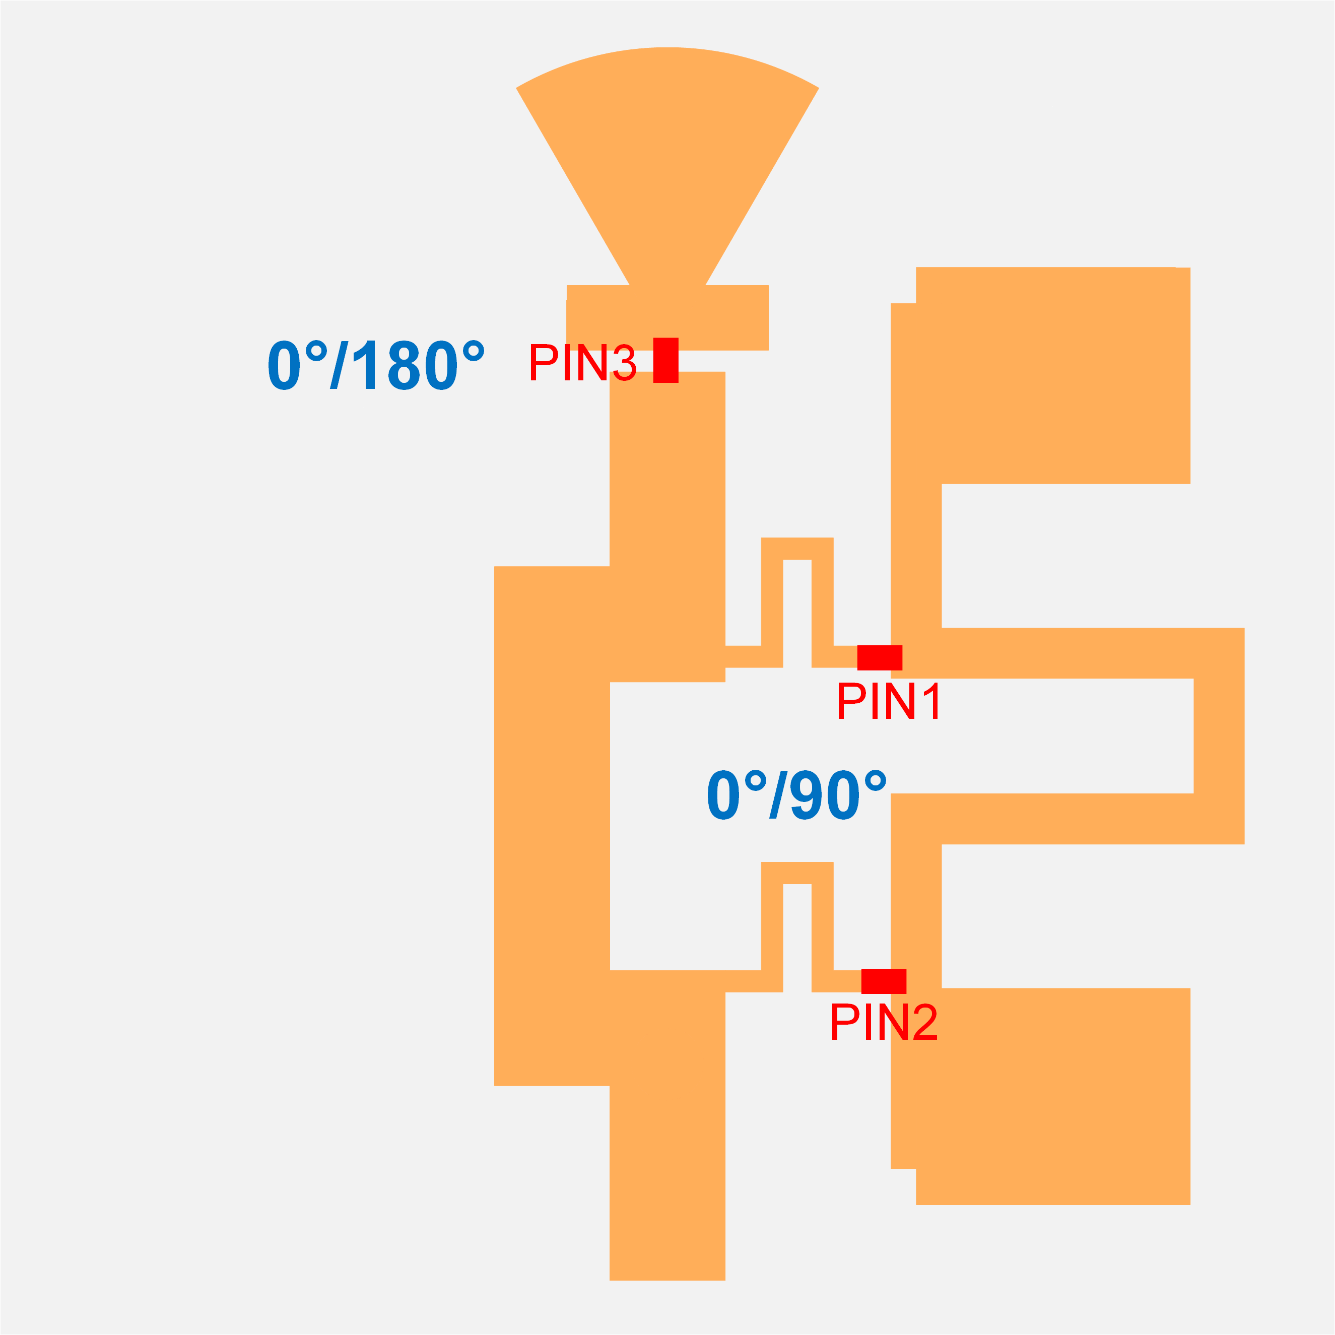
Fig. S6. Bottom-layer structure of the metasurface unit cell

Table S3. State correspondence between metasurface unit cells and diode ON/OFF configurations
States | PIN Diodes
States | PIN 3 | PIN 1 / PIN 2
00 | OFF | OFF
01 | OFF | ON
10 | ON | OFF
11 | ON | ON

Fig. S6 depicts the bottom-layer configuration of the proposed metasurface unit cell, functioning as a reflective phase shifter. Simultaneous switching of PIN1 and PIN2 introduces a 90° phase shift in reflection between their ON and OFF states. The sector-shaped stub connected to PIN3 acts as a short circuit at the operating frequency, enabling an additional 180° phase shift through PIN3 switching. Table S3 summarizes the operational state mappings of the metasurface unit cell corresponding to different diode switching configurations.

Supplementary Note 5. Test results of 4 data streams for a single user in the proposed CDM system

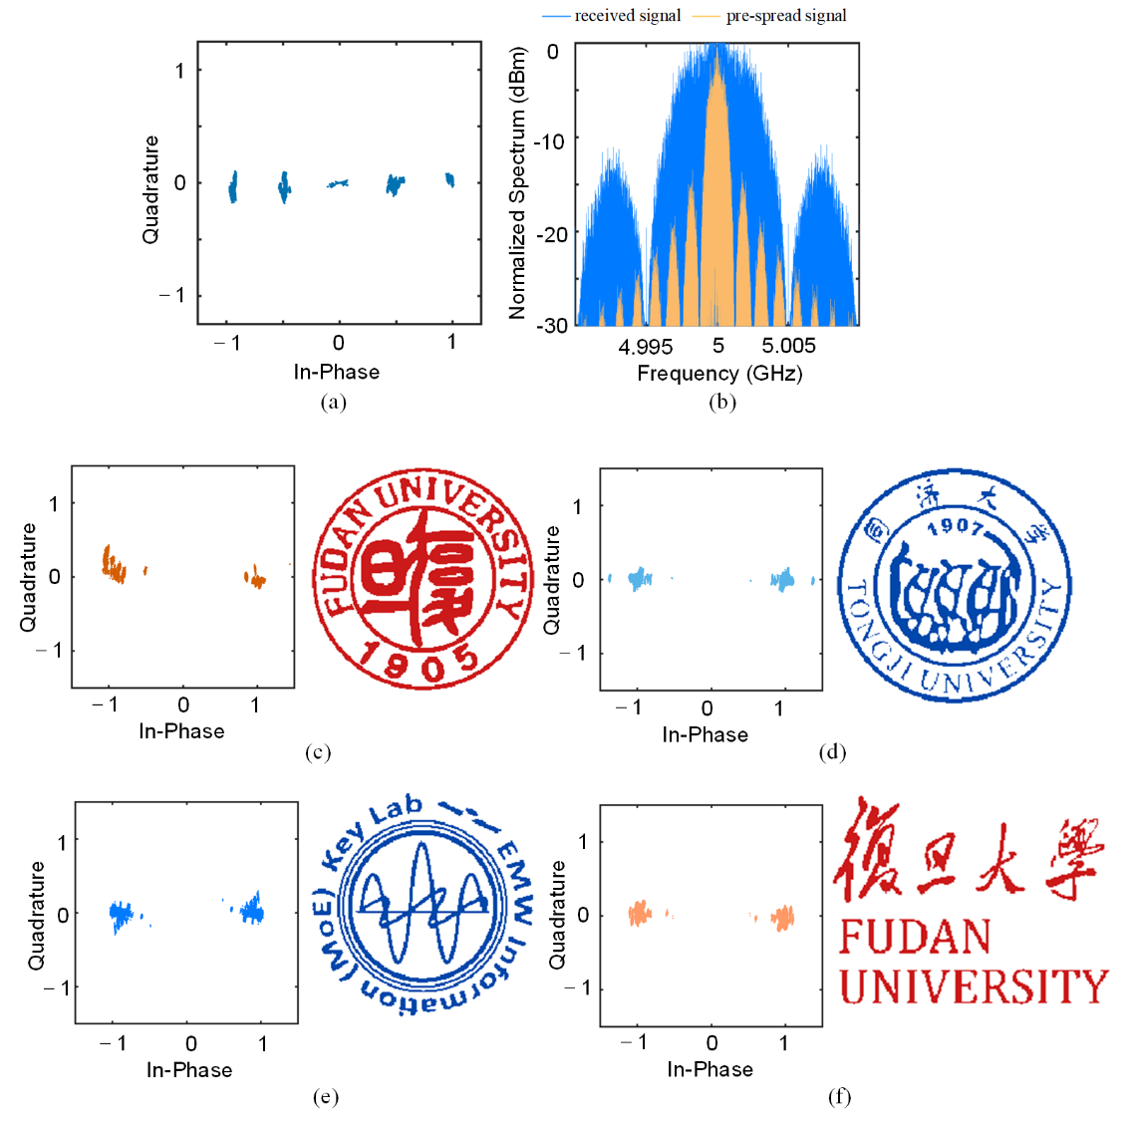
Fig. S7. (a) Constellation diagram of the received signal. (b) Spectrum of the transmitted signal and original bit stream. (c)–(f) Constellation diagrams and recovered images corresponding to stream 1, stream 2, stream 3 and stream 4.

For the four-stream single-user scenario, the metasurface is configured such that every two adjacent columns are modulated by the same transmitted information signal. The two remaining columns are covered with microwave-absorbing material to eliminate unwanted reflections. The following orthogonal spreading codes are assigned to each stream:
c₁= [1, 1, 1, 1]
c₂= [1, 0, 1, 0]
c₃= [1, 1, 0, 0]
c₄= [1, 0, 0, 1]

Figs. S7a show the constellation diagram of the signal received by the horn antenna. Figs. S7b shows the spectrum of original bit stream and transmitted signal. The signal bandwidth is expanded to four times that of the original pre-spreading signal, consistent with the length of the spreading codes. Figs. S7c-f present the constellation diagrams and the recovered images corresponding to each independent region of the metasurface. Although slight dispersion is observable in the constellations, the structures remain clearly distinguishable, confirming successful signal separation.

